Towards a simpler ecocrop model

Andy South and Nicole Forstenhaeusler

2017-12-05

## Abstract

We describe a relatively simple approach for investigating the responses to climate change of the global distributions of hundreds of crops.

The large changes predicted in high-end climate scenarios are outside of the tolerances of many existing crops where they are currently grown. Potential adaptation strategies include growing crops in new areas that become suitable under a changed climate and stopping growing in areas that become unsuitable.

There are a wide range of existing approaches for predicting the response of crop distributions to climate change. These differ in whether they are statistical or mechanistic and in the level of detail they include. There is a trade off between this level of detail and the generality of application in terms of numbers of crops and geographic area. Detailed models, e.g. representing the growth of crops daily, have data requirements that restrict their application to very few crops and to restricted geographic areas. A relatively simple mechanistic approach based upon the temperature and precipitation requirements of hundreds of crops held in the FAO EcoCrop database was developed more than 15 years ago. This modeling approach, also termed EcoCrop, was implemented in both GIS and a package in the statistical language R. A more recent paper describes the application of a modified version of this approach to a single crop, Sorghum.

The existing ecocrop model has not been applied to a large number of crops at large geographic extents even though the potential to do this is one of the advanatges of it's simplicity.

We describe an even simpler method than the ecocrop model for predicting crop suitability based upon the FAO ecocrop database. This new simple method produces better true positive rates than the original ecocrop model when tested against MIRCA harvested area data for the year 2000.

Some of the details in the original ecocrop modelling approach seem not to be justified by these tests against field data.

The new simpler method simply predicts if an area is suitable or not (0/1), rather than predicting a suitability value between 0 and 1. It aims for a conservative approach, to be able to exclude areas that are unsuitable with some confidence, while being less concerned that some unsuitable areas are classed as suitable. [todo I'm not sure about that sentence]

This new approach is both simpler, more transparent and more open. We provide a documented R package implementing the method, including methods to test against field data.

end of abstract

## Introduction

The FAO ecocrop database holds data for more than 2500 crops including requirements for temperature, rainfall and soils based upon expert judgement. The ecocrop modelling approach estimates suitability for crops based on temperature and precipitation using these requirements[1]. The ecocrop modelling approach has been implemented in a number of slightly different ways and can be run from an R package and Diva-GIS. Ecocrop the modelling is designed to be simpler than other crop models allowing it to be applied to a wider range of crops and situations.

In summary the ecocrop the modelling approach : 1. Calculates a mean of the minimum and maximum crop growth cycle 2. Rounds this mean (up or down) to the nearest number of months to calculate a 'duration' 3. Finds whether there are 'duration' consecutive months in between the ecocrop temperature limits 4. Finds whether there is a concurrent 'duration' period where the total precipitation is between the ecocrop rainfall requirements of the crop.

This is a broad summary of the ecocrop model as implemented within the R package dismo and with Diva-GIS.

In addition the model uses 'optimal' temperature and precipitation limits specified in FAO ecocrop to develop an index of suitability per month, the best month and the value of the index in the best month.

Ecocrop the model as implemented in this way has not been well tested against empirical data.

For what is supposed to be a simple modelling approach the method becomes quite tricky and not very transparent.

Firstly it doesn't seem very mechanistic to me that a mean of the minimum and maximum crop growth cycles is used as one of the most influential parameters. For example for maize the minimum and maximum crop growth cycles are 65 days and 365 days which round to 3 months and 12 months. The ecocrop model thus assesses temperatures for a 7 month growth cycle. The figure below shows the minimum and maximum crop growth cycles stored within ecocrop for some important crops.

Secondly the crop parameters as specified in the FAO ecocrop database are necessarily very broad. Whilst they are based on expert judgement they cannot hope to capture the majority of the processes that influence the suitability of an area for a crop. For this reason a more realistic goal than trying to predict a suitability score is to try to predict which areas are definitely not suitable for a crop. This also has the advantage that predicted absence is easier than a suitability score to test against global crop data.

## Methods

A simpler, more transparent, method could allow us to use both the minimum and maximum growth cycles and to develop predictions of which areas are not suitable for a crop.

The proposed method is :

1. Use the minimum crop growth cycle to assess whether there is a minimum period within the year within the crop temperature limits that could allow the crop to grow.
2. Use the maximum crop growth cycle to assess whether there is a period that could allow the crop to get sufficient water. Trials have shown that using either the maximum crop growth cycle to assess temperature or the minimum crop growth cycle to assess rainfall leads to the exclusion of unrealistic areas (e.g. excluding maize from most of Europe).

The base ecocrop predictions have some aspects that also look wrong for example they too predict that maize will not grow in Europe. This is also the problem that Nicole had making predictions far into the future, the ecocrop method of using the mean growing cycle to find time periods without low temperatures was excluding moderately northern latitudes.

TODO

I need to justify advantages over a statistical approach (statistical works on where crops are grown not on where they could be grown)

##### Table 1 : The new simpler method has a better true positive rate than ecocrop for rainfed crops. Comparing global predictions for the year 2000 to Mirca.

|  |  |  |
| --- | --- | --- |
| crop | simple_true_positive | ecocrop_true_positive |
| maize | 0.86 | 0.44 |
| rice | 0.51 | 0.37 |
| wheat | 0.78 | 0.35 |
| soya_bean | 0.60 | 0.51 |

|  |  |  |  |
| --- | --- | --- | --- |
| crop | simple_true_positive | tmax_true_positive | ecocrop_true_positive |
| maize | 0.86 | 0.86 | 0.44 |
| rice | 0.51 | 0.50 | 0.37 |
| wheat | 0.78 | 0.47 | 0.35 |
| soya_bean | 0.60 | 0.59 | 0.51 |
| sorghum | 0.89 | 0.89 | 0.60 |

##### Table 2 : The new simpler method has a slightly poorer true negative rate (specificity) than ecocrop for rainfed crops. However the true negative rate is not such a good test because we expect that other factors (e.g. such as history and economy) contribute to crops not being grown in areas that have a suitable climate.

|  |  |  |
| --- | --- | --- |
| crop | simple_true_negative | ecocrop_true_negative |
| maize | 0.12 | 0.15 |
| rice | 0.20 | 0.21 |
| wheat | 0.11 | 0.16 |
| soya_bean | 0.15 | 0.16 |

##### Maps showing how the new simpler predictions compare both to Mirca and the existing ecocrop model.

Both Mirca and ecocrop have a gradation of values, these are converted to 0/1 in the testing process.

In the first set of maps I convert everything to 0/1 to aid comparisons.

In the 2nd set of maps I keep the range of values in the Mirca and ecocrop predictions. In these later maps grey in the Mirca maps represents harvested area greater than 0 (but low). Grey in the suitability maps represents 0 suitability. I think that the fact that the green pattern in the suitability maps follows the grey pattern in the mirca maps is a good sign. I just want us to discuss this and then I can improve the colour schemes.

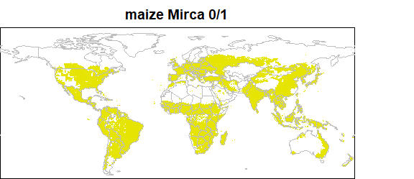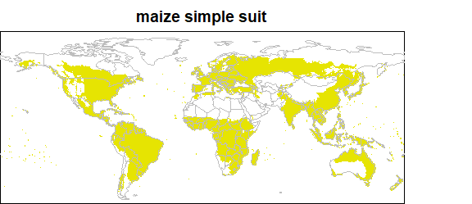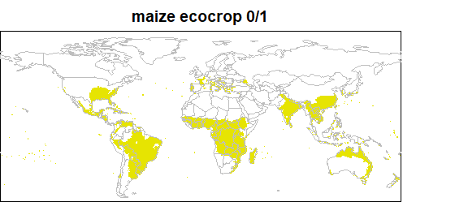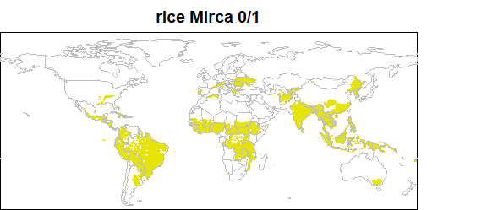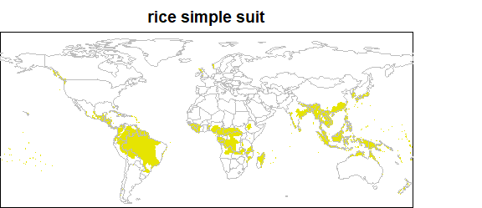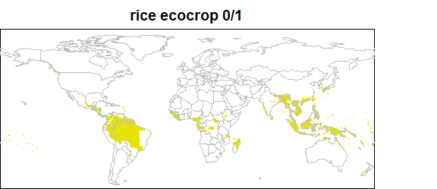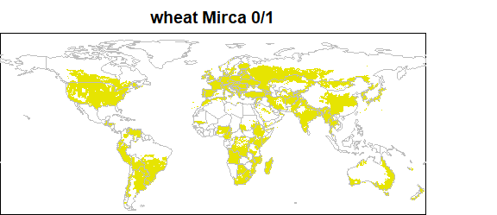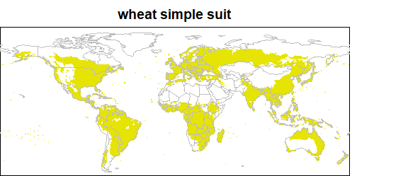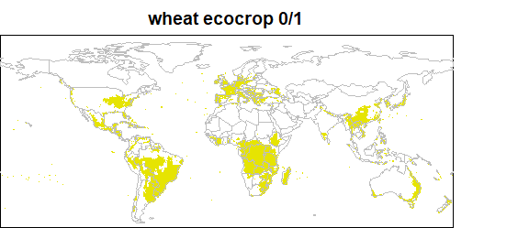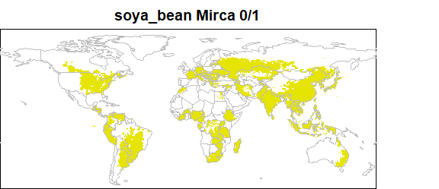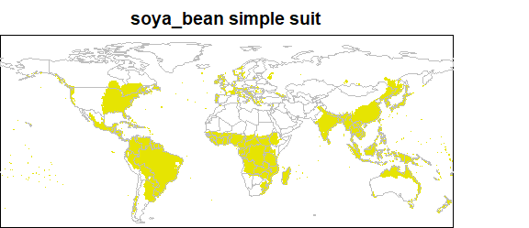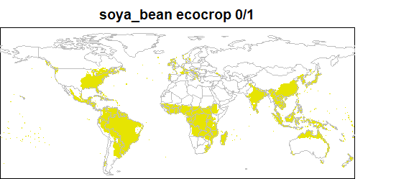

The new simpler method is quantitatively better than ecocrop when compared to Mirca, but still has large differences from Mirca. 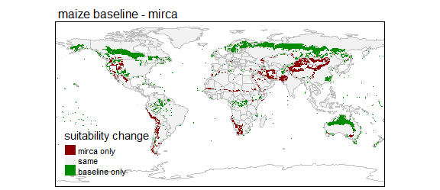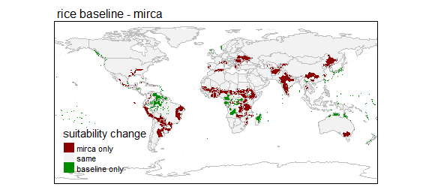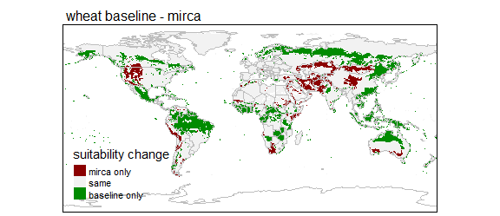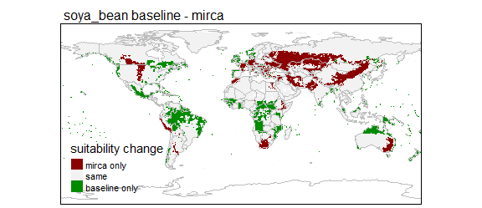

The utility of having simple 0/1 predictions is that it is also clearer to compare predicted change against a baseline. Calculating future - baseline gives you +1 for areas expected to gain the ability to support a crop and -1 for areas expected to lose the ability to support a crop. These can be displayed as in the map below.

## Warning: Currect projection of shape maize_change unknown. Long-lat (WGS84)  
## is assumed.

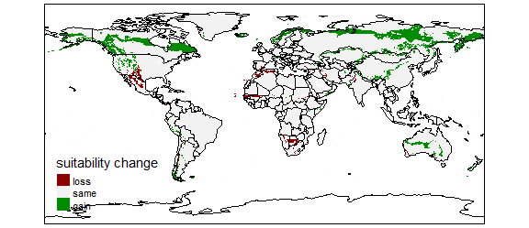

### comparing using maximum rather than mean temp climate data

### to assess simple suitability

### length of crop growth cycles from ecocrop

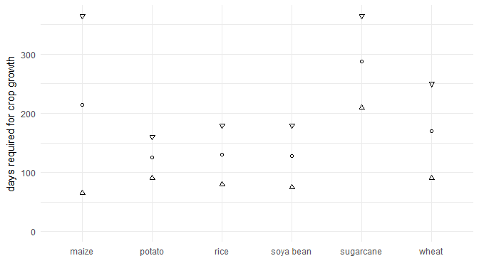

## References

temporary citations to start ref list [1] sorghum paper [2] differences in global crop models and maps [3] diva-gis manual [4] comparing mechanistic and empirical crop models [5] climate cahnge impacts on maize based on 3 different modelling approaches [6] how do weather influence croppping area and intensity [7] geographic distribution of major crops [8] global gridded crop model evaluation [9] MIRCA crop maps

1. Ramirez-Villegas J, Jarvis A, Läderach P: **Empirical approaches for assessing impacts of climate change on agriculture: The EcoCrop model and a case study with grain sorghum**. *Agricultural and Forest Meteorology* 2013, **170**:67–78.

2. Anderson W, You L, Wood S, Wood-Sichra U, Wu W: **An analysis of methodological and spatial differences in global cropping systems models and maps**. *Global Ecology and Biogeography* 2015, **24**:180–191.

3. Hijmans R, Guarino L, Mathur P: *DIVA-GIS Version 7.5 Manual*. 2012:71.

4. Estes LD, Bradley BA, Beukes H, Hole DG, Lau M, Oppenheimer MG, Schulze R, Tadross MA, Turner WR: **Comparing mechanistic and empirical model projections of crop suitability and productivity: Implications for ecological forecasting**. *Global Ecology and Biogeography* 2013, **22**:1007–1018.

5. Holzkämper A, Calanca P, Honti M, Fuhrer J: **Projecting climate change impacts on grain maize based on three different crop model approaches**. *Agricultural and Forest Meteorology* 2015, **214-215**:219–230.

6. Iizumi T, Ramankutty N: **How do weather and climate influence cropping area and intensity?** *Global Food Security* 2015, **4**:46–50.

7. Leff B, Ramankutty N, Foley JA: **Geographic distribution of major crops across the world**. *Global Biogeochemical Cycles* 2004, **18**:n/a–n/a.

8. Müller C, Elliott J, Chryssanthacopoulos J, Arneth A, Balkovic J, Ciais P, Deryng D, Folberth C, Glotter M, Hoek S, Iizumi T, Izaurralde RC, Jones C, Khabarov N, Lawrence P, Liu W, Olin S, Pugh TA, Ray DK, Reddy A, Rosenzweig C, Ruane AC, Sakurai G, Schmid E, Skalsky R, Song CX, Wang X, De Wit A, Yang H: **Global gridded crop model evaluation: Benchmarking, skills, deficiencies and implications**. *Geoscientific Model Development* 2017, **10**:1403–1422.

9. Portmann FT, Siebert S, Döll P: **MIRCA2000-Global monthly irrigated and rainfed crop areas around the year 2000: A new high-resolution data set for agricultural and hydrological modeling**. *Global Biogeochemical Cycles* 2010, **24**:n/a–n/a.