getting field data into insecticide resistance model

### Section demonstrating getting field data into the model, to be added to Malaria Journal paper.

The main model inputs relating to properties of the mosquitoes and insecticides can be derived from data on the relative survival of the different genotypes (RR,RS,SS) Table x.

**Table x1. Calculating model inputs from field data.**

|  |  |
| --- | --- |
| Parameter | Calculation (where RRfit, RSfit, SSfit are fitnesses of genotypes) |
| 1. Effectiveness | 1 - SSfit in presence of insecticide |
| 2. Exposure | estimated |
| 3. Resistance restoration | (RRfit-SSfit) / Effectiveness in presence of insecticide |
| 4. Dominance of restoration | (RSfit-SSfit)/(RRfit-SSfit) in presence of insecticide |
| 5. Frequency | estimated |
| 6. Cost of resistance | 1 - RRfit in absence of insecticide |
| 7. Dominance of cost | (RSfit-RRfit)/(RRfit-SSfit) in absence of insecticide |

Exposure, the proportion of mosquitoes that are exposed to the insecticide, is a property of the location and will depend on the use of nets or IRS and mosquito behaviour. The frequency of resistance alleles can be measured, although when at low levels a large number of mnosquitos would need to be sampled to detect low frequencies.

As an example of making these calculations we use data for Anopheles gambiae on pyrethroid (Etofenprox) resistance associated with the Kdr mutation [1] and carbamate (Bendiocarb) resistance associated with the Ace1 mutation [2].

In both cases data were provided as numbers alive and dead by genotype. We used these to calculate genotype-specific survival values that we assume are a good indication of fitness and from that the values of our model inputs (Table x2).

|  |  |  |  |  |  |  |
| --- | --- | --- | --- | --- | --- | --- |
| Insecticide/Mutation | survival RR | survival RS | survival SS | Effectiveness | Resistance restoration | Dominance of restoration |
| Pyrethroid/Kdr | 0.84 | 0.65 | 0.57 | 0.43 | 0.63 | 0.30 |
| Carbamate/Ace1 | 0.84 | 0.56 | 0.02 | 0.98 | 0.84 | 0.66 |

These input values can then be used in the model. In Figure x insecticide 1 and 2 are set to the pyrethroid (red) and carbamate (blue) respectively. Exposure is set to 0.5 and starting frequencies to 0.01.

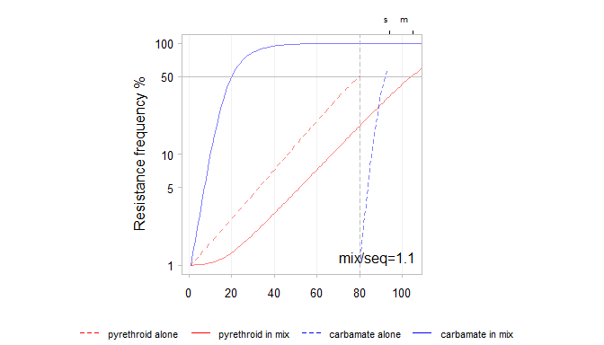

Figure 10. Running the model using field data.

Resistance to the carbamate (blue) rises quickly because it has high effectiveness and dominance. The mixture performs better than the sequence because the carbamate with it's high effectiveness provides high protection to the pyrethroid.

# References

1. Kolaczinski JH, Fanello C, Hervé JP, Conway DJ, Carnevale P, Curtis CF: **Experimental and molecular genetic analysis of the impact of pyrethroid and non-pyrethroid insecticide impregnated bednets for mosquito control in an area of pyrethroid resistance.** *Bulletin of entomological research* 2000, **90**:125–32.

2. Essandoh J, Yawson AE, Weetman D: **Acetylcholinesterase (Ace-1) target site mutation 119S is strongly diagnostic of carbamate and organophosphate resistance in Anopheles gambiae s.s. and Anopheles coluzzii across southern Ghana**. *Malaria Journal* 2013, **12**:404.