A one page intro to conducting Schwartz values analysis in R using the rschwartzvalues package.
Andy South, August 2012. southandy@gmail.com

This document assumes that you have responses to a Schwartz values analysis based on 21 or 57 questions. The responses need to be numerical and stored in a text file. You have the package file rschwartzvalues_1.0.zip saved on your PC. Below text in bold is what you need to type into the R console. [] encloses text that you may need to modify.
The main functions in the package are :
valueSetsPlots() takes question responses, calculates ‘Value sets’ and produces one plot for each group
valueSets() just calculates the ‘Value sets’ from the question responses
rosePlot() creates individual circular rose plot from value sets (or other) data

To install the package to R :
install.packages("rschwartzvalues_1.0.zip") #you will need to provide the path to the file
library(rschwartzvalues)
?rschwartzvalues #To access the online help

Save your data as a .csv or .txt file, with each question as a column (in the correct order), and each row as the response of one individual. Use the first column to specify the group membership of each individual.
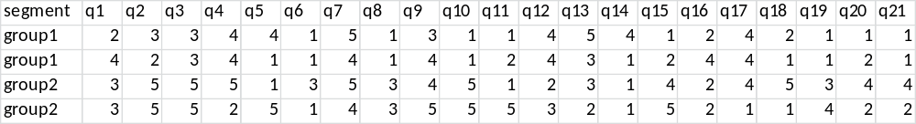

Read the data into R : dFmyData <- read.csv("[my infilename]")

To do a quick analysis of all the groups in your file producing one plot for each group :
valueSetsPlots(dFmyData, numQs=21)

To do the analysis in stages allowing greater flexibility :
To calculate the ‘Value sets’ from the raw data and save to a file (example results shown opposite):  dFmyValueSets <- valueSets(dFmyData, numQs=21)  write.csv( dFmyValueSets, "[my outfilename]", row.names = F )
  setID | setName | group1 | group2
  un | Universalism | 2.83 | 4.33
  be | Benevolence | 2.5 | 2.83
  po | Power | 2.75 | 3.75
  ac | Achievement | 2.25 | 4.75
  he | Hedonism | 1.5 | 3.75
  st | Stimulation | 4 | 2.5
  sd | Self-Direction | 2.5 | 1
  co | Conformity | 3.5 | 2.25
  se | Security | 1.25 | 3.25
  tr | Tradition | 1.25 | 3
To create individual plots from the value sets results.
rosePlot(dFmyValueSets, names='setName', values='group1')
Save the plot to a pdf : savePlot("[myFile.pdf]",type='pdf'))

Modify plot appearance :
rosePlot(dFmyValueSets, names='setName', values='group1', ,textSize=0.5, palette='grey', ringCol='red ' )
To look at the lookup tables used to convert from question responses to ‘Value sets’
data(dFlookup21)
dFlookup21

