

Operation and Automation Solutions

Coding Task

**Points to Note**

Please let us know the link to download zip / git clone your work.

Try Your Best & Enjoy the Process.

Good Luck!

Q1. (10%)

Write a Java program to reverse a given string without using any built-in methods or libraries.

e.g.

Input: retlaohS

Output: Shoalter

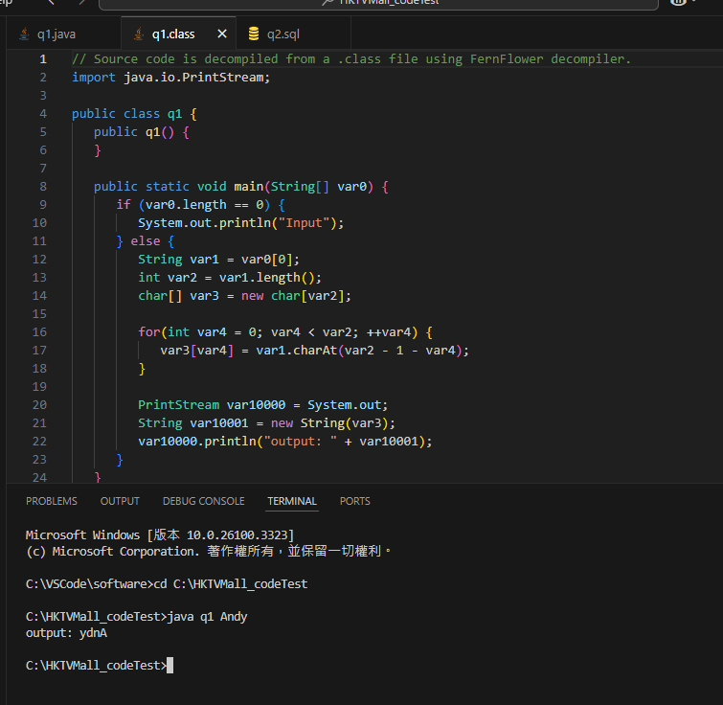

Q2. (15%)

Warehouse supervisor requests an hourly report to show how well their packers perform. Based on the sample table and data given below, please write a SQL statement to generate the number of totes being PACKED per user during 10:00:00 to 10:59:59, and provide the expected output.

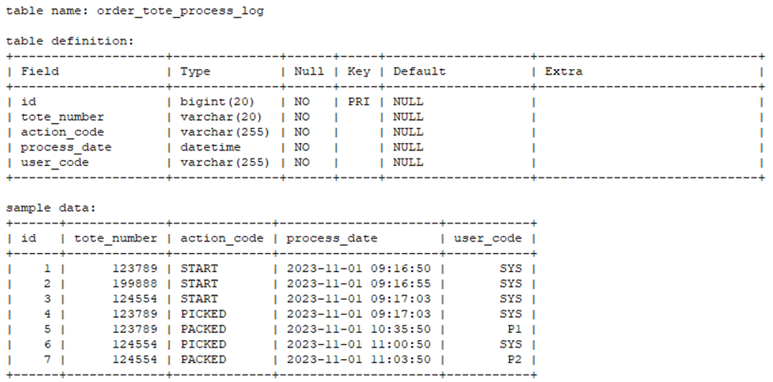

Here I will add the auto_increment with id which is auto add the unique number and no repair on db setting, but some online compiler is not allow it.

<https://onecompiler.com/mysql/43bqmh3a7>

The link is online complier and plz change to db language mysql first. 

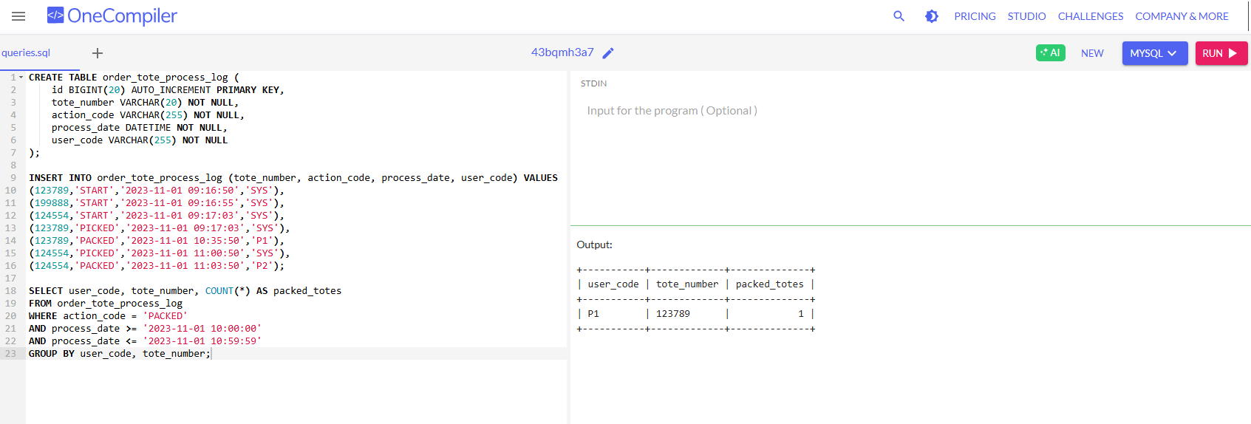

Q3. (25%)

Logistics team requests a feature to allow customers to calculate the shipping fee according to the dimension (cm) / weight (kg) / temperature condition / quantity of the parcels. Based on the sample rate card given below, please 1) design an API and draft the API specification for the shipping fee calculation request, 2) develop a workable demo web application.

Assumption:

1. Can have multiple items in single request
2. Will not have items with mixed temperature condition in single request

Volumetric Weight formula: (length x width x height) / 5000

Rate Card:

|  |  |  |
| --- | --- | --- |
| **Weight (kg)** | **Temperature Condition** | **HKD (per kg)** |
| ≤ 5 | Ambient | $10 |
| > 5 | Ambient | $15 |
| ≤ 5 | Chill | $20 |
| > 5 | Chill | $30 |

* The weight is according to the volumetric weight or physical weight, whichever is higher

Here I use the Spring Initializr to make the project and Plz run code on cmd with using command mvnw.cmd spring-boot:run on demo

