**PROMOTIONAL MATERIAL**

With keen cyclists within our team, there was an opportunity to create our own bespoke promotional material. This would allow us to create, stage and use photographs that would have a brand identity or constant look throughout the range. It further allowed us to design an image in advance, knowing how it would be exploited within our project. Not only did this save considerable time in trying to find suitable library images, it also removed any copyright problems.

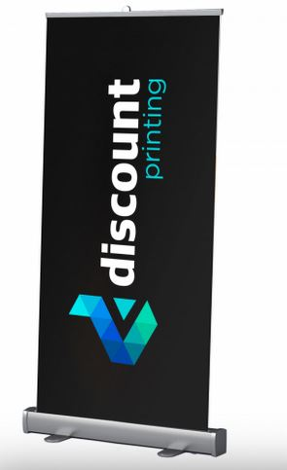It was envisaged that these images would be used on the project web pages. It was further intended that these would enhance the presentation of our project through the use of a backdrop promotional display poster, alongside promotional flyers etc. An example promotional flyer can be seen overleaf.

A brief investigation found that online suppliers such as discount printing, could provide printed roller displays as illustrated, for under £31 inc VAT (price as of 16th April 2020.[1] An additional benefit of staging our own photo-shoot was that we had high quality images, that could be blown-up to billboard size if required.

A photo-shoot was arranged outside of the MVB building on Woodlands Road for the 16th March 2020, just ahead of the major impact of the Corvid-19 situation upon the university. The location, whilst convenient was deemed suitable as the road is usually quiet, with good visibility, and a gradient to allow for some action photographs.

The images were taken on a Nikon D7000 with a variety of lenses. Unfortunately there was no prototype light box to clip on to the helmets and whilst the Pimoroni LED matrix was photographed in those locations with a view to compositing it within the image, its light output was too feeble to use.

The helmet device was therefore added using Adobe Photoshop, alongside using in-camera panning techniques and post-processing of blurs etc to create a sense of motion. A wider selection of rough conceptual images can be seen in Portfolio>photos.

The flyer overleaf, had the 3D Blender model incorporated within the image, replacing the rough concept design used in Photoshop. More time would need to be spent to make it sit, or composite, properly within the image. Indeed a reshoot using a mirror ball to allow Image-Based-Lighting (IBL) techniques would be desirable following the failure of the Pimoroni matrix. These IBL techniques use the mirrored ball to faithfully capture the location and position of all light sources, allowing them to be recreated within the 3D modelling software.

However, the removal of the presentation element of the project, meant that this approach would be abandoned.

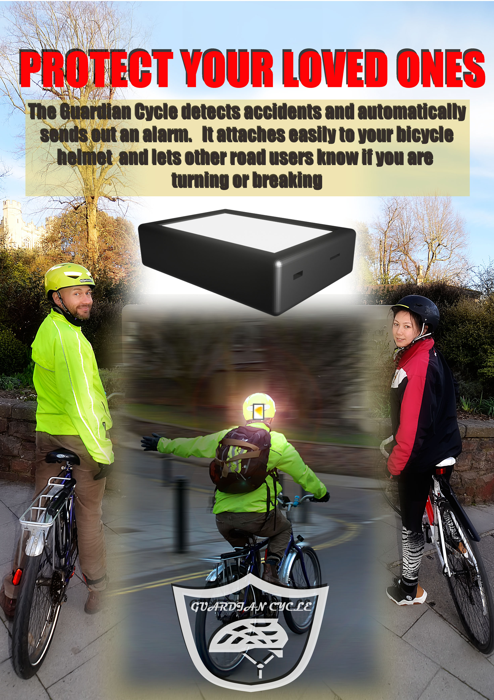

Example flyer demonstrating the indicator light.

Beyond the use of the images in printed media, they allowed us to have high quality images that we could manipulate as required. As an example of a house style, repeating the splitting of the two cyclists as seen in the advert above, a rough demo display for a web page was created. This example explored the possibility of additional design features afforded to us with higher quality images. Here the cyclists, split in to two banners, have a gold and black aesthetic to them – demonstrating that the images could replicate any colour choices implemented within the project web pages.

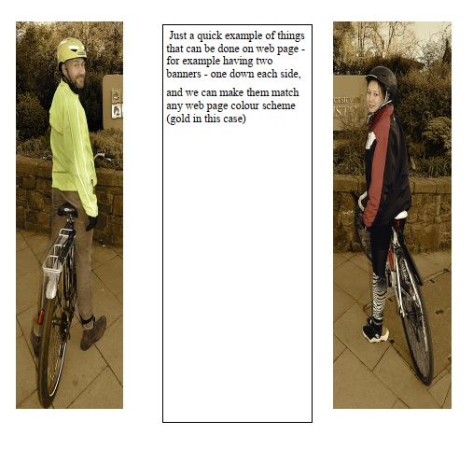

This use of a gold colour (note it is not fully implemented on the cyclists themselves to enable them to stand out from the fully gold based background) was only an example, and most colour schemes could be implemented with something like this.

1. https://www.discountprinting.co.uk/print/roll-up-banners-2/800mm-banner-stand-2/?gclid=Cj0KCQjw4dr0BRCxARIsAKUNjWTUGWgGVNoOZqGDWFWg5kcm-emyYyp4kiUbzSsJ2nKk11a5oV0LzYEaAnPhEALw_wcB