Launchpad X
Programmer’s reference manual

Table of Contents
About this Guide 4
Bootloader 5
MIDI on Launchpad X 6
Device Inquiry message 6
SysEx message format used by the device 6
Selecting layouts 7
Programmer / Live mode switch 7
Controlling the Surface 9
Switching to Lighting modes 9
Programmer mode layout 10
Factory default Lighting Custom Mode layouts 11
Colour palette 12
Sending colours by MIDI events 13
Flashing colour 13
Pulsing colour 13
Examples 14
LED lighting SysEx message 15
Software Interaction 16
Enabling / disabling DAW mode 16
The DAW In/Out interface 16
DAW state clear 17
Session mode 18
DAW Faders 18
DAW Fader bank set-up 19
DAW Drum Rack 20
DAW Note / Drum Rack mode select 20
Simple Drum Rack 21
Intelligent Drum Rack 21
Intelligent Drum Rack position 21
DAW Session button colour set 22
DAW Note mode Active colour set 22
Miscellaneous surface control 23
Text scrolling 23
Power management 24
Sleep SysEx message 24
Configuration messages 25
Brightness level 25
LED Feedbacks 25
Velocity curve 25
Aftertouch 26
Fader velocity toggle 26
Set Note Mode’s mode 27
Set Note Mode’s configuration 27
SysEx command summary 29

About this Guide
This document provides all the information you need to be able to control Launchpad X.
Launchpad X communicates using MIDI over USB. This document describes the MIDI implementation for the device, which can be used to control LEDs and access Launchpad X’s various features.
MIDI data is expressed in this manual in several different ways:
- A plain English description of the message.
- When we describe a musical note, middle C is deemed to be ‘C3’ or note 60. MIDI channel 1 is the lowest-numbered MIDI channel: channels range from 1 - 16.
- MIDI messages are also expressed in plain data, with decimal and hexadecimal equivalents. The hexadecimal number will always be followed by an ‘h’ and the decimal equivalent given in brackets. For example, a note on message on channel 1 is signified by the status byte 90h
(144).

Bootloader
Launchpad X has a bootloader mode that allows the user to configure and save certain settings. The bootloader is accessed by holding the Capture MIDI button whilst plugging the device in.
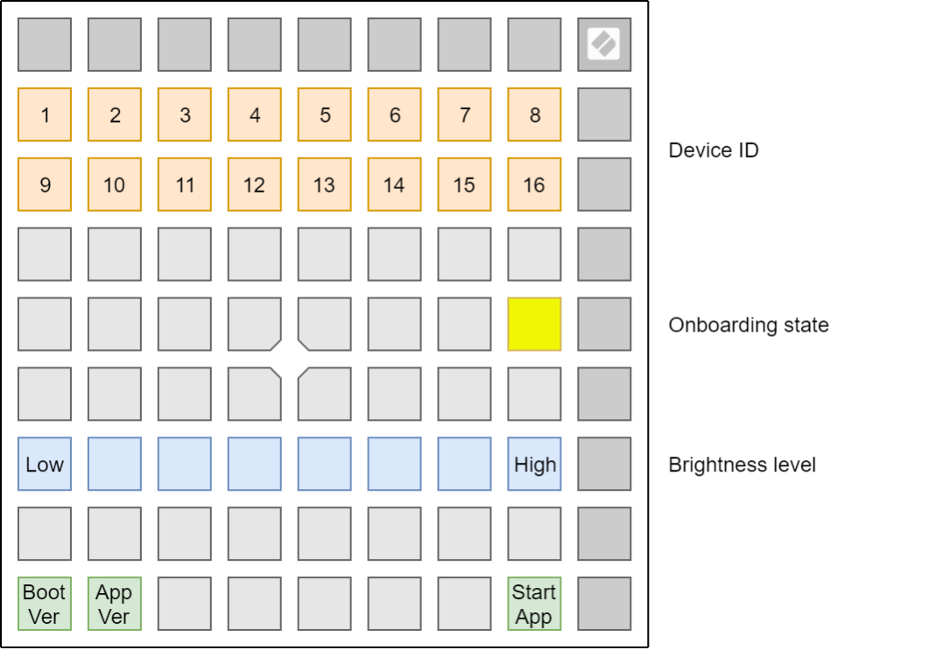
The top two rows of pads can be used to set the USB device ID of the Launchpad X. The device ID ranges from 1 to 16, the selected ID is represented by a brightly lit pad. The default ID from factory is 1. If more than one Launchpad X is used on the same USB, each should have a different device ID selected.
The single yellow pad on the middle right can be used to toggle Onboarding. When Onboarding is ON, the Launchpad X shows up as a Mass Storage Device to provide a more convenient first-time experience. You can turn this off once you are familiar with the device to disable this Mass Storage Device.
The blue row of pads can be used to adjust the Launchpad X’s brightness level to something comfortable for the environment the device is used in. This control is also available on the Setup display when starting the Launchpad X normally. Note that low brightness levels may be required for Launchpad X to be powered on by certain devices.
The green pads on the bottom left can be used to display the version number of the Bootloader and the Application respectively.
The single green pad on the bottom right can be used to start the Application.

MIDI on Launchpad X
The Launchpad X has two MIDI interfaces providing two pairs of MIDI inputs and outputs over USB. They are as follows:
- LPX DAW In / Out (or first interface on Windows): This interface is used by DAWs and similar software to interact with the Launchpad X’s Session mode.
- LPX MIDI In / Out (or second interface on Windows): This interface is used to receive MIDI from Note mode and Custom modes; and is used to provide external MIDI input or Light controls in Lighting Custom Modes and Programmer mode.
If you wish to use Launchpad X as a control surface for a DAW (Digital Audio Workstation), you will likely want to use the DAW interface (See Software Interaction chapter).
Otherwise, you may interact with the device using the MIDI interface.
The Launchpad X sends Note On (90h – 9Fh) with velocity zero for Note Offs. It accepts either Note Offs (80h – 8Fh) or Note Ons (90h – 9Fh) with velocity zero for Note Off.

Device Inquiry message
The Launchpad X responds to the Universal Device Inquiry Sysex message, which can be used to identify the device. This exchange is as follows:
Host => Launchpad X:
Hex: F0h 7Eh 7Fh 06h 01h F7h
Dec: 240 126 127 6 1 247
Launchpad X => Host (Application):
Hex: F0h 7Eh 00h 06h 02h 00h 20h 29h 13h 01h 00h 00h <app_version> F7h
Dec: 240 126 0 6 2 0 32 41 19 1 0 0 <app_version> 247
Launchpad X => Host (Bootloader):
Hex: F0h 7Eh 00h 06h 02h 00h 20h 29h 13h 11h 00h 00h <boot_version> F7h
Dec: 240 126 0 6 2 0 32 41 19 17 0 0 <boot_version> 247
The <app_version> or <boot_version> field is 4 bytes long, providing the Application or the Bootloader version respectively. The version is the same version which can be viewed using the lower left green pads on the Bootloader’s surface, provided as four bytes, each byte corresponding to one digit, ranging from 0 – 9.

SysEx message format used by the device
All SysEx messages begin with the following header regardless of direction (Host => Launchpad X or Launchpad X => Host):
Hex: F0h 00h 20h 29h 02h 0Ch Dec: 240 0 32 41 2 12
After the header, a command byte follows, selecting the function to use.
Several of the messages have a readback variant which can be accessed in the following manner:
Host => Launchpad X:
Hex: F0h 00h 20h 29h 02h 0Ch <command> F7h
Dec: 240 0 32 41 2 12 <command> 247
Launchpad X => Host:
Hex: F0h 00h 20h 29h 02h 0Ch <command> <data> F7h
Dec: 240 0 32 41 2 12 <command> <data> 247
Where the <data> is formatted in the same manner as normally it would be provided to the Launchpad X after the command. These readback forms are described for each of the commands where available.

Selecting layouts
The Launchpad X has several layouts to choose from, which can be controlled by either the device’s User Interface (see the User Guide for more details), or the following SysEx message:
Host => Launchpad X:
Hex: F0h 00h 20h 29h 02h 0Ch 00h <layout> F7h
Dec: 240 0 32 41 2 12 0 <layout> 247
Where the available layouts are:
- 00h (0): Session (only selectable in DAW mode)
- 01h (1): Note mode
- 04h (4): Custom mode 1 (Drum Rack by factory default)
- 05h (5): Custom mode 2 (Keys by factory default)
- 06h (6): Custom mode 3 (Lighting mode in Drum Rack layout by factory default)
- 07h (7): Custom mode 4 (Lighting mode in Session layout by factory default)
- 0Dh (13): DAW Faders (only selectable in DAW mode)
- 7Fh (127): Programmer mode
Readback variant is available by the following SysEx message:
Host => Launchpad X:
Hex: F0h 00h 20h 29h 02h 0Ch 00h F7h Dec: 240 0 32 41 2 12 0 247
When selecting Programmer mode using this SysEx message, the Setup entry (holding down Session for half a second) is disabled. To return the Launchpad X to normal operation, use this SysEx message to select any other layout than Programmer mode.

Programmer / Live mode switch
There is a dedicated SysEx message for Programmer / Live mode select:
Host => Launchpad X:
Hex: F0h 00h 20h 29h 02h 0Ch 0Eh <mode> F7h
Dec: 240 0 32 41 2 12 14 <mode> 247
Where <mode> is 0 for Live mode, 1 for Programmer mode.
Readback variant is available by the following SysEx message:
Host => Launchpad X:
Hex: F0h 00h 20h 29h 02h 0Ch 0Eh F7h
Dec: 240 0 32 41 2 12 14 247
When selecting Live mode with this message, Launchpad X switches to Session layout, or Note mode when not in DAW mode.
When selecting Programmer mode using this SysEx message, the Setup entry (holding down Session for half a second) is disabled. To return the Launchpad X to normal operation, use this SysEx message to switch back to Live mode.

Controlling the Surface
This chapter describes the wide range of possibilities for controlling and lighting up the Launchpad X surface. If you aim to light Launchpad X’s surface, this chapter contains all the information you will likely need for it. You can also use these capabilities to realize surfaces for interacting with software, however for that purpose, using the DAW mode is preferable as it keeps the MIDI port free for playing and interacting with virtual instruments. See chapter Software Interaction.

Switching to Lighting modes
If you aim to control the Launchpad X using scripts, the best option for lighting pads/buttons or creating an interactive surface is switching to Programmer mode. You can use the Programmer / Live mode switch message to achieve this or access it from the setup menu (hold Session, then press bottom Scene Launch button). Programmer Mode sends out a message for every pad or button that is pressed, and equally lights pads or buttons when the same message is received Remember to switch the device back to Live mode once done.
Alternatively, you may use Lighting Custom Modes in the same way, but you are limited to interacting only with the 8x8 grid. On a Launchpad X in its factory default state, Custom mode 3 and Custom mode 4 are set up for lighting pads, each with a different layout. You can switch to either of these using the Launchpad X’s User Interface. In these Lighting Custom Modes, you may enable Ghost mode which allows the lighting area to expand beyond the 8x8 grid into the top and side button rows and logo. Access Ghost Mode by pressing the Note and Custom buttons in rapid succession (with the appropriate Custom mode already selected).
In a Lighting Custom Mode, Ghost mode is automatically enabled when:
- Sending any Control Change message on the MIDI interface (these can be used to light up the top row of buttons, the logo and the right-side buttons). - Sending the LED lighting SysEx message.

Programmer mode layout
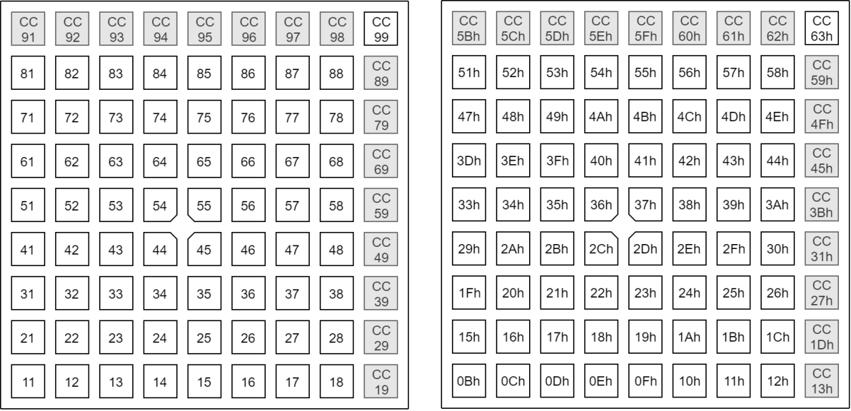
Note that in Programmer mode, all buttons and pads accept either Note or Control Change messages. The indicated type is which is sent by the device on the MIDI interface when the corresponding button or pad is pressed.

Factory default Lighting Custom Mode layouts
Custom Mode 3:
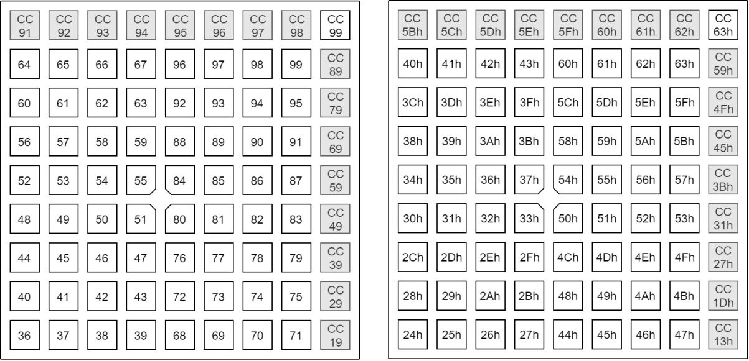
Custom Mode 4:

Colour palette
When providing colours by MIDI notes or control changes, the colours are chosen according to the following table, decimal:
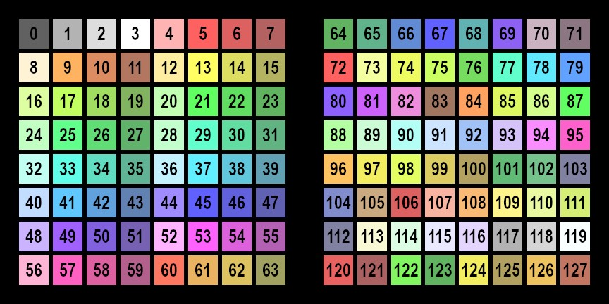
The same table with hexadecimal indexing:
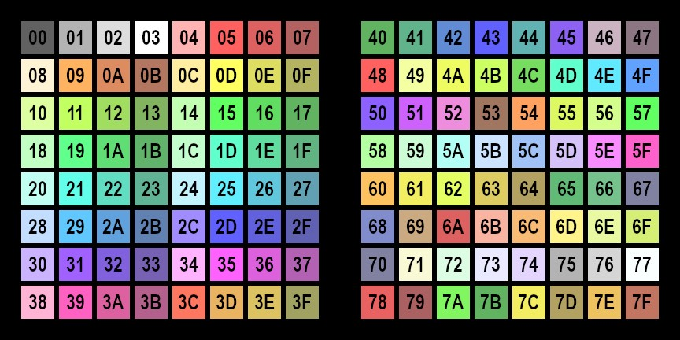

Sending colours by MIDI events
In Lighting Custom Modes (and Programmer mode) the Launchpad X accepts colours through the MIDI interface. Channels are used as follows:
- Channel 1, Notes: 90h (144), Control Changes: B0h (176): Static colour.
- Channel 2, Notes: 91h (145), Control Changes: B1h (177): Flashing colour. - Channel 3, Notes: 92h (146), Control Changes: B2h (178): Pulsing colour.
The Note number selects the pad to control (as shown on the layout mappings) and the velocity the colour to use (as shown on the colour palette). Similarly, for Control Changes the CC number selects the pad to control and the value the colour to use.

Flashing colour
When sending Flashing colour, the colour flashes between that set as Static or Pulsing colour (A), and that contained in the MIDI event setting flashing (B), at 50% duty cycle, synchronized to the MIDI beat clock (or 120bpm or the last clock if no clock is provided). One period is one beat long.
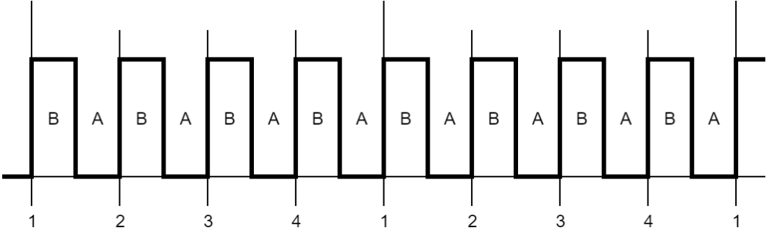

Pulsing colour
The colour pulses between dark and full intensity synchronized to the MIDI beat clock (or 120bpm or the last clock if no clock is provided). One period is two beats long, using the following waveform:
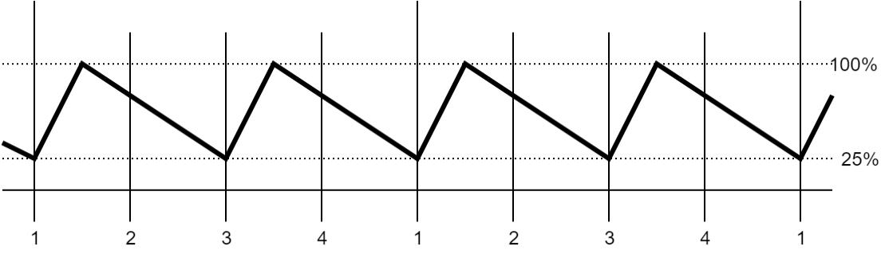

Examples
For these examples, switch the Launchpad into Programmer Mode.
Lighting the lower left pad static red:
Host => Launchpad X:
Hex: 90h 0Bh 05h Dec: 144 11 5
This is Note On, Channel 1, Note number 0Bh (11), with Velocity 05h (5). The Channel specifies the lighting mode (static), the Note number the pad to light (which is the lower left one in Programmer mode), the Velocity the colour (which is Red, see Colour Palette).
Flashing the upper left pad green:
Host => Launchpad X:
Hex: 91h 51h 13h Dec: 145 81 19
This is Note On, Channel 2, Note number 51h (81), with Velocity 13h (19). The Channel specifies the lighting mode (flashing), the Note number the pad to light (which is the upper left one in Programmer mode), the Velocity the colour (which is Green, see Colour Palette).
Pulsing the lower right pad blue:
Host => Launchpad X:
Hex: 92h 12h 2Dh
Dec: 146 18 45
This is Note On, Channel 3, Note number 12h (18), with Velocity 2Dh (45). The Channel specifies the lighting mode (pulsing), the Note number the pad to light (which is the lower right one in Programmer mode), the Velocity the colour (which is Blue, see Colour Palette).
Turning a colour off:
Host => Launchpad X:
Hex: 90h 12h 00h Dec: 144 18 0
This is Note Off (Note On with Velocity of zero), Channel 1, Note number 12h (18), with Velocity 00h (0). The Channel specifies the lighting mode (static), the Note number the pad to light (which is the lower right one in Programmer mode), the Velocity the colour (which is blank, see Colour Palette). If the Pulsing colour was set up there with the previous message, this would turn it off. Alternatively, a Midi Note Off message can also be used for the same effect:
Host => Launchpad X:
Hex: 80h 12h 00h Dec: 128 18 0

LED lighting SysEx message
This message can be sent to Lighting Custom Modes and the Programmer mode to light up LEDs. The LED indices used always correspond to those of Programmer mode, regardless of the layout selected:
Host => Launchpad X:
Hex: F0h 00h 20h 29h 02h 0Ch 03h <colourspec> [<colourspec> […]] F7h
Dec: 240 0 32 41 2 12 3 <colourspec> [<colourspec> […]] 247 The <colourspec> is structured as follows:
- Lighting type (1 byte)
- LED index (1 byte)
- Lighting data (1 – 3 bytes)
Lighting types:
- 0: Static colour from palette, Lighting data is 1 byte specifying palette entry.
- 1: Flashing colour, Lighting data is 2 bytes specifying Colour B and Colour A.
- 2: Pulsing colour, Lighting data is 1 byte specifying palette entry.
- 3: RGB colour, Lighting data is 3 bytes for Red, Green and Blue (127: Max, 0: Min).
The message may contain up to 81 <colourspec> entries to light up the entire Launchpad X surface.
Example:
Host => Launchpad X:
Hex: F0h 00h 20h 29h 02h 0Ch 03h 00h 0Bh 0Dh 01h 0Ch 15h 17h 02h 0Dh 25h F7h Dec: 240 0 32 41 2 12 3 0 11 13 1 12 21 23 2 13 37 247
Sending this message to the Launchpad X in Programmer layout sets up the bottom left pad to static yellow, the pad next to it to flashing green (between dim and bright green), and the pad next to that pulsing turquoise.

Software Interaction
This chapter describes the means to interact with the Launchpad X by DAW (Digital Audio Workstation) or DAW like software. This mostly involves interacting with the Session layout to realize surfaces through which the DAW may provide its user interface.

Enabling / disabling DAW mode
Launchpad X must be switched into DAW mode before software may interact with it. When DAW mode is enabled, the Session button will light and become available to press.
When the DAW/software exits, it should send SysEx to revert the device to Standalone mode. Doing this ensures that all the state is cleared, and the device remains useful as a standalone device once the DAW is done using it (without power cycling to restore it).
When entering DAW mode, all DAW states start cleared.
The SysEx message is as follows:
Host => Launchpad X:
Hex: F0h 00h 20h 29h 02h 0Ch 10h <mode> F7h
Dec: 240 0 32 41 2 12 16 <mode> 247
Where <mode> is 0 for Standalone, 1 for DAW (Session / DAW Fader layouts enabled).
Readback variant is available by the following SysEx message:
Host => Launchpad X:
Hex: F0h 00h 20h 29h 02h 0Ch 10h F7h
Dec: 240 0 32 41 2 12 16 247

The DAW In/Out interface
The DAW should interact with the Launchpad X through the USB DAW In/Out interface. MIDI events sent on this interface control the DAW state within the Launchpad X as follows:
- Channel 1, Notes: 90h (144), Control Changes: B0h (176): Static colour on Session layout.
- Channel 2, Notes: 91h (145), Control Changes: B1h (177): Flashing colour on Session layout.
- Channel 3, Notes: 92h (146), Control Changes: B2h (178): Pulsing colour on Session layout.
- Channel 5, Control Changes: B4h (180): DAW Fader position sets.
- Channel 6, Control Changes: B5h (181): DAW Fader colour sets.
- Channel 9, Notes: 98h (152): Static colour on DAW Drum Rack layout.
- Channel 10, Notes: 99h (153): Flashing colour on DAW Drum Rack layout.
- Channel 11, Notes: 9Ah (154): Pulsing colour on DAW Drum Rack layout.
- Channel 16, Notes: 9Fh (159): External note injection on all External MIDI channels.
The Launchpad X sends button and pad events to the DAW as follows:
- Channel 1, Notes: 90h (144), Control Changes: B0h (176): Session layout activities.
- Channel 5, Control Changes: B4h (180): DAW fader activities.
- Channel 9, Notes: 98h (152): DAW Drum Rack layout activities.
For the available colours, see the colour palettes in the Controlling the Surface chapter.
Note that Aftertouch (either as key aftertouch or channel pressure depending on configuration) is also sent on the appropriate channels (Channel 1 for Session, Channel 9 for Drum Rack).
These interactions are all available regardless of which layout is selected on the Launchpad X, and the state set up by the MIDI events is preserved even when it is not visible (the Launchpad X is not on the corresponding layout).
Text scrolling can also be used in DAW mode as desired to display information, the text scroll overlaying on top of the surface without affecting it.

DAW state clear
This message can be used as a shortcut to clear DAW state, instead of sending out all the corresponding MIDI events with a data value of zero:
Host => Launchpad X:
Hex: F0h 00h 20h 29h 02h 0Ch 12h <session> <drumrack> <controlchanges> F7h
Dec: 240 0 32 41 2 12 18 <session> <drumrack> <controlchanges> 247
Each of <session>, <drumrack> and <controlchange> can be either 0 to keep the corresponding state intact or 1 to clear it. Clearing is equivalent of sending 128 MIDI events with value of zero as follows:
- <session>: 90h (144) (Session layout Note states)
- <drumrack>: 98h (152) (DAW Drum Rack layout states)
- <controlchange>: B0h (176) (Control Change states)
Example:
Host => Launchpad X:
Hex: F0h 00h 20h 29h 02h 0Ch 12h 01h 00h 00h F7h Dec: 240 0 32 41 2 12 18 1 0 0 247
This message clears the Session layout Note states without affecting the DAW Drum Rack or Control Change states.

Session mode
Session mode is selectable by the Session button, it is the surface on which most interactions should take place. Its layout is as follows:
The top row’s Session, Note and Custom buttons are not available for control by the DAW, however they still send the corresponding CC messages on interaction, allowing the DAW to catch relevant events as the user interacts with the device (layout changes). All the other pads and buttons (as well as the logo) are available, and reflect the state set up by the corresponding MIDI events.

DAW Faders
The DAW can use the DAW Fader layout to set up banks of faders. There are up to 8 faders on a fader bank, which all share orientation (either horizontal or vertical), however each may be configured individually to be either unipolar or bipolar.
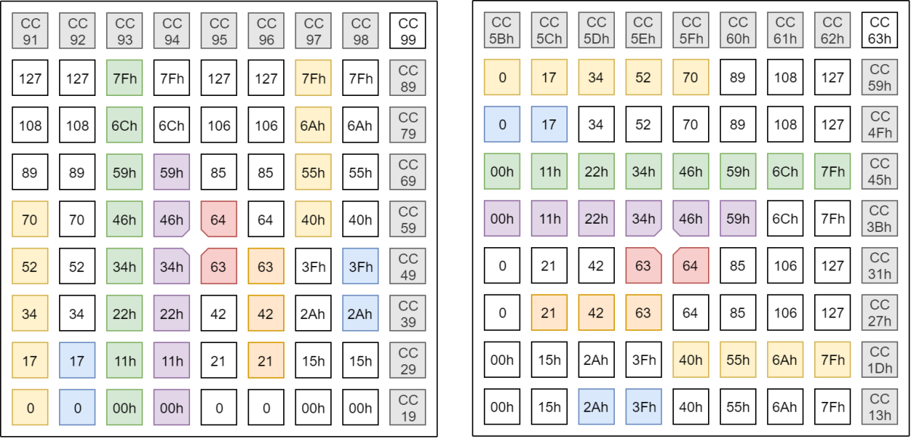

DAW Fader bank set-up
The DAW Fader bank can be set up using the following SysEx message:
Host => Launchpad X:
Hex: F0h 00h 20h 29h 02h 0Ch 01h 00h <orientation> <fader> [<fader> […]] F7h
Dec: 240 0 32 41 2 12 1 0 <orientation> <fader> [<fader> […]] 247 The <orientation> byte can be 0 for Vertical faders or 1 for Horizontal faders.
The <fader> entry specifies the configuration of one fader as follows:
- Fader index (1 byte), 0 – 7, left to right (vertical) or top to bottom (horizontal).
- Fader type (1 byte), 0: Unipolar, 1: Bipolar.
- Control Change associated (1 byte).
- Fader’s colour (1 byte), a palette entry.
The fader’s colour can be set to 0, this may be used to disable the fader (as it will not show on the surface then).
The message may contain up to 8 <fader> entries to set up the entire DAW Fader bank.
Readback variant is available by the following SysEx message:
Host => Launchpad X:
Hex: F0h 00h 20h 29h 02h 0Ch 01h F7h
Dec: 240 0 32 41 2 12 1 247
Example:
Host => Launchpad X:
00h |  | 00h 00h 07h 25h |  | 01h 01h 08h 15h
 |  | 0 0 7 37 |  | 1 1 8 21
Hex: F0h 00h 20h 29h 02h 0Ch 01h 00h F7h Dec: 240 0 32 41 2 12 1 0 0247
Host => Launchpad X:
Hex: F0h 00h 20h 29h 02h 0Ch 00h 0Dh F7h Dec: 240 0 32 41 2 12 0 13 247
The first message populates a DAW Fader bank with:
- Vertical orientation
- A turquoise unipolar fader on the leftmost column set to CC 7
- A green bipolar fader in the next column along set to CC 8
The second message switches to the fader layout (blank by default). DAW Mode must be enabled for these messages to work. Keep in mind that the state of the fader layout persists even when switching away from it, so it is recommended to set up the faders first and switch to the layout afterwards when
a new fader layout is to be set up to prevent the previous state momentarily showing up when switching from a different layout.

DAW Drum Rack
The DAW can request the Note Mode to show a Drum Rack instead of the regular Note Mode layout. This layout is designed for Ableton Live’s Drum Rack, normally set up according to the available drum samples using the MIDI events described in the DAW In/Out interface chapter. The layout of this Drum Rack is as follows:

DAW Note / Drum Rack mode select
This message can be used to select the DAW Drum Rack mode. It is only available in DAW mode. Changing the mode does not change the currently active layout on the Launchpad X. if Note mode is selected, the change is immediately visible, otherwise the change will be seen when Note Mode is next selected.
Host => Launchpad X:
Hex: F0h 00h 20h 29h 02h 0Ch 0Fh <mode> F7h Dec: 240 0 32 41 2 12 15 <mode> 247
Where the <mode> byte can be one of the followings:
- 0: Note mode.
- 1: Simple Drum Rack.
- 2: Intelligent Drum Rack.
Readback variant is available by the following SysEx message:
Host => Launchpad X:
Hex: F0h 00h 20h 29h 02h 0Ch 0Fh F7h Dec: 240 0 32 41 2 12 15 247

Simple Drum Rack
In this mode, the layout is fixed, while the DAW may control the four directional buttons on the upper right (with the same Control Change messages like available on Session layout).

Intelligent Drum Rack
In this mode, the layout is scrollable by the four directional buttons, which the Launchpad X operates on its own (colouring them yellow if the control is available, blank if not), allowing to pan the view over the 128 possible drum samples.
- Up / Down moves one 4x4 grid up/down.
- Left / Right moves an 1x4 row down/up.

Intelligent Drum Rack position
This message can be used to set or retrieve the Intelligent Drum Rack’s position, so the DAW could retain its position or control it by itself:
Host => Launchpad X:
Hex: F0h 00h 20h 29h 02h 0Ch 13h <position> F7h
Dec: 240 0 32 41 2 12 19 <position> 247
Where <position> is the lower left pad’s index, which may range between 0 and 64.
Readback variant is available by the following SysEx message:
Host => Launchpad X:
Hex: F0h 00h 20h 29h 02h 0Ch 13h F7h
Dec: 240 0 32 41 2 12 19 247

DAW Session button colour set
This message can be used to change the active and inactive colours of the Session button:
Host => Launchpad X:
Hex: F0h 00h 20h 29h 02h 0Ch 14h <active> <inactive> F7h
Dec: 240 0 32 41 2 12 20 <active> <inactive> 247
Each of <active> and <inactive> is a palette entry. Setting <active> to zero reverts to the default colours. When entering DAW mode, the Session button always has the default colouring.
Readback variant is available by the following SysEx message:
Host => Launchpad X:
Hex: F0h 00h 20h 29h 02h 0Ch 14h F7h
Dec: 240 0 32 41 2 12 20 247

DAW Note mode Active colour set
This message can be used to change the active colour of Note mode (which is normally green):
Host => Launchpad X:
Hex: F0h 00h 20h 29h 02h 0Ch 17h <colour> F7h
Dec: 240 0 32 41 2 12 23 <colour> 247
The <colour> is a palette entry. Setting it to zero reverts to the default (green) colour.
Readback variant is available by the following SysEx message:
Host => Launchpad X:
Hex: F0h 00h 20h 29h 02h 0Ch 17h F7h
Dec: 240 0 32 41 2 12 23 247

Miscellaneous surface control

Text scrolling
The Launchpad X can display scrolling text across the pads and the right-side buttons. The top row buttons and the logo is not affected by the scroll, and any lighting covered by the scroll is retained (will return once the scroll is stopped or completed).
Host => Launchpad X:
Hex: F0h 00h 20h 29h 02h 0Ch 07h [<loop> [<speed> [<colourspec> [<text>]]]] F7h
Dec: 240 0 32 41 2 12 7 [<loop> [<speed> [<colourspec> [<text>]]]] 247
- <loop> (1 byte) specifies whether the text should loop, 0: don’t loop, 1: loop.
- <speed> (1 byte) is the scrolling speed expressed in pads / second units.
- <colourspec> (2 – 4 bytes) is a colour specification. - <text> is the text to display.
The colour specification <colourspec>:
- If first byte is 0, then the next byte is colour from palette, 2 bytes total.
- If first byte is 1, then Red, Green and Blue follows (127: Max, 0: Min), 4 bytes total.
When the message is empty:
Host => Launchpad X:
Hex: F0h 00h 20h 29h 02h 0Ch 07h F7h
Dec: 240 0 32 41 2 12 7 247
Any text scroll which was ongoing is terminated.
Omitting <text> results in changing the currently scrolling text’s configuration (looping, speed or colour). Turning off looping for a text scroll which was looping results in ending the scroll after the text completely scrolled out of the surface.
If <speed> is 40h or above, it is interpreted as a negative number, formed by subtracting 80h from it (text scrolls from left to right).
Example:
Host => Launchpad X:
Hex: F0h 00h 20h 29h 02h 0Ch 07h F7h
01h |  | 07h |  | 00h 25h |  |  | 48h 65h 6Ch 6Ch 6Fh 20h 57h 6Fh 72h 6Ch 64h
 |  | 7 |  | 0 37 |  |  | 72 101 104 104 111 32 87 111 114 104 100
Dec: 240 0 32 41 2 12 7 1 247
This message will make the Launchpad displaying “Hello World” scrolling across its surface.
- Yellow: Sets Looping to enabled.
- Green: Sets Speed to 7 pads / seconds.
- Turquoise: Sets the colour of the text to turquoise.
- Grey: The text to display, it is the ASCII codes of the string “Hello World”.

Power management
This chapter contains messages used for accessing power management features of the Launchpad X.

Sleep SysEx message
The Sleep message can be used to turn off all lights until turning them back on with this message or interacting with the device:
Host => Launchpad X:
Hex: F0h 00h 20h 29h 02h 0Ch 09h <mode> F7h
Dec: 240 0 32 41 2 12 9 <mode> 247
Where <mode> is 0 to turn the LEDs Off, 1 to turn them back On.
Readback variant is available by the following SysEx message:
Host => Launchpad X:
Hex: F0h 00h 20h 29h 02h 0Ch 09h F7h
Dec: 240 0 32 41 2 12 9 247

Configuration messages
The messages described further can be used to change various settings of the Launchpad X.

Brightness level
This message sets the Launchpad X’s brightness level on a 0 – 127 scale. Value 0 corresponds to the lowest brightness level, 127 to the highest. This setting is normally available on the LED view of the Setup menu, where 8 brightness levels can be set.
Host => Launchpad X:
Hex: F0h 00h 20h 29h 02h 0Ch 08h <brightness> F7h
Dec: 240 0 32 41 2 12 8 <brightness> 247
Readback variant is available by the following SysEx message:
Host => Launchpad X:
Hex: F0h 00h 20h 29h 02h 0Ch 08h F7h
Dec: 240 0 32 41 2 12 8 247

LED Feedbacks
This message sets the Internal and External Feedbacks, which are normally available on the LED view of the Setup menu:
- Internal Feedback: Whether notes played, or controls activated should light up.
- External Feedback: Whether MIDI notes coming from the MIDI In / Out interface should light up corresponding pads.
Host => Launchpad X:
Hex: F0h 00h 20h 29h 02h 0Ch 0Ah <internal> <external> F7h
Dec: 240 0 32 41 2 12 10 <internal> <external> 247
For both <internal> and <external>, 0 corresponds to inactive, 1 to active.
Readback variant is available by the following SysEx message:
Host => Launchpad X:
Hex: F0h 00h 20h 29h 02h 0Ch 0Ah F7h
Dec: 240 0 32 41 2 12 10 247

Velocity curve
This message configures the Velocity curve, which is normally available on the VEL view of the Setup menu:
Host => Launchpad X:
Hex: F0h 00h 20h 29h 02h 0Ch 04h <curve> <fixed> F7h
Dec: 240 0 32 41 2 12 4 <curve> <fixed> 247
For <curve>, the followings are available:
- 0: Low (Playing soft notes is easier).
- 1: Medium.
- 2: High (Playing hard notes is easier). - 3: Fixed velocity.
The <fixed> parameter provides the fixed velocity value to use when selecting Fixed velocity. By default, this is 7Fh. Changing this is not possible on the Setup menu.
The velocity curve (or fixed velocity) is also used for Faders when the Faders are configured to be Velocity sensitive.
Readback variant is available by the following SysEx message:
Host => Launchpad X:
Hex: F0h 00h 20h 29h 02h 0Ch 04h F7h Dec: 240 0 32 41 2 12 4 247

Aftertouch
This message configures Aftertouch, which is normally available on the AFT view of the Setup menu:
Host => Launchpad X:
Hex: F0h 00h 20h 29h 02h 0Ch 0Bh <type> <threshold> F7h Dec: 240 0 32 41 2 12 11 <type> <threshold> 247
For <type>, the followings are available:
- 0: Polyphonic Aftertouch (Key Pressure events, A0h – AFh).
- 1: Channel Aftertouch (Channel Pressure events, D0h – DFh). - 2: Aftertouch Off.
For <threshold>, the followings are available:
- 0: Low (Aftertouch is very sensitive)
- 1: Medium
- 2: High (Aftertouch only kicks in at high pressure on the pads)
Readback variant is available by the following SysEx message:
Host => Launchpad X:
Hex: F0h 00h 20h 29h 02h 0Ch 0Bh F7h
Dec: 240 0 32 41 2 12 11 247

Fader velocity toggle
This message configures whether Faders should be velocity sensitive, which is normally available on the FAD view of the Setup menu:
Host => Launchpad X:
Hex: F0h 00h 20h 29h 02h 0Ch 0Dh <mode> F7h Dec: 240 0 32 41 2 12 13 <mode> 247
Setting <mode> 0 turns off Fader velocity sensitivity, 1 turns it on.
Readback variant is available by the following SysEx message:
Host => Launchpad X:
Hex: F0h 00h 20h 29h 02h 0Ch 0Dh F7h Dec: 240 0 32 41 2 12 13 247

Set Note Mode’s mode
This message can set Note Mode’s mode: either Chromatic or Scale mode. This setting is independent of DAW Drum Racks and is normally accessible on the Note Mode setup display.
Host => Launchpad X:
Hex: F0h 00h 20h 29h 02h 0Ch 15h <mode> F7h
Dec: 240 0 32 41 2 12 21 <mode> 247
Where <mode> is 0 for Chromatic mode, 1 is for Scale mode.
Readback variant is available by the following SysEx message:
Host => Launchpad X:
Hex: F0h 00h 20h 29h 02h 0Ch 15h F7h
Dec: 240 0 32 41 2 12 21 247

Set Note Mode’s configuration
This message configures either the Chromatic or Scale mode of Note Mode. Most of the settings are shared, except for Width. These configuration options are normally accessible on the Note Mode setup display.
Host => Launchpad X:
Hex: F0h 00h 20h 29h 02h 0Ch 16h <mode> <parameters> F7h
Dec: 240 0 32 41 2 12 22 <mode> <parameters> 247
The <mode> byte is 0 for configuring Chromatic mode, 1 for Scale mode.
Where <parameters> are as follows:
- Selected octave (1 byte), signed 2’s complement with 0 selecting C2.
- Selected transposition (1 byte), signed 2’s complement, -12 to +12.
- MIDI channel (1 byte), 0 – 15 selecting MIDI channel 1 to 16 respectively.
- Width (1 byte), number of pads which don’t overlap (fingers).
- Scale type (1 byte), 0 for selecting one of the presets, 1 for a custom scale. - Scale definition (1 or 11 bytes).
When Scale type is 0, the Scale definition is 1 byte, ranging from 0 to 15, selecting one of the preset scales on the Note Mode setup display.
When Scale type is 1, a custom scale can be supplied, 11 bytes, specifying whether each note is inscale (1) or out-of-scale (0), apart from the Root note, which is always in-scale.
For Octave and Transposition, signed 2’s complement means that values including and above 40h represent negative numbers, which can be obtained by subtracting 80h from the message byte.
The Note Mode setup display adapts to the changes performed by this message, always matching its surface as best as possible for the passed configuration (such as recognizing if a custom scale matched one of the presets). If a configuration is not possible to be represented (Width or Scale), neither of the corresponding set of pads would light up.
For navigating on Note Mode, you can send this message only supplying Octave and Transposition:
Host => Launchpad X:
Hex: F0h 00h 20h 29h 02h 0Ch 16h <mode> <octave> <transposition> F7h Dec: 240 0 32 41 2 12 22 <mode> <octave> <transposition> 247 Readback variant is available by the following SysEx message:
Host => Launchpad X:
Hex: F0h 00h 20h 29h 02h 0Ch 16h F7h
Dec: 240 0 32 41 2 12 22 247
This reads back the currently selected mode’s (Chromatic / Scale) configuration.
Host => Launchpad X:
Hex: F0h 00h 20h 29h 02h 0Ch 16h <mode> F7h
Dec: 240 0 32 41 2 12 22 <mode> 247
This reads back the specified mode’s (0: Chromatic, 1: Scale) configuration.
Example:
Host => Launchpad X:
Hex: F0h 00h 20h 29h 02h 0Ch 16h 01h 7Fh 02h 04h 05h 00h 00h F7h Dec: 240 0 32 41 2 12 22 1 127 2 4 5 0 0 247
This message sets Scale mode configuration, Octave at C1, Transposed to D1, MIDI channel to 5, Width to 5 (5 fingers), and a Major scale.
- First Yellow: Selects Scale mode to configure.
- First Green: Octave set to -1 (127 in 7 bits signed 2’s complement corresponds to -1).
- First Turquoise: Transposition set to +2.
- Second Yellow: Midi channel set to 5 (Note: the value of 0 corresponds to Channel 1).
- Second Green: Width set to 5 fingers.
- Second Turquoise: Scale type is one of the 16 presets, selects Preset 0 (Major scale).

SysEx command summary
The following table summarizes the SysEx messages occurring in this document for a quick reference.
Parameter Name | Command Code | Value 1 | Value 2 | Value 3 | Value 4 | Repeatable? | Read back
Select  Layout | 00h (0) | <layout> | - | - | - | - | Yes
DAW Fader Setup | 01h (1) | 00h (0) | <orientation> | <fader> | - | <fader> only | Yes
LED Lighting | 03h (3) | <colourspec> | - | - | - | <colourspec> | No
Velocity Curve | 04h (4) | <curve> | <fixed> | - | - | - | Yes
Text  Scrolling | 07h (7) | <loop> | <speed> | <colour spec> | <text> | - | No
Brightness Level | 08h (8) | <brightness> | - | - | - | - | Yes
LED Sleep | 09h (9) | <mode> | - | - | - | - | Yes
LED Feedback | 0Ah (10) | <internal> | <external> | - | - | - | Yes
Aftertouch Config | 0Bh (11) | <type> | <threshold> | - | - | - | Yes
Fader  Velocity | 0Dh (13) | <mode> | - | - | - | - | Yes
Programmer/  Live Toggle | 0Eh (14) | <mode> | - | - | - | - | Yes
DAW Note/  Drum Rack | 0Fh (15) | <mode> | - | - | - | - | Yes
DAW /  Standalone | 10h (16) | <mode> | - | - | - | - | Yes
Clear DAW state | 12h (18) | <session> | <drumrack> | <control changes> | - | - | No
Drum Rack  (Intelligent) | 13h (19) | <position> | - | - | - | - | Yes
Session Colour | 14h (20) | <active> | <inactive> | - | - | - | Yes
Note Mode Scale/Chro | 15h (21) | <mode> | - | - | - | - | Yes
Note Mode  Configuration | 16h (22) | <mode> | <parameters> | - | - | - | Yes
DAW Note  Active Colour | 17h (23) | <colour> | - | - | - | - | Yes

