InspectIQ
  - Final Group Project Report
  - Visual Defect Detection Using Deep Learning
and Ensemble Anomaly Scoring
Pattern Recognition Systems Practice Module
National University of Singapore
Institute of Systems Science

Group 30
Group member | Student ID
Yeom Dongjun | A0354802H
Zaiyu Zhang | A0357851U
Worameth Wittanakorn | A0356365W
Nguyen Tri Nghia | A0355672W

Report date: 31 October 2026
Project repository
https://github.com/AndyYeom/Visual_Defect_Detection
Final application release
https://github.com/AndyYeom/Visual_Defect_Detection/releases/tag/v1.0.1
Project scope
An academic visual inspection prototype trained on normal product images. The system detects and visualises suspected defects for human review. Factory deployment, safety certification and demonstrated production cost savings are outside the evaluated scope.

Table of Contents
Section | Page
1 Introduction | 3
2 Application Context and Related Research | 4
3 Project Scope and Data Preparation | 5
4 Dataset Composition | 6
5 Models and Anomaly Scoring | 7
5 Models and Anomaly Scoring continued | 8
6 Evaluation Design | 9
7 System Design and Implementation | 10
7 System Design and Implementation continued | 11
8 Results | 12
8 Results by Category | 13
8 Error Analysis | 14
9 Challenges and Limitations | 15
10 Future Work and Conclusion | 16
References | 17
Appendix A Original Proposal | 18
Appendix B Technique Mapping | 19
Appendix C Installation and User Guide | 20
Appendix D Supplementary Materials | 21

Reading guide
Sections 5 and 6 describe the methods and experimental protocol. Section 8 contains measured results and failure analysis. Appendices B and C map the work to the module requirements and explain how to run the final system.

1 Introduction
Visual inspection is a pattern recognition task in which subtle differences in appearance can determine whether a manufactured product needs further review. Collecting every possible defect is difficult, while images of normal production are usually more accessible. Our project therefore investigates normal-only anomaly detection: learn a representation of normal appearance, then identify images and regions that differ from it.
InspectIQ is the demonstration application for our project, Visual Defect Detection Using Deep Learning and Ensemble Anomaly Scoring. A user selects a product category, uploads an image and receives an anomaly score, a threshold-based decision and an overlay of suspected defect regions. The result supports inspection rather than automatically certifying or rejecting a physical product.
We compared six methods on all 15 categories of MVTec AD: a convolutional autoencoder, a frozen CNN feature-distance baseline, their fixed-weight ensemble, PatchCore, a DINOv2-based anomaly detector and an autoencoder-DINO ensemble. PatchCore achieved the highest category-average image AUROC, 0.983951, and F1, 0.951429, under our 224-pixel evaluation protocol. It was therefore selected for the final application.

1.1 Objectives
Objective | Evidence in this report
Detect anomalous product appearance | Six-method comparison on 1,725 test images
Visualise suspected defect locations | Anomaly overlays and pixel-level evaluation
Evaluate the original ensemble hypothesis | Fixed 50/50 ensembles compared with their components
Deliver a runnable inspection prototype | CPU/CUDA application, downloadable models and installation guide

1.2 Main Finding
The experiment favoured pretrained patch representations over the small reconstruction baseline. Adding the autoencoder score did not improve the corresponding CNN or DINO baseline in the macro results. The contribution is a reproducible comparison and a working deployment of the selected model, rather than a new anomaly detection algorithm.
A high AUROC does not mean that the system is 98.4% accurate at a fixed threshold. PatchCore still produced 59 false alarms and missed 73 defects across the test set. Category-level operating behaviour and the limits of the benchmark are therefore central to our conclusions.

2 Application Context and Related Research

2.1 Inspection Use Case
The intended user is an inspector or engineering team evaluating product appearance under a reasonably consistent camera setup. The prototype reduces the need to enumerate defect classes in advance and presents a location cue for manual review. Its practical value would depend on whether it reduces missed defects and review effort without creating excessive false alarms.
We did not conduct customer interviews, a factory pilot or a cost-benefit study. Throughput, scrap reduction and commercial pricing are therefore not reported as outcomes. A future pilot should compare the system with the existing inspection process on the same production stream, including setup and human review time.

2.2 Research Context
Approach | Relevant idea | Role in this project
Reconstruction baseline | Learn normal images and score reconstruction differences | Implemented as a transparent starting point
PatchCore [2] | Match patch features to a representative normal memory bank | Implemented and selected for deployment
DINOv2 and AnomalyDINO [3, 4] | Use pretrained transformer patch representations for anomaly detection | Adapted full-shot comparison
PaDiM [5] | Model distributions of pretrained patch embeddings | Related work; our diagonal baseline is not full PaDiM
EfficientAD [6] | Efficient student-teacher based visual anomaly detection | Candidate for a future latency-focused comparison

2.3 Interpreting State of the Art
State of the art refers to the best reported performance under a specified task and evaluation protocol. PatchCore reported up to 99.6% image AUROC on MVTec AD in its original study [2]. AnomalyDINO specifically investigates one-shot and few-shot settings [3]. Neither figure is a direct target for our changed training split and implementation settings.
Our benchmark holds image size, category coverage and test manifests constant across implemented methods. It does not reproduce every paper setting or establish a current leaderboard result. The external papers motivate the model choices; the final selection follows our measured comparison.

3 Project Scope and Data Preparation

3.1 Scope and Changes from the Proposal
The original proposal specified an autoencoder, a pretrained CNN and an ensemble, while leaving the dataset to be selected. We retained those experiments, selected MVTec AD and extended the comparison with PatchCore and a DINOv2-based method. The final interface serves PatchCore because it performed best in our comparison; the ensemble implementations remain available in the research code.
The runnable scope is single-image inspection for 15 known categories. The user supplies the category. Automatic object identification, live camera acquisition, production-line control, multi-user authentication and persistent inspection history are not implemented.

3.2 Dataset Selection
MVTec AD provides industrial object and texture categories with normal training images and normal/defective test images. Defective test images have localisation annotations [1]. The local dataset contains 3,629 normal training images and 1,725 test images. This supports both image-level anomaly detection and pixel-level analysis without requiring labelled defects for training.
The five texture categories are carpet, grid, leather, tile and wood. The ten object categories are bottle, cable, capsule, hazelnut, metal nut, pill, screw, toothbrush, transistor and zipper. Their differences in shape, texture and defect size provide a broader comparison than a single bottle demonstration.

3.3 Preparation and Leakage Controls
For each category, normal training paths are sorted, shuffled with seed 42 and divided into a training subset and a held-out normal validation subset. The validation count is the rounded value of 20% of that category. The resulting total is 2,903 training and 726 validation images; the official test split remains unchanged.
Each manifest records relative paths, split assignments, labels and SHA-256 image hashes. The pipeline rejects duplicate image content, changed files and anomalous images in training or validation. This guards against accidental content overlap; it does not establish independence between visually similar items captured by the original dataset provider.
Images are converted to RGB and resized directly to 224 by 224. The pipeline does not crop, rotate or augment the final benchmark images. The same image manifests are used across methods. Ground-truth masks are resized with nearest-neighbour interpolation for pixel evaluation. The original dataset is obtained separately from its provider; it is not committed to the repository.

4 Dataset Composition
Category | Train normal | Val normal | Test normal | Test defect
bottle | 167 | 42 | 20 | 63
cable | 179 | 45 | 58 | 92
capsule | 175 | 44 | 23 | 109
carpet | 224 | 56 | 28 | 89
grid | 211 | 53 | 21 | 57
hazelnut | 313 | 78 | 40 | 70
leather | 196 | 49 | 32 | 92
metal nut | 176 | 44 | 22 | 93
pill | 214 | 53 | 26 | 141
screw | 256 | 64 | 41 | 119
tile | 184 | 46 | 33 | 84
toothbrush | 48 | 12 | 12 | 30
transistor | 170 | 43 | 60 | 40
wood | 198 | 49 | 19 | 60
zipper | 192 | 48 | 32 | 119
Total | 2903 | 726 | 467 | 1258

Table 1. Local dataset counts after the deterministic normal-only split. Counts were checked against the dataset used by the project.
The test set is defect-heavy: 1,258 of 1,725 images are anomalous. This is suitable for benchmarking, but it does not reproduce the defect prevalence of a production line. Precision can change substantially when the prevalence changes, even if sensitivity and false-positive rate remain similar.
Validation sample sizes differ sharply. Toothbrush has only 12 normal validation images, whereas hazelnut has 78. A 95th-percentile threshold estimated from a small sample can be unstable. We retain one common calibration rule for comparability and discuss its category-specific failures rather than tuning thresholds after viewing test labels.
All final results use the 224-pixel protocol. An earlier 128-pixel baseline was exploratory and is excluded from the final comparison. The completed 224-pixel bottle experiment was reused, while the remaining 14 categories were executed by the resumable suite.

5 Models and Anomaly Scoring

5.1 Convolutional Autoencoder
The autoencoder compresses RGB input through three stride-2 convolution layers with 16, 32 and 64 channels and reconstructs it through mirrored transposed convolutions. ReLU activations are used internally and a sigmoid produces the reconstructed image. It is trained on normal images for 10 epochs with Adam, learning rate 0.001 and batch size 16.
The training loss is mean squared reconstruction error. At inference, the channel-averaged squared error forms a spatial anomaly map. The image score is the mean of the largest 1% of map values, a fixed rule intended to retain sensitivity to local defects. This is distinct from averaging reconstruction error across the whole image.
A reconstruction model can respond to lighting or texture variation, and it may reconstruct abnormal content well enough to miss a defect. The experiment tests this baseline rather than assuming reconstruction error is a reliable defect score.

5.2 Frozen CNN Feature Distance
The CNN baseline uses ImageNet-pretrained ResNet-18 features through layer2. The backbone remains frozen. For every spatial feature position and channel, the training images estimate a mean and variance. Variances are clamped to at least 0.0001. The anomaly map averages squared, variance-normalised deviations over channels, then resizes the map to the input resolution.
This is a position-specific diagonal Gaussian distance model. It does not fit a full covariance matrix and should not be described as an exact PaDiM implementation. Like the autoencoder, it aggregates the top 1% of map values into an image score. The use of fixed spatial statistics also makes alignment and viewpoint consistency relevant.

5.3 Fixed Score Ensembles
Each component score is standardised using its mean and standard deviation on the normal validation set. The standardised scores are combined with equal weights. The ensemble threshold is then the 95th percentile of normal validation ensemble scores. The same procedure is applied to AE plus CNN and AE plus DINO.
For two component scores s1 and s2, the fusion rule is E = 0.5(s1 - mean1)/std1 + 0.5(s2 - mean2)/std2. Calibration statistics and thresholds are saved with the model. We do not search weights or optimise thresholds using test labels. An ensemble can degrade a strong detector if the weaker score contributes noise or incompatible ranking information.

5 Models and Anomaly Scoring continued

5.4 PatchCore
PatchCore uses local pretrained visual features and a representative set of normal patches [2]. Our implementation uses the anomalib 2.7.0 Torch model with Wide ResNet-50-2 features from layer2 and layer3, a 1% coreset sampling ratio and nine neighbours. The feature extractor stays in evaluation mode while normal training embeddings are collected.
The memory bank is fitted from the training subset only. At inference, the model compares test patch features with normal memory features and returns an anomaly map and image score. We use anomalib's returned PatchCore score, including its configured neighbour treatment, rather than replacing it with the baseline top-1% score.
The 1% coreset reduces the retained feature bank. This setting was used across categories, but coreset ratios were not compared in an ablation study. We therefore cannot attribute the final performance to this ratio being optimal. The threshold for each category is calibrated separately using held-out normal images.

5.5 DINOv2 Based Comparison
The DINO comparison uses the anomalib AnomalyDINO adapter with the pretrained ViT-S/14 DINOv2 encoder, one neighbour, no foreground masking and no coreset subsampling. DINOv2 supplies self-supervised visual features [4]; the adapter builds a normal patch memory bank for anomaly scoring.
Unlike the few-shot emphasis of the AnomalyDINO paper [3], our run uses all images in the normal training subset. We apply no rotation augmentation or foreground masking. The input is resized to 224 by 224 using bicubic interpolation, while PatchCore uses bilinear interpolation. Both use ImageNet channel normalisation. Consequently, this is a matched-dataset comparison of practical adapters, not an identical-preprocessing ablation or paper reproduction.

5.6 Configuration Summary
Item | Final setting
Input resolution | 224 by 224 for every method
Normal split and seed | 80% train / 20% validation per category; seed 42
AE optimisation | Adam; 0.001 learning rate; 10 epochs; batch 16
PatchCore bank | Wide ResNet-50-2 layer2/layer3; 1% coreset; 9 neighbours
DINO bank | ViT-S/14; full memory; 1 neighbour; masking disabled
Ensemble and threshold | Equal score weights; normal validation 95th percentile

6 Evaluation Design

6.1 Experimental Questions
The evaluation asks whether pretrained feature methods outperform the reconstruction baseline, whether a fixed ensemble improves its component detector, and whether the selected method provides useful localisation with manageable inference cost. Every method is evaluated on the same test manifest within each category.
Model parameters and memory banks use normal training data. Calibration uses only normal validation data. The test set is reserved for reporting. The final choice of PatchCore is nevertheless based on this benchmark comparison, so the reported test results are model-selection evidence rather than an independent confirmation of the selected product. A new dataset or production holdout is needed for that confirmation.

6.2 Metrics and Aggregation
Metric | Interpretation
Image AUROC | Threshold-independent ranking of anomalous versus normal images
Precision and recall | Correct defect alerts among alerts; detected defects among defects
F1 | Harmonic mean of precision and recall at the fixed threshold
False-positive rate | Normal images incorrectly flagged divided by normal test images
Pixel AUROC and pixel AP | Ranking and precision-recall quality against resized defect masks
Inference latency | Measured per image; excludes model loading and disk I/O

The main table reports an unweighted mean of the 15 category metrics. Pooled counts are reported separately and must not be substituted for macro values. For example, pooled F1 computed from all test predictions weights large categories more heavily than a category-average F1.
Pixel metrics include all resized test images, with zero masks for normal images. Pixel AUROC can remain high when small defect regions are imprecisely localised when easy background regions dominate the evaluated negative pixels. Pixel average precision and visual inspection provide complementary evidence. No binary pixel threshold or PRO metric was evaluated.

6.3 Execution and Reproducibility
The complete comparison ran on a Colab Tesla T4. The suite records stage outputs, hashes and completion receipts, supports verified reuse of completed stages and produces category and macro summaries. The final run identifier is full15_224_v1. Checkpoints preserve model settings, calibration, manifest identity and package versions.
Timing uses accelerator synchronisation. PatchCore and DINO measurements include image conversion, resizing, normalisation, device transfers and inference after warm-up. Baseline component timings have a narrower scope, so they are not presented as directly comparable end-to-end latency. The AE-DINO ensemble has no reported latency result.

7 System Design and Implementation

7.1 Architecture
Layer | Responsibility | Implementation
User interface | Category selection, upload, inspection results and downloads | Streamlit
Input handling | RGB conversion, EXIF orientation and image size checks | Pillow
Inference service | Load verified models, preprocess and calculate scores/maps | PyTorch and anomalib
Decision and display | Compare score to category threshold; render relative overlay | Python and NumPy
Model distribution | Shared backbone, category memory banks and hashes | GitHub Release ZIP

The frontend and inference service run in one Streamlit process. A separate React frontend, REST API or database is unnecessary for the demonstrated single-user workflow. This keeps the application installable on a laptop while leaving room to introduce a service boundary if future deployment requires concurrent clients.
The model package contains one shared frozen backbone and 15 category memory banks. During export, backbone tensors are checked for equality across category checkpoints. Category thresholds and preprocessing metadata are preserved. The compressed model archive is 205,176,197 bytes, approximately 205 MB in decimal units.
The installer verifies the archive SHA-256 and model-file checksums. Inference verifies the selected category model and backbone, loads tensors using weights_only=True and constructs the backbone without requesting pretrained weights from the network. After initial installation, image inference can run offline.

7.2 Runtime Behaviour
Automatic device selection uses CUDA when available and otherwise CPU. The released demo supports CPU and NVIDIA CUDA, not Apple MPS. A cached detector avoids reloading a model for every image; a per-model lock serialises inference on the cached instance.
The interface accepts PNG and JPEG images up to 20 MB and 25 million pixels. Results are keyed by category, device and image hash so that changing the category or image does not display an unrelated previous prediction. The inspection JSON records the score, threshold, decision, image hash, timestamp and device. It is a downloadable record, not a persistent server-side audit database.

7 System Design and Implementation continued

7.3 Demonstration Interface
The interface presents setup controls, image input and a deliberate Run inspection action. A normal image receives a no-anomaly message; an above-threshold image receives a potential-defect message. Original and overlay views are shown together for human interpretation.
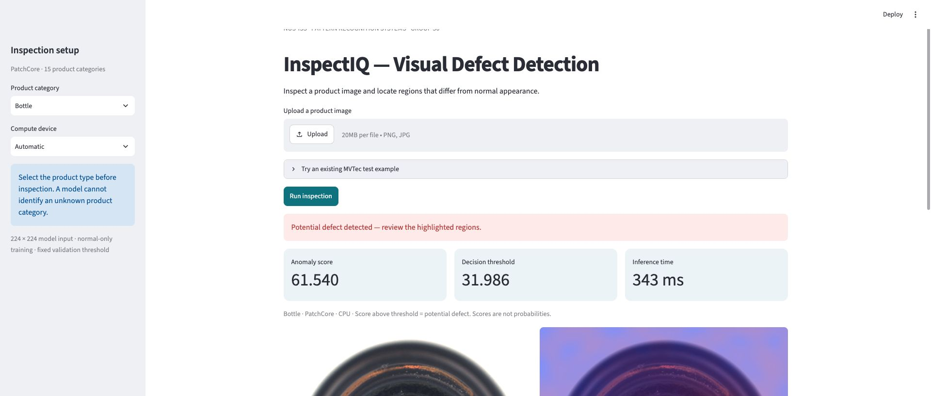
Figure 1. Actual local Streamlit application inspecting an MVTec bottle image. The displayed score is produced by the exported PatchCore model, not a mock response.
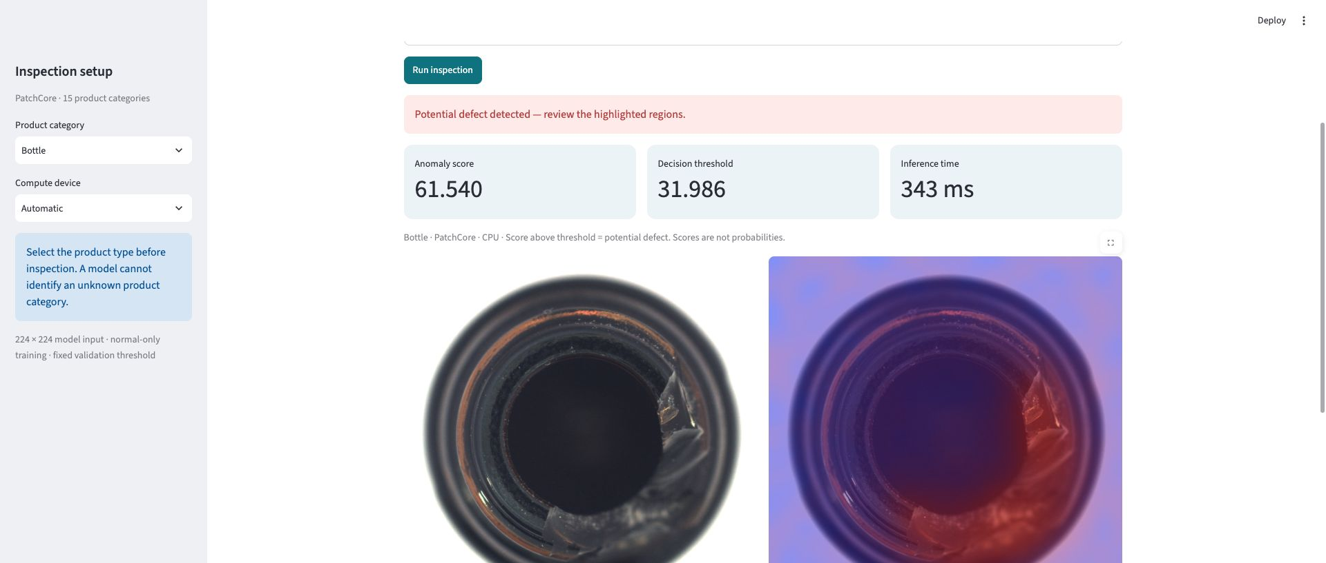
Figure 2. Actual inspection result with original image and relative anomaly overlay. Colours highlight candidate regions and are not a calibrated pixel mask.

7.4 Verification
All 15 exported category models loaded and produced 224 by 224 anomaly maps on real local test images. Unit and protocol checks reported 13 passes and two accelerator-dependent skips. Streamlit tests covered sample selection, inspection metrics and clearing stale results after a category change. Public release downloading and checksum installation were also verified.

8 Results

8.1 Comparison of Six Methods
Method | AUROC | F1 | Precision | Recall | FPR
Autoencoder | 0.5781 | 0.2715 | 0.7366 | 0.1810 | 0.0497
Frozen CNN | 0.8588 | 0.7027 | 0.9138 | 0.6246 | 0.1361
AE + CNN | 0.8197 | 0.6818 | 0.9106 | 0.6059 | 0.1288
PatchCore | 0.9840 | 0.9514 | 0.9510 | 0.9567 | 0.1522
DINO adapter | 0.9679 | 0.9258 | 0.9323 | 0.9304 | 0.1480
AE + DINO | 0.9464 | 0.9091 | 0.9535 | 0.8845 | 0.0942

Table 2. Unweighted macro image metrics over all 15 categories. All thresholded metrics use fixed normal-validation thresholds.
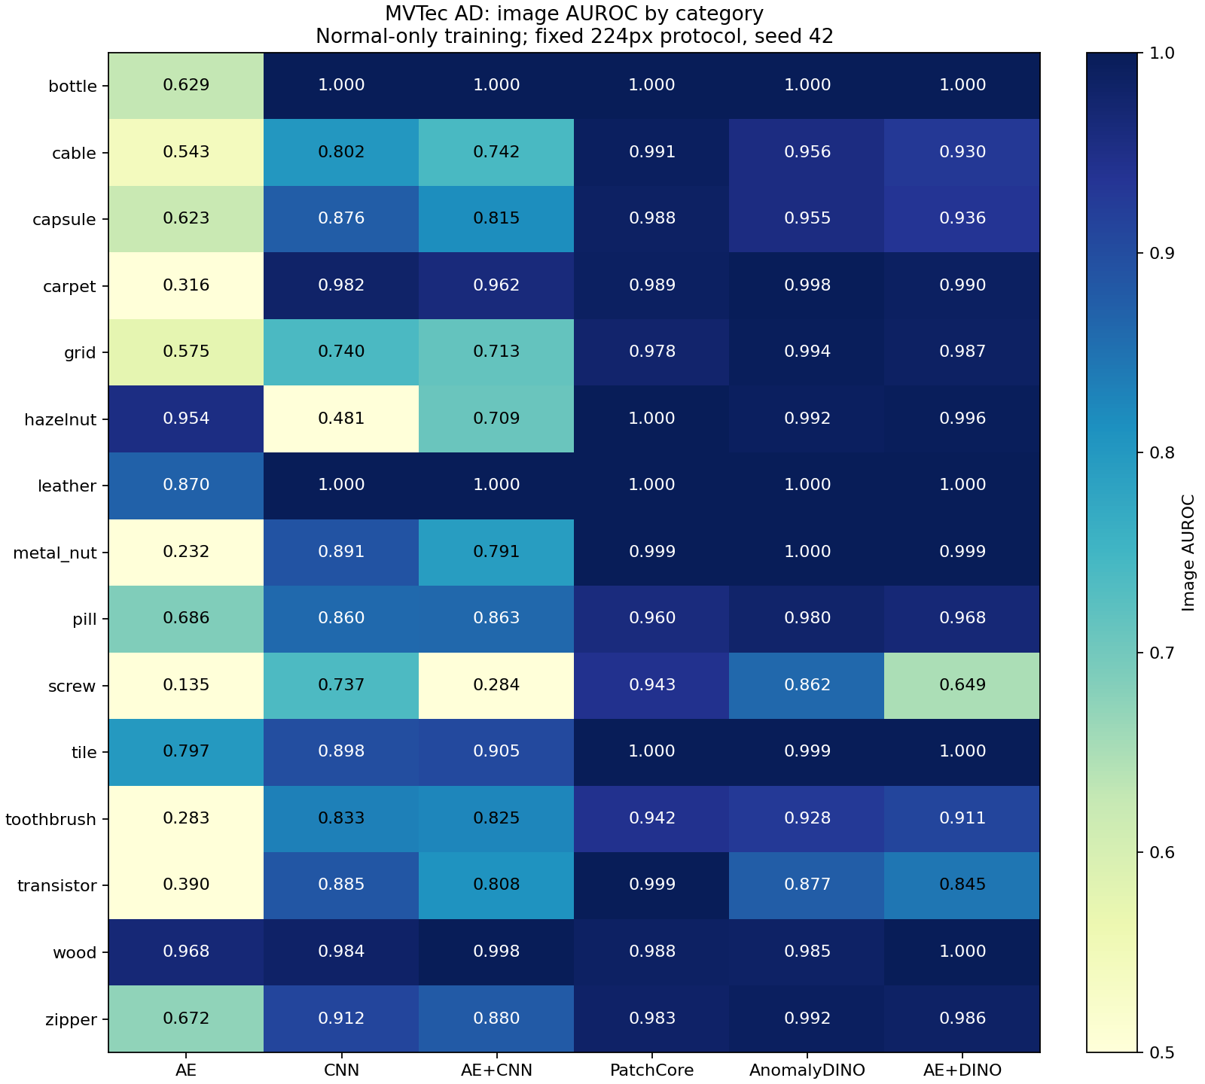
Figure 3. Image AUROC by category for the six evaluated methods.
PatchCore leads the comparison at AUROC 0.9840 and F1 0.9514. The DINO adapter is second at AUROC 0.9679 and F1 0.9258. The PatchCore advantage is 0.0161 AUROC and 0.0256 F1; repeated seeds and uncertainty estimates were not measured, so this should not be described as statistically significant.
AE + CNN decreases AUROC from the CNN value of 0.8588 to 0.8197. AE + DINO decreases AUROC from 0.9679 to 0.9464. These outcomes reject the assumption that equal-weight fusion necessarily helps. The lower false-positive rate of AE + DINO comes with lower recall, illustrating an operating trade-off rather than an unqualified improvement.

8 Results by Category
Category | AUROC | F1 | FPR | FP | FN
bottle | 1.0000 | 1.0000 | 0.0000 | 0 | 0
cable | 0.9910 | 0.9727 | 0.0345 | 2 | 3
capsule | 0.9880 | 0.8878 | 0.0000 | 0 | 22
carpet | 0.9892 | 0.9362 | 0.3929 | 11 | 1
grid | 0.9783 | 0.9739 | 0.0952 | 2 | 1
hazelnut | 1.0000 | 1.0000 | 0.0000 | 0 | 0
leather | 1.0000 | 0.9388 | 0.3750 | 12 | 0
metal nut | 0.9985 | 0.9840 | 0.0909 | 2 | 1
pill | 0.9599 | 0.9125 | 0.0769 | 2 | 21
screw | 0.9430 | 0.8818 | 0.0976 | 4 | 22
tile | 1.0000 | 0.9941 | 0.0303 | 1 | 0
toothbrush | 0.9417 | 0.9206 | 0.3333 | 4 | 1
transistor | 0.9987 | 0.9756 | 0.0333 | 2 | 0
wood | 0.9877 | 0.9302 | 0.4737 | 9 | 0
zipper | 0.9832 | 0.9633 | 0.2500 | 8 | 1

Table 3. PatchCore category metrics and test error counts. FP = false positives; FN = false negatives.
Bottle and hazelnut achieve perfect image discrimination and classification in this run. Leather also has AUROC 1.0000, yet its false-positive rate is 0.3750. This shows that a ranking can be excellent while a fixed threshold transfers poorly from normal validation images to normal test images.
Capsule, pill and screw account for 65 of the 73 missed defects. Wood has the highest false-positive rate, 9 of 19 normal images, or 0.4737. These concentrations identify concrete targets for further validation rather than suggesting uniform performance across products.

8.2 Pooled Counts and Localisation
Summing category errors gives TP = 1,185, FN = 73, TN = 408 and FP = 59. The resulting pooled false-positive rate is 59/467 = 12.63%, whereas the macro false-positive rate is 15.22%. Both are valid summaries, but they answer different weighting questions.
PatchCore macro pixel AUROC is 0.9763 and pixel AP is 0.5423, compared with 0.9633 and 0.5021 for DINO. The moderate pixel AP cautions against treating visually plausible heatmaps as precise segmentation. The mean of PatchCore category mean latencies is 68.16 ms per image on the recorded T4 run; this is not a measured production throughput.

8 Error Analysis
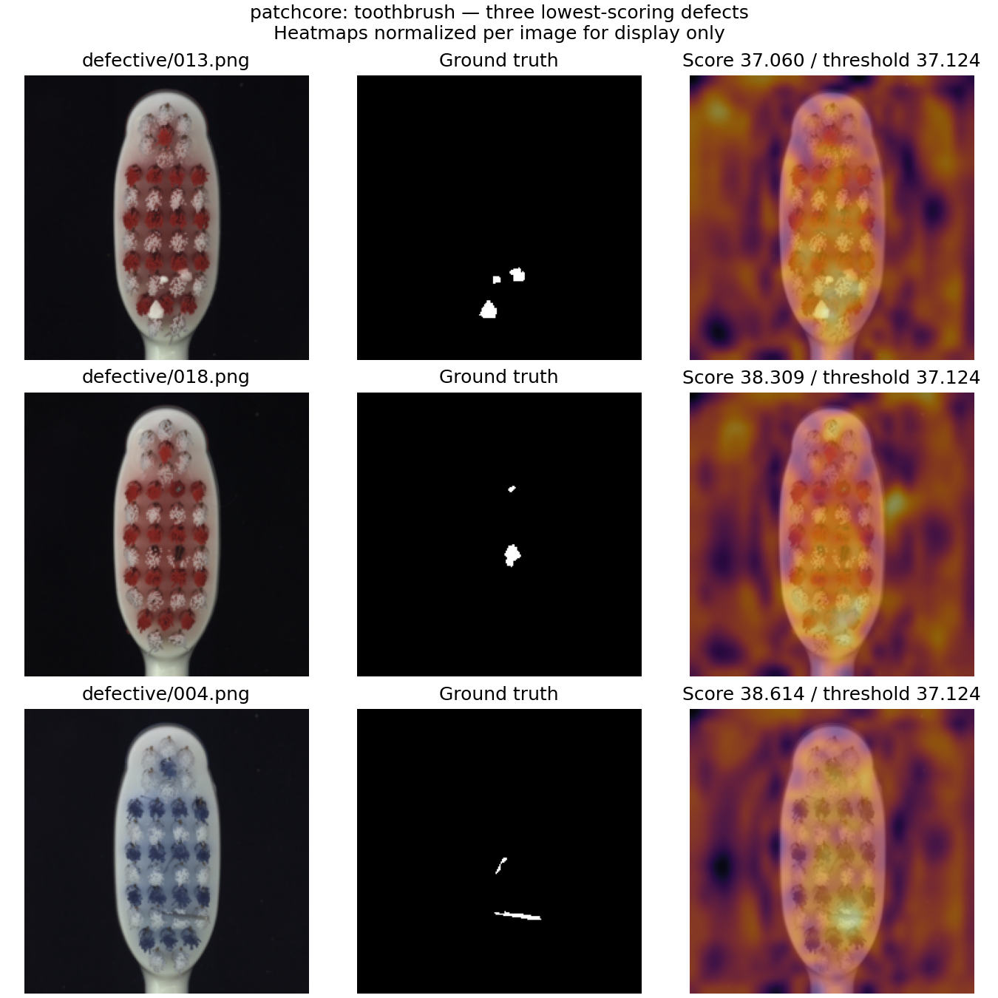
Figure 4. Three lowest-scoring defective toothbrush images under PatchCore, shown with ground truth and relative overlays. Only the first image falls below the fixed threshold; the other two are low-scoring true positives. Source images and masks: MVTec AD [1].
For toothbrush defective/013.png, the score is approximately 37.060 against a threshold of 37.124, producing a false negative. The map shows broad responses around the brush and background rather than a crisp defect outline. The next two examples score 38.309 and 38.614 and are correctly flagged, despite being difficult cases.
The figure supports qualitative localisation review, but it does not establish the cause of every error. Lower resolution, small defect extent, appearance variation and representation mismatch are plausible factors to test. They should not be reported as proven explanations without controlled experiments.

9 Challenges and Limitations

9.1 Calibration and Model Selection
Thresholds estimated from normal validation images are a practical way to avoid defect-labelled calibration. They do not guarantee a 5% false-positive rate on a shifted test distribution. The high rates for wood, carpet and leather show this limitation directly. Test-driven threshold adjustment would improve the apparent score without providing an independent estimate of generalisation.
The final model was selected after comparing benchmark results. Future changes to architecture, thresholds or ensemble weights should use a separate development set and then be assessed on a new untouched holdout. Only one seed and one main resolution were evaluated; there are no confidence intervals, repeated-run significance tests or coreset/resolution ablations.

9.2 Representation and Localisation
The autoencoder has limited capacity and a short fixed training schedule. Its weak result is evidence about this implementation, not evidence that every reconstruction method is unsuitable. Similarly, the frozen CNN uses diagonal spatial statistics and is not equivalent to richer covariance or memory-based approaches.
Images are resized to 224 by 224, potentially reducing small-defect detail and changing aspect ratio. Pixel metrics are calculated at that resized resolution. The DINO adapter uses a different interpolation rule and omits optional masking and rotations. These differences prevent causal claims that the backbone alone explains the performance gap.

9.3 Engineering and External Validity
Colab runtime persistence and transfer of large artifacts required explicit completion receipts, hashes and packaging. Some remote checkpoint paths were unavailable at export, so existing local Colab checkpoints were recovered only after matching their saved hashes. The final package consolidates the common backbone instead of duplicating it for every category.
The final loader was checked on CPU using all 15 models. For bottle/good/000.png, the original GPU score 27.816252 and exported CPU score 27.816444 both fall below threshold 31.986477. For bottle/broken_large/000.png, scores 61.540009 and 61.539986 both exceed it. Small numerical differences are expected; this does not validate every image across every device.
MVTec AD is a curated benchmark, not a prospective factory stream. Changes in camera, lighting, pose and product design can affect scores. The prototype does not automatically recognise unknown product categories, reject all out-of-domain inputs, identify defect types or guarantee safety. Human review and representative production validation remain necessary.

10 Future Work and Conclusion

10.1 Prioritised Next Steps
Priority | Proposed work | Required evaluation
1 | Collect representative normal production images and a separate labelled holdout | False alarms and missed defects at a predeclared operating point
2 | Study 224 versus higher resolution and coreset size | Quality, memory and latency under identical splits
3 | Investigate capsule, pill and screw misses; texture false alarms | Per-defect and category analysis without test-set retuning
4 | Compare EfficientAD and calibrated alternatives | Matched hardware, preprocessing and timing scope
5 | Evaluate user workflow and live acquisition | Review time, operator agreement and handling of unknown products

If ensembling is revisited, weights should be fitted on separate development data and compared against the best single detector. A learned ensemble should not use the final test labels. Better uncertainty communication could include an explicitly validated review band around the threshold rather than presenting the anomaly score as a probability.
Production engineering would require camera integration, access controls, persistent inspection records, model/version traceability and monitoring for drift. These additions should follow a measured use case; they are not prerequisites for demonstrating the current academic image-inspection workflow.

10.2 Conclusion
The project implements an end-to-end normal-only visual defect detection workflow, from deterministic data preparation and comparative modelling to a runnable inspection application. Six methods were evaluated across 15 MVTec AD categories using common splits and validation-based thresholds.
PatchCore provided the strongest macro results in this experiment and was selected for InspectIQ. The original ensemble hypothesis was tested rather than assumed: neither equal-weight ensemble improved its stronger component in the reported macro results. The final system retains the full experimental code and delivers the selected detector with verified, downloadable models.
The principal remaining limitation is the difference between good anomaly ranking and dependable operating decisions. False positives in texture categories, concentrated missed defects and moderate pixel AP all require further work. The outcome is a reproducible academic prototype with documented strengths and limitations, not evidence of certified production readiness.

References
[1] MVTec Software GmbH. MVTec AD Industrial Anomaly Detection Dataset. Dataset and benchmark documentation. https://www.mvtec.com/research-teaching/datasets/mvtec-ad
[2] Roth, K., Pemula, L., Zepeda, J., Schölkopf, B., Brox, T., and Gehler, P. Towards Total Recall in Industrial Anomaly Detection. CVPR, 2022, pp. 14318-14328. https://openaccess.thecvf.com/content/CVPR2022/html/Roth_Towards_Total_Recall_in_Industrial_Anomaly_Detection_CVPR_2022_paper.html
[3] Damm, S., Laszkiewicz, M., Lederer, J., and Fischer, A. AnomalyDINO: Boosting Patch-Based Few-Shot Anomaly Detection with DINOv2. WACV, 2025. https://arxiv.org/abs/2405.14529
[4] Oquab, M. et al. DINOv2: Learning Robust Visual Features without Supervision. 2023. https://arxiv.org/abs/2304.07193
[5] Defard, T., Setkov, A., Loesch, A., and Audigier, R. PaDiM: a Patch Distribution Modeling Framework for Anomaly Detection and Localization. 2020. https://arxiv.org/abs/2011.08785
[6] Batzner, K., Heckler, L., and König, R. EfficientAD: Accurate Visual Anomaly Detection at Millisecond-Level Latencies. WACV, 2024, pp. 128-138. https://arxiv.org/abs/2303.14535
[7] Open Edge Platform. Anomalib source implementation, version 2.7.0. https://github.com/open-edge-platform/anomalib
[8] Group 30. Visual Defect Detection project source, release v1.0.1 and experiment outputs. 2026. https://github.com/AndyYeom/Visual_Defect_Detection
[9] NUS Institute of Systems Science. Pattern Recognition Systems Practice Module 7.0, full-time briefing. 2026. Project requirements and deliverables, pp. 9, 15-16.
[10] Group 30. Visual Defect Detection Using Deep Learning and Ensemble Anomaly Scoring. Original project proposal, 30 September 2026. Reproduced in Appendix A.

Implementation and result provenance
Numerical results in this report come from the project run full15_224_v1 and its summary.json, category_metrics.csv and analysis outputs. Model descriptions were checked against the project source. External research is cited for method context, not as a substitute for our measured results.

Appendix A Original Proposal
Original proposal dated 30 September 2026. The retained proposal records the planned scope; the main report explains the final dataset choice, added comparators and selection of PatchCore.

Original proposal reproduced from the submitted project document.

Appendix B Technique Mapping
Module aspect [9] | Implemented evidence | Report sections
Unsupervised learning scenario | Normal-only representation fitting; held-out normal calibration; anomalous test images used only for evaluation | 3-6
Machine learning and deep learning | Convolutional autoencoder, pretrained ResNet features, PatchCore and DINOv2 representations | 5
Hybrid or ensemble approach | Fixed 50/50 calibrated AE-CNN and AE-DINO ensembles; comparison with individual methods | 5 and 8
Image interpretation | Spatial anomaly maps and human-review overlays; no live sensor hardware claim | 7 and 8

B.1 Coverage of the Original Objectives
The work demonstrates at least the three aspects identified in the proposal: unsupervised learning, deep learning and an ensemble approach. Selecting a single model for the application does not remove the implemented and evaluated ensemble experiments. Their negative result is a finding that should be retained.
The learning scenario is normal-only for this target dataset. Some backbones were pretrained on external data, including supervised ImageNet representations, so the whole history of every feature extractor should not be described as label-free. The distinction is that no MVTec defect labels are used to fit the deployed detector or select its threshold.

B.2 Practical Skills
The project applies image preprocessing, feature extraction, reconstruction learning, distance-based modelling, score calibration, ensemble fusion, comparative evaluation and error analysis. Engineering work includes content-hashed manifests, GPU-aware execution, resumable experiments, model packaging and an interactive inference interface. Together these connect the modelling pipeline to a usable pattern recognition system.

Appendix C Installation and User Guide

C.1 Installation
Python 3.12 is recommended. A CPU is sufficient for the final demo. CUDA-enabled PyTorch and an NVIDIA GPU are optional. Run the following commands in a terminal on macOS or Linux:
git clone https://github.com/AndyYeom/Visual_Defect_Detection.git
cd Visual_Defect_Detection
python3.12 -m venv .venv
source .venv/bin/activate
python -m pip install --upgrade pip
python -m pip install -e ".[demo]"
python scripts/download_models.py
python -m streamlit run app/streamlit_app.py
On Windows, use py -3.12 -m venv .venv and activate with .venv\Scripts\Activate.ps1 in PowerShell. Then run the same python installation and launch commands. Open http://localhost:8501. The model download is a one-time step; image inference then works offline.

C.2 Demonstration Steps
Step | Action | Expected result
1 | Select Bottle and Automatic device | Correct category model; CUDA if available, otherwise CPU
2 | Upload bottle/test/good/000.png | Image ready for inspection
3 | Click Run inspection | Score about 27.816 below threshold 31.986; normal result
4 | Upload bottle/test/broken_large/000.png and inspect | Score about 61.540; potential defect and overlay
5 | Use the download controls | Inspection JSON and overlay PNG

The two example files come from a separately downloaded MVTec AD dataset. Their recorded results illustrate this model; arbitrary images can behave differently. To enable the local example selector, set VDD_DATA_ROOT to the dataset root before launching. The full dataset is not needed for ordinary uploaded-image inference.

C.3 Troubleshooting
If weights are missing, run the downloader. If network download is unavailable, obtain patchcore-models-v1.zip from the v1.0.0 release and pass --archive /path/to/file.zip to scripts/download_models.py. Do not mix files across packages. If CUDA is unavailable, select CPU. If the input category differs from the selected category, choose the correct model before interpreting the score. Stop the local server with Ctrl+C in its terminal.

Appendix D Supplementary Materials

D.1 Contributions
Member | Contribution
Yeom Dongjun | Led the overall implementation and system integration, coordinated GPU experiment execution and the six-method comparison across all 15 MVTec AD categories, and developed the Streamlit inspection interface. Integrated the selected PatchCore model into the application and coordinated end-to-end demonstration testing.
Nguyen Tri Nghia | Managed model packaging and deployment preparation, verified model loading and inference behaviour, and maintained execution instructions and release documentation. Conducted false-positive and false-negative analysis, reviewed anomaly heatmaps, and assessed technical limitations and improvement opportunities.
Zaiyu Zhang | Reviewed related research and anomaly detection techniques, contributed to experimental design and the evaluation protocol, and analysed model and ensemble performance. Supported the interpretation of evaluation metrics and the rationale for selecting the final model.
Worameth Wittanakorn | Researched and documented the MVTec AD dataset, contributed to data preparation and split validation, and reviewed category coverage and normal/defective image characteristics. Organised representative examples and checked the consistency of dataset descriptions and visual materials.
Shared contribution: All four members participated in researching datasets and reference materials, reviewing code and experimental findings, and discussing implementation decisions. The allocation identifies primary responsibilities rather than exclusive ownership.

D.2 Project Artifacts
Artifact | Location or identifier
Runnable source and README | GitHub repository; final application release v1.0.1
Trained models | patchcore-models-v1.zip in release v1.0.0; downloaded by the installer
Aggregate and category results | docs/results/summary.json and category_metrics.csv
Error review outputs | Model package analysis/errors.csv and hard-case figures
Experiment notebooks | notebooks/Group30_GPU_Baseline.ipynb, Comparison and Full15 notebooks
Original proposal | Appendix A and the retained proposal document

D.3 AI Assistance
OpenAI Codex assisted with code development, GPU support, experiment orchestration, result analysis, model packaging, documentation and preparation of this report. It also helped verify references and document layout. Reported metrics come from executed experiments, not generated example values. The project team remains responsible for checking the code, interpreting the results and reviewing the final submission.

D.4 Team and Submission Context
The project team comprises Yeom Dongjun, Zaiyu Zhang, Worameth Wittanakorn and Nguyen Tri Nghia. Individual contributions and learning reflections are addressed in the separate individual reports required by the module. This group report describes the system and evidence at project level.
The module requires a runnable system, dataset resources, source and model files, a final report, slides for both presentations and a 10-15 minute presentation video. Each member also submits a 1-2 page individual report and completes peer review [9]. Those separate presentation and individual deliverables are not replaced by this group report.

D.5 Reproduction Boundaries
The final report describes the released English-language application and the completed 15-category benchmark. It does not claim that a factory trial, user study, live camera integration or additional model training was completed during report preparation. Reproducing training requires separately obtaining the dataset and pretrained feature extractors; reproducing inference requires only the released model package and a matching input image.

