**Web Travel Map Application**

Yiwen Liu, Kaiyue Zang, Jiemin Zhou

1. **Introduction**

Web travel map allows users to create their own trip maps. Users can add their travel date, locations, pictures and even comments. When the map is created, all travel locations can be displayed on the map. By clicking on the location, photos and detailed information will be displayed in a sidebar. Workflow as shown:

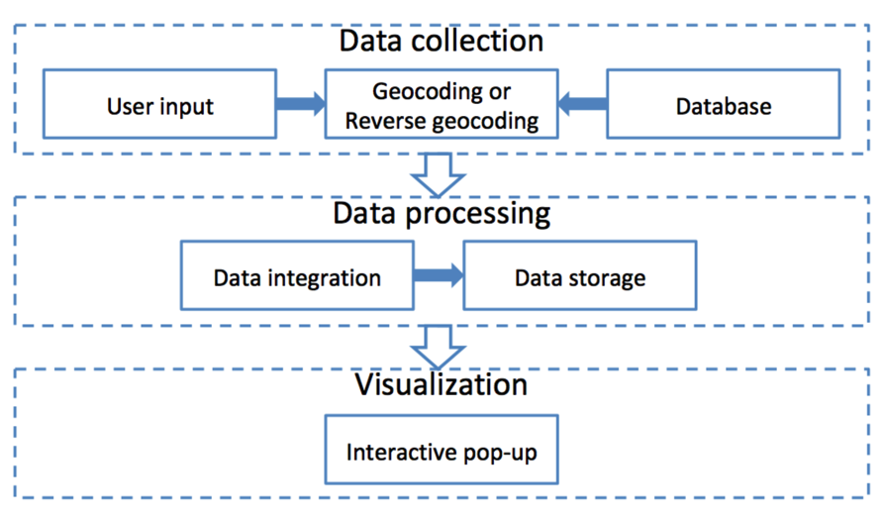

1. **Implementation**

This application has some basic functions like other web map application such as scale, base map switcher, hawk eye map and so on. In addition, there are some special functions for travel, including uploading sight photos, adding locations for photos, commenting on the sights and map interaction function. The basic interface of this application is shown in the figure below

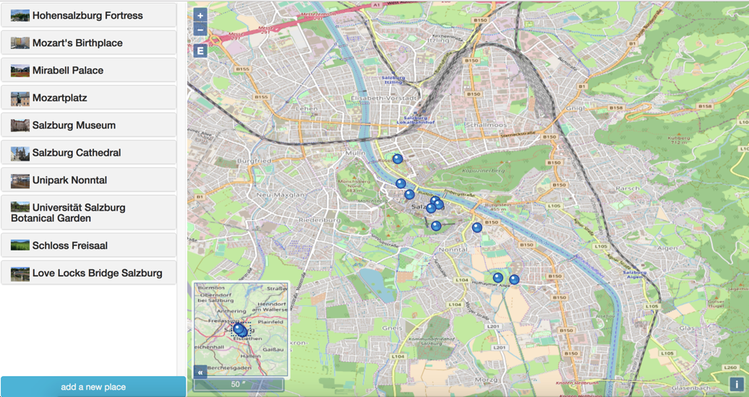

2.1 Basic functions

Openlayer provides a variety of basic functions APIs. We used ‘ol.control.ScaleLine’, ‘ol.control.ZoomToExtent’, ‘ol.control.OverviewMap’ to implement scale, zoom to default center and hawk eye map. (When the projection is WGS84, the scale bar does not display the length correctly, so the current unit is 'degrees')

2.2 Uploading photos

Users can click the “Add a new place” button to upload their sight photos. (But because we don’t have a web server to publish this web application, temporarily, user can only upload photos from the "IMG" folder in the project directory.) For each sight photo, users can leave their text reviews and ratings. For location of sight photos, we used geocode API of Google map. When users type place name of photo, the mark will appear in the corresponding position on the map, if not, a warning will pop up: ‘it is hard to find the place!’

All information of sight photos will be save in a JSON file(‘place.json’).

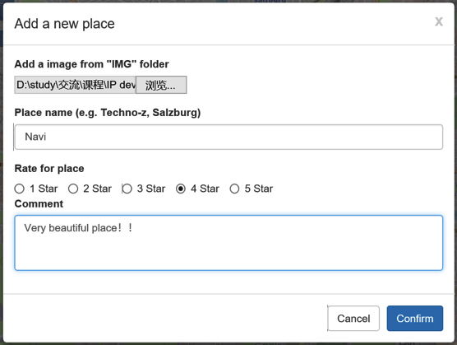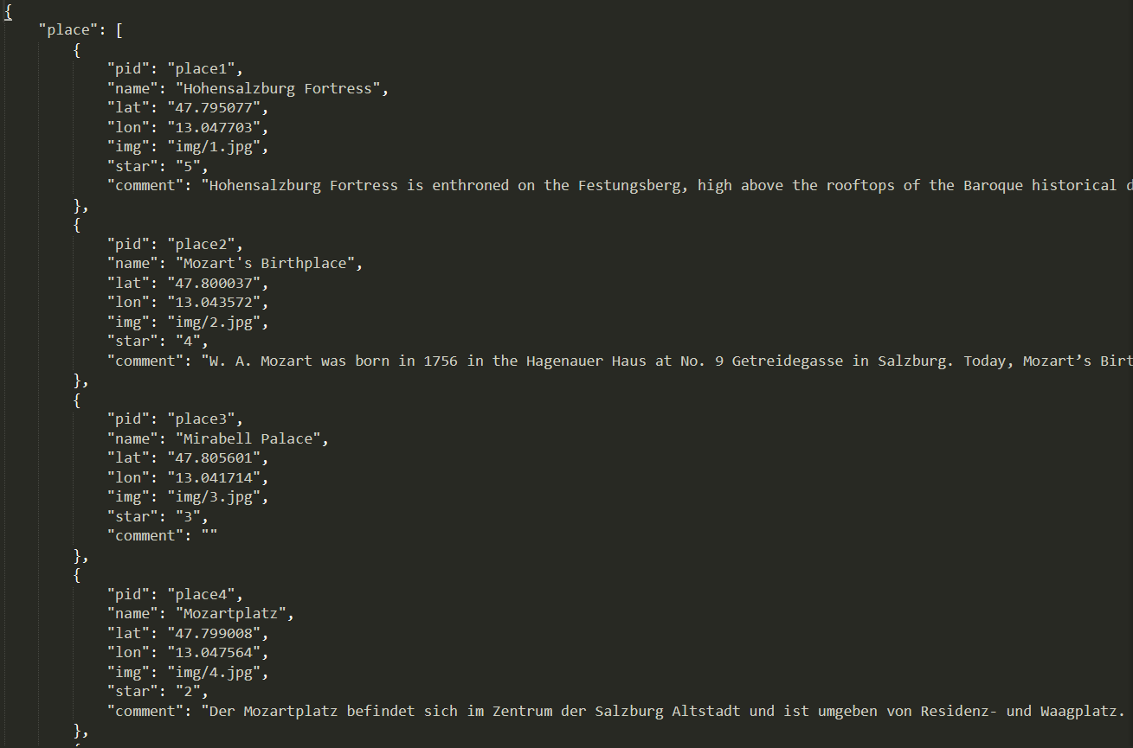

2.3 Map interaction

All existing attraction records are shown in the left sidebar with thumbnails and names. Click on the one mark on the map and the corresponding attraction description records will be displayed in detail.

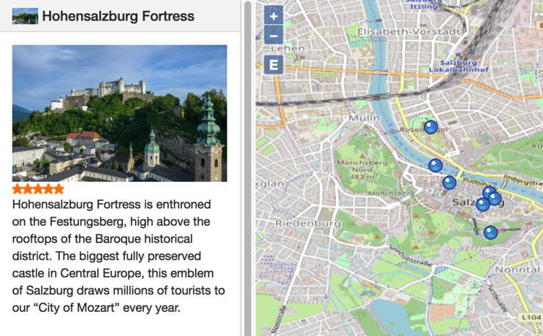

1. **Team work**

Yiwen Liu(33%) : Interactive function; documentation

Kaiyue Zang(33%) : Data acquisition, storage and loading; documentation

Jiemin Zhou(33%) : Interface design; documentation

1. **File Organize**

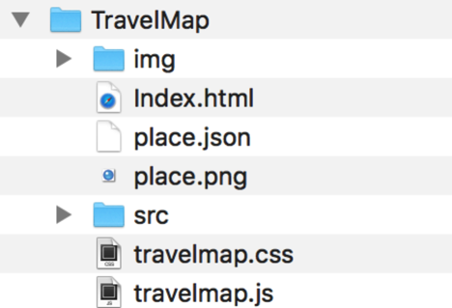

Note：Due to the need to access local files, please open "Index.html" using Firefox. Or, open with local HTTP server like python’s “python3 -m http.server 8000”, then open url: “localhost:8000”.