Quantum Lottery: A Decentralized Blockchain Lottery Application

Chung Ka Wai

20857033

Technical Specifications
- Network: Sepolia Testnet
- Contract Address: 0x2199C9d2657c4Cc7810FC3a37F5522225555fCE4
- EtherScan Link: link
- Front-end: HTML, CSS, JavaScript with Ethers.js v6
- Source Code: https://github.com/Andychung1229/comp-bitcoin-real
Since this project requires backend server , please go to the github repo and follow the set up written in the README.md

1. Project Idea and Innovation Points

Concept Overview
The Quantum Lottery is a decentralized lottery system that reimagines traditional lottery mechanisms through blockchain technology. Rather than relying on centralized authorities to manage funds and determine winners, this application creates a trustless environment where lottery rounds operate on fixed time intervals with transparent winner selection and automatic prize distribution.

Key Innovation Points
The Quantum Lottery implements a precise time-based mechanism where each lottery round operates on a fixed 5-minute duration. State transitions happen automatically based on time passage, with a unique 10-second "threshold period" that prevents last-minute strategic entries. This time-based approach creates a more predictable and fair environment for all participants while maintaining the excitement of limited entry windows.
The project addresses one of blockchain's fundamental challenges - generating unpredictable random outcomes in a deterministic environment. The solution combines multiple entropy sources including Ethereum's prevrandao value (introduced in the Merge), block timestamp, block coinbase, and the number of tickets sold. These sources are hashed with keccak256 to create a uniformly distributed outcome that cannot be easily predicted or manipulated by participants or validators.
In contrast to most lottery systems that rely on privileged operators, this DApp features public draw functions that any participant can trigger when time expires. The checkAndDraw() function enables anyone to initiate the winner selection process once the lottery time has elapsed, ensuring that rounds progress even without manager intervention. This approach minimizes centralized control points and enhances the trustless nature of the application.
To improve user experience and reduce unnecessary gas costs, the application employs view functions like getRemainingTime(), isInThresholdPeriod(), and isLotteryActive() that can be called by the front-end without transaction costs. These functions allow the client-side application to accurately reflect the lottery's current state without requiring frequent blockchain transactions.

2. Application Functionality

Core Features

Time-Based Lottery System
- Each lottery round runs for precisely 5 minutes (LOTTERY_DURATION constant)
- A real-time countdown timer shows remaining time via getRemainingTime()
- Ticket purchases automatically close during the final 10-second threshold (END_THRESHOLD constant)

Ticket Purchase Mechanism
- Fixed ticket price (0.001 ETH) to ensure accessibility
- One ticket per address per round to prevent dominance by wealthy participants
- Instant participant registration with blockchain confirmation
- Maximum participate is 100 , once reach automate draw is triggered

Transparent Winner Selection
- On-chain randomness calculation visible to all participants
- Equal probability distribution regardless of entry time
- Multiple entropy sources combined to prevent manipulation

Prize Distribution
- 95% of the collected pool is awarded to the winner
- 5% allocated to protocol maintenance
- Automatic distribution immediately upon winner selection

Lottery History
- Complete historical record of all previous lottery rounds
- Detailed information including winners, prize amounts, and timestamps
- Full participant lists per round with winner highlighting

User Roles and Permissions
Standard users can connect wallets and purchase tickets through an intuitive interface. They can view lottery status and participant information in real-time, trigger winner drawing when time expires, and access the complete lottery history. This comprehensive access ensures users have visibility into all aspects of the lottery operation.
The contract deployer serves as a manager with additional capabilities for manual winner drawing in edge cases. This is implemented through the onlyManager modifier that restricts certain functions to the address stored in the manager state variable. These manager functions provide a safety mechanism for addressing unexpected circumstances while maintaining the primarily decentralized operation of the lottery.

3. Security Implementation and Attack Prevention

Security Vulnerabilities Addressed

Reentrancy Attacks
- Vulnerability: Malicious contracts could repeatedly call back into the lottery contract during execution to drain funds.
- Implementation:
  - Imported OpenZeppelin's ReentrancyGuard (import {ReentrancyGuard} from "openzeppelin-contracts/utils/ReentrancyGuard.sol")
  - Applied nonReentrant modifier to all external functions handling ETH (buyTicket, checkAndDraw, drawWinner)
  - Implemented checks-effects-interactions pattern throughout the contract
  - Updated state variables before any external calls

Randomness Manipulation
- Vulnerability: Miners or validators could influence randomness to increase their chances of winning.
- Implementation:
  - Multiple entropy sources combined to prevent predictability
  - Usage of block.prevrandao which is resistant to miner manipulation
  - Additional variables like ticketsSold and lottery duration included in entropy calculation
  - Creation of randomness via: bytes32 entropy = keccak256(abi.encodePacked(block.prevrandao, block.timestamp, block.coinbase, currentTicketsSold, reason));

Timestamp Dependence
- Vulnerability: Block timestamps could be slightly manipulated by validators.
- Implementation:
  - Time thresholds are sufficiently large (5 minutes for rounds, 10 seconds for threshold)
  - Multiple conditions govern state transitions, not just time
  - The small variance possible in timestamps (~15 seconds) doesn't significantly impact fairness

Access Control Exploits
- Vulnerability: Unauthorized access to privileged functions could compromise lottery integrity.
- Implementation:
  - Strict modifier-based access control for manager functions
  - Public functions carefully designed with appropriate permission checks
  - Implementation of onlyManager modifier: require(msg.sender == manager, "Only manager");

Front-Running Attacks
- Vulnerability: Participants could observe pending transactions and front-run them.
- Implementation:
  - 10-second threshold period prevents last-moment strategic entries
  - Single ticket per address prevents capitalization on observed patterns
  - Randomness calculation incorporates sufficient unpredictable elements

Integer Overflow/Underflow
- Vulnerability: Mathematical operations could result in unexpected values.
- Implementation:
  - Solidity 0.8.x compiler with automatic overflow/underflow checks
  - Additional boundary validations on critical calculations
  - Use of appropriate data types for different numerical ranges

Security Through OpenZeppelin Integration
A critical security element of the Quantum Lottery is the integration of the OpenZeppelin ReentrancyGuard library. This industry-standard security component provides protection against reentrancy attacks, one of the most common and dangerous vulnerabilities in smart contracts handling funds. The contract inherits from ReentrancyGuard and applies the nonReentrant modifier to all external functions that perform state changes and ETH transfers, creating a robust barrier against potential exploits.
By importing this trusted security library (import {ReentrancyGuard} from "openzeppelin-contracts/utils/ReentrancyGuard.sol"), the contract leverages battle-tested code that has been audited and proven effective across thousands of production contracts. This approach is significantly more secure than attempting to implement custom reentrancy protection, as it benefits from the collective security expertise of the OpenZeppelin team and community.
The implementation is complemented by following the checks-effects-interactions pattern throughout the contract. All state changes occur before any external calls, ensuring that even if a malicious contract attempts to reenter the Quantum Lottery during execution, it would encounter updated state variables that prevent exploitation. This is particularly evident in the _drawWinner function, where all state recording and updates occur before any ETH transfers take place.

4. Implementation Details

Smart Contract Design Patterns
The lottery implements a sophisticated state machine where states are determined by time and ticket sales rather than explicit flags. This is evident in the helper functions like isLotteryActive() and isInThresholdPeriod() which compute the current state based on time relationships. Transitions occur automatically at predefined thresholds, and each state restricts allowed actions appropriately. This approach creates a more intuitive flow through the lottery cycle while minimizing state storage costs.
The contract emits detailed events for lottery round initiation (LotteryStarted), ticket purchases (TicketPurchased), winner selection (WinnerSelected), and draw triggers (AutomaticDraw). These events enable efficient front-end updates without requiring expensive storage operations. By listening for these events, the front-end can maintain an accurate representation of the lottery state without frequent blockchain queries.
For security in prize distribution, winners receive funds immediately rather than requiring a separate withdrawal transaction. This is implemented in the _drawWinner function where prizes are sent directly to winners after state changes are completed. This eliminates the need for complex withdrawal tracking and reduces the attack surface area compared to withdrawal patterns. The immediate transfer creates a more satisfying user experience while maintaining security.
Functions within the contract are segregated by permission level, with public functions accessible to all users and manager-only functions protected by modifiers. Internal helper functions like _startNewLottery() and _recordResult() improve code organization and readability. This hierarchy ensures appropriate access control while maintaining clean code structure.

Front-End Architecture
The interface maintains accurate state through the contract's view functions like getRemainingTime(), isLotteryActive(), and getParticipants(). These functions allow the front-end to query current lottery status without transaction costs. The contract's event emissions facilitate real-time updates when blockchain state changes, while the view functions serve as a reliable data source for periodic polling.
By implementing these comprehensive security measures and design patterns, the Quantum Lottery provides a secure, transparent, and trustless lottery system that demonstrates the power of blockchain technology for creating fair and open gambling applications.

Front-End UI

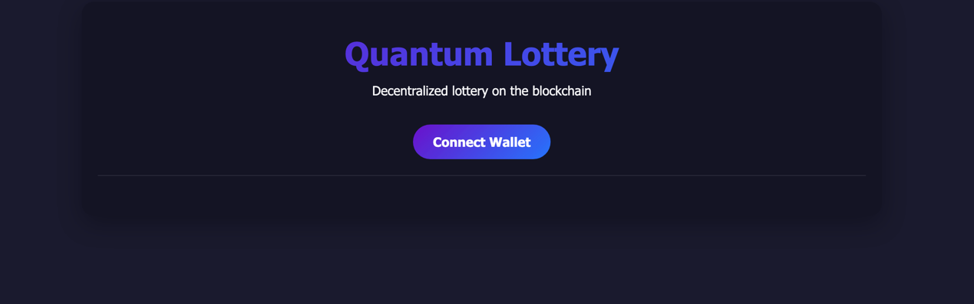

Figure 1: Login Page to connect to Metamask

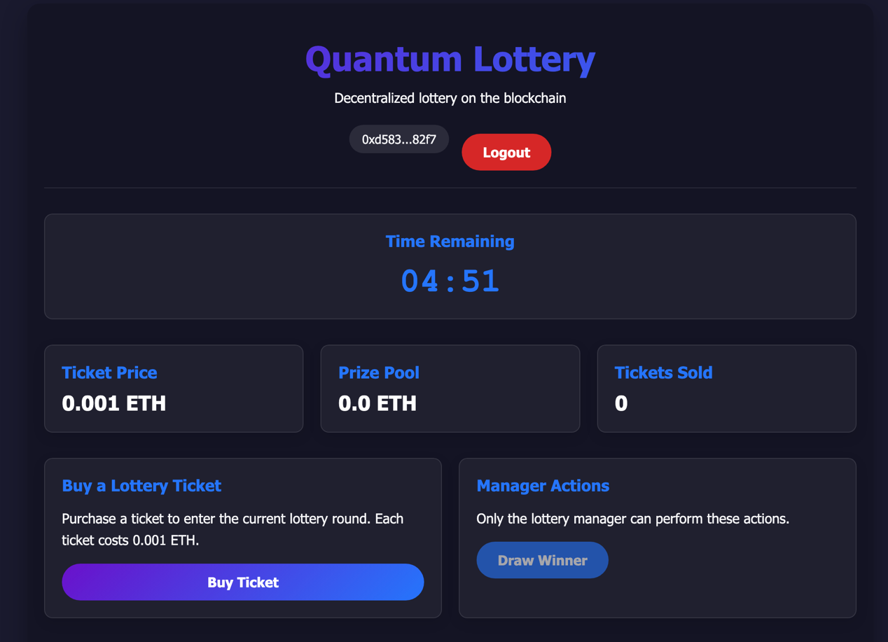

Figure 2: Admin Panel with manually draw winner function

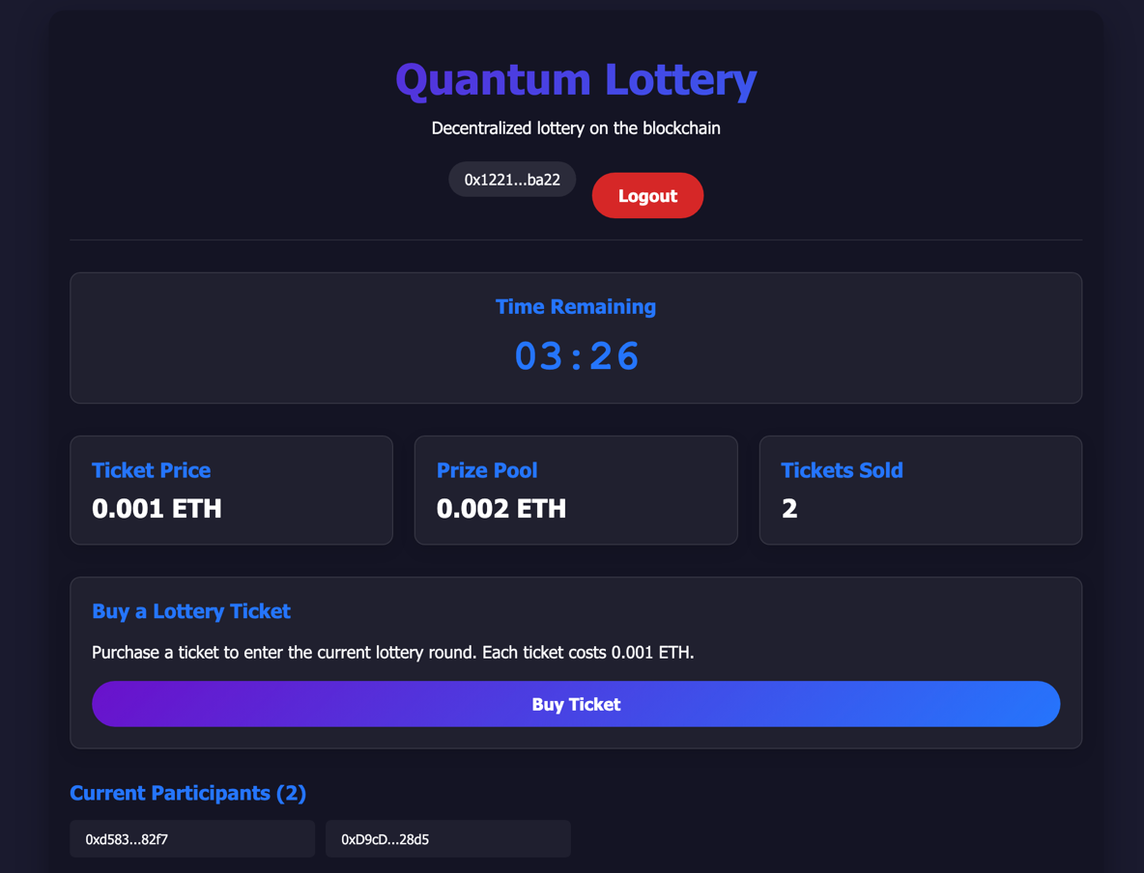

Figure 3: User Panel with current participant list

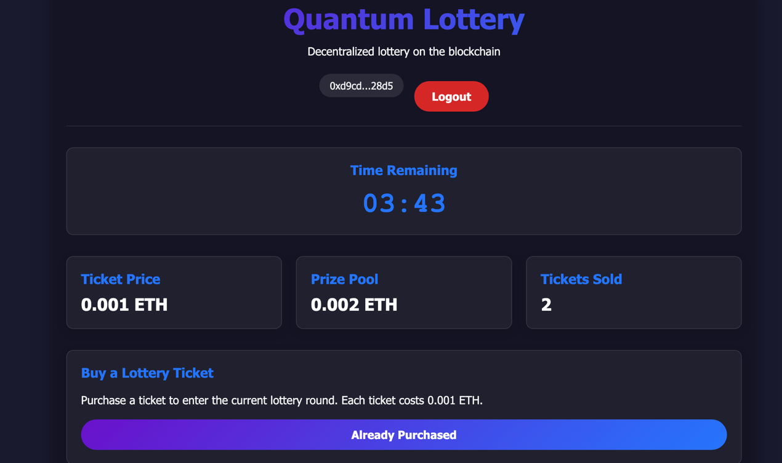

Figure 4 : UI when buy ticket is already successful

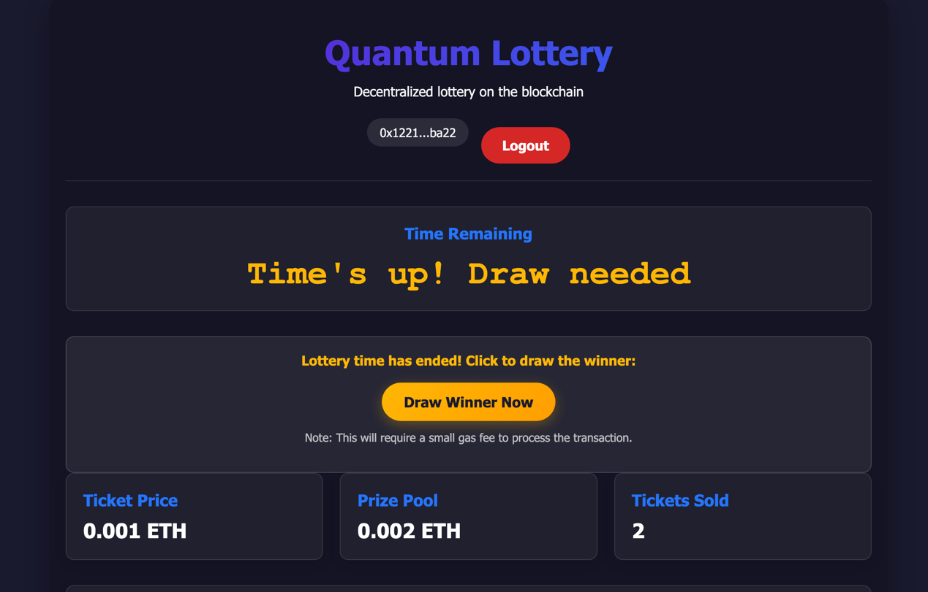

Figure 5: UI when time is up

Methods for testing
- Interact via Remix panel
- Interact via UI
- Validate internal transaction using Etherscan
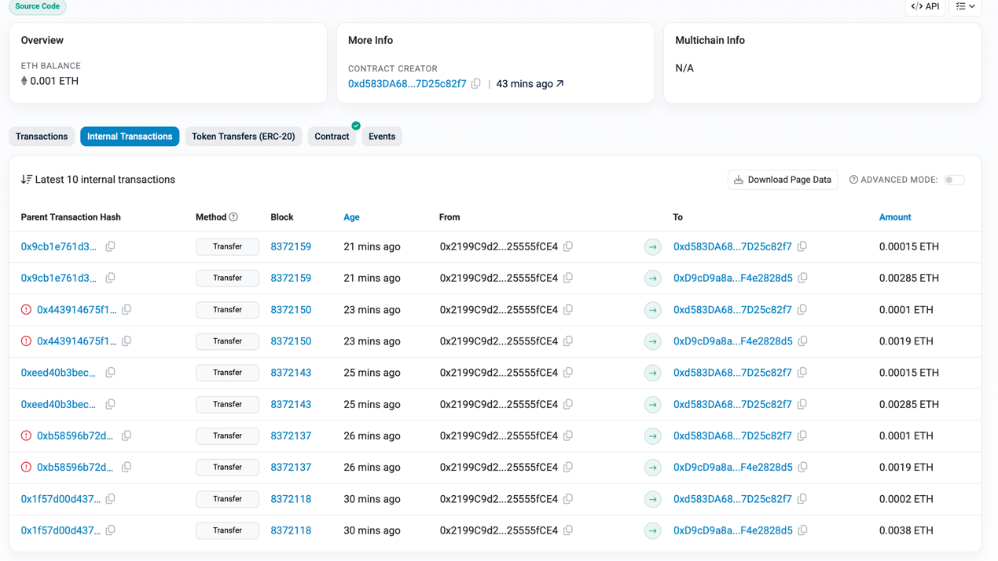
Figure 6 : Transaction Record to ensure the function is working (reward claiming)
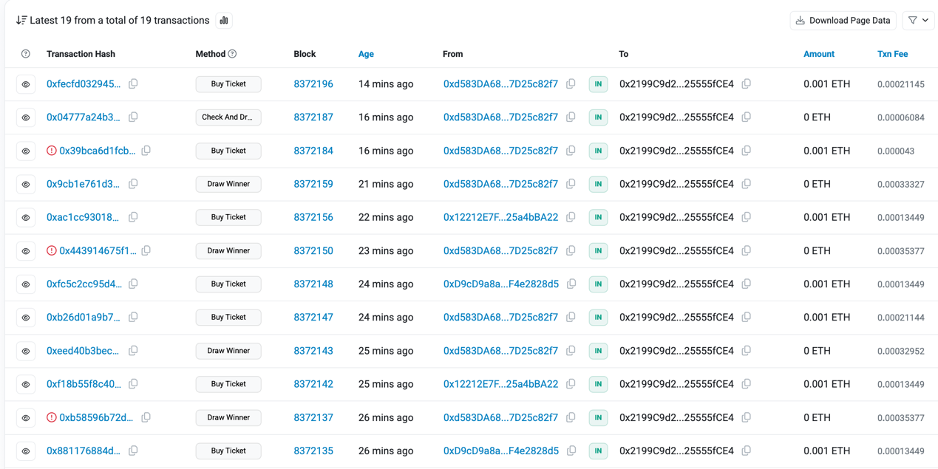
Figure 7: Record for calling function with admin count and non admin account to test account access

Conclusion
Developing the Quantum Lottery DApp has been an invaluable learning experience in blockchain development. Through this project, I gained practical skills in Solidity programming, security implementation, and front-end integration with blockchain technology. The challenges of creating secure randomness and implementing proper state management pushed me to research best practices and security patterns. Building a fully decentralized application that operates without central authority intervention helped me understand blockchain's true potential for creating trustless systems. This project demonstrated how carefully designed smart contracts can create transparent, fair applications while addressing traditional gambling systems' trust issues. The knowledge gained will serve as a foundation for my future blockchain development endeavors.

