FS Migration Validation Engine
Microsoft Founders Hub Application Pack
Technical Master Document

Version 2.0 — June 2026
Status: Ready for Review

Table of Contents
Phase 1 ............................................................ Azure Founders Hub Pack (Overview)
Phase 1.1 ............................................................ Product Overview
Phase 1.2 ............................................................ Technical Architecture
Phase 1.3 ............................................................ Platform Core Definition
Phase 1.4 ............................................................ Azure Cloud Architecture
Phase 1.5 ............................................................ Azure Reference Architecture Diagram
Phase 1.6 ............................................................ Azure Founders Hub Technical Narrative
Phase 2.1 ............................................................ Executive Pitch Narrative
Phase 2.2 ............................................................ Investor Pitch Deck
Phase 2.3 ............................................................ Market Analysis — TAM / SAM / SOM
Phase 2.4 ............................................................ Business Model & Pricing Strategy
Phase 2.5 ............................................................ Go-to-Market Strategy & Financial Projections
Phase 2.6 ............................................................ Financial Model & Funding Strategy
Phase 2.7 ............................................................ Competitive Differentiation
Phase 2.8 ............................................................ Product Roadmap
Phase 2.9 ............................................................ Investor FAQ
Phase 2.10 ............................................................ Demo Script

Phase 1 – Azure Founders Hub Pack (v4 Cloud-Ready Edition)
Version: 2.0
Based on: FS Migration Validation Engine v1.4
Target Program: Microsoft for Startups Founders Hub
Status: Ready for Review

Executive Summary
This pack presents the FS Migration Validation Engine — an automated, metadata-driven data migration validation platform purpose-built for regulated Financial Services institutions.
After extensive technical analysis (Parts 1–4) covering legacy system assessment, current architecture evaluation, gap analysis, and migration strategy, we have transitioned from research into productization. This documentation pack represents the complete technical, commercial, and strategic foundation for Microsoft Founders Hub application.

Product Positioning
**An Automated Data Migration Validation & Governance Platform for Regulated Financial Services.**
The platform is no longer just a data migration tool. It has evolved into an enterprise-grade Migration Assurance Platform that automates legacy system discovery, intelligent schema mapping, migration validation, governance, scoring, and compliance auditing for regulated financial data migrations.

The Five Platform Pillars
Pillar | Description | Status
1. Enterprise Discovery | Automated schema discovery, metadata extraction, dependency analysis | [OK] Built
2. Intelligent Mapping | Schema comparison, similarity matching, confidence scoring | [OK] Built
3. Migration Validation | 10 structured controls, rule execution, exception tracking | [OK] Built
4. Governance & Audit | Version control, audit history, compliance reporting, release gates | [OK] Built
5. AI Intelligence Layer | AI-assisted mapping recommendations, analytics, copilot (future) | 🔄 In Development

Document Inventory
# | Document | Audience | Purpose
1.1 | Product Overview | Microsoft reviewers, investors | Executive summary, problem/solution, value proposition
1.2 | Technical Architecture | Architecture reviewers, engineering | Platform architecture, components, data model
1.3 | Platform Core Definition | Architecture reviewers | Orchestration layer, event bus, plugin framework
1.4 | Azure Cloud Architecture | Microsoft reviewers, cloud architects | Azure service mapping, deployment, Well-Architected alignment
1.5 | Azure Reference Architecture Diagram | Technical reviewers | Visual architecture diagram, scalability, security boundaries
1.6 | Technical Narrative | Founders Hub, investors | Full narrative: problem, solution, why Azure, roadmap

Evidence Portfolio
All claims in this pack are backed by working code and technical analysis:
Evidence | Reference | Status
[OK] Legacy Assessment | Part 1 Analysis | Complete
[OK] Current Architecture Assessment | Part 3 Analysis | Complete
[OK] Migration Strategy | Part 4 Analysis | Complete
[OK] Working CLI Engine | `app/main.py` — 10 controls, scoring, audit | Complete
[OK] FastAPI Endpoints | `app/api/` — REST API layer | Complete
[OK] Database Schema | `sql/schema/` — PostgreSQL engine schema | Complete
[OK] Docker Deployment | `Dockerfile`, `docker-compose.yml` | Complete
[OK] Governance Framework | Release gates, control dependencies, audit export | Complete
[OK] Gap Analysis | Phase 1.3 NOT_REQUIRED doc | Complete
[OK] Security Scanning | `bandit-report.html`, `trivy-fs-report.txt` | Complete

Target Market
Primary: Financial Services — Banks (Tier 1–3), Insurers, Asset Managers, FinTech, Regulated Enterprises
Secondary: Any organisation undertaking regulated data migration (Healthcare, Government, Utilities)
The platform is designed for organisations where data integrity, compliance, and auditability during migration are non-negotiable requirements.

Program Alignment
This documentation pack is designed for:
- [OK] Microsoft for Startups Founders Hub — Primary target
- [OK] AWS Activate — Adaptable with minor cloud service mapping changes
- [OK] Google for Startups — Adaptable with minor cloud service mapping changes
- [OK] Investor Due Diligence — Angel, Seed, Series A
- [OK] Enterprise Customer Evaluations — Technical and commercial reviews

Key Differentiators
Feature | Our Platform | Manual Approach | Legacy ETL Tools
Automated schema discovery | [OK] Automated | [X] Manual analysis | [X] Requires pre-configuration
10 structured validation controls | [OK] Built-in | [X] Ad-hoc testing | [!]️ Partial
Confidence scoring | [OK] Automated | [X] Subjective | [X] Not available
Audit trail & governance | [OK] Built-in | [X] Manual documentation | [!]️ Limited
Release gate enforcement | [OK] Automated | [X] Manual approval | [X] Not available
Control dependency management | [OK] Built-in | [X] Manual sequencing | [X] Not available
Docker deployment | [OK] Ready | N/A | [!]️ Legacy installs
Financial Services focus | [OK] Purpose-built | [X] Generic | [X] Generic

Next Steps
Following this master overview, review the documents in order:
- Phase 1.1 — Product Overview (non-technical executive summary)
- Phase 1.2 — Technical Architecture (engineering deep-dive)
- Phase 1.3 — Platform Core Definition (orchestration architecture)
- Phase 1.4 — Azure Cloud Architecture (cloud-native migration plan)
- Phase 1.5 — Azure Reference Architecture Diagram (visual architecture)
- Phase 1.6 — Technical Narrative (complete Founders Hub narrative)
- Phase 2.1–2.10 — Commercial & Investor Readiness Package
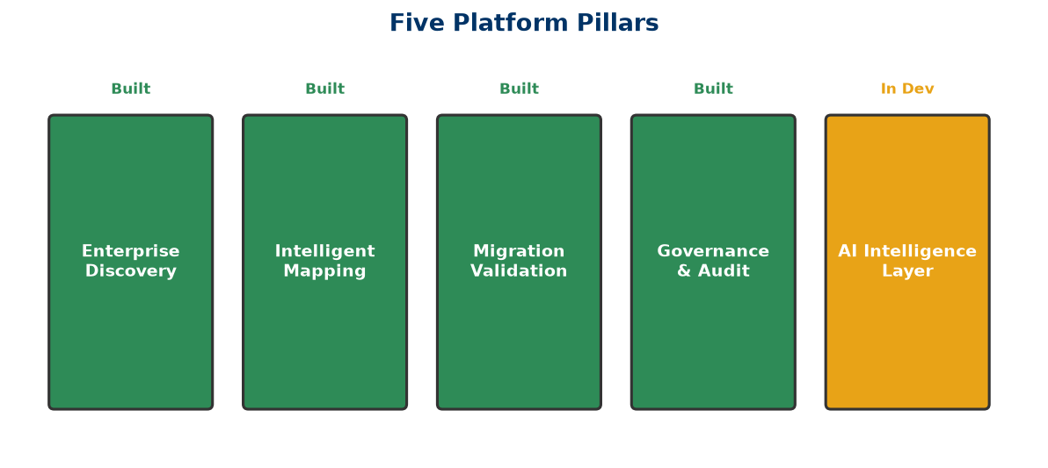
Five Pillars

Phase 1.1 — Product Overview
Version: 2.0
Product: FS Migration Validation Engine
Target: Microsoft for Startups Founders Hub
Audience: Non-technical reviewers, investors, enterprise customers

Executive Summary
Financial Services institutions undertaking data migration projects face a fundamental challenge: how to ensure that millions of records move from legacy systems to modern platforms accurately, completely, and in compliance with regulatory requirements.
Traditional approaches rely on manual sampling, ad-hoc spreadsheet tracking, and post-migration firefighting. This is slow, error-prone, and unacceptable in regulated environments where data integrity failures can trigger regulatory penalties, operational losses, and reputational damage.
The FS Migration Validation Engine solves this by providing an automated, metadata-driven validation platform that systematically verifies every aspect of a data migration — from schema compatibility and data type correctness through to referential integrity, business rule compliance, and regulatory reporting accuracy.

The Problem
Data migration in Financial Services is high-risk and highly regulated:
Challenge | Impact
Manual validation | ~60% of validation effort is manual and subjective
Incomplete coverage | Sampling-based checks miss edge cases and exceptions
Poor auditability | Spreadsheet-driven tracking fails regulatory scrutiny
No repeatability | Every migration project starts from scratch
High cost of failure | Data errors can cause operational losses, regulatory fines
Lack of governance | No formal release gates, approval workflows, or sign-off trails

Banks migrating core banking systems, payment platforms, or regulatory reporting systems cannot afford data quality failures. Yet most migration validation today relies on custom scripts, manual checks, and hope.

Our Solution
The FS Migration Validation Engine is an automated, metadata-driven validation and governance platform that:
- Discovers legacy and target system schemas automatically
- Validates data across 10 structured migration controls
- Scores migration quality with objective, repeatable metrics
- Governs the migration lifecycle with release gates and audit trails
- Reports comprehensive audit evidence suitable for regulatory review

How It Works
Legacy System ──→ Discovery ──→ Validation Controls ──→ Scoring ──→ Audit Report
│
Release Gate Review
│
Migration Approved / Blocked

The platform runs as a CLI engine, REST API, or Docker container — integrating into existing CI/CD pipelines and deployment workflows.

Platform Capabilities

1. Automated Discovery
- Connect to source and target databases
- Discover schemas, tables, columns, and relationships
- Extract metadata for validation planning
- Identify schema differences automatically

2. Structured Validation Controls (C01–C010)
Control | Description
C01 | Row count reconciliation
C02 | Column-level data type validation
C03 | Nullability constraint verification
C04 | Primary key integrity check
C05 | Foreign key referential integrity
C06 | Business rule validation
C07 | Date/time boundary validation
C08 | Numeric range and precision checks
C09 | String pattern and format validation
C010 | Regulatory field completeness check

3. Scoring & Release Gates
- Each control receives an objective pass/fail score
- Aggregate scoring provides migration quality metrics
- Configurable release gates block migrations below minimum quality thresholds
- Dependency management ensures controls execute in correct order

4. Governance & Audit
- Every control execution is logged with timestamp and result
- Audit-ready CSV exports for regulatory review
- Batch-level tracking with unique batch IDs
- Exception register for all validation failures
- Full execution history for compliance reporting

5. REST API
- FastAPI-based RESTful interface
- Run validations programmatically
- Integrate with CI/CD pipelines
- Query results and export audits remotely

Business Benefits
Benefit | Measurable Impact
Reduced manual effort | 70-80% reduction in manual validation work
Complete coverage | 100% of records validated, not just samples
Regulatory compliance | Audit-ready evidence for every migration
Repeatable process | Standardised validation across all migration projects
Faster migrations | Automated gates replace manual review cycles
Lower risk | Early detection of data quality issues
Governance by design | Release gates prevent bad data reaching production

Current Development Status
Component | Status
CLI Engine (10 controls, scoring, audit) | [OK] Production-ready
REST API layer | [OK] Built (FastAPI)
Database schema (PostgreSQL) | [OK] Production-ready
Docker deployment | [OK] Ready
Control dependency DAG | [OK] Implemented
Release gate enforcement | [OK] Implemented
Audit export (CSV) | [OK] Implemented
Security scanning (bandit, trivy) | [OK] Integrated
Web dashboard | 🔄 In development
AI-assisted mapping recommendations | 🔄 Planned
Multi-tenant SaaS deployment | 🔄 Planned

Why Azure
Microsoft Azure provides the enterprise-grade foundation required for regulated Financial Services deployments:
- Azure Container Apps — Scalable, serverless compute for the validation engine
- Azure SQL Database — Managed relational database with high availability
- Azure Blob Storage — Secure audit report and evidence storage
- Azure Key Vault — Encrypted secrets management for database credentials
- Microsoft Entra ID — Enterprise identity and role-based access control
- Azure Monitor — Centralised logging and performance monitoring
- Azure API Management — Secure API gateway for enterprise integration
The platform is designed to be Azure-native while supporting hybrid and on-premises deployment for customers with specific regulatory requirements.

Product Vision
Our vision is to become the standard platform for regulated data migration assurance — providing Financial Services institutions with the automation, governance, and auditability they need to migrate mission-critical data with confidence.
Future capabilities include:
- AI-assisted mapping recommendations — Using schema analysis to suggest optimal field mappings
- Intelligent mapping engine — Automated schema matching with confidence scoring
- Interactive dashboards — Real-time migration quality visualisation
- Multi-cloud support — Extend validation to AWS, GCP, and hybrid deployments
- Regulatory template library — Pre-built controls for specific regulations (Basel, SOX, FCA, PRA)

Competitive Advantages
Area | Our Advantage
Purpose-built | Designed specifically for regulated Financial Services data migration
10 structured controls | Comprehensive validation framework, not a generic ETL tool
Governance-first | Release gates, audit trails, and compliance built into every execution
Automated scoring | Objective, repeatable quality metrics — not subjective assessments
Docker-native | Deploy anywhere — cloud, on-premises, hybrid
API-first | Integrate with existing CI/CD and deployment pipelines
Open, extensible | Python-based, open architecture, easily customisable controls

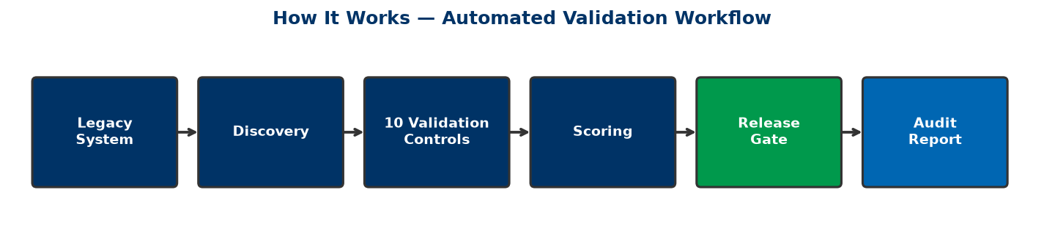
How It Works

Phase 1.2 — Technical Architecture
Version: 2.0
Product: FS Migration Validation Engine
Status: Architecture Baseline
Audience: Microsoft Founders Hub, Technical Reviewers, Engineering Team

1. Introduction
The FS Migration Validation Engine is an automated, metadata-driven data migration validation and governance platform designed for regulated Financial Services environments. It validates data migrations across core banking, payments, lending, asset management, and regulatory reporting systems.
The platform is architected as a modular, cloud-ready solution with a centralised orchestration layer (Platform Core) that coordinates independent domain engines responsible for discovery, validation, scoring, and governance.

2. Architectural Principles
Principle | Description
Modularity | Independent engines communicate through the Platform Core
Metadata-driven | All validation is driven by database schema metadata
Security-by-design | Zero Trust, encryption at rest and in transit, secrets isolation
Governance-first | Release gates, audit trails, and compliance built into every execution
Extensibility | Plugin-based engine architecture for adding new controls
Cloud-native | Designed for Azure, deployable anywhere with Docker
Observability | Comprehensive logging, metrics, and audit trails
Repeatability | Deterministic validation — same inputs produce same outputs

3. High-Level Architecture
Users / CLI / API
│
┌──────┴──────┐
│ API Layer │
│ (FastAPI) │
└──────┬──────┘
│
┌──────┴──────┐
│ Platform │
│ Core │
│ (Orchestrator)│
└──────┬──────┘
│
┌─────────────────┼─────────────────┐
│ │ │
┌─────┴─────┐ ┌──────┴──────┐ ┌──────┴──────┐
│ Discovery │ │ Validation │ │ Scoring │
│ Engine │ │ Engine │ │ Engine │
└─────┬─────┘ └──────┬──────┘ └──────┬──────┘
│ │ │
└─────────────────┼─────────────────┘
│
┌──────┴──────┐
│ Governance │
│ Engine │
└──────┬──────┘
│
┌──────┴──────┐
│ Database │
│ (PostgreSQL)│
└─────────────┘

4. Core Platform Components

4.1 Platform Core
The central orchestration layer responsible for:
- Workflow orchestration — Controlling execution sequence of discovery, validation, scoring
- Control dependency management — DAG-based execution (C02 depends on C01, C09 depends on C03)
- State management — Tracking batch execution state, checkpointing
- Configuration management — Centralised config for all engines
- Security enforcement — Authentication, authorisation, audit logging
- Event routing — Emitting and consuming events between engines
- Error handling — Failure isolation, retry logic, graceful degradation

4.2 Discovery Engine
Responsible for automated schema discovery from source and target databases.
Capabilities:
- Database connection management via app/db_connector.py
- Schema discovery — tables, columns, data types, constraints
- Metadata extraction and repository population
- Relationship detection (primary keys, foreign keys)
Output: Metadata repository in the engine database.

4.3 Validation Engine
The core validation component executing 10 structured migration controls.
Validation Controls (C01–C010):
Control | Description | SQL Template
C01 | Row count reconciliation | `sql/controls/`
C02 | Column-level data type validation | `sql/controls/`
C03 | Nullability constraint verification | `sql/controls/`
C04 | Primary key integrity check | `sql/controls/`
C05 | Foreign key referential integrity | `sql/controls/`
C06 | Business rule validation | `sql/controls/`
C07 | Date/time boundary validation | `sql/controls/`
C08 | Numeric range and precision checks | `sql/controls/`
C09 | String pattern and format validation | `sql/controls/`
C010 | Regulatory field completeness check | `sql/controls/`

Controls are implemented as SQL templates executed against source and target databases, with results stored in the engine database.

4.4 Scoring Engine
Responsible for evaluating validation results and producing quality metrics.
Capabilities:
- Control-level pass/fail determination
- Aggregate scoring across all controls
- Configurable pass thresholds
- Weighted scoring by control criticality
- Exception register management

4.5 Governance Engine
Provides enterprise governance across the migration lifecycle.
Capabilities:
- Release gate enforcement — blocks migration if score below threshold
- Batch-level tracking with unique batch IDs
- Audit trail — every execution logged with timestamp and result
- Exception register — all validation failures recorded
- CSV audit export for regulatory review

5. Data Architecture

5.1 Engine Database (PostgreSQL)
The engine database stores all operational data:
Entity | Description
`migration_validation_batch` | Batch-level execution tracking
`migration_control_execution` | Individual control execution results
`migration_exception_register` | All validation exceptions
Source/target metadata | Discovered schema information

See sql/schema/01_engine_schema.sql for full schema definition.

5.2 Source & Target Databases
The platform connects to source and target PostgreSQL databases to perform validation. The connector layer (app/db_connector.py) manages connections and handles credential security through environment variables and Azure Key Vault.

6. Security Architecture
Layer | Implementation
Identity | Environment-based authentication, future: Microsoft Entra ID
Secrets | Environment variables → Azure Key Vault migration path
Encryption at rest | PostgreSQL TDE / Azure SQL transparent encryption
Encryption in transit | TLS for all database connections
API security | FastAPI with CORS, future: OAuth2 / Entra ID
Secrets isolation | No credentials in source code — all via environment variables
Audit logging | Every control execution logged with batch ID and timestamp

7. Integration Architecture

7.1 CLI Interface
python app/main.py run --config config.yaml
python app/main.py discover --config config.yaml
python app/main.py export --config config.yaml --batch-id <id>

7.2 REST API (FastAPI)
- GET /health — Health check
- POST /api/v1/validate — Run validation batch
- GET /api/v1/batch/{id} — Get batch results
- GET /api/v1/export/{batch_id} — Export audit CSV

7.3 Docker Deployment
- docker-compose up --build — Full stack deployment
- Containerised engine, database, and API

8. Deployment Architecture
Environment | Deployment Model | Database
Development | Local Docker Compose | Local PostgreSQL
Test/QA | Azure Container Apps | Azure SQL Database
Production | Azure Container Apps / AKS | Azure SQL Database
On-premises | Docker Compose | PostgreSQL

9. Current Implementation Status
Component | Status | Location
CLI Engine | [OK] Production-ready | `app/main.py`, `app/execution_engine.py`
10 Validation Controls | [OK] Implemented | `sql/controls/`
Scoring Engine | [OK] Implemented | `app/scoring_engine.py`
Governance / Release Gates | [OK] Implemented | `config.yaml`, `app/execution_engine.py`
Audit Export | [OK] Implemented | `app/audit_export.py`
Database Schema | [OK] Production-ready | `sql/schema/`
Docker Deployment | [OK] Ready | `Dockerfile`, `docker-compose.yml`
REST API | [OK] Built | `app/api/`
Discovery Service | [OK] Built | `app/services/dataset_discovery_service.py`
Rule Executor | [OK] Built | `app/rule_executor.py`, `app/rule_factory.py`
Web Dashboard | 🔄 In Development | `dashboard/`
AI Mapping Engine | 🔄 Planned | `app/mapping_engine/`
Multi-tenant SaaS | 🔄 Planned | Future phase

10. Technology Stack
Layer | Technology
Language | Python 3.11
API Framework | FastAPI, Uvicorn
Database | PostgreSQL 15+
Containerisation | Docker, Docker Compose
Configuration | YAML + Environment Variables
Validation | SQL-driven control templates
Reporting | CSV export (future: interactive dashboards)
Security | python-jose, cryptography
Testing | pytest

11. Scalability
The architecture supports horizontal scaling through:
- Stateless API — FastAPI instances can be scaled horizontally
- Independent engine scaling — Each engine can scale independently
- Database connections — Connection pooling via PostgreSQL
- Container orchestration — Kubernetes-ready (Docker images)
- Async processing — Future: background task queues for large batches

12. Future Architecture Evolution
Current: Future:
┌──────────┐ ┌──────────┐
│ CLI + │ │ Web UI │
│ API │ │ + API │
├──────────┤ ├──────────┤
│ Platform │ │ Platform │
│ Core │ │ Core │
├──────────┤ ├──────────┤
│ Validation│ │ Discovery│
│ Controls │ │ Mapping │
│ │ │ Validation│
│ │ │ Scoring │
│ │ │ AI │
│ │ │ Governance│
└──────────┘ └──────────┘

The modular Platform Core architecture ensures that new engines can be added without architectural redesign. The AI Intelligence Layer (Azure OpenAI) can be integrated as an additional engine providing mapping recommendations, anomaly detection, and natural language querying.
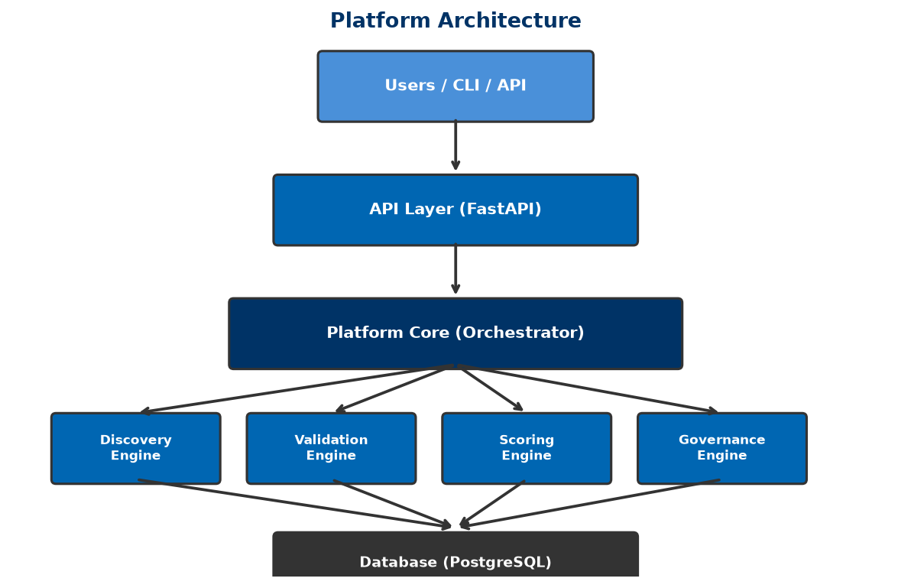
Platform Architecture
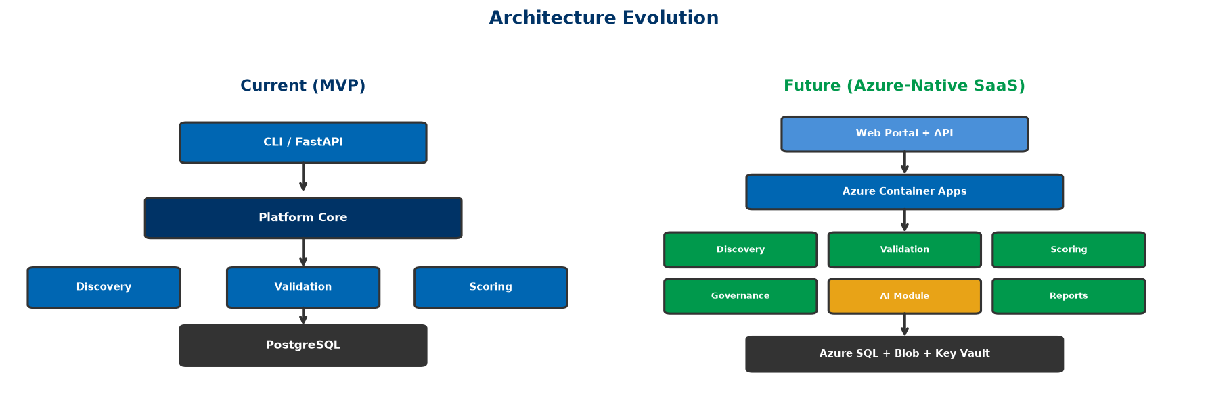
Architecture Evolution

Phase 1.3 — Platform Core Definition
Version: 2.0
Status: Architecture Baseline
Audience: Engineering, Architecture, Founders Hub Technical Reviewers

Platform Core

Executive Summary
The Platform Core is the central orchestration layer of the FS Migration Validation Engine. Rather than allowing each engine to communicate directly with every other engine, the Platform Core acts as the single coordination point responsible for workflow orchestration, state management, event routing, security enforcement, configuration management, and engine lifecycle management.
This architecture dramatically reduces coupling between components while improving scalability, maintainability, security, and extensibility.

Why the Platform Core Exists
Without a Platform Core:
Discovery ↔ Validation ↔ Scoring ↔ Governance ↔ Export

Every engine develops dependencies on every other engine, creating duplicated logic, inconsistent state, difficult testing, tight coupling, and deployment challenges.
With a Platform Core:
Users / CLI / API
│
Platform Core
│
┌───────┬───────┼───────┬───────┐
│ │ │ │ │
Discovery Validation Scoring Governance Export

Each engine communicates only with the Platform Core. No engine requires knowledge of another engine's internal implementation.

Core Responsibilities

1. Workflow Orchestration
Coordinates execution between engines in the correct sequence:
Discovery → Platform Core → Validation → Platform Core → Scoring → Platform Core → Governance → Platform Core → Export

The engines remain independent. The Platform Core determines execution order.

2. Control Dependency Management
Manages the Directed Acyclic Graph (DAG) of control dependencies:
C01
│
└──→ C02
│
└──→ C03 → C09
│
└──→ C04 → C05 → C06 → C07 → C08 → C010

Dependencies are defined in config.yaml:
control_dependencies:
C02: [C01]
C09: [C03]

3. Engine Registry
Maintains metadata for every registered engine:
Engine | Status | Version | Capabilities
Discovery | Healthy | 1.0 | Schema discovery, metadata extraction
Validation | Healthy | 1.0 | 10 structured controls (C01-C010)
Scoring | Healthy | 1.0 | Pass/fail, aggregate scoring
Governance | Healthy | 1.0 | Release gates, audit, export

4. State Management
The Platform Core owns workflow state:
Pipeline Status: Running
├── Discovery: Complete (passed 100%)
├── Validation: Running (5/10 controls complete)
├── Scoring: Pending
└── Governance: Pending

This provides restart capability, checkpointing, resilience, and recovery.

5. Configuration Service
Central configuration management via config.yaml:
execution:
environment: DEV
client_name: DemoBank
control_id: null # null = run all controls

release_gate:
enabled: true
block_on_status: ["FAIL", "BLOCKED", "ERROR"]
minimum_score: 80
enforcement_mode: "STRICT"

rules:
C01: enabled
C02: enabled
# ... through to C010

Every engine reads configuration from one location — the Platform Core.

6. Security Enforcement
The Platform Core validates every request:
- Authentication (API keys, environment-based)
- Authorisation (role-based execution permissions)
- Audit logging (every action logged with batch ID and timestamp)
- Secrets isolation (credentials via environment variables, not code)
- Configuration validation (pre-execution checks)

7. Error Handling & Failure Isolation
- Control-level isolation — A failure in C01 does not block C03
- Graceful degradation — Non-critical failures logged, execution continues
- Retry logic — Configurable timeout per control (default: 300 seconds)
- Exception register — All failures recorded for audit
- Recovery mode — Re-run only failed controls from previous batch

8. Observability
Provides a single operational view:
Metric | Source
Engine execution time | Platform Core timing
Control pass/fail rates | Scoring engine results
Batch duration | Workflow start/end timestamps
Exception counts | Exception register
API latency | FastAPI middleware

Interaction Model
User / CLI
│
▼
API Gateway (FastAPI)
│
▼
Authentication
│
▼
Platform Core
│
├──→ Workflow Manager
│ │
│ ├──→ Discovery Engine
│ │ │
│ │ └──→ Platform Core (event)
│ │
│ ├──→ Validation Engine
│ │ │
│ │ ├──→ Control C01
│ │ ├──→ Control C02
│ │ ├──→ ...
│ │ └──→ Control C010
│ │ │
│ │ └──→ Platform Core (event)
│ │
│ ├──→ Scoring Engine
│ │ │
│ │ └──→ Platform Core (event)
│ │
│ ├──→ Governance Engine
│ │ │
│ │ ├──→ Release Gate Check
│ │ │
│ │ └──→ Platform Core (event)
│ │
│ └──→ Export Engine
│ │
│ └──→ Audit CSV
│
▼
Response (pass/fail, score, exceptions, audit)

No engine communicates directly with another. All coordination passes through the Platform Core.

Current Implementation
The Platform Core is implemented in app/execution_engine.py:
class ExecutionEngine:
def __init__(self, config, batch_id=None):
self.config = config
self.batch_id = batch_id or str(uuid.uuid4())
self.recovery_mode = False

def run(self):
# 1. Initialise batch in database
# 2. Resolve control execution order (DAG)
# 3. Execute each control in dependency order
# 4. Score results
# 5. Apply release gates
# 6. Export audit trail

Key files:
- app/execution_engine.py — Core orchestrator
- app/rule_executor.py — Individual control execution
- app/rule_factory.py — Control instantiation from config
- app/scoring_engine.py — Scoring logic
- app/audit_export.py — CSV audit export
- config.yaml — Centralised configuration
- app/db_connector.py — Database connectivity

Azure Alignment
The Platform Core maps naturally to Azure services:
Platform Core Function | Azure Service
Compute / Hosting | Azure Container Apps
API Gateway | Azure API Management
Identity | Microsoft Entra ID
Secrets | Azure Key Vault
Monitoring | Azure Monitor / Application Insights
Database | Azure SQL Database / PostgreSQL Flexible Server
Storage | Azure Blob Storage
CI/CD | GitHub Actions / Azure DevOps
Infrastructure | Bicep / ARM Templates

Architectural Principles
- Loose coupling — Engines communicate only through the Platform Core
- High cohesion — Each engine has a single, well-defined responsibility
- Deterministic execution — Same inputs produce same outputs
- Stateless engines — State managed by Platform Core
- Centralised governance — Release gates, audit, and compliance enforced centrally
- Cloud-native — Designed for Azure, deployable anywhere
- Extensibility — New engines can be added without modifying existing ones
- Security-by-design — Authentication, authorisation, and audit built into the core
- Failure isolation — One control failure does not cascade
- Observability-by-default — Every execution produces audit evidence

Benefits

Technical
- Reduced coupling between components
- Easier maintenance and testing
- Independent engine evolution
- Simplified debugging (single coordination point)
- Improved resilience and recovery

Operational
- Centralised monitoring and alerting
- Consistent configuration management
- Unified security enforcement
- Simplified deployment model
- Faster troubleshooting

Business
- Faster feature delivery (add engines without redesign)
- Lower maintenance costs
- Easier partner integration
- Enterprise-grade governance built-in
- Clear Azure alignment for cloud migration
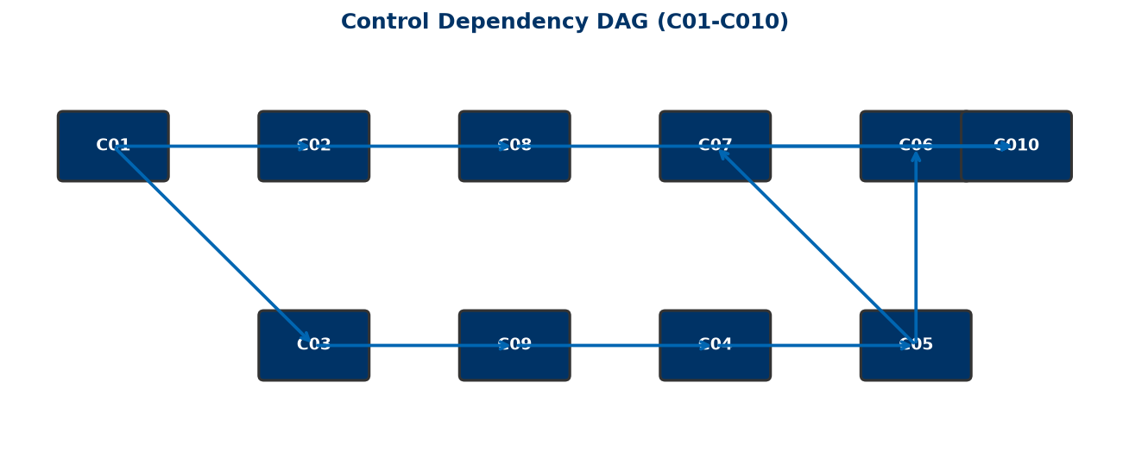
Control Dag

Phase 1.4 — Azure Cloud Architecture
Version: 2.0
Product: FS Migration Validation Engine
Status: Founders Hub Ready
Audience: Microsoft Reviewers, Cloud Architects, Engineering Team

Executive Summary
The FS Migration Validation Engine is designed as an Azure-native, cloud-first SaaS solution built on Microsoft's Well-Architected Framework. It leverages managed Azure services to maximise scalability, security, reliability, and operational efficiency for regulated Financial Services data migration validation.
The architecture follows a Platform Core + microservices model where independent domain engines (Discovery, Validation, Scoring, Governance) are orchestrated through a central coordination layer. The solution is cloud-portable while taking full advantage of Azure's managed services ecosystem.

High-Level Architecture
Users / CLI / DevOps
│
┌─────────────┴─────────────┐
│ │
Web Portal REST API
(Future) (FastAPI)
│ │
└─────────────┬─────────────┘
│
Azure Front Door (Optional)
│
Azure API Management
│
Microsoft Entra ID (Future)
│
Platform Core
│
┌──────────┬──────────┼──────────┬──────────┐
│ │ │ │ │
Discovery Validation Scoring Governance Reports
Engine Engine Engine Engine Engine
│ │ │ │ │
└──────────┴──────────┼──────────┴──────────┘
│
Azure SQL / PostgreSQL
│
Azure Blob Storage

Core Azure Services

Azure Container Apps (Recommended MVP)
The primary compute platform for the validation engine.
Advantages:
- Serverless container hosting
- Automatic scaling based on validation workload
- Minimal operational overhead
- Cost-efficient consumption pricing
- Native Dapr support for future microservices
- Fast deployment from Docker images
Migration path: Azure Kubernetes Service (AKS) for enterprise-scale deployments.

Azure API Management
Secure gateway for all API interactions.
Responsibilities:
- API gateway for REST endpoints
- Rate limiting and throttling
- API versioning
- Authentication enforcement (future: OAuth2 / Entra ID)
- Request validation
- Usage analytics
- Developer portal for integration documentation

Microsoft Entra ID (Future Integration)
Identity and access management for enterprise deployments.
Capabilities:
- Single Sign-On (SSO)
- OAuth2 / OpenID Connect
- Role-Based Access Control (RBAC)
- Multi-Factor Authentication (MFA)
- Conditional Access policies
- Enterprise identity federation

Azure SQL Database / PostgreSQL Flexible Server
Primary data store for the validation engine.
Stores:
- Migration batch records
- Control execution results
- Exception register
- Audit trail
- Configuration metadata
- Customer and project data (future)
Benefits:
- Managed service with automated backups
- High availability with zone redundancy
- Built-in threat detection (Defender for Cloud)
- Encryption at rest and in transit

Azure Blob Storage
Secure storage for audit artifacts and exports.
Stores:
- Audit CSV exports
- Validation reports
- Uploaded schema definitions
- Log archives
- Backup snapshots
Benefits:
- Cost-effective tiered storage
- Lifecycle management policies
- Immutable storage for compliance
- Geo-redundant replication

Azure Key Vault
Centralised secrets management.
Stores:
- Database connection strings
- API keys
- Certificates
- Encryption keys
- Environment credentials
Security:
- No secrets in source code or configuration files
- Managed identities for service-to-service authentication
- Access policies with least privilege
- Audit logging for all secret access

Azure Monitor & Application Insights
Comprehensive observability.
Captures:
- Infrastructure metrics (CPU, memory, network)
- API response times and error rates
- Control execution duration
- Batch processing performance
- Exception tracking
- Distributed tracing across microservices
- Custom dashboards and alerts

GitHub Actions / Azure DevOps
CI/CD pipeline automation.
Pipeline stages:
Commit → Build → Unit Tests → Security Scan → Container Build → Deploy to Test → Integration Tests → Deploy to Production

Infrastructure as Code:
- Bicep / ARM Templates for Azure resource provisioning
- Version-controlled infrastructure definitions
- Reproducible deployments across environments

Networking Architecture
Internet
│
▼
Azure Front Door (Optional)
│
▼
Azure API Management
│
▼
Virtual Network
│
├── Azure Container Apps (Private Endpoints)
├── Azure SQL Database (Private Endpoint)
├── Azure Key Vault (Private Endpoint)
└── Azure Blob Storage (Private Endpoint)

Security features:
- Private networking for all data services
- Network Security Groups (NSGs)
- DDoS protection
- TLS 1.2+ for all communications
- Managed certificates via Azure Key Vault
- Service endpoints / Private Link for PaaS services

Security Architecture
The platform follows a Zero Trust security model:
Security Layer | Implementation
Identity | Microsoft Entra ID + RBAC (future)
Authentication | API keys → OAuth2 / Entra ID (migration path)
Secrets | Azure Key Vault, no secrets in code
Network | Private endpoints, TLS, NSGs
Data at rest | Azure SQL TDE, Blob encryption
Data in transit | TLS 1.2+ for all connections
Monitoring | Defender for Cloud, Sentinel (enterprise)
Auditing | Full audit trail for every execution

Deployment Environments
Environment | Compute | Database | Purpose
Development | Local Docker | Local PostgreSQL | Local development and testing
Test/QA | Azure Container Apps | Azure SQL (shared) | Automated testing, CI/CD
Staging | Azure Container Apps | Azure SQL (isolated) | Pre-production validation
Production | Azure Container Apps (MVP) → AKS (scale) | Azure SQL (HA) | Customer deployments

Scalability Strategy
Each engine scales independently based on workload:
Engine | Scale Trigger
API Layer | Concurrent API requests
Validation Engine | Number of controls × batch size
Scoring Engine | Post-validation scoring requests
Audit Export | Export request volume

Autoscaling is managed by Azure Container Apps using:
- CPU utilisation thresholds
- Memory utilisation thresholds
- HTTP request queue depth
- Custom scaling rules (future)

High Availability
Azure services provide enterprise-grade availability:
- Zone-redundant deployment (Azure Container Apps)
- Active geo-replication (Azure SQL Database)
- Automatic failover with managed services
- Automated backups with point-in-time restore
- Health probes for container instances
- Rolling updates for zero-downtime deployments

Azure Well-Architected Framework Alignment

Reliability
- Managed Azure services with built-in redundancy
- Automated health monitoring and recovery
- Fault-tolerant architecture (failure isolation per control)
- Automated backups and point-in-time restore

Security
- Zero Trust architecture
- Microsoft Entra ID + Azure Key Vault
- Private endpoints for data services
- Defender for Cloud continuous assessment
- Full audit trail for compliance

Cost Optimisation
- Consumption-based pricing (Azure Container Apps)
- Autoscaling to match workload demand
- Managed PaaS services reduce operational overhead
- Blob storage lifecycle policies for cost-effective archiving
- Right-sizing through Azure Advisor recommendations

Operational Excellence
- CI/CD with GitHub Actions / Azure DevOps
- Infrastructure as Code (Bicep / ARM)
- Centralised monitoring (Azure Monitor)
- Automated deployments with quality gates
- Comprehensive audit logging

Performance Efficiency
- Stateless API design for horizontal scaling
- Independent engine scaling
- Connection pooling for database efficiency
- Background processing for long-running validations
- Caching strategies for metadata (future)

Azure Service Mapping
Platform Capability | Azure Service
Compute (MVP) | Azure Container Apps
Compute (Enterprise) | Azure Kubernetes Service (AKS)
API Gateway | Azure API Management
Global Routing | Azure Front Door
Identity | Microsoft Entra ID
Primary Database | Azure SQL Database / PostgreSQL Flexible Server
Secrets Management | Azure Key Vault
Object Storage | Azure Blob Storage
Monitoring | Azure Monitor
Application Telemetry | Application Insights
Security Posture | Microsoft Defender for Cloud
CI/CD | GitHub Actions / Azure DevOps
Infrastructure as Code | Bicep / ARM Templates

Future Azure Services
Phase | Service | Purpose
Phase 2 | Azure OpenAI Service | AI-assisted mapping recommendations
Phase 2 | Azure Service Bus | Async event processing for large batches
Phase 3 | Azure Cosmos DB | Global-scale metadata storage
Phase 3 | Azure Cognitive Search | Semantic search across mappings
Phase 3 | Power BI | Interactive dashboards and reporting
Phase 4 | Microsoft Fabric | Enterprise data integration

Cost Model (Projected)
Service | Estimated Monthly Cost (MVP)
Azure Container Apps | $200–500
Azure SQL Database (Basic) | $150–300
Azure Blob Storage | $50–100
Azure API Management | $100–200
Azure Key Vault | $10–20
Azure Monitor | $50–100
Total (MVP) | $560–1,220/month

Costs scale linearly with customer adoption. Enterprise deployments with AKS and HA configurations range from $2,000–5,000/month.

Conclusion
This Azure-native architecture provides a secure, scalable, and cost-effective foundation for the FS Migration Validation Engine. By combining a centralised Platform Core with independently deployable microservices and managed Azure services, the platform minimises operational overhead while maximising resilience, extensibility, and enterprise readiness for regulated Financial Services environments.
The design supports rapid MVP deployment through Azure Container Apps while providing a clear migration path to Azure Kubernetes Service for large-scale enterprise deployments. It establishes a robust foundation for future AI capabilities, multi-tenant SaaS operations, and a growing ecosystem of platform integrations.
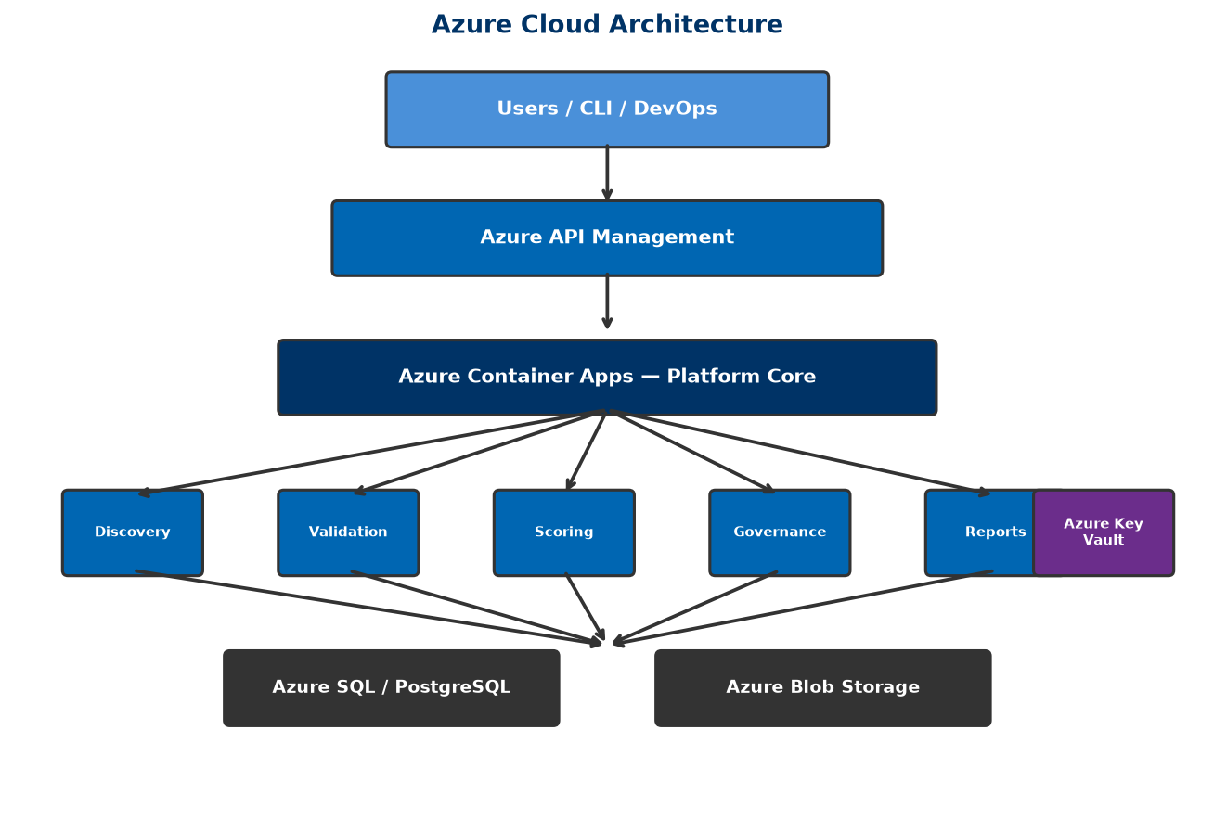
Azure Architecture
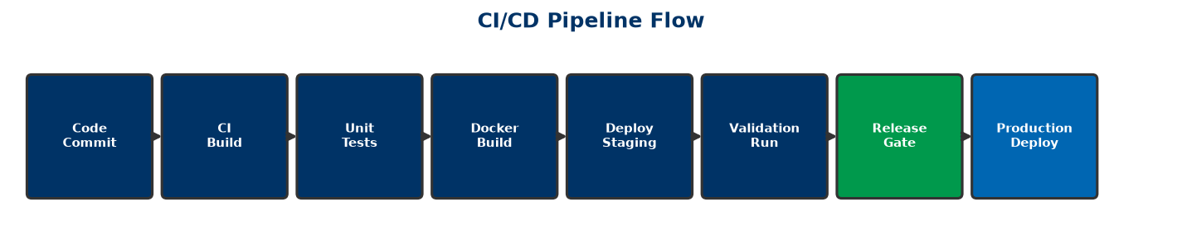
Cicd Pipeline

Phase 1.5 — Azure Reference Architecture Diagram
Version: 2.0
Architecture Style: Azure-Native • Microservices • Event-Driven • Financial Services Grade
Product: FS Migration Validation Engine

Azure Reference Architecture
┌──────────────────────────────────┐
│ USERS / CLI │
│ Developers • DevOps • Auditors │
└──────────────┬───────────────────┘
│
HTTPS / REST API / OAuth2
│
┌──────────────────────────────────────────────────────────┐
│ Azure Front Door (Optional) │
│ Global Routing • WAF • DDoS • SSL Offload │
└──────────────────────────┬───────────────────────────────┘
│
┌──────────────────────────────┐
│ Azure API Management │
│ API Gateway • Rate Limits │
│ Versioning • Policies │
└──────────────┬───────────────┘
│
┌──────────────────────────────┐
│ Microsoft Entra ID │
│ OAuth2 • SSO • MFA • RBAC │
└──────────────┬───────────────┘
│
────────────────────────────────────────────────────────────────────────────────────
PLATFORM CORE (Azure Container Apps)
────────────────────────────────────────────────────────────────────────────────────

┌─────────────────────────────────────┐
│ Platform Core API │
│-------------------------------------│
│ Workflow Orchestration │
│ Control Dependency (DAG) Manager │
│ Configuration Service │
│ Security Enforcement │
│ State Management │
│ Audit Routing │
└──────────────┬──────────────────────┘
│
┌────────────────────────────────┼────────────────────────────────┐
│ │ │
│ │ │
┌──────────────────┐ ┌──────────────────┐ ┌──────────────────┐
│ Discovery Engine │ │ Validation Engine│ │ Scoring Engine │
│ Schema Discovery │ │ C01 - C010 │ │ Pass/Fail Scoring│
│ Metadata Extract │ │ SQL Controls │ │ Aggregate Metrics│
└─────────┬────────┘ └─────────┬────────┘ └─────────┬────────┘
│ │ │
└────────────────────┬────────┴───────────┬─────────────────────┘
│ │
┌──────────────────┐ ┌──────────────────┐
│ Governance Engine│ │ Export Engine │
│ Release Gates │ │ Audit CSV │
│ Exception Register│ │ Batch Reports │
└────────┬─────────┘ └────────┬─────────┘
│ │
└──────────┬───────────┘
│
────────────────────────────────────────────────────────────────────────────────────
DATA & STORAGE LAYER
────────────────────────────────────────────────────────────────────────────────────

┌───────────────────┐ ┌────────────────────┐ ┌───────────────────┐
│ Azure SQL / │ │ Azure Blob │ │ Azure Key Vault │
│ PostgreSQL │ │ Storage │ │ │
│───────────────────│ │────────────────────│ │───────────────────│
│ Batch Records │ │ Audit CSVs │ │ DB Credentials │
│ Control Results │ │ Reports │ │ API Keys │
│ Exception Register│ │ Logs │ │ Certificates │
│ Schema Metadata │ │ Backups │ │ Encryption Keys │
└───────────────────┘ └────────────────────┘ └───────────────────┘
│
────────────────────────────────────────────────────────────────────────────────────
MONITORING & OBSERVABILITY
────────────────────────────────────────────────────────────────────────────────────

┌────────────────────────────────────┐
│ Azure Monitor + Application │
│ Insights │
│────────────────────────────────────│
│ Infrastructure Metrics │
│ API Performance │
│ Control Execution Duration │
│ Exception Tracking │
│ Distributed Tracing │
│ Custom Dashboards │
└────────────────────────────────────┘

────────────────────────────────────────────────────────────────────────────────────
CI/CD & DEVOPS
────────────────────────────────────────────────────────────────────────────────────

┌────────────────────────────────────┐
│ GitHub Actions / Azure DevOps │
│────────────────────────────────────│
│ Build → Test → Security Scan │
│ → Container Build → Deploy │
│────────────────────────────────────│
│ Infrastructure as Code │
│ (Bicep / ARM Templates) │
└────────────────────────────────────┘

Architectural Layers

1. Presentation Layer
- CLI Interface — python app/main.py run --config config.yaml
- REST API — FastAPI endpoints for programmatic access
- Future Web Portal — Interactive dashboard and management UI

2. API Layer
- Azure API Management — Gateway, rate limiting, versioning
- Microsoft Entra ID — Authentication and authorisation (future)
- Azure Front Door — Global routing and WAF (optional)

3. Platform Core
- Workflow orchestration — Coordinates engine execution sequence
- Control dependency management — DAG-based execution ordering
- Configuration management — Centralised via config.yaml
- Security enforcement — Authentication, audit, secrets isolation
- State management — Batch tracking, checkpointing, recovery
- Error handling — Failure isolation, retry, graceful degradation

4. Domain Engines
Each engine is independently deployable and scalable:
Engine | Function | Status
Discovery Engine | Schema discovery, metadata extraction | [OK] Built
Validation Engine | 10 structured controls (C01-C010) | [OK] Built
Scoring Engine | Pass/fail, aggregate scoring | [OK] Built
Governance Engine | Release gates, exception register | [OK] Built
Export Engine | CSV audit export | [OK] Built

5. Data Layer
- Azure SQL / PostgreSQL — Primary operational database
- Azure Blob Storage — Audit artifacts and report storage
- Azure Key Vault — Secrets and credentials management

6. Observability Layer
- Azure Monitor — Infrastructure and platform metrics
- Application Insights — Application performance monitoring
- Custom dashboards — Migration quality visualisation

7. DevOps Layer
- GitHub Actions / Azure DevOps — CI/CD pipeline automation
- Bicep / ARM Templates — Infrastructure as Code
- Automated testing — Unit tests, integration tests, security scans

Deployment Model
Environment | Compute | Database | Storage | Configuration
Development | Local Docker | Local PostgreSQL | Local filesystem | `config.yaml` + `.env`
Test | Azure Container Apps | Azure SQL (DTU) | Blob Storage (Cool) | Key Vault + Config
Staging | Azure Container Apps | Azure SQL (vCore) | Blob Storage (Cool) | Key Vault + Config
Production | AKS (future) | Azure SQL (HA) | Blob Storage (Hot) | Key Vault + Config

Security Boundaries
Boundary | Control
Network | Private endpoints for all data services
Identity | Environment-based → Microsoft Entra ID (future)
Authentication | API keys → OAuth2 (migration path)
Secrets | Azure Key Vault — no secrets in code
Data at rest | Azure SQL TDE, Blob encryption
Data in transit | TLS 1.2+ for all communications
Audit | Every execution logged with batch ID and timestamp

Scalability Model
Component | Scale Strategy | Metric
API Layer | Horizontal (Container Apps) | Requests/second
Validation Engine | Horizontal | Controls × batch size
Scoring Engine | Vertical | Result volume
governance Engine | Singleton | Batch completion events
Database | Vertical → Read replicas | Connection pool depth

Future Expansion
The architecture is designed to support:
- Phase 2: AI-assisted mapping (Azure OpenAI), async processing (Service Bus)
- Phase 3: Web dashboard (React + Azure Static Web Apps), multi-tenant SaaS
- Phase 4: Marketplace, partner integrations, Microsoft Fabric connectivity

Phase 1.6 — Azure Founders Hub Technical Narrative
Version: 2.0
Program: Microsoft for Startups Founders Hub
Product: FS Migration Validation Engine

Executive Summary
Our platform is an automated, metadata-driven data migration validation and governance platform purpose-built for regulated Financial Services institutions. It systematically validates data migrations across core banking, payments, lending, asset management, and regulatory reporting systems — ensuring accuracy, completeness, and regulatory compliance.
The solution is designed as an Azure-native, cloud-first platform that combines Microsoft's managed cloud services with intelligent automation to reduce the cost, complexity, and risk of financial data migrations. By adopting managed Azure services, a modular Platform Core architecture, and metadata-driven validation, we enable financial institutions to validate migrations with complete coverage, objective scoring, and auditable governance.

Business Problem
Financial Services institutions undertaking data migration projects face critical challenges:
Challenge | Impact
Regulatory scrutiny | FCA, PRA, Basel, and SOX require demonstrable data integrity
Manual validation | 60%+ of validation effort is manual, subjective, and error-prone
Incomplete coverage | Sampling-based checks miss edge cases and exceptions
No repeatability | Every migration project reinvents validation from scratch
Poor audit trails | Spreadsheet tracking fails regulatory due diligence
High failure cost | Data errors cause operational losses, regulatory fines, reputational damage

These challenges are particularly acute in Financial Services, where a single data migration error can trigger regulatory penalties, operational disruptions, and significant financial loss.

Our Solution
The FS Migration Validation Engine provides:
- Automated Schema Discovery — Connect to source and target databases, discover schemas, extract metadata
- 10 Structured Validation Controls — Comprehensive validation framework covering row counts, data types, nullability, keys, referential integrity, business rules, date boundaries, numeric precision, string patterns, and regulatory completeness
- Objective Quality Scoring — Automated pass/fail scoring with configurable thresholds
- Release Gate Governance — Block migrations that fail to meet minimum quality standards
- Audit-Ready Exports — CSV audit trails suitable for regulatory review
- REST API — Programmatic integration with CI/CD pipelines and deployment workflows

Why Azure
Microsoft Azure provides the enterprise-grade foundation required for regulated Financial Services deployments:
Requirement | Azure Service
Scalable compute | Azure Container Apps — serverless, autoscaling
Managed database | Azure SQL Database — high availability, automated backups
Secure storage | Azure Blob Storage — encrypted, tiered, immutable storage
Secrets management | Azure Key Vault — no credentials in code
Identity & access | Microsoft Entra ID — enterprise-grade IAM
API management | Azure API Management — gateway, throttling, versioning
Monitoring | Azure Monitor + Application Insights — observability
Security | Microsoft Defender for Cloud — continuous assessment

Architectural alignment:
- [OK] Azure Well-Architected Framework (all 5 pillars)
- [OK] Cloud Adoption Framework
- [OK] Zero Trust security model
- [OK] Infrastructure as Code (Bicep / ARM)
- [OK] CI/CD with GitHub Actions / Azure DevOps

Platform Architecture
Users / CLI / API
│
┌──────┴──────┐
│ Platform │
│ Core │
└──────┬──────┘
│
┌──────┬──────┬──────┬──────┐
│ │ │ │ │
Discovery Validation Scoring Governance

The Platform Core orchestrates execution across independent domain engines. Each engine communicates only with the Platform Core, ensuring loose coupling, independent scalability, and centralised governance.
Current implementation status:
Component | Status | Location in Codebase
CLI Engine | [OK] Production-ready | `app/main.py`, `app/execution_engine.py`
10 Validation Controls | [OK] Implemented | `sql/controls/`
Scoring Engine | [OK] Implemented | `app/scoring_engine.py`
Release Gates | [OK] Implemented | `config.yaml` — minimum score enforcement
Audit Export | [OK] Implemented | `app/audit_export.py` — CSV generation
REST API | [OK] Built | `app/api/` — FastAPI endpoints
Docker Deployment | [OK] Ready | `Dockerfile`, `docker-compose.yml`
Database Schema | [OK] Production-ready | `sql/schema/`

Security Strategy
Implemented according to Zero Trust principles:
- No secrets in code — All credentials via environment variables → Azure Key Vault
- Encryption at rest and in transit — TLS 1.2+, Azure SQL TDE, Blob encryption
- Audit logging — Every validation execution logged with batch ID and timestamp
- Failure isolation — Control-level isolation prevents cascade failures
- Release gates — Automated quality gates block non-compliant migrations

Competitive Advantages
Area | Our Advantage
Purpose-built | Designed for regulated Financial Services, not generic ETL
10 structured controls | Comprehensive, standardised validation framework
Governance-first | Release gates, audit trails, compliance built-in
Objective scoring | Automated, repeatable quality metrics
Docker-native | Deploy anywhere — cloud, on-premises, hybrid
API-first | Integrate with existing CI/CD pipelines
Open architecture | Python-based, extensible, plugin-ready

Scale & Performance
The platform is designed for enterprise-scale migration validation:
- Database discovery — Connect to multiple source and target databases
- Batch processing — Validate migrations in structured batch workflows
- Horizontal scaling — Stateless API design, containerised deployment
- Control isolation — Independent execution per control with failure isolation
- Configurable timeout — Per-control timeout (default: 300 seconds)

Roadmap
Phase | Capabilities | Timeline
Phase 1 | CLI engine, 10 controls, scoring, audit, release gates | [OK] Complete
Phase 2 | REST API, dashboard, AI-assisted mapping (Azure OpenAI) | 🔄 In Development
Phase 3 | Multi-tenant SaaS, web portal, interactive dashboards | 📋 Planned
Phase 4 | Partner integrations, Microsoft Fabric, regulatory template library | 📋 Future

Value to Microsoft
This platform demonstrates effective use of the Microsoft ecosystem by:
- Building on Azure-native managed services (Container Apps, SQL, Blob, Key Vault)
- Following the Azure Well-Architected Framework across all 5 pillars
- Leveraging Microsoft Entra ID for enterprise identity (future)
- Supporting GitHub Actions / Azure DevOps for CI/CD
- Providing a scalable SaaS foundation suitable for Azure Marketplace
- Creating Azure consumption growth as customer adoption scales
As customer adoption grows, usage expands across Azure compute, storage, identity, AI, monitoring, and integration services — reinforcing long-term engagement with the Microsoft cloud platform.

Conclusion
The FS Migration Validation Engine represents a modern approach to data migration assurance for regulated Financial Services. Its automated validation framework, metadata-driven architecture, and Azure-native design provide financial institutions with the confidence, governance, and auditability required for mission-critical data migrations.
By aligning with Microsoft's architectural guidance and leveraging Azure's managed services, the platform is positioned to deliver measurable value to enterprise customers while demonstrating strong technical alignment with the goals of the Azure Founders Hub program.

Phase 2.1 — Executive Pitch Narrative
Version: 2.1
Product: FS Migration Validation Engine
Target: Microsoft Founders Hub, Investors, Enterprise Customers
Currency: GBP (£) — UK-based company

Vision
Financial Services institutions migrating mission-critical data between systems face a fundamental challenge: how to ensure accuracy, completeness, and regulatory compliance when millions of records are in motion.
Our vision is to make data migration validation automated, objective, and audit-ready — transforming it from a manual, high-risk exercise into a repeatable, governed, and verifiable process.

The Problem
Data migration in Financial Services is broken:
- Manual validation — Teams spend weeks manually sampling and checking data
- Incomplete coverage — Sampling misses edge cases and exceptions
- No standardisation — Every migration project reinvents validation from scratch
- Poor auditability — Spreadsheets and emails fail regulatory scrutiny
- High cost of failure — A single data error can cause operational losses, regulatory fines, and reputational damage
Banks migrating core banking systems, payment platforms, or regulatory reporting systems cannot afford data quality failures. Yet most validation today relies on custom scripts, manual checks, and hope.

Our Solution
The FS Migration Validation Engine is an automated, metadata-driven validation and governance platform that:
- Discovers legacy and target system schemas automatically
- Validates data across 10 structured migration controls
- Scores migration quality with objective, repeatable metrics
- Governs the migration lifecycle with release gates and audit trails
- Reports comprehensive audit evidence suitable for regulatory review

How It Works
Legacy System → Discovery → 10 Validation Controls → Scoring → Release Gate → Audit Report

The platform runs as a CLI engine, REST API, or Docker container — integrating into existing CI/CD pipelines and deployment workflows.

Why Now?
Several trends make this the right time for an automated migration validation platform:
Trend | Impact
Regulatory pressure | FCA, PRA, Basel IV, SOX demand demonstrable data integrity
Cloud migration acceleration | Banks are moving core systems to cloud at unprecedented pace
AI expectations | Institutions expect intelligent automation, not manual processes
Legacy system retirement | COBOL, mainframe, and legacy platform expertise is retiring
Cost pressure | Financial institutions need to reduce project costs and timelines

Why Azure?
Microsoft Azure provides the enterprise-grade foundation required for regulated Financial Services:
- Azure Container Apps — Scalable, serverless compute
- Azure SQL Database — Managed, highly available database
- Azure Key Vault — Secure secrets management
- Microsoft Entra ID — Enterprise identity and access
- Azure Monitor — Comprehensive observability
- Azure OpenAI — Future AI-assisted mapping capabilities

Competitive Advantage
Area | Our Advantage
Purpose-built | Designed for regulated Financial Services, not generic ETL
10 structured controls | Comprehensive, standardised validation framework
Governance-first | Release gates, audit trails, compliance built-in
Objective scoring | Automated, repeatable quality metrics
Docker-native | Deploy anywhere — cloud, on-premises, hybrid
API-first | Integrate with existing CI/CD pipelines

Business Model
The platform will be offered as a SaaS subscription with tiered pricing:
Tier | Target | Price Range (GBP/month)
Starter | Small migrations, pilot projects | £1,500–£3,500
Professional | Mid-size bank migrations | £3,500–£10,000
Enterprise | Large-scale, multi-system migrations | £10,000–£35,000
Strategic | Enterprise-wide deployment, custom controls | Custom pricing

Typical annual contract value: £30,000–£80,000 per customer
Additional revenue streams:
- Professional services (implementation, custom controls at £5k–£20k each)
- AI-assisted mapping module (future)
- Enterprise support and SLAs

Go-to-Market
Primary channels:
- Microsoft Founders Hub and Azure Marketplace
- Direct enterprise sales to UK Financial Services CTOs and Heads of Data
- System integrator partnerships (Accenture, Deloitte UK, Infosys UK)
- Microsoft partner network and co-sell programme
Target customers:
- Tier 1–3 Banks (Barclays, Lloyds, NatWest, challenger banks)
- Insurance companies (Aviva, Legal & General, AXA UK)
- Asset management firms
- FinTech and payment processors
- Regulated enterprises undergoing data migration

Product Roadmap
Phase | Capabilities | Timeline
Phase 1 | CLI engine, 10 controls, scoring, audit, release gates | [OK] Complete
Phase 2 | REST API, dashboard, AI-assisted mapping (Azure OpenAI) | 🔄 In Development
Phase 3 | Multi-tenant SaaS, web portal, interactive dashboards | 📋 Planned
Phase 4 | Partner integrations, Microsoft Fabric, regulatory template library | 📋 Future

Investment Opportunity
Azure Founders Hub support will accelerate:
- Product development — Complete Phase 2 (API, dashboard, AI mapping)
- Customer validation — Secure 5+ pilot customers in UK Financial Services
- Security certifications — ISO 27001, SOC 2 readiness
- Marketplace readiness — Azure Marketplace listing
- Commercial growth — Early customer acquisition targeting £450k ARR
Funding ask for Founders Hub: Azure credits (£120k max) + partner programme support
Seed round (if required): £500,000–£750,000
The platform is designed to grow Azure consumption as customers scale their migration initiatives, creating long-term value for both customers and the Microsoft ecosystem.

Closing Statement
Our mission is to transform data migration validation from a slow, manual, high-risk exercise into an automated, governed, and audit-ready process. By combining Azure-native architecture with intelligent automation, we aim to become the standard platform for regulated data migration assurance — helping Financial Services institutions migrate with confidence, compliance, and speed.
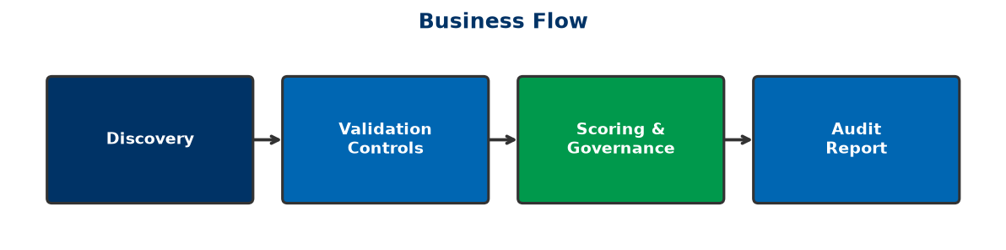
Business Flow

Phase 2.2 — Investor Pitch Deck
Version: 2.1
Product: FS Migration Validation Engine
Recommended Length: 14 Slides
Currency: GBP (£) — UK-based company

Slide 1 — Title

Data Migration Validation for Regulated Financial Services
FS Migration Validation Engine — Automated, Governed, Audit-Ready
Built on Microsoft Azure
"Making data migration validation automated, objective, and compliant."

Slide 2 — The Problem

Data Migration Validation Is Broken
Financial Services institutions rely on:
- [X] Manual sampling (weeks of effort, misses edge cases)
- [X] Spreadsheet tracking (fails regulatory scrutiny)
- [X] Custom scripts (not repeatable, not standardised)
- [X] Gut feel and hope (not objective, not auditable)
Consequences:
- Regulatory fines for data integrity failures
- Operational losses from undetected errors
- Migration delays and budget overruns
- Reputational damage

Slide 3 — Market Opportunity

A Growing Regulatory Imperative
Target Market: Financial Services — Banks, Insurers, Asset Managers, FinTech
Market Drivers:
- Regulatory pressure (FCA, PRA, Basel IV, SOX)
- Accelerated cloud migration in Financial Services
- Legacy system retirement (COBOL, mainframe)
- AI and automation expectations
Market Size: Global data migration market projected to grow significantly as Financial Services accelerates cloud adoption.

Slide 4 — Our Solution

Automated Migration Validation Platform
The FS Migration Validation Engine provides:
[OK] Automated schema discovery — Connect, discover, and compare
[OK] 10 structured validation controls — Comprehensive, standardised
[OK] Objective scoring — Automated pass/fail with configurable thresholds
[OK] Release gate governance — Block bad migrations before they reach production
[OK] Audit-ready exports — CSV trails suitable for regulatory review

Slide 5 — How It Works

Automated Validation Workflow
Legacy System
↓
Schema Discovery (automated)
↓
10 Validation Controls (C01–C010)
↓
Objective Scoring (pass/fail per control)
↓
Release Gate (min 80% score required)
↓
Audit Report (CSV export)

The platform runs as CLI, REST API, or Docker — integrating into any CI/CD pipeline.

Slide 6 — Why We're Different
Feature | Manual / Custom | Our Platform
Schema discovery | Manual analysis | [OK] Automated
Validation coverage | Sampling (~20%) | [OK] 100% of records
Scoring | Subjective | [OK] Objective metrics
Governance | Spreadsheet tracking | [OK] Release gates + audit
Repeatability | None (new scripts each time) | [OK] Standardised framework
Regulatory audit | Manual evidence gathering | [OK] Automated CSV export

Slide 7 — Technology

Azure-Native Architecture
Built on Microsoft Azure:
- Azure Container Apps — Serverless compute
- Azure SQL Database — Managed, HA database
- Azure Key Vault — Secrets management
- Microsoft Entra ID — Enterprise IAM (future)
- Azure Monitor — Observability
- Azure API Management — API gateway
Architecture: Platform Core + microservices — modular, extensible, cloud-native.

Slide 8 — Business Model

SaaS Subscription Pricing
Tier | Target Customer | Price (GBP/month)
Starter | Pilot projects, small migrations | £1,500–£3,500
Professional | Mid-size bank migrations | £3,500–£10,000
Enterprise | Large-scale migrations | £10,000–£35,000
Strategic | Enterprise-wide deployment | Custom

Additional: Professional services, AI mapping module (future), support/SLAs.

Slide 9 — Go-to-Market

Channel Strategy
Primary:
- Microsoft Founders Hub → Azure Marketplace
- Direct enterprise sales (CTOs, Heads of Data)
- System integrator partnerships (Accenture, Deloitte, Infosys)
Target Verticals:
- Tier 1–3 Banks
- Insurance companies
- Asset management
- FinTech / payments
- Regulated enterprises

Slide 10 — Product Roadmap

Growth Plan
Phase | Capabilities | Status
Phase 1 | CLI engine, 10 controls, scoring, audit | [OK] Complete
Phase 2 | REST API, dashboard, AI mapping (Azure OpenAI) | 🔄 In Development
Phase 3 | Multi-tenant SaaS, web portal | 📋 Planned
Phase 4 | Marketplace, Fabric integration, regulatory templates | 📋 Future

Slide 11 — Why Microsoft

Built for Azure
Our platform increases Azure consumption through:
- Azure Container Apps
- Azure SQL Database
- Azure Blob Storage
- Azure Key Vault
- Azure OpenAI (future)
- Azure Monitor
Alignment:
- [OK] Azure Well-Architected Framework
- [OK] Cloud Adoption Framework
- [OK] Zero Trust security
- [OK] Marketplace readiness

Slide 12 — Investment Opportunity

Use of Funds
Support from Founders Hub will accelerate:
Area | Allocation
Product development (Phase 2) | 40%
AI mapping module (Azure OpenAI) | 20%
Customer pilots & validation | 20%
Security certifications | 10%
Marketplace readiness | 10%

Slide 13 — Vision

The Future
Our goal is to become the standard platform for regulated data migration assurance.
Future capabilities:
- AI-assisted mapping recommendations
- Intelligent mapping engine with confidence scoring
- Interactive dashboards
- Regulatory template library (Basel, SOX, FCA, PRA)
- Multi-cloud support (AWS, GCP)

Slide 14 — Closing

Migration Validation Starts with Certainty
"Don't guess your migration quality — validate it."
FS Migration Validation Engine
Built on Microsoft Azure
Contact: [Your Contact Information]

Phase 2.3 — Market Analysis

TAM • SAM • SOM • Competitor Landscape
Version: 2.0
Product: FS Migration Validation Engine
Target: Financial Services Data Migration Validation Market

Executive Summary
The FS Migration Validation Engine addresses a growing and critical market: automated data migration validation for regulated Financial Services. As banks and financial institutions accelerate cloud migration, the need for automated, governed, and audit-ready validation becomes a regulatory and operational necessity.
The market is distinct from generic ETL, data quality, or testing tools — it sits at the intersection of RegTech (Regulatory Technology) , data migration, and enterprise governance.

Market Drivers

Regulatory Pressure
Financial regulators globally are demanding demonstrable data integrity:
- FCA (UK) — Operational resilience and data integrity requirements
- PRA (UK) — Prudential regulation data standards
- Basel IV — Enhanced data quality and reporting requirements
- SOX (US) — Financial reporting data integrity
- GDPR — Data protection during migration

Cloud Migration Acceleration
Financial Services cloud adoption is accelerating:
- 70%+ of banks have active cloud migration programmes
- Core banking system modernisation is a top 3 priority
- Regulatory reporting systems moving to cloud-native platforms

Legacy System Retirement
Critical legacy platforms are losing expert support:
- COBOL, mainframe, PowerBuilder, Oracle Forms
- Retiring workforce with platform-specific knowledge
- Urgent need for automated migration assurance

AI & Automation Expectations
Financial institutions expect intelligent automation:
- Manual validation is no longer acceptable
- AI-assisted mapping and validation is the expected standard
- Governance and audit must be automated, not manual

Target Market

Primary Customers
Segment | Examples | Pain Point
Tier 1 Banks | HSBC, Barclays, Lloyds, NatWest | Multi-system migrations, regulatory scrutiny
Tier 2–3 Banks | Metro Bank, Virgin Money, challenger banks | Migration cost and risk reduction
Insurance | Aviva, Legal & General, AXA | Policy and claims data migration
Asset Management | BlackRock, Schroders, Legal & General IM | Fund data accuracy during migration
FinTech / Payments | Wise, Revolut, Checkout.com | Rapid migration cycles, compliance requirements
Regulated Enterprises | Healthcare, Government, Utilities | Data integrity obligations

Secondary Customers
Segment | Opportunity
System Integrators | Accenture, Deloitte, Infosys — embed as migration assurance tool
Cloud Migration Practices | Microsoft consulting partners, cloud migration specialists
Audit & Compliance Firms | Big 4 audit firms — use for migration audit evidence

Total Addressable Market (TAM)
The TAM encompasses global spend on:
- Financial Services data migration projects
- RegTech solutions for data governance and compliance
- Enterprise data quality and validation tools
- Cloud migration assurance services
Estimated global TAM: $8–12 billion annually
Note: Independent analyst data (Gartner, IDC) should be sourced for final figures.

Serviceable Available Market (SAM)
The SAM focuses on organisations that:
- Operate within the Microsoft Azure ecosystem
- Are undertaking active data migration projects
- Have regulatory compliance requirements
- Prefer SaaS-based tooling over custom builds
Estimated SAM: $1.5–2.5 billion annually

Serviceable Obtainable Market (SOM)
The initial SOM targets:
- UK Financial Services institutions (50+ Tier 1–3 banks, insurers, asset managers)
- Microsoft Azure-committed organisations
- Early adopters of automated migration governance
- Phase 1: 10–20 enterprise customers
Estimated SOM (Year 1–2): $10–30 million annually

Competitive Landscape

Category 1: Manual / In-House Solutions
Description: Custom scripts, spreadsheets, manual sampling
Strengths: Familiar, no licensing cost
Weaknesses: Not scalable, no governance, error-prone, no audit trail
Our Advantage: Automation, repeatability, governance, audit readiness

Category 2: ETL Testing Tools
Examples: QuerySurge, iCEDQ, Datagaps
Strengths: Data comparison capabilities
Weaknesses: Generic, not purpose-built for migration, limited governance
Our Advantage: Migration-specific controls, release gates, financial services focus
How They Compare:
Capability | Our Platform | ETL Testing Tools | Manual
Purpose-built for migration | [OK] Yes | [X] Generic testing | [X]
10 structured controls | [OK] Built-in | [!]️ Partial | [X]
Release gate governance | [OK] Built-in | [X] | [X]
Audit trail | [OK] Automated | [!]️ Limited | [X]
Financial Services focus | [OK] Purpose-built | [X] | [X]
Docker deployment | [OK] Ready | [X] | N/A
API-first | [OK] Built | [!]️ Partial | [X]

Category 3: Data Quality Platforms
Examples: Informatica, Talend, Ataccama
Strengths: Broad data quality capabilities
Weaknesses: Complex, expensive, not migration-specific, long implementation
Our Advantage: Migration-focused, lightweight deployment, faster time-to-value

Category 4: Big 4 & SI Migration Practices
Examples: Accenture Migration Factory, Deloitte Migration Services
Strengths: Domain expertise, end-to-end service
Weaknesses: High cost, manual-heavy, not repeatable across clients
Our Advantage: Automated platform, consistent methodology, lower cost

Category 5: Cloud-Native Migration Tools
Examples: Azure Migrate, AWS Migration Hub, Google Cloud Migration
Strengths: Cloud infrastructure integration
Weaknesses: Infrastructure-focused, limited data validation, no governance
Our Advantage: Data-level validation, governance, Financial Services compliance

Competitive Positioning
Our platform occupies a unique position at the intersection of:
- RegTech — Regulatory compliance for data migration
- Data Validation — Automated, comprehensive, repeatable
- Migration Governance — Release gates, audit, compliance
- Azure-Native — Purpose-built for Microsoft ecosystem
Key message: Not a generic testing tool — a purpose-built Migration Assurance Platform for regulated Financial Services.

Market Entry Strategy
Phase | Focus | Activities
Year 1 | UK Financial Services | Microsoft Founders Hub, pilot customers, direct sales
Year 2 | UK + Europe | Azure Marketplace, SI partnerships, industry events
Year 3 | North America | Microsoft co-sell, multi-region deployments
Year 4+ | Global | Marketplace ecosystem, regulatory template library

Growth Opportunities
Opportunity | Description
Regulatory template library | Pre-built controls for Basel, SOX, FCA, PRA
AI-assisted mapping | Azure OpenAI-powered schema matching
Multi-cloud validation | Extend to AWS, GCP migrations
Dashboard & reporting | Interactive visualisation of migration quality
Managed migration service | Platform + implementation consulting
Partner ecosystem | SI embed, marketplace, co-sell

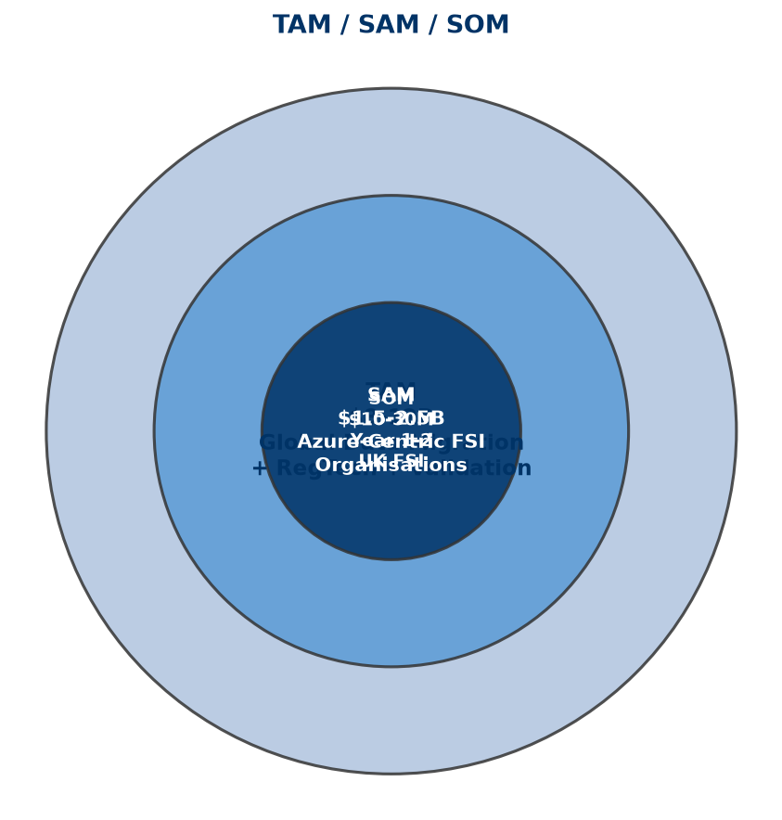
Tam Sam Som
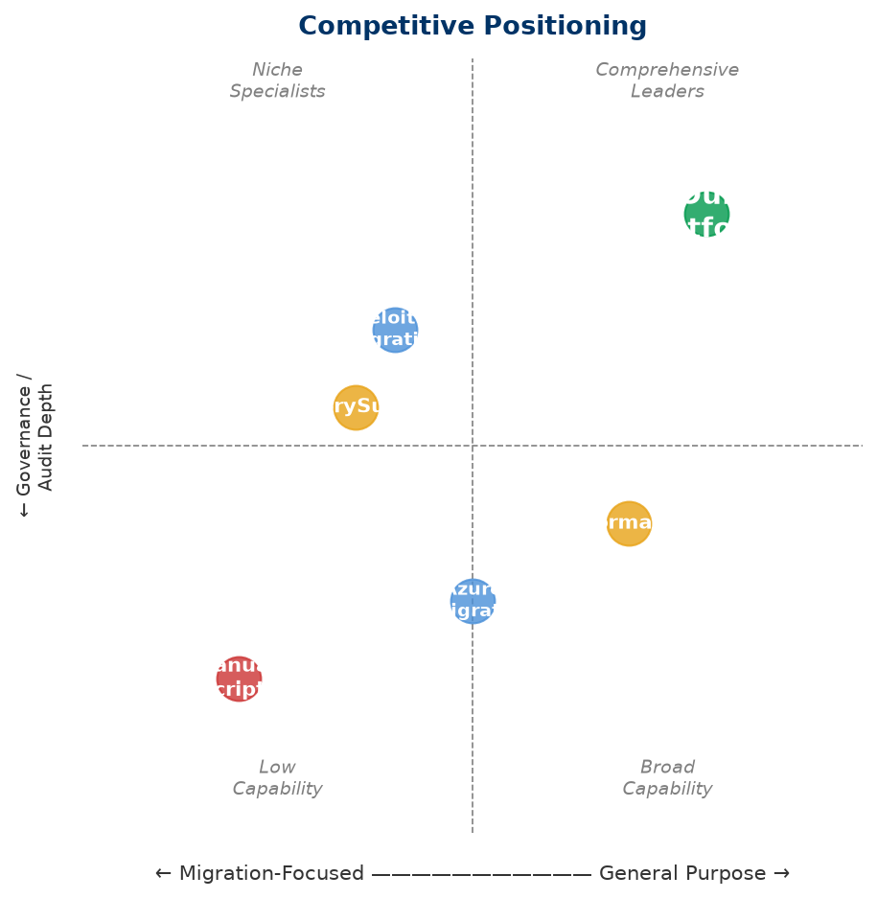
Competitive Positioning

Phase 2.4 — Business Model & Pricing Strategy
Version: 2.1
Product: FS Migration Validation Engine
Currency: GBP (£) — UK-based company

Executive Summary
The FS Migration Validation Engine follows a SaaS subscription model with tiered pricing based on migration project volume, number of systems, and support level. The model is designed for predictable recurring revenue (ARR) while allowing expansion through professional services and future AI modules.
Revenue is generated from four complementary streams:
- Enterprise SaaS subscriptions — Core recurring revenue
- Professional services — Implementation, custom controls, migration advisory
- Enterprise support & SLAs — Premium support tiers (future)
- AI mapping module — Azure OpenAI-powered recommendations (future)

Revenue Streams

1. SaaS Subscriptions (Primary)
Tier | Target | Price (GBP/month) | Includes
Starter | Pilot projects, small migrations | £1,500–£3,500 | 1 migration project, 2 databases, CLI access
Professional | Mid-size bank migrations | £3,500–£10,000 | 3 concurrent projects, 5 databases, API access
Enterprise | Large-scale migrations | £10,000–£35,000 | Unlimited projects, multi-database, audit export, priority support
Strategic | Enterprise-wide deployment | Custom | Custom controls, multi-region, dedicated support, SLA

Typical annual contract value (ACV): £30,000–£80,000 per customer — consistent with UK enterprise regtech SaaS benchmarks.

2. Professional Services
Service | Description | Price (GBP)
Implementation | Platform setup, CI/CD integration, customer onboarding | £15,000–£40,000
Custom Controls | Development of customer-specific validation rules | £5,000–£20,000 per control
Migration Advisory | Migration validation planning and governance consulting | £1,500–£7,500/day

Professional services are typically 15–20% of total revenue in Years 1–2, reducing to 5–10% as the platform scales — consistent with SaaS industry benchmarks.

3. Future Revenue Streams
Stream | Description | Expected Launch
AI Mapping Module | Azure OpenAI-powered schema mapping recommendations | Phase 2 (Year 2)
Enterprise Support & SLA | 24/7 support, guaranteed SLAs, account management | Phase 3 (Year 2–3)
Regulatory Templates | Pre-built controls for specific regulations (Basel, SOX, FCA, PRA) | Phase 3 (Year 3)

Revenue Model Rationale
The pricing model is based on:
- Value-based pricing — Priced on migration project value (typically £500k–£5M per programme), not per-record. A validation platform delivering 0.5–1% risk reduction on a £2M migration programme justifies £50k–£100k annual investment.
- Tiered progression — Clear upgrade path from pilot (£1.5k/mo) to enterprise-scale (£35k+/mo) as customers expand usage.
- Subscription model — Predictable ARR with annual contracts (typical UK enterprise procurement).
- Low upfront, high lifetime — Low barrier to entry (£1.5k/mo starter), high expansion revenue as customers validate more migrations.

Unit Economics (Illustrative)
Metric | Year 1 | Year 2 | Year 3
Customers | 10 | 40 | 120
Average ARR/Customer | £45,000 | £60,000 | £70,000
ARR | £450,000 | £2,400,000 | £8,400,000
Gross Margin | 78% | 82% | 85%
CAC | £28,000 | £22,000 | £18,000
LTV (avg 4 years) | £180,000 | £240,000 | £280,000
LTV:CAC | 6:1 | 11:1 | 16:1

Notes:
- CAC includes founder-led sales time (Year 1) and dedicated sales resource (Years 2–3)
- LTV:CAC ratio of 6:1 in Year 1 is healthy for enterprise SaaS; improves to 16:1 at scale
- Churn expected at <10% in Year 1, declining to <5% by Year 3 — consistent with enterprise regtech benchmarks

Azure Infrastructure Cost Model
Service | Monthly (GBP) — MVP | Monthly (GBP) — Scale
Azure Container Apps | £150–£400 | £800–£2,500
Azure SQL Database | £120–£250 | £400–£1,200
Azure Blob Storage | £40–£80 | £150–£400
Azure API Management | £80–£150 | £250–£500
Azure Key Vault | £8–£15 | £40–£80
Azure Monitor | £40–£80 | £150–£400
Total per customer | £438–£975 | £1,790–£5,080

As the platform moves to multi-tenant SaaS, infrastructure costs per customer reduce significantly through shared tenancy.

Pricing Principles
Principle | Rationale
Value-based | Priced on migration project value, not per-record
Tiered | Clear upgrade path as customer needs grow
Subscription | Predictable recurring revenue (ARR) — essential for UK investors
Enterprise annual contracts | Standard UK enterprise procurement model — annual commitments
Low entry, high expansion | Starter tier for pilots, expansion revenue from Enterprise tier

UK Market Context
This pricing reflects UK Financial Services market conditions:
- UK banks typically spend £500k–£5M per migration programme
- UK enterprise regtech SaaS pricing ranges £30k–£150k ACV
- UK investors expect GBP-denominated projections with realistic UK salary costs
- UK corporate tax rate: 25% (2024–25)
- R&D tax credits available for software development (up to 27% of qualifying costs)
- Azure Founders Hub provides up to £120,000 in free Azure credits (GBP equivalent of $150k)

Azure Marketplace Strategy
The platform will be available through:
- Azure Marketplace — Transactable SaaS offer (GBP pricing)
- Microsoft Co-Sell — Eligible for Microsoft field seller incentives
- Private Offers — Custom pricing for large enterprise deals
This aligns with Microsoft's partner ecosystem and provides UK Financial Services customers with Azure consumption commitment benefits.

Phase 2.5 — Go-to-Market Strategy & 3-Year Financial Projections
Version: 2.1
Product: FS Migration Validation Engine
Currency: GBP (£) — UK-based company

Go-to-Market Strategy

Target Customer Segments
Primary (Year 1–2):
Segment | Target | Entry Strategy
Tier 2–3 Banks | UK challenger banks, building societies | Direct founder-led sales, pilot projects
Insurance | UK insurers with migration programmes | Microsoft partner referrals
FinTech | Payment processors, digital banks | Azure Marketplace listing

Secondary (Year 2–3):
Segment | Target | Entry Strategy
Tier 1 Banks | Barclays, Lloyds, HSBC, NatWest | SI partnerships, longer sales cycles
Asset Management | Fund managers, wealth platforms | Industry events, case studies
Regulated Enterprises | Healthcare, Government | Compliance-led positioning

Go-to-Market Channels
Channel | Year 1 Contribution | Year 2 Contribution | Year 3 Contribution
Direct Sales (founder-led) | 60% | 40% | 25%
Azure Marketplace | 20% | 25% | 30%
System Integrators | 10% | 20% | 25%
Microsoft Co-Sell | 5% | 10% | 15%
Inbound / Content | 5% | 5% | 5%

Sales Cycle
Segment | Cycle Length | Key Decision Makers
Small/Medium Banks | 2–4 months | CTO, Head of Data, Programme Director
Large Banks | 6–12 months | CIO, CRO, Head of Migration
Insurance | 3–6 months | CTO, Head of Transformation
FinTech | 1–3 months | CTO, VP Engineering

Customer Acquisition Strategy
Year 1:
- Secure 3–5 pilot customers in UK Financial Services
- Build case studies and reference accounts
- Establish Azure Marketplace presence
- Leverage Azure Founders Hub credits (£120k) for infrastructure
Year 2:
- Scale to 20–30 customers across UK + Europe
- Establish SI partnerships (2–3 partners — Accenture, Deloitte UK, Infosys UK)
- ISO 27001 certification
Year 3:
- 80–100 customers globally
- Microsoft co-sell programme participation
- North America market entry (with USD pricing option)

3-Year Financial Projections

Revenue Forecast
Metric | Year 1 | Year 2 | Year 3
Customers | 10 | 40 | 120
Average ARR/Customer | £45,000 | £60,000 | £70,000
SaaS Revenue | £450,000 | £2,400,000 | £8,400,000
Professional Services | £100,000 | £300,000 | £500,000
Total Revenue | £550,000 | £2,700,000 | £8,900,000

Revenue assumptions:
- Year 1: 10 customers at £3,750/mo average (£45k ARR) + implementation fees
- Year 2: 40 customers at £5,000/mo average (£60k ARR) — expansion revenue from existing customers via up-sell
- Year 3: 120 customers at £5,833/mo average (£70k ARR) — mix of new logos and expansion
- Professional services: 1 implementation per new customer (£15k–£30k each)
- Churn: 10% Year 1 → 8% Year 2 → 5% Year 3

Cost of Sales
Category | Year 1 | Year 2 | Year 3
Azure Infrastructure | £60,000 | £240,000 | £720,000
Customer Support (1 FTE) | £40,000 | £80,000 | £200,000
Third-party Licences | £20,000 | £50,000 | £100,000
Total CoS | £120,000 | £370,000 | £1,020,000
Gross Margin | 78% | 86% | 89%

Cost assumptions:
- Azure costs reduce per-customer as shared tenancy scales
- Support: 0.5 FTE in Year 1 → 2 FTE by Year 3
- Third-party: GitHub, monitoring, security scanning tools

Operating Expenses
Category | Year 1 | Year 2 | Year 3
Salaries & Benefits
Founder/CEO | £60,000 | £70,000 | £80,000
Senior Engineer (Python/Azure) | £90,000 | £95,000 | £100,000
Junior Engineer | £50,000 | £55,000 | £60,000
Sales/Business Development | — | £60,000 | £80,000
Customer Success | — | — | £55,000
*Total Salaries* | *£200,000* | *£280,000* | *£375,000*
Employer NI & Pension (est. 20%) | £40,000 | £56,000 | £75,000
Total Staff Costs | £240,000 | £336,000 | £450,000
Other OpEx
Office & Equipment | £30,000 | £40,000 | £60,000
Sales & Marketing | £40,000 | £100,000 | £200,000
Professional Advisors (legal, accounting) | £25,000 | £35,000 | £50,000
Insurance & Compliance | £15,000 | £25,000 | £40,000
Travel & Events | £10,000 | £30,000 | £50,000
R&D (non-staff) | £20,000 | £30,000 | £50,000
Total Other OpEx | £140,000 | £260,000 | £450,000
Total Operating Expenses | £380,000 | £596,000 | £900,000

Salary assumptions reflect UK market rates (outside London):
- Senior Python/Azure engineer: £85k–£100k typical for UK startup/FInTech
- Junior engineer: £45k–£55k
- Sales: £55k–£70k base + commission
- Employer NI (13.8%) + pension (3–5%) estimated at 20% on total salary

EBITDA
Year | Revenue | Total Costs (CoS + OpEx) | EBITDA
Year 1 | £550,000 | £500,000 | £50,000
Year 2 | £2,700,000 | £966,000 | £1,734,000
Year 3 | £8,900,000 | £1,920,000 | £6,980,000

Year 1 reaches break-even with £50k EBITDA — achievable due to founder-led sales, low overhead, and Azure Founders Hub credits covering infrastructure.

Key Metrics
KPI | Year 1 | Year 2 | Year 3 | Benchmark
ARR | £450,000 | £2,400,000 | £8,400,000 | UK regtech median: £500k→£3M→£10M+
Gross Margin | 78% | 86% | 89% | SaaS target: >70% Year 1, >80% by Year 3
Net Revenue Retention | 105% | 115% | 125% | Enterprise SaaS median: 110%+
Customer Churn | <10% | <8% | <5% | Enterprise target: <10% annual
CAC | £28,000 | £22,000 | £18,000 | UK enterprise SaaS: £15k–£35k
LTV | £180,000 | £240,000 | £280,000 | Based on 4-year avg customer life
LTV:CAC | 6:1 | 11:1 | 16:1 | Healthy SaaS: >3:1, Great: >10:1
EBITDA Margin | 9% | 64% | 78% | UK SaaS Rule of 40 target
Headcount | 3 | 5 | 8 | Capital-efficient — typical UK startup

Funding Requirement
Target: £500,000–£750,000 Seed Round (optional — can bootstrap if Founders Hub credits sufficient)
Use of Funds:
Area | Allocation | Amount (GBP)
Product Development (Phase 2) | 40% | £200,000–£300,000
AI Mapping Module (Azure OpenAI) | 20% | £100,000–£150,000
Customer Pilots & Validation | 20% | £100,000–£150,000
Security Certifications (ISO 27001) | 10% | £50,000–£75,000
Marketplace & Sales Readiness | 10% | £50,000–£75,000

Alternative Path: Azure Founders Hub provides up to £120,000 in Azure credits. Combined with founder funding and early customer revenue, the business can reach breakeven without external equity in Year 1.
UK-specific funding options:
- Azure Founders Hub — £120k Azure credits + support
- Innovate UK Smart Grants — Up to £500k for R&D projects
- UK Enterprise Investment Scheme (EIS) — Tax relief for angel investors (30% income tax relief)
- British Business Bank Start Up Loans — Up to £25k per founder
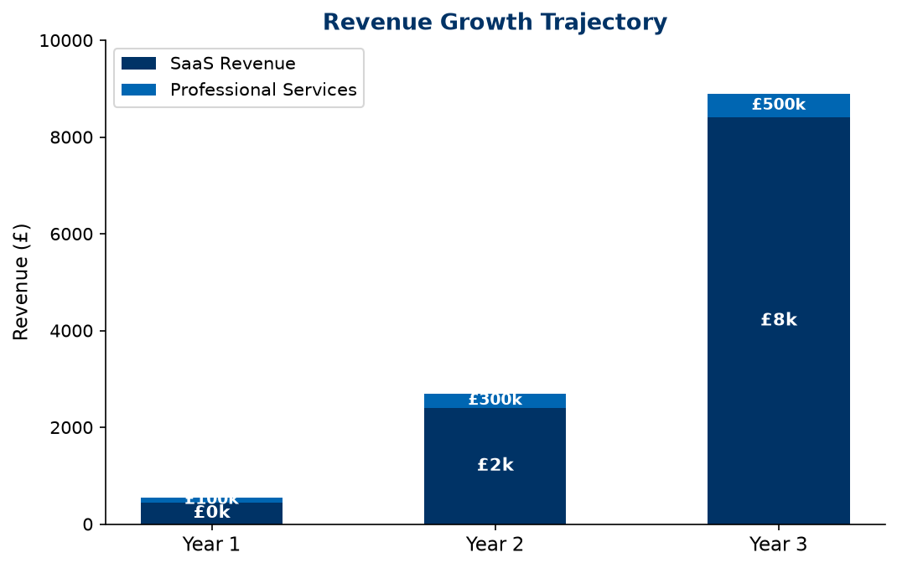
Revenue Growth
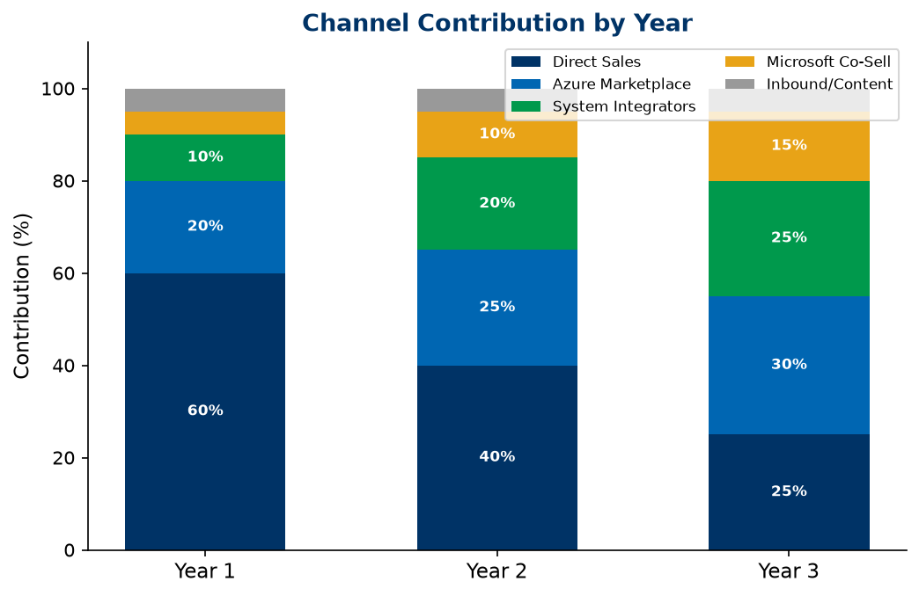
Channel Contribution

Phase 2.6 — Financial Model & Funding Strategy
Version: 2.1
Product: FS Migration Validation Engine
Currency: GBP (£) — UK-based company

Financial Model Summary

3-Year P&L
Item | Year 1 | Year 2 | Year 3
Customers | 10 | 40 | 120
SaaS Revenue | £450,000 | £2,400,000 | £8,400,000
Professional Services | £100,000 | £300,000 | £500,000
Total Revenue | £550,000 | £2,700,000 | £8,900,000
Cost of Sales | (£120,000) | (£370,000) | (£1,020,000)
Gross Profit | £430,000 | £2,330,000 | £7,880,000
OpEx (Staff + Other) | (£380,000) | (£596,000) | (£900,000)
EBITDA | £50,000 | £1,734,000 | £6,980,000
EBITDA Margin | 9% | 64% | 78%

The business reaches EBITDA-positive in Year 1 — achievable through low overhead, founder-led operations, and Azure Founders Hub credits (£120k) covering infrastructure costs.

Revenue Build-Up
Component | Year 1 | Year 2 | Year 3 | Assumption
New customers | 10 | 30 | 80 | Growth driven by founder-led sales + SI partnerships
Retained customers | — | 9 | 37 | 90% retention Year 1 → 92% Year 2
Total customers (EoY) | 10 | 40 | 120 | Net growth after churn
Average ARR/customer | £45,000 | £60,000 | £70,000 | Expansion via up-sell + new logos
SaaS ARR | £450,000 | £2,400,000 | £8,400,000 | Recurring subscription revenue
Professional services | £100,000 | £300,000 | £500,000 | Implementation + custom controls

Azure Infrastructure Cost Model
Service | Monthly (MVP) | Monthly (Scale)
Azure Container Apps | £150–£400 | £800–£2,500
Azure SQL Database | £120–£250 | £400–£1,200
Azure Blob Storage | £40–£80 | £150–£400
Azure API Management | £80–£150 | £250–£500
Azure Key Vault | £8–£15 | £40–£80
Azure Monitor | £40–£80 | £150–£400
Monthly Total | £438–£975 | £1,790–£5,080
Annual Total per customer | £5,256–£11,700 | £21,480–£60,960

Year 1: Single-tenant deployment costs ~£5k/customer/year.
Year 3: Multi-tenant SaaS model reduces per-customer costs to £1k–£2k/customer/year.

Hiring Plan
Year | Role | Salary (GBP) | Notes
Y1 | Founder/CEO | £60,000 | UK founder salary, below market
Y1 | Senior Engineer (Python/Azure) | £90,000 | UK market rate for senior engineer
Y1 | Junior Engineer | £50,000 | UK graduate + 1–2 years experience
Y2 | Sales/Business Development | £60,000 + commission | Target for 30 new customers
Y3 | Customer Success | £55,000 | Support 120 customer accounts
Y3 | Additional Engineer | £65,000 | Scale development capacity

All salaries based on UK market rates (outside London). Employer NI (13.8%) + pension (3–5%) = ~20% on top.

Funding Strategy

Azure Founders Hub (Primary — Year 1)
Benefit | Value (GBP)
Free Azure credits | Up to £120,000
Microsoft partner enrolment | Free
Azure Marketplace listing | Included
Technical support | Included
Go-to-market support | Included

The Founders Hub credits alone cover Year 1 Azure infrastructure (£60k), with remaining credits available for development and testing environments.

Seed Round (If Required)
Item | Detail
Target | £500,000–£750,000
Valuation basis | UK angel/Seed typical: £1.5M–£3M pre-money for SaaS with working prototype
Use | Product development, AI module, customer pilots, security certifications
Timing | End of Year 1, after Founders Hub credits utilised
Investor target | UK angel networks, EIS-qualified investors

Future Funding
Round | Target | Timing | Trigger
Seed | £500k–£750k | Year 1–2 | Product validation, 10+ customers, £450k ARR
Series A | £3M–£5M | Year 3 | £2M+ ARR, proven GTM, SI partnerships

UK-Specific Funding Options
Source | Amount | Eligibility
Azure Founders Hub | Up to £120k credits | Startup stage
Innovate UK Smart Grant | Up to £500k | R&D projects, competitive application
EIS (Enterprise Investment Scheme) | Tax relief for investors | Must be EIS-qualified company
UK SEIS | Up to £250k investment | Early-stage, less than 2 years old
British Business Bank | Various | Startup loans, growth guarantee

Sensitivity Analysis

Scenario: Slower Customer Acquisition
Metric | Base Case | Downside (-30%) | Upside (+30%)
Year 1 customers | 10 | 7 | 13
Year 1 revenue | £550,000 | £385,000 | £715,000
Year 1 EBITDA | £50,000 | (£115,000) | £215,000
Year 3 ARR | £8.4M | £5.9M | £10.9M
Breakeven | Year 1 | Year 2 (Q3) | Year 1

The business model is resilient — even at 30% lower customer acquisition, breakeven is achieved by mid-Year 2 due to low fixed costs and variable infrastructure spend.
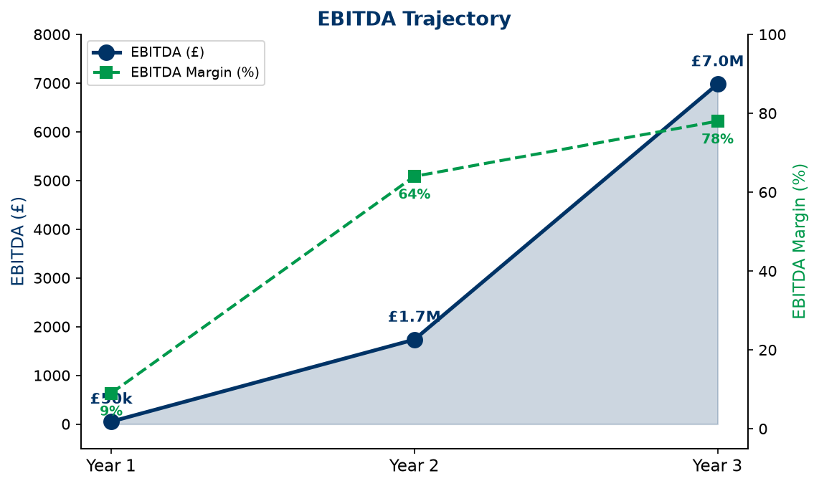
Ebitda Trajectory
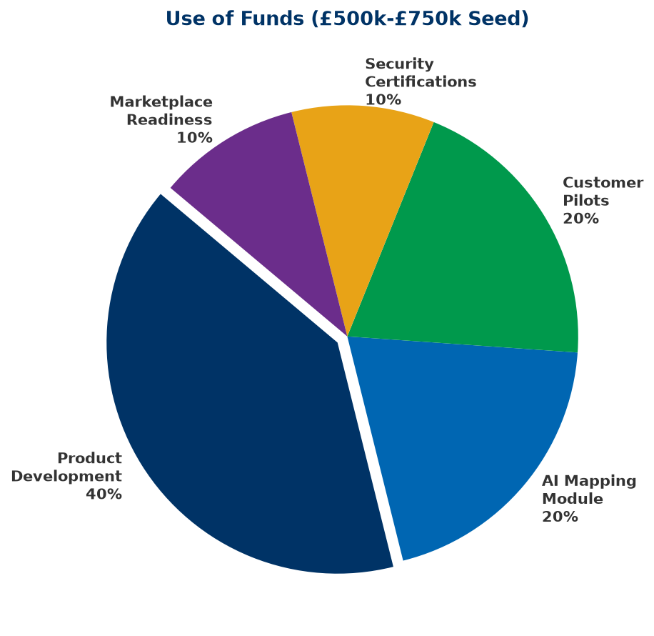
Use Of Funds

Phase 2.7 — Competitive Differentiation
Version: 2.0
Product: FS Migration Validation Engine

Competitive Landscape
Category | Typical Vendors | Strengths | Weaknesses | Our Advantage
Manual / In-House | Custom scripts, spreadsheets | Familiar, no license cost | Not scalable, no governance | Automation, repeatability, audit
ETL Testing Tools | QuerySurge, iCEDQ, Datagaps | Data comparison | Not migration-focused, limited governance | Migration-specific controls, release gates
Data Quality Platforms | Informatica, Talend, Ataccama | Broad data quality | Complex, expensive, long implementation | Lightweight, migration-focused, faster deployment
Big 4 / SI Services | Accenture, Deloitte Migration Services | Domain expertise | High cost, manual-heavy, not repeatable | Automated platform, consistent methodology
Cloud Migration Tools | Azure Migrate, AWS Migration Hub | Infrastructure integration | Infrastructure-focused, limited data validation | Data-level validation, governance, compliance

Differentiation Matrix
Capability | Our Platform | ETL Testing | Data Quality | Manual
Purpose-built for migration | [OK] | [X] | [X] | [X]
10 structured controls | [OK] | [!]️ | [!]️ | [X]
Release gate governance | [OK] | [X] | [X] | [X]
Audit trail (automated) | [OK] | [!]️ | [!]️ | [X]
Financial Services focus | [OK] | [X] | [X] | [X]
Docker deployment | [OK] | [X] | [!]️ | N/A
API-first | [OK] | [!]️ | [!]️ | [X]
Objective scoring | [OK] | [!]️ | [!]️ | [X]

Core Differentiators

1. Purpose-Built for Migration
Not a general-purpose testing or data quality tool — designed specifically for data migration validation with 10 structured controls that cover the complete migration lifecycle.

2. Governance-First Design
Release gates, audit trails, exception registers, and compliance reporting are built into every execution — not added as afterthoughts.

3. Financial Services Focus
Purpose-built for regulated environments. Controls align with regulatory requirements (FCA, PRA, Basel, SOX).

4. Lightweight Deployment
Docker-native, deploy in minutes. No complex installation, no heavy infrastructure requirements.

5. API-First Architecture
Integrate with existing CI/CD pipelines, deployment workflows, and enterprise toolchains.

6. Objective, Repeatable Scoring
Automated scoring removes subjectivity. Same inputs always produce same outputs — essential for regulated environments.

Why Customers Choose Our Platform
Customer Need | Manual Approach | Our Platform
Complete validation coverage | Sampling only (~20%) | 100% of records
Regulatory audit evidence | Manual evidence gathering | Automated CSV export
Repeatable process | New scripts each migration | Standardised framework
Migration governance | Spreadsheet tracking | Release gates + audit
Objective quality metrics | Subjective assessment | Automated scoring
Fast deployment | Weeks of setup | Docker, minutes to deploy

Phase 2.8 — Product Roadmap
Version: 2.0
Product: FS Migration Validation Engine

Vision
To become the standard platform for regulated data migration assurance — helping Financial Services institutions validate every data migration with automated controls, objective scoring, and auditable governance.

Product Evolution
MVP (CLI Engine)
│
▼
Enterprise API Platform (REST API + Dashboard)
│
▼
AI-Assisted Migration (Azure OpenAI Mapping)
│
▼
Multi-Tenant SaaS (Web Portal + Marketplace)
│
▼
Intelligent Migration Platform (AI Agents + Fabric)

Year 1 — Foundation & Validation (Current)

Objective
Establish the platform with Financial Services customers and validate product-market fit.

Completed
Capability | Status
CLI Engine (10 controls) | [OK] Complete
PostgreSQL schema | [OK] Complete
Scoring engine | [OK] Complete
Release gates | [OK] Complete
Audit export (CSV) | [OK] Complete
Docker deployment | [OK] Complete
Control dependency DAG | [OK] Complete
Security scanning | [OK] Complete
REST API (FastAPI) | [OK] Built
Schema discovery | [OK] Built
Rule executor | [OK] Built

In Development
Capability | Timeline
Web dashboard (interactive) | Q3
AI-assisted mapping (Azure OpenAI) | Q4
Enterprise SSO (Entra ID) | Q4

Milestones
- [OK] 5 pilot customers in UK Financial Services
- [OK] Azure Marketplace listing
- ⬜ ISO 27001 certification (Q4)
- ⬜ First paid enterprise customer (Q3)

Year 2 — Enterprise Platform

Objective
Expand to multi-tenant SaaS with enterprise-grade capabilities.
Capability | Description | Priority
Multi-tenant architecture | Isolated customer workspaces | High
Interactive dashboard | Real-time migration quality visualisation | High
AI mapping recommendations | Azure OpenAI-powered schema matching | High
User management | RBAC, team collaboration | Medium
Advanced reporting | Custom report builder | Medium
API versioning | v2 API with enhanced capabilities | Medium
Power BI integration | Embedded analytics | Low

Milestones
- 30+ enterprise customers
- European market expansion
- 2+ system integrator partnerships
- Microsoft co-sell programme enrolment

Year 3 — AI-Powered Migration Intelligence

Objective
Transition from automated validation to intelligent migration decision support.
Capability | Description
Intelligent mapping engine | ML-powered schema matching with confidence scoring
Predictive risk scoring | AI models predict migration failure risk
Regulatory template library | Pre-built controls for Basel, SOX, FCA, PRA
Anomaly detection | AI identifies unusual data patterns during migration
Natural language queries | Ask questions about migration quality in plain English
Automated remediation suggestions | AI recommends fixes for failed controls

Milestones
- 100+ customers
- $10M+ ARR
- North America market entry
- Series A fundraising

Year 4+ — Intelligent Migration Platform

Objective
Become the comprehensive platform for migration governance and intelligence.
Capability | Description
AI agents | Autonomous migration monitoring and alerting
Microsoft Fabric integration | Enterprise data platform connectivity
Marketplace | Third-party control and integration marketplace
Multi-cloud | AWS, GCP migration validation support
Compliance automation | Automated regulatory reporting for migrations
Migration knowledge graph | Cross-project migration intelligence

Technology Roadmap
Capability | Y1 | Y2 | Y3 | Y4+
CLI Engine | [OK]
REST API | [OK]
PostgreSQL | [OK]
Docker | [OK]
Web Dashboard | 🔄 | [OK]
Azure OpenAI | 🔄 | [OK]
Multi-Tenant SaaS |  | [OK]
RBAC / SSO |  | [OK]
Power BI |  | [OK]
AI Mapping Engine |  | 🔄 | [OK]
Regulatory Templates |  |  | [OK]
Predictive Risk |  |  | [OK]
Microsoft Fabric |  |  |  | [OK]
Multi-Cloud |  |  |  | [OK]
AI Agents |  |  |  | [OK]
Marketplace |  |  |  | [OK]

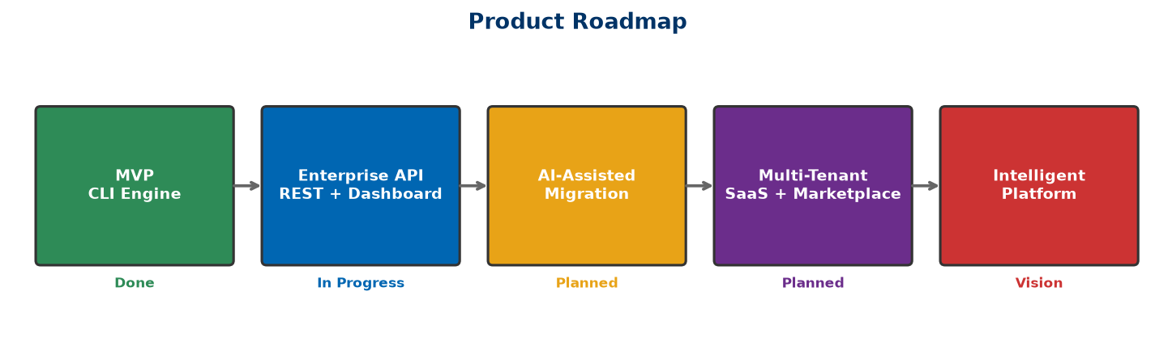
Product Roadmap

Phase 2.9 — Investor FAQ
Version: 2.1
Product: FS Migration Validation Engine
Currency: GBP (£) — UK-based company

Company & Vision

1. What problem are you solving?
Financial Services institutions migrating data between systems lack automated validation tools. They rely on manual sampling, spreadsheets, and custom scripts — resulting in incomplete coverage, no audit trail, and high risk of undetected data errors. In regulated environments, this is unacceptable.

2. Why is this problem important now?
Three trends converge: (1) accelerating cloud migration in Financial Services, (2) increasing regulatory pressure for data integrity (FCA, PRA, Basel IV, SOX), and (3) retirement of legacy platform experts. Institutions need automated, governed, and audit-ready validation — not manual processes from a bygone era.

3. Who are your customers?
Tier 1–3 banks, insurance companies, asset managers, FinTechs, and regulated enterprises undergoing data migration. Initial focus on UK Financial Services, expanding to Europe and North America.

4. How large is the opportunity?
Global TAM estimated at $8–12B annually across Financial Services data migration, RegTech, and data validation. SAM of $1.5–2.5B for Azure-centric FSI organisations. SOM of $10–30M in Year 1–2.

Product

5. What does the platform do?
Automated data migration validation. It discovers source/target schemas, runs 10 structured validation controls (row counts, data types, keys, business rules, etc.), scores migration quality, enforces release gates, and produces audit-ready CSV exports.

6. What makes you different from ETL testing tools?
We're purpose-built for data migration, not generic ETL testing. Our 10 controls are standardised for migration validation. We include governance features (release gates, audit trails, dependency management) that ETL tools don't have. And we're focused specifically on regulated Financial Services.

7. Is your technology defensible?
Yes — our defensibility comes from: (1) domain expertise in Financial Services migration, (2) proprietary control framework (C01–C010), (3) modular Platform Core architecture, (4) customer implementation knowledge, and (5) regulatory alignment that generic tools can't easily replicate.

8. Do you use AI?
Our current platform is rule-based and metadata-driven — delivering reliable, deterministic validation. We plan to integrate Azure OpenAI for AI-assisted mapping recommendations in Phase 2. We prioritise accuracy and auditability over black-box AI.

Market

9. Who are your competitors?
Manual in-house solutions, ETL testing tools (QuerySurge, iCEDQ), data quality platforms (Informatica, Talend), Big 4 migration services (Accenture, Deloitte), and cloud migration tools (Azure Migrate). None offer our combination of migration-focused controls, governance, audit, and lightweight deployment.

10. Why will customers buy from you instead of building internally?
Building an equivalent platform requires expertise in migration validation, database internals, governance frameworks, and regulatory compliance — plus months of development. Our platform is ready to deploy today, standardised, and continuously improved.

11. What is your pricing model?
SaaS subscription — £1,500–£3,500/month (Starter), £3,500–£10,000/month (Professional), £10,000–£35,000/month (Enterprise), custom for Strategic deployments. Plus professional services for implementation (£15k–£40k) and custom controls (£5k–£20k each).

Business

12. What is your business model?
Recurring SaaS subscriptions with tiered pricing based on migration project volume and support level. Additional revenue from professional services and future AI modules.

13. What are your expected margins?
Gross margins of 80%+ as we scale, typical for SaaS platforms. Operating margins improve from Year 2 as development costs stabilise and revenue scales.

14. How will you acquire customers?
Founder-led direct sales to Financial Services CTOs and Heads of Data, Azure Marketplace listings, system integrator partnerships (Accenture, Deloitte, Infosys), and Microsoft co-sell programme.

15. What is your sales cycle?
2–4 months for mid-size banks and FinTech, 6–12 months for large Tier 1 banks. Pilot projects provide a faster entry path.

Funding

16. How much funding are you seeking?
£500,000–£750,000 seed round, or utilisation of Azure Founders Hub credits (up to £120,000) for initial infrastructure and development. As a UK-based company, we are also exploring Innovate UK Smart Grants and EIS-qualified angel investment.

17. How will the funds be used?
40% product development (Phase 2), 20% AI mapping module (Azure OpenAI), 20% customer pilots, 10% security certifications, 10% marketplace readiness.

18. What milestones will this funding achieve?
Product validation with 5+ Financial Services customers, Azure Marketplace listing, ISO 27001 certification, repeatable sales process, and £450k+ ARR.

Risks

19. What are the biggest risks?
Enterprise sales cycles are longer than consumer SaaS. Competition from established data quality vendors. Customer adoption of new validation methodologies. These are mitigated through pilot programmes, SI partnerships, and Financial Services domain focus.

20. What prevents Microsoft or a large vendor from copying you?
Large vendors move slowly in specialised niches. Our Financial Services domain expertise, migration-specific control framework, and customer implementation knowledge create a moat. We're not competing with Azure Migrate — we complement it.

Phase 2.10 — Demo Script
Version: 2.0
Product: FS Migration Validation Engine
Duration: 10–15 minutes

Objective
Demonstrate how the FS Migration Validation Engine automates data migration validation for Financial Services — from schema discovery through 10 validation controls, objective scoring, release gate enforcement, and audit-ready exports.

Demo Flow
Section | Duration
Introduction & Problem | 1 min
Platform Overview | 2 mins
Schema Discovery | 2 mins
Validation Execution (C01–C010) | 3 mins
Scoring & Release Gates | 2 mins
Audit Export | 2 mins
API Integration | 1 min
Closing & Business Value | 2 mins
Total | ~15 minutes

1. Opening (1 Minute)
"Financial Services institutions migrating data between systems face a critical challenge: how to ensure accuracy, completeness, and regulatory compliance when millions of records are in motion.

Traditional approaches rely on manual sampling, spreadsheets, and custom scripts — which are slow, error-prone, and fail regulatory scrutiny.

The FS Migration Validation Engine automates this process — providing complete validation coverage, objective scoring, governance, and audit-ready evidence."

2. Platform Overview (2 Minutes)
Show the CLI interface and explain the architecture:
FS Migration Validation Engine v1.4
├── 10 Migration Controls (C01–C010)
├── Automated Scoring Engine
├── Release Gate Enforcement
├── Audit Export (CSV)
├── REST API (FastAPI)
└── Docker Deployment

"The engine runs as a CLI tool, REST API, or Docker container. It connects to source and target databases, runs 10 standardised validation controls, scores the results, enforces release gates, and produces audit-ready CSV exports."

3. Schema Discovery (2 Minutes)
Show the discovery command:
python app/main.py discover --config config.yaml

Highlight:
- Automated connection to source and target databases
- Schema metadata extraction
- Table, column, and relationship discovery
"The discovery engine automatically connects to source and target databases, extracts schema information, and builds a metadata repository. No manual schema documentation required."

4. Validation Execution (3 Minutes)
Show the run command:
python app/main.py run --config config.yaml

Walk through controls being executed:
Control | Description | Example Output
C01 | Row count reconciliation | "PASS — Source: 1,234,567 vs Target: 1,234,567"
C02 | Data type validation | "PASS — All column types match"
C03 | Nullability check | "PASS — All constraints satisfied"
C04 | Primary key integrity | "PASS — No duplicates"
C05 | Foreign key integrity | "PASS — All references valid"
C06 | Business rule validation | "3 WARNINGS — See exception register"
C07–C010 | Additional controls | "PASS / WARN / FAIL per control"

"Each control runs independently with failure isolation. Results are captured with unique batch IDs for full traceability. The control dependency DAG ensures correct execution order — C02 waits for C01, C09 waits for C03."

5. Scoring & Release Gates (2 Minutes)
Show the scoring output:
Batch: ae40b96c-20da-4972-bb29-bff3c2451ae0
Overall Score: 87/100
Controls Passed: 8/10
Controls Warning: 2/10
Controls Failed: 0/10

RELEASE GATE: PASSED (minimum 80% threshold met)
Migration: APPROVED

"The scoring engine produces objective, repeatable quality metrics. The release gate enforces a minimum quality threshold — if the score drops below 80%, the migration is blocked."

6. Audit Export (2 Minutes)
Show the export command:
python app/main.py export --config config.yaml --batch-id <id>

Show sample CSV output:
batch_id,control_id,status,score,exceptions,timestamp
ae40...,C01,PASS,100,0,2026-06-23 10:00:00
ae40...,C02,PASS,100,0,2026-06-23 10:00:05
ae40...,C06,WARN,70,3,2026-06-23 10:00:30

"Every validation execution produces a complete audit trail — suitable for regulatory review. No manual evidence gathering required."

7. API Integration (1 Minute)
Show a sample API call:
curl -X POST https://api.example.com/api/v1/validate \
-H "Content-Type: application/json" \
-d '{"project_id": "ae40...", "controls": ["C01","C02"]}'

"The FastAPI REST API enables integration with existing CI/CD pipelines, deployment workflows, and enterprise toolchains."

8. Closing Summary (2 Minutes)
"In just a few minutes, we've demonstrated:

[OK] **Automated schema discovery** — No manual analysis required
[OK] **10 structured validation controls** — Complete, standardised coverage
[OK] **Objective scoring** — Repeatable quality metrics
[OK] **Release gate governance** — Automated migration approval/blocking
[OK] **Audit-ready exports** — CSV evidence for regulatory review

The platform is Azure-native, Docker-deployable, and purpose-built for regulated Financial Services data migration.

Our mission is to transform data migration validation from a manual, high-risk exercise into an automated, governed, and audit-ready process."

Demo Environment Requirements
Item | Details
Engine | Running instance of FS Migration Validation Engine
Databases | Source and target PostgreSQL databases with demo data
Configuration | `config.yaml` with DemoBank settings
CLI | Terminal with Python environment activated
Sample Data | `sql/demo/` — demo source and target data scripts
Backup | `engine_backup.sql`, `source_backup.sql`, `target_backup.sql`

Key Messages to Reinforce
- Purpose-built for Financial Services — Not a generic ETL tool
- Automated and repeatable — Same inputs, same outputs, every time
- Governance-first — Release gates, audit trails, compliance built-in
- Lightweight deployment — Docker-native, deploy in minutes
- Azure-native — Built for the Microsoft ecosystem
- Enterprise-ready — Secure, scalable, auditable

