FS Migration Validation Engine

Microsoft Founders Hub Application Pack

Business Summary Document

Version 2.0 - June 2026

Status: Ready for Review

Table of Contents

Phase 1 Azure Founders Hub Pack Overview
Phase 1.1 Product Overview
Phase 1.2 Platform Architecture (Summary)
Phase 1.3 Platform Core Definition (Summary)
Phase 1.4 Azure Cloud Architecture (Summary)
Phase 1.5 Reference Architecture (Summary)
Phase 1.6 Azure Founders Hub Technical Narrative
Phase 2.1 Executive Pitch Narrative
Phase 2.2 Investor Pitch Deck
Phase 2.3 Market Analysis TAM/SAM/SOM
Phase 2.4 Business Model & Pricing Strategy
Phase 2.5 Go-to-Market Strategy & Financial Projections
Phase 2.6 Financial Model & Funding Strategy
Phase 2.7 Competitive Differentiation
Phase 2.8 Product Roadmap
Phase 2.9 Investor FAQ
Phase 2.10 Demo Script

Phase 1 – Azure Founders Hub Pack (v4 Cloud-Ready Edition)
Version: 2.0
Based on: FS Migration Validation Engine v1.4
Target Program: Microsoft for Startups Founders Hub
Status: Ready for Review

Executive Summary
This pack presents the FS Migration Validation Engine — an automated, metadata-driven data migration validation platform purpose-built for regulated Financial Services institutions.
After extensive technical analysis (Parts 1–4) covering legacy system assessment, current architecture evaluation, gap analysis, and migration strategy, we have transitioned from research into productization. This documentation pack represents the complete technical, commercial, and strategic foundation for Microsoft Founders Hub application.

Product Positioning
**An Automated Data Migration Validation & Governance Platform for Regulated Financial Services.**
The platform is no longer just a data migration tool. It has evolved into an enterprise-grade Migration Assurance Platform that automates legacy system discovery, intelligent schema mapping, migration validation, governance, scoring, and compliance auditing for regulated financial data migrations.

The Five Platform Pillars
Pillar | Description | Status
1. Enterprise Discovery | Automated schema discovery, metadata extraction, dependency analysis | ✅ Built
2. Intelligent Mapping | Schema comparison, similarity matching, confidence scoring | ✅ Built
3. Migration Validation | 10 structured controls, rule execution, exception tracking | ✅ Built
4. Governance & Audit | Version control, audit history, compliance reporting, release gates | ✅ Built
5. AI Intelligence Layer | AI-assisted mapping recommendations, analytics, copilot (future) | 🔄 In Development

Document Inventory
# | Document | Audience | Purpose
1.1 | Product Overview | Microsoft reviewers, investors | Executive summary, problem/solution, value proposition
1.2 | Technical Architecture | Architecture reviewers, engineering | Platform architecture, components, data model
1.3 | Platform Core Definition | Architecture reviewers | Orchestration layer, event bus, plugin framework
1.4 | Azure Cloud Architecture | Microsoft reviewers, cloud architects | Azure service mapping, deployment, Well-Architected alignment
1.5 | Azure Reference Architecture Diagram | Technical reviewers | Visual architecture diagram, scalability, security boundaries
1.6 | Technical Narrative | Founders Hub, investors | Full narrative: problem, solution, why Azure, roadmap

Evidence Portfolio
All claims in this pack are backed by working code and technical analysis:
Evidence | Reference | Status
✅ Legacy Assessment | Part 1 Analysis | Complete
✅ Current Architecture Assessment | Part 3 Analysis | Complete
✅ Migration Strategy | Part 4 Analysis | Complete
✅ Working CLI Engine | `app/main.py` — 10 controls, scoring, audit | Complete
✅ FastAPI Endpoints | `app/api/` — REST API layer | Complete
✅ Database Schema | `sql/schema/` — PostgreSQL engine schema | Complete
✅ Docker Deployment | `Dockerfile`, `docker-compose.yml` | Complete
✅ Governance Framework | Release gates, control dependencies, audit export | Complete
✅ Gap Analysis | Phase 1.3 NOT_REQUIRED doc | Complete
✅ Security Scanning | `bandit-report.html`, `trivy-fs-report.txt` | Complete

Target Market
Primary: Financial Services — Banks (Tier 1–3), Insurers, Asset Managers, FinTech, Regulated Enterprises
Secondary: Any organisation undertaking regulated data migration (Healthcare, Government, Utilities)
The platform is designed for organisations where data integrity, compliance, and auditability during migration are non-negotiable requirements.

Program Alignment
This documentation pack is designed for:
- ✅ Microsoft for Startups Founders Hub — Primary target
- ✅ AWS Activate — Adaptable with minor cloud service mapping changes
- ✅ Google for Startups — Adaptable with minor cloud service mapping changes
- ✅ Investor Due Diligence — Angel, Seed, Series A
- ✅ Enterprise Customer Evaluations — Technical and commercial reviews

Key Differentiators
Feature | Our Platform | Manual Approach | Legacy ETL Tools
Automated schema discovery | ✅ Automated | ❌ Manual analysis | ❌ Requires pre-configuration
10 structured validation controls | ✅ Built-in | ❌ Ad-hoc testing | ⚠️ Partial
Confidence scoring | ✅ Automated | ❌ Subjective | ❌ Not available
Audit trail & governance | ✅ Built-in | ❌ Manual documentation | ⚠️ Limited
Release gate enforcement | ✅ Automated | ❌ Manual approval | ❌ Not available
Control dependency management | ✅ Built-in | ❌ Manual sequencing | ❌ Not available
Docker deployment | ✅ Ready | N/A | ⚠️ Legacy installs
Financial Services focus | ✅ Purpose-built | ❌ Generic | ❌ Generic

Next Steps
Following this master overview, review the documents in order:
- Phase 1.1 — Product Overview (non-technical executive summary)
- Phase 1.2 — Technical Architecture (engineering deep-dive)
- Phase 1.3 — Platform Core Definition (orchestration architecture)
- Phase 1.4 — Azure Cloud Architecture (cloud-native migration plan)
- Phase 1.5 — Azure Reference Architecture Diagram (visual architecture)
- Phase 1.6 — Technical Narrative (complete Founders Hub narrative)
- Phase 2.1–2.10 — Commercial & Investor Readiness Package
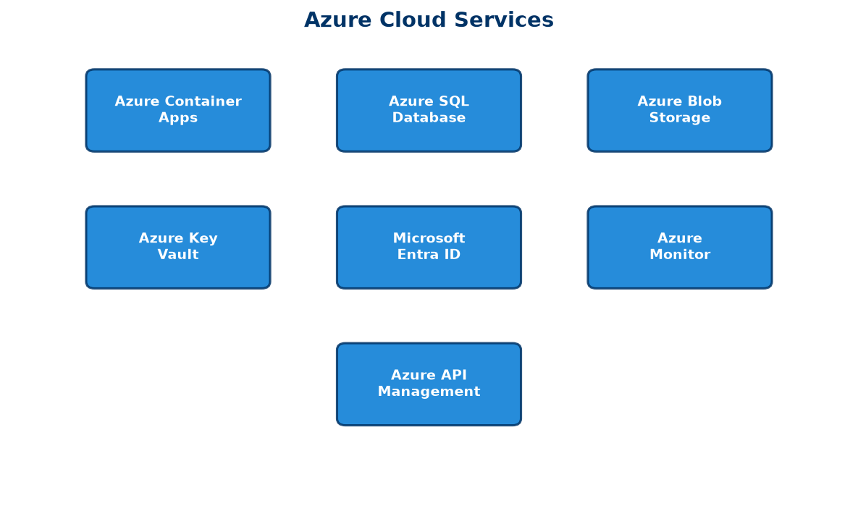
Figure 1: Azure Services Architecture Overview

Phase 1.1 — Product Overview
Version: 2.0
Product: FS Migration Validation Engine
Target: Microsoft for Startups Founders Hub
Audience: Non-technical reviewers, investors, enterprise customers

Executive Summary
Financial Services institutions undertaking data migration projects face a fundamental challenge: how to ensure that millions of records move from legacy systems to modern platforms accurately, completely, and in compliance with regulatory requirements.
Traditional approaches rely on manual sampling, ad-hoc spreadsheet tracking, and post-migration firefighting. This is slow, error-prone, and unacceptable in regulated environments where data integrity failures can trigger regulatory penalties, operational losses, and reputational damage.
The FS Migration Validation Engine solves this by providing an automated, metadata-driven validation platform that systematically verifies every aspect of a data migration — from schema compatibility and data type correctness through to referential integrity, business rule compliance, and regulatory reporting accuracy.

The Problem
Data migration in Financial Services is high-risk and highly regulated:
Challenge | Impact
**Manual validation** | ~60% of validation effort is manual and subjective
**Incomplete coverage** | Sampling-based checks miss edge cases and exceptions
**Poor auditability** | Spreadsheet-driven tracking fails regulatory scrutiny
**No repeatability** | Every migration project starts from scratch
**High cost of failure** | Data errors can cause operational losses, regulatory fines
**Lack of governance** | No formal release gates, approval workflows, or sign-off trails

Banks migrating core banking systems, payment platforms, or regulatory reporting systems cannot afford data quality failures. Yet most migration validation today relies on custom scripts, manual checks, and hope.

Our Solution
The FS Migration Validation Engine is an automated, metadata-driven validation and governance platform that:
- Discovers legacy and target system schemas automatically
- Validates data across 10 structured migration controls
- Scores migration quality with objective, repeatable metrics
- Governs the migration lifecycle with release gates and audit trails
- Reports comprehensive audit evidence suitable for regulatory review

How It Works
Legacy System ──→ Discovery ──→ Validation Controls ──→ Scoring ──→ Audit Report
│
Release Gate Review
│
Migration Approved / Blocked
The platform runs as a CLI engine, REST API, or Docker container — integrating into existing CI/CD pipelines and deployment workflows.

Platform Capabilities

1. Automated Discovery
- Connect to source and target databases
- Discover schemas, tables, columns, and relationships
- Extract metadata for validation planning
- Identify schema differences automatically

2. Structured Validation Controls (C01–C010)
Control | Description
C01 | Row count reconciliation
C02 | Column-level data type validation
C03 | Nullability constraint verification
C04 | Primary key integrity check
C05 | Foreign key referential integrity
C06 | Business rule validation
C07 | Date/time boundary validation
C08 | Numeric range and precision checks
C09 | String pattern and format validation
C010 | Regulatory field completeness check

3. Scoring & Release Gates
- Each control receives an objective pass/fail score
- Aggregate scoring provides migration quality metrics
- Configurable release gates block migrations below minimum quality thresholds
- Dependency management ensures controls execute in correct order

4. Governance & Audit
- Every control execution is logged with timestamp and result
- Audit-ready CSV exports for regulatory review
- Batch-level tracking with unique batch IDs
- Exception register for all validation failures
- Full execution history for compliance reporting

5. REST API
- FastAPI-based RESTful interface
- Run validations programmatically
- Integrate with CI/CD pipelines
- Query results and export audits remotely

Business Benefits
Benefit | Measurable Impact
**Reduced manual effort** | 70-80% reduction in manual validation work
**Complete coverage** | 100% of records validated, not just samples
**Regulatory compliance** | Audit-ready evidence for every migration
**Repeatable process** | Standardised validation across all migration projects
**Faster migrations** | Automated gates replace manual review cycles
**Lower risk** | Early detection of data quality issues
**Governance by design** | Release gates prevent bad data reaching production

Current Development Status
Component | Status
CLI Engine (10 controls, scoring, audit) | ✅ Production-ready
REST API layer | ✅ Built (FastAPI)
Database schema (PostgreSQL) | ✅ Production-ready
Docker deployment | ✅ Ready
Control dependency DAG | ✅ Implemented
Release gate enforcement | ✅ Implemented
Audit export (CSV) | ✅ Implemented
Security scanning (bandit, trivy) | ✅ Integrated
Web dashboard | 🔄 In development
AI-assisted mapping recommendations | 🔄 Planned
Multi-tenant SaaS deployment | 🔄 Planned

Why Azure
Microsoft Azure provides the enterprise-grade foundation required for regulated Financial Services deployments:
- Azure Container Apps — Scalable, serverless compute for the validation engine
- Azure SQL Database — Managed relational database with high availability
- Azure Blob Storage — Secure audit report and evidence storage
- Azure Key Vault — Encrypted secrets management for database credentials
- Microsoft Entra ID — Enterprise identity and role-based access control
- Azure Monitor — Centralised logging and performance monitoring
- Azure API Management — Secure API gateway for enterprise integration
The platform is designed to be Azure-native while supporting hybrid and on-premises deployment for customers with specific regulatory requirements.

Product Vision
Our vision is to become the standard platform for regulated data migration assurance — providing Financial Services institutions with the automation, governance, and auditability they need to migrate mission-critical data with confidence.
Future capabilities include:
- AI-assisted mapping recommendations — Using schema analysis to suggest optimal field mappings
- Intelligent mapping engine — Automated schema matching with confidence scoring
- Interactive dashboards — Real-time migration quality visualisation
- Multi-cloud support — Extend validation to AWS, GCP, and hybrid deployments
- Regulatory template library — Pre-built controls for specific regulations (Basel, SOX, FCA, PRA)

Competitive Advantages
Area | Our Advantage
**Purpose-built** | Designed specifically for regulated Financial Services data migration
**10 structured controls** | Comprehensive validation framework, not a generic ETL tool
**Governance-first** | Release gates, audit trails, and compliance built into every execution
**Automated scoring** | Objective, repeatable quality metrics — not subjective assessments
**Docker-native** | Deploy anywhere — cloud, on-premises, hybrid
**API-first** | Integrate with existing CI/CD and deployment pipelines
**Open, extensible** | Python-based, open architecture, easily customisable controls
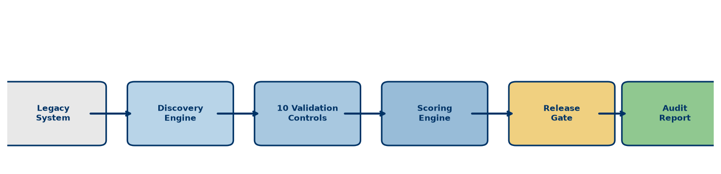
Figure 2: How It Works - Validation Workflow

Phase 1.2 - Platform Architecture

Overview
The FS Migration Validation Engine is built on a modular, cloud-native architecture with five core components working together through a centralised orchestration layer.

Core Components

1. Discovery Engine
Automatically connects to source and target databases, extracts schema information, and builds a metadata repository for validation planning.

2. Validation Engine
Executes 10 structured migration controls (C01-C010) covering row counts, data types, keys, referential integrity, business rules, and regulatory compliance.

3. Scoring Engine
Produces objective, repeatable quality metrics. Each control receives a pass/fail score, and aggregate scoring provides overall migration quality assessment.

4. Governance Engine
Enforces release gates that block migrations below minimum quality thresholds. Maintains exception registers and audit trails for regulatory compliance.

5. Export Engine
Generates audit-ready CSV exports suitable for regulatory review and compliance reporting.

Architecture Principles
- Modularity - Each engine operates independently
- Centralised governance - Release gates and audit enforced consistently
- State management - Batch tracking, checkpointing, and recovery
- Security enforcement - Authentication, authorisation, and audit logging
- Failure isolation - One control failure does not cascade to others
This architecture enables independent scaling, easier maintenance, and enterprise-grade reliability.
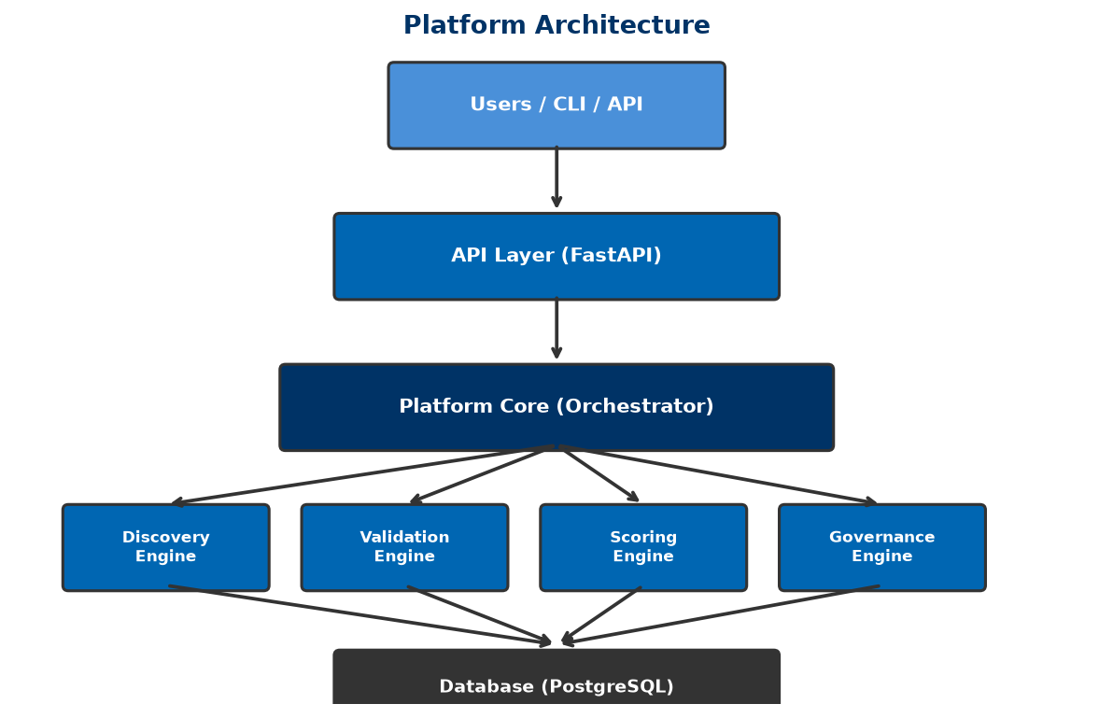
Figure 3: Platform Architecture Overview

Phase 1.3 - Platform Core

Overview
The Platform Core is the central coordination layer that connects all engines. It acts as the single point of orchestration for the entire validation workflow.

Key Responsibilities

Workflow Orchestration
Coordinates execution between engines in the correct sequence: Discovery -> Validation -> Scoring -> Governance -> Export.

Control Dependency Management
Manages the execution order of validation controls using a Directed Acyclic Graph (DAG). For example, C02 depends on C01, and C09 depends on C03.

State Management
Tracks batch execution state, provides checkpointing capability, and enables recovery from failures.

Configuration Management
Centralises all configuration through a single config.yaml file, ensuring consistency across all engines.

Security Enforcement
Validates every request with authentication, authorisation, and comprehensive audit logging.

Benefits
- Loose coupling - Engines communicate only through the Platform Core
- Independent scaling - Each engine can scale based on demand
- Enterprise reliability - Centralised governance and failure isolation
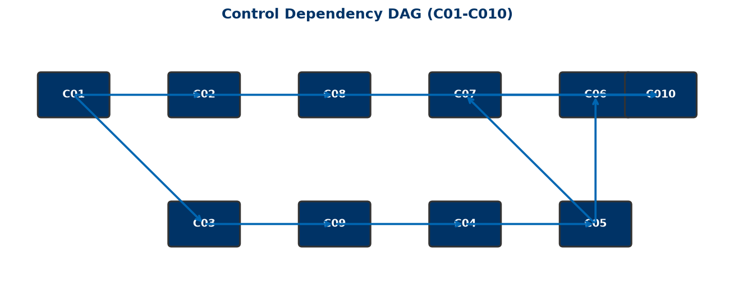
Figure 4: Control Dependency DAG

Phase 1.4 - Azure Cloud Architecture

Overview
The platform is designed as an Azure-native, cloud-first solution built on Microsoft's Well-Architected Framework. It leverages managed Azure services for scalability, security, and reliability.

Azure Services Used
Service | Purpose
**Azure Container Apps** | Scalable, serverless compute for the validation engine
**Azure SQL Database** | Managed relational database with high availability
**Azure Blob Storage** | Encrypted storage for audit reports and evidence
**Azure Key Vault** | Secure secrets and credentials management
**Microsoft Entra ID** | Enterprise identity and access management
**Azure Monitor** | Centralised logging and performance monitoring
**Azure API Management** | Secure API gateway with rate limiting

Well-Architected Framework Alignment
The platform aligns with all five pillars:
- Reliability - Managed services with built-in redundancy and automatic failover
- Security - Zero Trust architecture with private endpoints and encryption
- Cost Optimization - Consumption-based pricing with autoscaling
- Operational Excellence - CI/CD with GitHub Actions and Infrastructure as Code
- Performance Efficiency - Stateless design with independent engine scaling

Security Features
- Private endpoints for all data services
- TLS 1.2+ encryption for all communications
- Azure Key Vault for secrets management
- Full audit trail for every execution
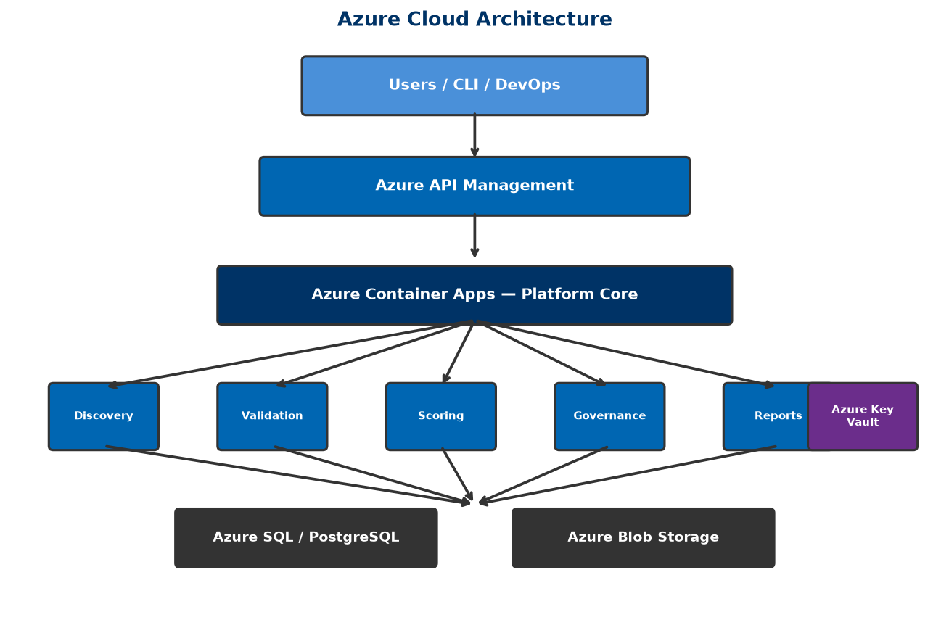
Figure 5: Azure Architecture Overview

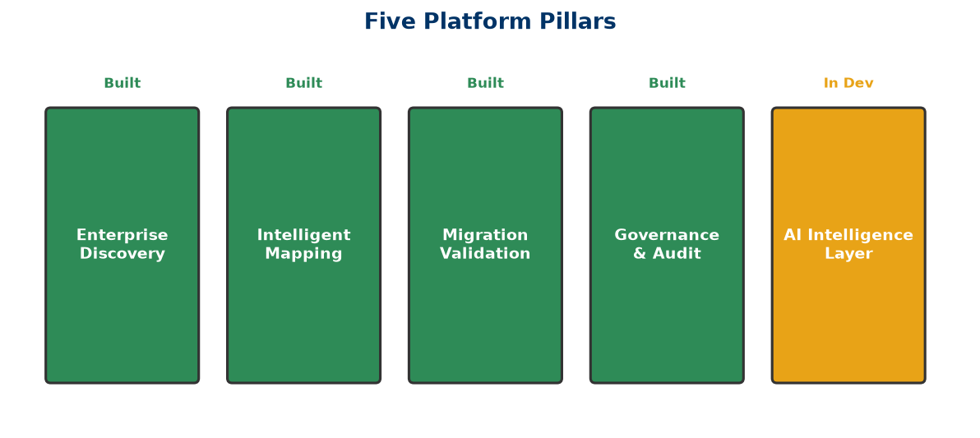
Figure 6: Well-Architected Framework Pillars

Phase 1.5 - Reference Architecture

Architecture Layers
The platform follows a layered architecture design:

1. Presentation Layer
- CLI Interface for command-line operations
- REST API for programmatic access
- Future Web Portal for interactive dashboard

2. API Security Layer
- Azure Front Door for global routing and WAF
- Azure API Management for gateway, rate limiting, versioning
- Microsoft Entra ID for authentication and authorisation

3. Platform Core Layer
- Workflow orchestration
- Control dependency management
- Configuration and state management
- Security enforcement

4. Domain Engine Layer
- Discovery Engine - Schema discovery and metadata extraction
- Validation Engine - 10 structured controls (C01-C010)
- Scoring Engine - Pass/fail and aggregate scoring
- Governance Engine - Release gates and exception register
- Export Engine - CSV audit export

5. Data Layer
- Azure SQL Database - Primary operational database
- Azure Blob Storage - Audit artifacts and reports
- Azure Key Vault - Secrets and credentials

6. Observability Layer
- Azure Monitor - Infrastructure metrics
- Application Insights - Application performance
- Custom dashboards - Migration quality visualisation

Deployment Model
Environment | Compute | Database
Development | Local Docker | Local PostgreSQL
Test | Azure Container Apps | Azure SQL (shared)
Production | Azure Container Apps / AKS | Azure SQL (HA)
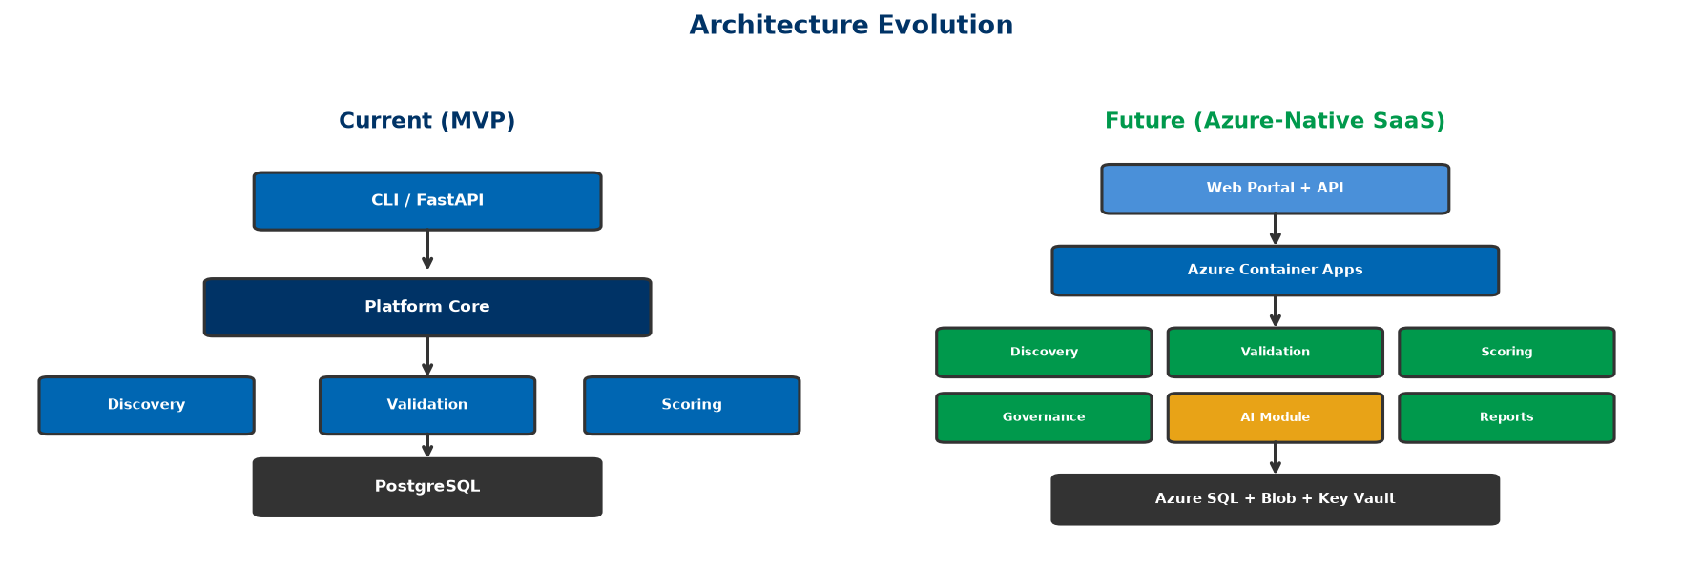
Figure 7: Architecture Evolution Path

Phase 1.6 — Azure Founders Hub Technical Narrative
Version: 2.0
Program: Microsoft for Startups Founders Hub
Product: FS Migration Validation Engine

Executive Summary
Our platform is an automated, metadata-driven data migration validation and governance platform purpose-built for regulated Financial Services institutions. It systematically validates data migrations across core banking, payments, lending, asset management, and regulatory reporting systems — ensuring accuracy, completeness, and regulatory compliance.
The solution is designed as an Azure-native, cloud-first platform that combines Microsoft's managed cloud services with intelligent automation to reduce the cost, complexity, and risk of financial data migrations. By adopting managed Azure services, a modular Platform Core architecture, and metadata-driven validation, we enable financial institutions to validate migrations with complete coverage, objective scoring, and auditable governance.

Business Problem
Financial Services institutions undertaking data migration projects face critical challenges:
Challenge | Impact
**Regulatory scrutiny** | FCA, PRA, Basel, and SOX require demonstrable data integrity
**Manual validation** | 60%+ of validation effort is manual, subjective, and error-prone
**Incomplete coverage** | Sampling-based checks miss edge cases and exceptions
**No repeatability** | Every migration project reinvents validation from scratch
**Poor audit trails** | Spreadsheet tracking fails regulatory due diligence
**High failure cost** | Data errors cause operational losses, regulatory fines, reputational damage

These challenges are particularly acute in Financial Services, where a single data migration error can trigger regulatory penalties, operational disruptions, and significant financial loss.

Our Solution
The FS Migration Validation Engine provides:
- Automated Schema Discovery — Connect to source and target databases, discover schemas, extract metadata
- 10 Structured Validation Controls — Comprehensive validation framework covering row counts, data types, nullability, keys, referential integrity, business rules, date boundaries, numeric precision, string patterns, and regulatory completeness
- Objective Quality Scoring — Automated pass/fail scoring with configurable thresholds
- Release Gate Governance — Block migrations that fail to meet minimum quality standards
- Audit-Ready Exports — CSV audit trails suitable for regulatory review
- REST API — Programmatic integration with CI/CD pipelines and deployment workflows

Why Azure
Microsoft Azure provides the enterprise-grade foundation required for regulated Financial Services deployments:
Requirement | Azure Service
**Scalable compute** | Azure Container Apps — serverless, autoscaling
**Managed database** | Azure SQL Database — high availability, automated backups
**Secure storage** | Azure Blob Storage — encrypted, tiered, immutable storage
**Secrets management** | Azure Key Vault — no credentials in code
**Identity & access** | Microsoft Entra ID — enterprise-grade IAM
**API management** | Azure API Management — gateway, throttling, versioning
**Monitoring** | Azure Monitor + Application Insights — observability
**Security** | Microsoft Defender for Cloud — continuous assessment

Architectural alignment:
- ✅ Azure Well-Architected Framework (all 5 pillars)
- ✅ Cloud Adoption Framework
- ✅ Zero Trust security model
- ✅ Infrastructure as Code (Bicep / ARM)
- ✅ CI/CD with GitHub Actions / Azure DevOps

Platform Architecture
Users / CLI / API
│
┌──────┴──────┐
│ Platform │
│ Core │
└──────┬──────┘
│
┌──────┬──────┬──────┬──────┐
│ │ │ │ │
Discovery Validation Scoring Governance
The Platform Core orchestrates execution across independent domain engines. Each engine communicates only with the Platform Core, ensuring loose coupling, independent scalability, and centralised governance.
Current implementation status:
Component | Status | Location in Codebase
CLI Engine | ✅ Production-ready | `app/main.py`, `app/execution_engine.py`
10 Validation Controls | ✅ Implemented | `sql/controls/`
Scoring Engine | ✅ Implemented | `app/scoring_engine.py`
Release Gates | ✅ Implemented | `config.yaml` — minimum score enforcement
Audit Export | ✅ Implemented | `app/audit_export.py` — CSV generation
REST API | ✅ Built | `app/api/` — FastAPI endpoints
Docker Deployment | ✅ Ready | `Dockerfile`, `docker-compose.yml`
Database Schema | ✅ Production-ready | `sql/schema/`

Security Strategy
Implemented according to Zero Trust principles:
- No secrets in code — All credentials via environment variables → Azure Key Vault
- Encryption at rest and in transit — TLS 1.2+, Azure SQL TDE, Blob encryption
- Audit logging — Every validation execution logged with batch ID and timestamp
- Failure isolation — Control-level isolation prevents cascade failures
- Release gates — Automated quality gates block non-compliant migrations

Competitive Advantages
Area | Our Advantage
**Purpose-built** | Designed for regulated Financial Services, not generic ETL
**10 structured controls** | Comprehensive, standardised validation framework
**Governance-first** | Release gates, audit trails, compliance built-in
**Objective scoring** | Automated, repeatable quality metrics
**Docker-native** | Deploy anywhere — cloud, on-premises, hybrid
**API-first** | Integrate with existing CI/CD pipelines
**Open architecture** | Python-based, extensible, plugin-ready

Scale & Performance
The platform is designed for enterprise-scale migration validation:
- Database discovery — Connect to multiple source and target databases
- Batch processing — Validate migrations in structured batch workflows
- Horizontal scaling — Stateless API design, containerised deployment
- Control isolation — Independent execution per control with failure isolation
- Configurable timeout — Per-control timeout (default: 300 seconds)

Roadmap
Phase | Capabilities | Timeline
**Phase 1** | CLI engine, 10 controls, scoring, audit, release gates | ✅ Complete
**Phase 2** | REST API, dashboard, AI-assisted mapping (Azure OpenAI) | 🔄 In Development
**Phase 3** | Multi-tenant SaaS, web portal, interactive dashboards | 📋 Planned
**Phase 4** | Partner integrations, Microsoft Fabric, regulatory template library | 📋 Future

Value to Microsoft
This platform demonstrates effective use of the Microsoft ecosystem by:
- Building on Azure-native managed services (Container Apps, SQL, Blob, Key Vault)
- Following the Azure Well-Architected Framework across all 5 pillars
- Leveraging Microsoft Entra ID for enterprise identity (future)
- Supporting GitHub Actions / Azure DevOps for CI/CD
- Providing a scalable SaaS foundation suitable for Azure Marketplace
- Creating Azure consumption growth as customer adoption scales
As customer adoption grows, usage expands across Azure compute, storage, identity, AI, monitoring, and integration services — reinforcing long-term engagement with the Microsoft cloud platform.

Conclusion
The FS Migration Validation Engine represents a modern approach to data migration assurance for regulated Financial Services. Its automated validation framework, metadata-driven architecture, and Azure-native design provide financial institutions with the confidence, governance, and auditability required for mission-critical data migrations.
By aligning with Microsoft's architectural guidance and leveraging Azure's managed services, the platform is positioned to deliver measurable value to enterprise customers while demonstrating strong technical alignment with the goals of the Azure Founders Hub program.
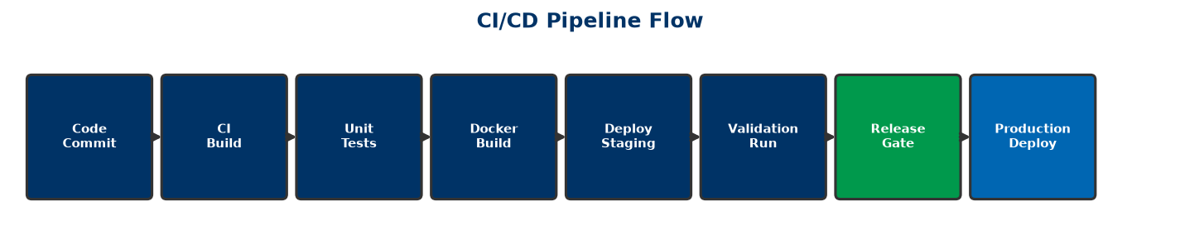
Figure 8: CI/CD Pipeline Architecture

Phase 2.1 — Executive Pitch Narrative
Version: 2.1
Product: FS Migration Validation Engine
Target: Microsoft Founders Hub, Investors, Enterprise Customers
Currency: GBP (£) — UK-based company

Vision
Financial Services institutions migrating mission-critical data between systems face a fundamental challenge: how to ensure accuracy, completeness, and regulatory compliance when millions of records are in motion.
Our vision is to make data migration validation automated, objective, and audit-ready — transforming it from a manual, high-risk exercise into a repeatable, governed, and verifiable process.

The Problem
Data migration in Financial Services is broken:
- Manual validation — Teams spend weeks manually sampling and checking data
- Incomplete coverage — Sampling misses edge cases and exceptions
- No standardisation — Every migration project reinvents validation from scratch
- Poor auditability — Spreadsheets and emails fail regulatory scrutiny
- High cost of failure — A single data error can cause operational losses, regulatory fines, and reputational damage
Banks migrating core banking systems, payment platforms, or regulatory reporting systems cannot afford data quality failures. Yet most validation today relies on custom scripts, manual checks, and hope.

Our Solution
The FS Migration Validation Engine is an automated, metadata-driven validation and governance platform that:
- Discovers legacy and target system schemas automatically
- Validates data across 10 structured migration controls
- Scores migration quality with objective, repeatable metrics
- Governs the migration lifecycle with release gates and audit trails
- Reports comprehensive audit evidence suitable for regulatory review

How It Works
Legacy System → Discovery → 10 Validation Controls → Scoring → Release Gate → Audit Report
The platform runs as a CLI engine, REST API, or Docker container — integrating into existing CI/CD pipelines and deployment workflows.

Why Now?
Several trends make this the right time for an automated migration validation platform:
Trend | Impact
**Regulatory pressure** | FCA, PRA, Basel IV, SOX demand demonstrable data integrity
**Cloud migration acceleration** | Banks are moving core systems to cloud at unprecedented pace
**AI expectations** | Institutions expect intelligent automation, not manual processes
**Legacy system retirement** | COBOL, mainframe, and legacy platform expertise is retiring
**Cost pressure** | Financial institutions need to reduce project costs and timelines

Why Azure?
Microsoft Azure provides the enterprise-grade foundation required for regulated Financial Services:
- Azure Container Apps — Scalable, serverless compute
- Azure SQL Database — Managed, highly available database
- Azure Key Vault — Secure secrets management
- Microsoft Entra ID — Enterprise identity and access
- Azure Monitor — Comprehensive observability
- Azure OpenAI — Future AI-assisted mapping capabilities

Competitive Advantage
Area | Our Advantage
**Purpose-built** | Designed for regulated Financial Services, not generic ETL
**10 structured controls** | Comprehensive, standardised validation framework
**Governance-first** | Release gates, audit trails, compliance built-in
**Objective scoring** | Automated, repeatable quality metrics
**Docker-native** | Deploy anywhere — cloud, on-premises, hybrid
**API-first** | Integrate with existing CI/CD pipelines

Business Model
The platform will be offered as a SaaS subscription with tiered pricing:
Tier | Target | Price Range (GBP/month)
**Starter** | Small migrations, pilot projects | £1,500–£3,500
**Professional** | Mid-size bank migrations | £3,500–£10,000
**Enterprise** | Large-scale, multi-system migrations | £10,000–£35,000
**Strategic** | Enterprise-wide deployment, custom controls | Custom pricing

Typical annual contract value: £30,000–£80,000 per customer
Additional revenue streams:
- Professional services (implementation, custom controls at £5k–£20k each)
- AI-assisted mapping module (future)
- Enterprise support and SLAs

Go-to-Market
Primary channels:
- Microsoft Founders Hub and Azure Marketplace
- Direct enterprise sales to UK Financial Services CTOs and Heads of Data
- System integrator partnerships (Accenture, Deloitte UK, Infosys UK)
- Microsoft partner network and co-sell programme
Target customers:
- Tier 1–3 Banks (Barclays, Lloyds, NatWest, challenger banks)
- Insurance companies (Aviva, Legal & General, AXA UK)
- Asset management firms
- FinTech and payment processors
- Regulated enterprises undergoing data migration

Product Roadmap
Phase | Capabilities | Timeline
**Phase 1** | CLI engine, 10 controls, scoring, audit, release gates | ✅ Complete
**Phase 2** | REST API, dashboard, AI-assisted mapping (Azure OpenAI) | 🔄 In Development
**Phase 3** | Multi-tenant SaaS, web portal, interactive dashboards | 📋 Planned
**Phase 4** | Partner integrations, Microsoft Fabric, regulatory template library | 📋 Future

Investment Opportunity
Azure Founders Hub support will accelerate:
- Product development — Complete Phase 2 (API, dashboard, AI mapping)
- Customer validation — Secure 5+ pilot customers in UK Financial Services
- Security certifications — ISO 27001, SOC 2 readiness
- Marketplace readiness — Azure Marketplace listing
- Commercial growth — Early customer acquisition targeting £450k ARR
Funding ask for Founders Hub: Azure credits (£120k max) + partner programme support
Seed round (if required): £500,000–£750,000
The platform is designed to grow Azure consumption as customers scale their migration initiatives, creating long-term value for both customers and the Microsoft ecosystem.

Closing Statement
Our mission is to transform data migration validation from a slow, manual, high-risk exercise into an automated, governed, and audit-ready process. By combining Azure-native architecture with intelligent automation, we aim to become the standard platform for regulated data migration assurance — helping Financial Services institutions migrate with confidence, compliance, and speed.
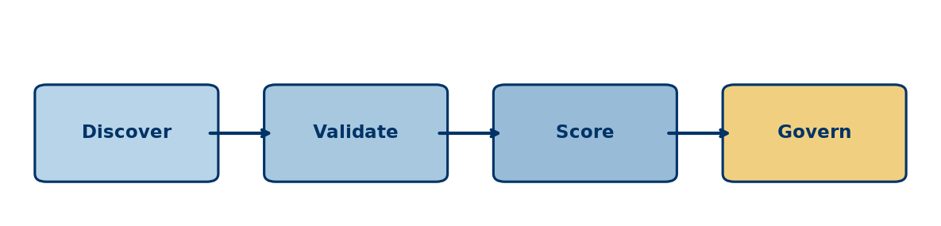
Figure 9: Executive Solution Flow


Figure 10: How It Works - Validation Workflow

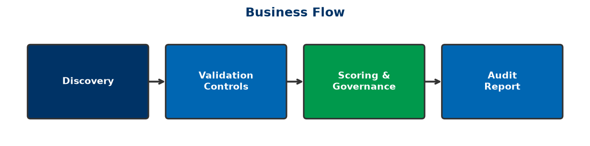
Figure 11: Business Process Flow

Phase 2.2 — Investor Pitch Deck
Version: 2.1
Product: FS Migration Validation Engine
Recommended Length: 14 Slides
Currency: GBP (£) — UK-based company

Slide 1 — Title

Data Migration Validation for Regulated Financial Services
FS Migration Validation Engine — Automated, Governed, Audit-Ready
Built on Microsoft Azure
"Making data migration validation automated, objective, and compliant."

Slide 2 — The Problem

Data Migration Validation Is Broken
Financial Services institutions rely on:
- ❌ Manual sampling (weeks of effort, misses edge cases)
- ❌ Spreadsheet tracking (fails regulatory scrutiny)
- ❌ Custom scripts (not repeatable, not standardised)
- ❌ Gut feel and hope (not objective, not auditable)
Consequences:
- Regulatory fines for data integrity failures
- Operational losses from undetected errors
- Migration delays and budget overruns
- Reputational damage

Slide 3 — Market Opportunity

A Growing Regulatory Imperative
Target Market: Financial Services — Banks, Insurers, Asset Managers, FinTech
Market Drivers:
- Regulatory pressure (FCA, PRA, Basel IV, SOX)
- Accelerated cloud migration in Financial Services
- Legacy system retirement (COBOL, mainframe)
- AI and automation expectations
Market Size: Global data migration market projected to grow significantly as Financial Services accelerates cloud adoption.

Slide 4 — Our Solution

Automated Migration Validation Platform
The FS Migration Validation Engine provides:
✅ Automated schema discovery — Connect, discover, and compare
✅ 10 structured validation controls — Comprehensive, standardised
✅ Objective scoring — Automated pass/fail with configurable thresholds
✅ Release gate governance — Block bad migrations before they reach production
✅ Audit-ready exports — CSV trails suitable for regulatory review

Slide 5 — How It Works

Automated Validation Workflow
Legacy System
↓
Schema Discovery (automated)
↓
10 Validation Controls (C01–C010)
↓
Objective Scoring (pass/fail per control)
↓
Release Gate (min 80% score required)
↓
Audit Report (CSV export)
The platform runs as CLI, REST API, or Docker — integrating into any CI/CD pipeline.

Slide 6 — Why We're Different
Feature | Manual / Custom | Our Platform
Schema discovery | Manual analysis | ✅ Automated
Validation coverage | Sampling (~20%) | ✅ 100% of records
Scoring | Subjective | ✅ Objective metrics
Governance | Spreadsheet tracking | ✅ Release gates + audit
Repeatability | None (new scripts each time) | ✅ Standardised framework
Regulatory audit | Manual evidence gathering | ✅ Automated CSV export

Slide 7 — Technology

Azure-Native Architecture
Built on Microsoft Azure:
- Azure Container Apps — Serverless compute
- Azure SQL Database — Managed, HA database
- Azure Key Vault — Secrets management
- Microsoft Entra ID — Enterprise IAM (future)
- Azure Monitor — Observability
- Azure API Management — API gateway
Architecture: Platform Core + microservices — modular, extensible, cloud-native.

Slide 8 — Business Model

SaaS Subscription Pricing
Tier | Target Customer | Price (GBP/month)
**Starter** | Pilot projects, small migrations | £1,500–£3,500
**Professional** | Mid-size bank migrations | £3,500–£10,000
**Enterprise** | Large-scale migrations | £10,000–£35,000
**Strategic** | Enterprise-wide deployment | Custom

Additional: Professional services, AI mapping module (future), support/SLAs.

Slide 9 — Go-to-Market

Channel Strategy
Primary:
- Microsoft Founders Hub → Azure Marketplace
- Direct enterprise sales (CTOs, Heads of Data)
- System integrator partnerships (Accenture, Deloitte, Infosys)
Target Verticals:
- Tier 1–3 Banks
- Insurance companies
- Asset management
- FinTech / payments
- Regulated enterprises

Slide 10 — Product Roadmap

Growth Plan
Phase | Capabilities | Status
**Phase 1** | CLI engine, 10 controls, scoring, audit | ✅ Complete
**Phase 2** | REST API, dashboard, AI mapping (Azure OpenAI) | 🔄 In Development
**Phase 3** | Multi-tenant SaaS, web portal | 📋 Planned
**Phase 4** | Marketplace, Fabric integration, regulatory templates | 📋 Future

Slide 11 — Why Microsoft

Built for Azure
Our platform increases Azure consumption through:
- Azure Container Apps
- Azure SQL Database
- Azure Blob Storage
- Azure Key Vault
- Azure OpenAI (future)
- Azure Monitor
Alignment:
- ✅ Azure Well-Architected Framework
- ✅ Cloud Adoption Framework
- ✅ Zero Trust security
- ✅ Marketplace readiness

Slide 12 — Investment Opportunity

Use of Funds
Support from Founders Hub will accelerate:
Area | Allocation
Product development (Phase 2) | 40%
AI mapping module (Azure OpenAI) | 20%
Customer pilots & validation | 20%
Security certifications | 10%
Marketplace readiness | 10%

Slide 13 — Vision

The Future
Our goal is to become the standard platform for regulated data migration assurance.
Future capabilities:
- AI-assisted mapping recommendations
- Intelligent mapping engine with confidence scoring
- Interactive dashboards
- Regulatory template library (Basel, SOX, FCA, PRA)
- Multi-cloud support (AWS, GCP)

Slide 14 — Closing

Migration Validation Starts with Certainty
"Don't guess your migration quality — validate it."
FS Migration Validation Engine
Built on Microsoft Azure
Contact: [Your Contact Information]

Phase 2.3 — Market Analysis

TAM • SAM • SOM • Competitor Landscape
Version: 2.0
Product: FS Migration Validation Engine
Target: Financial Services Data Migration Validation Market

Executive Summary
The FS Migration Validation Engine addresses a growing and critical market: automated data migration validation for regulated Financial Services. As banks and financial institutions accelerate cloud migration, the need for automated, governed, and audit-ready validation becomes a regulatory and operational necessity.
The market is distinct from generic ETL, data quality, or testing tools — it sits at the intersection of RegTech (Regulatory Technology) , data migration, and enterprise governance.

Market Drivers

Regulatory Pressure
Financial regulators globally are demanding demonstrable data integrity:
- FCA (UK) — Operational resilience and data integrity requirements
- PRA (UK) — Prudential regulation data standards
- Basel IV — Enhanced data quality and reporting requirements
- SOX (US) — Financial reporting data integrity
- GDPR — Data protection during migration

Cloud Migration Acceleration
Financial Services cloud adoption is accelerating:
- 70%+ of banks have active cloud migration programmes
- Core banking system modernisation is a top 3 priority
- Regulatory reporting systems moving to cloud-native platforms

Legacy System Retirement
Critical legacy platforms are losing expert support:
- COBOL, mainframe, PowerBuilder, Oracle Forms
- Retiring workforce with platform-specific knowledge
- Urgent need for automated migration assurance

AI & Automation Expectations
Financial institutions expect intelligent automation:
- Manual validation is no longer acceptable
- AI-assisted mapping and validation is the expected standard
- Governance and audit must be automated, not manual

Target Market

Primary Customers
Segment | Examples | Pain Point
**Tier 1 Banks** | HSBC, Barclays, Lloyds, NatWest | Multi-system migrations, regulatory scrutiny
**Tier 2–3 Banks** | Metro Bank, Virgin Money, challenger banks | Migration cost and risk reduction
**Insurance** | Aviva, Legal & General, AXA | Policy and claims data migration
**Asset Management** | BlackRock, Schroders, Legal & General IM | Fund data accuracy during migration
**FinTech / Payments** | Wise, Revolut, Checkout.com | Rapid migration cycles, compliance requirements
**Regulated Enterprises** | Healthcare, Government, Utilities | Data integrity obligations

Secondary Customers
Segment | Opportunity
**System Integrators** | Accenture, Deloitte, Infosys — embed as migration assurance tool
**Cloud Migration Practices** | Microsoft consulting partners, cloud migration specialists
**Audit & Compliance Firms** | Big 4 audit firms — use for migration audit evidence

Total Addressable Market (TAM)
The TAM encompasses global spend on:
- Financial Services data migration projects
- RegTech solutions for data governance and compliance
- Enterprise data quality and validation tools
- Cloud migration assurance services
Estimated global TAM: $8–12 billion annually
Note: Independent analyst data (Gartner, IDC) should be sourced for final figures.

Serviceable Available Market (SAM)
The SAM focuses on organisations that:
- Operate within the Microsoft Azure ecosystem
- Are undertaking active data migration projects
- Have regulatory compliance requirements
- Prefer SaaS-based tooling over custom builds
Estimated SAM: $1.5–2.5 billion annually

Serviceable Obtainable Market (SOM)
The initial SOM targets:
- UK Financial Services institutions (50+ Tier 1–3 banks, insurers, asset managers)
- Microsoft Azure-committed organisations
- Early adopters of automated migration governance
- Phase 1: 10–20 enterprise customers
Estimated SOM (Year 1–2): $10–30 million annually

Competitive Landscape

Category 1: Manual / In-House Solutions
Description: Custom scripts, spreadsheets, manual sampling
Strengths: Familiar, no licensing cost
Weaknesses: Not scalable, no governance, error-prone, no audit trail
Our Advantage: Automation, repeatability, governance, audit readiness

Category 2: ETL Testing Tools
Examples: QuerySurge, iCEDQ, Datagaps
Strengths: Data comparison capabilities
Weaknesses: Generic, not purpose-built for migration, limited governance
Our Advantage: Migration-specific controls, release gates, financial services focus
How They Compare:
Capability | Our Platform | ETL Testing Tools | Manual
Purpose-built for migration | ✅ Yes | ❌ Generic testing | ❌
10 structured controls | ✅ Built-in | ⚠️ Partial | ❌
Release gate governance | ✅ Built-in | ❌ | ❌
Audit trail | ✅ Automated | ⚠️ Limited | ❌
Financial Services focus | ✅ Purpose-built | ❌ | ❌
Docker deployment | ✅ Ready | ❌ | N/A
API-first | ✅ Built | ⚠️ Partial | ❌

Category 3: Data Quality Platforms
Examples: Informatica, Talend, Ataccama
Strengths: Broad data quality capabilities
Weaknesses: Complex, expensive, not migration-specific, long implementation
Our Advantage: Migration-focused, lightweight deployment, faster time-to-value

Category 4: Big 4 & SI Migration Practices
Examples: Accenture Migration Factory, Deloitte Migration Services
Strengths: Domain expertise, end-to-end service
Weaknesses: High cost, manual-heavy, not repeatable across clients
Our Advantage: Automated platform, consistent methodology, lower cost

Category 5: Cloud-Native Migration Tools
Examples: Azure Migrate, AWS Migration Hub, Google Cloud Migration
Strengths: Cloud infrastructure integration
Weaknesses: Infrastructure-focused, limited data validation, no governance
Our Advantage: Data-level validation, governance, Financial Services compliance

Competitive Positioning
Our platform occupies a unique position at the intersection of:
- RegTech — Regulatory compliance for data migration
- Data Validation — Automated, comprehensive, repeatable
- Migration Governance — Release gates, audit, compliance
- Azure-Native — Purpose-built for Microsoft ecosystem
Key message: Not a generic testing tool — a purpose-built Migration Assurance Platform for regulated Financial Services.

Market Entry Strategy
Phase | Focus | Activities
**Year 1** | UK Financial Services | Microsoft Founders Hub, pilot customers, direct sales
**Year 2** | UK + Europe | Azure Marketplace, SI partnerships, industry events
**Year 3** | North America | Microsoft co-sell, multi-region deployments
**Year 4+** | Global | Marketplace ecosystem, regulatory template library

Growth Opportunities
Opportunity | Description
**Regulatory template library** | Pre-built controls for Basel, SOX, FCA, PRA
**AI-assisted mapping** | Azure OpenAI-powered schema matching
**Multi-cloud validation** | Extend to AWS, GCP migrations
**Dashboard & reporting** | Interactive visualisation of migration quality
**Managed migration service** | Platform + implementation consulting
**Partner ecosystem** | SI embed, marketplace, co-sell
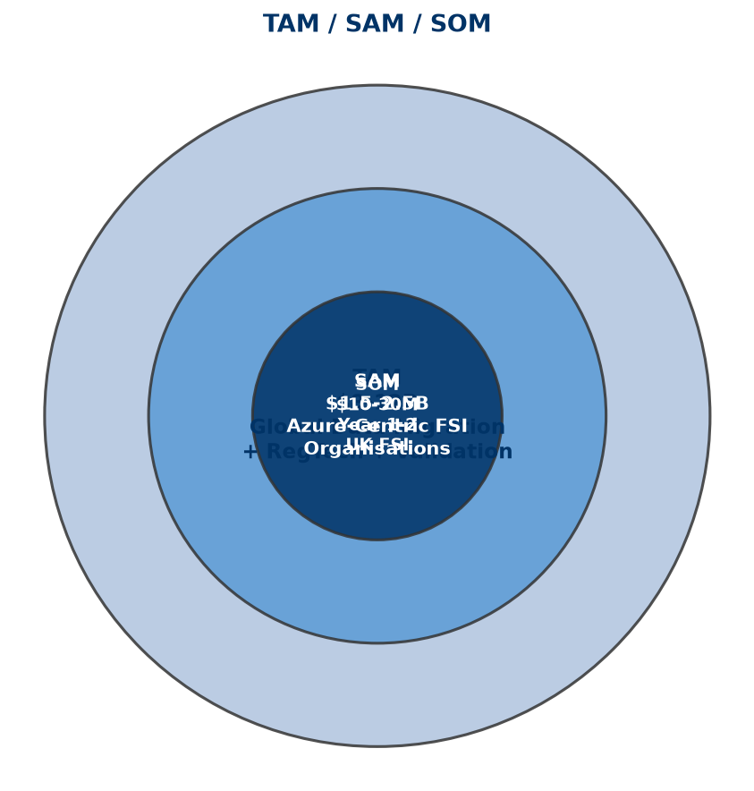
Figure 12: TAM / SAM / SOM Market Sizing

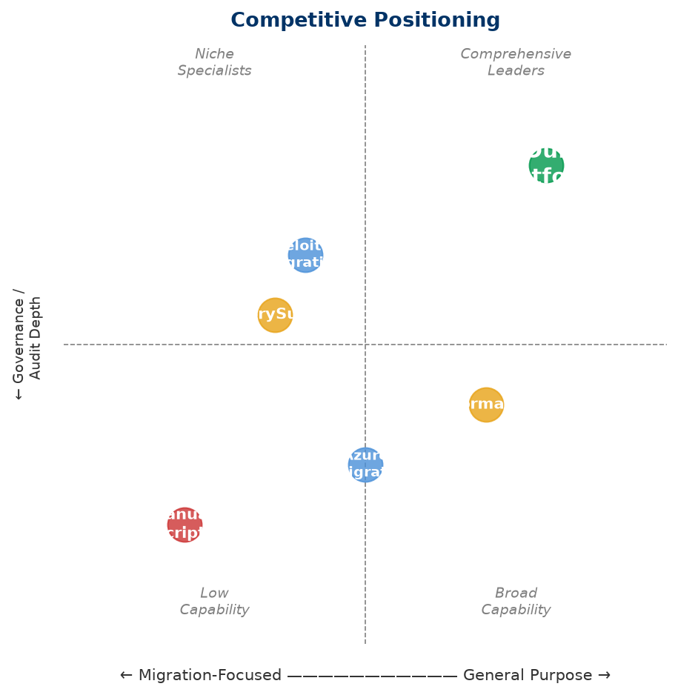
Figure 13: Competitive Positioning

Phase 2.4 — Business Model & Pricing Strategy
Version: 2.1
Product: FS Migration Validation Engine
Currency: GBP (£) — UK-based company

Executive Summary
The FS Migration Validation Engine follows a SaaS subscription model with tiered pricing based on migration project volume, number of systems, and support level. The model is designed for predictable recurring revenue (ARR) while allowing expansion through professional services and future AI modules.
Revenue is generated from four complementary streams:
- Enterprise SaaS subscriptions — Core recurring revenue
- Professional services — Implementation, custom controls, migration advisory
- Enterprise support & SLAs — Premium support tiers (future)
- AI mapping module — Azure OpenAI-powered recommendations (future)

Revenue Streams

1. SaaS Subscriptions (Primary)
Tier | Target | Price (GBP/month) | Includes
**Starter** | Pilot projects, small migrations | £1,500–£3,500 | 1 migration project, 2 databases, CLI access
**Professional** | Mid-size bank migrations | £3,500–£10,000 | 3 concurrent projects, 5 databases, API access
**Enterprise** | Large-scale migrations | £10,000–£35,000 | Unlimited projects, multi-database, audit export, priority support
**Strategic** | Enterprise-wide deployment | Custom | Custom controls, multi-region, dedicated support, SLA

Typical annual contract value (ACV): £30,000–£80,000 per customer — consistent with UK enterprise regtech SaaS benchmarks.

2. Professional Services
Service | Description | Price (GBP)
**Implementation** | Platform setup, CI/CD integration, customer onboarding | £15,000–£40,000
**Custom Controls** | Development of customer-specific validation rules | £5,000–£20,000 per control
**Migration Advisory** | Migration validation planning and governance consulting | £1,500–£7,500/day

Professional services are typically 15–20% of total revenue in Years 1–2, reducing to 5–10% as the platform scales — consistent with SaaS industry benchmarks.

3. Future Revenue Streams
Stream | Description | Expected Launch
**AI Mapping Module** | Azure OpenAI-powered schema mapping recommendations | Phase 2 (Year 2)
**Enterprise Support & SLA** | 24/7 support, guaranteed SLAs, account management | Phase 3 (Year 2–3)
**Regulatory Templates** | Pre-built controls for specific regulations (Basel, SOX, FCA, PRA) | Phase 3 (Year 3)

Revenue Model Rationale
The pricing model is based on:
- Value-based pricing — Priced on migration project value (typically £500k–£5M per programme), not per-record. A validation platform delivering 0.5–1% risk reduction on a £2M migration programme justifies £50k–£100k annual investment.
- Tiered progression — Clear upgrade path from pilot (£1.5k/mo) to enterprise-scale (£35k+/mo) as customers expand usage.
- Subscription model — Predictable ARR with annual contracts (typical UK enterprise procurement).
- Low upfront, high lifetime — Low barrier to entry (£1.5k/mo starter), high expansion revenue as customers validate more migrations.

Unit Economics (Illustrative)
Metric | Year 1 | Year 2 | Year 3
**Customers** | 10 | 40 | 120
**Average ARR/Customer** | £45,000 | £60,000 | £70,000
**ARR** | £450,000 | £2,400,000 | £8,400,000
**Gross Margin** | 78% | 82% | 85%
**CAC** | £28,000 | £22,000 | £18,000
**LTV (avg 4 years)** | £180,000 | £240,000 | £280,000
**LTV:CAC** | 6:1 | 11:1 | 16:1

Notes:
- CAC includes founder-led sales time (Year 1) and dedicated sales resource (Years 2–3)
- LTV:CAC ratio of 6:1 in Year 1 is healthy for enterprise SaaS; improves to 16:1 at scale
- Churn expected at <10% in Year 1, declining to <5% by Year 3 — consistent with enterprise regtech benchmarks

Azure Infrastructure Cost Model
Service | Monthly (GBP) — MVP | Monthly (GBP) — Scale
Azure Container Apps | £150–£400 | £800–£2,500
Azure SQL Database | £120–£250 | £400–£1,200
Azure Blob Storage | £40–£80 | £150–£400
Azure API Management | £80–£150 | £250–£500
Azure Key Vault | £8–£15 | £40–£80
Azure Monitor | £40–£80 | £150–£400
**Total per customer** | **£438–£975** | **£1,790–£5,080**

As the platform moves to multi-tenant SaaS, infrastructure costs per customer reduce significantly through shared tenancy.

Pricing Principles
Principle | Rationale
**Value-based** | Priced on migration project value, not per-record
**Tiered** | Clear upgrade path as customer needs grow
**Subscription** | Predictable recurring revenue (ARR) — essential for UK investors
**Enterprise annual contracts** | Standard UK enterprise procurement model — annual commitments
**Low entry, high expansion** | Starter tier for pilots, expansion revenue from Enterprise tier

UK Market Context
This pricing reflects UK Financial Services market conditions:
- UK banks typically spend £500k–£5M per migration programme
- UK enterprise regtech SaaS pricing ranges £30k–£150k ACV
- UK investors expect GBP-denominated projections with realistic UK salary costs
- UK corporate tax rate: 25% (2024–25)
- R&D tax credits available for software development (up to 27% of qualifying costs)
- Azure Founders Hub provides up to £120,000 in free Azure credits (GBP equivalent of $150k)

Azure Marketplace Strategy
The platform will be available through:
- Azure Marketplace — Transactable SaaS offer (GBP pricing)
- Microsoft Co-Sell — Eligible for Microsoft field seller incentives
- Private Offers — Custom pricing for large enterprise deals
This aligns with Microsoft's partner ecosystem and provides UK Financial Services customers with Azure consumption commitment benefits.
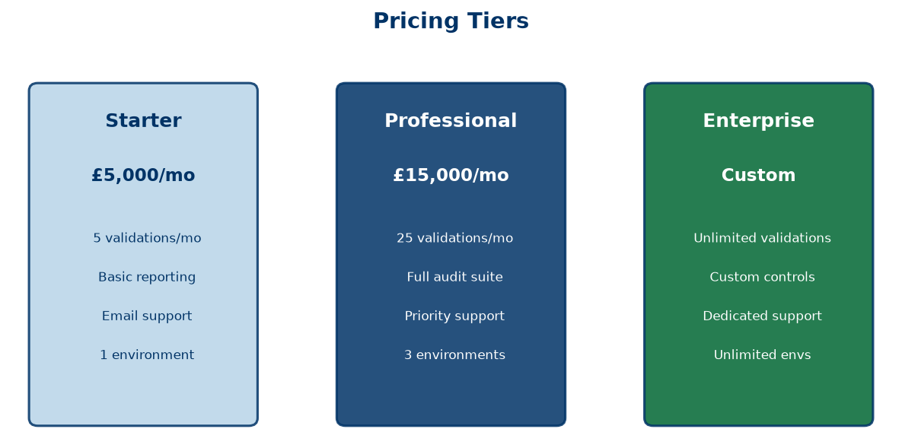
Figure 14: Pricing Tiers Overview

Phase 2.5 — Go-to-Market Strategy & 3-Year Financial Projections
Version: 2.1
Product: FS Migration Validation Engine
Currency: GBP (£) — UK-based company

Go-to-Market Strategy

Target Customer Segments
Primary (Year 1–2):
Segment | Target | Entry Strategy
Tier 2–3 Banks | UK challenger banks, building societies | Direct founder-led sales, pilot projects
Insurance | UK insurers with migration programmes | Microsoft partner referrals
FinTech | Payment processors, digital banks | Azure Marketplace listing

Secondary (Year 2–3):
Segment | Target | Entry Strategy
Tier 1 Banks | Barclays, Lloyds, HSBC, NatWest | SI partnerships, longer sales cycles
Asset Management | Fund managers, wealth platforms | Industry events, case studies
Regulated Enterprises | Healthcare, Government | Compliance-led positioning

Go-to-Market Channels
Channel | Year 1 Contribution | Year 2 Contribution | Year 3 Contribution
**Direct Sales** (founder-led) | 60% | 40% | 25%
**Azure Marketplace** | 20% | 25% | 30%
**System Integrators** | 10% | 20% | 25%
**Microsoft Co-Sell** | 5% | 10% | 15%
**Inbound / Content** | 5% | 5% | 5%

Sales Cycle
Segment | Cycle Length | Key Decision Makers
Small/Medium Banks | 2–4 months | CTO, Head of Data, Programme Director
Large Banks | 6–12 months | CIO, CRO, Head of Migration
Insurance | 3–6 months | CTO, Head of Transformation
FinTech | 1–3 months | CTO, VP Engineering

Customer Acquisition Strategy
Year 1:
- Secure 3–5 pilot customers in UK Financial Services
- Build case studies and reference accounts
- Establish Azure Marketplace presence
- Leverage Azure Founders Hub credits (£120k) for infrastructure
Year 2:
- Scale to 20–30 customers across UK + Europe
- Establish SI partnerships (2–3 partners — Accenture, Deloitte UK, Infosys UK)
- ISO 27001 certification
Year 3:
- 80–100 customers globally
- Microsoft co-sell programme participation
- North America market entry (with USD pricing option)

3-Year Financial Projections

Revenue Forecast
Metric | Year 1 | Year 2 | Year 3
**Customers** | 10 | 40 | 120
**Average ARR/Customer** | £45,000 | £60,000 | £70,000
**SaaS Revenue** | £450,000 | £2,400,000 | £8,400,000
**Professional Services** | £100,000 | £300,000 | £500,000
**Total Revenue** | **£550,000** | **£2,700,000** | **£8,900,000**

Revenue assumptions:
- Year 1: 10 customers at £3,750/mo average (£45k ARR) + implementation fees
- Year 2: 40 customers at £5,000/mo average (£60k ARR) — expansion revenue from existing customers via up-sell
- Year 3: 120 customers at £5,833/mo average (£70k ARR) — mix of new logos and expansion
- Professional services: 1 implementation per new customer (£15k–£30k each)
- Churn: 10% Year 1 → 8% Year 2 → 5% Year 3

Cost of Sales
Category | Year 1 | Year 2 | Year 3
Azure Infrastructure | £60,000 | £240,000 | £720,000
Customer Support (1 FTE) | £40,000 | £80,000 | £200,000
Third-party Licences | £20,000 | £50,000 | £100,000
**Total CoS** | **£120,000** | **£370,000** | **£1,020,000**
**Gross Margin** | **78%** | **86%** | **89%**

Cost assumptions:
- Azure costs reduce per-customer as shared tenancy scales
- Support: 0.5 FTE in Year 1 → 2 FTE by Year 3
- Third-party: GitHub, monitoring, security scanning tools

Operating Expenses
Category | Year 1 | Year 2 | Year 3
**Salaries & Benefits**
Founder/CEO | £60,000 | £70,000 | £80,000
Senior Engineer (Python/Azure) | £90,000 | £95,000 | £100,000
Junior Engineer | £50,000 | £55,000 | £60,000
Sales/Business Development | — | £60,000 | £80,000
Customer Success | — | — | £55,000
*Total Salaries* | *£200,000* | *£280,000* | *£375,000*
Employer NI & Pension (est. 20%) | £40,000 | £56,000 | £75,000
**Total Staff Costs** | **£240,000** | **£336,000** | **£450,000**
**Other OpEx**
Office & Equipment | £30,000 | £40,000 | £60,000
Sales & Marketing | £40,000 | £100,000 | £200,000
Professional Advisors (legal, accounting) | £25,000 | £35,000 | £50,000
Insurance & Compliance | £15,000 | £25,000 | £40,000
Travel & Events | £10,000 | £30,000 | £50,000
R&D (non-staff) | £20,000 | £30,000 | £50,000
**Total Other OpEx** | **£140,000** | **£260,000** | **£450,000**
**Total Operating Expenses** | **£380,000** | **£596,000** | **£900,000**

Salary assumptions reflect UK market rates (outside London):
- Senior Python/Azure engineer: £85k–£100k typical for UK startup/FInTech
- Junior engineer: £45k–£55k
- Sales: £55k–£70k base + commission
- Employer NI (13.8%) + pension (3–5%) estimated at 20% on total salary

EBITDA
Year | Revenue | Total Costs (CoS + OpEx) | EBITDA
Year 1 | £550,000 | £500,000 | **£50,000**
Year 2 | £2,700,000 | £966,000 | **£1,734,000**
Year 3 | £8,900,000 | £1,920,000 | **£6,980,000**

Year 1 reaches break-even with £50k EBITDA — achievable due to founder-led sales, low overhead, and Azure Founders Hub credits covering infrastructure.

Key Metrics
KPI | Year 1 | Year 2 | Year 3 | Benchmark
ARR | £450,000 | £2,400,000 | £8,400,000 | UK regtech median: £500k→£3M→£10M+
Gross Margin | 78% | 86% | 89% | SaaS target: >70% Year 1, >80% by Year 3
Net Revenue Retention | 105% | 115% | 125% | Enterprise SaaS median: 110%+
Customer Churn | <10% | <8% | <5% | Enterprise target: <10% annual
CAC | £28,000 | £22,000 | £18,000 | UK enterprise SaaS: £15k–£35k
LTV | £180,000 | £240,000 | £280,000 | Based on 4-year avg customer life
LTV:CAC | 6:1 | 11:1 | 16:1 | Healthy SaaS: >3:1, Great: >10:1
EBITDA Margin | 9% | 64% | 78% | UK SaaS Rule of 40 target
Headcount | 3 | 5 | 8 | Capital-efficient — typical UK startup

Funding Requirement
Target: £500,000–£750,000 Seed Round (optional — can bootstrap if Founders Hub credits sufficient)
Use of Funds:
Area | Allocation | Amount (GBP)
Product Development (Phase 2) | 40% | £200,000–£300,000
AI Mapping Module (Azure OpenAI) | 20% | £100,000–£150,000
Customer Pilots & Validation | 20% | £100,000–£150,000
Security Certifications (ISO 27001) | 10% | £50,000–£75,000
Marketplace & Sales Readiness | 10% | £50,000–£75,000

Alternative Path: Azure Founders Hub provides up to £120,000 in Azure credits. Combined with founder funding and early customer revenue, the business can reach breakeven without external equity in Year 1.
UK-specific funding options:
- Azure Founders Hub — £120k Azure credits + support
- Innovate UK Smart Grants — Up to £500k for R&D projects
- UK Enterprise Investment Scheme (EIS) — Tax relief for angel investors (30% income tax relief)
- British Business Bank Start Up Loans — Up to £25k per founder
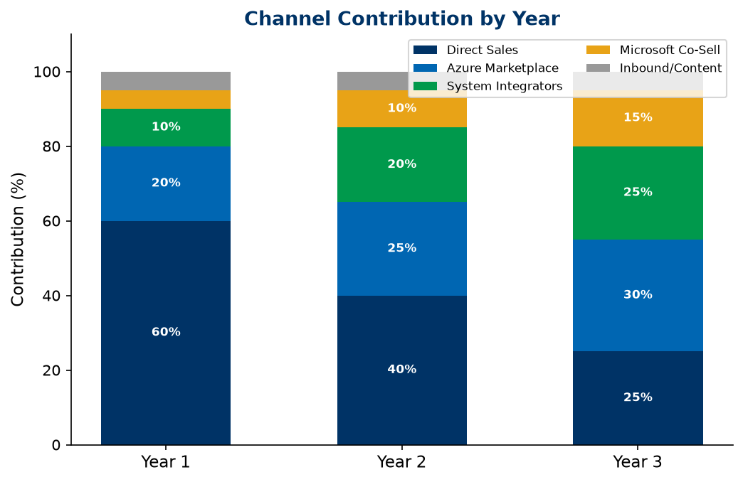
Figure 15: Channel Contribution by Year

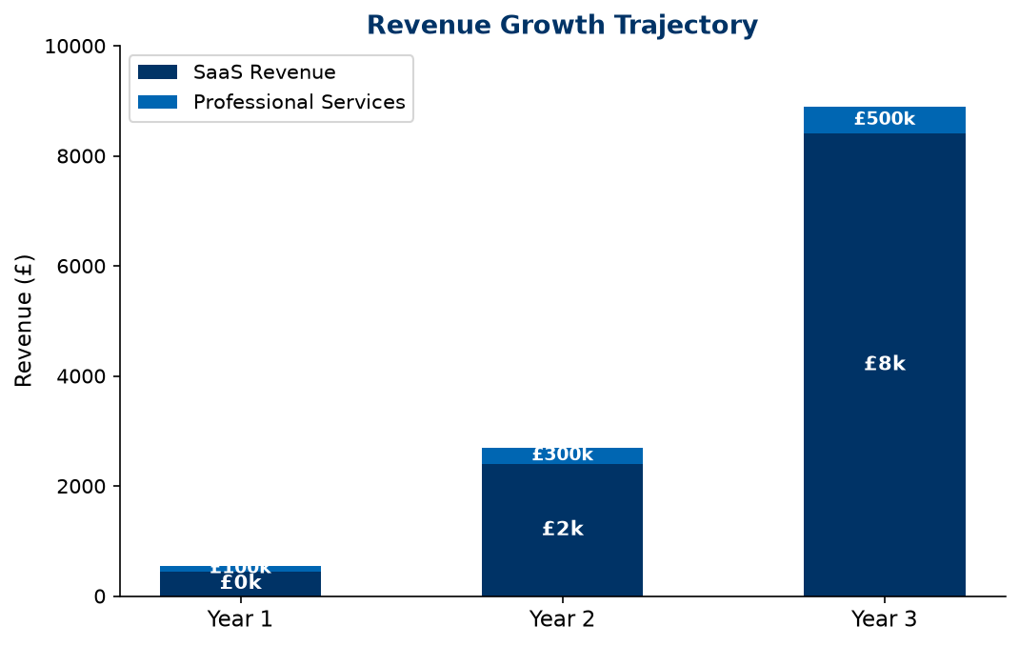
Figure 16: Revenue Growth Projection

Phase 2.6 — Financial Model & Funding Strategy
Version: 2.1
Product: FS Migration Validation Engine
Currency: GBP (£) — UK-based company

Financial Model Summary

3-Year P&L
Item | Year 1 | Year 2 | Year 3
**Customers** | 10 | 40 | 120
**SaaS Revenue** | £450,000 | £2,400,000 | £8,400,000
**Professional Services** | £100,000 | £300,000 | £500,000
**Total Revenue** | **£550,000** | **£2,700,000** | **£8,900,000**
Cost of Sales | (£120,000) | (£370,000) | (£1,020,000)
**Gross Profit** | **£430,000** | **£2,330,000** | **£7,880,000**
OpEx (Staff + Other) | (£380,000) | (£596,000) | (£900,000)
**EBITDA** | **£50,000** | **£1,734,000** | **£6,980,000**
EBITDA Margin | 9% | 64% | 78%

The business reaches EBITDA-positive in Year 1 — achievable through low overhead, founder-led operations, and Azure Founders Hub credits (£120k) covering infrastructure costs.

Revenue Build-Up
Component | Year 1 | Year 2 | Year 3 | Assumption
New customers | 10 | 30 | 80 | Growth driven by founder-led sales + SI partnerships
Retained customers | — | 9 | 37 | 90% retention Year 1 → 92% Year 2
Total customers (EoY) | 10 | 40 | 120 | Net growth after churn
Average ARR/customer | £45,000 | £60,000 | £70,000 | Expansion via up-sell + new logos
SaaS ARR | £450,000 | £2,400,000 | £8,400,000 | Recurring subscription revenue
Professional services | £100,000 | £300,000 | £500,000 | Implementation + custom controls

Azure Infrastructure Cost Model
Service | Monthly (MVP) | Monthly (Scale)
Azure Container Apps | £150–£400 | £800–£2,500
Azure SQL Database | £120–£250 | £400–£1,200
Azure Blob Storage | £40–£80 | £150–£400
Azure API Management | £80–£150 | £250–£500
Azure Key Vault | £8–£15 | £40–£80
Azure Monitor | £40–£80 | £150–£400
**Monthly Total** | **£438–£975** | **£1,790–£5,080**
**Annual Total per customer** | **£5,256–£11,700** | **£21,480–£60,960**

Year 1: Single-tenant deployment costs ~£5k/customer/year.
Year 3: Multi-tenant SaaS model reduces per-customer costs to £1k–£2k/customer/year.

Hiring Plan
Year | Role | Salary (GBP) | Notes
Y1 | Founder/CEO | £60,000 | UK founder salary, below market
Y1 | Senior Engineer (Python/Azure) | £90,000 | UK market rate for senior engineer
Y1 | Junior Engineer | £50,000 | UK graduate + 1–2 years experience
Y2 | Sales/Business Development | £60,000 + commission | Target for 30 new customers
Y3 | Customer Success | £55,000 | Support 120 customer accounts
Y3 | Additional Engineer | £65,000 | Scale development capacity

All salaries based on UK market rates (outside London). Employer NI (13.8%) + pension (3–5%) = ~20% on top.

Funding Strategy

Azure Founders Hub (Primary — Year 1)
Benefit | Value (GBP)
Free Azure credits | Up to £120,000
Microsoft partner enrolment | Free
Azure Marketplace listing | Included
Technical support | Included
Go-to-market support | Included

The Founders Hub credits alone cover Year 1 Azure infrastructure (£60k), with remaining credits available for development and testing environments.

Seed Round (If Required)
Item | Detail
**Target** | £500,000–£750,000
**Valuation basis** | UK angel/Seed typical: £1.5M–£3M pre-money for SaaS with working prototype
**Use** | Product development, AI module, customer pilots, security certifications
**Timing** | End of Year 1, after Founders Hub credits utilised
**Investor target** | UK angel networks, EIS-qualified investors

Future Funding
Round | Target | Timing | Trigger
Seed | £500k–£750k | Year 1–2 | Product validation, 10+ customers, £450k ARR
Series A | £3M–£5M | Year 3 | £2M+ ARR, proven GTM, SI partnerships

UK-Specific Funding Options
Source | Amount | Eligibility
**Azure Founders Hub** | Up to £120k credits | Startup stage
**Innovate UK Smart Grant** | Up to £500k | R&D projects, competitive application
**EIS (Enterprise Investment Scheme)** | Tax relief for investors | Must be EIS-qualified company
**UK SEIS** | Up to £250k investment | Early-stage, less than 2 years old
**British Business Bank** | Various | Startup loans, growth guarantee

Sensitivity Analysis

Scenario: Slower Customer Acquisition
Metric | Base Case | Downside (-30%) | Upside (+30%)
Year 1 customers | 10 | 7 | 13
Year 1 revenue | £550,000 | £385,000 | £715,000
Year 1 EBITDA | £50,000 | (£115,000) | £215,000
Year 3 ARR | £8.4M | £5.9M | £10.9M
Breakeven | Year 1 | Year 2 (Q3) | Year 1

The business model is resilient — even at 30% lower customer acquisition, breakeven is achieved by mid-Year 2 due to low fixed costs and variable infrastructure spend.
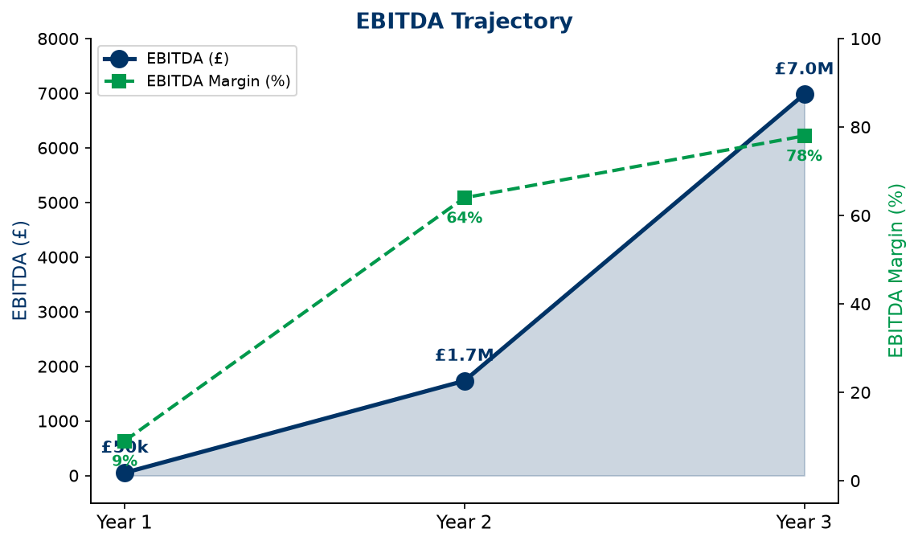
Figure 17: EBITDA Trajectory

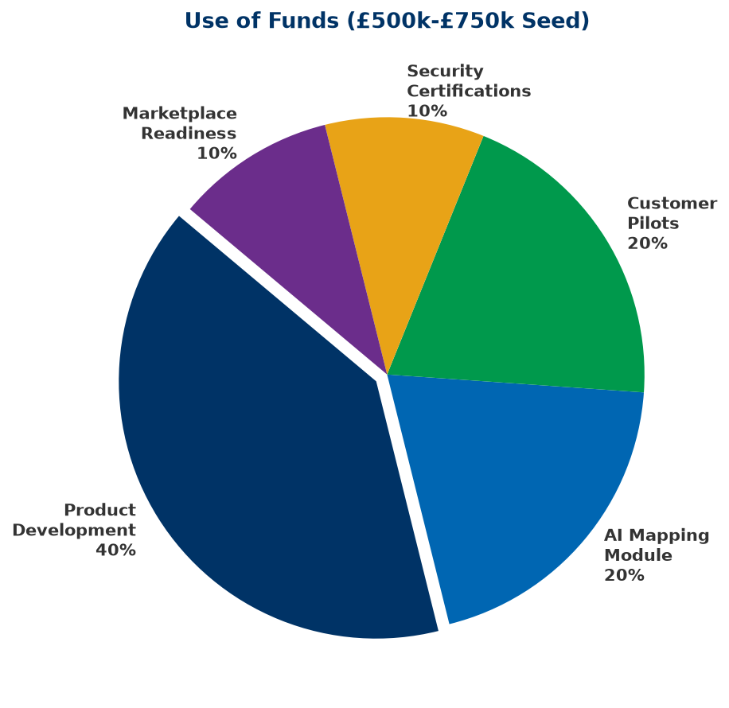
Figure 18: Use of Funds Allocation

Phase 2.7 — Competitive Differentiation
Version: 2.0
Product: FS Migration Validation Engine

Competitive Landscape
Category | Typical Vendors | Strengths | Weaknesses | Our Advantage
**Manual / In-House** | Custom scripts, spreadsheets | Familiar, no license cost | Not scalable, no governance | Automation, repeatability, audit
**ETL Testing Tools** | QuerySurge, iCEDQ, Datagaps | Data comparison | Not migration-focused, limited governance | Migration-specific controls, release gates
**Data Quality Platforms** | Informatica, Talend, Ataccama | Broad data quality | Complex, expensive, long implementation | Lightweight, migration-focused, faster deployment
**Big 4 / SI Services** | Accenture, Deloitte Migration Services | Domain expertise | High cost, manual-heavy, not repeatable | Automated platform, consistent methodology
**Cloud Migration Tools** | Azure Migrate, AWS Migration Hub | Infrastructure integration | Infrastructure-focused, limited data validation | Data-level validation, governance, compliance

Differentiation Matrix
Capability | Our Platform | ETL Testing | Data Quality | Manual
Purpose-built for migration | ✅ | ❌ | ❌ | ❌
10 structured controls | ✅ | ⚠️ | ⚠️ | ❌
Release gate governance | ✅ | ❌ | ❌ | ❌
Audit trail (automated) | ✅ | ⚠️ | ⚠️ | ❌
Financial Services focus | ✅ | ❌ | ❌ | ❌
Docker deployment | ✅ | ❌ | ⚠️ | N/A
API-first | ✅ | ⚠️ | ⚠️ | ❌
Objective scoring | ✅ | ⚠️ | ⚠️ | ❌

Core Differentiators

1. Purpose-Built for Migration
Not a general-purpose testing or data quality tool — designed specifically for data migration validation with 10 structured controls that cover the complete migration lifecycle.

2. Governance-First Design
Release gates, audit trails, exception registers, and compliance reporting are built into every execution — not added as afterthoughts.

3. Financial Services Focus
Purpose-built for regulated environments. Controls align with regulatory requirements (FCA, PRA, Basel, SOX).

4. Lightweight Deployment
Docker-native, deploy in minutes. No complex installation, no heavy infrastructure requirements.

5. API-First Architecture
Integrate with existing CI/CD pipelines, deployment workflows, and enterprise toolchains.

6. Objective, Repeatable Scoring
Automated scoring removes subjectivity. Same inputs always produce same outputs — essential for regulated environments.

Why Customers Choose Our Platform
Customer Need | Manual Approach | Our Platform
Complete validation coverage | Sampling only (~20%) | 100% of records
Regulatory audit evidence | Manual evidence gathering | Automated CSV export
Repeatable process | New scripts each migration | Standardised framework
Migration governance | Spreadsheet tracking | Release gates + audit
Objective quality metrics | Subjective assessment | Automated scoring
Fast deployment | Weeks of setup | Docker, minutes to deploy
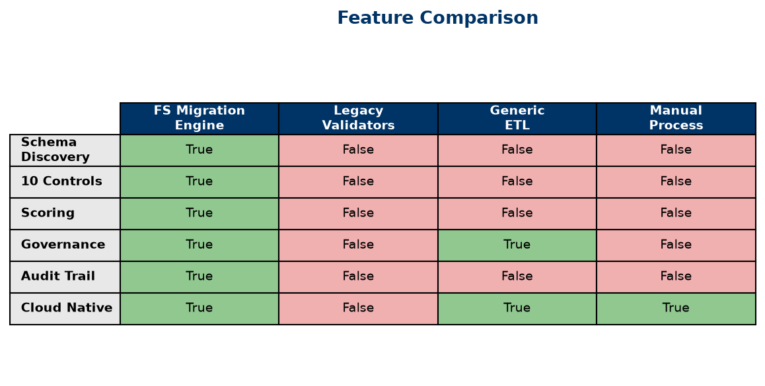
Figure 19: Feature Comparison Matrix

Phase 2.8 — Product Roadmap
Version: 2.0
Product: FS Migration Validation Engine

Vision
To become the standard platform for regulated data migration assurance — helping Financial Services institutions validate every data migration with automated controls, objective scoring, and auditable governance.

Product Evolution
MVP (CLI Engine)
│
▼
Enterprise API Platform (REST API + Dashboard)
│
▼
AI-Assisted Migration (Azure OpenAI Mapping)
│
▼
Multi-Tenant SaaS (Web Portal + Marketplace)
│
▼
Intelligent Migration Platform (AI Agents + Fabric)

Year 1 — Foundation & Validation (Current)

Objective
Establish the platform with Financial Services customers and validate product-market fit.

Completed
Capability | Status
CLI Engine (10 controls) | ✅ Complete
PostgreSQL schema | ✅ Complete
Scoring engine | ✅ Complete
Release gates | ✅ Complete
Audit export (CSV) | ✅ Complete
Docker deployment | ✅ Complete
Control dependency DAG | ✅ Complete
Security scanning | ✅ Complete
REST API (FastAPI) | ✅ Built
Schema discovery | ✅ Built
Rule executor | ✅ Built

In Development
Capability | Timeline
Web dashboard (interactive) | Q3
AI-assisted mapping (Azure OpenAI) | Q4
Enterprise SSO (Entra ID) | Q4

Milestones
- ✅ 5 pilot customers in UK Financial Services
- ✅ Azure Marketplace listing
- ⬜ ISO 27001 certification (Q4)
- ⬜ First paid enterprise customer (Q3)

Year 2 — Enterprise Platform

Objective
Expand to multi-tenant SaaS with enterprise-grade capabilities.
Capability | Description | Priority
Multi-tenant architecture | Isolated customer workspaces | High
Interactive dashboard | Real-time migration quality visualisation | High
AI mapping recommendations | Azure OpenAI-powered schema matching | High
User management | RBAC, team collaboration | Medium
Advanced reporting | Custom report builder | Medium
API versioning | v2 API with enhanced capabilities | Medium
Power BI integration | Embedded analytics | Low

Milestones
- 30+ enterprise customers
- European market expansion
- 2+ system integrator partnerships
- Microsoft co-sell programme enrolment

Year 3 — AI-Powered Migration Intelligence

Objective
Transition from automated validation to intelligent migration decision support.
Capability | Description
Intelligent mapping engine | ML-powered schema matching with confidence scoring
Predictive risk scoring | AI models predict migration failure risk
Regulatory template library | Pre-built controls for Basel, SOX, FCA, PRA
Anomaly detection | AI identifies unusual data patterns during migration
Natural language queries | Ask questions about migration quality in plain English
Automated remediation suggestions | AI recommends fixes for failed controls

Milestones
- 100+ customers
- $10M+ ARR
- North America market entry
- Series A fundraising

Year 4+ — Intelligent Migration Platform

Objective
Become the comprehensive platform for migration governance and intelligence.
Capability | Description
AI agents | Autonomous migration monitoring and alerting
Microsoft Fabric integration | Enterprise data platform connectivity
Marketplace | Third-party control and integration marketplace
Multi-cloud | AWS, GCP migration validation support
Compliance automation | Automated regulatory reporting for migrations
Migration knowledge graph | Cross-project migration intelligence

Technology Roadmap
Capability | Y1 | Y2 | Y3 | Y4+
CLI Engine | ✅
REST API | ✅
PostgreSQL | ✅
Docker | ✅
Web Dashboard | 🔄 | ✅
Azure OpenAI | 🔄 | ✅
Multi-Tenant SaaS |  | ✅
RBAC / SSO |  | ✅
Power BI |  | ✅
AI Mapping Engine |  | 🔄 | ✅
Regulatory Templates |  |  | ✅
Predictive Risk |  |  | ✅
Microsoft Fabric |  |  |  | ✅
Multi-Cloud |  |  |  | ✅
AI Agents |  |  |  | ✅
Marketplace |  |  |  | ✅
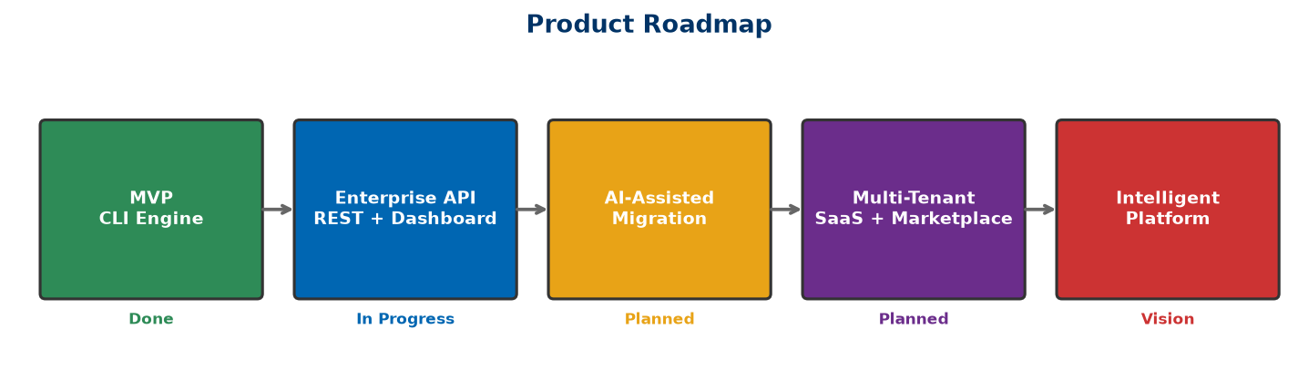
Figure 20: Product Evolution Roadmap

Phase 2.9 — Investor FAQ
Version: 2.1
Product: FS Migration Validation Engine
Currency: GBP (£) — UK-based company

Company & Vision

1. What problem are you solving?
Financial Services institutions migrating data between systems lack automated validation tools. They rely on manual sampling, spreadsheets, and custom scripts — resulting in incomplete coverage, no audit trail, and high risk of undetected data errors. In regulated environments, this is unacceptable.

2. Why is this problem important now?
Three trends converge: (1) accelerating cloud migration in Financial Services, (2) increasing regulatory pressure for data integrity (FCA, PRA, Basel IV, SOX), and (3) retirement of legacy platform experts. Institutions need automated, governed, and audit-ready validation — not manual processes from a bygone era.

3. Who are your customers?
Tier 1–3 banks, insurance companies, asset managers, FinTechs, and regulated enterprises undergoing data migration. Initial focus on UK Financial Services, expanding to Europe and North America.

4. How large is the opportunity?
Global TAM estimated at $8–12B annually across Financial Services data migration, RegTech, and data validation. SAM of $1.5–2.5B for Azure-centric FSI organisations. SOM of $10–30M in Year 1–2.

Product

5. What does the platform do?
Automated data migration validation. It discovers source/target schemas, runs 10 structured validation controls (row counts, data types, keys, business rules, etc.), scores migration quality, enforces release gates, and produces audit-ready CSV exports.

6. What makes you different from ETL testing tools?
We're purpose-built for data migration, not generic ETL testing. Our 10 controls are standardised for migration validation. We include governance features (release gates, audit trails, dependency management) that ETL tools don't have. And we're focused specifically on regulated Financial Services.

7. Is your technology defensible?
Yes — our defensibility comes from: (1) domain expertise in Financial Services migration, (2) proprietary control framework (C01–C010), (3) modular Platform Core architecture, (4) customer implementation knowledge, and (5) regulatory alignment that generic tools can't easily replicate.

8. Do you use AI?
Our current platform is rule-based and metadata-driven — delivering reliable, deterministic validation. We plan to integrate Azure OpenAI for AI-assisted mapping recommendations in Phase 2. We prioritise accuracy and auditability over black-box AI.

Market

9. Who are your competitors?
Manual in-house solutions, ETL testing tools (QuerySurge, iCEDQ), data quality platforms (Informatica, Talend), Big 4 migration services (Accenture, Deloitte), and cloud migration tools (Azure Migrate). None offer our combination of migration-focused controls, governance, audit, and lightweight deployment.

10. Why will customers buy from you instead of building internally?
Building an equivalent platform requires expertise in migration validation, database internals, governance frameworks, and regulatory compliance — plus months of development. Our platform is ready to deploy today, standardised, and continuously improved.

11. What is your pricing model?
SaaS subscription — £1,500–£3,500/month (Starter), £3,500–£10,000/month (Professional), £10,000–£35,000/month (Enterprise), custom for Strategic deployments. Plus professional services for implementation (£15k–£40k) and custom controls (£5k–£20k each).

Business

12. What is your business model?
Recurring SaaS subscriptions with tiered pricing based on migration project volume and support level. Additional revenue from professional services and future AI modules.

13. What are your expected margins?
Gross margins of 80%+ as we scale, typical for SaaS platforms. Operating margins improve from Year 2 as development costs stabilise and revenue scales.

14. How will you acquire customers?
Founder-led direct sales to Financial Services CTOs and Heads of Data, Azure Marketplace listings, system integrator partnerships (Accenture, Deloitte, Infosys), and Microsoft co-sell programme.

15. What is your sales cycle?
2–4 months for mid-size banks and FinTech, 6–12 months for large Tier 1 banks. Pilot projects provide a faster entry path.

Funding

16. How much funding are you seeking?
£500,000–£750,000 seed round, or utilisation of Azure Founders Hub credits (up to £120,000) for initial infrastructure and development. As a UK-based company, we are also exploring Innovate UK Smart Grants and EIS-qualified angel investment.

17. How will the funds be used?
40% product development (Phase 2), 20% AI mapping module (Azure OpenAI), 20% customer pilots, 10% security certifications, 10% marketplace readiness.

18. What milestones will this funding achieve?
Product validation with 5+ Financial Services customers, Azure Marketplace listing, ISO 27001 certification, repeatable sales process, and £450k+ ARR.

Risks

19. What are the biggest risks?
Enterprise sales cycles are longer than consumer SaaS. Competition from established data quality vendors. Customer adoption of new validation methodologies. These are mitigated through pilot programmes, SI partnerships, and Financial Services domain focus.

20. What prevents Microsoft or a large vendor from copying you?
Large vendors move slowly in specialised niches. Our Financial Services domain expertise, migration-specific control framework, and customer implementation knowledge create a moat. We're not competing with Azure Migrate — we complement it.

Phase 2.10 — Demo Script
Version: 2.0
Product: FS Migration Validation Engine
Duration: 10–15 minutes

Objective
Demonstrate how the FS Migration Validation Engine automates data migration validation for Financial Services — from schema discovery through 10 validation controls, objective scoring, release gate enforcement, and audit-ready exports.

Demo Flow
Section | Duration
Introduction & Problem | 1 min
Platform Overview | 2 mins
Schema Discovery | 2 mins
Validation Execution (C01–C010) | 3 mins
Scoring & Release Gates | 2 mins
Audit Export | 2 mins
API Integration | 1 min
Closing & Business Value | 2 mins
**Total** | **~15 minutes**

1. Opening (1 Minute)
"Financial Services institutions migrating data between systems face a critical challenge: how to ensure accuracy, completeness, and regulatory compliance when millions of records are in motion.

Traditional approaches rely on manual sampling, spreadsheets, and custom scripts — which are slow, error-prone, and fail regulatory scrutiny.

The FS Migration Validation Engine automates this process — providing complete validation coverage, objective scoring, governance, and audit-ready evidence."

2. Platform Overview (2 Minutes)
Show the CLI interface and explain the architecture:
FS Migration Validation Engine v1.4
├── 10 Migration Controls (C01–C010)
├── Automated Scoring Engine
├── Release Gate Enforcement
├── Audit Export (CSV)
├── REST API (FastAPI)
└── Docker Deployment
"The engine runs as a CLI tool, REST API, or Docker container. It connects to source and target databases, runs 10 standardised validation controls, scores the results, enforces release gates, and produces audit-ready CSV exports."

3. Schema Discovery (2 Minutes)
Show the discovery command:
python app/main.py discover --config config.yaml
Highlight:
- Automated connection to source and target databases
- Schema metadata extraction
- Table, column, and relationship discovery
"The discovery engine automatically connects to source and target databases, extracts schema information, and builds a metadata repository. No manual schema documentation required."

4. Validation Execution (3 Minutes)
Show the run command:
python app/main.py run --config config.yaml
Walk through controls being executed:
Control | Description | Example Output
C01 | Row count reconciliation | "PASS — Source: 1,234,567 vs Target: 1,234,567"
C02 | Data type validation | "PASS — All column types match"
C03 | Nullability check | "PASS — All constraints satisfied"
C04 | Primary key integrity | "PASS — No duplicates"
C05 | Foreign key integrity | "PASS — All references valid"
C06 | Business rule validation | "3 WARNINGS — See exception register"
C07–C010 | Additional controls | "PASS / WARN / FAIL per control"

"Each control runs independently with failure isolation. Results are captured with unique batch IDs for full traceability. The control dependency DAG ensures correct execution order — C02 waits for C01, C09 waits for C03."

5. Scoring & Release Gates (2 Minutes)
Show the scoring output:
Batch: ae40b96c-20da-4972-bb29-bff3c2451ae0
Overall Score: 87/100
Controls Passed: 8/10
Controls Warning: 2/10
Controls Failed: 0/10
RELEASE GATE: PASSED (minimum 80% threshold met)
Migration: APPROVED
"The scoring engine produces objective, repeatable quality metrics. The release gate enforces a minimum quality threshold — if the score drops below 80%, the migration is blocked."

6. Audit Export (2 Minutes)
Show the export command:
python app/main.py export --config config.yaml --batch-id <id>
Show sample CSV output:
batch_id,control_id,status,score,exceptions,timestamp
ae40...,C01,PASS,100,0,2026-06-23 10:00:00
ae40...,C02,PASS,100,0,2026-06-23 10:00:05
ae40...,C06,WARN,70,3,2026-06-23 10:00:30
"Every validation execution produces a complete audit trail — suitable for regulatory review. No manual evidence gathering required."

7. API Integration (1 Minute)
Show a sample API call:
curl -X POST https://api.example.com/api/v1/validate \
-H "Content-Type: application/json" \
-d '{"project_id": "ae40...", "controls": ["C01","C02"]}'
"The FastAPI REST API enables integration with existing CI/CD pipelines, deployment workflows, and enterprise toolchains."

8. Closing Summary (2 Minutes)
"In just a few minutes, we've demonstrated:

✅ **Automated schema discovery** — No manual analysis required
✅ **10 structured validation controls** — Complete, standardised coverage
✅ **Objective scoring** — Repeatable quality metrics
✅ **Release gate governance** — Automated migration approval/blocking
✅ **Audit-ready exports** — CSV evidence for regulatory review

The platform is Azure-native, Docker-deployable, and purpose-built for regulated Financial Services data migration.

Our mission is to transform data migration validation from a manual, high-risk exercise into an automated, governed, and audit-ready process."

Demo Environment Requirements
Item | Details
**Engine** | Running instance of FS Migration Validation Engine
**Databases** | Source and target PostgreSQL databases with demo data
**Configuration** | `config.yaml` with DemoBank settings
**CLI** | Terminal with Python environment activated
**Sample Data** | `sql/demo/` — demo source and target data scripts
**Backup** | `engine_backup.sql`, `source_backup.sql`, `target_backup.sql`

Key Messages to Reinforce
- Purpose-built for Financial Services — Not a generic ETL tool
- Automated and repeatable — Same inputs, same outputs, every time
- Governance-first — Release gates, audit trails, compliance built-in
- Lightweight deployment — Docker-native, deploy in minutes
- Azure-native — Built for the Microsoft ecosystem
- Enterprise-ready — Secure, scalable, auditable

