Market Penetration of Bowtie VHIS proposal
(targeting early working adults)

Introduction to the Target Segment
In Hong Kong's changing insurance market, young adults just starting work—mostly millennials and Gen Z people born in the 1990s and 2000s—stand out as a key and always fresh group. Below are their Characteristics and Preferences:
． Each year, a big wave of new graduates enters the job world, creating steady chances to connect with them and grow the market.
． This group is paying more attention to their health and overall well-being, driven by new social trends and a stronger focus on preventive care.
． Recent studies show they actively buy health products and services.
． Unlike older groups, they value making their own choices and hate pushy sales.
． They prefer clear, helpful ways to interact that help them make smart decisions in their fast, tech-filled lives.

Bowtie VHIS to Promote
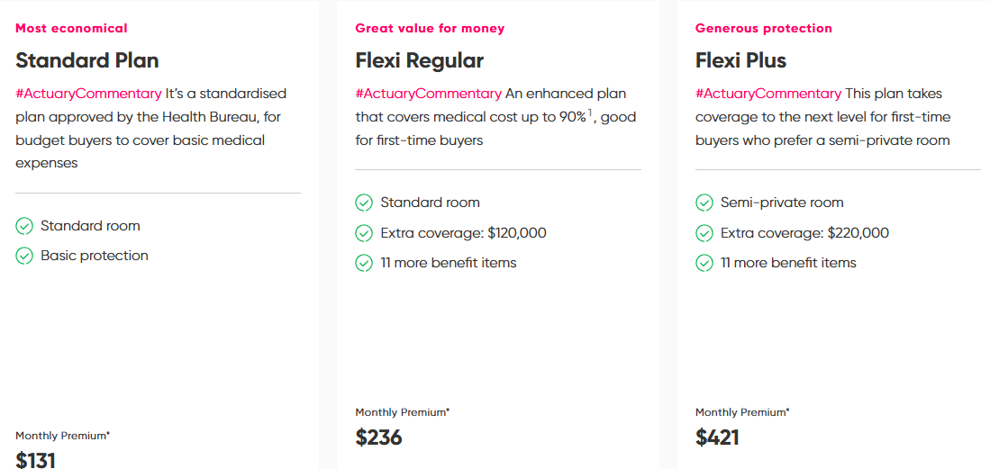

Why Bowtie
Competitive Advantages
- First fully virtual insurer in Hong Kong, authorized in 2018, enabling a streamlined, agent-free model that cuts out commissions and reduces premiums by up to 50% compared to traditional insurers.
- Focus on pure protection products with transparent pricing and no hidden fees, contrasting with competitors' complex structures.
- Entirely digital processes: Quotes, applications, claims, and policy management all handled online via app or website for speed and convenience.
- No pushy sales tactics; empowers users with autonomy, including easy anytime cancellations without penalties.
- Guaranteed renewals, simpler claims processes, broader coverage with fewer exclusions, and shorter waiting periods than conventional plans.
- Rapid growth from startup to top 10 life insurer in five years, driven by digital innovation and customer-centric approach.
Strategy Alignment
- The strategy uses digital-first campaigns on platforms like Instagram, TikTok, and YouTube, which match Bowtie's online-only operations and target tech-savvy young adults.
- Emphasizes non-intrusive, informative content (e.g., influencer stories, webinars, SEO articles) to avoid aggressive sales, aligning with the audience's preference for autonomy.
- Highlights affordability, transparency, and ease to showcase Bowtie's no-agent model, building trust and encouraging self-directed conversions.
- Cost-effective outreach leverages Bowtie's low-overhead strengths, driving market penetration among early working adults who value convenience and value.

Digital Marketing Campaigns
Targeted Social Media Ads on Social Media
&
SEO and Paid Search Campaigns for Broader Exposure
These campaigns are designed to capitalize on Bowtie's unique strengths, such as its no-sales-agent model and fully online processes, attracting young searchers who value autonomy and convenience without pushy interactions. The goal is to position Bowtie as the top-of-mind choice when people think of insurance, making it the first brand they recall for quick, hassle-free health coverage.

KPI
． Website Traffic and Engagement: Target 20-30% increase in visitors and session time, linking to lead growth.
． Click-Through Rate (CTR): Aim for 2-5% on ads, reflecting content appeal to the audience.
． Lead Generation and Conversion Rate: Goal of 15% from clicks to quotes/sign-ups, measuring funnel success.

