Q2B
The Search Demand trend over the 24 months shows significant variability: It starts moderate in early 2021, peaks sharply in March (100566), declines mid-year, and ends lower in December (34764). In 2022, it dips in February (24811), rises to a high in June (69516), and tapers off by year-end (46430). A line chart visualization would display these peaks in Q1 2021 and Q2 2022, with overall growth from 2021 to 2022 mid-year but consistent end-of-year drops.
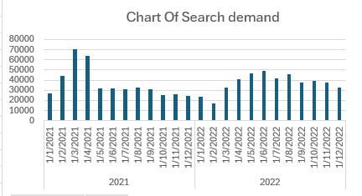

Q2C
From the chart, where the orange line shows Lead Volume and the blue bars represent Search Demand, there's a clear positive correlation between the two. The trends align closely
(Graph below)
