AJ Jordan
Lab 4
CSC 172
February 18th, 2018

Task 1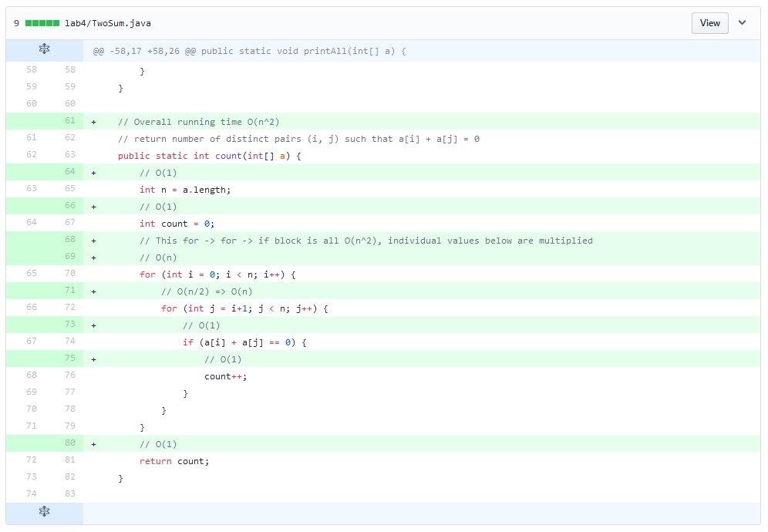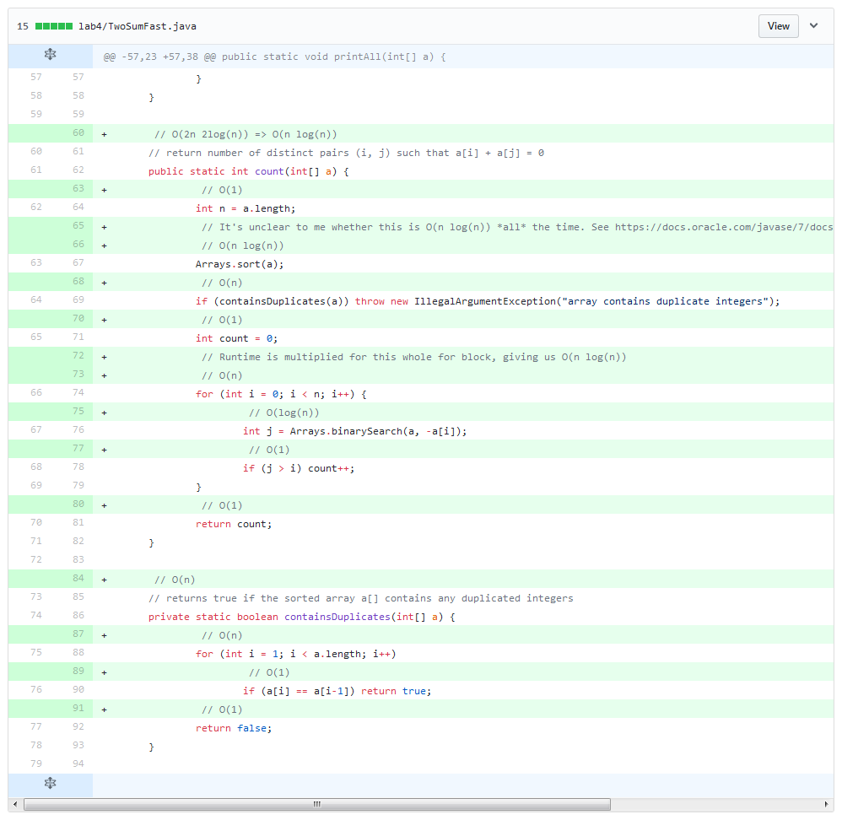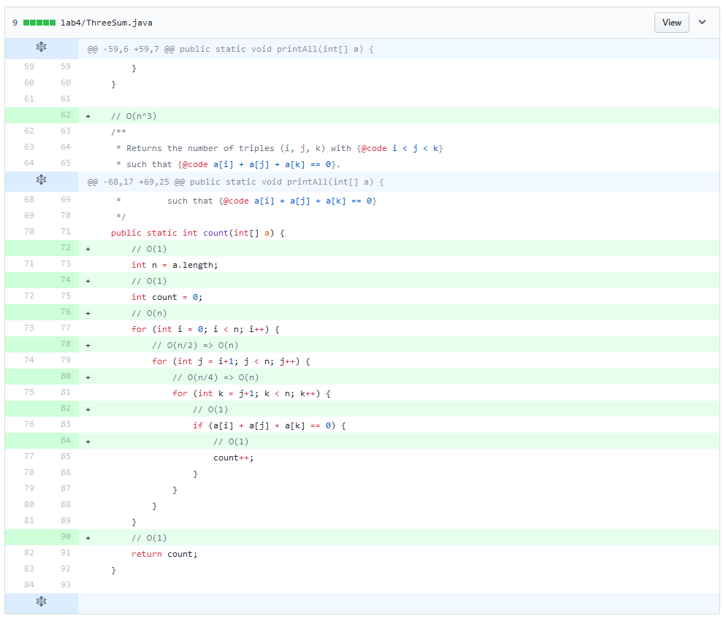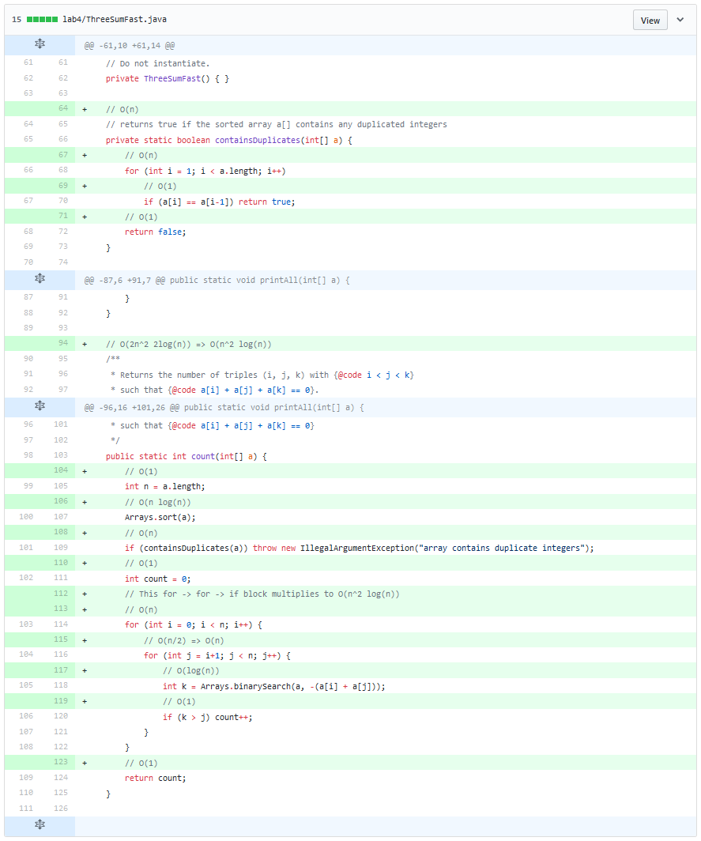
See the accompanying annotated source code. These diff view was taken from GitHub: https://github.com/strugee/csc-172-labs/commit/53d76fceb1e6074905e3d70f73035950f8502f55#diff-fe915644400aba1a8c272fc955b0c5b4

Task 2
The lab requires us to provide screenshots, so there they are. But probably you want to ignore this section and look at the plaintext version instead, in the “all-run.log” file. 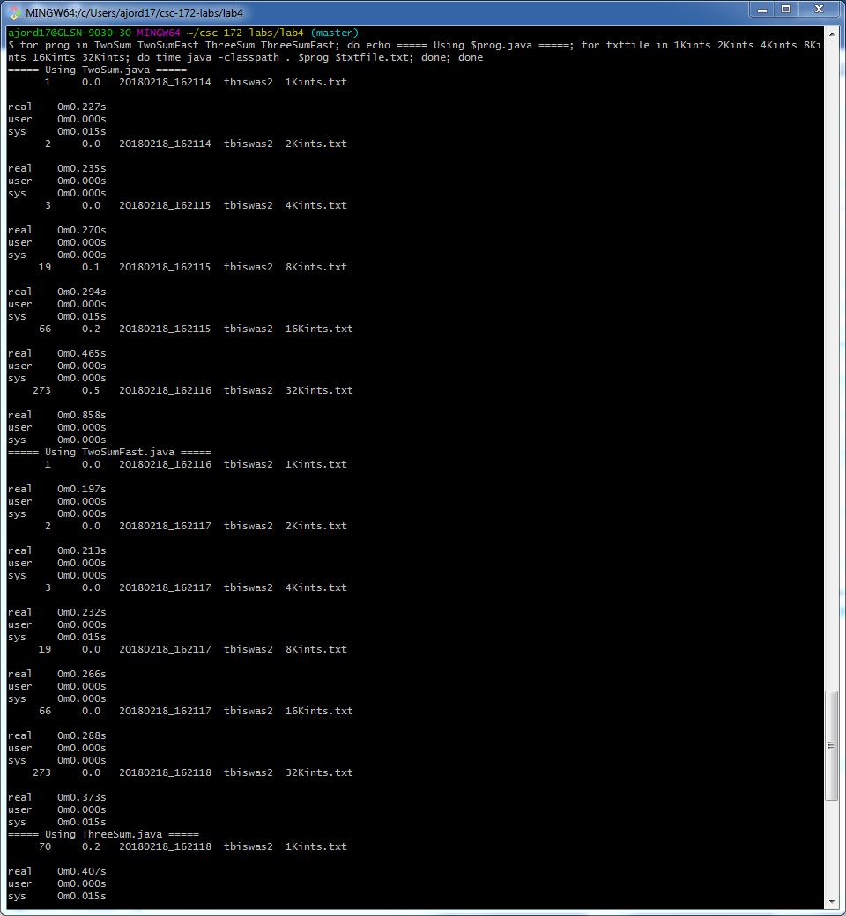
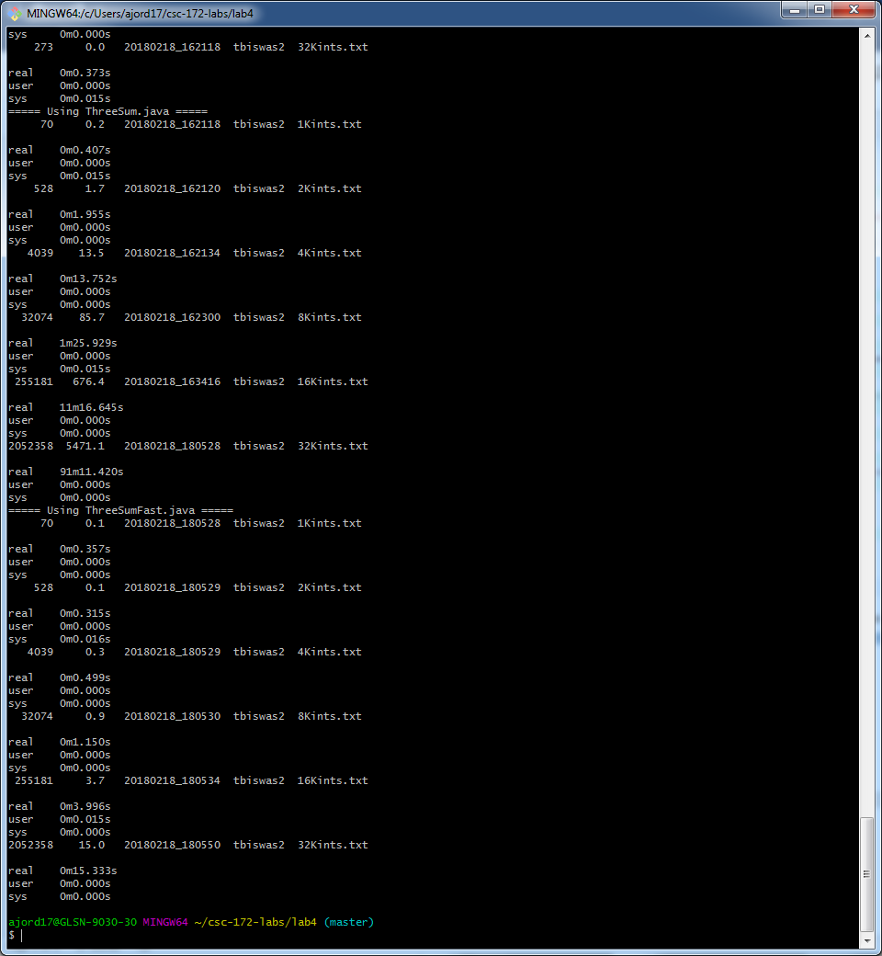

And here are the charts:
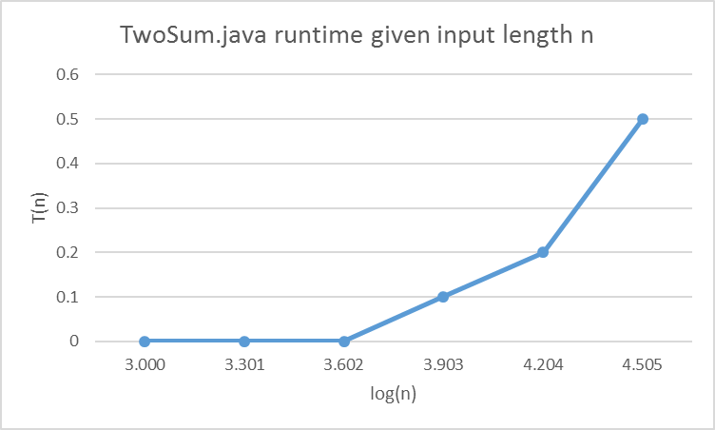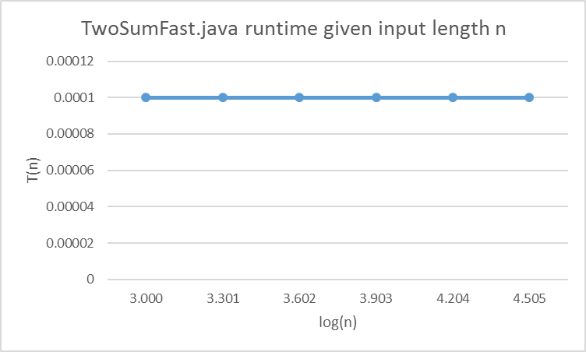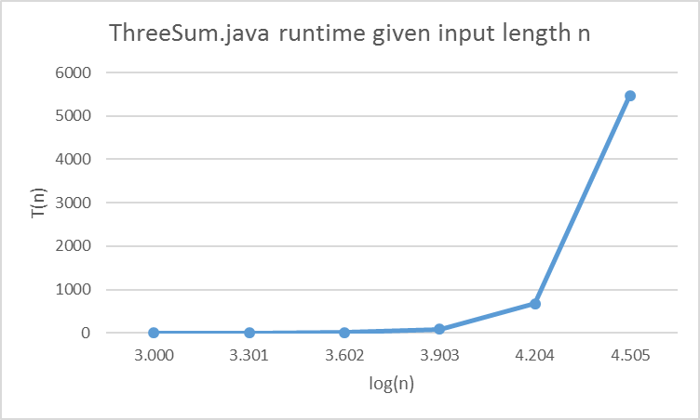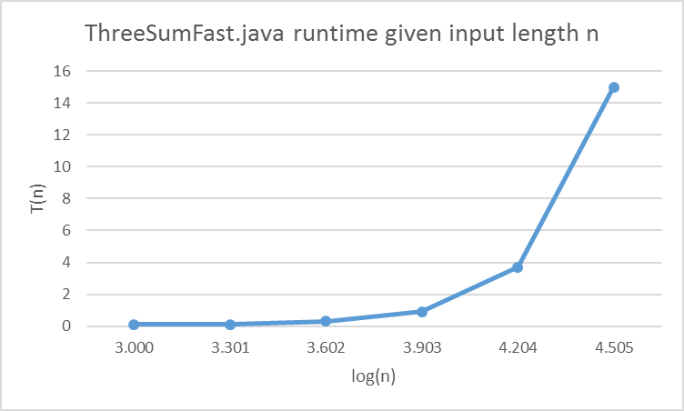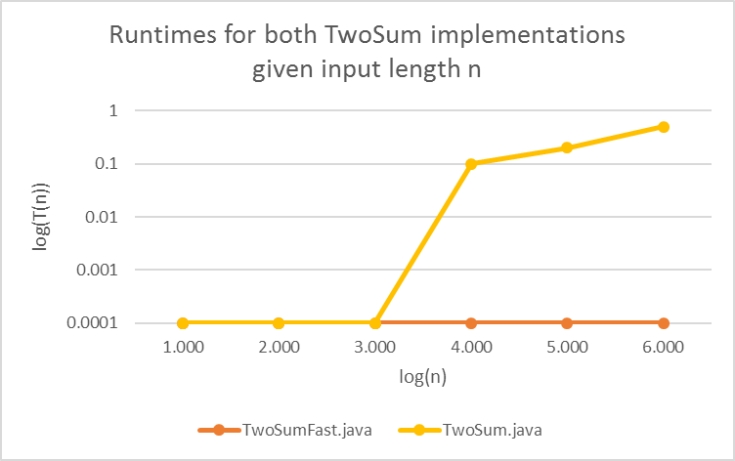
This chart shows that the “naïve” implementation grows quickly when n gets big, whereas the fast algorithm does not grow nearly as quickly.

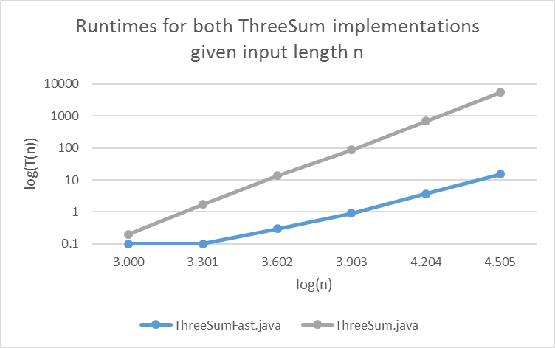
This shows basically the same thing. However it should be noted that the speedup is less noticeable than with TwoSum.

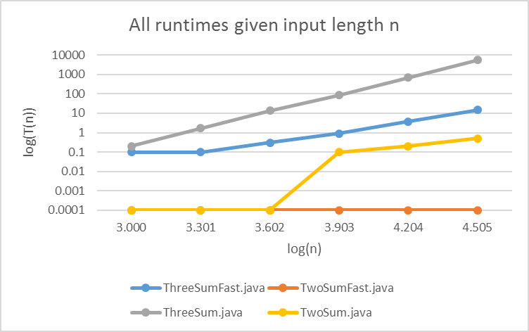

Task 3
For TwoSum, the ratio of the 1k to 2k run was ~1, 2k to 4k was ~1, 4k to 8k was ~.001, 8k to 16k was 0.5. Based on this I would estimate that 32k would be 0.2*2=0.4 seconds, which is pretty close to the real number, 0.5. For 1m (~32,000*2^5), I would estimate 32 seconds.
For TwoSumFast, the ratio of all runs to the last was ~1. Therefore I’d also expect negligible (< 0.01 seconds) execution time for 32k and 1m. This at least holds true for 32k; I did not run 1m.
For ThreeSum, the ratio of the 1k to 2k run was ~0.12, 2k to 4k was ~0.13, 4k to 8k was ~0.16, 8k to 16k was 0.13. I’d estimate that 32k runs with a ratio of ~0.19 (so 28795.26 seconds), but actually it runs with a ratio of ~0.12, or 5471.1. This seems inconsistent with the big-Oh runtime, though, and I suspect the benchmark was affected by something else on the system. (It did run for an hour and a half after all; I did a lot during that time.) Therefore I estimate that the 1m run would take ~130887.56 seconds (a ratio of ~0.22 to the previous), though I didn’t run this.
XXX ThreeSumFast

