Dr. Damian Dechev is an Assistant Professor at the EECS Department at the University of Central Florida and the founder of the Computer Software Engineering - Scalable and Secure Systems Lab at UCF. Dr. Dechev specializes in the design of scalable multiprocessor data structures and algorithms and has applied them in the design of real-time embedded space systems at NASA JPL and the HPC data-intensive applications at Sandia National Labs. In the past four years Dr. Dechev's research in multiprocessor algorithm design has been supported by grants from the National Science Foundation, Sandia National Laboratories, and the Department of Energy.

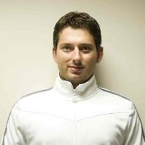

Deli Zhang is a Ph.D. student at the EECS Department at the University of Central Florida. He is also a research assistant in the Computer Software Engineering - Scalable and Secure Systems Lab at UCF. He actively researches in the field of parallel computing. Responsible for the ongoing collaboration project with Sandia Nation Laboratory on performance analysis and automatic validation of SST/Macro, a coarse-grained simulator of exascale parallel machines. Other researches include developing non-blocking data structures and algorithms, applying non-blocking synchronization in existing performance critical applications.

