HORECA1
Technology Stack, Pricing &
System Architecture Report

━━━━━━━━━━━━━━━━━━━━━━━━━━━━━━━━━━━━━━━━━━━━━━━━━━

Prepared: March 13, 2026
For: Management Review
Project: Horeca1 — B2B Multi-Vendor Wholesale Marketplace
(Procurement + Cloud-PoS)

1. Executive Summary
Horeca1 is a multi-vendor, multi-store B2B wholesale marketplace — a procurement platform for HORECA customers and a cloud-PoS for vendors. This report covers every technology in our proposed stack: what it does, whether we actually need it right now, when it becomes critical, and exactly how much it costs in Indian Rupees (₹).
IMPORTANT: All prices are converted at 1 USD = ₹85 (approximate current rate). All USD-based services will also attract 18% GST on reverse-charge basis for Indian entities.

2. Complete Technology Stack — At a Glance
# | Component | Technology | Type | Cost (Launch)
1 | Frontend Framework | Next.js (App Router) | Open Source / Free | ₹0
2 | Backend (API) | Next.js API Routes | Open Source / Free | ₹0
3 | Database | PostgreSQL (Supabase) | Managed Service | ₹2,125/mo
4 | ORM | Prisma | Open Source / Free | ₹0
5 | Authentication | Supabase Auth | Included | ₹0 (part of DB)
6 | Payments | Razorpay | Per-transaction | ~2% per txn
7 | Search | PostgreSQL FTS + pgvector | Built-in | ₹0
8 | Image Management | ImageKit | Free tier | ₹0 → ₹7,565/mo
9 | Hosting | Vercel | Free → Pro | ₹0 → ₹1,700/mo
10 | Queue / Jobs | Upstash Redis (BullMQ) | Serverless | ₹0 → ₹850/mo
11 | Event Bus | Custom (in-app) | Self-built | ₹0
12 | Logging | Sentry | Free tier | ₹0 → ₹2,210/mo

3. Detailed Breakdown — Each Technology Explained

3.1 Next.js (App Router) — Frontend + Backend
What is it?
Next.js is a React-based framework that lets us build both the website (frontend) and the server/API (backend) in one single codebase.
Why do we need it?
- • Single codebase = faster development, fewer bugs
- • Server-side rendering = better SEO for vendor store pages
- • API Routes = backend APIs right inside the same project
- • Industry standard (Swiggy, Zomato, Flipkart use React/Next.js)
Do we really need it? ✅ YES — Absolutely essential. Non-negotiable.
Cost: ₹0 — Open source, completely free.

3.2 PostgreSQL Database (via Supabase)
What is it?
PostgreSQL is the world's most advanced open-source relational database. Supabase is a managed platform that hosts PostgreSQL for us — no need to hire a database admin or manage servers.
What Supabase gives us:
- • Hosted PostgreSQL database (no server management)
- • Built-in Authentication (login, signup, OTP)
- • Real-time subscriptions (live updates for orders, stock)
- • Row-Level Security (multi-tenancy — each vendor sees only their data)
Do we really need it? ✅ YES — Core infrastructure.
Pricing:
Plan | Monthly (₹) | Annual (₹) | What You Get
Free | ₹0 | ₹0 | 500 MB storage, 50K auth users
Pro ⭐ | ₹2,125 | ₹25,500 | 8 GB storage, 100K users, backups
Team | ₹50,915 | ₹6,10,980 | SOC2, SSO, higher limits
Enterprise | Custom | Custom | HIPAA, VPC, 24/7 support
RECOMMENDATION: Start FREE during dev. Move to Pro (₹2,125/mo) at launch. Handles 100K monthly active users.
When to upgrade:
User Range | Plan Needed | Monthly Cost
0 – 500 users | Free | ₹0
500 – 50,000 | Pro | ₹2,125/mo
50K – 100K | Pro + Compute | ₹8,500 – ₹10,625/mo
100,000+ | Team / Enterprise | ₹50,915+/mo

3.3 Supabase Auth — Authentication
Handles all login/signup flows — email + password, OTP, social logins, session management.
Do we really need it? ✅ YES — Every user must log in.
Cost: ₹0 — Included with Supabase. Free: 50K MAUs. Pro: 100K MAUs.

3.4 Prisma ORM
Lets developers write database queries in TypeScript instead of raw SQL. Auto-generates types, handles migrations.
Do we really need it? ✅ YES — Critical for productivity.
Cost: ₹0 — Completely free and open-source.

3.5 Razorpay — Payment Gateway
India's leading payment gateway. Supports UPI, cards, net banking, wallets, EMI.
Do we really need it? ✅ YES — Cannot process payments without it.
Pricing:
Payment Method | Fee | GST
UPI | 2% | +18% GST
Debit/Credit Cards | 2% | +18% GST
Net Banking / Wallets | 2% | +18% GST
EMI / Corp Cards / Intl | 3% | +18% GST
NOTE: No monthly fee, no setup fee, no AMC. Only on successful transactions. >₹5L/mo gets custom rates.
Example: ₹10,000 order via UPI → Fee ₹200 + GST ₹36 = ₹236 deducted. Vendor gets ₹9,764.

3.6 PostgreSQL Full-Text Search + pgvector
Built-in search in PostgreSQL. pgvector adds AI-powered semantic search.
Do we really need it? ✅ YES — Search is critical for our UX.
Cost: ₹0 — Built into PostgreSQL.

3.7 ImageKit — Image CDN & Management
Image hosting, optimization, and CDN service for product images and vendor assets.
Do we really need it? ⚠️ RECOMMENDED — can start FREE.
Plan | Monthly (₹) | Annual (₹/yr) | What You Get
Free Forever | ₹0 | ₹0 | 20 GB bandwidth, 3 GB storage
Premium | ₹7,565 | ₹90,780 | 225 GB bandwidth, 225 GB storage
Enterprise | ₹42,500+ | Custom | Custom CDN, SSO, support
RECOMMENDATION: Free plan handles ~1M image deliveries/mo. Upgrade at 5,000+ products.

3.8 Vercel — Hosting & Deployment
Hosting, CI/CD, global CDN, serverless functions — optimized for Next.js.
Do we really need it? ✅ YES — Best hosting for Next.js.
Plan | Monthly (₹) | Annual (₹/yr) | What You Get
Hobby (Free) | ₹0 | ₹0 | Non-commercial only
Pro ⭐ | ₹1,700/user | ₹20,400/user | 10M requests, 1 TB bandwidth
Enterprise | Custom | Custom | 99.99% SLA, SSO
IMPORTANT: Hobby is non-commercial only. Horeca1 MUST use Pro (₹1,700/mo) from launch.

3.9 Upstash Redis + BullMQ — Queue / Background Jobs
Serverless Redis + job queue for background tasks (notifications, invoicing, reconciliation, AI).
Do we need it NOW? ⚠️ Not Day 1, but within 1-2 months.
Phase | Needed? | Why
MVP (0-500) | ❌ Can defer | Simple workarounds suffice
Post-Launch (500-5K) | ✅ YES | Notifications, invoicing critical
Scale (5,000+) | ✅ CRITICAL | Tasks fail under load
Plan | Monthly (₹) | Annual (₹) | What You Get
Free | ₹0 | ₹0 | 256 MB, 500K commands/mo
Fixed 250 MB | ₹850 | ₹10,200 | 50 GB bandwidth
Fixed 1 GB | ₹1,700 | ₹20,400 | 100 GB bandwidth

3.10 Event Bus — Internal Event System
Modules emit events (e.g., "OrderConfirmed") and others react — decoupled communication.
Do we need it? ✅ YES — Self-built, FREE.
Scale | Solution | Cost
0 – 10K users | In-app EventEmitter | ₹0
10K – 50K | Redis Pub/Sub | Included
50K+ | Apache Kafka | ₹15,000 – ₹50,000/mo

3.11 Sentry — Error Monitoring & Logging
Auto-captures errors, crashes, performance issues. Alerts dev team proactively.
Do we need it? ⚠️ FREE from Day 1. Paid when team grows.
Plan | Monthly (₹) | Annual (₹) | What You Get
Developer (Free) | ₹0 | ₹0 | 5K errors/mo, 1 user
Team | ₹2,210 | ~₹22,100 | 50K errors, unlimited users
Business | ₹6,800 | ~₹68,000 | 100K errors, SSO

4. Monthly Cost Summary — What We MUST Pay

🟢 Phase 1: Development (0 – 500 users)
Service | Plan | Monthly (₹)
Next.js | Free | ₹0
Supabase | Free | ₹0
Prisma | Free | ₹0
Razorpay | Per-txn | ₹0 fixed
Search | Built-in | ₹0
ImageKit | Free | ₹0
Vercel | Hobby | ₹0
Upstash Redis | Free | ₹0
Event Bus | Self-built | ₹0
Sentry | Free | ₹0
TOTAL |  | ₹0/mo

🟡 Phase 2: Launch (500 – 5,000 users)
Service | Plan | Monthly (₹)
Next.js | Free | ₹0
Supabase | Pro | ₹2,125
Prisma | Free | ₹0
Razorpay | Per-txn | ₹0 fixed
Search | Built-in | ₹0
ImageKit | Free | ₹0
Vercel | Pro | ₹1,700
Upstash Redis | Fixed 250MB | ₹850
Event Bus | Self-built | ₹0
Sentry | Free→Team | ₹0–₹2,210
TOTAL |  | ₹4,675–₹6,885/mo

🔴 Phase 3: Growth (5,000 – 50,000 users)
Service | Plan | Monthly (₹)
Next.js | Free | ₹0
Supabase | Pro+Compute | ₹8,500
Prisma | Free | ₹0
Razorpay | Per-txn | ₹0 fixed
Search | Built-in | ₹0
ImageKit | Premium | ₹7,565
Vercel | Pro (3) | ₹5,100
Upstash Redis | Fixed 1GB | ₹1,700
Event Bus | Redis | Included
Sentry | Team | ₹2,210
TOTAL |  | ~₹25,075/mo

5. System Architecture Design

5.1 Architecture Overview
The system follows a 5-layer architecture. The diagram below shows how all components connect:
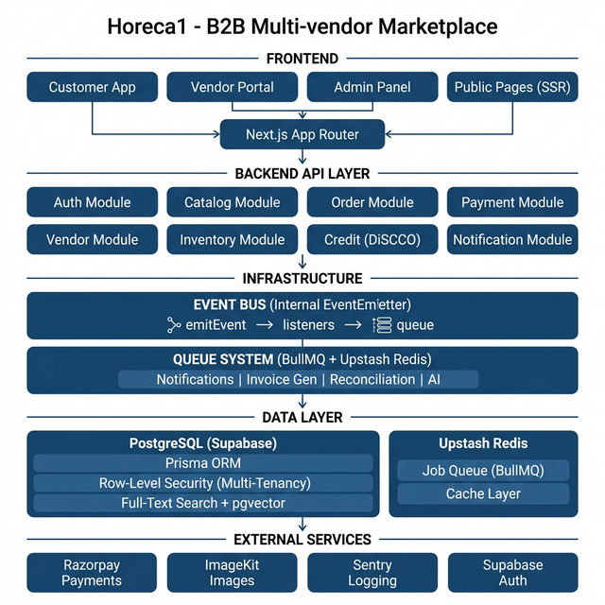
Figure 1: Horeca1 System Architecture — 5-Layer Design

- Layer 1 — FRONTEND: Next.js App Router (Customer App, Vendor Portal, Admin Panel, Public Pages)
- Layer 2 — BACKEND API: Next.js API Routes with 9 independent modules
- Layer 3 — INFRASTRUCTURE: Event Bus + Queue System (BullMQ + Redis)
- Layer 4 — DATA: PostgreSQL (Supabase) with Prisma, RLS, FTS; Redis for queues/cache
- Layer 5 — EXTERNAL: Razorpay, ImageKit, Sentry, Supabase Auth

5.2 Modular Backend — NO Monolith
Each module owns its data and APIs. Modules communicate via Event Bus, never directly.
Module | Owns | Key APIs | Events Emitted
Auth | Users, Sessions, Roles | login, signup, verifyOTP | UserRegistered, UserLoggedIn
Vendor | Profiles, stores, settings | createVendor, updateStore | VendorOnboarded, StoreUpdated
Catalog | Products, categories, pricing | addProduct, searchProducts | ProductAdded, PriceUpdated
Inventory | Stock levels, availability | checkStock, updateStock | StockUpdated, OutOfStock
Order | Orders, POs, history | createPO, confirmOrder, reorder | OrderCreated, OrderConfirmed
Payment | Transactions, settlements | initiatePayment, verify | PaymentReceived, PaymentFailed
Credit | Credit lines, limits, dues | checkCredit, applyCredit | CreditApplied, CreditDue
Notification | Templates, logs | sendSMS, sendEmail, sendWA | NotificationSent/Failed
Quick Order | Saved lists, templates | createList, orderFromList | ListCreated, ListOrdered

5.3 Multi-Tenancy — Vendor Data Isolation
Every vendor-specific table has a "vendor_id" column. PostgreSQL Row-Level Security (RLS) enforces data isolation at the database level.
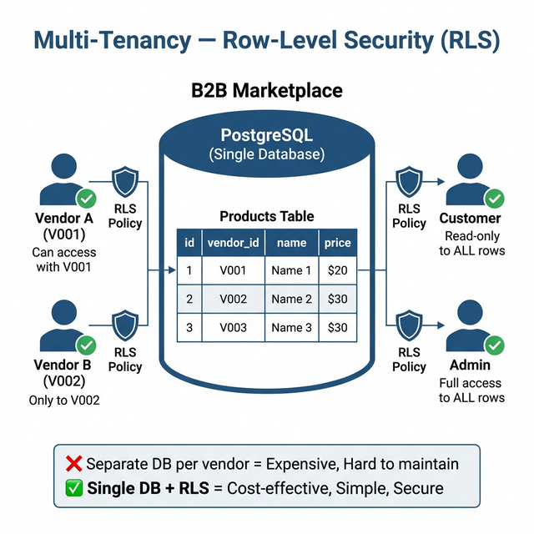
Figure 2: Multi-Tenancy via Row-Level Security (RLS)

- • Vendor A sees ONLY Vendor A's data
- • Vendor B sees ONLY Vendor B's data
- • Customers see ALL vendors in their pincode area (read only)
- • Admin sees ALL data (full access)
Why Single DB + RLS, not separate databases?
- • Separate DB per vendor = expensive, hard to maintain, hard to search across
- • Single DB + RLS = cost-effective, simpler, security enforced at DB level

5.4 API Design — Versioned REST APIs
All APIs are versioned (/api/v1/) — new versions can be released without breaking existing clients.
Endpoint | Method | Purpose
/api/v1/auth/login | POST | Login with OTP/password
/api/v1/auth/signup | POST | Register user
/api/v1/vendors | GET | List vendors by pincode
/api/v1/vendors/:id | GET | Vendor store details
/api/v1/vendors/:id/products | GET | Vendor catalog
/api/v1/products/search | GET | Search across vendors
/api/v1/categories | GET | Category listing
/api/v1/orders | POST | Create Purchase Order
/api/v1/orders/reorder/:id | POST | Reorder past order
/api/v1/cart | GET | View cart (vendor-grouped)
/api/v1/cart/checkout | POST | Initiate checkout
/api/v1/lists | GET | Quick Order Lists
/api/v1/lists/:id/order | POST | Order from list
/api/v1/payments/initiate | POST | Start Razorpay payment
/api/v1/payments/verify | POST | Verify webhook
/api/v1/credit/check | GET | Check credit
/api/v1/credit/apply | POST | Apply credit

5.5 Event-Driven Flow — Order Placement
The diagram below shows what happens when a customer places an order:
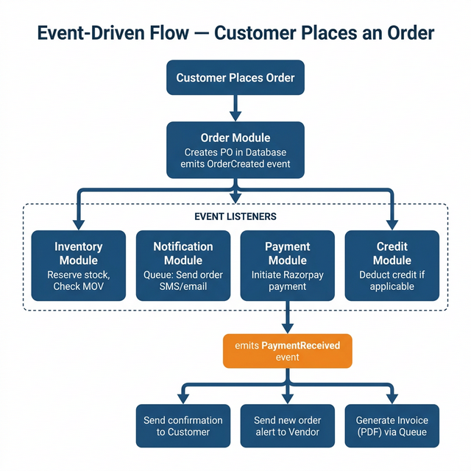
Figure 3: Event-Driven Order Flow — from Customer to Invoice

Step 1: Customer places order → Order Module creates PO → emits "OrderCreated"
Step 2: Event listeners react:
- • Inventory → Reserve stock, check MOV
- • Notification → Queue SMS/email to customer
- • Payment → Initiate Razorpay payment
- • Credit → Deduct credit if applicable
Step 3: After payment confirmed → "PaymentReceived" triggers:
- • Confirmation to Customer & Vendor
- • Invoice PDF generation via background queue

6. Compulsory vs. Optional — Decision Matrix
Technology | Compulsory? | Start Free? | When Paid Required
Next.js | ✅ Yes | ✅ Always Free | Never
PostgreSQL (Supabase) | ✅ Yes | ✅ Yes | At launch (₹2,125/mo)
Supabase Auth | ✅ Yes | ✅ Yes | Included with Supabase
Prisma ORM | ✅ Yes | ✅ Always Free | Never
Razorpay | ✅ Yes | ✅ No monthly fee | Txn fees from Day 1
PostgreSQL FTS | ✅ Yes | ✅ Always Free | Never
Vercel | ✅ Yes | ⚠️ Dev only | At launch (₹1,700/mo)
ImageKit | ⚠️ Recommended | ✅ Yes | >20GB BW (~3K users)
Upstash Redis | ⚠️ Soon | ✅ Yes | >500K cmds (~1K users)
Event Bus | ✅ Yes | ✅ Self-built | External at 50K+ only
Sentry | ⚠️ Recommended | ✅ Yes | >5K errors or team>1

7. Minimum Compulsory Monthly Spend at Launch
Service | Monthly (₹) | Annual (₹)
Supabase Pro | ₹2,125 | ₹25,500
Vercel Pro (1 user) | ₹1,700 | ₹20,400
FIXED TOTAL | ₹3,825/mo | ₹45,900/yr
NOTE: Plus Razorpay transaction fees (2% + GST). Everything else starts free.

8. Key Architectural Principles
Principle | How We Implement It
No Monolith | Independent modules with own data & APIs
Clear Data Ownership | Each module owns its tables exclusively
Multi-Tenancy at DB | PostgreSQL RLS per vendor
API-First | Versioned REST APIs (/api/v1/)
Event-Driven | All critical actions emit events
Queue System | BullMQ + Upstash Redis
Logging & Monitoring | Sentry + PostgreSQL audit logs

Critical Notes for Manager
1. Minimum fixed cost to go live: ₹3,825/month (~₹46K/year)
2. Razorpay charges are variable (2% + GST per payment)
3. At 5,000 users → ₹6,000 – ₹8,000/mo infrastructure cost
4. At 50,000 users → ₹25,000 – ₹30,000/mo (very cost-effective for B2B SaaS)
5. All base prices in USD — actual ₹ varies with exchange rate

━━━━━━━━━━━━━━━━━━━━━━━━━━━━━━━━━━━━━━━━━━━━━━━━━━
End of Report

