


Your Trusted Partner in Global Chemical SuPR!X + 3PL Solutions
(Specializing in Phosphorus Chemicals | Amines | Phenols | Custom Demulsifiers & Emulsiliers)

About Us
Robust India is a premier import—export company providing end-to-end chemical supply-chain and FTWZ logistics solutions. Built on reliability, transparency,
and innovation, we deliver specialty and bulk chemicals
to industries including oil & gas, agrochemicals, water treatment, lubricants, and specialty polymers.

Phosphorus-Based Chemicals
* I

Trimethyf Phosphite | 121-45-9 | Intermediate for agrochemicals and flame retardants
Triphenyl Phosphite | 101-02-0 | Antioxidant and stabilizer in polymers and lubricant
Triethyf Phosphite | 122-52-1 | Intermediate for organophosphorus compounds
Diethyf Phosphite | 762-04-9 | Intermediate for flame retardants and plasticizers
Dimethyl Phosphite (DMPi) | 868-85-9 | Intermediate for phosphonate esters and pesticides
Dimethyf Methylphosphonate (DMf•tP) | 756-79-6 | Flame retardant and additive
Tributyl Phosphate (TBP) | 126-73-8 | Solvent and extractant for rare earths and uranium
Red Phosphorus | 7723-14-0 | Used in safety matches and ftame retardants
Sulfur-Based Chemicals

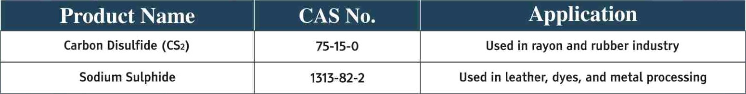
Carbon Disuffide (CS2)
75-15-0
Used in rayon and rubber industry
Sodium Sulphide
1313-82-2
Used in leather, dyes, and metal processing

Cyanide-Based Chemicals

Sodium Cyanide Cyanuric Chloride
* #1
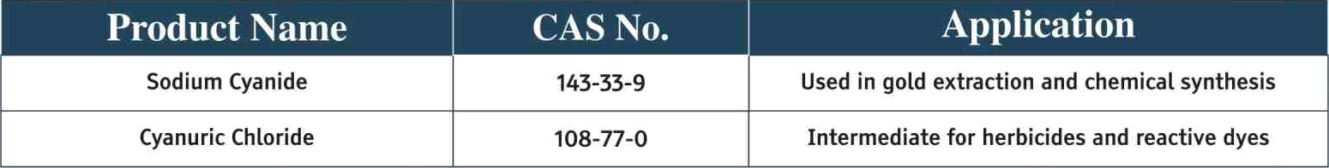
143-33-9 Used in gold extraction and chemical synthesis
108-77-0 Intermediate for herbicides and reactive dyes
Amines

 |  | * I
Ethyfenediamine (EDA) | 107-15-3 | Corrosion inhibitor, chelating agent
Diethylenetriamine (DETA) | 111-40-0 | Used in epoxy curing and oil additives
Aminoethyl Ethanolamine (AEEA) | 111-41-1 | Surfactant intermediate and corrosion inhibitor
Aminoethyl Piperazine (AEP) | 140-31-8 | Used in polyurethane and epoxy curing agents | ^
Piperazine (Anhydrous) | 110-85-0 | Pharmaceutical and corrosion inhibitor intermediate

Alkanolamines Group
I I
Methyl Monoethanolamine (MMEA) | 109-83-1 | Gas treating agent, surfactant intermediate
Methyl Diethanolamine (MDEA) | 105-59-9 | Acid gas scrubbing, absorbent for Com and H2S
Di-Methyl Ethanofamine (DMEA) | 108-01-0 | Intermediate for corrosion inhibitors and surfactants
Di-Ethyl Ethanolamlne (DEEA) | 100-37-8 | Gas treating and catalyst intermediate
Ethyl f'tonoethanolamine (Ef tEA) | 110-73-6 | Solvent and intermediate for surfactants
Ethyl Diethanolamine (EDEA) | 139-87-7 | Gas purification and surfactant additive

Trisopropanolamine (T1PA 85'X») | 122-20-3 | Cement additive, surfactant, and corrosion inhibitor
Nonoethanolamine (MEA) | 141-43-5 | Gas treatment, emulsifier, surfactant intermediate
Diethanolamine (DEA) | 111-42-2 | Surfactant intermediate and gas treating
Triethanotamine-Tech (TEA-85'Y») | JO2-71-6 | Emulsifier, cement additive, pH adjuster
Triethanolamine-Pure (TEA-99%) | 102-71-6 | High-purity version for cosmetics and pharma
2-Phenoxy Ethanol | 122-99-6 | Solvent and preservative in formulations
Diethanol Isopropanolamine (DEIPA 85°/») | 6712-98-7 | Cement grinding aid and surfactant intermediate
N-2 Hydroxy Ethyl Pyrrofidine | 2955-88-6 | Intermediate for specialty chemicals
Bromine Derivatives & Specialty Intermediates
 |  | * I
Calcium Bromide (Liquid) | 7789-41-5 | Used in oilfield drilling and completion fluids
Calcium Bromide (Powder) | 7789-41-5 | Source of bromine for flame retardant formulations
Sodium Bromide Solution | 7647-15-6 | Brine formulation for clear completion fluids
Zinc Bromide Solution | 7699-45-8 & 7789-41-5 | Heavy brine for oilfield operations
Hydrobromic Acid - 48'X» | 10035-10-6 | Intermediate for inorganic and organic bromides

Di-Phenyt Oxide
101-84-8
Heat transfer fluid component and intermediate

Phenols & Antioxidants

Para Tertiary Butyf Phenol (PTBP) | 98-SP-4 | Used in resins, stabifizers, and lubricants
Ortho Tertiary Butyl Phenol (OTBP) | 88-18-6 | Zntermediate for resins and coatings
2,4-Di Tertiary Butyt Phenol (2,4-DTBP) | 96-76-4 | Antioxidant for fuels, lubricants, and polymers
2,6-Di Tertiary Butyl Phenol (2,6-DTBP) | 128-39-2 | Antioxidant for polymers and fuels

Ortho Sec Butyl Phenol (OSBP) Di Sec Butyf Phenol (2,6-DSBP) Antioxidant 1010
89-72-5
5510-99-6
sss3-19-a
tntermediate for resins, coatings, and rubber -
processing
Antioxidant and stabilizer in fuels, lubricants,
and polymers
Primary antioxidant for plastics and elastomers “

Antioxidant 1076
Antioxidant 1098
Antioxidant 168
Antioxidant 1135
2082-79-3 Hindered phenolic antioxidant
23128-74-7 Antioxidant for nylon, poLyamides, and plastics 31570-04-4 Phosphite antioxidant for pofyofefins
J256A3-61-0 Antioxidant for polyurethane, adhesives, and coatings

Lubricant Additives

Zinc Diafkyf Dithiophosphate (ZDDP-f'4D) —
Zinc Diafkyl Dithiophosphate (ZDDP-IM) —
Anti-wear additive for lubricants
Antioxidant and corrosion inhibitor

Benzene-Baseil Clieiiiicals

Isa Butyl Benzene (IBB) | 538-93-2 | Intermediate for Ibuprofen and surfactants
Tertiary Amyl Benzene (TAB) | 2049-95-8 | Detergent alkylate precursor
Normal Butyl Benzene (NBB) | 104-51-8 | Intermediate for plasticizers and resins
Secondary Butyl Benzene (SBB) | 135-98-8 | Intermediate for surfactants and lubricants

.dci j lainitle c$ Sulphuiiiv ¥citl-Diisetl Clieiiiiciils

2-Acrylamido-2-1 lethyfpropane Sulphonic Acid (ATBS)
Sodium Salt of 2-Acryfamido-2- Methylpropane Sulphonic Acid (NaATBS)
N-Tertiary Butyl Acrylamide (TBA) N-Tertiary Octyl Acrylamide (TOA)
15214-89-8 f•tonomer for water treatment polymers
5165-97-9 Used in enhanced oil recovery (EOR) and dispersants 107-58-4 Used in adhesives and coatings
4223-03-4 Copolymer monomer for hair fixatives

Deiiitilsifiers c$ Eiiirilsitiei s

Custom Demulsifiers
Tailor- made blends for efficient water-oil separation.
Oilfield production, refining, and crude dehydration.

Custom Emulsifiers R&D Support
Designed for stabi\ity in oil-in- Agrochemicals, lubricants, coatings, industrial water or water-in-oil systems. formulations.
Developed as per client feedstock & performance requirements.

We mall ufacture Deiti fffsfJers mid Eniiilsifiers us per your reqfi freitieiit.

Aliphatic ‹k lienzi 1-Dasccl Cliciiiitals

N-Benzyl Ethanolamine (NBzEA) | 104-63-2 | Intermediate for surfactants and polymers
Isobutylene (IB) | 115-11-7 | Intermediate for polyisobutylene and alkytation
3-Phenylpentane (3-PP) | 1196-58-3 | Intermediate for fragrances and fine chemicals
Isohexane SBP | 64742-49-0 | Solvent for coatings and adhesives

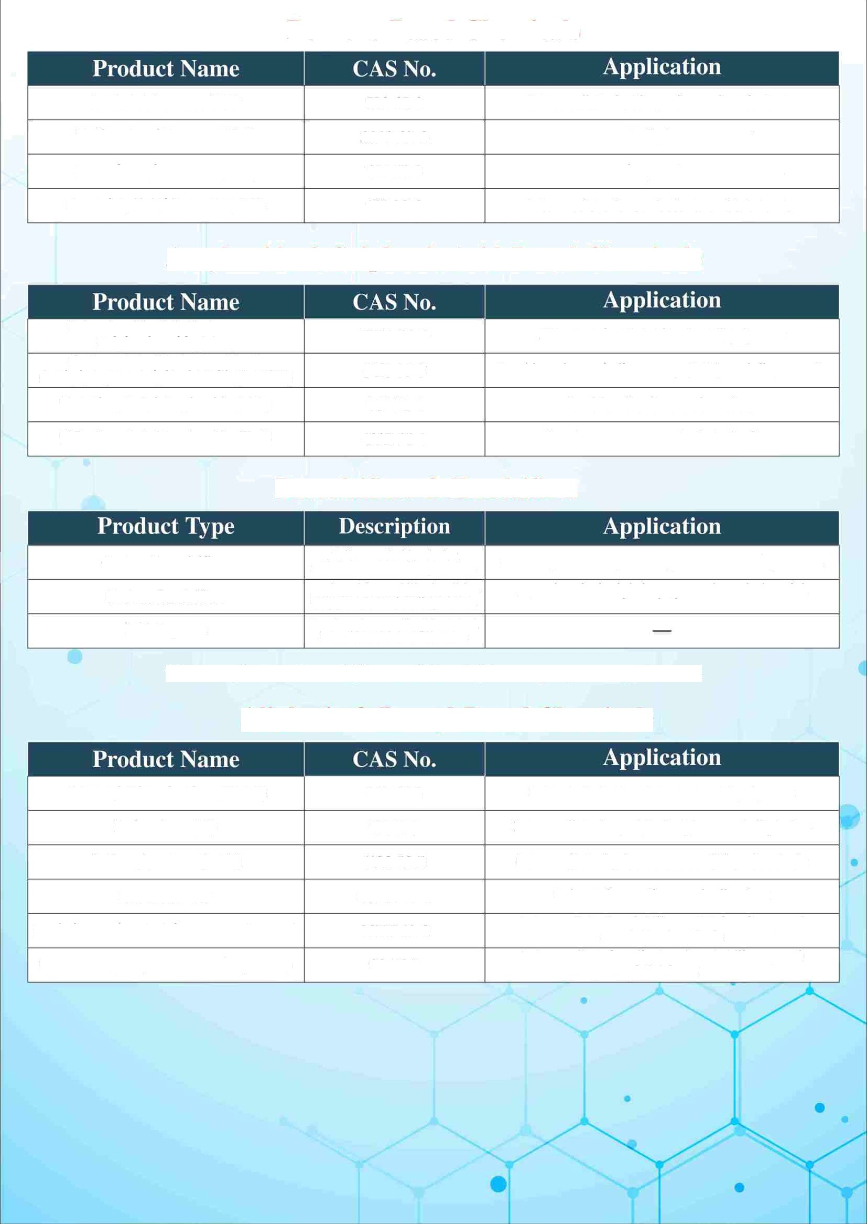
Methyl 4-Tertiary Butyl Benzoate ( PTBMB) Para Tertiary Butyl Benzoic Acid (PTBBA)
26537-19-9
98-73-7
Intermediate for stabilizers, UVabsorbers, and specialty chemicals
Intermediate for alkyd resins,stabilizers, and plasticizers

