––
COMPUTER SCIENCE(083) PROJECT
Topic: Bookstore Management
Name: Aneek Kumar Sinha
Class: XII
Roll No:
Session:2023-2024
Faculty: Mr. Anustup Gupta
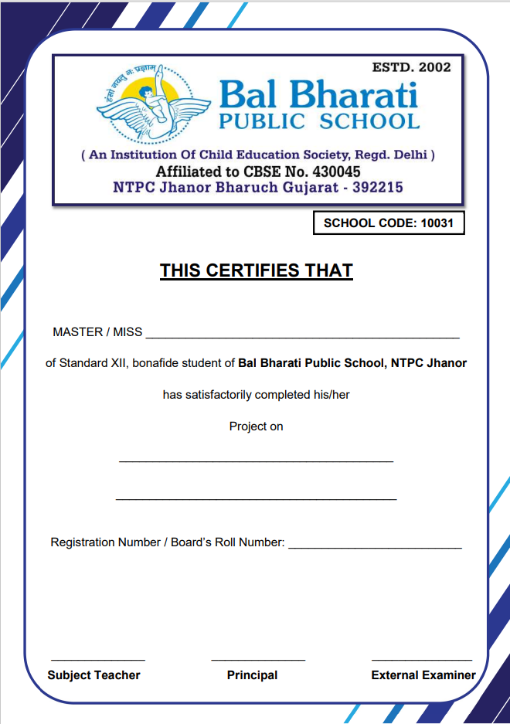INDEX
S.No | Content | Page No.
1 | Acknowledgement | 1
2 | Introduction | 2
3 | Source Code | 3-22
4 | Output Snapshots | 23-33
5 | Bibliography | 34
ACKNOWLEDGEMENT
I wish to express deep gratitude and sincere thanks to the principal, MR. KALPESH KUMAR KAYASTH, BAL BHARATI PUBLIC SCHOOL, JHANOR for his encouragement and for all facilities that he provided for this project. I sincerely appreciate this magnanimity by taking me into his fold for which I shall remain indebted to him.
I extend my healthy thanks to MR. ANUSTUP GUPTA, COMPUTER SCIENCE teacher who guided me to the successful completion of the project. I take this opportunity to express my deep sense of gratitude for his valuable guidance, constant encouragement, constructive comments, Sympathetic attitude and immense motivation, which has sustained my efforts at all stages of this project work.
Signature-____________
Name of the student-__________________________
Date-______________
INTRODUCTION
This is a bookstore management system. The main purpose of a Book-store Management System is to focus on the solution of all the problems related to the paperwork for different reasons. It provides a facility to handle all the activities in one place. With the help of this application, the admin can perform a different kind of operations at the same time and place. Bookstore management System has the ability to keep records safe related to Books.

SOURCE CODE

AddBooks.py
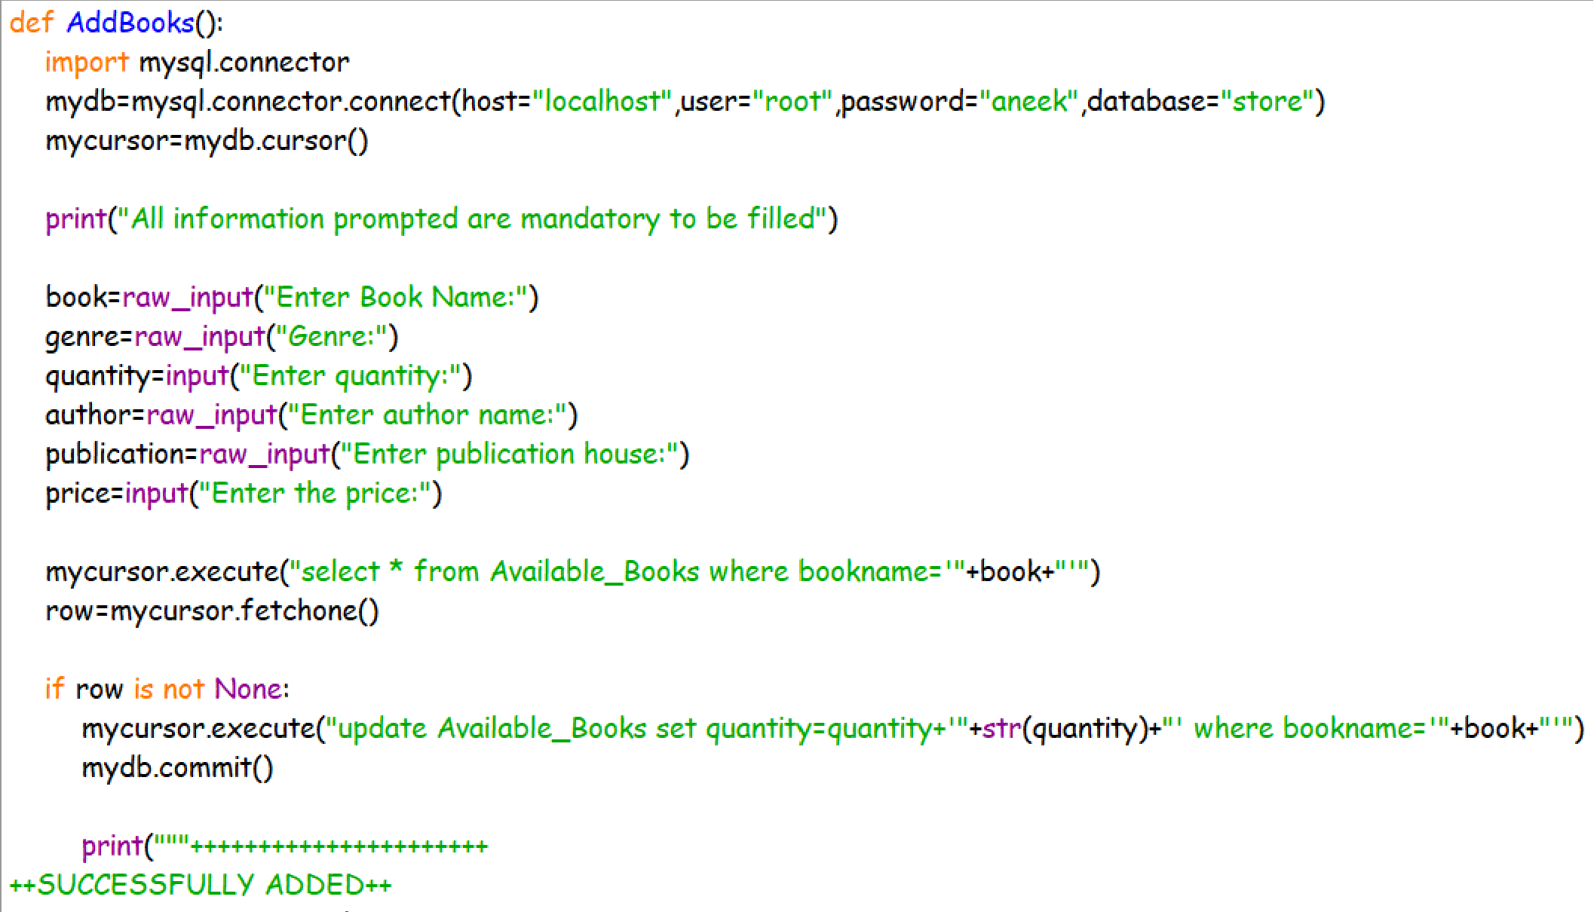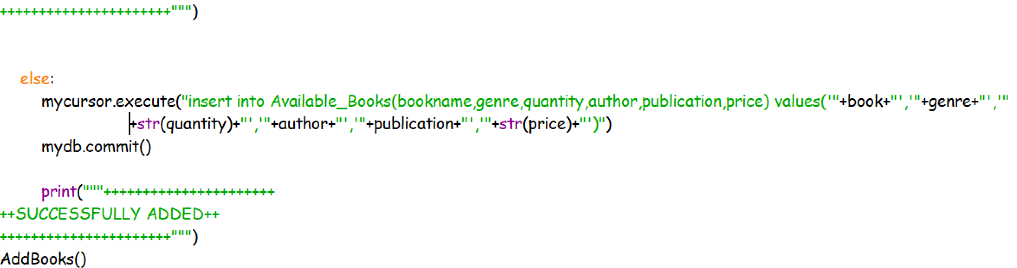
availbooks.py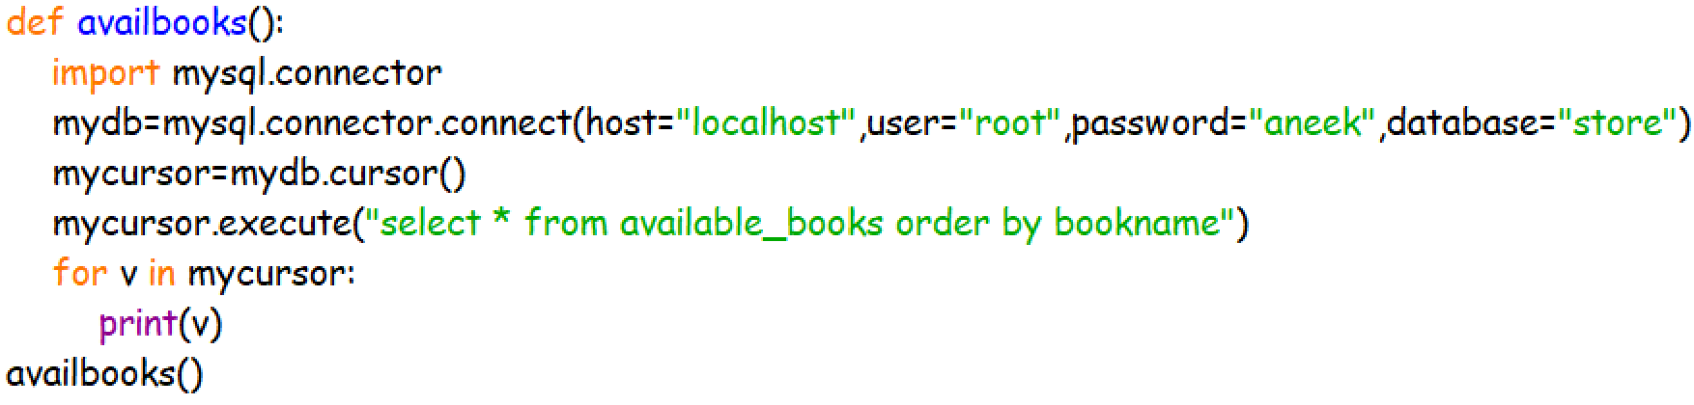

delbooks.py
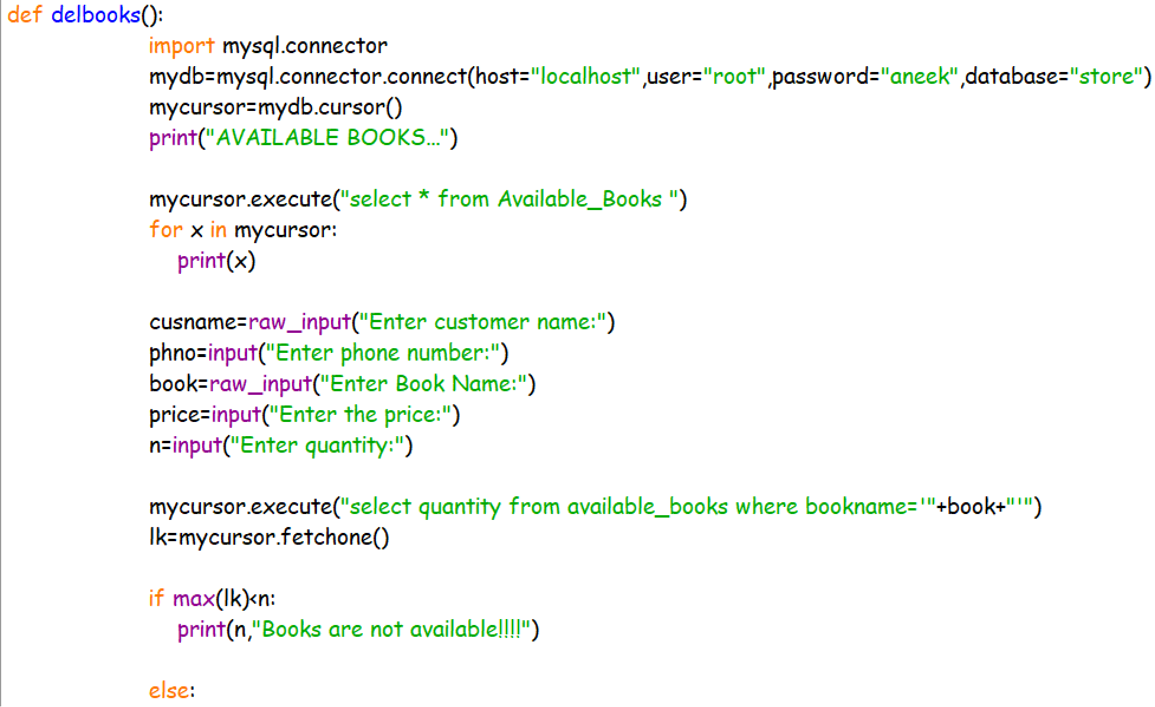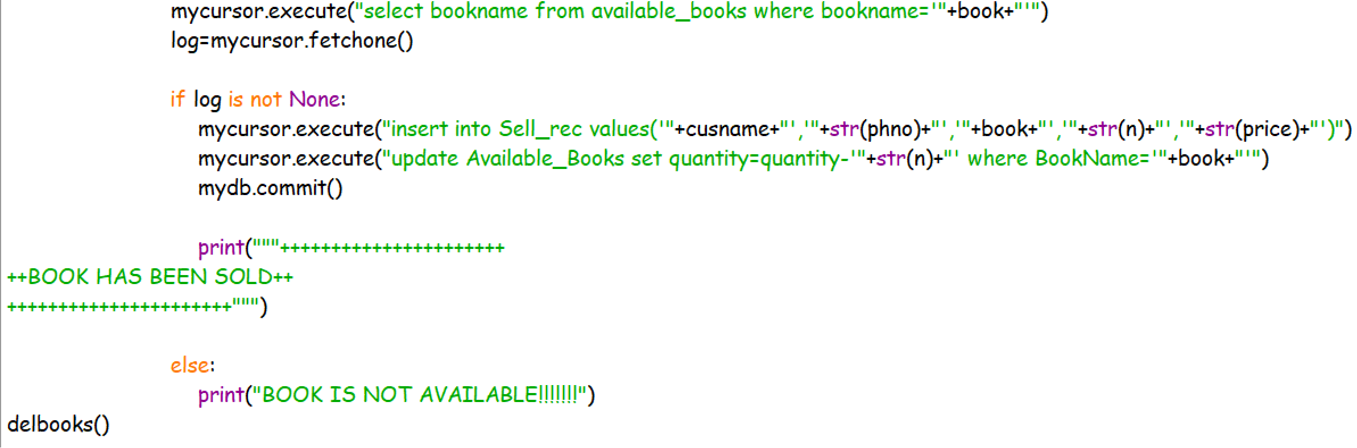
income.py

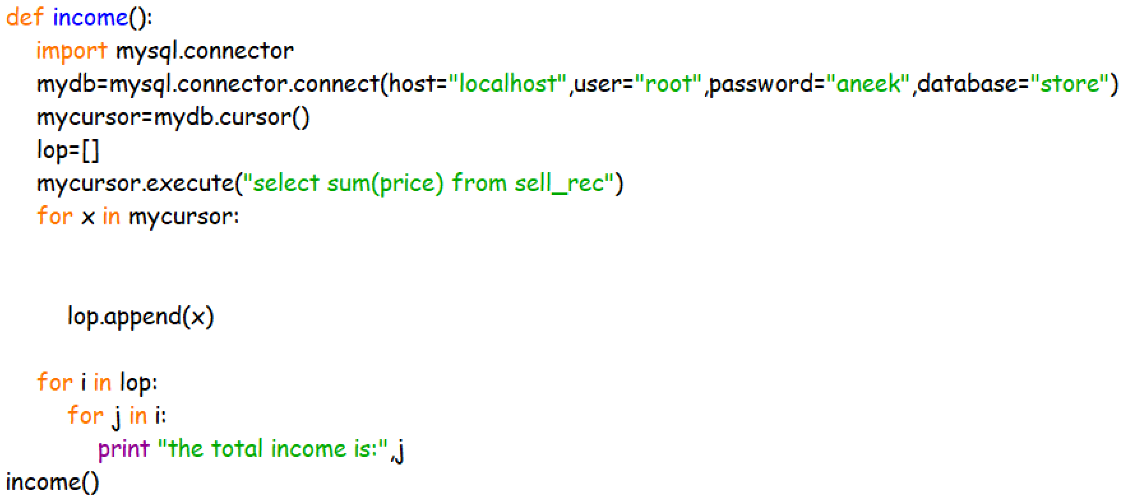
search.py
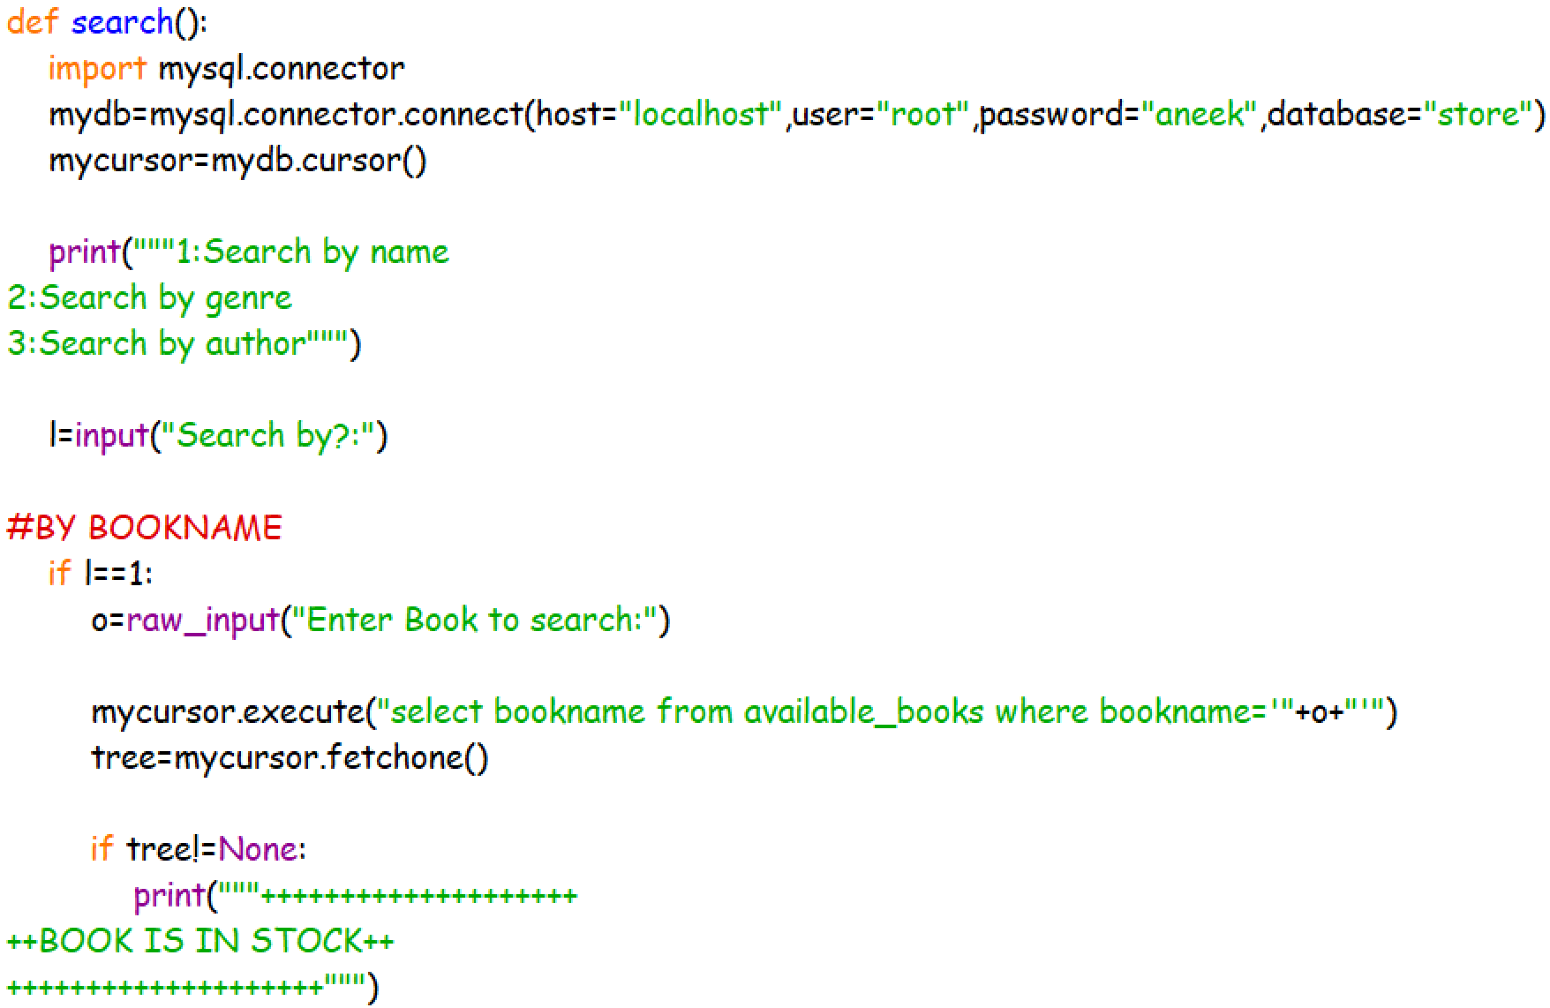
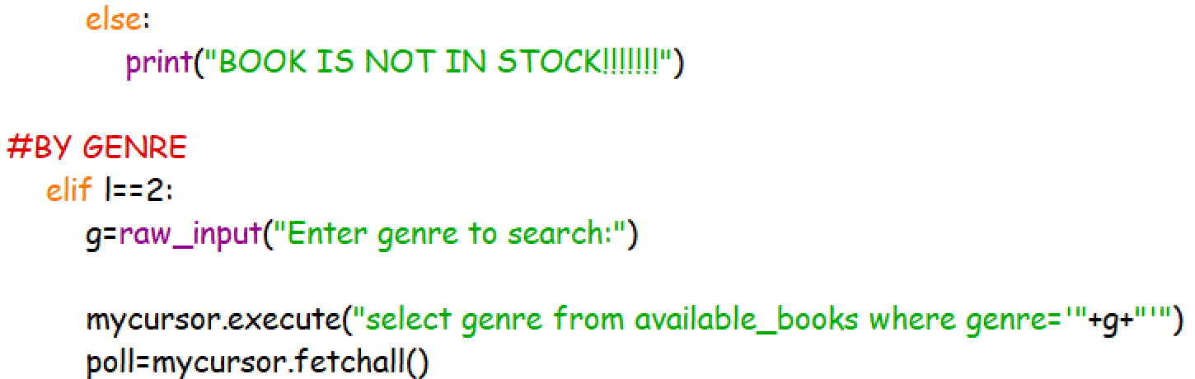

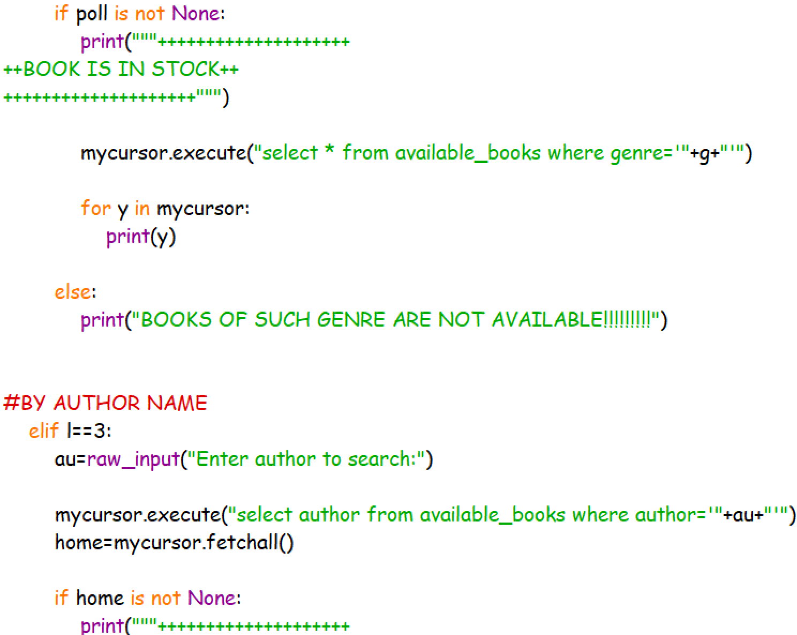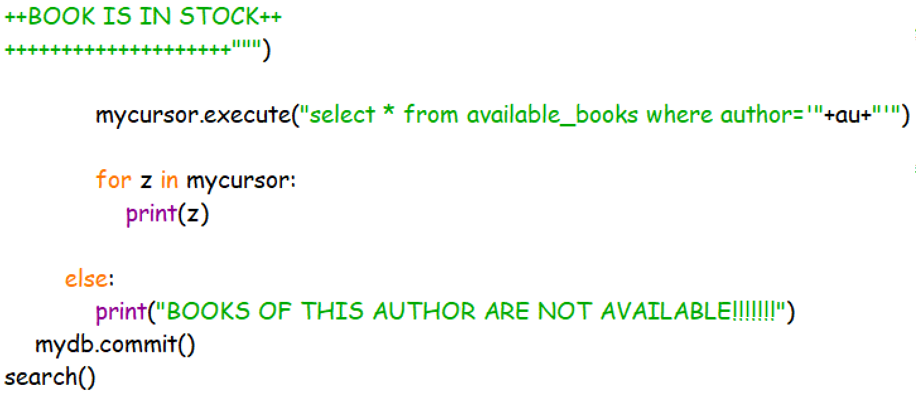
sellHistory.py
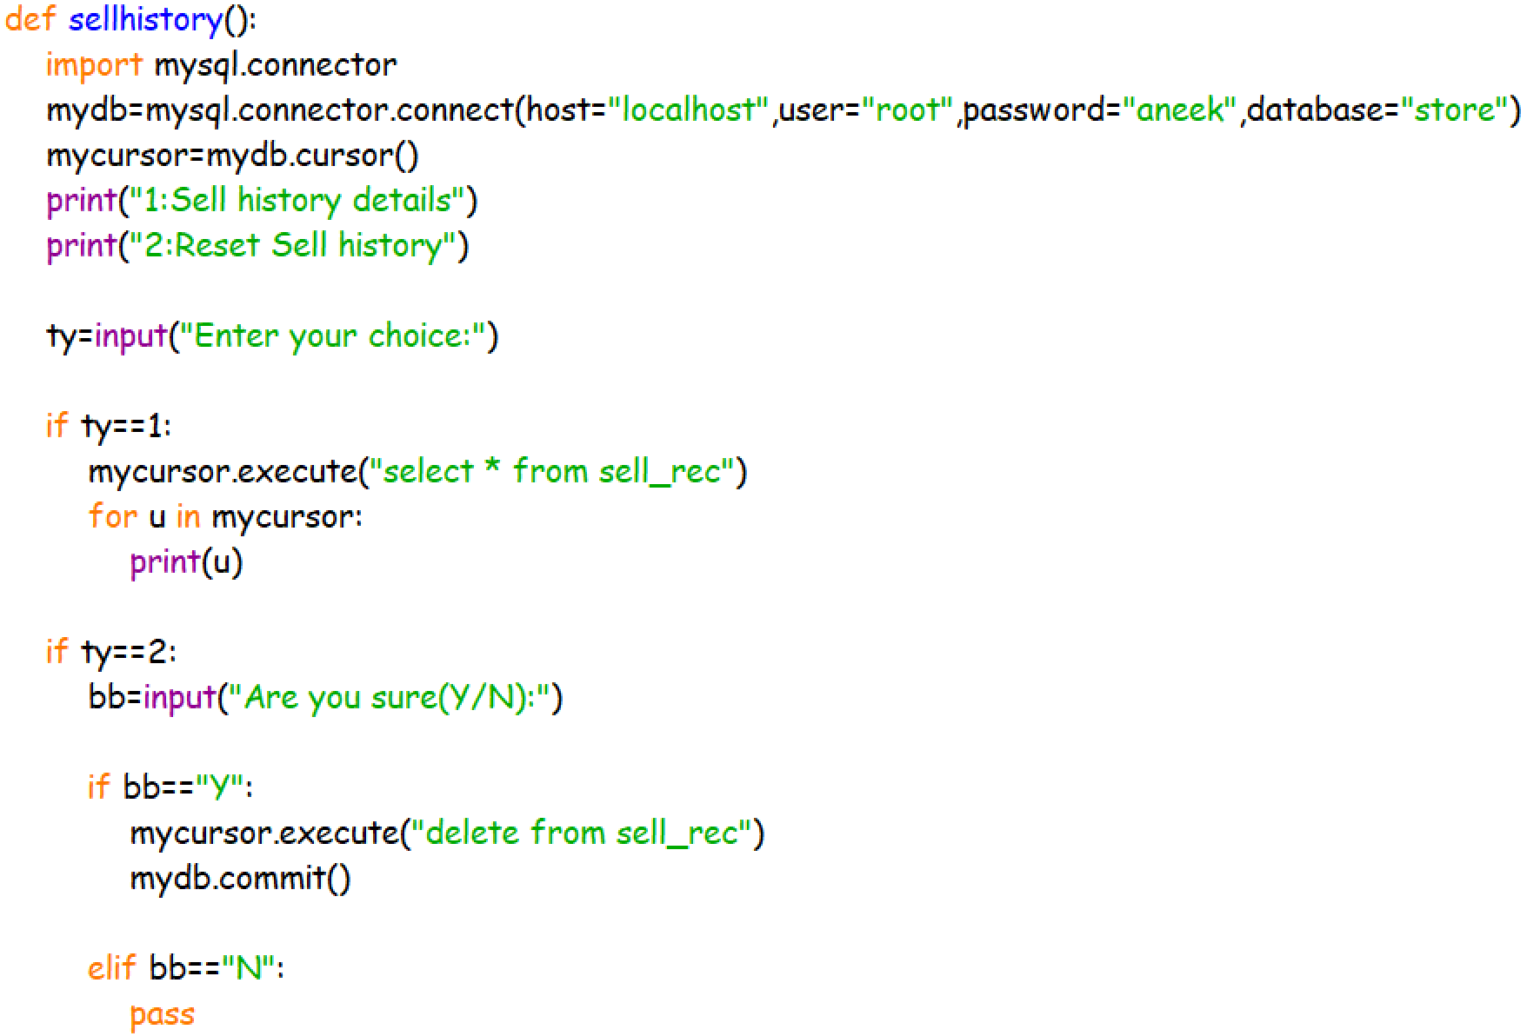
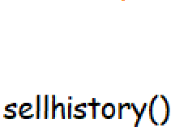

Staffdetail.py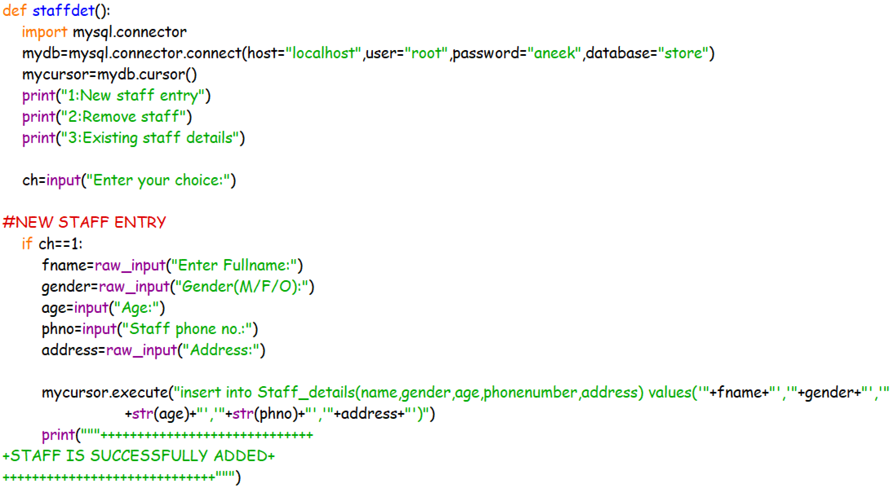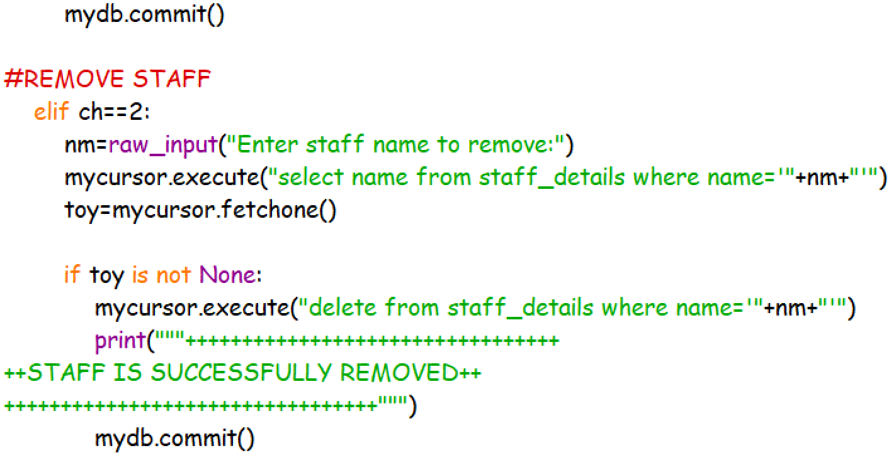

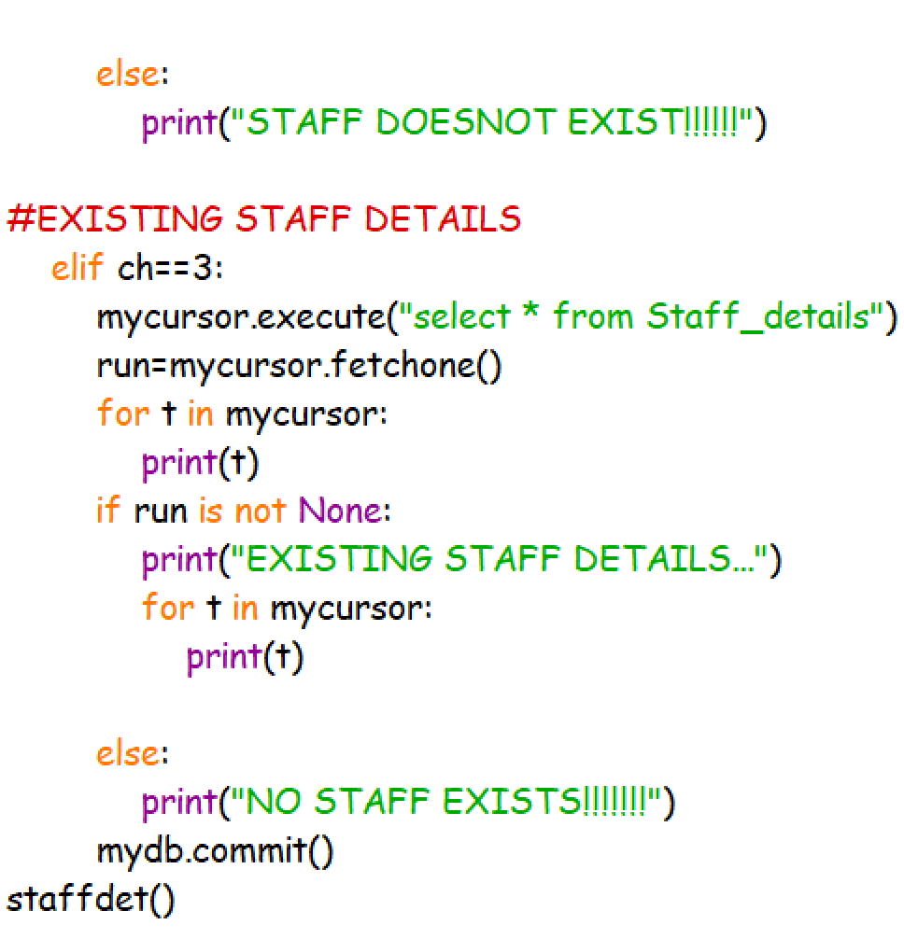

Book Folder

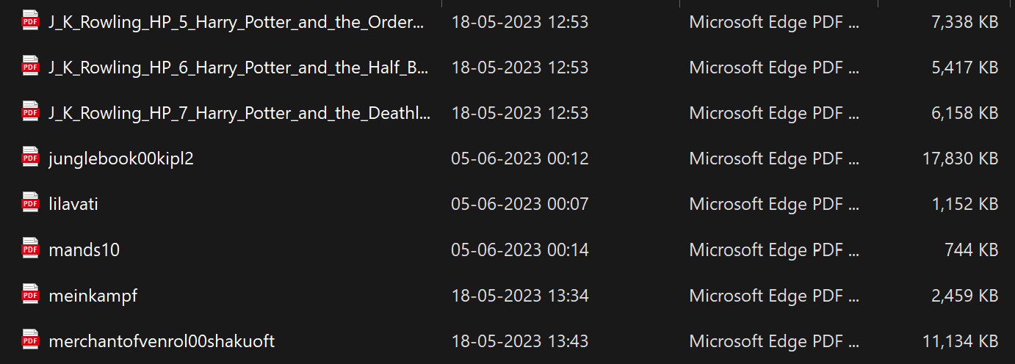


booksRead.py

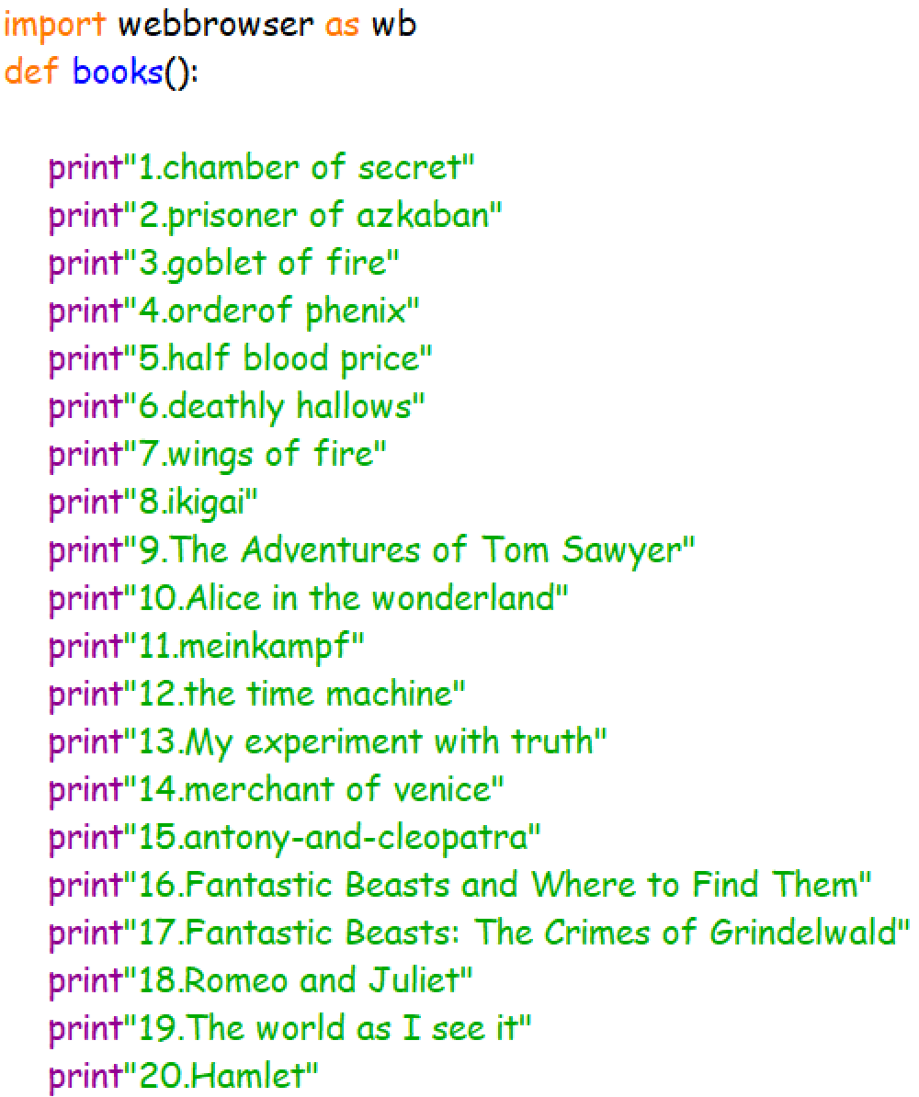

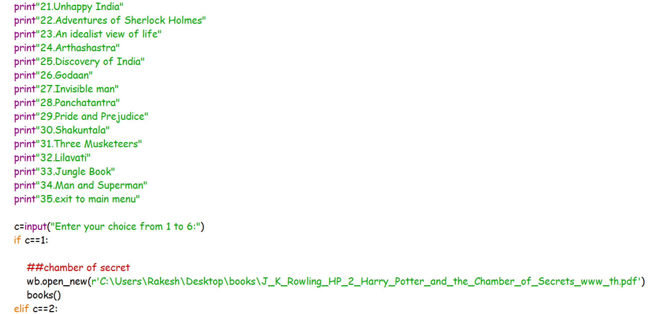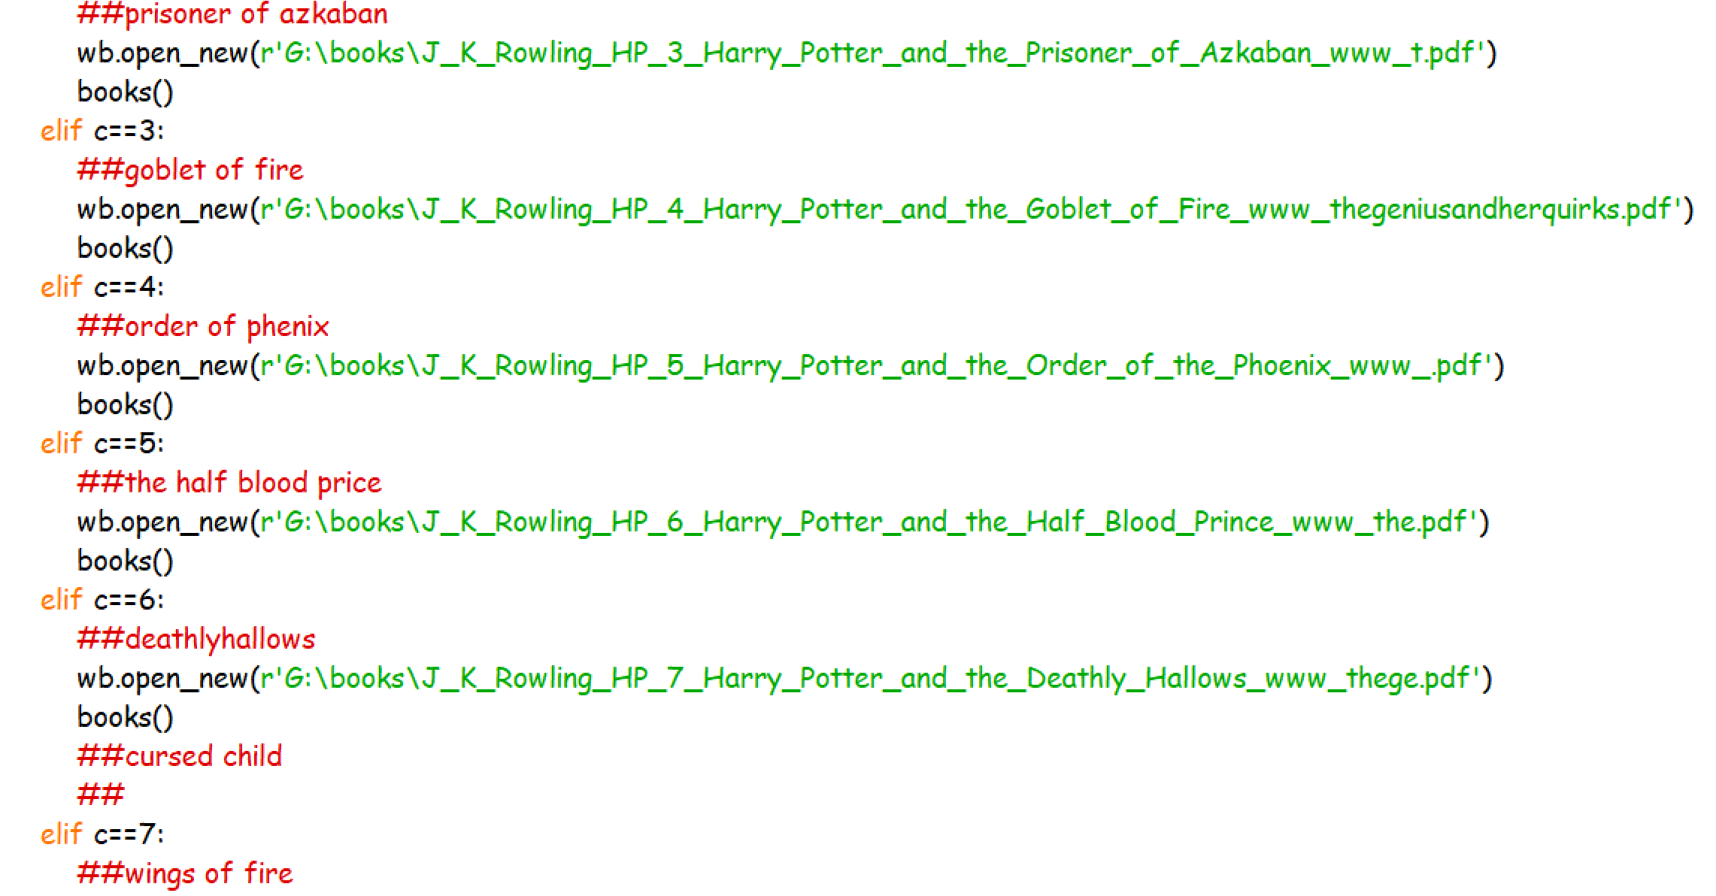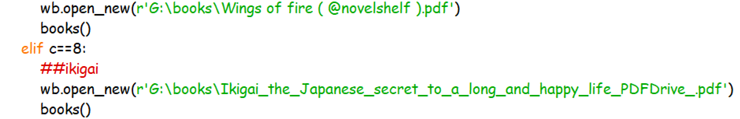

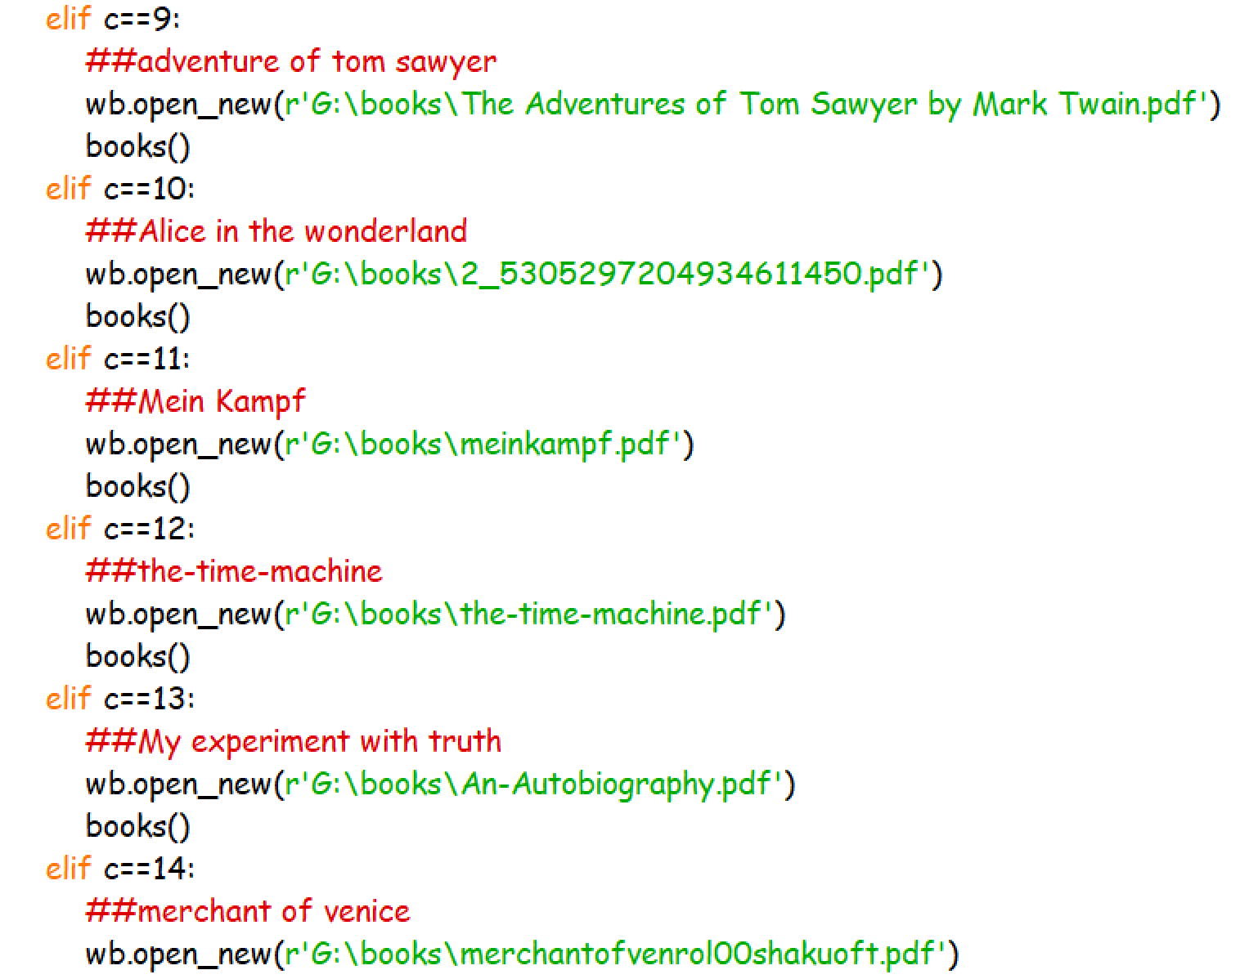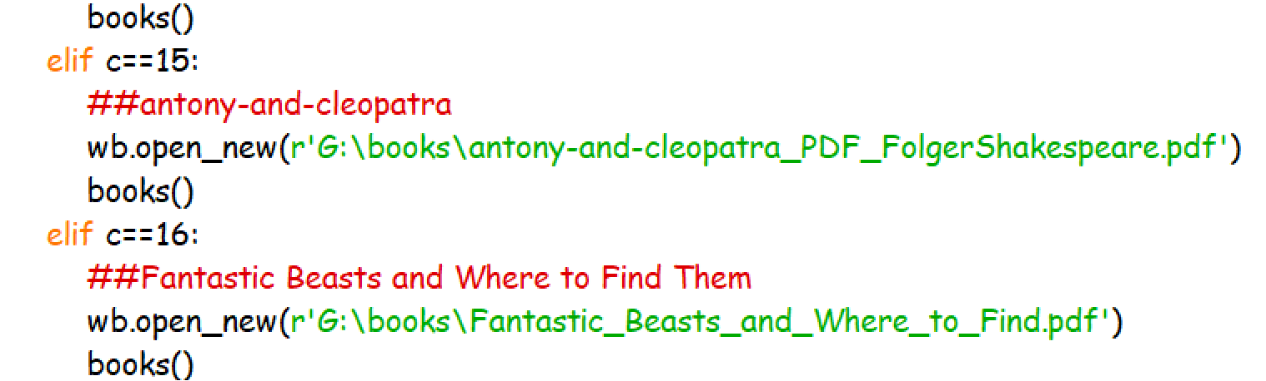

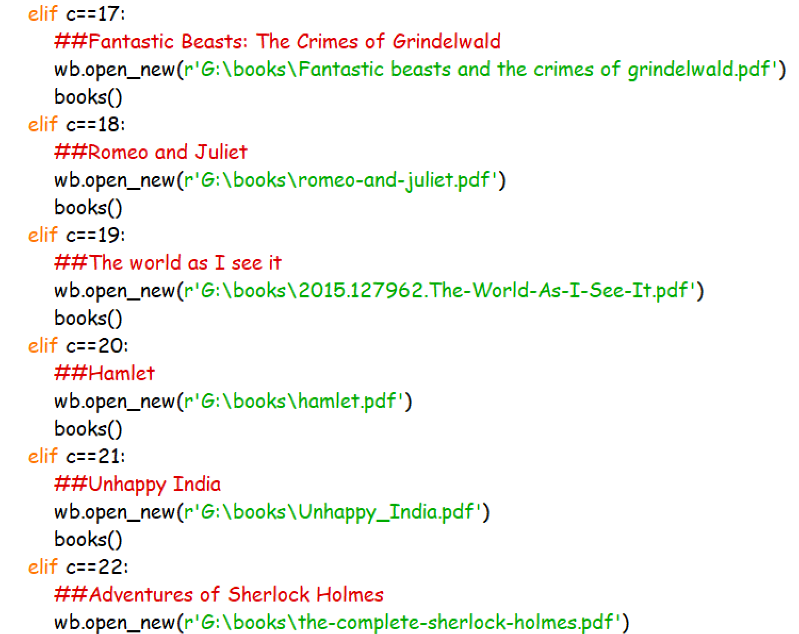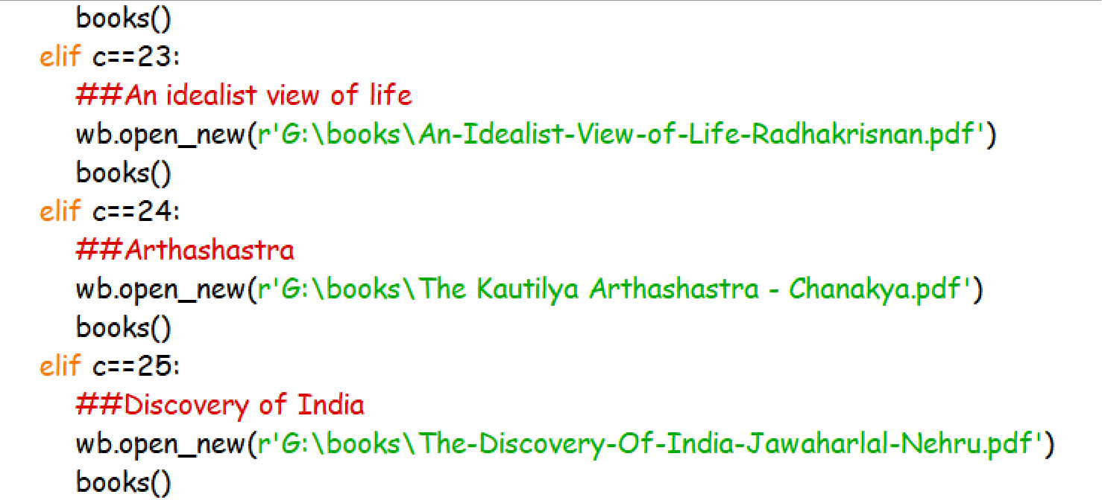
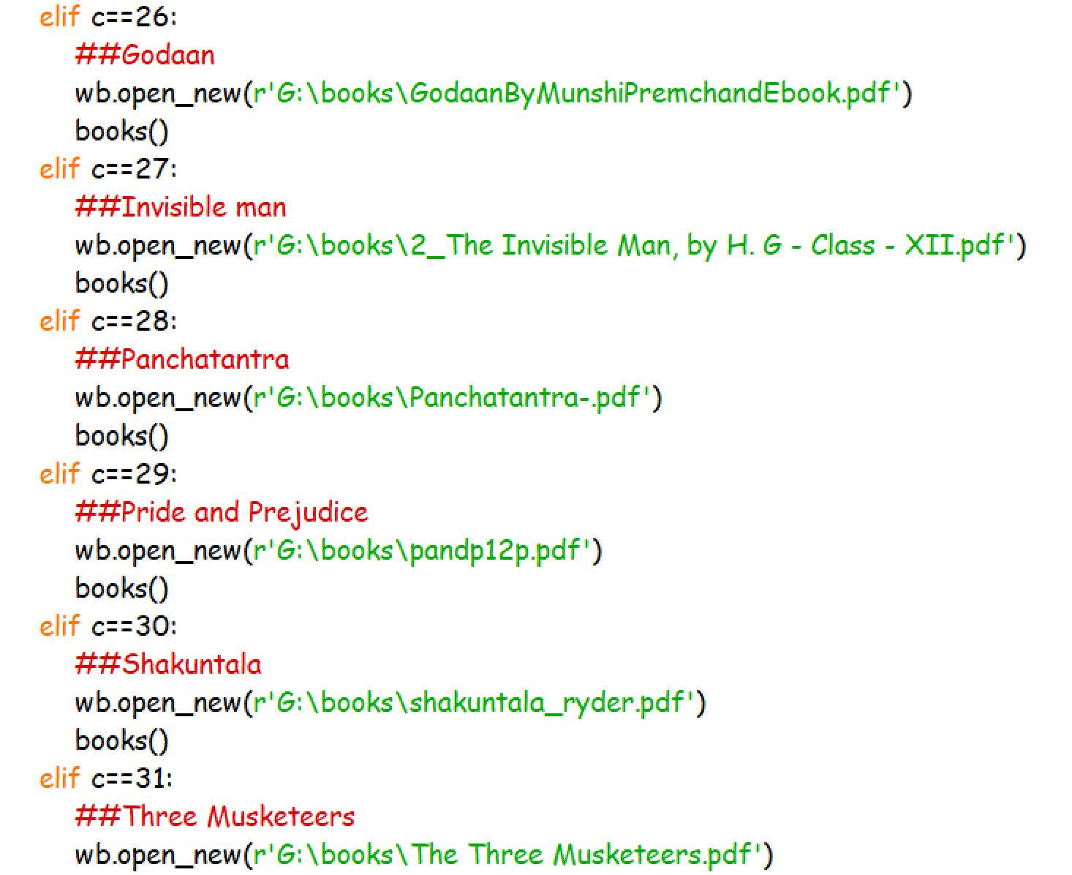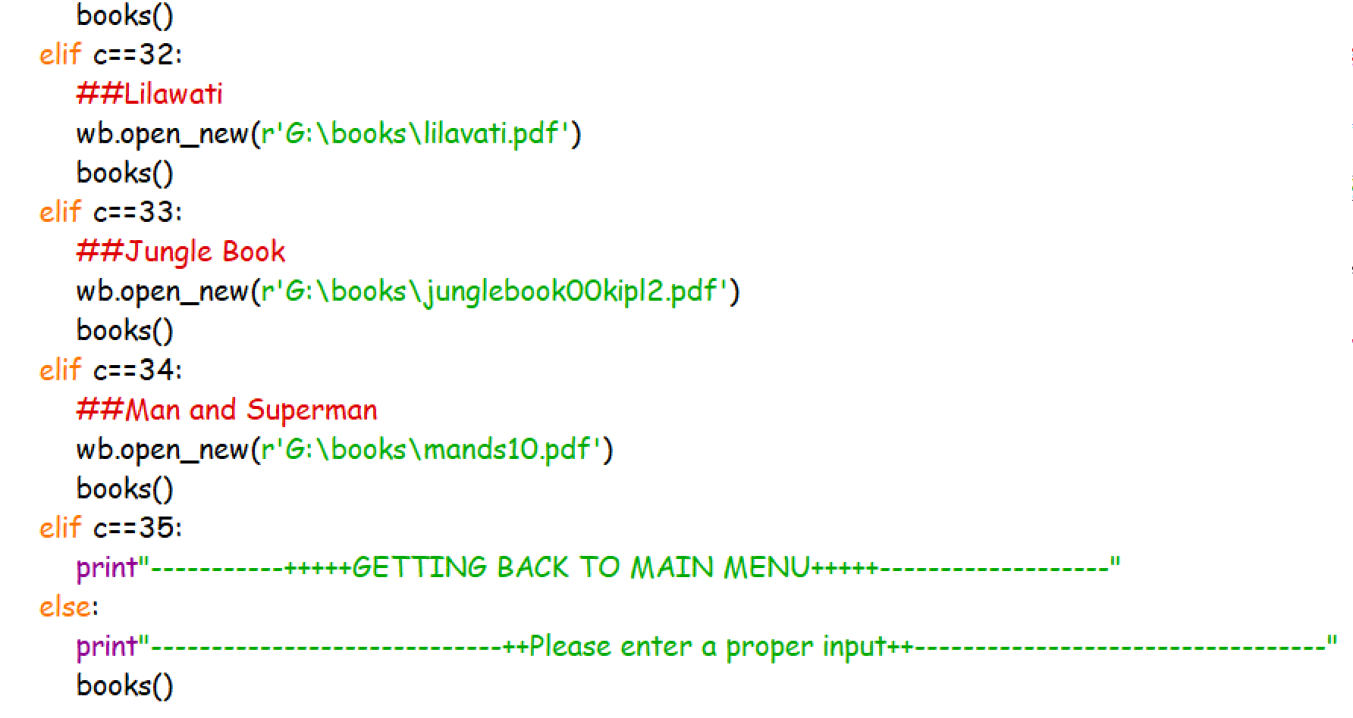

Main.py
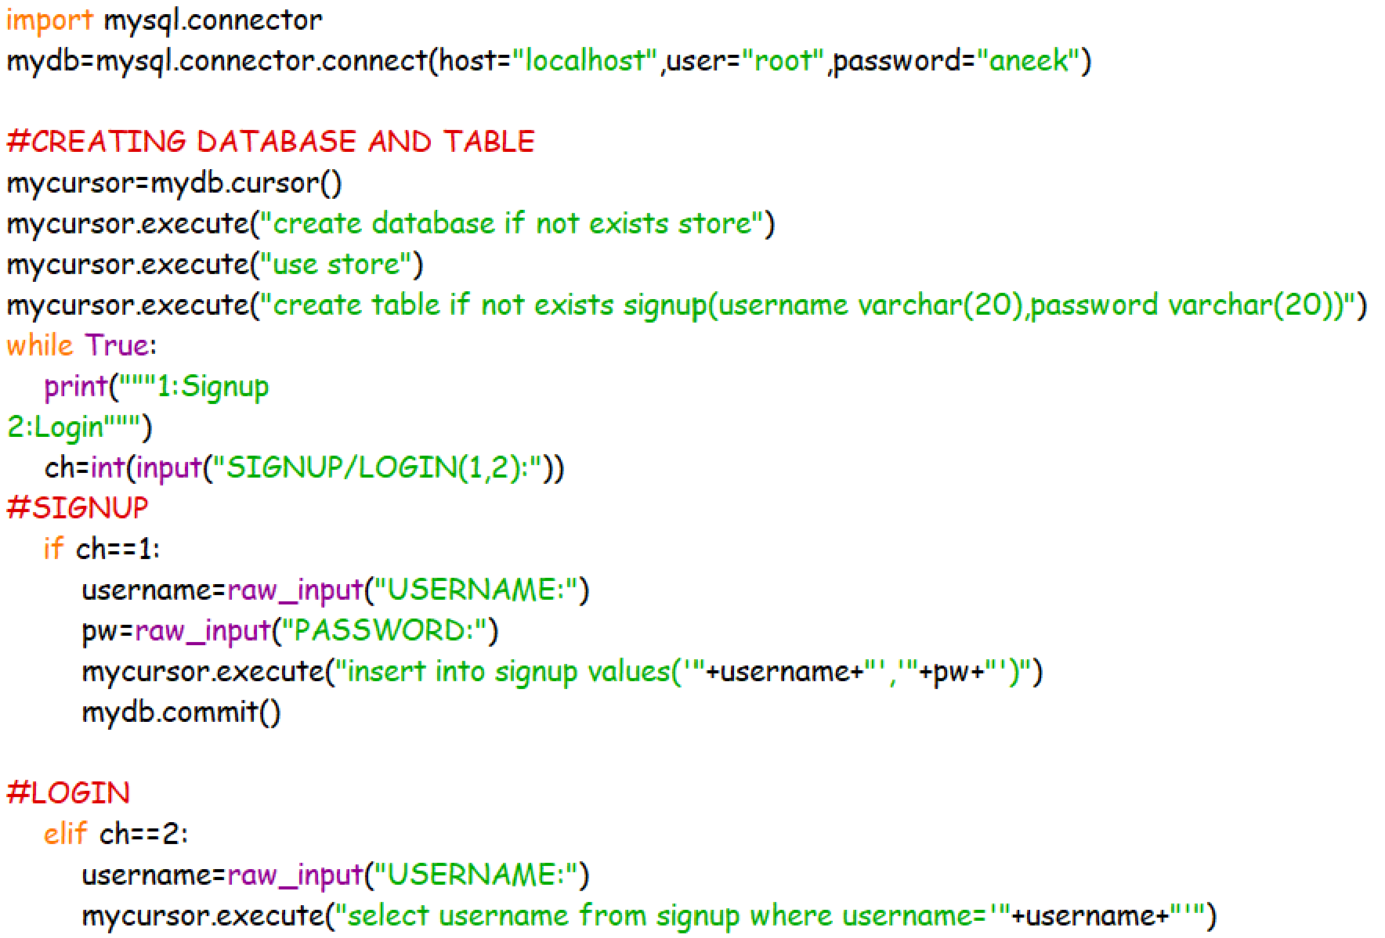
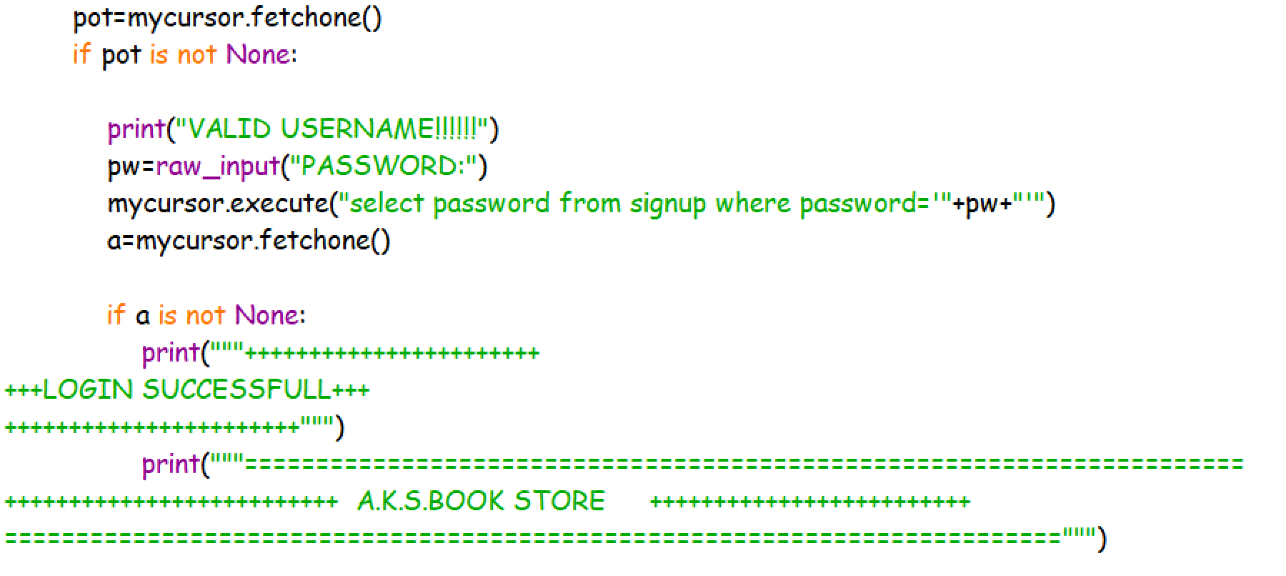

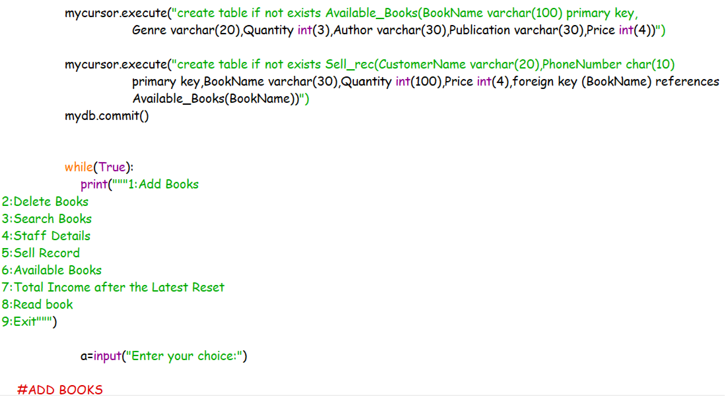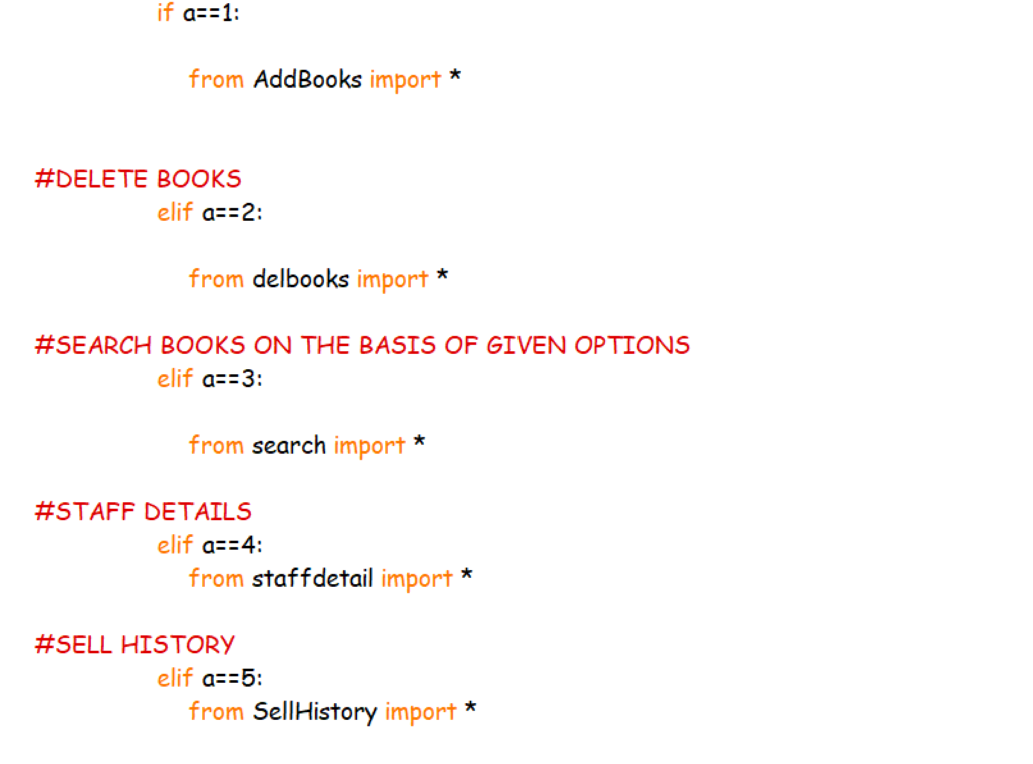

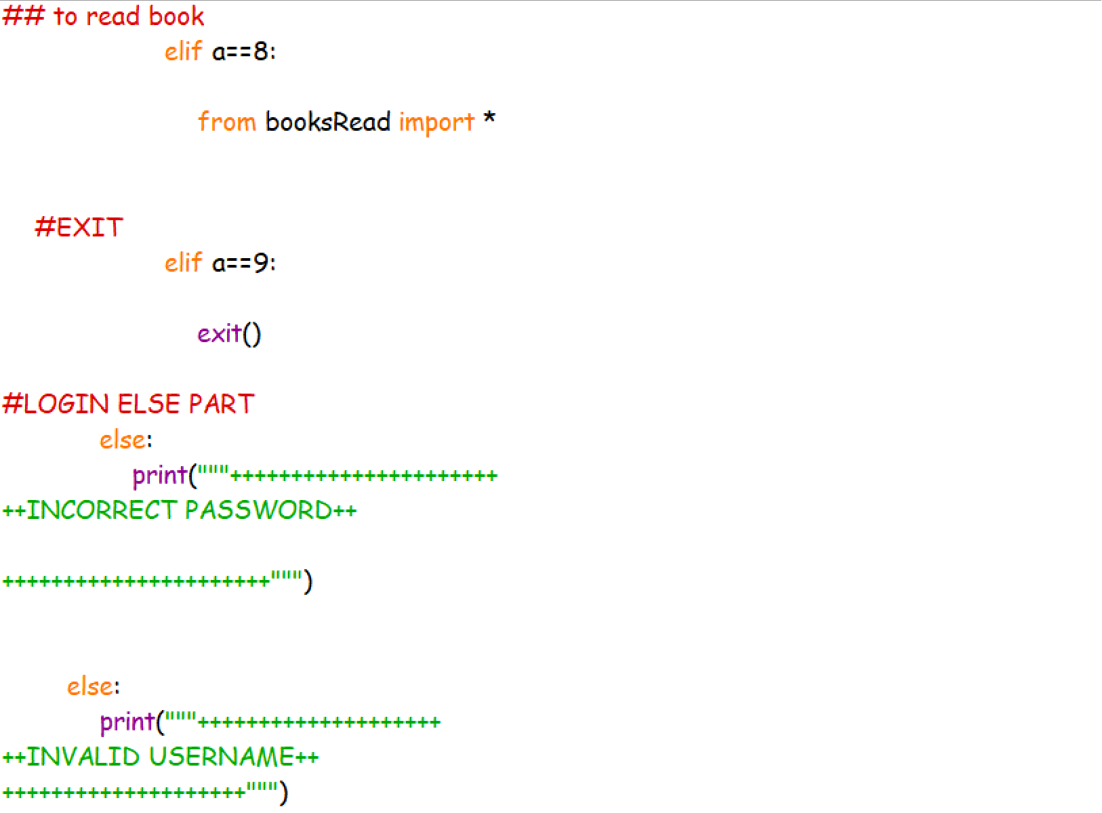

OUTPUT
SNAPSHOTS

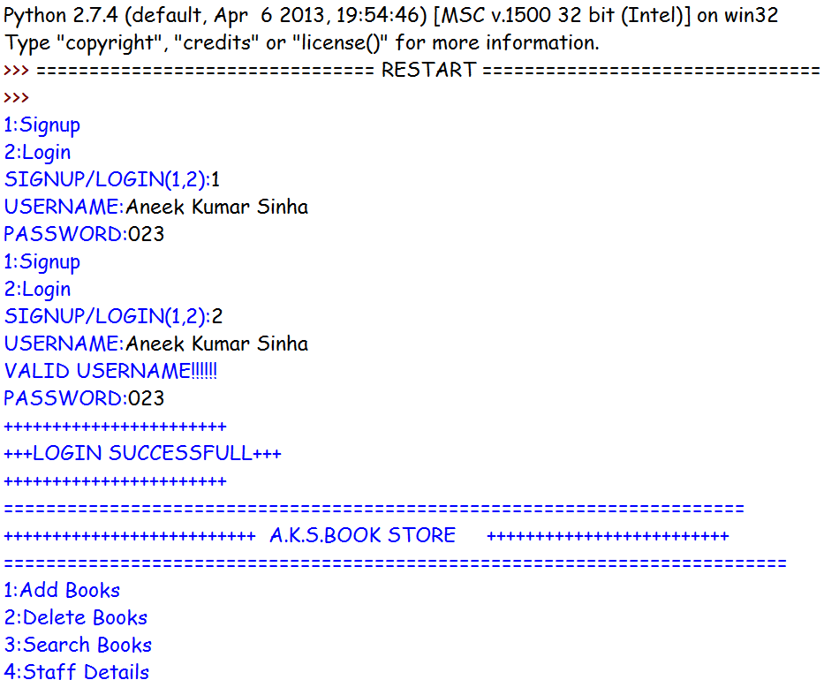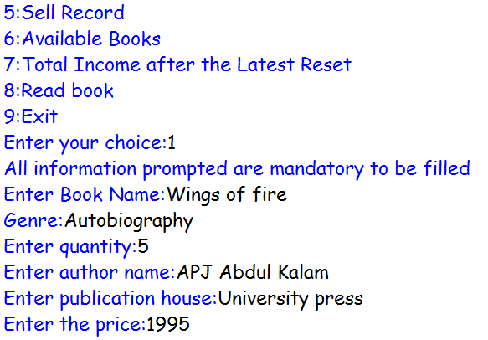

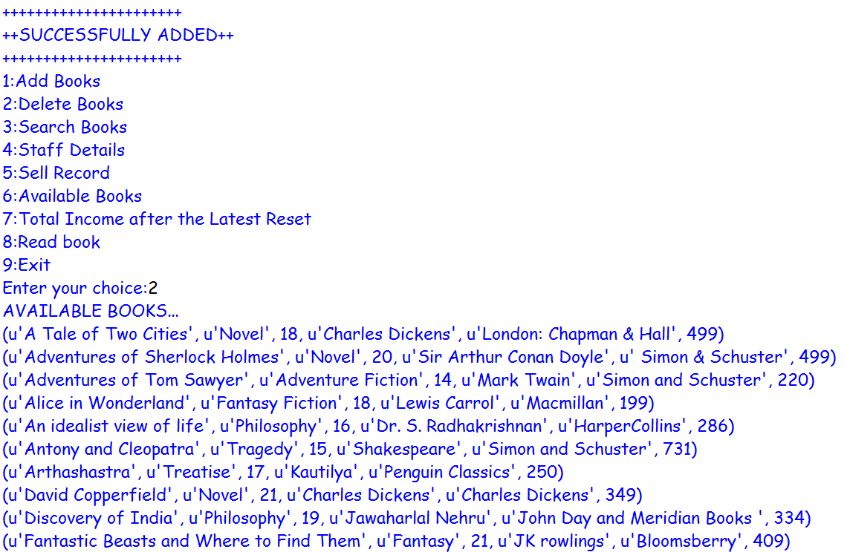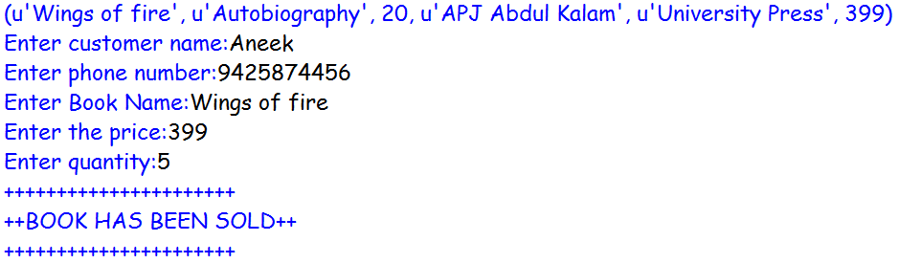
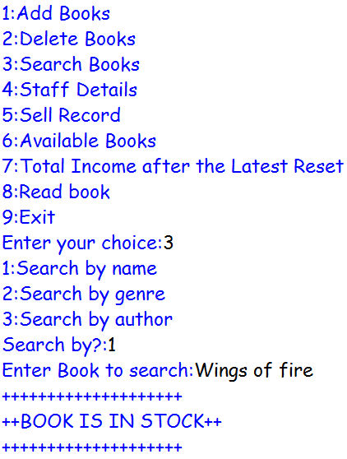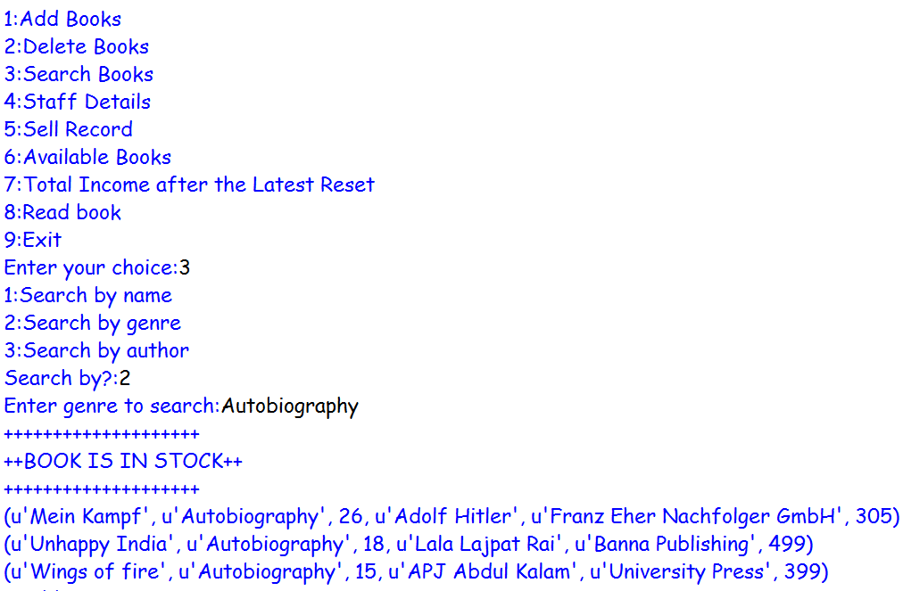
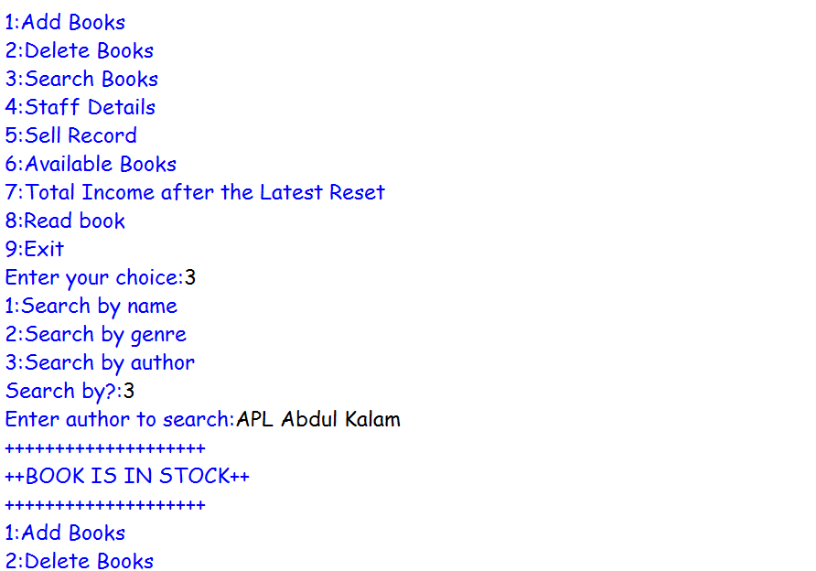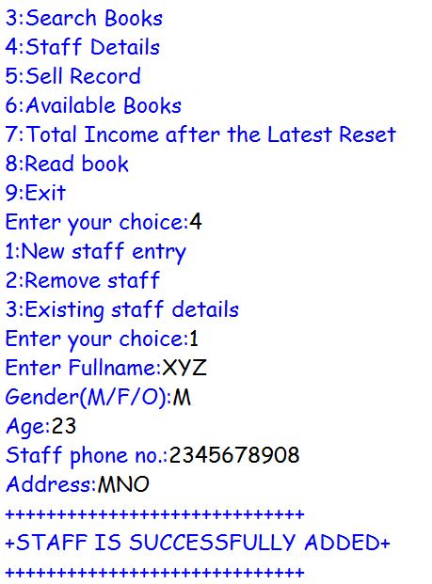
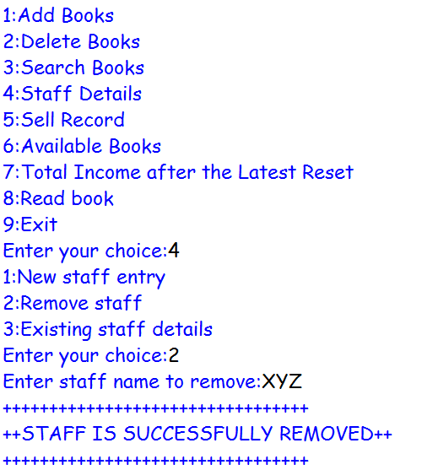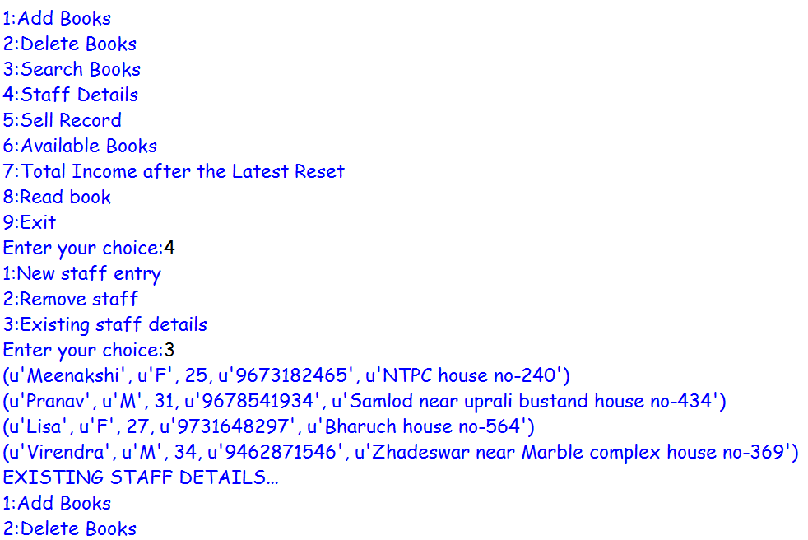
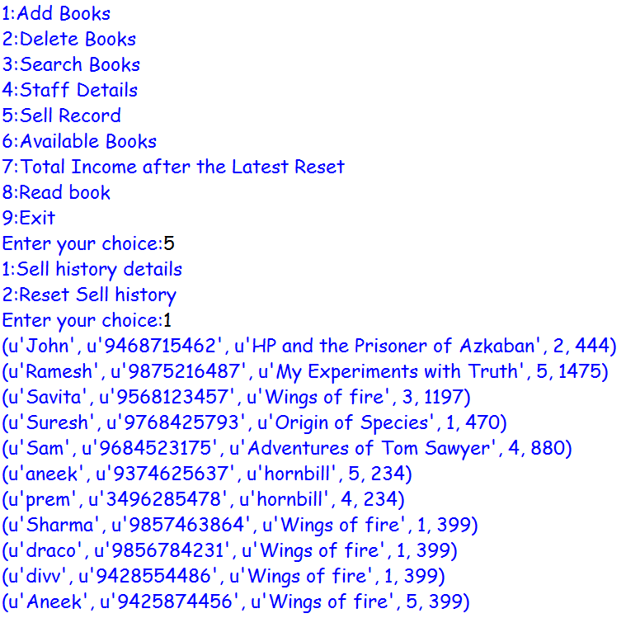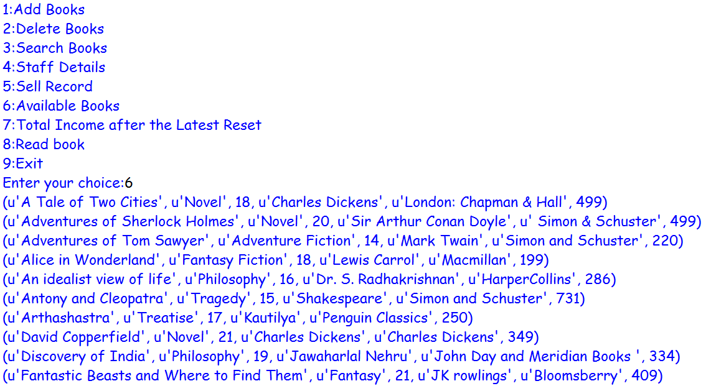
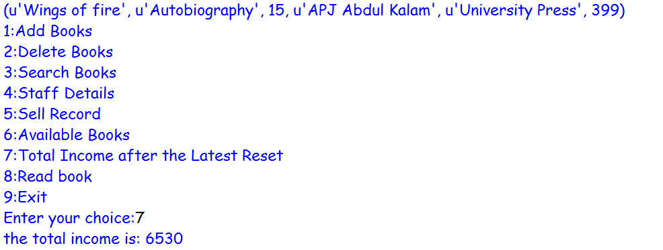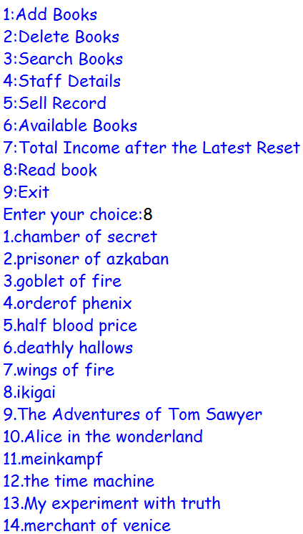
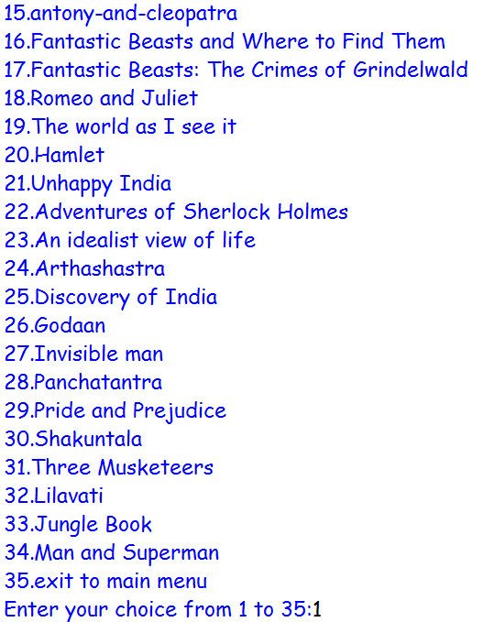

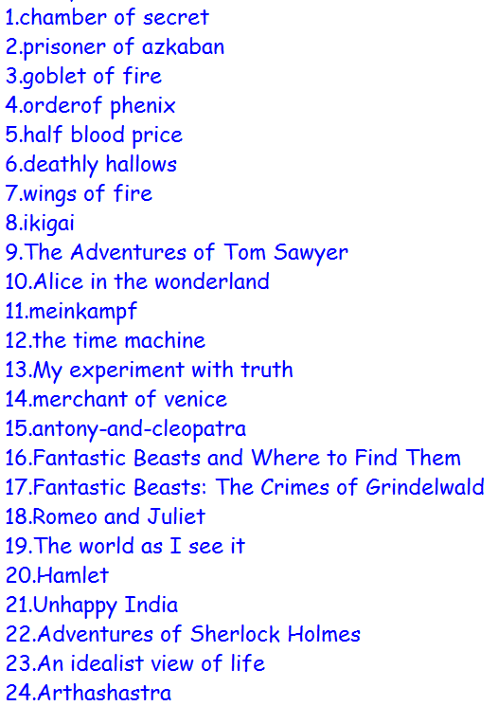

BIBLIOGRAPHY

- www.python.mykvs.in

- www.geeksforgeeks.in

- Google and YouTube

- Text Book

