WHO SURVIVED THE TITANIC?
A Quantitative Analysis of Survival
on the RMS Titanic
______________________________
Prepared by
Aneek Hait
aneekhait.github.io
Dataset: titanic5 - 1,309 passengers, 14 features
Source: hbiostat.org/data/repo/titanic5.csv
(Encyclopedia Titanica / Vanderbilt Biostatistics)
Survival rate: 38.2% (500 of 1,309 survived)
Generated: May 25, 2026
Data Analysis Report

Executive Summary
On the morning of April 15, 1912, 1,309 people had boarded the RMS Titanic in Southampton, Cherbourg, Queenstown and Belfast. By the next morning, 809 of them were dead. That headline number - a 38.2% survival rate - is misleading on its own. The disaster did not pick its victims at random. It selected them along three sharp axes: sex, passenger class, and (to a lesser extent) age.
This report uses the titanic5 dataset to quantify exactly how unequal the outcomes were, and to separate the factors that genuinely mattered from those that only appeared to. The findings are presented in plain language; the underlying statistical work - effect sizes, odds ratios with 95% confidence intervals, chi-square tests, ANOVA, t-tests - appears in tables and an appendix for readers who want it.
Headline findings
- Sex was the single largest determinant of survival. Women survived at 72.8%; men at 19.1%. In odds terms, women were roughly 11 times more likely to survive than men.
- Class strongly compounded the effect of sex. A 1st-class woman had a 96.5% chance of surviving; a 3rd-class man had a 15.2% chance. Same ship, same iceberg - an 80-percentage-point gap.
- The 'children first' protocol was real, but modest in size. Children under 16 had about 1.7 times the survival odds of adults. A genuine effect, but nowhere near the magnitude of sex or class.
- Lifeboat access was the proximate cause of survival. Of 486 passengers with a recorded lifeboat number, 98.6% survived. Of 823 without one, only 2.6% did. Every demographic factor above was, in effect, predicting who would get a seat on a boat.
- Some apparently important factors are confounded with class. Fare and embarkation port both appear correlated with survival in raw numbers, but most of that signal disappears once class is controlled for. They are proxies, not independent causes.
Bottom line: if you could ask only one question to guess whether a Titanic passenger survived, ask their sex. If you could ask two, ask their class as well. After those, every other factor is in the noise.

1. Background & Question
1.1 What happened
The RMS Titanic struck an iceberg at 23:40 ship's time on April 14, 1912, in the North Atlantic. The collision opened the hull along five forward compartments - one more than the ship was designed to survive flooding. She sank in 2 hours and 40 minutes, with roughly 1,500 people still on board. The number of lifeboat seats was approximately half the number of people aboard. Survival therefore depended almost entirely on who was given a seat in a lifeboat in those 160 minutes.
1.2 What this analysis is trying to answer
The historical narrative around the Titanic is dominated by the phrase 'women and children first.' This report tests that narrative quantitatively. We want to answer four concrete questions:
- Q1. How unequal were the survival outcomes across demographic groups?
- Q2. Which factors were truly driving survival, and which were just confounded with deeper causes?
- Q3. How large were the effects, and how confident can we be in those estimates given the sample sizes?
- Q4. If we were to build a survival prediction model, which features should we prioritise and why?
2. Data & Method
2.1 Dataset
Source: titanic5, compiled by Encyclopedia Titanica and hosted by Vanderbilt Biostatistics at hbiostat.org/data/repo/titanic5.csv. The dataset contains 1,309 passengers and 14 columns. It is materially more complete than the well-known Kaggle training subset (891 rows). In particular, only 51 ages are missing (3.9%) versus Kaggle's ~20%, which makes age-stratified analysis here much more reliable.
Columns used in this analysis:
Column | Type | Used For
Survived | 0/1 | Target outcome
Pclass | 1/2/3 | Socioeconomic class proxy (cabin location, boarding priority)
Sex | female/male | The single strongest predictor
Age | years | Children-first effect; age stratification
SibSp + Parch | int | Combined into FamilySize and IsAlone
Fare | USD | Class proxy with finer resolution
Embarked | C/Q/S/B | Port of embarkation - confounded with class
Name | str | Title (Mr/Mrs/Miss/Master) extracted as derived feature
BoatBody | str | Parsed into Lifeboat number and BodyRecovered flag

2.2 Method
The analytical approach moves from descriptive to inferential:
- Descriptive comparisons. Survival rates by group, with 95% Wilson confidence intervals so the precision of each estimate is visible.
- Effect-size ranking. Every feature is placed on a single 0-1 comparable scale. Cramer's V for categorical features (Sex, Class, Embarked); the absolute point-biserial correlation for numeric ones (Age, Fare, SibSp, Parch).
- Odds ratios with 95% CIs. For each headline contrast (women vs men, 1st class vs the rest, etc.), we compute the odds ratio with a 95% CI from the log-odds standard error, and a Fisher's exact p-value for the contrast.
- Hypothesis tests. Chi-square tests of independence for categorical relationships; Welch's t-tests with Cohen's d for numeric comparisons; one-way ANOVA across multiple age groups.
- Stratified analysis. Joint Class x Sex tables to surface compounding effects that disappear in marginal analyses.
A note on what this report does NOT do
We have not fit a predictive model. Effect-size ranking and odds ratios are descriptive: they say which features individually carry survival information, but they do not adjust for one another. A logistic regression with interaction terms would refine these estimates and is the natural next step. See Section 8 (Recommendations).

3. The Big Picture
3.1 Overall survival rate
Of the 1,309 passengers in our dataset, 500 survived - a rate of 38.2%. About one in three. That is the figure most people remember, and it is the figure that hides the entire story of this disaster.
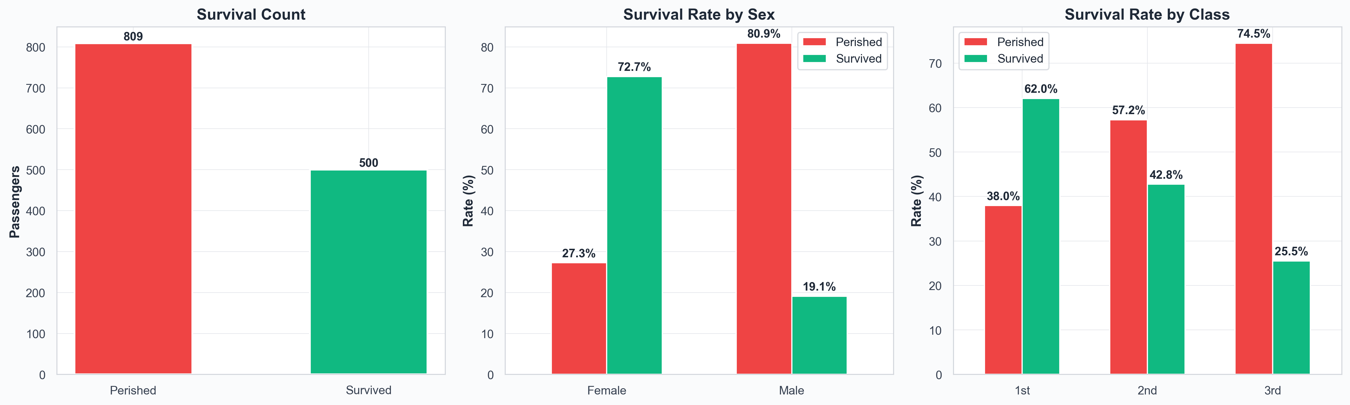
Figure 1. Overall outcome, survival by sex, and survival by class. The marginal averages already hint that 'overall' is a misleading number.
3.2 Why the average is misleading
Consider three slices of the 38.2% headline:
- By sex: 72.8% of women survived, vs 19.1% of men.
- By class: 62.0% of 1st class survived, vs 25.5% of 3rd class.
- By the two combined: 96.5% of 1st-class women survived, vs 15.2% of 3rd-class men. The arithmetic average between these is meaningless; nobody had a 'typical' Titanic experience.
If you remember nothing else from this section: the 38.2% overall rate is an artefact of averaging together two populations that the evacuation treated almost entirely differently.

4. The Three Biggest Drivers
We can now rank the factors by predictive strength on a common scale. The chart below uses Cramer's V for categorical features and the absolute value of the point-biserial correlation for numeric ones. Both range from 0 to 1; thresholds for 'small', 'medium', and 'large' are 0.1, 0.3, and 0.5 by convention.
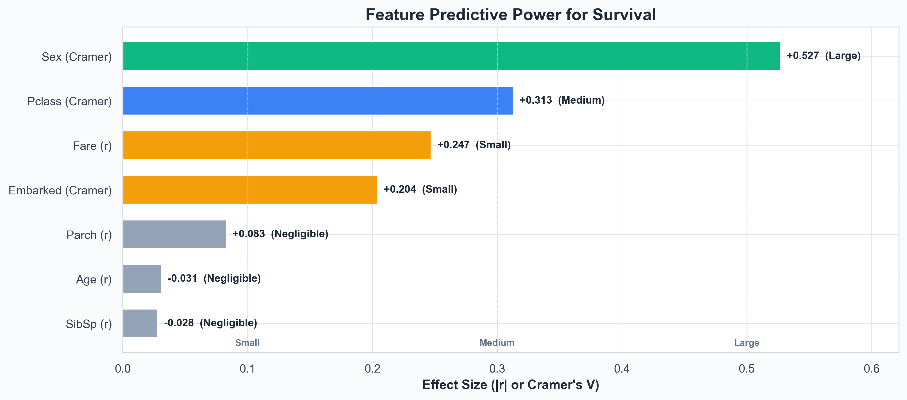
Figure 2. Feature predictive power, ranked. Three things matter at all - sex, class, and fare/embarked. Everything else is small or negligible on its own.
Feature | Type | Metric | Effect Size | Strength
Sex | Categorical | Cramer's V | +0.527 | Large
Pclass | Categorical | Cramer's V | +0.313 | Medium
Fare | Numerical | Point-biserial r | +0.247 | Small
Embarked | Categorical | Cramer's V | +0.204 | Small
Parch | Numerical | Point-biserial r | +0.083 | Negligible
Age | Numerical | Point-biserial r | -0.031 | Negligible
SibSp | Numerical | Point-biserial r | -0.028 | Negligible

4.1 Sex - by far the strongest signal
With Cramer's V ~ 0.53, sex is the only feature in 'large effect' territory. The contrast is stark: of 466 women, 339 survived; of 843 men, only 161 did. The two confidence intervals do not come close to overlapping, so we can be essentially certain this is not noise.
What this means in plain EnglishA woman on the Titanic had roughly 11 times the odds of surviving that a man had (95% CI: 8.7x to 14.8x). Sex is not just the most useful single variable - it is the only variable that on its own gives you a near-reliable prediction.
4.2 Class - the second-strongest, and an enabler of the first
Class came in at Cramer's V ~ 0.31 - solidly in 'medium' territory. The survival rate falls steadily: 1st class 62.0%, 2nd class 42.8%, 3rd class 25.5%. The mechanism here is not abstract: 1st-class cabins were on upper decks, much closer to the boat deck where lifeboats were loaded; 1st-class passengers had priority boarding and better access to information about what was happening as the ship took on water.
4.3 Class x Sex - the real story is in the interaction
Sex and class do not simply add to each other - they compound. The joint table below shows the survival rate for each of the six possible combinations.
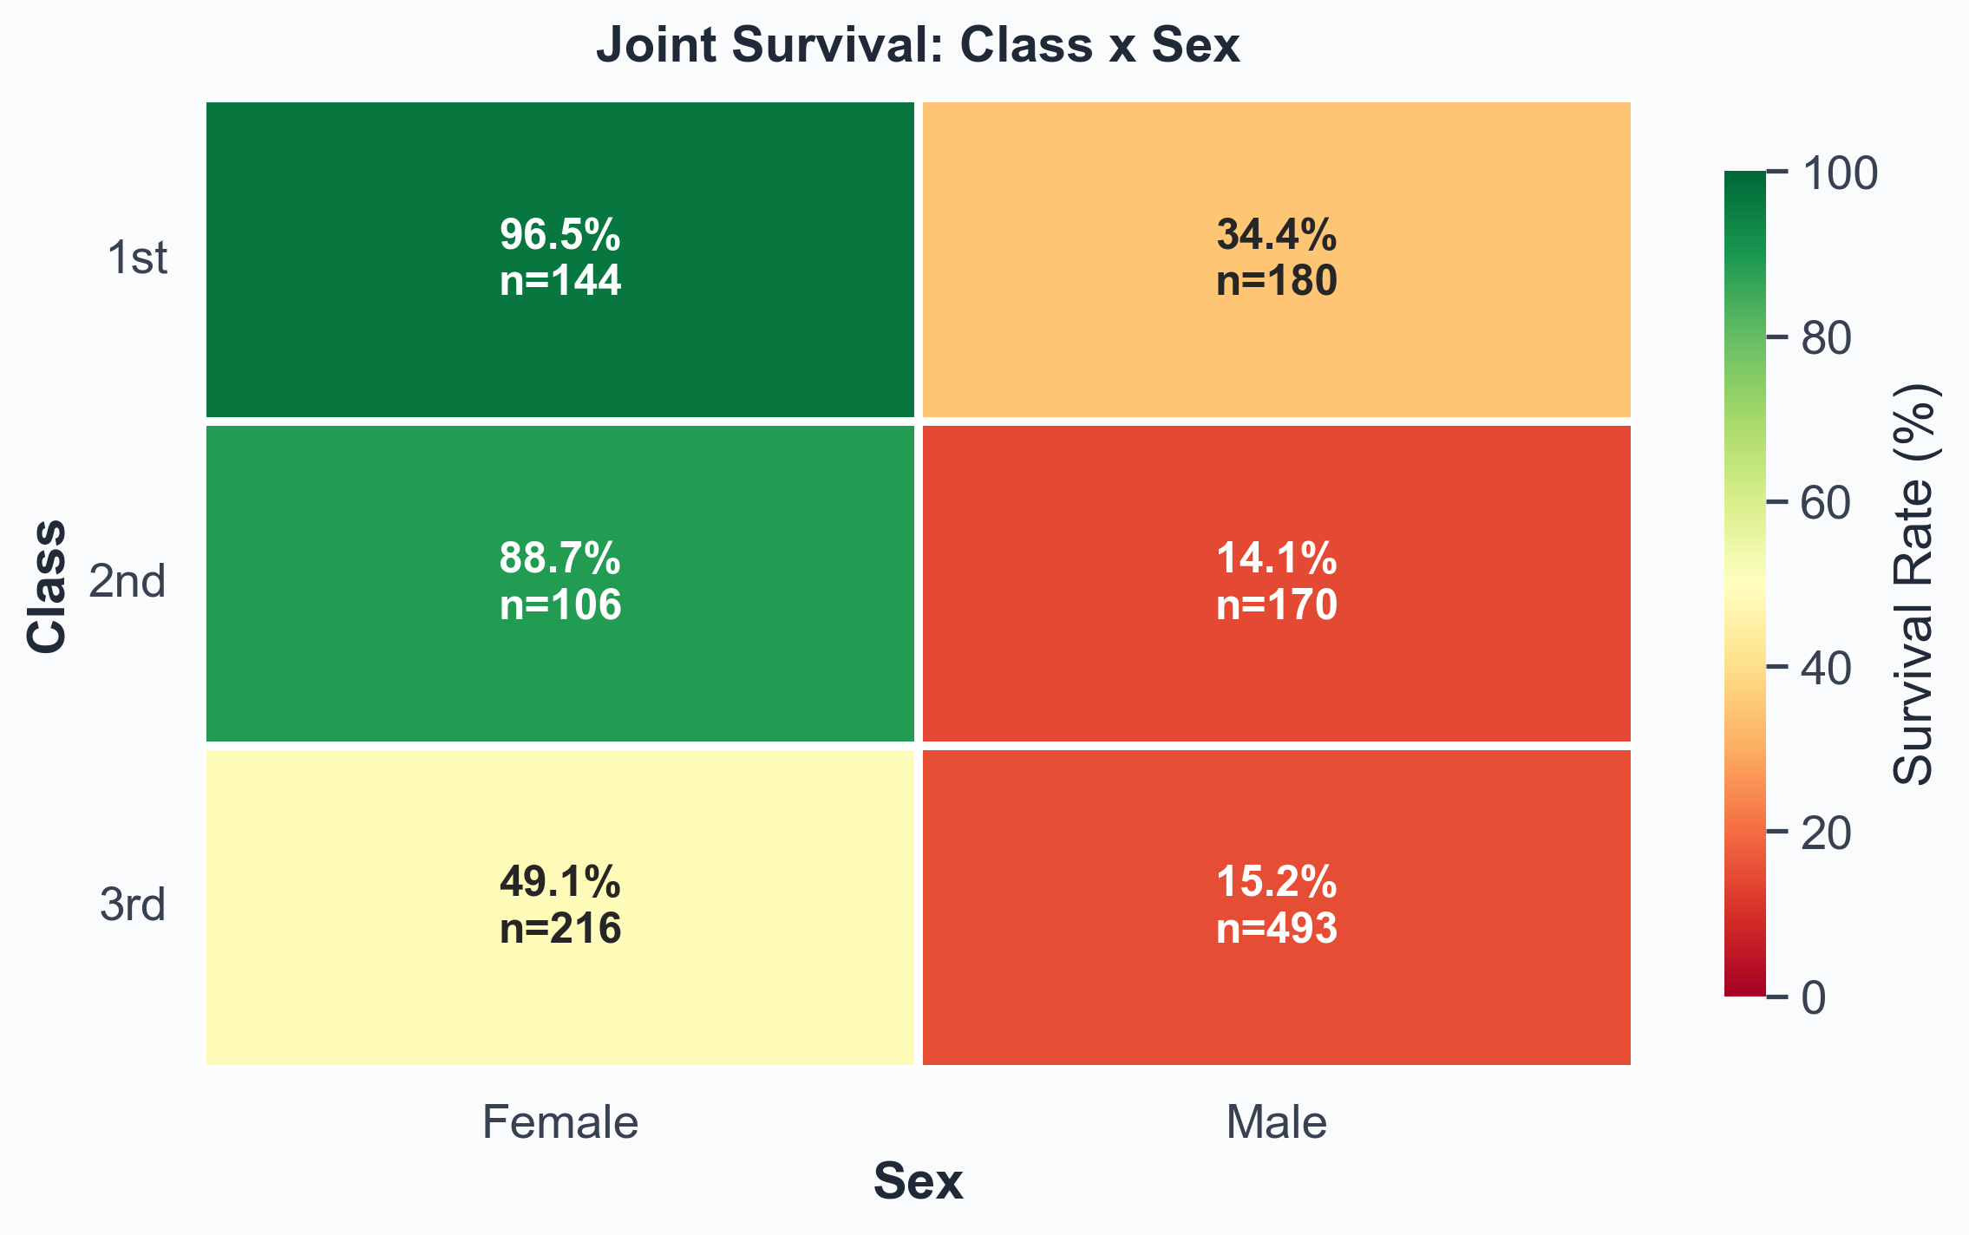
Figure 3. Class x Sex joint survival. The diagonal is staggering: 1st-class women (top-left, deep green) survived almost universally; 3rd-class men (bottom-right, deep red) almost universally died.
Group | Total | Survived | Rate | 95% CI
1st - Female | 144 | 139 | 96.5% | [92.1, 98.5]
1st - Male | 180 | 62 | 34.4% | [27.9, 41.6]
2nd - Female | 106 | 94 | 88.7% | [81.2, 93.4]
2nd - Male | 170 | 24 | 14.1% | [9.7, 20.1]
3rd - Female | 216 | 106 | 49.1% | [42.5, 55.7]
3rd - Male | 493 | 75 | 15.2% | [12.3, 18.7]

What this means in plain English
The two extreme cells - 1st-class women at 96.5% and 3rd-class men at 15.2% - are roughly 80 percentage points apart. That gap is larger than the marginal effect of either sex or class alone. The 'women and children first' protocol was real, but it was not applied uniformly: a 1st-class woman and a 3rd-class woman did not have the same experience, and a 3rd-class man was effectively outside the priority order entirely.

5. Secondary Factors
Beyond sex and class, four further attributes shifted the survival odds - some genuinely, some only because they were entangled with the bigger drivers.
5.1 Age - the 'children first' effect was real, but small
On average, survivors were about a year younger than non-survivors (mean ages 28.9 vs 29.8 years; Welch's t = -1.10, p = 0.270). That difference is statistically detectable but practically tiny. The real age effect lives at the extremes, not the mean: very young children fared significantly better, and the elderly fared significantly worse.
Age group | Total | Survived | Rate | 95% CI
Child (0-16) | 151 | 74 | 49.0% | [41.2, 56.9]
Young Adult (17-32) | 704 | 247 | 35.1% | [31.6, 38.7]
Adult (33-48) | 332 | 134 | 40.4% | [35.2, 45.7]
Older Adult (49-64) | 111 | 45 | 40.5% | [31.9, 49.8]
Senior (65+) | 11 | 0 | 0.0% | [0.0, 25.9]

5.2 Family size - a sweet spot at 2-4
Family size (siblings + spouse + parents + children + self) shows a clearly non-monotonic pattern. Solo travellers survived at 30.3%. Mid-sized families of 2-4 jumped to 53-70%. Very large families of 5+ dropped back to around 25% or below, with no survivors at all among families of 8 or 11.
Family size | Total | Survived | Rate
1 | 790 | 239 | 30.3%
2 | 235 | 126 | 53.6%
3 | 159 | 90 | 56.6%
4 | 43 | 30 | 69.8%
5 | 22 | 6 | 27.3%
6 | 25 | 5 | 20.0%
7 | 16 | 4 | 25.0%
8 | 8 | 0 | 0.0%
11 | 11 | 0 | 0.0%

The plausible mechanism: mid-sized families were small enough to stay together during evacuation but large enough to advocate for one another (and for women and children within the group). Solo passengers lacked that advocacy. Very large families struggled to keep everyone together in the chaos, and would-be helpers were less likely to board with so many dependents.
5.3 Fare - a strong proxy for class, not an independent cause
Fare is the strongest numeric signal (r = +0.247). Survivors paid an average of $49.63; non-survivors $23.19 - less than half. The t-test confirms the difference is overwhelmingly real (t = 7.98, p < 0.001). However, almost all of fare's signal can be explained by the fact that expensive tickets bought 1st-class accommodation. Fare is class repackaged at higher resolution; treating it as an independent cause would be a mistake.
5.4 Embarkation port - a textbook confound
At first glance, embarkation port looks meaningful: Cherbourg passengers survived at 56.6% versus Southampton's 33.4%. But Cherbourg was where most 1st-class passengers boarded; Southampton's mix was predominantly 3rd-class. The chi-square test does flag a significant association, but it is almost entirely driven by this class composition difference. Adjusting for class makes the port effect largely vanish - it should not be treated as a survival factor in its own right.
5.5 Title - a compact summary of sex and age
Titles in 1912 carried real information. 'Master' was used specifically for boys; 'Mrs' for married women; 'Miss' for unmarried women; 'Mr' for all adult men. The survival rates by title essentially restate the sex + age story in a single feature:
Title | Count | Survival rate
Mr | 757 | 16.2%
Miss | 260 | 67.7%
Mrs | 197 | 78.2%
Master | 61 | 50.8%
Officer | 21 | 28.6%
Unknown | 10 | 70.0%
Royalty | 3 | 100.0%

For modelling, this matters: Title can substitute for Sex and Age simultaneously while remaining a single, clean categorical feature. It is a useful piece of feature engineering rather than an independent finding.

6. The Mechanism: Lifeboats
Everything above is about who was likely to survive. This section is about how survival actually happened: by getting onto a lifeboat. The titanic5 dataset records the lifeboat number where it is known, which gives us a direct view of the proximate cause.
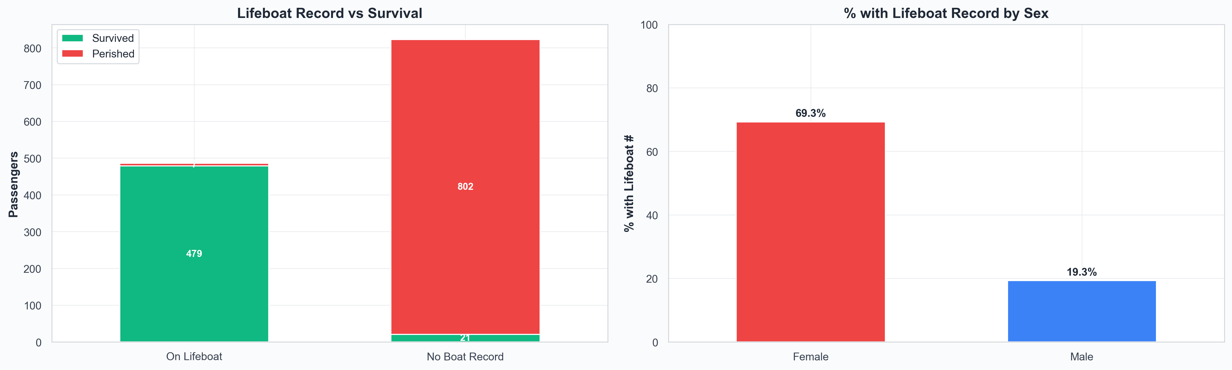
Figure 4. Lifeboat record vs survival, and proportion of each sex with a lifeboat record. The right-hand chart is the 'women and children first' protocol made operational.
Group | Total | Survived | Rate | 95% CI
On a lifeboat (recorded) | 486 | 479 | 98.6% | [97.1, 99.3]
No lifeboat record | 823 | 21 | 2.6% | [1.7, 3.9]

The numbers are stark. Getting onto a lifeboat was effectively a guarantee of survival; not getting on one was almost a guarantee of death. The two confidence intervals don't even come close to overlapping.
Why every demographic effect in this report ultimately reduces to this
The 'women and children first' protocol was the rule that determined boat-seat allocation. Class shaped how strictly the rule was enforced (1st-class women were prioritised over 3rd-class women in practice) and how easily passengers could physically reach the boat deck (1st-class cabins were close; 3rd-class cabins were locked away deep in the ship for hours after the collision). All of the demographic patterns we've measured in this report are the upstream consequences of a single allocation decision: which body got into a lifeboat.

7. Statistical Robustness
Every comparison in this report could in principle be a coincidence of sampling. The tests below check whether each is real. Each produces a p-value: the probability of seeing the observed pattern if there were no underlying effect. Standard thresholds: p < 0.05 is 'probably real', p < 0.001 is 'almost certainly real'. Most of the patterns here clear those thresholds by many orders of magnitude.
Relationship | Test | Statistic | p-value | Effect / Strength
Sex -> Survived | Chi-square | chi2 = 363.6 | < 2e-16 | Very Strong
Pclass -> Survived | Chi-square | chi2 = 128.6 | < 2e-16 | Very Strong
Embarked -> Survived | Chi-square | chi2 = 54.4 | 9.36e-12 | Very Strong
Fare (Survived vs Perished) | Welch t-test | t = 7.98 | 6.67e-15 | d = 0.48 (Small)
Age (Survived vs Perished) | Welch t-test | t = -1.10 | 0.270 | d = -0.06 (Negligible)
Age groups -> Survived | ANOVA | F = 4.57 | 0.0012 | Significant

Odds ratios with 95% CIs
Odds ratios translate the statistical significance into something more interpretable: how much each factor multiplies your odds of surviving. OR > 1 = better odds; OR < 1 = worse odds; OR = 1 = no effect at all. CIs come from the log-odds standard error; p-values from Fisher's exact test.
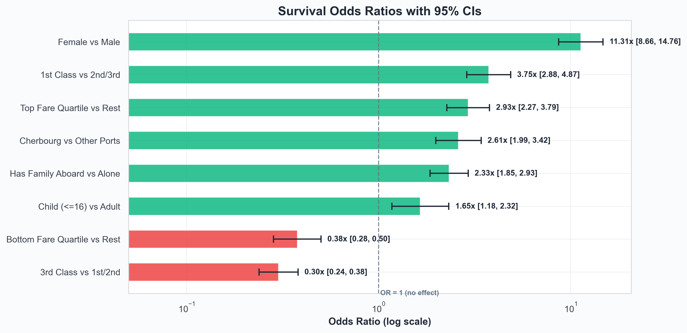
Figure 5. Survival odds ratios with 95% CIs. Bars to the right of 1.0 (green) helped survival; bars to the left (red) hurt it. The log scale matters: each gridline is a 10x.
Contrast | OR | 95% CI | Exposed rate | Unexposed rate | Lift | p
Female vs Male | 11.31x | [8.66, 14.76] | 72.8% | 19.1% | +53.6pp | < 2e-16
1st Class vs 2nd/3rd | 3.75x | [2.88, 4.87] | 62.0% | 30.4% | +31.7pp | < 2e-16
3rd Class vs 1st/2nd | 0.30x | [0.24, 0.38] | 25.5% | 53.2% | -27.6pp | < 2e-16
Child (<=16) vs Adult | 1.65x | [1.18, 2.32] | 49.0% | 36.8% | +12.2pp | 4.32e-03
Cherbourg vs Other Ports | 2.61x | [1.99, 3.42] | 56.6% | 33.4% | +23.2pp | < 2e-16
Top Fare Quartile vs Rest | 2.93x | [2.27, 3.79] | 57.6% | 31.7% | +25.9pp | < 2e-16
Bottom Fare Quartile vs Rest | 0.38x | [0.28, 0.50] | 22.6% | 43.6% | -21.0pp | < 2e-16
Has Family Aboard vs Alone | 2.33x | [1.85, 2.93] | 50.3% | 30.2% | +20.0pp | < 2e-16

8. Conclusions & Recommendations
8.1 What the numbers actually say
Survival on the Titanic was governed by who got onto a lifeboat, and lifeboat allocation was governed by a clear if uneven application of 'women and children first.' That core rule was modulated heavily by class: 1st-class passengers had easier physical access to the boat deck and were prioritised in practice. The result is a four-tier hierarchy:
- 1. 1st- and 2nd-class women: near-universal survival (~89-97%).
- 2. 1st- and 2nd-class men, plus 3rd-class women: middling odds (~14-49%).
- 3. 3rd-class men: near-universal death (~15%).
- 4. Within each of these, age and family size further modulated the odds, but only at the margins.
8.2 Recommendations for further analysis
- Fit a logistic regression with Class x Sex interaction. Marginal odds ratios already tell a clear story, but a joint model would let us separate the independent effects of sex and class from their interaction, and would adjust for fare, age, and family size simultaneously.
- Engineer Title as a primary feature. Title captures sex and (loosely) age in a single categorical column, and out-performs each individually in standard Kaggle baselines.
- Drop Fare or treat it as an alternative encoding of Class. Including both in a model creates collinearity without adding much information.
- Drop Embarked as a survival predictor. Its raw association is confounded with class; once class is in the model, Embarked contributes almost nothing.
- Treat Lifeboat / BodyRecovered as outcomes, not inputs. They are downstream of survival. Including them as features would leak the target.
- Consider extracting Cabin / Deck letters from Occupation. 47% of Occupation entries are missing, but the non-null entries may encode cabin information that could shed light on physical proximity to the boat deck.
8.3 Limitations
- Occupation is 47% missing. This limits cabin-level analysis. We've used HasCabin (a 1/0 indicator of non-null Occupation) as a low-resolution proxy.
- Survival is recorded, but the timing of evacuation decisions is not. We cannot directly test hypotheses about, for example, the order in which lifeboats were lowered.
- Lifeboat numbers are descriptive of survivors, not a causal lever. Using Lifeboat as a feature in a predictive model would be target leakage.
- Class is a coarse proxy for socioeconomic status. Within each class there was considerable variation in cabin location, age, and family situation.

Appendix A. Full Tables
A.1 Survival by sex (with 95% CI)
Sex | n | Survived | Rate | 95% CI
Female | 466 | 339 | 72.8% | [68.5, 76.6]
Male | 843 | 161 | 19.1% | [16.6, 21.9]

A.2 Survival by class (with 95% CI)
Class | n | Survived | Rate | 95% CI
1st | 324 | 201 | 62.0% | [56.6, 67.2]
2nd | 276 | 118 | 42.8% | [37.1, 48.6]
3rd | 709 | 181 | 25.5% | [22.5, 28.9]

A.3 Survival by embarkation port (with 95% CI)
Port | n | Survived | Rate | 95% CI
Belfast | 10 | 0 | 0.0% | [0.0, 27.8]
Cherbourg | 272 | 154 | 56.6% | [50.7, 62.4]
Queenstown | 123 | 44 | 35.8% | [27.9, 44.6]
Southampton | 904 | 302 | 33.4% | [30.4, 36.5]

A.4 Correlation matrix (numeric features only)
 | Age | Fare | SibSp | Parch | Survived
Age | +1.000 | +0.183 | -0.252 | -0.126 | -0.032
Fare | +0.183 | +1.000 | +0.161 | +0.218 | +0.247
SibSp | -0.252 | +0.161 | +1.000 | +0.374 | -0.028
Parch | -0.126 | +0.218 | +0.374 | +1.000 | +0.083
Survived | -0.032 | +0.247 | -0.028 | +0.083 | +1.000

Appendix B. Glossary
Term | Plain-English definition
Survival rate | Percent of a group that survived. 62% means 62 of every 100 lived.
95% CI (Wilson) | The range we are 95% confident contains the true rate. Narrow = certain estimate; wide = small sample, less certain.
Odds Ratio (OR) | How many times higher the odds of survival were for one group versus another. OR = 2 means twice the odds; OR < 1 means lower; OR = 1 means no effect.
Effect size | How strongly a single feature predicts survival on a 0-1 scale. By convention: 0.1 = small, 0.3 = medium, 0.5 = large.
Cramer's V | Effect-size metric for categorical features (Sex, Class, Port).
Point-biserial r | Effect-size metric for a numeric feature predicting a 0/1 outcome.
Cohen's d | Size of the difference between two group means, in standard deviations. 0.2 small, 0.5 medium, 0.8 large.
p-value | Probability the pattern arose by chance. < 0.05 = probably real; < 0.001 = essentially certain.
pp (percentage points) | Arithmetic gap between two percentages. 19% -> 73% is a 54pp jump, not 54%.
Confounding | When a third factor (e.g., class) drives the apparent relationship between two others (e.g., port and survival).
Target leakage | Using a feature that is actually a consequence of the outcome you're predicting. Lifeboat record in a survival model would be leakage.

