Lab sheet for Computational Fluid Dynamics

College of engineering Pune

Lab # 1: Computational Heat Conduction

Date: Time:
Note: Both problem and answer sheet are provided below.

1-D Computational Heat Conduction (CHC):
Consider a 1D Cartesian computational domain of size L=1 m, for CHC transient simulation in a thin (in x-direction) long steel plate (density: 7750 kg/m3, specific-heat: 500 J/Kg K, thermal-conductivity: 16.2 W/m-K. The plate is taken from a furnace at a temperature of 150⁰C (initial-condition) and is subjected to various thermal boundary conditions and volumetric heat generation; shown in a table below.
Develop the code for the above problem, run the code for four different boundary-conditions (Cases), given as:
Cases | Boundary Conditions |  | Volumetric Heat  Generation (W/m³)
Cases | Left | Right | Volumetric Heat  Generation (W/m³)
A | 0⁰C | 100⁰C | 0
B | 100⁰C | h=100W/m².K, T∞=30⁰C | 0
C | 0⁰C | 100⁰C | 30,000
D | 100⁰C | h=100W/m².K, T∞=30⁰C | 30,000

Take the maximum number of grid points in x-and y-direction as imax=12 and convergence criteria as 0.000001.
Report the results as
- Plot the steady state temperature profiles for the different cases (4 figures).
- Discuss the effect of volumetric heat generation on the results for both the types of BCs.

Answer Sheet
1-D Computational Heat Conduction (CHC) :

- Plot the steady-state temperature profile (T(x)) for the different cases (4 figures).

(a) | (b)
(c) | (d)

Fig. 2.1: Steady state temperature profile T(x) in the 1D domain for (a) Case A, (b) Case B,
(c) Case C and (d) Case D

- Discuss the effect of volumetric heat generation on the results for both the types of BCs.

Write your answer, limited inside this text box only

Lab sheet for Computational Fluid Dynamics

College of engineering Pune

Lab # 2: Computational Heat Conduction

Date: Time:

2- D Computational Heat Conduction (CHC) :
Consider a 2D Cartesian computational x-y domain of size L=1 m and H=1 m, for CHC transient simulation in a long (in z-direction) steel plate (density: 7750 kg/m3, specific-heat: 500 J/Kg K, thermal-conductivity: 16.2 W/m-K. The plate is taken from a furnace at a temperature of 150⁰C (initial-condition) and is subjected to various thermal boundary conditions and volumetric heat generation; shown in a table below.
Develop the code for the above problem, run the code for four different boundary-conditions (Cases), given as:
Cases | Boundary Conditions |  |  |  | Volumetric Heat  Generation (W/m³)
Cases | Left | Bottom | Right | Top | Volumetric Heat  Generation (W/m³)
A | 100⁰C | 200⁰C | 300⁰C | 400⁰C | 0
B | 100⁰C | Insulated | q_{W}=10,000 W/m² | h=100W/m².K, T∞=30⁰C | 0
C | 100⁰C | 200⁰C | 300⁰C | 400⁰C | 50,000
D | 100⁰C | Insulated | q_{W}=10,000 W/m² | h=100W/m².K, T∞=30⁰C | 10,000
Take the maximum number of grid points in x-and y-direction as imax=jmax=12 and convergence criteria as 0.000001.

Report the results as
- Plot the steady state temperature contours for the different cases (4 figures).
- Prepare a table for heat transfer (positive for outward/heat-loss and negative for inward/heat-gain) from the different walls of the plate, volumetric heat generation, total heat-gain, total heat-loss and energy balance; for the different cases.
- Discuss the effect of volumetric heat generation on the results for both the types of BCs.

Answer Sheet
2-D Computational Heat Conduction (CHC) :
- Plot the steady state temperature contours for the different cases (4 figures).

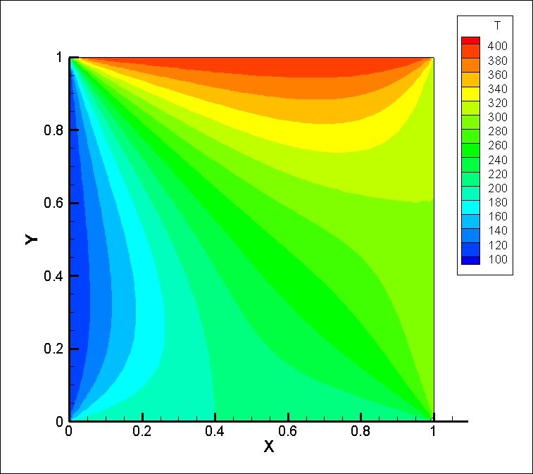  (a) | 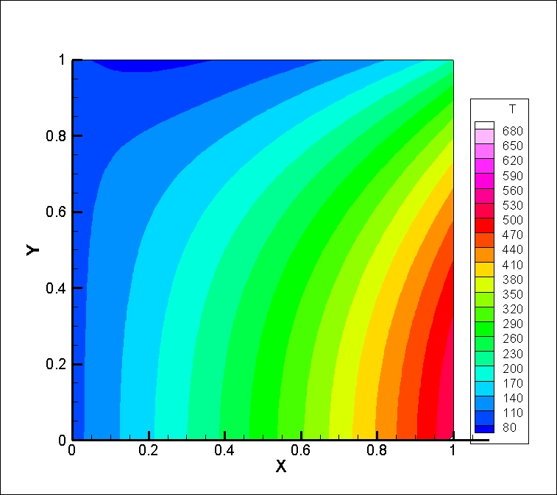  (b)
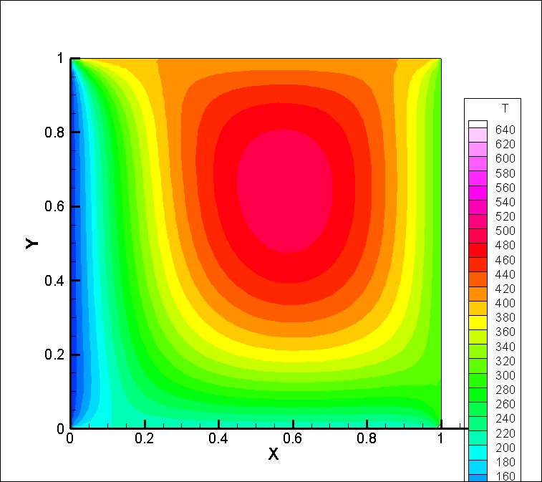  (c) | 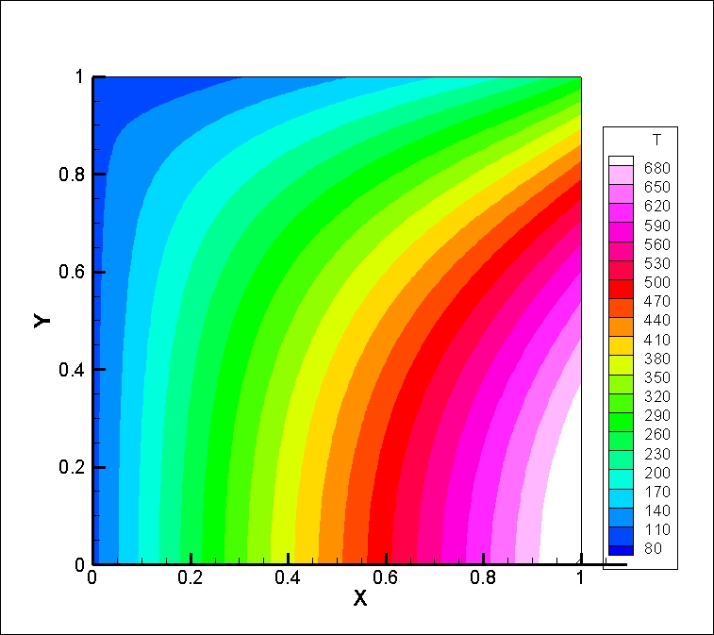  (d)

Fig. 2.2: Steady state temperature contours in the 2D domain for (a) Case A, (b) Case B,
(c) Case C and (d) Case D

- Prepare a table for heat transfer (positive for outward/heat-loss and negative for inward/heat-gain) from the different walls of the plate, volumetric heat generation, total heat-gain, total heat-loss and energy balance; for the different cases.
Table 2.1: Heat transfer related parameters obtained for different test cases of 2D heat conduction
 | Case A | Case B | Case C | Case D
Heat transfer from left
Heat transfer from right
Heat transfer from top
Heat transfer from bottom
Volumetric heat generation
Total heat gain
Total heat loss
Energy balance

- Discuss the effect of volumetric heat generation on the results for both the types of BCs.
Write your answer, limited inside this text box only

