Lab sheet for Computational Fluid Dynamics

College of engineering Pune
Lab # 3: Computational Heat Advection and Convection

Date: Time:

- 2D Computational Heat Advection (CHA):

Consider a 2D Cartesian (x,y) computational domain of size L=1m and H=1 m, for CHA of a fluid (ρ=1000 kg/m³ and c_{p}=4180 W/m.K) moving with a uniform velocity u=v=1 m/s and an initial temperature of 50⁰C. The left and top boundary of the domain is subjected to 100⁰C; and the bottom and right boundary to 0⁰C
Develop the code or set up the case using ANSYS CFD for the above problem, run the code or set up for three different advection schemes: (a) FOU, (b) SOU and (c) QUICK. Take the maximum number of grid points in x-and y-direction as imax=jmax=22 and convergence criteria as 0.000001.
Report the results as
- Plot and discuss the steady state temperature contours for the different advection schemes (3 figures).
- Plot and discuss the temperature profile at the vertical centerline(x=0.5), T(y), for the different advection schemes (3 figures).

Answer Sheet
2D Computational Heat Advection (CHA):
- Plot and discuss the steady state temperature contours for the different advection schemes (3 figures).
- Plot and discuss the temperature profile at the vertical centerline(x=0.5), T(y), for the different advection schemes (3 figures).
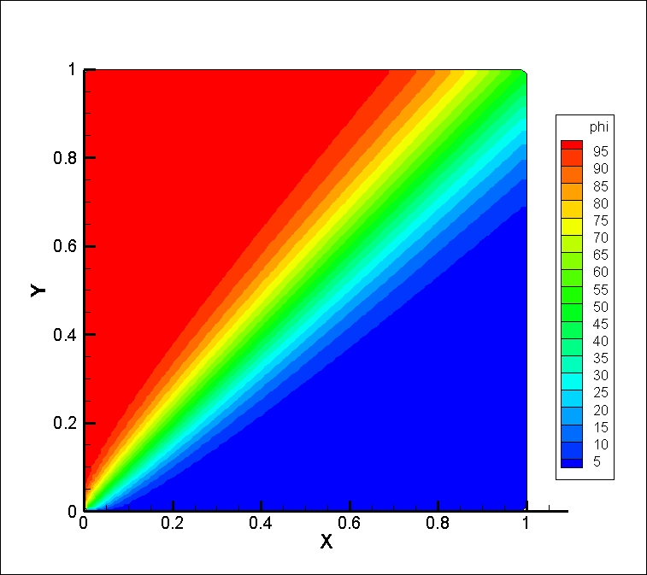  (a1) | 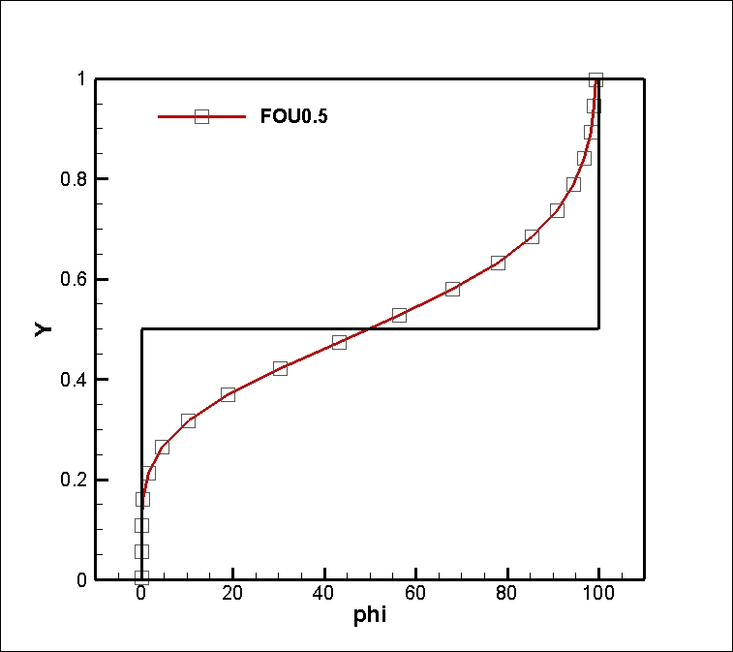  (a2)
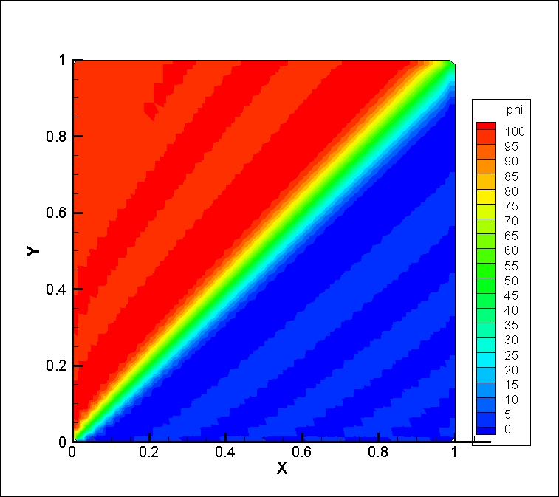  (b1) | 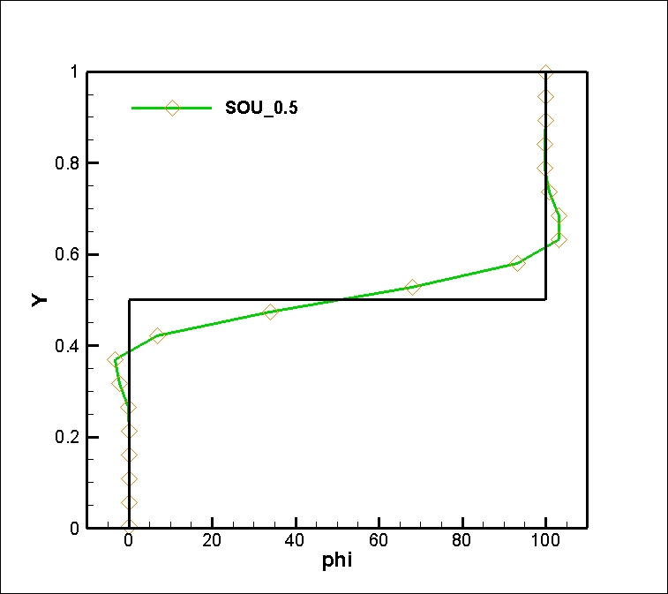  (b2)
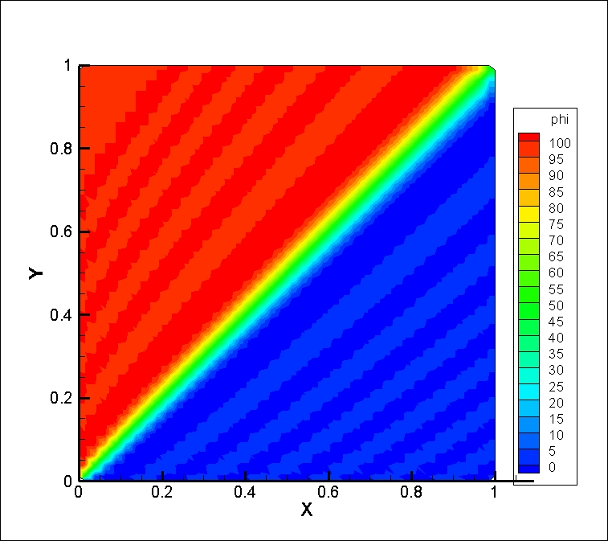  (c1) | 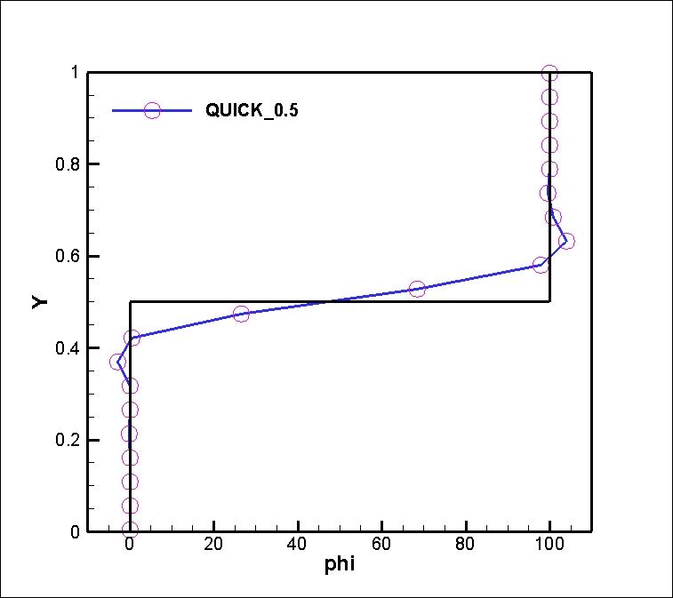  (c2)

Fig. 3.1: Steady state temperature contours using the (a1) FOU scheme (b1) SOU scheme (c1) QUICK
Scheme Temperature variation along the vertical centerline using the (a2) FOU scheme (b2)
SOU scheme (c2) QUICK scheme

Discuss Fig. 3.1 here, limited inside this text box only

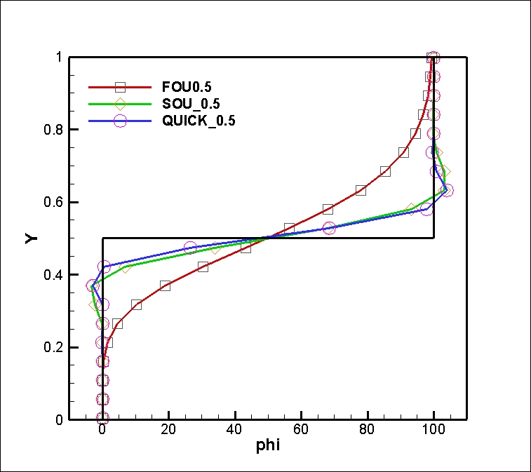

Lab sheet for Computational Fluid Dynamics
College of Engineering Pune

Lab # 4: Computational Heat Advection and Convection

Date: Time:

1D Computational Heat Convection (CHC):

Consider one-dimensional unsteady-state convection, in a domain of length L=1. The fluid has a density ρ=1, diffusion coefficient Γ=0.02 and a velocity of U=1; resulting in a Peclet number Pe= ρUL/ Γ = 50. The boundary condition for the advected variable is φ=0 at x=0 and φ =1 at x=1. The initial condition is φ=0.5.
Develop the code or set up the case for the above problem, run the code or set up for two different advection schemes: (a) SOU and (b) QUICK. Take the convergence criteria as 0.000001.
Plot and discuss the steady state temperature profile T(x) for the different advection schemes on two different grid sizes:
- imax=12 (2 figures)
- imax=42 (2 figures)

Plot and discuss the steady state temperature profile T(x) for the SOU and QUICK advection schemes on two different grid sizes: (a) imax=12 (2 figures) and (b) imax=42 (2 figures).

(a1) | (a2)
(b1) | (b2)

Fig. 4.1: Steady state temperature profile T(x) using the (a1,a2) FOU scheme (b1,b2) CD scheme, on a
grid size of (a1,b1) 12 and (a2,b2) 42 grid points.

Discuss Fig. 4.1 here, limited inside this text box only

Lab sheet for Computational Fluid Dynamics
College of Engineering Pune

Lab # 5: Computational Heat Advection and Convection

Date: Time:

2D Computational Heat Convection (CHC):

Consider a 2D Cartesian computational x-y domain of size L=6 unit and H=1 unit, for CHC with a prescribed velocity field. This corresponds to a slug flow (u=1, v=0) of a fluid in a channel; subjected to a non-dimensional temperature of 1 at the inlet and 0 at the walls. At the outlet, fully developed Neumann BC is used. The initial condition for non-dimensional temperature of the fluid is 0.
Develop the code or set up the case using ANSYS CFD for the above problem, run the code of the case for two different advection schemes: (a) FOU and (b) QUICK; at Re=10 and Pr=1. Take the maximum number of grid points in x-and y-direction as imax=62 and jmax=22, respectively; and convergence criteria as 0.000001.
Report the results as
- Plot and discuss the steady state temperature contours for the different advection schemes (2 figures).
- Plot and discuss the temperature profile, T(y), at different axial locations (x/L=0.2, 0.4, 0.6, 0.8 and 1), for the different advection schemes (2 figures).

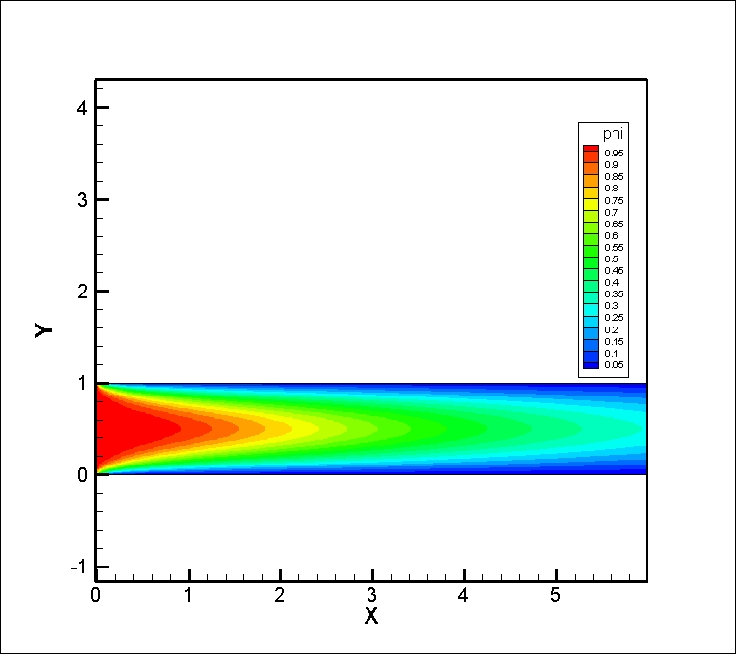  (a1) | 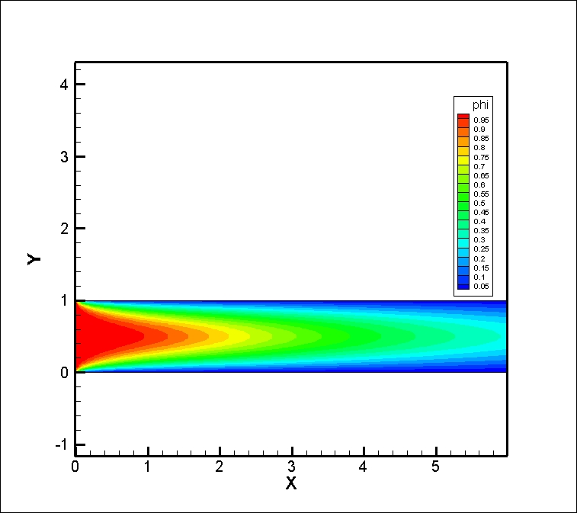  (a2)
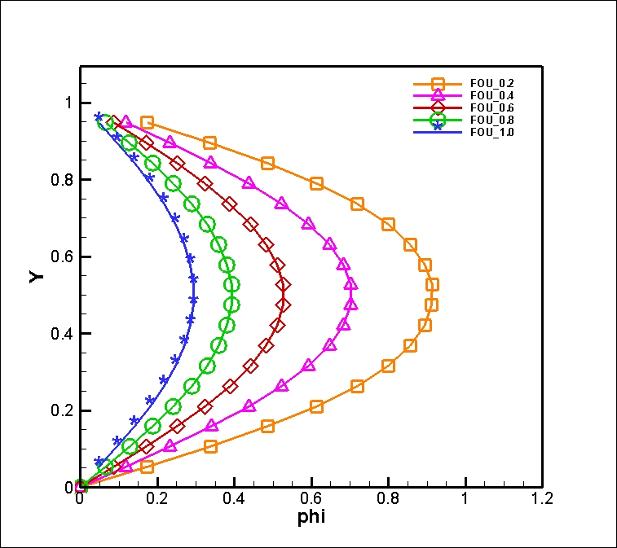  (b1) | 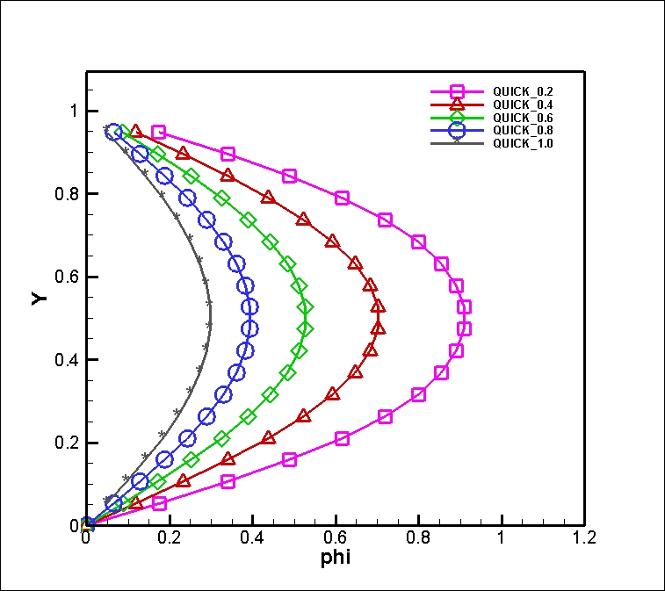  (b2)

Fig. 5.1: Steady state temperature contours using the (a1) FOU scheme and (b1) QUICK scheme.
Temperature variation at different axial locations using the (a2) FOU scheme and (b2) QUICK
Scheme.

Discuss Fig. 5.1 here, limited inside this text box only
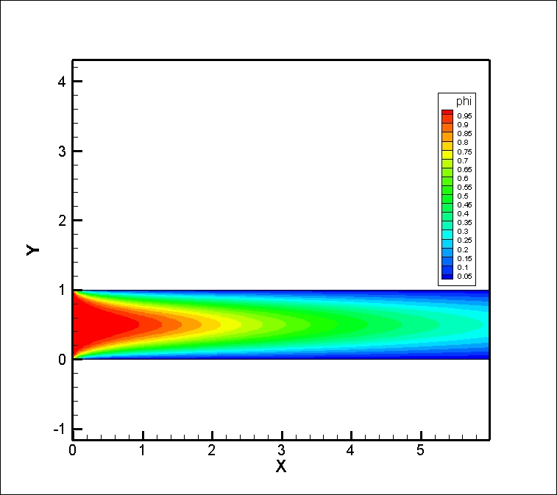  (a1) | 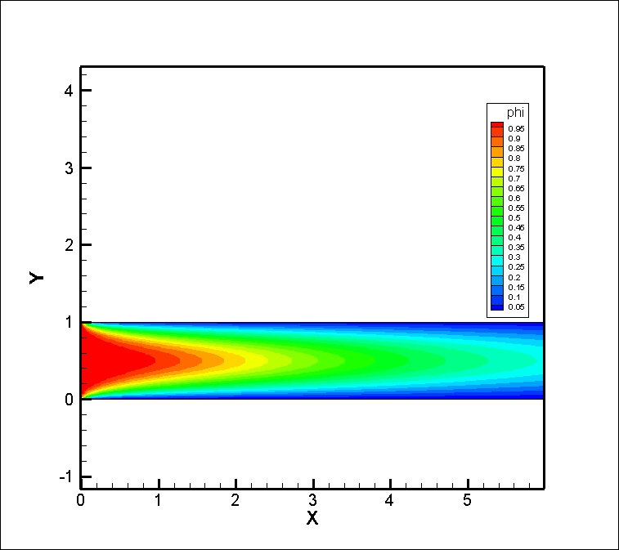  (a2)
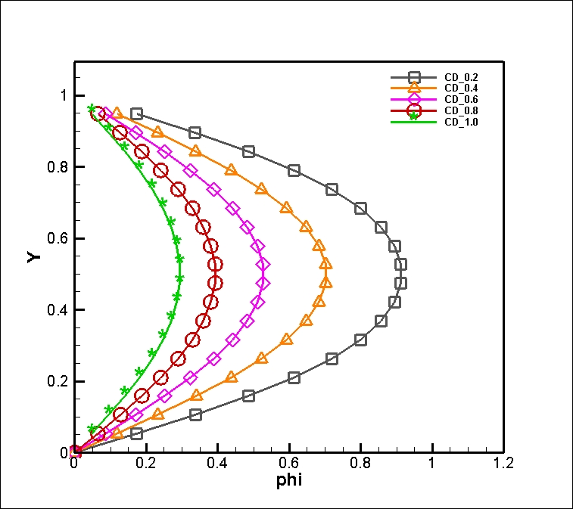  (b1) | 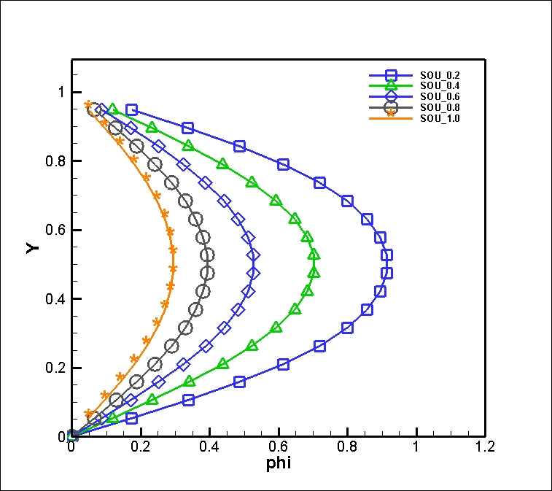  (b2)

Fig. 5.1: Steady state temperature contours using the (a1) CD scheme and (b1) SOU scheme.
Temperature variation at different axial locations using the (a2) CD scheme and (b2) SOU
Scheme.

