Selenium Waits in Java — Concepts & Examples

1. Overview
Selenium tests often need to wait for elements or certain conditions on the page. Using waits prevents brittle tests that fail due to timing (elements not yet loaded). This document shows how to use waits in Selenium with Java, including sample programs.

2. Maven dependency (Selenium 4+)
Add the following to your pom.xml dependencies:
<dependency>
<groupId>org.seleniumhq.selenium</groupId>
<artifactId>selenium-java</artifactId>
<version>4.10.0</version> <!-- adjust to latest stable -->
</dependency>
Also ensure you have a compatible ChromeDriver (or other driver) for your browser version.

3. Types of waits in Java
a) Implicit Wait
• Configured once on the WebDriver and applies to all findElement/findElements calls.
• If an element is not immediately present, the driver polls until timeout.
• Simpler but less flexible; can mask synchronization issues.
b) Explicit Wait (recommended)
• Wait for a specific condition using WebDriverWait + ExpectedConditions.
• More precise and preferred for specific synchronization needs.
c) Fluent Wait
• A version of explicit wait with customizable polling frequency and ignored exceptions.
• Implemented via FluentWait or by configuring WebDriverWait in Selenium 4.

4. When to use which
• Use implicit wait for a simple baseline (short timeout) but avoid relying on it solely.
• Prefer explicit waits (WebDriverWait) for actions requiring specific conditions (clickable, visible, etc.).
• Use FluentWait for complex polling strategies or to ignore transient exceptions.

5. Common ExpectedConditions
Examples: presenceOfElementLocated, visibilityOfElementLocated, elementToBeClickable, textToBePresentInElement, alertIsPresent

6. Sample Java Program (complete)
This sample demonstrates implicit wait, explicit wait (WebDriverWait), and FluentWait.
// SeleniumWaitsDemo.java
import java.time.Duration;
import org.openqa.selenium.By;
import org.openqa.selenium.WebDriver;
import org.openqa.selenium.WebElement;
import org.openqa.selenium.chrome.ChromeDriver;
import org.openqa.selenium.chrome.ChromeOptions;
import org.openqa.selenium.NoSuchElementException;
import org.openqa.selenium.TimeoutException;
import org.openqa.selenium.support.ui.ExpectedConditions;
import org.openqa.selenium.support.ui.FluentWait;
import org.openqa.selenium.support.ui.WebDriverWait;
import java.util.function.Function;
public class SeleniumWaitsDemo {
public static void main(String[] args) {
// Path to chromedriver executable (adjust to your path)
System.setProperty("webdriver.chrome.driver", "/path/to/chromedriver");
ChromeOptions options = new ChromeOptions();
// options.addArguments("--headless=new"); // optional headless mode
WebDriver driver = new ChromeDriver(options);
try {
// 1) Implicit wait - applies to all findElement calls
driver.manage().timeouts().implicitlyWait(Duration.ofSeconds(5));
driver.get("https://example.com");
// Try to find element using implicit wait
try {
WebElement el = driver.findElement(By.id("some-element-id"));
System.out.println("Found element using implicit wait: " + el);
} catch (NoSuchElementException e) {
System.out.println("Element not found with implicit wait");
}
// 2) Explicit wait - WebDriverWait with ExpectedConditions
WebDriverWait wait = new WebDriverWait(driver, Duration.ofSeconds(15));
try {
WebElement loginButton = wait.until(
ExpectedConditions.elementToBeClickable(By.cssSelector("button.login"))
);
loginButton.click();
System.out.println("Clicked login button (explicit wait)");
} catch (TimeoutException ex) {
System.out.println("Login button was not clickable within 15s");
}
// 3) FluentWait - custom polling and ignoring exceptions
FluentWait<WebDriver> fluentWait = new FluentWait<>(driver)
.withTimeout(Duration.ofSeconds(20))
.pollingEvery(Duration.ofMillis(500))
.ignoring(NoSuchElementException.class);
try {
WebElement dynamic = fluentWait.until(new Function<WebDriver, WebElement>() {
public WebElement apply(WebDriver d) {
return d.findElement(By.xpath("//div[@id='dynamic']"));
}
});
System.out.println("Found dynamic element (fluent wait): " + dynamic.getText());
} catch (TimeoutException ex) {
System.out.println("Dynamic element did not appear within 20s");
}
} finally {
driver.quit();
}
}
}

7. Running the sample
1. Install Java JDK 11+ and Maven.
2. Add selenium-java dependency to pom.xml.
3. Download ChromeDriver matching your Chrome version and set the webdriver.chrome.driver system property or put it on PATH.
4. Compile and run:
mvn compile
mvn exec:java -Dexec.mainClass="SeleniumWaitsDemo"
Note: If using an IDE (IntelliJ/Eclipse), create a Java project and run the main class directly.

8. Tips & Best Practices
• Prefer explicit waits over implicit waits for predictable synchronization.
• Avoid mixing implicit and explicit waits with long timeouts (can cause unexpected delays).
• Keep explicit wait timeouts reasonable to avoid long test runs.
• Use targeted expected conditions (e.g., elementToBeClickable) rather than Thread.sleep().
• Wrap wait logic in helper methods or a base Page Object to keep tests readable.

9. Quick reference (Java)
import org.openqa.selenium.support.ui.WebDriverWait;
import org.openqa.selenium.support.ui.ExpectedConditions;
// wait for presence:
new WebDriverWait(driver, Duration.ofSeconds(10))
.until(ExpectedConditions.presenceOfElementLocated(By.id("id")));
// wait for visibility:
new WebDriverWait(driver, Duration.ofSeconds(10))
.until(ExpectedConditions.visibilityOfElementLocated(By.cssSelector(".class")));
// fluent wait example:
new FluentWait<>(driver)
.withTimeout(Duration.ofSeconds(20))
.pollingEvery(Duration.ofMillis(500))
.ignoring(NoSuchElementException.class)
.until(d -> d.findElement(By.xpath("//button")));

Waits :

https://demoqa.com/dynamic-properties

Implicit wait
=============
driver.manage().timeouts().implicitlyWait(Duration.ofSeconds(10))

drive.findElemnt().click();
drive.findElemnt().click();
drive.findElemnt().click();
drive.findElemnt().click();

Explicit Wait:
==============
1)waits for a specific condition to be true for specific element
2)WebDriverWait

WebDriverWait wait = new WebDriverWait(driver,Duration.OfSeconds(15));
WebElement element =wait.until(ExpectedContions.visibilityOfElementLocated(By.xpath(""));

TimeoutException

Fluent wait
============

setting for polling time
ignoring the exceptions

FluentWait wait = new FluentWait(driver);
wait.withTimeout(Duation.OfSeconds(15))
.pollingEvery(Duration.OfMilliSeconds(250)
.ignoring(NoSuchElementException.class);

TimeoutException

Thread.sleep(2000) - uninterrupted exception

it will pause you execution unconditionally

Page Load timeout:
=================
wait for the whole page to load completely
driver.manage().timeouts().pageLoadTimeout(Duration.ofSeonds(30));

Script Timeout
=============
driver.manage().timeouts().scriptTimeOut(Duration.OfSeonds(10));

)

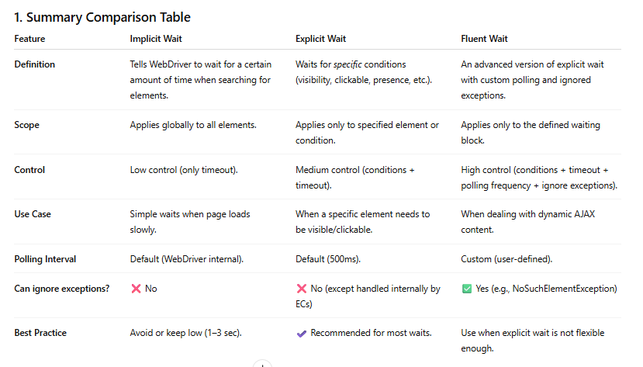

Implicit Wait – Default Error
Default Exception:
NoSuchElementException
Why?
Implicit wait only retries finding the element.
If it is still not found within the timeout → Selenium throws NoSuchElementException.

2. Explicit Wait – Default Error
Default Exception:
TimeoutException
Why?
Explicit wait stops when:
- condition is NOT met within timeout → throws TimeoutException
Java Example
WebDriverWait wait = new WebDriverWait(driver, Duration.ofSeconds(5));
wait.until(ExpectedConditions.visibilityOfElementLocated(By.id("nope")));

3. Fluent Wait – Default Error
Default Exception:
TimeoutException (same as explicit wait)
Why?
FluentWait is basically an advanced explicit wait.
If the condition is not satisfied → TimeoutException is thrown.
Java Example
FluentWait<WebDriver> wait = new FluentWait<>(driver)
.withTimeout(Duration.ofSeconds(10))
.pollingEvery(Duration.ofSeconds(1))
.ignoring(NoSuchElementException.class);

wait.until(d -> d.findElement(By.id("missing")));

