

Assignment 1

[Document subtitle]



[Company address]

Nathu Mal Omani

146715

Assignment1

Quiz Generator

Introduction

In this assignment I used here concepts of GIU Swing Library classes objects and java concepts.In this application User First login in its account the He/She has authority to create Quiz or attempt Quiz and he three option of creating Quiz Mcqs and False and Numerals and on the back it store in serilized form .When Student can attempt quiz.

Login

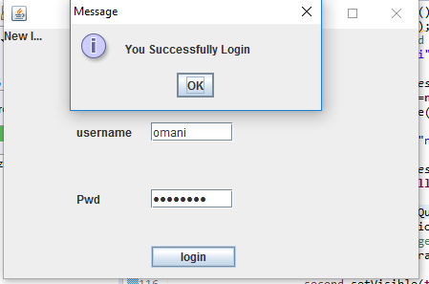

Title and Description

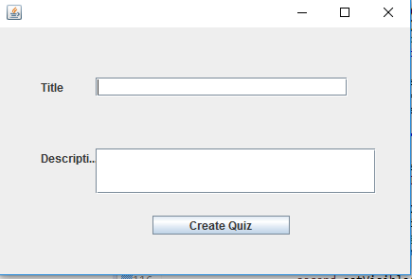

Select Option

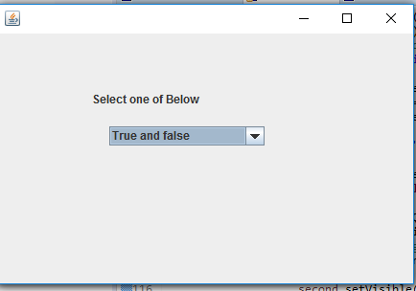

Mcqs

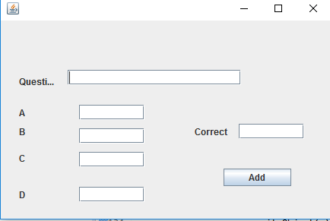

True and false

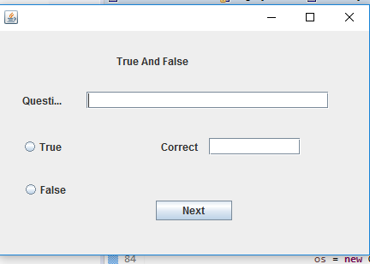

Numerals

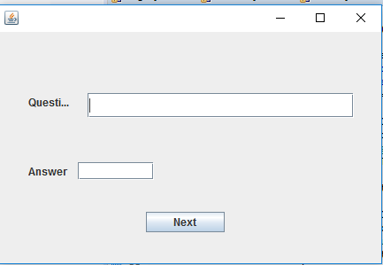

Student Quiz attempt

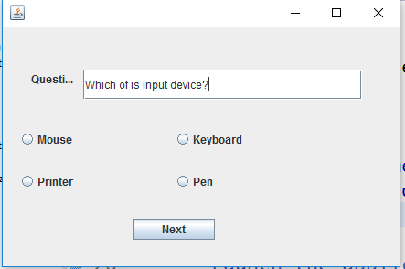

Unit Test Case

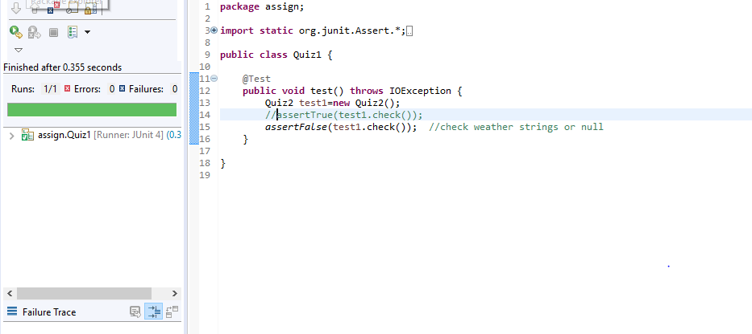

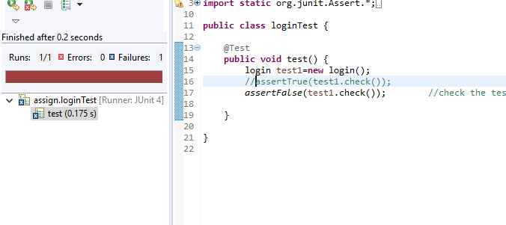

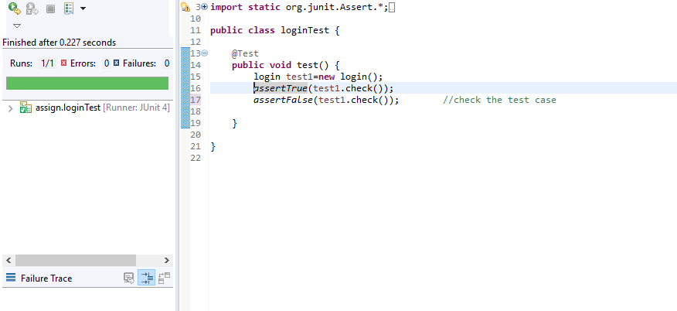

Profiling Memory

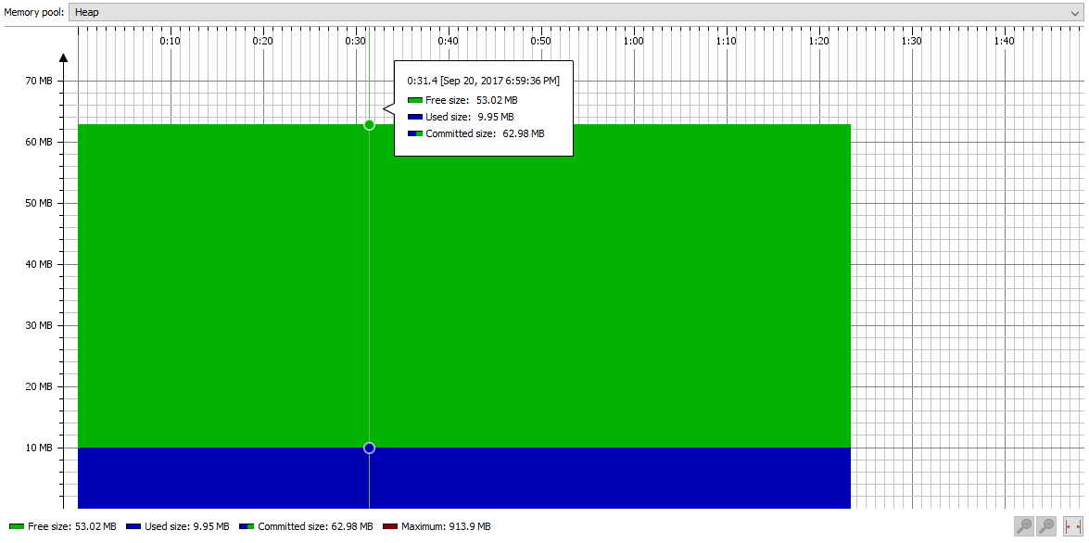

CPU Load

