Python Project 1 - To-Do List Application
Submitted By: Aneela naz shahani
Batch: 2026

Objective
Develop a To-Do List Application using Python to add, view, complete, and delete tasks.

Introduction
This project demonstrates Python lists, dictionaries, loops, and conditional statements.

Tools and Technologies
Python, VS Code/IDLE, Lists, Dictionaries, Loops, Conditions.

Algorithm
1. Start
2. Create empty task list
3. Show menu
4. Add/View/Complete/Delete tasks
5. Exit
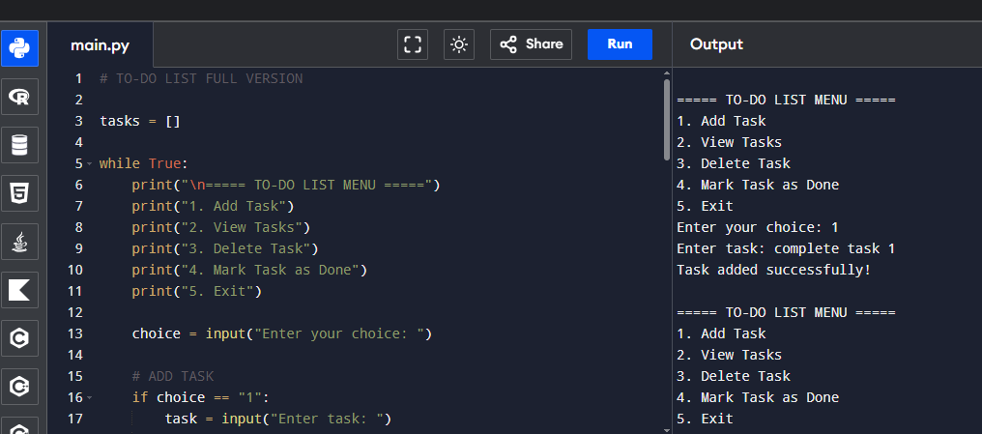
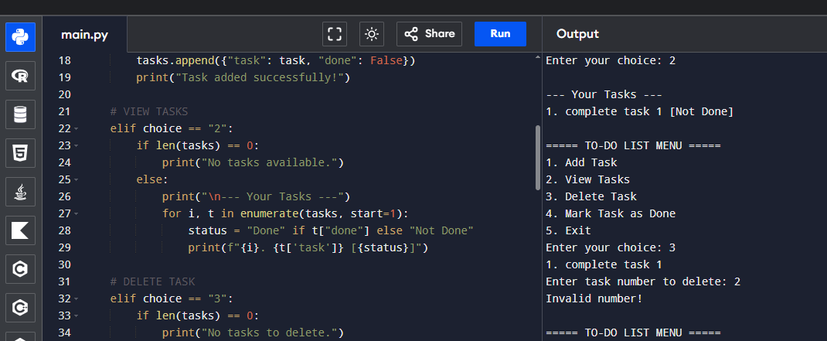
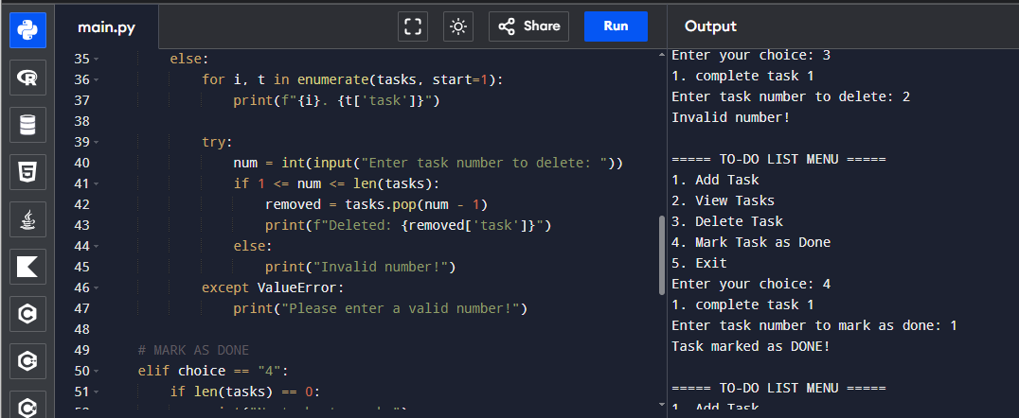
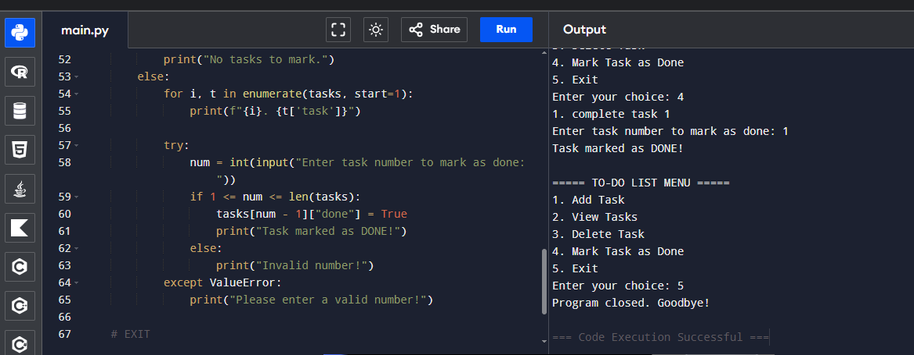

Conclusion
The project demonstrates basic data management and forms a foundation for database-driven applications.

