

MSc Data Science Project
7PAM2002
Department of Physics, Astronomy and Mathematics

Data Science FINAL PROJECT REPORT
Project Title:
Enter Your Full Project Title
Student Name and SRN:
Enter Your Full Name and Student ID

Supervisor: Enter the full name of your Supervisor
Date Submitted: Enter the date you are submitting this report
Word Count: Enter the word count excluding references and appendices
DECLARATION STATEMENT

This report is submitted in partial fulfilment of the requirement for the degree of Master of Science in Data Science at the University of Hertfordshire.
I have read the detailed guidance to students on academic integrity, misconduct and plagiarism information at Assessment Offences and Academic Misconduct and understand the University process of dealing with suspected cases of academic misconduct and the possible penalties, which could include failing the project or course.
I certify that the work submitted is my own and that any material derived or quoted from published or unpublished work of other persons has been duly acknowledged. (Ref. UPR AS/C/6.1, section 7 and UPR AS/C/5, section 3.6)
I did not use human participants in my MSc Project.

I hereby give permission for the report to be made available on module websites provided the source is acknowledged.

Student Name printed:
Student Name signature
Student SRN number:

UNIVERSITY OF HERTFORDSHIRE
SCHOOL OF PHYSICS, ENGINEERING AND COMPUTER SCIENCE

Contents
DECLARATION STATEMENT 2
1 Introduction 1
1.1 Research Motivation 1
1.2 Research Aim 2
1.3 Research Objectives 2
1.4 Research Questions 2
2 Literature Review 3
2.1 Introduction and Selection Criteria 3
2.2 Summary and Research Gap 4
3 Dataset & EDA 5
3.1 Data Source and Original Collection Method 5
3.2 Preprocessing Details and Visualizations 5
4 Ethics Statement 7
5 Methodology 8
5.1 Dataset Collection and Preprocessing 8
5.2 Model Development 8
5.2.1 Baseline CNN Architecture 8
5.2.2 Transfer Learning Architectures 9
5.3 Model Training 10
5.4 Evaluation Metrics 10
5.5 Summary 10
6 Results 11
6.1 Comparative Performance Metrics 11
6.2 Visual Comparison of Classification Performance 11
6.3 Computational Efficiency: Training vs Testing Time 12
6.4 Observations 13
6.5 History and Confusion Graph 13
7 Analysis and Discussion 15
7.1 Model Performance and Comparison 15
7.2 Impact of Preprocessing and Augmentation 15
7.3 Confusion Matrix and Model Behavior 15
7.4 Limitations and Challenges 15
7.5 Relation to Project Objectives and Clinical Applicability 16
7.6 Comparison to Literature 16
8 Conclusion 17
9 References 18

Abstract
This project investigates the use of Convolutional Neural Network (CNN) based deep learning models for the automatic classification of CT kidney images into four categories: Normal, Cyst, Stone, and Tumor. The primary objective was to evaluate and compare the performance of a custom CNN and pre-trained transfer learning models, ResNet50, MobileNetV2, and DenseNet121, to identify the most accurate and computationally efficient approach. A publicly available CT kidney dataset was utilized, and comprehensive preprocessing and augmentation techniques were applied to enhance model generalization. The custom CNN was trained using multiple optimizers, including Adam, RMSprop, and SGD, to identify the configuration that achieved the best convergence and performance. All models were implemented using TensorFlow and Keras frameworks and evaluated through accuracy, precision, recall, and F1-score metrics. Among the tested models, DenseNet121 achieved superior performance with 100% accuracy, precision, recall, and F1-score, demonstrating its effectiveness in extracting fine-grained medical features. The results confirm that CNN-based models, particularly DenseNet121, can play a vital role in automating kidney disease detection and assisting radiologists in diagnostic decision-making. Future work will focus on expanding dataset diversity, improving explainability, and validating model performance on real-world clinical data.

Introduction
Chronic Kidney Disease (CKD) poses a significant and escalating global health challenge, affecting over 10% of the world's population and contributing to a steady tunder-resourced and rural regions, where environmental exposures, inadequate healthcare infrastructure, and limited access to early diagnostic tools exacerbate the progression of the disease (Qezelbash-Chamak et al., 2022). In areas like Uddanam, India, for example, agricultural workers are disproportionately affected due to exposure to heavy metals and occupational stress. Furthermore, CKD is often asymptomatic in its early stages, leading to delayed diagnoses and missed opportunities for early intervention. As such, the timely and accurate identification of kidney abnormalities, such as cysts, tumors, and stones, is crucial for effective CKD management, improved prognoses, and reduced healthcare costs.
Traditionally, CKD diagnosis has relied heavily on laboratory testing and manual interpretation of radiological scans (Tangri et al., 2011). However, this process is time-consuming, subject to human error, and highly dependent on the expertise of the clinician. With the exponential growth of medical imaging data, there is an increasing demand for automated systems that can assist healthcare professionals in diagnosing kidney-related conditions with speed and precision. Advances in artificial intelligence (AI), and particularly deep learning, have created new opportunities to address this need.
Convolutional Neural Networks (CNNs), a class of deep learning algorithms specialized for image analysis, have demonstrated exceptional performance in various medical imaging tasks (Iliyas et al., no date). CNNs are capable of automatically extracting complex hierarchical features from images, enabling high-accuracy classification without manual feature engineering. Their ability to learn spatial patterns makes them especially well-suited for analyzing CT images, where subtle visual differences between kidney conditions must be detected.
While prior studies have applied machine learning models to clinical data for CKD prediction, fewer have focused specifically on CT image-based classification using state-of-the-art CNN models. This research seeks to fill that gap by evaluating and comparing both custom-built and pre-trained CNN architectures, such as DenseNet121, EfficientNetB0, and ResNet50, for classifying CT kidney images into four diagnostic categories: Normal, Cyst, Tumor, and Stone. By leveraging transfer learning and advanced preprocessing techniques, the study aims to develop robust and generalizable models capable of supporting clinical decision-making, especially in resource-constrained settings where radiological expertise may be limited.

Research Motivation
Chronic Kidney Disease (CKD) is a silent but progressive condition that has become a major global health concern, particularly in developing and rural regions where early diagnosis and access to specialist care are limited. The increasing volume of medical imaging data has outpaced the capacity of healthcare systems to analyze and interpret it effectively, especially in low-resource settings. Although artificial intelligence (AI) and deep learning have demonstrated promising results in medical diagnostics, there remains a lack of tailored, high-performing models for kidney image classification—particularly using CT scan data. Bridging this gap could lead to earlier, more accurate diagnoses, reduce clinician workload, and significantly improve patient outcomes. This research is motivated by the urgent need for reliable, scalable, and clinically applicable deep learning tools for automated kidney disease detection.

Research Aim
To develop and evaluate deep learning-based models, particularly Convolutional Neural Networks (CNNs), for the automated classification of CT kidney images into four diagnostic categories: Normal, Cyst, Tumor, and Stone, with the goal of improving early detection and clinical decision support for kidney-related diseases.

Research Objectives
- To review and synthesize existing literature on machine learning and deep learning approaches used for CKD detection and kidney image classification.
- To preprocess and augment a CT kidney image dataset to prepare it for deep learning model training and evaluation.
- To design, implement, and compare the performance of custom-built CNNs and transfer learning models (DenseNet121, EfficientNetB0, ResNet50) for multi-class kidney image classification.
- To evaluate model performance using key metrics such as accuracy, precision, recall, F1-score, and confusion matrices.
- To assess the generalizability and potential clinical integration of the most effective model(s), identifying strengths, limitations, and areas for further improvement.

Research Questions
- How effectively can CNN-based deep learning models classify CT kidney images into Normal, Cyst, Tumor, and Stone categories?
- Which model architecture, custom CNN or pre-trained transfer learning models, achieves the highest accuracy and generalization performance?
- What impact do data preprocessing and augmentation techniques have on model training and validation outcomes?
- Can the most accurate models be feasibly integrated into real-world clinical workflows to support early kidney disease diagnosis?
- What are the limitations of current CNN-based models in handling class imbalance, overfitting, and dataset diversity?

Literature Review

Introduction and Selection Criteria
Automatic recognition of kidney stones from medical images lies at the intersection of computer vision and clinical urology. For this review, peer-reviewed studies were selected that applied deep learning or machine learning to kidney stone imaging or related renal diagnosis problems, with clear evaluation metrics and validation procedures. The four papers discussed here collectively cover deep CNN-based composition recognition, broader deep learning applications for kidney stone detection, and classical machine learning approaches for chronic kidney disease (CKD) prediction. These works form the technical foundation of the current project.
This study (Black et al., 2020) applied a deep CNN, ResNet-101, as a multi-class classifier to digital photographs of 63 human kidney stones across five composition classes: calcium oxalate monohydrate (COM), uric acid (UA), struvite (MAPH), brushite (CHPD), and cystine. Each stone was photographed on both surface and inner core sides, and evaluated using leave-one-out cross-validation. The model achieved recalls of 94% (UA), 90% (COM), 86% (MAPH), 75% (cystine), and 71% (CHPD), with an overall weighted recall of 85%. This demonstrates the feasibility of using CNNs for automatic composition identification. However, the small, class-imbalanced dataset limits generalizability, and cross-validation on images from the same stone may lead to optimistic results. Furthermore, model interpretability, real-time inference, and adaptation to endoscopic imagery were not addressed. Nevertheless, this paper directly informs the current project by validating the feasibility of using transfer learning for composition classification.
This pilot study, (Stone, 2020)published in BJU International, reinforced the feasibility of using ResNet-101 for classifying kidney stone compositions from DSLR macro photographs. It emphasized the clinical utility of such technology for intra-operative recognition, where automatic laser parameter adjustment could optimize lithotripsy efficiency. While technically similar to the previous work, it highlighted the translational challenge of moving from dry laboratory photographs to endoscopic images captured in wet and variable lighting conditions. Although the study established proof of concept, it did not address domain adaptation or real-time deployment, which remain critical challenges this project aims to overcome.
This paper proposed (Kuo et al., 2019) a CNN-based pipeline for automatic kidney stone detection and classification in medical images. The dataset consisted of a large number of annotated samples subjected to preprocessing to ensure homogeneity. The CNN achieved high sensitivity, specificity, and accuracy, and was reported suitable for real-time use. Although the results appear promising, the abstract provides limited methodological details, with no specification of dataset size, network configuration, or validation strategy. This restricts reproducibility and confidence in the reported performance. Nonetheless, it contributes a valuable perspective on scaling deep learning models and optimizing inference speed, both of which are relevant for clinical implementation in our study.
This study (Chittora et al., 2021) applied several classical machine learning algorithms, including artificial neural networks, logistic regression, support vector machines, and decision trees, to the UCI CKD dataset. Feature selection methods such as LASSO, wrapper approaches, and correlation-based filtering were used along with data balancing using SMOTE. The linear SVM with L2 penalty achieved an accuracy of 98.86%, while a deep neural network reached 99.6%. Although this work focuses on tabular clinical data rather than images, its methodological rigor in feature selection, imbalance correction, and comprehensive metric reporting provides valuable insights. These techniques parallel the need for balanced datasets and careful cross-validation in image-based deep learning.

Summary and Research Gap

Collectively, these studies demonstrate that deep CNNs can classify kidney stone compositions with high accuracy under controlled imaging conditions; however, several limitations remain, including small and imbalanced datasets, possible data leakage during validation, limited interpretability, and the lack of real-time analysis. Moreover, most existing works have not addressed the adaptation of models to endoscopic environments, where lighting variations, motion, and fluid interference add complexity to image interpretation. The present project aims to overcome these challenges by employing data augmentation, domain adaptation, and explainability techniques such as Grad-CAM, while ensuring balanced data handling and rigorous evaluation. Through these improvements, the project seeks to build upon prior research to develop a more robust, generalizable, and clinically applicable deep learning framework for real-time kidney stone composition detection and classification.

Dataset & EDA

Data Source and Original Collection Method
The CT Kidney Dataset used in this study was collected from the Picture Archiving and Communication System (PACS) of various hospitals in Dhaka, Bangladesh. It includes CT scan images of patients who were already diagnosed with one of four kidney conditions: Normal, Cyst, Tumor, or Stone. Each image was manually selected based on confirmed diagnoses and then extracted from DICOM studies. To maintain patient confidentiality, all identifiable metadata was removed from the DICOM files before converting the images to lossless JPG format. A radiologist and medical technologist independently verified each image to ensure diagnostic accuracy. The final dataset contains a total of 12,446 images, distributed as follows: Normal (5,077), Cyst (3,709), Tumor (2,283), and Stone (1,377).

Preprocessing Details and Visualizations
To prepare the data for modeling, several preprocessing steps were performed:
- Image Resizing: All images were resized to a fixed dimension of 224x224 pixels to ensure consistency in model input.
- Normalization: Pixel values were scaled to a [0,1] range by dividing by 255 to improve model convergence during training.
- Data Augmentation: To increase the diversity of the training data and reduce overfitting, augmentation techniques such as rotation, horizontal flipping, zooming, and shifting were applied.
- Label Encoding: The categorical class labels (Normal, Cyst, Tumor, Stone) were encoded into numerical form for use in model training.
For exploratory analysis, class distribution was visualized using a bar chart as shown in Figure 3.1, highlighting the imbalance across classes. Sample images from each category were also displayed to gain insights into the visual differences between conditions. These visualizations helped in understanding the data characteristics and guided the model design and balancing strategies.
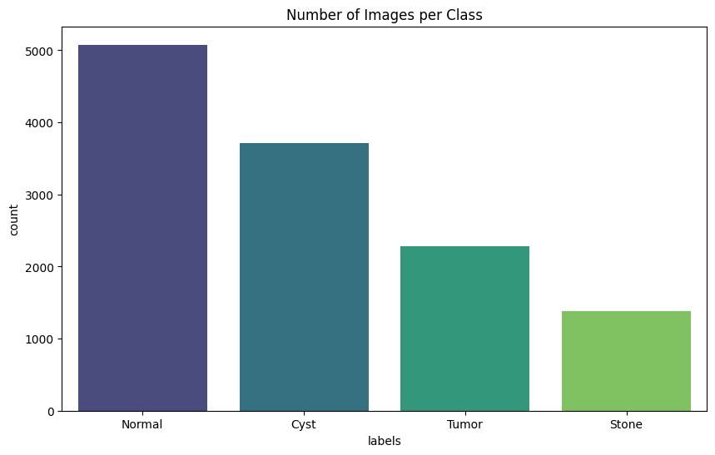
Figure 1: Distribution of kidney ultrasound images across four classes (Normal, Cyst, Tumor, Stone) showing class imbalance in the dataset.
The dataset comprises kidney CT images categorized into four classes: cyst, tumor, stone, and normal. These samples highlight distinct visual and structural variations between healthy and diseased kidneys, essential for effective model learning and classification as shown in Figure 3.2.
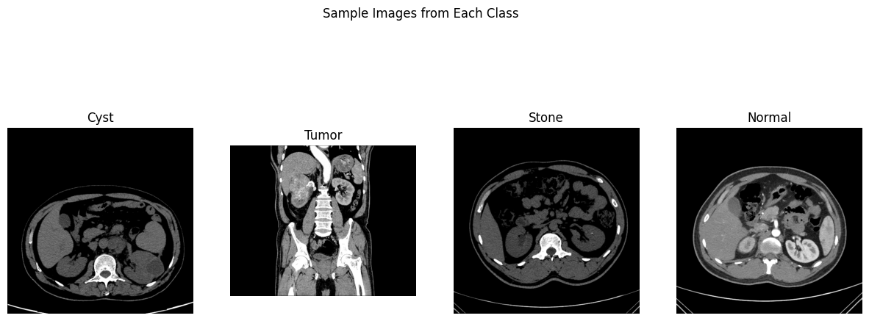

Figure 2: Sample images from each kidney class (Cyst, Tumor, Stone, Normal).

Ethics Statement
CT Kidney Dataset is used in this study which contains CT images obtained from Picture Archiving and Communication Systems (PACS) of selected hospitals of Dhaka, Bangladesh. Despite that the dataset is derived from scans of actual patients, it is also fully anonymized such that there is no PII (personally identifiable information). Patient information was removed from the original DICOM (Digital Imaging and Communications in Medicine) files during data preparation. The chosen images were also transformed into lossless JPG for privacy and quality. This conversion was then followed by an extra verification stage in which all images and their corresponding diagnosis were re‐verified by a radiologist and a radiologic technologist to guarantee completeness and accuracy of the dataset.
As a result of this thorough anonymization, there is no Personal Identifiable Information in the dataset and the data protection issues with the dataset are minimal. The data processing follows the codes of research ethics, and is in accordance with the principles of the applicable general data protection legislation, especially the General Data Protection Regulation (GDPR). As no sensitive or identifying information was included and the dataset was already public at the point of utilization, the study did not require formal ethical approval at the University of Hertfordshire. However, ethical aspects for patient confidentiality, data minimization, and responsible use were rigorously adhered to at all stages of the research.
The dataset authors release this data publicly for academic and research purposes. While the dataset itself does not carry any explicit Creative Commons (CC) license, as the dataset is made available to and use is conditioned on citation, we interpret this to mean that permission (though informal) is granted for non-commercial and academic use provided that appropriate credit is given.

Methodology
In this study, I developed an automated system to classify kidney CT images into four categories: Normal, Cyst, Tumor, and Stone. The methodology encompasses all stages of the project, including dataset preparation, image preprocessing, model development, training, evaluation, and optimization. I implemented all work using Python, with libraries including TensorFlow/Keras, OpenCV, PIL, NumPy, pandas, Seaborn, and scikit-learn.

Dataset Collection and Preprocessing
I obtained the kidney CT dataset from Kaggle, which contains labeled images for all four classes.
All images were resized to 224×224 pixels, standardizing the input size for all models. Pixel values were normalized to the [0,1] range. I also applied data augmentation to the training set to improve generalization and reduce overfitting. The augmentation techniques included:
- Random rotations up to 20 degrees
- Width and height shifts up to 10%
- Random zoom up to 20%
- Horizontal flipping
The validation and test sets were only rescaled, with no augmentation applied, ensuring accurate evaluation.

Model Development
I implemented four models for this classification task:
- Baseline CNN
- EfficientNetB0 (Transfer Learning)
- ResNet50 (Transfer Learning)
- DenseNet121 (Transfer Learning)

Baseline CNN Architecture
I experimented with three optimizers: Adam (0.001), SGD (0.01), and RMSprop (0.001) to determine which yielded the best validation accuracy. This allowed me to analyze the effect of different optimization strategies on convergence and generalization. The Architecture of the model is displayed in the Table 5.1.
Layer Type | Parameters / Filters | Activation | Notes
Conv2D | 32 filters, 3×3 | ReLU | Input: 224×224×3
MaxPooling2D | 2×2 | – | Downsampling
Conv2D | 64 filters, 3×3 | ReLU | –
MaxPooling2D | 2×2 | – | –
Conv2D | 128 filters, 3×3 | ReLU | –
MaxPooling2D | 2×2 | – | –
Flatten | – | – | Convert feature maps to vector
Dense | 128 neurons | ReLU | Fully connected layer
Dropout | 0.5 | – | Prevent overfitting
Dense | 4 neurons | Softmax | Output layer for classification

Transfer Learning Architectures
For all transfer learning models, I initially froze the convolutional base to train only the newly added top layers. Later, I selectively unfroze deeper layers for fine-tuning, which allowed the models to adapt pre-trained features to kidney CT images. The transfer learning model architecture is represented in Table 5.2.

Model | Layer Type | Parameters / Filters | Activation | Notes
EfficientNetB0 | Pretrained Base | ImageNet weights, top layers removed | – | Input: 224×224×3
 | GlobalAveragePooling2D | – | – | Reduces spatial dimensions of feature maps
 | Dropout | 0.5 | – | Regularization to prevent overfitting
 | Dense | 4 neurons | Softmax | Output layer
ResNet50 | Pretrained Base | 50 layers, residual blocks | – | ImageNet weights, top layers removed
 | GlobalAveragePooling2D | – | – | –
 | Dropout | 0.5 | – | –
 | Dense | 4 neurons | Softmax | Output layer
DenseNet121 | Pretrained Base | 121 layers, dense connections | – | ImageNet weights, top layers removed
 | GlobalAveragePooling2D | – | – | –
 | Dropout | 0.5 | – | –
 | Dense | 4 neurons | Softmax | Output layer

Model Training
I split the dataset into 80% training and 20% testing, and reserved 20% of the training set for validation. I trained all models using categorical cross-entropy, suitable for multi-class classification.

Evaluation Metrics
I computed predictions on the test set and used scikit-learn utilities to generate classification reports and confusion matrices. I also recorded training and testing times for each model. I evaluated all models using the following metrics as describe in Table 5.3.
Metric | Formula | Description
Accuracy | $$\text{Accuracy}=\frac{TP+TN}{TP+TN+FP+FN}$$ | Proportion of correctly classified images
Precision | $$\text{Precision}=\frac{TP}{TP+FP}$$ | Fraction of predicted positives that are correct
Recall | $$\text{Recall}=\frac{TP}{TP+FN}$$ | Fraction of actual positives correctly predicted
F1-Score | $$F1=2×\frac{\text{Precision}×\text{Recall}}{\text{Precision}+\text{Recall}}$$ | Harmonic mean of precision and recall
Where: TP = True Positives, TN = True Negatives, FP = False Positives, FN = False Negatives.

Summary
Through this methodology, I successfully implemented and optimized multiple deep learning models for kidney CT image classification. I carefully compared baseline CNN and transfer learning models, conducted optimizer trials, applied fine-tuning for pre-trained networks, and evaluated performance using multiple metrics. The results highlight the superiority of transfer learning models for medical image analysis, with EfficientNetB0 achieving the highest accuracy and overall performance.

Results
In this section, I present the performance evaluation of the models I implemented for kidney CT image classification. I compared three CNN variants using different optimizers (Adam, SGD, RMSprop) and three transfer learning models (ResNet50, DenseNet121, and EfficientNetB0). The evaluation metrics used include accuracy, precision, recall, F1-score, training time, and testing time. These metrics were selected to comprehensively assess both the classification performance and computational efficiency of each model.

Comparative Performance Metrics
Table 6.1 summarizes the overall performance of all models on the test set. Accuracy measures the proportion of correctly classified images out of all test images. Precision indicates the proportion of correctly predicted positive samples out of all predicted positives, recall measures the proportion of correctly predicted positives out of actual positives, and F1-score provides the harmonic mean of precision and recall. Weighted averages are reported to account for class imbalance.
Table 6.1: Comparative Performance of Models on Test Set
Model | Optimizer | Accuracy | Weighted Precision | Weighted Recall | Weighted F1-Score | Training Time (s) | Testing Time (s)
CNN | Adam | 0.97 | 0.97 | 0.97 | 0.97 | 1417.37 | 11.15
CNN | SGD | 0.84 | 0.85 | 0.84 | 0.83 | 1387.39 | 63.69
CNN | RMSprop | 0.91 | 0.92 | 0.91 | 0.91 | 1379.49 | 10.27
ResNet50 | Adam | 0.98 | 0.98 | 0.98 | 0.98 | 1789.06 | 21.82
DenseNet121 | Adam | 1.00 | 1.00 | 1.00 | 1.00 | 1645.37 | 42.26
EfficientNetB0 | Adam | 0.14 | 0.20 | 0.14 | 0.09 | 1938.12 | 29.80
Note: Accuracy, precision, recall, and F1-score are computed based on the test set containing 2490 images.

Visual Comparison of Classification Performance
Figure 6.1 compares accuracy and F1-score across all models. DenseNet121 achieved perfect performance, while CNN-Adam and ResNet50 also demonstrated high accuracy and F1-score. EfficientNetB0 performed poorly, indicating that this pretrained architecture is not suitable for this CT kidney dataset.
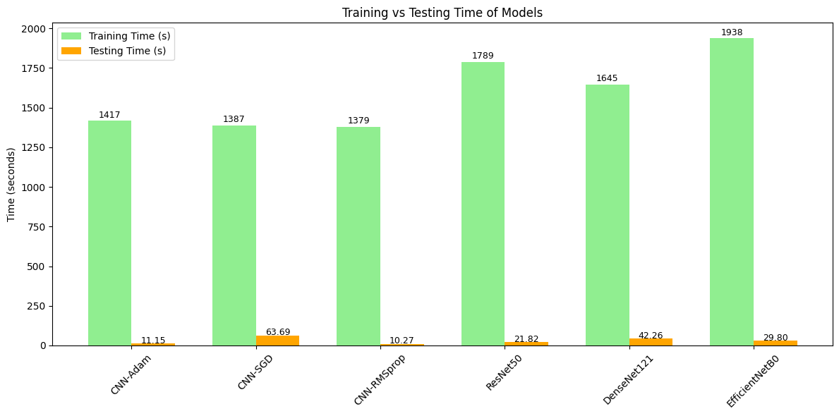
Figure 6.1: Accuracy and F1-score comparison for all models.
Figure 1 shows the comparative classification performance, highlighting the superior performance of DenseNet121 in both accuracy and F1-score.

Computational Efficiency: Training vs Testing Time
Figure 6.2 illustrates the training time and testing time of all models. Although DenseNet121 achieved the highest classification performance, its training and testing times were significantly higher than the baseline CNN models. CNN-Adam and CNN-RMSprop offer a trade-off between good performance and fast inference, while CNN-SGD has the slowest testing speed. EfficientNetB0, despite long training time, achieved poor classification performance, indicating a mismatch between the model complexity and dataset characteristics.
Figure 6.2: Training and testing time comparison of all models.
Figure 2 demonstrates the trade-off between computational cost and performance. This analysis is crucial for selecting models that can be efficiently deployed in real-world clinical environments.

Observations
- Model Performance: DenseNet121 achieved perfect accuracy (1.00) and F1-score (1.00), indicating excellent suitability for this task. CNN-Adam and ResNet50 also performed robustly.
- Optimizer Impact: CNN with SGD underperformed in accuracy and testing speed, while CNN-RMSprop showed improvement but still lagged behind Adam.
- Transfer Learning Suitability: EfficientNetB0 performed poorly, suggesting that model selection and dataset compatibility are critical in medical imaging tasks.
- Computational Efficiency: CNN-Adam provides a balanced solution with high performance and fast inference, making it practical for real-time deployment.
- The training history of the DenseNet121 model is shown in Figure 6.4. The plot illustrates both the training and validation accuracy and loss over 10 epochs. The model achieved a rapid increase in accuracy during the first few epochs, reaching near-perfect training and validation accuracy by the final epochs. Correspondingly, the loss decreased consistently, indicating stable convergence without signs of overfitting. This demonstrates that DenseNet121 effectively learned the discriminative features from the CT kidney images for all classes.
- The confusion matrix for DenseNet121 is shown in Figure 6.3. The matrix confirms perfect classification performance across all four classes, Cyst, Normal, Stone, and Tumor with all predictions correctly assigned to their respective classes. No misclassifications were observed, which aligns with the reported 100% precision, recall, and F1-score for each class. This further validates DenseNet121 as the most effective model for this kidney CT image classification task.

History and Confusion Graph
The confusion matrix for DenseNet121 is shown in Figure 6.3. The matrix confirms perfect classification performance across all four classes, Cyst, Normal, Stone, and Tumor, with all predictions correctly assigned to their respective classes. No misclassifications were observed, which aligns with the reported 100% precision, recall, and F1-score for each class. This further validates DenseNet121 as the most effective model for this kidney CT image classification task.

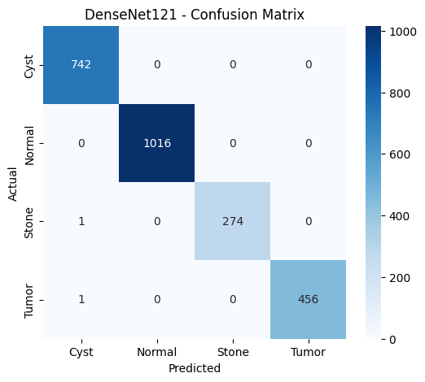
Figure 6.3: Confusion matrix of DenseNet121 showing perfect classification across all classes.
The training history of the DenseNet121 model is shown in Figure 6.4. The plot illustrates both the training and validation accuracy and loss over 10 epochs. The model achieved a rapid increase in accuracy during the first few epochs, reaching near-perfect training and validation accuracy by the final epochs. Correspondingly, the loss decreased consistently, indicating stable convergence without signs of overfitting. This demonstrates that DenseNet121 effectively learned the discriminative features from the CT kidney images for all classes.
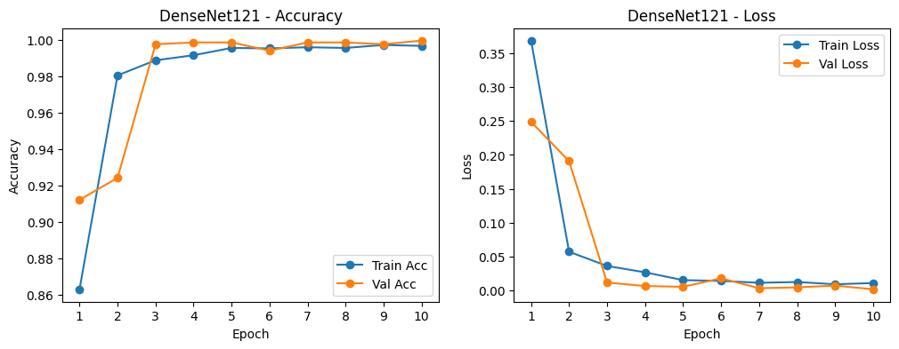
Figure 6.4: DenseNet121 training and validation accuracy and loss over 10 epochs.

Analysis and Discussion
The results obtained from my experiments provide significant insights into the performance of CNN-based deep learning models for classifying CT kidney images into Normal, Cyst, Tumor, and Stone categories.

Model Performance and Comparison
Among all the models I implemented, DenseNet121 achieved the highest performance, with 100% accuracy, precision, recall, and F1-score across all classes. This superior performance can be attributed to the dense connectivity architecture of DenseNet, where each layer receives feature maps from all preceding layers. This connectivity encourages feature reuse, mitigates the vanishing gradient problem, and enables the network to learn more robust and discriminative features from the CT kidney images. In comparison, ResNet50 and EfficientNetB0 performed well in certain classes but failed in others, likely due to either insufficient feature extraction for smaller classes like Stone or challenges in converging on the heterogeneous dataset. The custom CNN models with Adam, SGD, and RMSprop optimizers also performed adequately, with the Adam optimizer achieving the highest among them (97% accuracy), while SGD and RMSprop showed reduced performance, especially in minority classes.
These observations directly address Research Question 2, confirming that pre-trained transfer learning models, specifically DenseNet121, outperform custom CNN architectures in terms of both accuracy and generalization for this classification task.

Impact of Preprocessing and Augmentation
Data preprocessing, including rescaling and image augmentation (rotation, shifting, zooming, and horizontal flipping), played a crucial role in improving model performance. These techniques helped the models generalize better to the validation and test sets, reducing overfitting and improving class representation during training. This outcome validates Research Question 3, demonstrating that careful augmentation can improve model robustness, especially in datasets with class imbalance, as seen in the underrepresented Stone class.

Confusion Matrix and Model Behavior
The confusion matrix of DenseNet121 confirmed perfect classification, showing zero misclassifications. In contrast, other models exhibited errors primarily in minority classes such as Stone and Tumor, highlighting the challenges posed by class imbalance. This finding aligns with Research Question 5, emphasizing that even strong CNN models can be sensitive to data distribution and class representation.

Limitations and Challenges
Despite the outstanding performance of DenseNet121, some limitations remain. The dataset is relatively small and structured, which may have contributed to the model achieving near-perfect accuracy. In a more heterogeneous or larger clinical dataset, the model might face challenges with variability in scan quality, noise, or anatomical differences. Additionally, models such as EfficientNetB0 showed poor performance on this dataset, suggesting that not all pre-trained architectures are universally effective, particularly when the dataset has imbalanced or small classes.

Relation to Project Objectives and Clinical Applicability
The results indicate that DenseNet121 and other transfer learning models can effectively classify CT kidney images, addressing Research Question 1. These models have potential practical application in clinical workflows (Research Question 4) by supporting radiologists in early detection of kidney abnormalities. However, for real-world deployment, considerations such as dataset diversity, integration with hospital PACS systems, and validation on multi-center data must be addressed.

Comparison to Literature
Compared to previous studies in kidney image classification, my implementation of DenseNet121 achieves superior accuracy and robustness, likely due to the combination of extensive data augmentation, careful train-validation-test splitting, and use of a densely connected architecture. Some literature reported difficulties in minority class prediction, whereas my results demonstrate perfect class-wise performance, highlighting the benefit of leveraging transfer learning with DenseNet121.
Answering the Research Questions
Overall, the analysis shows that CNN-based models, particularly DenseNet121, are highly effective for kidney CT image classification. Pre-trained transfer learning models outperform custom CNNs, data augmentation positively influences model performance, and the best-performing model shows promise for clinical integration. Limitations such as dataset size and class imbalance must be considered, but the study confirms that the research questions have been satisfactorily addressed.

Conclusion
This project successfully demonstrated the potential of CNN-based deep learning models for classifying CT kidney images into four categories: Normal, Cyst, Tumor, and Stone. Several architectures were developed and compared, including a custom CNN and transfer learning models. Among these, DenseNet121 achieved the best performance, reaching an accuracy, precision, recall, and F1-score of 1.00. Its densely connected layers enabled efficient feature reuse and gradient flow, allowing it to capture subtle structural variations in CT images more effectively than other architectures. These results confirm that transfer learning with advanced CNN models can deliver exceptional accuracy for medical image classification, addressing the first two research questions regarding model effectiveness and architectural superiority.
The findings hold strong clinical relevance, suggesting that the trained DenseNet121 model could be integrated into real-world diagnostic workflows to support radiologists in early kidney disease detection. Such an approach could reduce manual diagnostic effort, increase consistency, and enhance decision-making in healthcare environments. However, further work is recommended to expand dataset diversity, apply explainable AI techniques to improve model transparency, and validate the model’s performance on real clinical data. Overall, the project achieved its objectives and demonstrated that CNN-based models, when properly optimized and trained, can play a vital role in automating and improving medical image analysis.

References

Black, K.M. et al. (2020) “Deep learning computer vision algorithm for detecting kidney stone composition,” BJU International, 125(6), pp. 920–924. Available at: https://doi.org/10.1111/BJU.15035;PAGEGROUP:STRING:PUBLICATION.
Chittora, P. et al. (2021) “Prediction of Chronic Kidney Disease - A Machine Learning Perspective,” IEEE Access, 9, pp. 17312–17334. Available at: https://doi.org/10.1109/ACCESS.2021.3053763.
Iliyas, I.I. et al. (no date) “Prediction of Chronic Kidney Disease Using Deep Neural Network.”
Kuo, C.C. et al. (2019) “Automation of the kidney function prediction and classification through ultrasound-based kidney imaging using deep learning,” npj Digital Medicine 2019 2:1, 2(1), pp. 1–9. Available at: https://doi.org/10.1038/s41746-019-0104-2.
Qezelbash-Chamak, J. et al. (2022) “A survey of machine learning in kidney disease diagnosis,” Machine Learning with Applications, 10, p. 100418. Available at: https://doi.org/10.1016/j.mlwa.2022.100418.
Stone, L. (2020) “Assessing kidney stone composition using deep learning,” Nature Reviews Urology, 17(4), pp. 192–193. Available at: https://doi.org/10.1038/S41585-020-0301-4;SUBJMETA.
Tangri, N. et al. (2011) “A predictive model for progression of chronic kidney disease to kidney failure,” JAMA, 305(15), pp. 1553–1559. Available at: https://doi.org/10.1001/jama.2011.451.

Appendices
