NLP-Based Sentiment Analysis of Product Reviews

Using TF-IDF and Logistic Regression
Mini NLP Project Report

Aneena Binoy

24UBC110

III BCA A

Git hub link: https://github.com/AneenaBinoy/NLP-Based-Sentiment-Analysis-of-Product-Reviews.git

1. Problem Statement
Online shoppers leave large volumes of free-text reviews on e-commerce platforms. Manually reading every review to gauge overall customer satisfaction is impractical at scale. This project addresses the problem of automatically classifying women's clothing product reviews into positive or negative sentiment using Natural Language Processing (NLP) and a machine learning classifier, so that customer opinion can be summarized and monitored automatically.

2. Objectives
- To design a text preprocessing pipeline suitable for real, noisy customer review data.
- To extract meaningful numerical features from review text using TF-IDF.
- To train a Logistic Regression classifier for binary sentiment classification.
- To analyse the effect of class imbalance on sentiment classification performance.
- To evaluate the model using standard classification metrics and analyse its limitations.

3. Problem Relevance
- Customers benefit from quick, aggregated sentiment summaries instead of reading hundreds of reviews per product.
- Retailers can track customer satisfaction per product, department, or class, and flag items with rising negative sentiment.
- NLP is well suited to this task because customer opinions are expressed in unstructured natural language, which cannot be analysed with simple numeric methods.
- Potential applications include e-commerce review dashboards, product-quality monitoring, and automated customer-feedback triage.

4. Dataset
Dataset: Women's E-Commerce Clothing Reviews
- Source: Kaggle — Women's E-Commerce Clothing Reviews dataset (a real, publicly available dataset of anonymized customer reviews of women's clothing).
- Raw size: 23,486 reviews, 11 columns (Clothing ID, Age, Title, Review Text, Rating, Recommended IND, Positive Feedback Count, Division Name, Department Name, Class Name).
- Size after cleaning: 19,818 reviews after removing reviews with missing review text and excluding neutral reviews with Rating = 3, leaving a binary classification problem.
- Attributes used: Review Text (input), Rating (used to derive the label).
- Target variable: sentiment — derived as Positive (Rating ≥ 4) or Negative (Rating ≤ 2).
- Number of classes: 2 — Negative (2,370 reviews) and Positive (17,448 reviews). The dataset is naturally imbalanced, since satisfied customers write disproportionately more reviews.
- Limitations: Class imbalance (~88% positive); limited to one product category (women's clothing); ratings-derived labels may not always match the true sentiment of the written text.
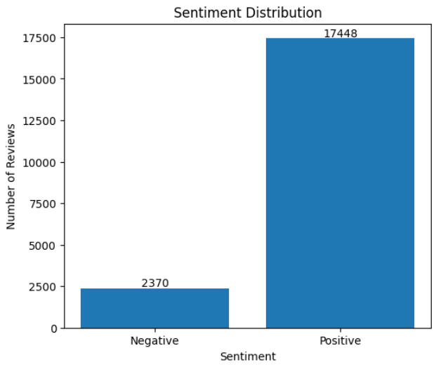

5. Methodology
Raw Review Text → Preprocessing → TF-IDF Vectorization → Logistic Regression → Prediction →
Evaluation

. Preprocessing
- Lowercasing all review text.
- Removing HTML tags and URLs using regular expressions.
- Removing punctuation and numeric characters.
- Collapsing extra whitespace.

. Feature Extraction — TF-IDF
Term Frequency–Inverse Document Frequency (TF-IDF) converts cleaned text into numeric feature vectors, giving higher weight to words that are frequent in a specific review but rare across the whole dataset. Unigrams and bigrams were used (e.g., 'not good' as a single feature), with the vocabulary capped at the top 10,000 features and English stopwords removed automatically by scikit-learn's TfidfVectorizer.

. Classification Model
A Logistic Regression classifier was trained on the TF-IDF features. Logistic Regression is suitable for binary classification and works effectively with high-dimensional sparse text features.
The data was divided into 80% training data (15,854 reviews) and 20% testing data (3,964 reviews). The trained model was then used to predict the sentiment of the test reviews and new unseen product reviews.

6. Implementation

● Programming language: Python 3
● Platform: Google Colab
● Libraries used: pandas, NumPy, scikit-learn, matplotlib, seaborn, joblib
● NLP techniques: text preprocessing and TF-IDF vectorization using unigrams and bigrams
● Algorithm/model: Logistic Regression
● Implementation details: The complete implementation is provided in the Jupyter Notebook

NLP_Sentiment_Analysis_Product_Reviews.ipynb. The trained model and TF-IDF vectorizer were also saved using joblib for reuse.

7. Results
The model was evaluated on the held-out 20% test set containing 3,964 reviews. The Logistic Regression model achieved the following performance:
Metric | Score
Accuracy | 92.43%
Precision (Positive class) | 92.81%
Recall (Positive class) | 99.08%
F1-score (Positive class) | 95.84%

These results show that the model performs well in classifying product reviews into Positive and Negative sentiment categories.

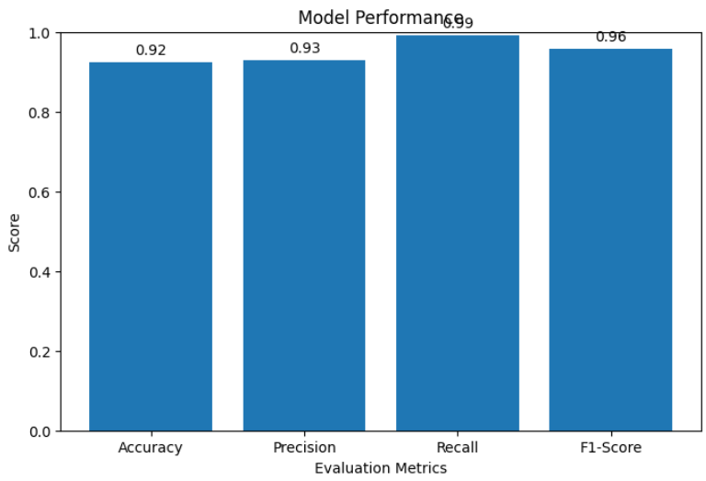
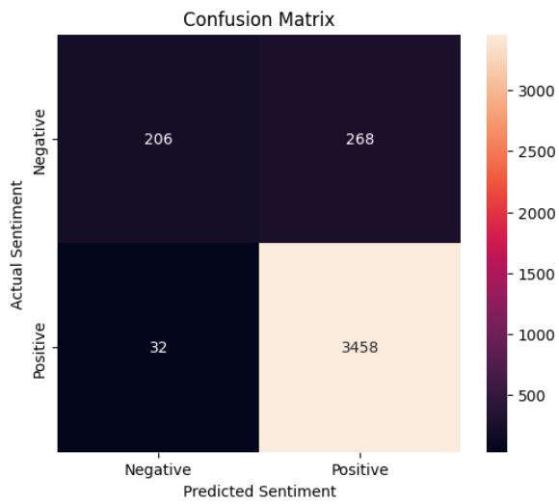

Overall accuracy is 92.43%. The model performs very well in identifying Positive reviews, with a recall of 99.08%, while the Negative class has a lower recall of 43.46%. This difference is mainly due to the class imbalance in the dataset, where Positive reviews are much more numerous than Negative reviews.

Sample Predictions on Unseen Reviews
- "I absolutely love this dress. The material is excellent and it fits perfectly."
→ Positive (99.24% confidence)
- "I am very disappointed with this product. The quality is poor and I do not like it."
→ Negative (98.95% confidence)
- "This dress is beautiful and very comfortable."
→ Positive (97.67% confidence)

8. Limitations
- Class imbalance: The dataset contains substantially more Positive reviews than Negative reviews. This imbalance can cause the model to perform better on the majority Positive class and may reduce its ability to correctly identify Negative reviews.
- Rating-derived labels are a proxy for true sentiment; a review can carry mixed or sarcastic language while still receiving a high or low star rating for unrelated reasons (e.g., shipping delays).
- The dataset is restricted to one domain (women's clothing), so the trained model may not generalize well to other product categories.
- Only binary sentiment (Positive/Negative) is modeled — neutral reviews (Rating = 3) were excluded entirely rather than classified.
- TF-IDF with n-grams still struggles with sarcasm, long-range negation, and comparative statements (e.g., 'better than my last dress but still not great').

9. Future Scope
- Model the neutral class instead of discarding it, turning this into 3-class sentiment classification.
- Use additional metadata already present in the dataset (Department Name, Class Name, Age) as extra features.
- Address class imbalance using resampling techniques such as oversampling or SMOTE.
- Experiment with deep learning / transformer-based models (LSTM, BERT) to better capture context and negation.
- Deploy the saved model (sentiment_model.pkl + tfidf_vectorizer.pkl) behind a simple Flask/FastAPI web app for real-time review scoring.

10. Conclusion
This project developed an end-to-end NLP pipeline for sentiment analysis of 19,818 women's clothing product reviews obtained from Kaggle. The review text was cleaned using text preprocessing techniques and converted into numerical features using TF-IDF. A Logistic Regression model was then trained to classify reviews as Positive or Negative. The model achieved an accuracy of 92.43%, precision of 92.81%, recall of 99.08%, and an F1-score of 95.84% on the test dataset. The model was also successfully tested on new product reviews and was able to predict their sentiment with high confidence. The project demonstrates how NLP and machine learning can be applied to automatically analyse customer opinions from e-commerce reviews.

