|  |  |
| --- | --- |
| A picture of a winding road and trees  software devevlopment life cycle  SDLC | Abstract "In today's rapidly evolving technological landscape, the Software Development Life Cycle (SDLC) has found new horizons in the cloud. This abstract explores the intersection of traditional SDLC methodologies with the dynamic capabilities of cloud computing. From planning and development to deployment and maintenance, the cloud offers unparalleled scalability, flexibility, and collaboration opportunities. Join us on a journey through the clouds as we uncover the transformative power of SDLC in the digital aria."  Anees Abd Al Aal |

**Task 1: Feasibility Study for a Cloud-Based Logistics Management System for a Global Logistics Company**

**A. Choosing and Directing the Appropriate Software Development Lifecycle Methodology for Transitioning from the Current System to the Cloud, Considering the Required Stages**

**Executive Summary**

Global Logistics is an international shipping company headquartered in Dubai, UAE. The company seeks to modernize its logistics operations by developing a new software platform. Afak Technology, an IT company specializing in software development, has been commissioned to develop a cloud-based logistics management system to streamline operations and enhance customer service.

This report aims to provide a detailed feasibility study for Global Logistics' project to develop a cloud-based logistics management system. The report seeks to assess the feasibility of the project by analyzing its requirements and identifying an appropriate software development lifecycle methodology for transitioning their current system to the cloud.

**Task 1: Analysis and Scope Definition**

**1.1 Choosing the Appropriate Software Development Lifecycle Methodology**

**Required Stages:**

**1. Planning:**

1. **Define project goals, requirements, and scope:** Determine what you want to achieve by moving the system to the cloud, the requirements of the new system, and the scope of work that includes all components and processes to be migrated.
2. **Analyze the current system status and identify gaps and challenges:** Analyze the current system to understand how it works, identify strengths and weaknesses, and identify gaps between current business needs and what the new system can provide.
3. **Evaluate different cloud solutions and choose the best one that suits the project's needs:** Evaluate different cloud solutions in terms of features, cost, performance, and security, and choose the most suitable solution for the project's needs.
4. **Develop a project timeline and budget:** Determine a realistic project timeline with tasks and responsibilities for each stage, and develop a budget that estimates the project costs.
5. **Form a project team and define roles and responsibilities:** Form a project team with appropriate skills and competencies, and define the roles and responsibilities of each team member.

**2. Design:**

1. **Design the new system architecture on the cloud:** Design the new system architecture on the cloud, identify the system components and processes, and identify the cloud services that will be used.
2. **Design user interfaces and user experience:** Design the user interfaces (UI) and user experience (UX) of the new system to ensure ease of use and attractiveness.
3. **Design databases and business processes:** Design the databases and business processes of the new system to ensure efficient performance and security.
4. **Design unit, integration, and system tests:** Design unit, integration, and system tests to ensure the quality and safety of the system.

**3. Development:**

1. **Write and test code for the different system modules:** Write code for the different system modules and test them thoroughly to ensure they are free of errors.
2. **Integrate system modules and test them comprehensively:** Integrate system modules and test them comprehensively to ensure they interact correctly with each other.
3. **Deploy the system to a cloud testing environment:** Deploy the system to a cloud testing environment to test its performance and functionality in a real-world environment.
4. **Conduct acceptance testing with end users:** Conduct acceptance testing with end users to gather their feedback and identify any issues or improvements required.

**4. Deployment:**

1. **Deploy the system to a cloud production environment:** Deploy the system to a cloud production environment after ensuring its safety and quality.
2. **Train users on the new system:** Train users on the new system to ensure they understand how it works and how to use it.
3. **Monitor system performance and address any issues that arise:** Continuously monitor system performance and address any issues that arise quickly.
4. **Provide ongoing user support:** Provide ongoing user support to answer their questions and resolve any issues they encounter.

**5. Maintenance:**

1. **Implement bug fixes and new feature releases:** Implement bug fixes and new feature releases regularly to keep the system secure and up-to-date.
2. **Update the system with the latest technologies:** Update the system with the latest technologies to maintain its competitiveness and improve its performance.
3. **Ensure system security and data protection:** Ensure system security and data protection by implementing best security practices and continuously monitoring the system.
4. **Provide ongoing user support:** Provide ongoing user support to answer their questions and resolve any issues they encounter.

**A. Linear Software Development Lifecycle Methodologies:**

* **Waterfall Model:** A traditional model characterized by a linear arrangement of stages, defining the requirements of each stage before moving to the next stage.
* **V-Model:** A model that integrates testing methodologies into each stage of the development lifecycle.
* **Advantages:**
  + Easy planning and control: Linear methodologies provide a clear roadmap for the project, making it easier to plan tasks, allocate resources, and track progress.
  + Clear documentation: Each stage typically involves the creation of detailed documentation, which can be helpful for future reference and maintenance.
  + Suitable for projects with well-defined requirements: When project requirements are well-defined and unlikely to change significantly, linear methodologies can be efficient and effective.
* **Disadvantages:**
  + Lack of flexibility: Linear methodologies are not very adaptable to changes in requirements. Once a stage is completed, it can be difficult and time-consuming to go back and make changes.
  + Slow development cycles: Due to the sequential nature of the stages, it can take a long time to deliver a finished product.
  + Limited user involvement: Users are typically not involved in the development process until later stages, which can lead to a final product that doesn't meet their needs.

**B. Iterative Software Development Lifecycle Methodologies**

* **Prototype Model:** Creates iterative, reusable prototypes to test ideas and gather feedback.
* **Agile Model:** An iterative and flexible approach that focuses on continuous development and delivery of value.

**Advantages:**

* High flexibility: Agile methodologies are highly adaptable to changes in requirements. The iterative nature allows for course correction and adjustments throughout the development process.
* Faster development cycles: Agile methodologies typically deliver working software in shorter increments, allowing for earlier feedback and faster time to market.
* Improved customer involvement: Customers are actively involved throughout the development process, ensuring the final product meets their needs.
* **Disadvantages:**
* Increased complexity in management: Agile methodologies require a more flexible and collaborative management style, which can be challenging for some organizations.
* Difficulty in predicting timelines and costs: The iterative nature of Agile can make it difficult to accurately predict project timelines and costs upfront.
* May require more detailed documentation: While Agile emphasizes working software over extensive documentation, some level of documentation is still necessary, especially for complex projects.

**Choosing the Right Methodology for the Project**

Considering the nature of the project, and the need for greater flexibility and adaptability to potential changes, I recommend adopting an Agile methodology for developing the cloud-based logistics management system.

**Why Agile was chosen for Global Logistics**

Several factors make Agile a suitable choice for Global Logistics' project:

* **Project size and complexity:** The Global Logistics project is large and complex, involving the migration of a substantial system to the cloud. Agile's ability to break down the project into smaller, manageable units makes it easier to manage and implement.
* **Changing system requirements:** The requirements of Global Logistics' system are likely to change over time due to:
  + Evolving customer needs
  + Market shifts requiring new features or functionalities
  + Advancements in technology offering new opportunities to improve the system

Agile is well-suited for projects with evolving requirements because it allows for continuous adaptation throughout the development process.

* **Project budget:** Agile methodologies can often be more cost-effective than linear methodologies. This is because:
  + The project is broken down into smaller units, allowing for better prioritization and resource allocation.
  + Units are regularly tested, which helps to identify and fix bugs early, reducing the cost of fixing them later in the development process.
  + Agile focuses on delivering working functionality early and often, which allows stakeholders to see the value of the project and potentially secure additional funding if needed.
* **Team skills:** Agile methodologies typically require a team with strong communication skills. This is because:
  + The methodology relies on collaboration between all stakeholders.
  + The team needs to provide regular feedback.
  + The team must be adaptable to changes.

Since the Global Logistics team is known to have strong communication skills, they are well-suited for an Agile approach.

**Overall, Agile was chosen for the Global Logistics project because it:**

* Aligns well with the project's size and complexity.
* Adapts to changing system requirements.
* Can be more cost-effective than linear methodologies.
* Requires a team with strong communication skills, which the Global Logistics team possesses.

In addition to the reasons mentioned above, Agile offers several other benefits, such as:

* **Improved product quality:** The focus on regular testing in Agile helps to improve the overall quality of the final product.
* **Increased customer satisfaction:** By involving customers throughout the development process, Agile ensures the system meets their needs.
* **Improved team morale:** The collaborative and communication-focused nature of Agile can boost team morale and productivity.
* **Reduced project risks:** Early and frequent detection of bugs allows for faster resolution, reducing overall project risks.

**Stages of the Agile Methodology:**

1. Planning: Define goals, requirements, and scope.
2. Design: Create detailed designs for features.
3. Development: Write and test code for the different system modules.
4. Testing: Conduct unit, integration, and system testing to ensure functionality and identify defects.
5. Deployment: Deliver the developed features to users in a production environment.
6. Review: Gather feedback from users and stakeholders, and identify areas for improvement.

**Advantages of Agile Methodology**

* **Adaptability to changes:** Agile allows for adjustments to requirements throughout the development process, making it suitable for projects with evolving needs.
* **Faster delivery:** Agile delivers working software in short iterations, enabling faster feedback and time-to-market.
* **Improved customer involvement:** Customers are actively involved throughout development, ensuring the final product aligns with their needs.

**Stages of Transitioning to the Cloud**

1. **Assessment:** Evaluate current infrastructure to identify systems and applications suitable for cloud migration.
2. **Design:** Design the cloud architecture and select appropriate cloud services.
3. **Migration:** Transfer data and applications to the cloud environment.
4. **Testing:** Thoroughly test the migrated system in the cloud environment to ensure functionality and meet requirements.
5. **Go-live:** Deploy the system to production in the cloud environment.
6. **Optimization:** Continuously monitor and optimize system performance in the cloud.

## 

**Detailed Comparison Table of Software Development Lifecycle Methodologies**

**Objective:** To assist the management of Global Logistics in selecting the appropriate software development lifecycle methodology for their cloud logistics management system project.

**Introduction:**

There are numerous software development lifecycle methodologies available, each with its own set of advantages and disadvantages. In this document, we compare two primary methodologies: linear and iterative methodologies.

**Linear Methodology:**

**Definition:** The linear methodology follows a defined sequence of stages, starting with planning and design and progressing to development, testing, and deployment.

**Ideal Methodology:**

* Projects with clear and well-defined requirements.
* Projects with fixed budgets.
* Projects requiring strict change control procedures.

**Advantages:**

* Easy project planning and control.
* Clear and detailed documentation.
* Reduced risk of errors.

**Disadvantages:**

* Lack of flexibility to accommodate changes in requirements.
* Longer development time.
* High risk of project failure if requirements are not accurately defined upfront.

**Iterative Methodology:**

**Definition:** The iterative methodology is divided into multiple cycles, each producing a testable prototype of the system.

**Ideal Methodology:**

* Projects with unclear or evolving requirements.
* Projects with flexible budgets.
* Projects requiring significant customer involvement.

**Advantages:**

* High flexibility to accommodate changes in requirements.
* Frequent delivery of system features.
* Improved software quality through extensive testing.
* Increased customer involvement.

**Disadvantages:**

* Difficulty in project planning and control.
* Less clear and detailed documentation.
* Higher risk of errors.

**Recommendation for Global Logistics:**

Based on the characteristics of the Global Logistics project, particularly the need for greater flexibility and adaptability to potential changes, an iterative methodology is recommended for developing the cloud-based logistics management system.

**Factors Supporting the Choice of Agile for Global Logistics:**

* **Project size and complexity:** The Global Logistics project is large and complex, involving the migration of a substantial system to the cloud. Agile's ability to break down the project into smaller, manageable units makes it easier to manage and implement.
* **Changing system requirements:** The requirements of Global Logistics' system are likely to change over time due to:
  + Evolving customer needs
  + Market shifts requiring new features or functionalities
  + Advancements in technology offering new opportunities to improve the system

Agile is well-suited for projects with evolving requirements because it allows for continuous adaptation throughout the development process.

* **Project budget:** Agile methodologies can often be more cost-effective than linear methodologies. This is because:
  + The project is broken down into smaller units, allowing for better prioritization and resource allocation.
  + Units are regularly tested, which helps to identify and fix bugs early, reducing the cost of fixing them later in the development process.
  + Agile focuses on delivering working functionality early and often, which allows stakeholders to see the value of the project and potentially secure additional funding if needed.
* **Team skills:** Agile methodologies typically require a team with strong communication skills. This is because:
  + The methodology relies on collaboration between all stakeholders.
  + The team needs to provide regular feedback.
  + The team must be adaptable to changes.

Since the Global Logistics team is known to have strong communication skills, they are well-suited for an Agile approach.

**Conclusion:**

Agile methodology offers a suitable approach for Global Logistics due to its adaptability, flexibility, and ability to accommodate changing requirements and deliver working software in short iterations. By adopting Agile, Global Logistics can effectively manage the development of their cloud-based logistics management system and achieve their project goals.

**Additional Considerations:**

* **Project management tools:** Utilize project management tools to facilitate task management, communication, and collaboration within the Agile team.
* **Continuous integration and continuous delivery (CI/CD):** Implement a CI/CD pipeline to automate the build, testing, and deployment of system components, ensuring frequent and reliable software releases.
* **User feedback and testing:** Regularly gather user feedback and conduct testing to ensure the system aligns with user needs and meets performance expectations.
* **Retrospectives:** Conduct regular retrospectives to identify areas for improvement and continuously refine the Agile process.

By following these recommendations and leveraging the benefits of Agile methodology, Global Logistics can successfully develop and implement their cloud-based logistics management system, enhancing their operational efficiency and customer satisfaction.

. مقارنة منهجيات دورة حياة تطوير البرمجيات:

|  |  |  |  |
| --- | --- | --- | --- |
| **Methodology** | **Description** | **Advantages** | **Disadvantages** |
| Waterfall | A traditional model with a linear sequence of stages. | Easy planning and control. Clear documentation. Suitable for projects with well-defined requirements. | Lack of flexibility. Difficulty in changing in later stages. Longer development time. |
| V-Model | Integrates testing into each stage of the development lifecycle. | Improved software quality. Reduced risks. | Greater complexity in management. Longer development time. |
| Prototype Model | Creates iterative, reusable prototypes to test ideas and gather feedback. | Easy to get feedback. Improved product quality. | Difficulty in controlling scope. Final product may not be robust. |
| Agile | An iterative and flexible approach that focuses on continuous development and delivery of value. | High flexibility. Easy adaptability to changes. Faster development time. Improved customer involvement. | Greater complexity in management. Difficulty in predicting timeline and cost. May require more detailed documentation. |
| RAD Model | Focuses on rapid development by using techniques such as pair programming and application prototyping. | Suitable for projects with changing and repetitive requirements. | Can be risky. Requires strong communication skills. |

**A. In-depth Analysis to Evaluate the Impact of Software Development Lifecycle Methodologies on the Outcomes of Global Logistics Project**

**Introduction:**

This analysis aims to evaluate the potential impacts of choosing different iterative and linear software development lifecycle (SDLC) methodologies on the outcomes of Global Logistics' project to develop a cloud-based logistics management system.

**1. Assessing the Impact of Methodologies on Project Outcomes:**

**a. Product Delivery:**

* **Iterative Methodology:** Allows for frequent delivery of system features, enabling early user feedback and adjustments.
* **Linear Methodology:** May lead to delayed delivery of final products, especially if requirements change during development phases.

**b. Schedule Adherence:**

* **Iterative Methodology:** Can be challenging to adhere to strict schedules due to the methodology's flexibility and potential requirement changes.
* **Linear Methodology:** Facilitates project planning and control, increasing the likelihood of meeting schedules.

**c. Resource Allocation:**

* **Iterative Methodology:** Requires more human and financial resources due to the repetition of development and testing phases.
* **Linear Methodology:** Can be more resource-efficient, especially when requirements are clear and fixed.

**d. Scalability:**

* **Iterative Methodology:** Enables the design of a scalable system by dividing it into independently developable modules.
* **Linear Methodology:** May make it difficult to scale the system easily if the design is inflexible.

**e. Adaptability to Change:**

* **Iterative Methodology:** Exhibits high flexibility in accommodating changes in requirements, making it suitable for projects with unclear or evolving requirements.
* **Linear Methodology:** Lacks flexibility in adapting to changes, potentially leading to delays and additional costs.

**2. Advantages and Disadvantages of Each Methodology:**

**Iterative Methodology:**

**Advantages:**

* High flexibility
* Continuous user feedback
* Improved software quality
* Increased customer involvement

**Disadvantages:**

* Difficulty in project planning and control
* Less clear and detailed documentation
* Higher risk of errors
* Higher cost

**Linear Methodology:**

**Advantages:**

* Easy project planning and control
* Clear and detailed documentation
* Reduced risk of errors
* Lower cost

**Disadvantages:**

* Lack of flexibility in accommodating changes
* Longer development time
* High risk of project failure if requirements are not accurately defined upfront

**3. Recommendations:**

Considering the complexity of Global Logistics' project and the potential for requirement changes, we recommend adopting the iterative SDLC methodology.

**Considerations:**

* The development team should work closely with Global Logistics to better understand their requirements and identify any necessary adjustments to the methodology.
* A detailed risk management plan should be developed to mitigate any potential risks that may arise during the project phases.
* Appropriate Agile tools and practices should be utilized to improve the efficiency and effectiveness of the development process.

**4. Website Project Proposal:**

**a. Business Context:**

Global Logistics faces increasing challenges in managing its logistics operations due to:

* **Growing Business Volume:** The company's rapid growth has led to more complex and voluminous logistics operations, making it difficult to manage using manual or outdated systems.
* **Multi-Channel Shipping:** The company offers shipping services through multiple channels (e.g., land, sea, air), requiring a system capable of managing data flows from all channels.
* **Evolving Customer Demands:** Customers expect more efficient and transparent services, necessitating a system that can track shipments and provide real-time status updates.
* **Heightened Competition:** The company faces increased competition from other firms offering advanced logistics solutions, demanding investment in new technologies to maintain competitiveness.

**b. Functional and Non-Functional Requirements:**

**Functional Requirements:**

* **Order Management:** Create, receive, and track orders.
* **Inventory Management:** Track inventory levels and generate replenishment orders.
* **Shipment Management:** Book, track, and provide status updates for shipments.
* **Invoice Management:** Generate and send invoices.
* **Customer Service:** Manage support requests and provide customer solutions.

**Non-Functional Requirements:**

* **Security:** Protect data from unauthorized access.
* **Performance:** Deliver fast and reliable performance.
* **Scalability:** Accommodate growing business needs.
* **Usability:** Provide a user-friendly interface for both customers and employees.
* **Compatibility:** Work across all browsers, laptops, and mobile devices.

**C. Analysis of Problems that Need to be Solved for Implementation:**

* **Data Integration:** Integrating data from different systems (e.g., CRM, ERP) into the logistics management system.
* **Industry Standards Compliance:** Adhering to industry standards related to shipping and tracking of goods.
* **Change Management:** Managing the change process within the company and engaging employees with the new system.

**D. Key Performance Indicators (KPIs) and User Acceptance Criteria for the Proposed Solution:**

* **Order Processing Time:** Reduce order processing time by 20%.
* **Shipping Accuracy:** Achieve 99% shipping accuracy.
* **Customer Satisfaction:** Improve customer satisfaction by 10%.
* **Support Request Response Time:** Reduce support request response time by 50%.
* **User Adoption Rate:** Achieve a user adoption rate of 90% within the first 6 months.

**E. Description of the Proposed Solution:**

We propose developing a cloud-based logistics management system that meets all the functional and non-functional requirements mentioned above. The system will consist of the following modules:

* **Order Management Module:** This module will allow for creating, receiving, and tracking orders.
* **Inventory Management Module:** This module will allow for tracking inventory levels and generating replenishment orders.
* **Shipping Management Module:** This module will allow for booking shipments, tracking them, and providing status updates.
* **Billing Management Module:** This module will allow for creating and sending invoices.
* **Customer Service Module:** This module will allow for managing support requests and providing customer solutions.

The system will be built using modern technologies that ensure security, performance, and scalability. The system will be available through a user-friendly web interface that can be accessed from any browser, laptop, or mobile device.

**F. Implementation Plan:**

**Phase 1: Requirements Analysis and System Design**

**Phase 2: System Development and Testing**

**Phase 3: System Deployment and Integration with Other Company Systems**

**Phase 4: Employee Training on the System**

**Phase 5: User Support and System Maintenance**

**G. Timeline:**

**Phase 1: Requirements Definition (1 Month):** Work with Global Logistics to define all functional and non-functional requirements for the system.

**Phase 2: System Design (2 Months):** Design the system based on the defined requirements.

**Phase 3: System Development (4 Months):** Develop the system using an Agile methodology. The project will be divided into short sprints of two to four weeks. In each sprint, new features will be designed, developed, and tested.

**Phase 4: System Testing (2 Months):** Thoroughly test the system to ensure its quality and security.

**Phase 5: System Deployment (1 Month):** Deploy the system to the production environment.

**H. Budget:**

**Phase 1: Requirements Definition ($10,000 USD):** This phase will cover the costs of gathering and analyzing requirements.

**Phase 2: System Design ($20,000 USD):** This phase will cover the costs of designing and documenting the system.

**Phase 3: System Development ($100,000 USD):** This phase will cover the costs of developing the system.

**Phase 4: System Testing ($40,000 USD):** This phase will cover the costs of testing the system.

**Phase 5: System Deployment ($10,000 USD):** This phase will cover the costs of deploying the system.

**I. Risks:**

* **Project Delays:** Changes in requirements or technical issues may lead to project delays.
* **Budget Overruns:** Changes in requirements or unexpected issues may lead to budget overruns.
* **User Resistance:** Employees may have difficulty adapting to the new system.
* **Security Issues:** Security vulnerabilities may lead to data theft or system disruption.

**J. Risk Mitigation Plan:**

* **Develop a Strong Project Management Plan:** This plan should include defining objectives, timeline, budget, and risks.
* **Effective Stakeholder Communication:** It is important to communicate effectively with stakeholders throughout the project phases.
* **Change Management:** A change management plan should be put in place to help employees adapt to the new system.
* **Comprehensive Security Testing:** Comprehensive security testing should be conducted on the system before it is deployed.

**K. Expected Benefits:**

* **Improved Logistics Operations Efficiency:** The system will improve logistics operations efficiency by automating tasks and reducing errors.
* **Reduced Costs:** The system will reduce costs by improving logistics operations efficiency and reducing resource usage.
* **Enhanced Customer Service:** The system will enhance customer service by providing real-time status updates and improving support request response time

**A. As a DevOps Engineer, my task is to create simple technical documentation that explains the DevOps pipeline specifications for this project. This documentation should cover setup, deployment, monitoring, and maintenance instructions, ensuring clarity and accessibility for both technical and non-technical stakeholders.**

**Technical Documentation for DevOps Pipeline Specifications for the Cloud Logistics Management System Project**

**Introduction:**

This documentation aims to explain the DevOps pipeline specifications for the cloud logistics management system project. This documentation will cover setup, deployment, monitoring, and maintenance instructions, ensuring clarity and accessibility for both technical and non-technical stakeholders.

**1. Analysis:**

**a. Understanding Project Needs:**

* Identify project goals and functional requirements.
* Assess project size and workload.
* Analyze team skills and training requirements.
* Determine security and budget requirements.

**b. System Architecture Analysis:**

* Understand the different system components and their interactions.
* Identify the technologies used in system development.
* Evaluate the system's cloud-readiness.

**c. Current Infrastructure Analysis:**

* Identify the infrastructure available for the project.
* Assess the infrastructure's ability to support DevOps requirements.
* Identify any challenges or constraints that may impact DevOps implementation.

**2. DevOps Pipeline Design:**

**a. Choosing a DevOps Methodology:**

* Evaluate the advantages and disadvantages of different DevOps methodologies (e.g., Waterfall, Agile, Continuous DevOps).
* Select the appropriate DevOps methodology for the project's needs and requirements.

**b. Designing DevOps Pipeline Stages:**

* Identify the main stages of the DevOps pipeline (e.g., development, testing, deployment).
* Determine the tools and technologies that will be used in each stage.
* Automate DevOps tasks as much as possible.

**c. Designing DevOps Infrastructure Architecture:**

* Identify the infrastructure requirements for the DevOps pipeline.
* Design a scalable and repeatable infrastructure.
* Ensure the security and integrity of the infrastructure.

**3. Implementation:**

**a. Installing DevOps Tools:**

* Install the selected DevOps tools on the DevOps server.
* Configure DevOps tools according to project requirements.

**b. Creating a Git Repository:**

* Create a new Git repository on the preferred platform (e.g., GitHub or GitLab).
* Copy the cloud logistics management system project code into the repository.
* Create README and CONTRIBUTING files to explain how to contribute to the project.

**c. Configuring DevOps Jobs:**

* Define different DevOps jobs (e.g., building, testing, deploying the system).
* Link DevOps jobs to DevOps tools and source code.
* Automate DevOps tasks as much as possible.

**4. Testing:**

**a. Testing the DevOps Pipeline:**

* Test each stage of the DevOps pipeline to ensure it functions correctly.
* Ensure the DevOps pipeline integrates seamlessly with the project infrastructure.
* Test the performance of the DevOps pipeline under load.

**b. Testing the Cloud Logistics Management System:**

* Test the functionality of the cloud logistics management system in different environments.
* Ensure the system meets all project requirements.
* Fix any bugs or defects discovered during testing.

**5. Deployment:**

**a. Deploying the Cloud Logistics Management System to the Production Environment:**

* Use the DevOps deployment job to deploy the system to the production environment.
* Ensure the system is deployed successfully without any errors.
* Monitor system performance after deployment.

**b. Deploying Updates to the System:**

* Use the DevOps deployment job to deploy updates to the system.
* Ensure updates are deployed successfully without any errors.
* Monitor system performance after deploying updates.

**6. Monitoring and Maintenance:**

**a. Monitoring System Performance:**

* Use performance monitoring tools (e.g., Prometheus and Grafana) to monitor the system's key performance indicators (KPIs).
* Set up alerts in case any KPIs exceed specified thresholds.
* Analyze performance data to identify areas for improvement.

**b. Monitoring System Logs:**

* Use log analysis tools (e.g., ELK Stack) to analyze system logs.
* Investigate and address any errors or warnings in system logs.
* Use system logs to track security events and identify potential problems.

**c. Handling Errors:**

* Use tools like PagerDuty to notify stakeholders of issues.
* Analyze the causes of errors and identify solutions.
* Implement solutions to prevent errors from recurring.

**d. System Improvement:**

* Collect and analyze user feedback.
* Use tools like user research and usability testing to gather user feedback.
* Analyze usage data to identify areas for improvement.
* Implement system improvements based on user feedback and data analysis.
* Deploy improvements to the system and follow the same deployment steps mentioned in section 5.a.
* Monitor the impact of improvements on system performance and user feedback.

**Additional Notes:**

* **DevOps is an ongoing process that requires continuous effort.**
* **It is important to involve stakeholders in all stages of the DevOps lifecycle.**
* **DevOps decisions should be based on data and evidence.**
* **The impact of DevOps practices should be measured and tracked.**
* **DevOps pipelines should be reviewed and updated periodically to meet evolving project needs and requirements.**

**Recommendations for Global Logistics:**

1. **Define DevOps Goals:**
   * **Improve development and deployment speed and efficiency.**
   * **Increase system quality and reliability.**
   * **Reduce operations and maintenance costs.**
   * **Enhance the user experience.**
2. **Choose a DevOps Methodology:**
   * **Agile methodology is suitable for Global Logistics' needs due to its focus on iterative development and continuous delivery.**
   * **Elements of the Continuous DevOps model can be incorporated to increase automation and improve delivery speed.**
3. **Design DevOps Pipelines:**
   * **Automate all stages of the DevOps pipeline as much as possible.**
   * **Use integrated DevOps tools such as Jenkins or GitLab CI/CD.**
   * **Design scalable and repeatable DevOps pipelines.**
   * **Integrate unit testing and integration testing into DevOps pipelines.**
   * **Use performance monitoring tools like Prometheus and Grafana to monitor system performance.**
   * **Use log analysis tools such as the ELK Stack to analyze system logs.**
   * **Integrate tools like PagerDuty to notify stakeholders of issues.**
4. **Implement DevOps:**
   * **Train team members on DevOps tools and processes.**
   * **Create a central Git repository for all source code.**
   * **Configure a DevOps server and connect it to the Git repository.**
   * **Define different DevOps jobs.**
   * **Test DevOps pipelines to ensure proper functionality.**
   * **Deploy the cloud logistics management system in the production environment.**
5. **Monitoring and Maintenance:**
   * **Continuously monitor system performance.**
   * **Address errors and issues in a timely manner.**
   * **Continuously improve the system based on user feedback and data analysis.**
   * **Regularly review and update DevOps pipelines.**

**Expected Benefits of Implementing DevOps:**

* **Improved development and deployment speed and efficiency.**
* **Increased system quality and reliability.**
* **Reduced operations and maintenance costs.**
* **Enhanced user experience.**
* **Increased innovation and faster feature rollout.**
* **Improved collaboration between development and operations teams.**

**Risks of Not Implementing DevOps:**

* **Delayed development and deployment.**
* **Reduced system quality and reliability.**
* **Higher operations and maintenance costs.**
* **Poor user experience.**
* **Loss of competitive edge in the market.**

**Conclusion:**

**DevOps is a necessary approach for global logistics companies aiming to improve development and deployment speed and efficiency, increase system quality and reliability, reduce operations and maintenance costs, and enhance user experience.**

**As a DevOps engineer, I can help Global Logistics implement DevOps by:**

* **Assessing the company’s needs and requirements.**
* **Designing and implementing DevOps pipelines.**
* **Training team members on DevOps tools and processes.**
* **Monitoring system performance and addressing errors and issues.**
* **Continuously improving the system based on user feedback and data analysis.**
* **Regularly reviewing and updating DevOps pipelines.**

**A.** After creating the project proposal and technical documentation, I need to support my work with more detailed analysis by addressing:

1. How the recommended solution meets the needs of the client and users
2. How potential risks will be mitigated
3. Project management decisions made regarding business requirements

To complete Task 1 and discuss project requirements, you need to review and assess the suitability of various software development lifecycle methodologies against the project requirements.

**Detailed Analysis to Support the Cloud Logistics Management System Project Proposal**

1. **Meeting Client and User Needs:** **a. Improving Logistics Operations Efficiency:**
   * Automating repetitive tasks such as order creation and shipment tracking.
   * Reducing manual errors and improving data accuracy.
   * Enhancing information flow between different company departments.

**b. Cost Reduction:**

* + Lowering labor costs through task automation.
  + Improving resource utilization through better planning.
  + Reducing costs from errors and enhancing operational efficiency.

**c. Improving Customer Service:**

* + Providing real-time shipment status updates.
  + Improving response times to customer inquiries.
  + Offering a more efficient and user-friendly customer experience.

**d. Increasing Competitive Advantage:**

* + Offering advanced logistics solutions that meet evolving customer needs.
  + Enhancing the company's ability to adapt to market changes.
  + Strengthening the company's position as a leader in its field.

1. **Mitigating Potential Risks:** **a. Project Delays:**
   * Establishing a strong project management plan that includes goals, timelines, budget, and risk assessment.
   * Maintaining effective communication with stakeholders throughout the project phases.
   * Using Agile methodologies to adapt to changes.

**b. Budget Overruns:**

* + Conducting a thorough feasibility study to evaluate the financial viability of the project.
  + Monitoring costs closely and adjusting the plan as necessary.
  + Using project management tools to track expenditures.

**c. User Resistance:**

* + Involving employees in the development process from the beginning.
  + Providing comprehensive training for employees on the new system.
  + Offering continuous support for employees during and after implementation.

**d. Security Issues:**

* + Conducting comprehensive security testing of the system before deployment.
  + Implementing best security practices to protect data.
  + Continuously monitoring the system for potential security vulnerabilities.

1. **Project Management Decisions:** **a. Choosing a Software Development Lifecycle Methodology:** Given the complexity of the cloud logistics management system project and the potential for changing requirements, we recommend adopting an iterative software development lifecycle methodology.
   * **Features of the Iterative Methodology:**
     + High flexibility in accommodating changing requirements.
     + Frequent delivery of system features.
     + Improved software quality through intensive testing.
     + Increased customer involvement.

**b. Assessing Business Requirements:** A comprehensive review of business requirements has been conducted to identify client and user needs. These requirements were analyzed to identify potential risks that the project may face.

**c. Project Requirements:**

* + **Functional Requirements:** Order management, inventory management, shipment management, billing management, customer service.
  + **Non-Functional Requirements:** Security, performance, scalability, usability, compatibility.
  + **Risks:** Project delays, budget overruns, user resistance, security issues.

**A.** As part of completing Task 1 and participating in the discussion of project requirements, it is necessary to evaluate and determine the suitability of various software development lifecycle methodologies with the project's requirements. I will conduct a comprehensive review to assess how each methodology addresses the project's objectives, constraints, and stakeholder expectations. I will provide an in-depth analysis highlighting the advantages and disadvantages of each methodology, and offer a recommendation for the most suitable approach based on my evaluation.

**Evaluation of Software Development Lifecycle Methodologies for the Cloud Logistics Management System Project: In-Depth Analysis**

**Introduction:** This analysis aims to evaluate and determine the suitability of various software development lifecycle (SDLC) methodologies with the requirements of the Cloud Logistics Management System project.

**A. Project Objectives Analysis:**

1. **Improving Logistics Operations Efficiency:**
   * This requires automating repetitive tasks and reducing manual errors to enhance data flow between different company departments.
2. **Cost Reduction:**
   * This involves improving resource utilization and reducing error costs through task automation and enhanced operational efficiency.
3. **Improving Customer Service:**
   * This entails providing real-time shipment status updates and improving response times to customer inquiries to offer a seamless customer experience.
4. **Increasing Competitive Advantage:**
   * This involves offering advanced logistics solutions that meet evolving customer needs and enhancing the company’s ability to adapt to market changes.

**B. Project Constraints Analysis:**

1. **Fixed Budget:**
   * This constraint requires careful planning and efficient resource management to ensure budget adherence.
2. **Tight Schedule:**
   * This constraint necessitates prioritizing tasks and efficient time management to achieve goals within the set timeframe.
3. **Need for Flexibility to Changes in Requirements:**
   * This constraint requires a development methodology that can adapt to expected and unexpected changes.

**C. Stakeholder Expectations Analysis:**

1. **Delivering a High-Quality System that Meets Their Needs:**
   * This expectation demands a thorough understanding of stakeholder needs and effective communication throughout the project phases.
2. **Efficient and Effective Project Management:**
   * This expectation requires meticulous planning, risk management, and informed decision-making.
3. **Continuous Communication with Stakeholders:**
   * This expectation involves regular updates on project progress and involving stakeholders in decision-making processes.

**2. Evaluation of Software Development Lifecycle Methodologies:**

**2.1. Waterfall Methodology:** **Advantages:**

* **Ease of Planning and Control:**
  + Provides a clear structure and defined stages, facilitating project planning and control.
* **Detailed Documentation:**
  + Produces comprehensive documentation outlining system requirements, design, and implementation.
* **Reduced Error Risk:**
  + Focuses on thorough testing at each stage, reducing the risk of errors.

**Disadvantages:**

* **Lack of Flexibility to Requirement Changes:**
  + Difficult to modify once implementation begins, making it unsuitable for projects with changing requirements.
* **Longer Development Time:**
  + Requires more time to complete the project due to the sequential nature of the stages.
* **High Risk of Project Failure:**
  + The project may fail if requirements are not accurately and correctly defined at the start.

**Suitability:**

* The Waterfall methodology is not suitable for the Cloud Logistics Management System project due to the need for flexibility in addressing changing requirements.

**2.2. Prototyping Methodology:** **Advantages:**

* **Early User Feedback:**
  + Allows for the creation of early system prototypes, enabling the collection of user feedback and system adjustments according to their needs.
* **Improved System Quality:**
  + Focuses on iterative development, where the system is continuously improved based on user feedback and testing results.
* **Increased Customer Involvement:**
  + Encourages customer involvement in the development process, leading to a system that better meets their needs.

**Disadvantages:**

* **Potential for an Unscalable System:**
  + Prototypes may become complex and difficult to maintain, making it challenging to develop them into a full system.
* **Project Management Difficulties:**
  + Unclear system requirements at the start may make project management difficult.
* **Final System May Not Meet All Stakeholder Needs:**
  + Prototypes may not address all stakeholder needs, leading to late-stage project adjustments.

**Suitability:**

* The Prototyping methodology is suitable for the Cloud Logistics Management System project due to its ability to gather early feedback and improve the system iteratively.

**2.3. Agile Methodology:** **Advantages:**

* **High Flexibility to Requirement Changes:**
  + Focuses on adapting to changing requirements, making it suitable for projects with evolving needs.
* **Frequent System Feature Delivery:**
  + Divides the development process into short cycles, allowing for frequent delivery of system features and early user feedback.
* **Improved Software Quality:**
  + Emphasizes continuous testing, leading to improved software quality.
* **Increased Customer Involvement:**
  + Encourages customer involvement in the development process, resulting in a system that better meets their needs.

**Disadvantages:**

* **Planning and Control Challenges:**
  + May be difficult to plan and control due to its dynamic nature and frequent changes.
* **Less Clear and Detailed Documentation:**
  + System documentation may be less clear and precise due to the focus on rapid development and frequent feature delivery.
* **Higher Risk of Errors:**
  + Higher risk of errors due to the speed and iterative nature of development.

**Suitability:**

* The Agile methodology is highly suitable for the Cloud Logistics Management System project due to its flexibility, frequent delivery, and focus on quality and customer involvement.

**Recommendation:**

* Based on the evaluation, the Agile methodology is the most suitable for the Cloud Logistics Management System project, as it aligns well with the project's objectives, constraints, and stakeholder expectations.

In task 2, the analysis phase has been completed, and now it's time to work on the development phase according to the following requirements:

1. Deploy the cloud-based solution chosen in task 1 using the specified DevOps pipeline tools, ensuring compliance with company requirements. Additionally, enhance the created solution by implementing improvements that boost performance and align with the needs of the global logistics company. I will explain the steps for deploying the cloud-based solution in order, from start to finish, with an explanation of each point.

First, I have created 3 instances and named them as follows:

* Production
* Jenkins
* Staging"

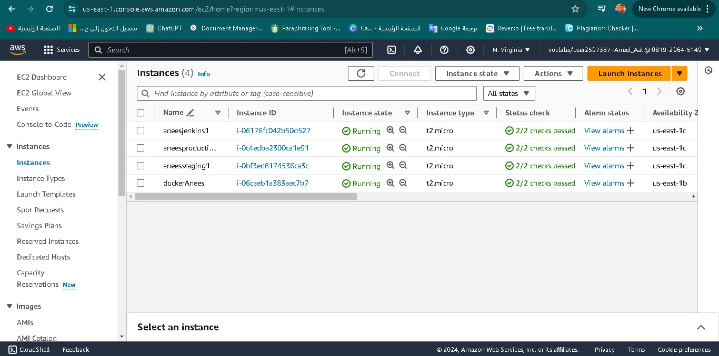

"Then, I modified the rules to be open source on port 8080, as shown in the image."  
  
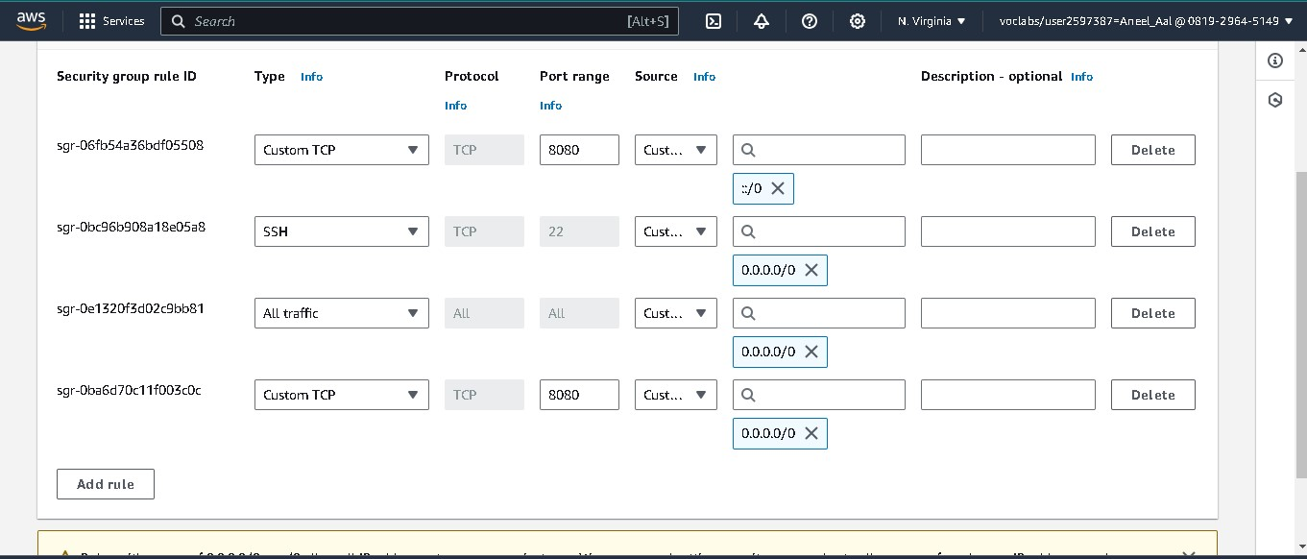

"After that, I downloaded Jenkins onto the Jenkins instance in order to create an account on Jenkins."

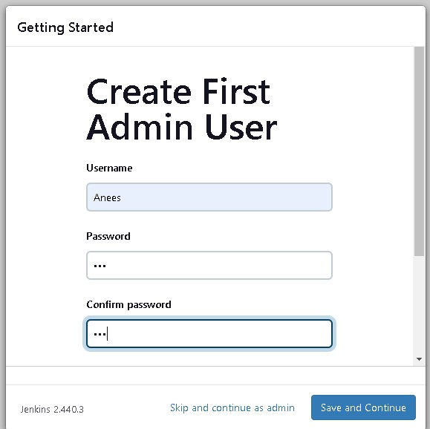

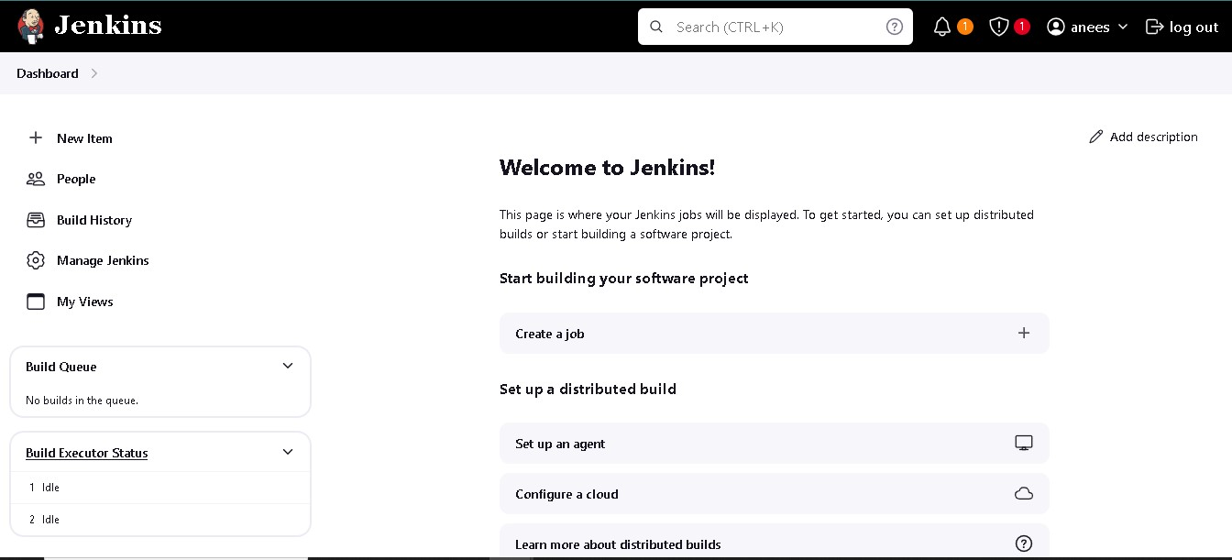

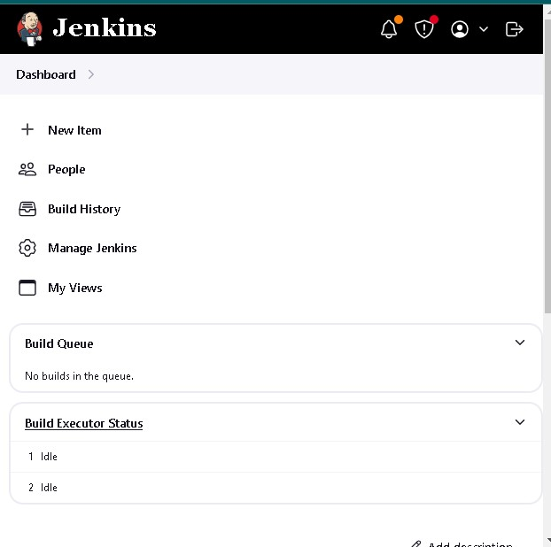

"Then, I created 2 nodes to link them with the instances, and they were successfully linked as shown in the image."

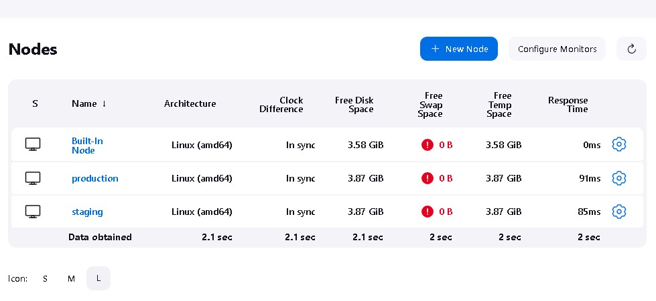

"Afterwards, I uploaded the index.html webpage file to a GitHub repository to link it with Jenkins."

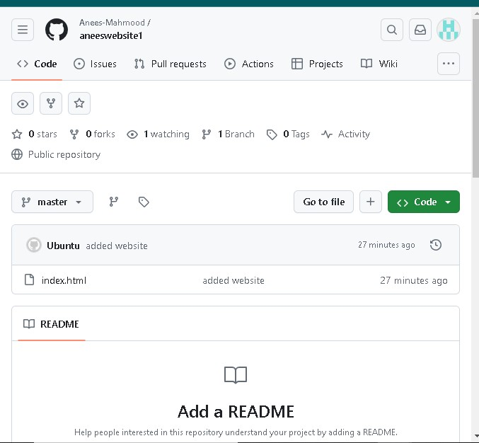

"Then, I created a Docker account and uploaded an image onto it, as shown in the image."

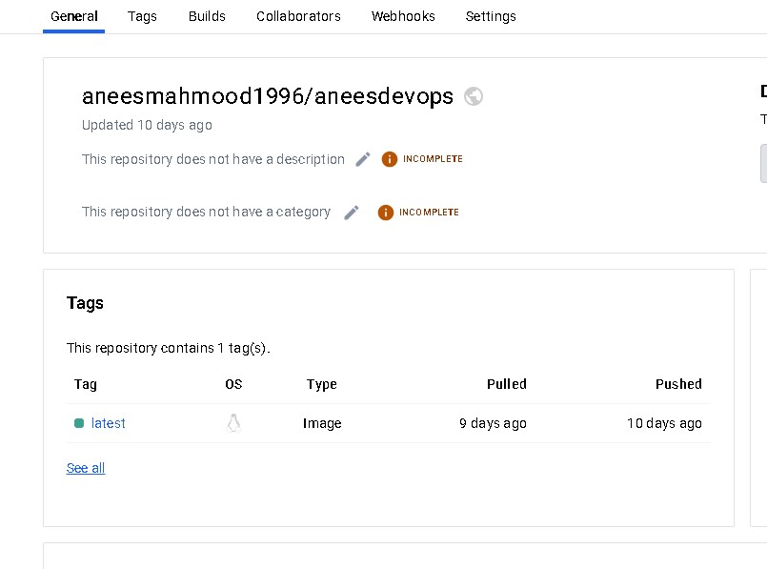

"Then, I created a 'Getjob' and the build process was successful."

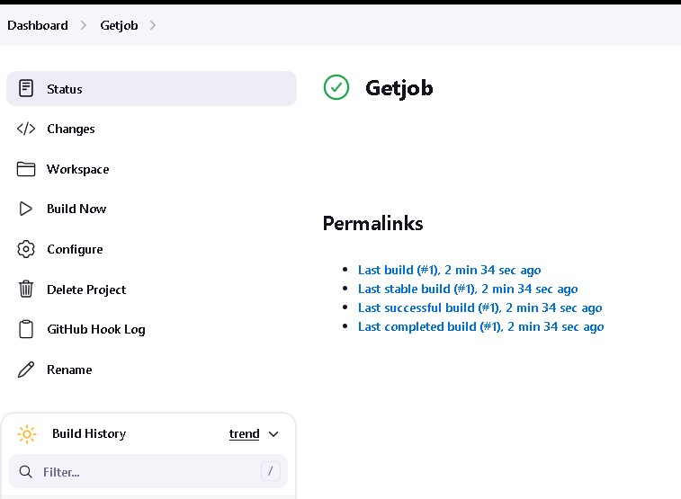

"Then, I created an 'aneesbuild' to link it with the 'Getjob' so that the webpage can be deployed afterward."

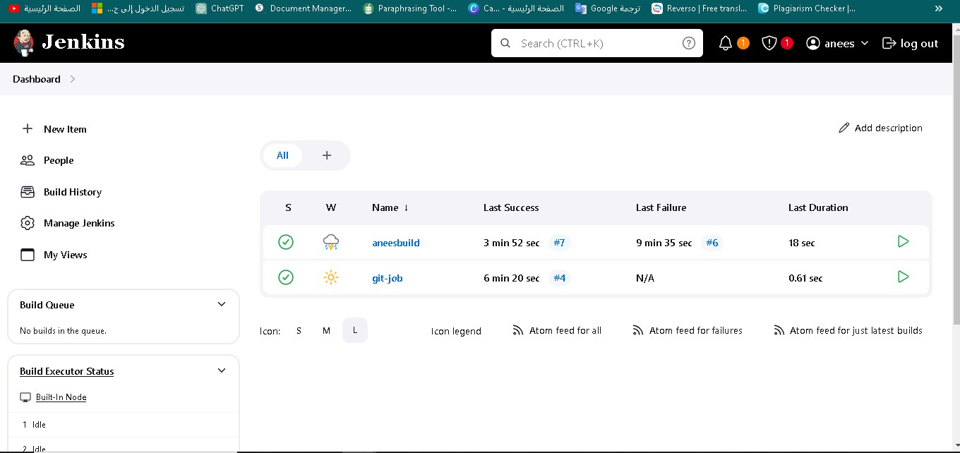

"Here, to ensure that the connection was established."

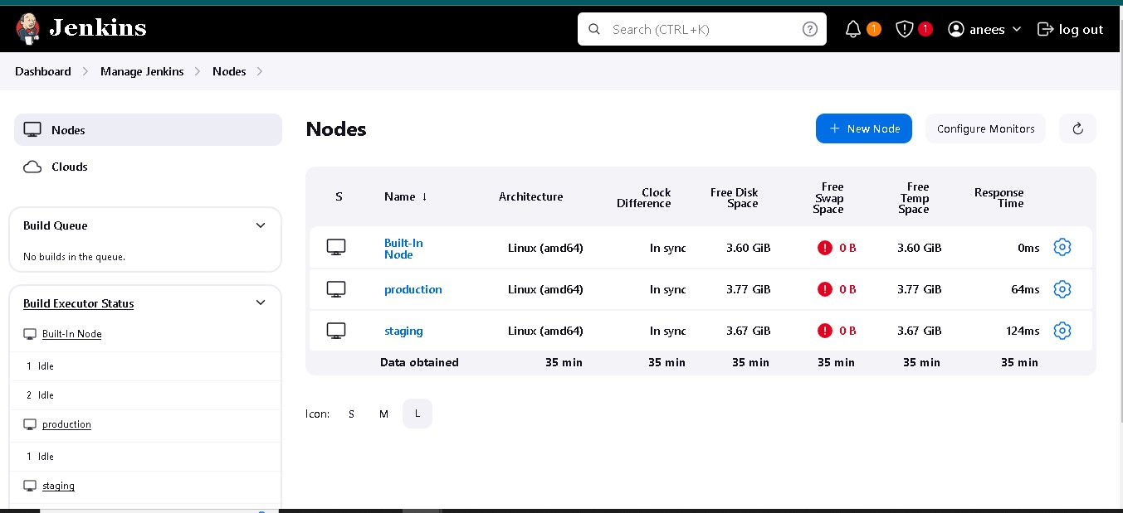

"Webhooks are a feature on GitHub that allows you to receive notifications when certain events occur in your repositories. For example, I can receive a notification when changes are pushed to the repository or any other new event."

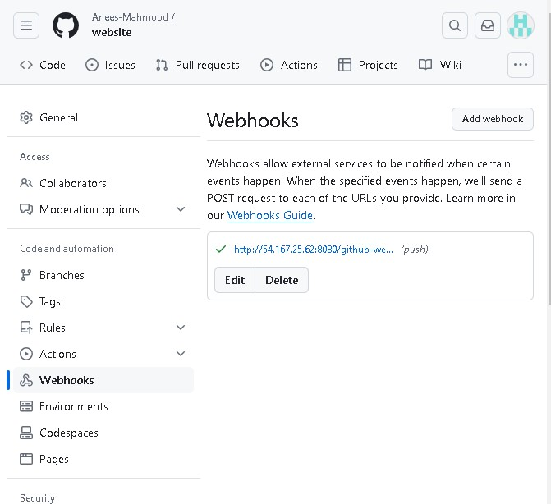

"Here, I created 'pushprod' to deploy the webpage and make it available to everyone."

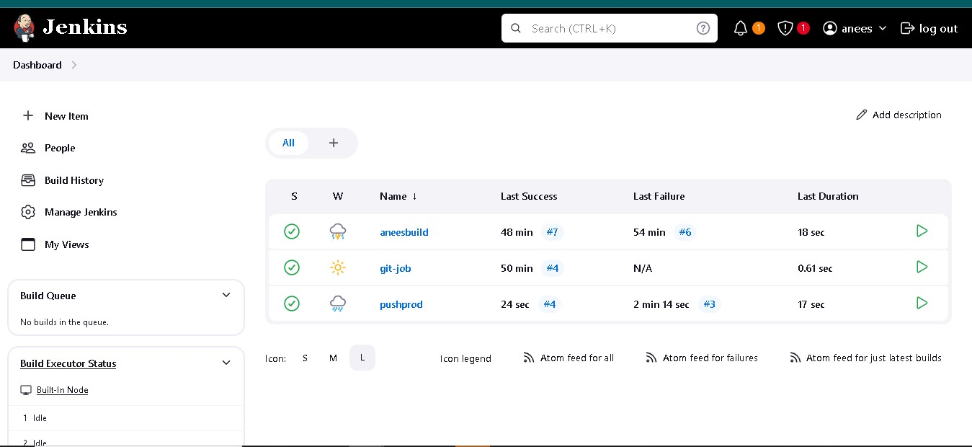

"Here, the webpage appears after it has been deployed."

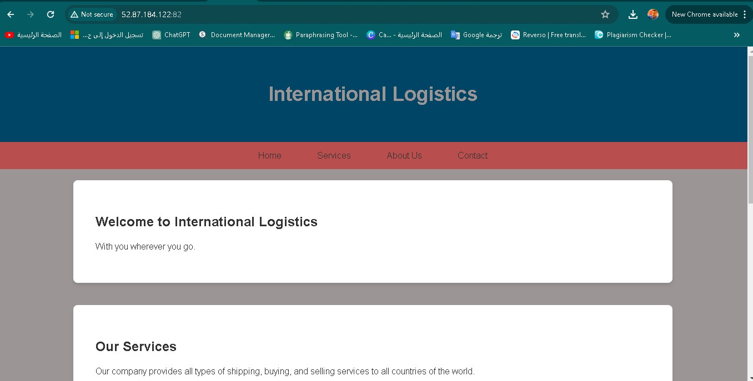

"Now, I will perform the testing through Maven to ensure that the webpage is functioning. The image shows that the testing process was successful."

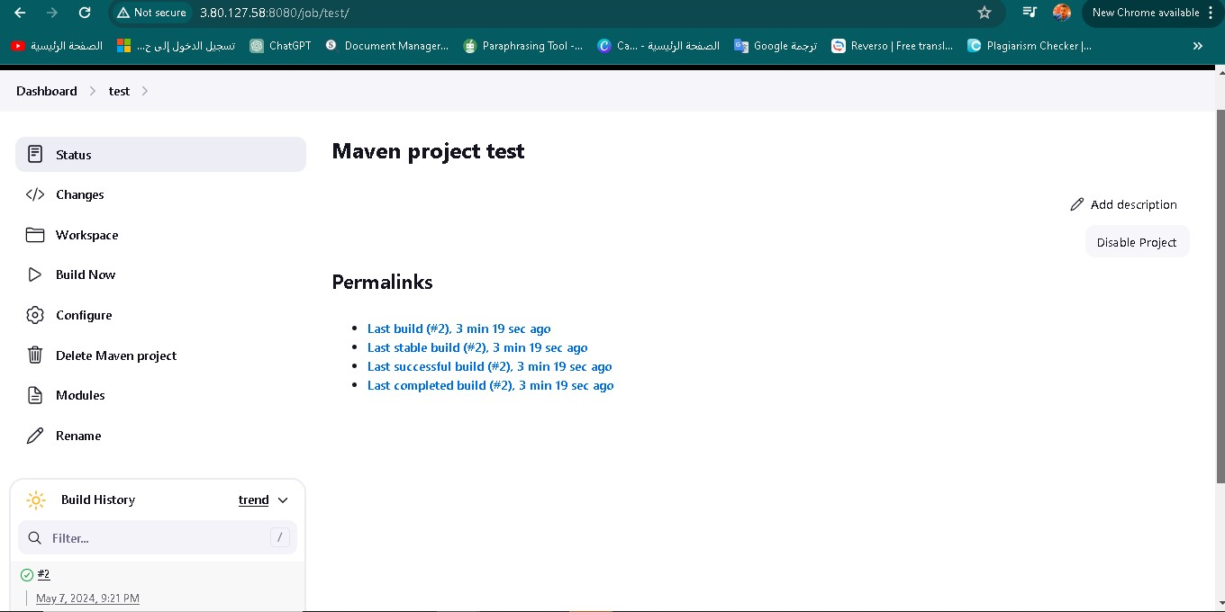

"Through these images, the testing code indicates that the process was successful."  
  
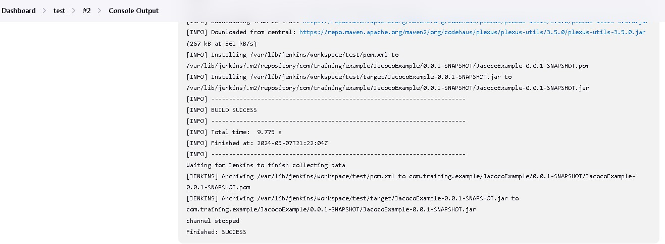

"I also used Jira to organize my tasks, as shown in the image."  
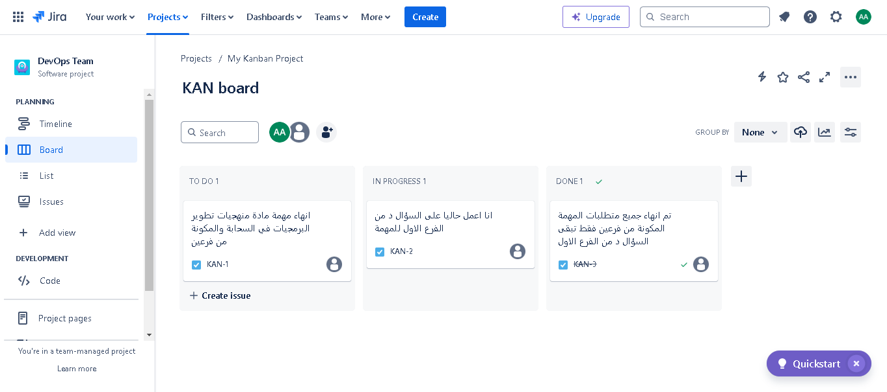

B. Emphasizing the importance of collaboration in DevOps projects by showcasing the use of collaborative technology tools during the development of my cloud-based solution. Additionally, justifying the use of these collaborative tools during the development phase. DevOps projects are one of the most common ways to develop and operate software in the modern era. These projects require close collaboration between different teams, such as development, operations, and security. Collaborative technology tools play a crucial role in facilitating this collaboration and enhancing the efficiency of DevOps projects. In this regard, we will discuss the importance of collaboration in DevOps projects and present the use of some common collaborative technology tools. Importance of collaboration in DevOps projects • Improving development speed: Effective collaboration enables synchronous development, where several developers can work on different features at the same time. • Reducing errors: Collaboration helps in early error detection in the development lifecycle through mutual review and exchange of ideas. • Enhancing communication: Collaboration improves communication between different teams, reducing misunderstandings and ensuring project consistency. • Increasing innovation: Collaboration encourages the exchange of ideas and innovation, leading to more effective and creative solutions. • Improving the quality of the final product: Collaboration contributes to ensuring the quality of the final product through the participation of different teams in the development process. Collaborative technology tools used in my DevOps project • Docker Hub: A platform for sharing Docker images. Docker Hub allows developers to share their Docker images so that others can use them in their projects.

• Jenkins: An automation tool for building CI/CD pipelines. Jenkins enables developers to automate tasks such as building, testing, and deployment. During the project, I built platforms to link them with the website and deploy them through AWS.

• GitHub: A platform for sharing Git repositories. GitHub allows developers to share their source code with others and communicate with them about the code. I stored the website code inside GitHub to link it with Jenkins and to easily develop and share the code.

• AWS: A cloud platform that provides a wide range of services, such as computing, storage, and databases. AWS allows developers to deploy their applications on the cloud easily. I created instances to deploy the website on the cloud through AWS, making it available to end users.

• Maven: A tool for managing Java builds. Maven enables developers to automate tasks such as building, testing, and packaging. I used it to test the website.

Examples of using collaborative technology tools in DevOps projects • Using Docker Hub to share Docker images: Developers can share their Docker images on Docker Hub. • Using Jenkins to automate CI/CD pipelines: Developers can use Jenkins to automate tasks such as building, testing, and deployment, saving time and reducing errors. • Using GitHub to share source code: Developers can share their source code on GitHub so that others can review it and provide feedback. • Using AWS to deploy applications on the cloud: Developers can use AWS to deploy their applications on the cloud easily, making them available to end users. • Using Maven to manage Java builds: Developers can use Maven to automate tasks such as building, testing, and packaging, saving time and ensuring build consistency.

C. Conclusion of my work by evaluating and reflecting on the effectiveness of DevOps pipeline tools and collaborative technologies used. I will evaluate how they contributed to meeting the requirements of the global logistics company.

Evaluation of the Effectiveness of DevOps Tools and Collaborative Technologies in the Global Logistics Company:

Global logistics companies rely on advanced technologies to meet increasing demands and improve their operational efficiency. DevOps tools and collaborative technologies play a crucial role in achieving these goals by automating processes, improving communication, and enhancing collaboration between different teams.

In this study, we evaluate the effectiveness of using DevOps tools and collaborative technologies in a global logistics company, and discuss how these tools contributed to meeting the company's requirements and improving its performance.

Introduction:

Global logistics companies face increasing challenges related to growing time pressures and evolving customer expectations. Therefore, the need to adopt effective technological solutions to improve operational efficiency and development speed is more critical than ever.

DevOps tools and collaborative technologies provide ideal solutions to these challenges by automating build, test, and deployment tasks, enhancing communication between teams, and facilitating the exchange of information and knowledge.

Used DevOps Tools and Collaborative Technologies:

The global logistics company used a range of DevOps tools and collaborative technologies, including:

• Docker Hub: for sharing Docker images with different teams, allowing for standardization of development, testing, and production environments.

• Jenkins: for automating CI/CD pipelines, significantly speeding up the development process.

• GitHub: for sharing source code and tracking changes, helping to improve the review process, testing, and reduce errors.

• AWS: for deploying applications on the cloud, providing high flexibility and scalability for the infrastructure.

Evaluation of Tool Effectiveness:

DevOps tools and collaborative technologies have significantly improved the performance of the global logistics company by:

• Improving development speed: Automating CI/CD pipelines using Jenkins has led to a reduction in the time required to develop new features and fix errors.

• Reducing errors: Tools like Docker Hub and GitHub have helped reduce errors by improving the review and testing process, leading to improved software quality.

• Increasing flexibility: Tools like AWS have increased the company's infrastructure flexibility, allowing for easy scalability to meet growing demands.

• Enhancing customer experience: Increased development speed and flexibility have led to an improved customer experience by providing new features faster and improving application performance.

Challenges:

Despite the numerous benefits, the global logistics company faced some challenges in using DevOps tools and collaborative technologies, including:

• Learning curve: Employees needed to learn how to use new tools, which took some time and effort.

• Integration: Integrating some tools with each other was challenging and required extra effort to facilitate data exchange.

• Security: Ensuring data and information security was important, requiring steps to implement appropriate security practices.

Improvement Recommendations:

• Provide training: Employees should be provided with sufficient training on how to use new tools, enabling them to maximize their capabilities.

• Improve integration: Efforts should be made to better integrate different tools for easier data exchange.

• Enhance security practices: Steps should be taken to implement appropriate security practices to protect data and information.

• Measure and analyze results: DevOps tools' usage and effectiveness should be tracked and analyzed regularly to identify areas for improvement.

• Continuous communication: Encourage continuous communication between different teams to share ideas, experiences, and ensure effective tool usage.

• Develop a future plan: A future plan should be developed for using DevOps tools and collaborative technologies, considering the company's evolving needs.

Conclusion:

DevOps tools and collaborative technologies have proven their effectiveness in improving the performance of global logistics companies by automating processes, improving communication, and enhancing collaboration between different teams.

With effective use of these tools and the above-mentioned recommendations, global logistics companies can continue to innovate and improve their competitive efficiency in an ever-changing business environment