**Milestone 01**



**Spring 2025**

Submitted by:

FAIZAN 2134

ANEES 2168

ZEESHAN 2217

Class Section: **B**

“On my honor, as student of University of Engineering and Technology, I have neither given nor received unauthorized assistance on this academic work.”

Submitted to:

Eng. Sumayyea Salahuddin

Month Day, Year (26 05, 2025)

Department of Computer Systems Engineering

University of Engineering and Technology, Peshawar

| **Field** | **Description** |
| --- | --- |
| **Id** | Primary key, unique identifier for each user. |
| **Name** | The user's full name. |
| **Email** | The user's email address. |
| **Phone** | The user's phone number. |
| **Usertype** | Type of the user. Can be 'admin' or 'user'. |
| **email_verified_at** | Timestamp when the user's email was verified. |
| **Password** | The hashed password for authentication. |
| **remember_token** | Token for remembering the user session. |
| **current_team_id** | ID of the current team associated with the user (if applicable). |
| **profile_photo_path** | Path to the user's profile photo (if applicable). |
| **created_at** | Timestamp when the user was created. |
| **updated_at** | Timestamp when the user details were last updated. |

**User:**

**Room Table**:

| **Field** | **Description** |
| --- | --- |
| **Id** | Primary key, unique identifier for each room. |
| **room_title** | Title or name of the room (e.g., "Luxury Suite", "Standard Room"). |
| **Image** | Path to an image representing the room. |
| **description** | Detailed description of the room, including features, size, etc. |
| **Price** | Price per night or booking period for the room. |
| **Wifi** | Indicates if the room has Wi-Fi (yes/no). |
| **room_type** | Type of room (e.g., "Single", "Double", "Suite"). |
| **created_at** | Timestamp when the room was created. |
| **updated_at** | Timestamp when the room details were last updated. |

**Booking Table**:

| **Field** | **Description** |
| --- | --- |
| **Id** | Primary key, unique identifier for each booking. |
| **room_id** | Foreign key referencing the **Room** table (the room that was booked). |
| **Name** | Name of the person who made the booking. |
| **Email** | Email address of the person who made the booking. |
| **Phone** | Phone number of the person who made the booking. |
| **start_date** | The start date of the booking. |
| **end_date** | The end date of the booking. |
| **created_at** | Timestamp when the booking was created. |
| **updated_at** | Timestamp when the booking details were last updated. |

**Contact Table:**

| **Field** | **Description** |
| --- | --- |
| **Id** | Primary key, unique identifier for each contact entry. |
| **Name** | Name of the person submitting the contact request. |
| **Email** | Email address of the person submitting the contact request. |
| **Phone** | Phone number of the person submitting the contact request. |
| **subject** | The subject or title of the contact message. |
| **message** | The content or body of the contact message. |
| **Status** | Current status of the message (e.g., 'unread', 'read', 'replied'). |
| **created_at** | Timestamp when the contact entry was created. |
| **updated_at** | Timestamp when the contact entry was last updated. |

1. Business Rules for Hotel Booking System

### **1. User Table**

**Business Rules:**

* **Id (Primary Key)**:
  + This is an auto-incrementing unique identifier for each user. It ensures that each user has a distinct ID.
* **Name**:
  + This field is mandatory. The name must be at least two characters long and cannot be empty.
  + It should consist only of alphabetic characters and spaces.
* **Email**:
  + Must be unique and follow a valid email format (e.g., user@example.com).
  + Cannot be empty.
  + Should be verified (via the email_verified_at field) to ensure the user's email address is legitimate.
  + The email_verified_at field should be automatically populated when a user clicks on the verification link sent to their email.
* **Phone**:
  + This field is optional but must be numeric and should follow a valid phone format (with country code if needed).
* **Usertype**:
  + Can either be admin or user.
  + Admins have higher privileges (e.g., ability to manage rooms, bookings, etc.).
* **Password**:
  + This field must be hashed and stored securely. The password must be at least 8 characters long.
* **Remember Token**:
  + This is a one-time token generated to remember the user’s session after they log in.
* **Current Team ID**:
  + This field is optional. If a user is part of a team, the current_team_id will reference the id from the teams table (if available).
* **Profile Photo Path**:
  + Optional field where the path to the user's profile photo is stored. If no photo is uploaded, this field remains null.
* **Created At & Updated At**:
  + Automatically managed timestamps.
  + created_at is set when the user is created.
  + updated_at is updated whenever user details are modified.

### **2. Room Table**

**Business Rules:**

* **Id (Primary Key)**:
  + Auto-incrementing unique identifier for each room.
* **Room Title**:
  + This is a required field, cannot be empty, and should be descriptive (e.g., "Luxury Suite", "Double Room").
* **Image**:
  + The image path should point to a valid location on the server. If the image is not provided, the field can remain empty or null.
* **Description**:
  + Must contain detailed information about the room, including size, features, and amenities.
  + Cannot be empty, but can have a minimum length to ensure the description provides adequate details.
* **Price**:
  + This is required and should be a positive decimal value.
  + Price must be specified per night or per booking period.
* **Wi-Fi**:
  + Must be either yes or no to indicate whether the room provides Wi-Fi.
* **Room Type**:
  + Required field, must be one of the predefined types such as Single, Double, Suite, etc.
* **Created At & Updated At**:
  + Automatically managed timestamps.
  + created_at is set when the room is created.
  + updated_at is updated whenever room details are modified.

### **3. Booking Table**

**Business Rules:**

* **Id (Primary Key)**:
  + Auto-incrementing unique identifier for each booking.
* **Room Id (Foreign Key)**:
  + References the id from the Room table, ensuring that each booking is for a valid room.
  + The room must exist before a booking can be made.
* **Name**:
  + The name of the person making the booking. It must not be empty and should be at least two characters long.
* **Email**:
  + The email address of the person making the booking. It must be a valid email format.
* **Phone**:
  + Optional, but if provided, it should follow a valid phone number format.
* **Start Date & End Date**:
  + start_date must be earlier than end_date.
  + The booking must not overlap with any existing bookings for the same room within the same date range.
  + A booking cannot be made for a room if the start date is earlier than today or if the room is already booked for that period.
* **Created At & Updated At**:
  + Automatically managed timestamps.
  + created_at is set when the booking is created.
  + updated_at is updated whenever booking details are modified.

### **4. Contact Table**

**Business Rules:**

* **Id (Primary Key)**:
  + Auto-incrementing unique identifier for each contact message.
* **Name**:
  + The name of the person submitting the contact request. It must be a required field and should be at least two characters long.
* **Email**:
  + Must be a valid email format.
* **Phone**:
  + Optional, but if provided, must follow a valid phone number format.
* **Subject**:
  + The subject of the contact message. This field cannot be empty.
* **Message**:
  + The content of the contact message. It must be a minimum of 10 characters long to ensure the message is detailed.
* **Status**:
  + Tracks the current state of the contact message. Values can be unread, read, or replied.
  + Initially set to unread when the contact is created.
  + Should be updated to read or replied once the staff has reviewed or responded to the message.
* **Created At & Updated At**:
  + Automatically managed timestamps.
  + created_at is set when the contact message is created.
  + updated_at is updated whenever the message status or content is modified.

**10. Relationships Summary**

### **Hotel Booking System – Relationship Types & Rules**

### **Relationships Between Tables**:

1. **User (1) -> Booking (Many)**: One user can have many bookings.
2. **Room (1) -> Booking (Many)**: One room can have many bookings.
3. **User (1) -> Contact (Many)**: One user can submit many contact requests.
4. **Room** and **Contact** have no direct relationship.

ERD DIAGRAM :

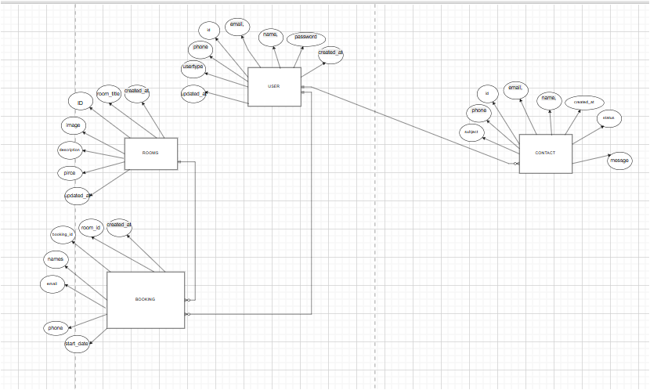

### **References**

1. ChatGPT. (2025). AI language model developed by OpenAI. Used for assistance in explanations and content generation. Available at: [https://chat.openai.com](https://chat.openai.com/)
2. Draw.io. (n.d.). Diagramming tool for creating ER diagrams and database schemas. Available at: [https://www.draw.io](https://www.draw.io/)
3. Google. (2025). Search engine used for gathering supplementary information. Available at: [https://www.google.com](https://www.google.com/)