# Email setup instructions

Please follow steps below to configure your Mind IT email in your Gmail account

Web Login: [http://webmail.minditsystems.com](http://webmail.minditsystems.com/)

To configure this in your webmail account :

1. Login in http://webmail.minditsystems.comGo to Accounts and Import
2. login with your emailid (*@minditsystem.com,which you already using) & your password(I will send you.
3. Reset your password. goto settings sign near others in menu->preference->password->click on Passowrd link, it will give you three box old password , new password and confirm password. kindly change your password through here.

To configure this in your Gmail or account **(Preferred)**:

1. Goto settings->Accounts and Import->Check mail from other accounts->edit info link
2. In password field, enter your new password (whcih you changed in previous steps)Click check mail from other accounts.
3. POP Server: webmail.minditsystems.com

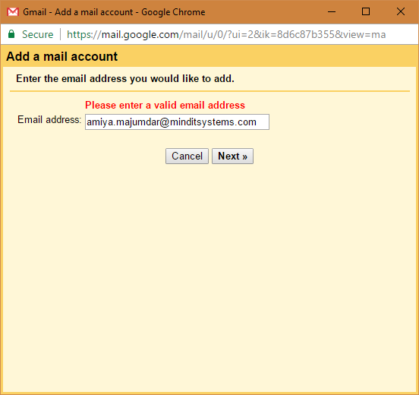

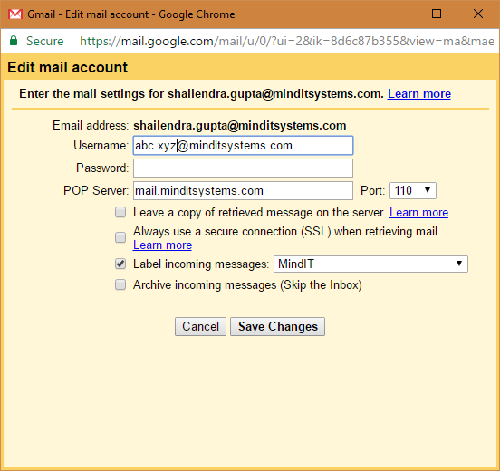

1. Save Changes.
2. Goto settings->Accounts and Import->Send mail as:->edit info link (in front of [*@minditsystems.com](mailto:*@minditsystems.com))
3. Click next steps.
4. In password enter your new password (which you changed in previous steps).
5. Fill in info

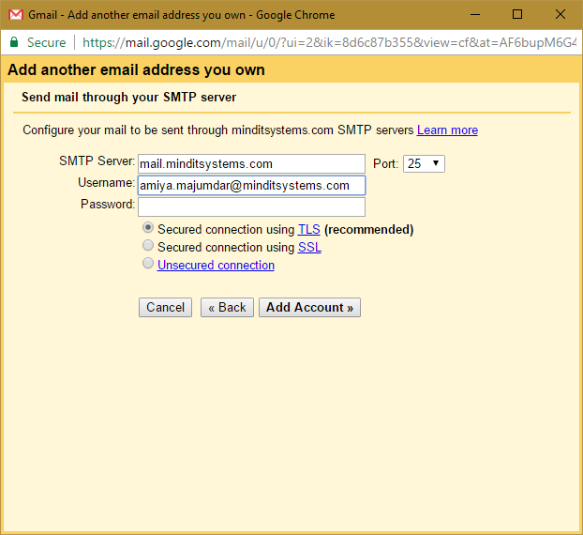

1. Done

* Please send yourself test email and check whether you are receiving emails from **@minditsystems.com id,

If you have any concern please let me know.