**1…Open Git UI 🡪create new repository**

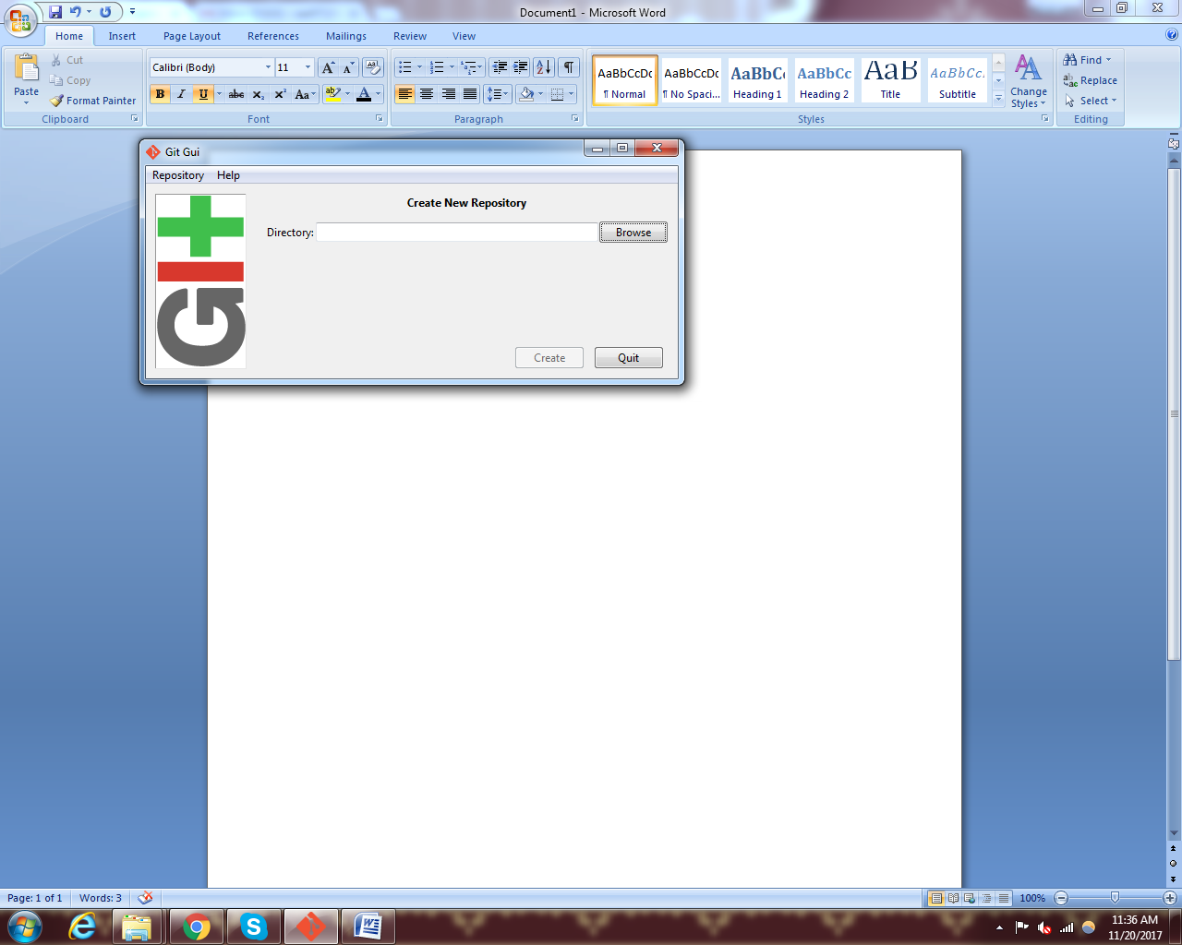

**2. give path of the project folder :** click on the browse and search for the path of the project

**Like**: D:\Training\ved\angular4Software

3…..you will see the following screen

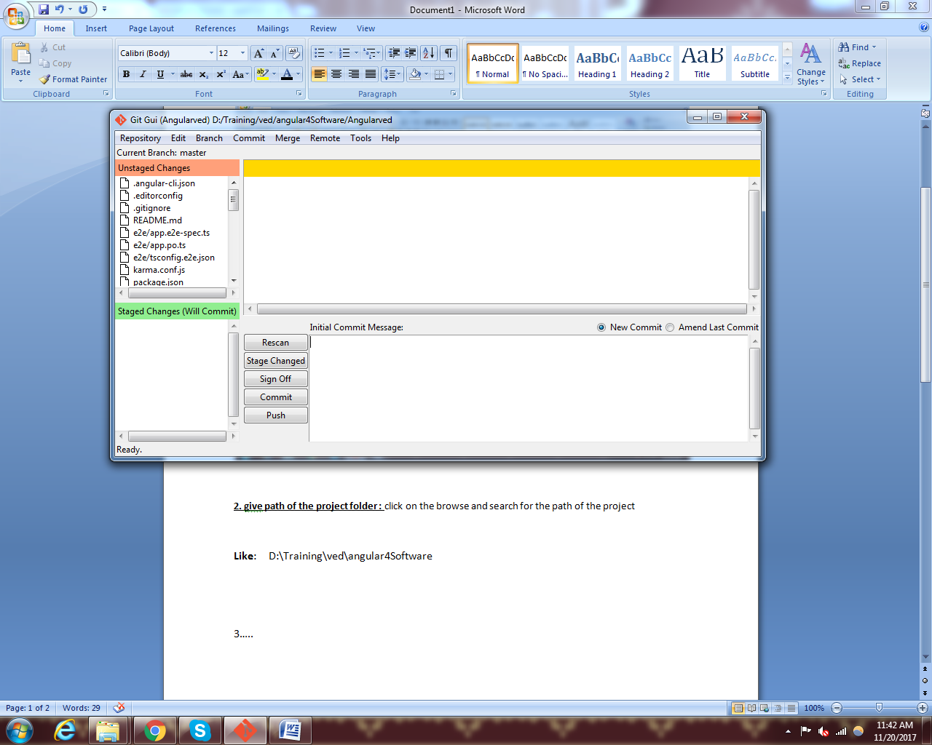

**4…. Click on the stage changed link**

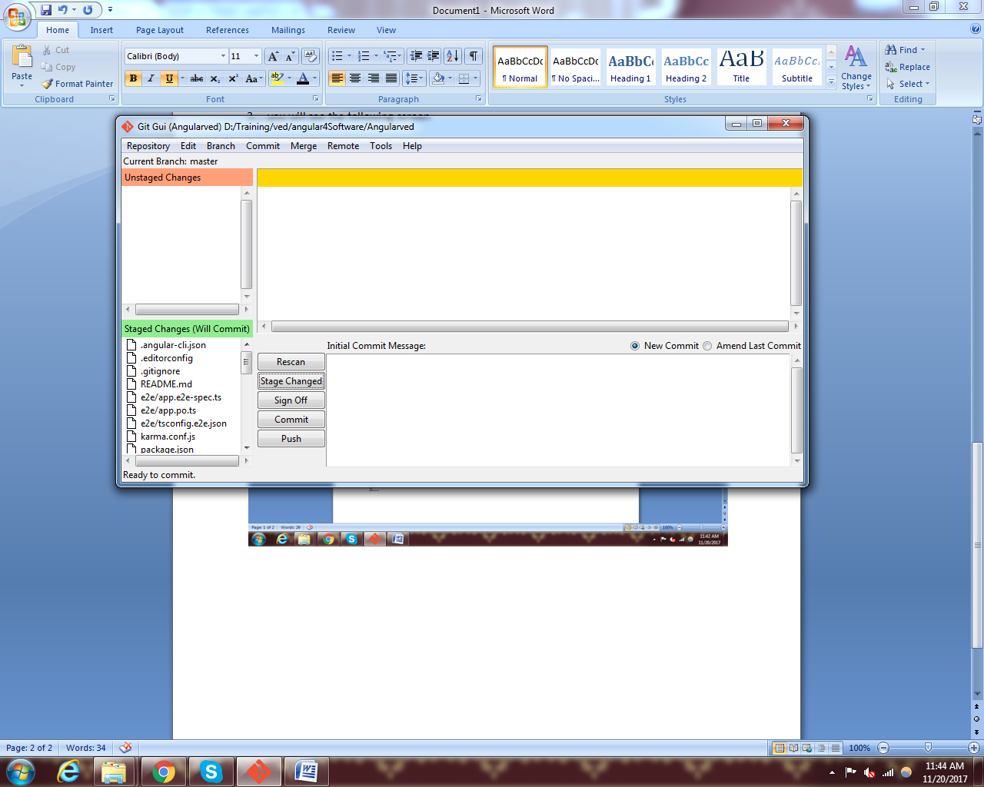

**5…. Type text as Initial commit and then click on commit link.**

**6…. Click on the remote tab--> click on the add remote**

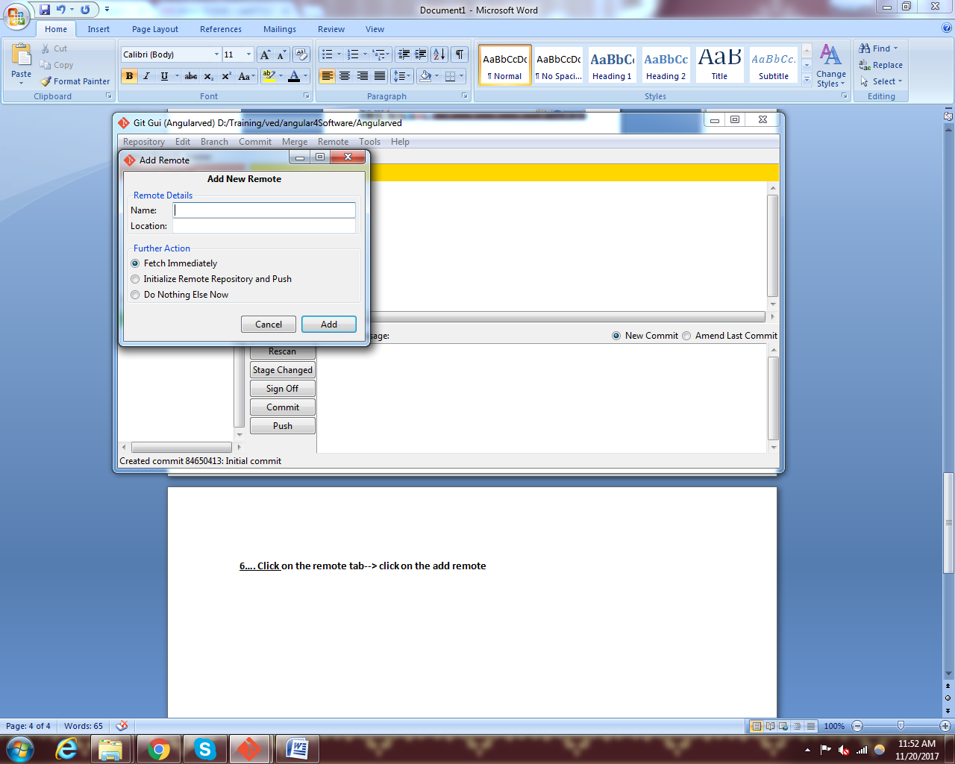

7.. give the name and location where you want to store your project on git server.-->

8… Select second radio button remote repository and puss.-->

9…..And click on add link-->

10….. now you are able to see the success massage then click on close.-->project deployed on git…

11….create a new file in your project at your local system--->

12. open git ui and click on the link given below at the end--->

13.click on the push button --- your file is saved in git project.

**14.For Cloning of project from GIT.**

15…. Open GIT UI and click on clone of project ----> give the path of source and target

Source----> from git project loation

Target----> To your local directory. Add /name to the target directory

Click on clone and your projects is currently stored in your local directory.