1. **ReactJS-HOL**

*Create a new React Application with the name “myfirstreact”, Run the application to print “welcome to the first session of React” as heading of that page.*

**Steps:**

* Install Nodejs and Npm

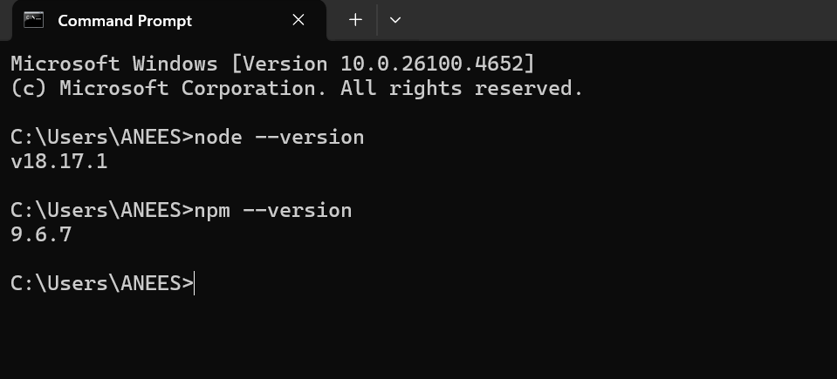

* Install the create-react-app tool globally

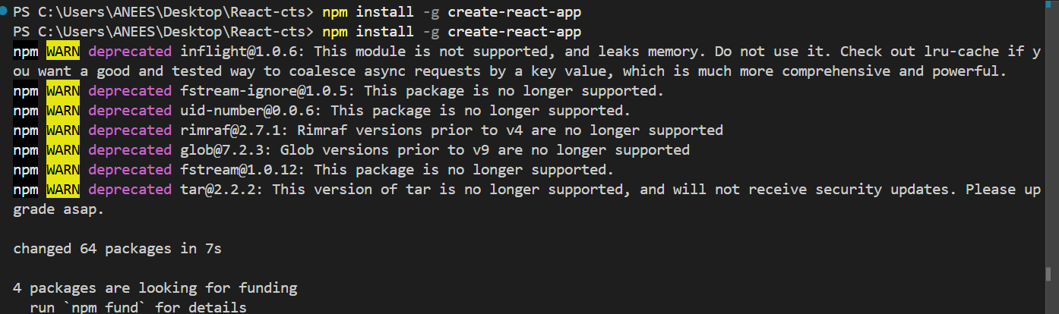

* Create a new React app named myfirstreact

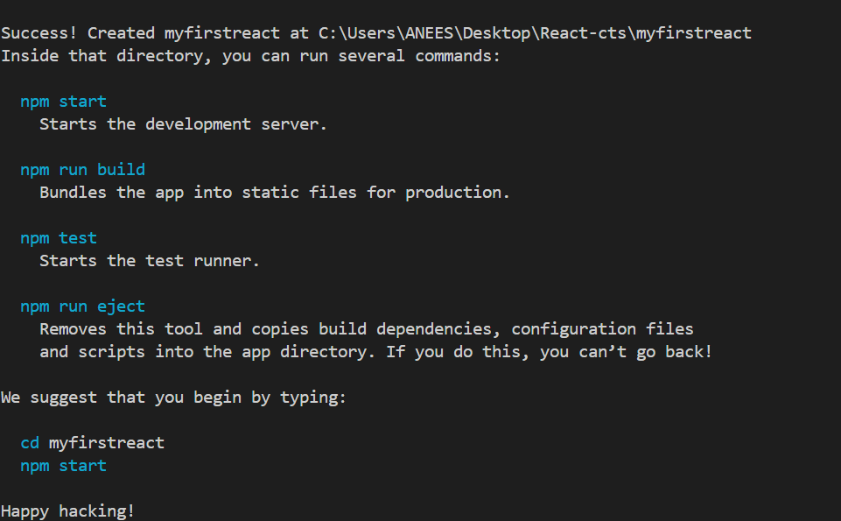

* Navigate into the folder of myfirstreact

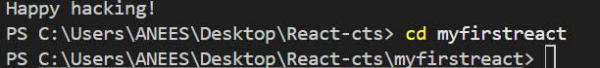

* Edit App.js

App.js

import React from 'react';

function App() {

return (

<div>

<h1>Welcome to the first session of React</h1>

</div>

);

}

export default App;

* Run the following command to execute the React application:

npm start

**Output:**

