**2. ReactJS-HOL**

Create a React app for Student Management Portal named StudentApp and create a component named Home, which will display the Message “Welcome to the Home page of Student Management Portal”. Create another component named About and display the Message “Welcome to the About page of the Student Management Portal”. Create a third component named Contact and display the Message “Welcome to the Contact page of the Student Management Portal”. Call all three components.

**Steps:**

* Create a React project named StudentApp

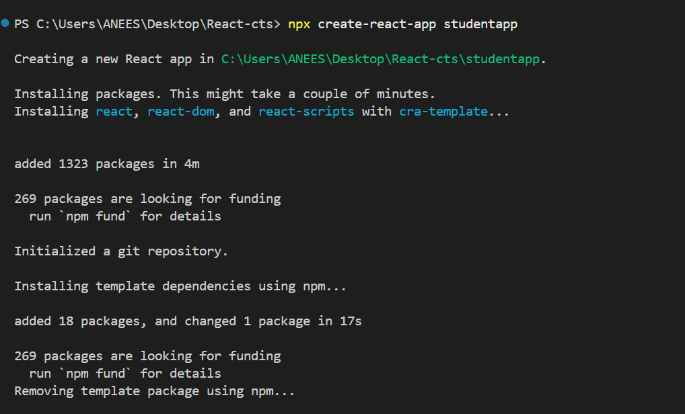

* Create a folder named Components inside src

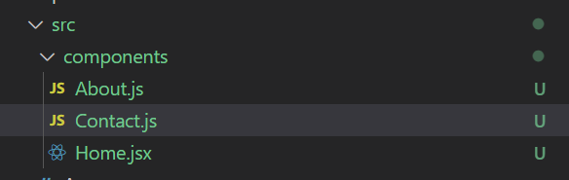

* Create Home.js, Contact.js, and About.js inside the Components folder

**Home.js**

import React, { Component } from 'react';

class Home extends Component {

render() {

return (

<div>

<h2>Welcome to the Home page of Student Management Portal</h2>

</div>

); }}

export default Home;

**About.js**

import React, { Component } from 'react';

class About extends Component {

render() {

return (

<div>

<h2>Welcome to the About page of the Student Management Portal</h2>

</div>

); }}

export default About;

**Contact.js**

import React, { Component } from 'react';

class Contact extends Component {

render() {

return (

<div>

<h2>Welcome to the Contact page of the Student Management Portal</h2>

</div>

); } }

export default Contact;

* Edit App.js to render the three components

**App.js**

import React from 'react';

import Home from './Components/Home';

import About from './Components/About';

import Contact from './Components/Contact';

function App() {

return (

<div className="App">

<h1>Student Management Portal</h1>

<Home />

<About />

<Contact />

</div>

);}

export default App;

* Run the Application:

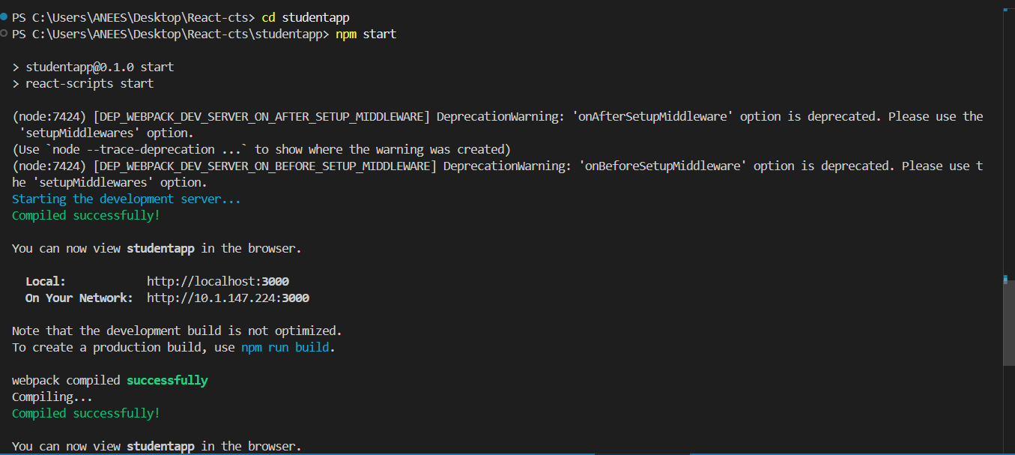

**Output**

