Introduction

Purpose
The aim of this project is to design and implement a web-based software system for virtual stock trading. Users can log in to the system and they can buy and sell socks. The virtual system will permit the users to practice and learn how the trade market works without real money. Moreover, the advantage is that you can practice anywhere because it is an online application and it is open 24 hours a day. The trading prices will be obtained by matching the buying and selling orders, each with their target price, as in the real market. The system will record the history of stock prices and provide graphical tools to present this data. Users will be able to view their personal information, owned stocks, transaction history and their current orders to buy and sell and the prices of the stocks. The system is a web-based application designed using appropriate technologies and will support a relatively large number of users. The application will show a list of the company’s stocks with their current prices and a list of buyers and sellers with the name of the stocks that they can buy or sell. Moreover, users will be able to see the orders sorted. The best order in the case of buy is the major price which will appear first and the worst order is the lower price which will appear at last and in the orders to sell, the lower price will appear first and the major price at last.

Document Purpose
The purpose of this document is to give a detailed description of the requirements for the “Virtual Stock Exchange” application. This document outlines the entire application giving detailed requirements which are to be used by the development team in the production phase and by the testing teams in the testing phase to ensure that the customers’ requirements are satisfied.

Conventions
No specific conventions are used in this document. Every requirement statement is of prime significance unless mentioned otherwise.

Objectives
The main objective of my project is to set an Apache Web Server up and running and a Database server in MySQL. The web pages will be done in HTML, PHP, CSS and JavaScript. These tools will permit users connect to the system through the Internet from anywhere with any Operating System and browser. The data will be saved in the SQL database and the information about the purchases and sales can be accessed with RSS. The users can see how the transactions change and how the orders of buying and selling match them. If there is a buyer who wants to buy a stock for a certain amount of money and there is a seller who wants to sell this stock, it will be a transaction. In this application the current price of the stocks in the trade market will be the price of the last sale. Users would be able to see the graphics about the history of the stock. The graphics will be done with a PHP’s library. Moreover, users can generate a PDF file with his information, his data and his stocks and can get update notifications using RSS.

Project Features
The product is restricted to beginners in the trade. Users can see the variations of the prices of stocks in the trade by means of graphics. Also, users can see their own stocks and they can buy and sell stocks. Users will be able to see all information anywhere because the application is in a server connected in the Internet. Henceforth, users can consult the information and do changes when and where they want. The application is programmed using HTML, PHP, JavaScript and XML to do the RSS. Moreover, users can export a PDF file with their stocks and their personal information. Furthermore, users can receive RSS about the new purchases and sales.
The system works in any Operating System and browser.

Product Scope

PDF: (Portable Document Format) is a file format created by Adobe Systems for document exchange. PDF is used for representing two-dimensional documents in a manner independent of the application software, hardware, and operating system. The documents in a PDF format have the smaller in size. PDF is an open standard.

RSS: is a family of Web feed formats used to publish frequently updated works in a standardized format. They benefit readers who want to subscribe to timely updates from favored websites or to aggregate feeds from many sites into one place. RSS feeds can be read using software called an "RSS reader", "feed reader", or "aggregator", which can be web-based, desktop-based, mobile device or any computerized Internet connected device. A standardized XML file format allows the information to be published once and viewed by many different programs.

PHP: is a scripting language originally designed for producing dynamic web pages. It has evolved to include a command line interface capability and can be used in standalone software and graphical applications. PHP was created by Rasmus Lerdorf in 1995. PHP is produced by The PHP Group. PHP is free software released under the PHP License. However it is incompatible with the GNU General Public License (GPL), due to restrictions on the usage of the term
PHP is a widely-used general-purpose scripting language that is especially suited for web development and can be embedded into HTML. It generally runs on a web server, taking PHP code as its input and creating web pages as output. It can be deployed on most web servers and on almost every operating system and platform.

HTML (Hypertext Markup Language): is the predominant mark-up language for web pages. It is used to describe the structure and the content in a text manner and to complete the text with objects like images. HTML is written in the form of tags that are surrounded by angle brackets (<,>). HTML can also describe the appearance of a document, and can include a script (such as JavaScript) that can affect the behavior of Web browsers and other HTML processors. HTML also is used to refer to the MIME type content text/html or XML (like XHTML 1.0 or subsequent versions) or SGML (like HTML 4.01 and previous versions). HTML files use the extension .htm or .html.
JavaScript: Is an interpret language program, it does not require compilation. It is usually used in web pages. It has syntax similar to Java and C language. JavaScript is an object oriented language like Java. It includes inheritance using the Prototype-based programming, the new classes are generated cloning the base classes (prototypes) and extending their functionality. All of the modern browsers interpret JavaScript code integrated in the web pages. It works with a DOM implementation. JavaScript was invented by Brendan Eich in the company Netscape Communications. This company developed the first commercial web browsers. The first time that appeared JavaScript was in the Netscape product Netscape Navigator 2.0. Years before, it was using in a HTML web pages, to realize tasks and operations in the framework of a costumer application, without access to server functions. JavaScript is executed in the user agent and the sentences are downloading with the HTML code.
DOM (Document Object Model): is a cross-platform and language convention for representing and interacting with objects in HTML, XHTML and XML documents. The rules for programming and interacting with the DOM are specified in the DOM Application Programming Interface (API). The programs can access and modify the content, structure and style in the HTML and XML documents with DOM. W3C (World Wide Web Consortium) is the responsible of DOM.

References
- Stock-broking Today, J. Dundas Hamilton (MacMillan Press Ltd. ISBN: 0-333-24237-8)
- McGraw-Hill Dictionary of Modern Economics, Greenwald & Associates (McGraw-Hill)
- A Guide To Financial Markets, Charles R. Geisst (MacMillan Press Ltd. ISBN: 0-333-30919-7)
- The Work of the Stock Exchange, Sir Stephen Killik (E. Couchman & Co. Ltd.)
- Bulls, Bears, and Microcomputers: Programming for Successful Investment, G. T. Childs (Sigma)
- http://finesse.ac.uk/tags/finesse.html
- http://game.marketwatch.com/
- http://www.tradingsimulation.com/tsimlite/

Overview of Virtual Stock Exchange System
- The Stock Exchange System is an online database of Information about Stocks such as Company Name, Stock Price and Number of Stocks issued, Market index, Previous history and Available Shares.
- Our Stock Exchange System is made up of the following modules to interact with the user.
  - Home Page Module
  - Registration module
  - Login module
  - User module
    - Visitor
    - Normal user: 5 Functional modules
    - Exchange Administrator: 6 Functional Modules

Virtual Stock Exchange System Overview Diagram

System Features and Functional Requirements

List of Modules
System can be thought of as an integration of the following modules.
- Home Page
- User Registration module
- Login Module
- User Module
  - Visitor
  - Registered user
  - Exchange Administrator

Home Page
This page will work as the welcome page for the portal. This should provide login and registration facility for the user,
Registered users get insight about the objectives of the Stock Exchange Application from the page. This page is so designed to attract users to the application.

User Registration Module
Any new user is allowed to register on the site so as to access all the features of the system. Stock prices can be viewed without logging into the system.
Registered users will be provided access to the buy and sell stocks and also view owned stocks. Besides, graphs about personal stocks are available. This information will be stored on the website.
The following are the information about the user that should be collected at the time of registration.
- User Name
- Password
- Email Id
- Bank Details
Every field should be mandatory and the conditions for the fields are as follows.
- User name: User has the flexibility to choose any username that is not already registered in the system.
- Password: Password is suggested to be strong if it has more than 8 alphanumeric characters.
- Email Id: The email id is checked for credibility.
- Bank Details: Bank Details are verified for authenticity.

Login Module
This module will allow the user to login to the system with registered password. This authenticates the user. The system will look into the database user table and checks if the username and passwords entries match. If so, then it authorizes user to enter the home page.

User module
This module describes the various facilities available to the user.

View information about owned stocks
This feature lets the user see information about all the shares that are already owned by him. It shows Company, Number of shares held and the Current price per share.
.

Buy Stocks
This feature allows the user to select the stocks he wants to purchase and then make payment. The user has to enter the Company name and the number of shares he wishes to buy.

Sell Stocks
This feature allows the user to select the stocks he wants to sell and then the amount will be credited to his account. The user has to select the number of shares that he wants to sell and the amount will be credited immediately to his account.

Edit Profile
This feature allows the user to change personal details such as bank account details. The user can change his username, age, email id, address and bank account details.

Cancel order
This feature allows the user to cancel orders that he does not wish to perform.

Exchange Administrator

View User Details
This feature allows the admin to view the details of all the users. The administrator can view the Full name, username, address, age, email id, Bank account details of all the users.

Calculate Index
This feature allows the user to calculate the Index. This function is automated to dynamically calculate the index after every transaction by any user.

Manage Price
This allows the admin to change the stock prices. The admin can alter the stock prices of companies as per requirement.

Manage Company
This allows the admin to change the Company Details. The administrator can add new Companies, delete existing Companies, change their Website address, change their register address and change the total number of shares released by the company.

System Features
The product is a web-based software system for virtual stock trading. It uses a SQL database operated through a PHP framework. The features are mentioned below.

Database: The system keeps the information about users, companies, orders, history and stock’s prices. This is continuously updated after every transaction.

User management: Users can register in the system and they can edit their personal information: name, address, age, email id, bank details.

Company management: The information about companies (name, address, Website, total) is kept in the system.

Stock management: The system keeps each the stocks with his owner. It also maintains stock prices which are dynamically updated and the number of stocks available.

Order management: The system keeps the orders to buy and sell. Sellers can order sell stocks and buyers can order buy stocks. These transactions are recorded in the sell and buy history for future reference.

Consult options: Users can consult their stocks with the history of the prices. Users can see previous prices to decide what shares to buy/sell and the quantity.

Functional Requirements
Register: Users can register on the system by giving their details, Full name, Username, Address, Age, Email ID, Bank account details.

Open session: Users can open session to see more options such as stock prices and available shares.

Close session: Users can close session and save their details in the database securely.

See information about a specific ticker: Both logged in users and anonymous users can see the information about a specific ticker to see their evolution of prices in graphics.

See orders: Users can see a list of orders with their prices and details.

See tickers: Users can see a list of tickers with their prices and details.

Sell stocks: Sellers can sell their stocks. They have to detail the price and the volume.

Buy stocks: Buyers can buy their stocks. They have to detail the price and the volume user

The following paragraph explains the tables of the Data Base:

• Company: This table contains the information of the companies, name address, web and the total of stocks that the company has.

• Stock: This table contains the name of the ticker in each stock, the number of stocks available and the price per share.

• User: This table contains the information about the users, login, password, name, address, age and the cash that the user has.

• Ownership: This table links “User” with “Stock”. It contains the stocks owned by each user along with company name and number of stocks held.

• Sell: This table links “User” with “Stock”. It contains the stocks that the user wants to sell. It stores the number of shares sold and the company associated.

• Buy: This table links “User” with “Stock”. It contains the stocks that the user wants to buy. It stores the number of shares sold and the company associated.

• History: This table links “User” with “Stock”. It contains all the transactions done in the trade market, it has the information about the buyer, seller and number of stocks sold, price, ticker and date.

Non-Functional Requirements

Performance
The system is expected to do all the operations of buying, selling, maintenance and updating of stock prices in real time in a reasonable amount of time. This can be considered to be efficient enough since price management has to be done on a large number of firms. The market virtualization has to be close to the real world and periodical update of real world prices is necessary.

Reliability
The application is expected to allow login and buying or selling of shares. Naturally we can expect errors in the virtual prices from the real prices, but by employing regular price update process, we can make the system more reliable.

Security
All the data is stored in a database and is not open to public use. It is not stored in a simple csv file which can be opened and read. Thus we can say that the classified data are kept sufficiently private and confidential. Access rights are provided based on the user privileges which is obtained from the login information.

Availability
The system will not have any issues with availability as long as the server is not overloaded. Our design keeps in mind the maximum expected number of concurrent users. Also, there is no reason to expect unavailability for longer durations since the client is given a chance to connect as soon as load decreases even at peak usage.

Portability
The application is independent of the resident operating system and needs a compatible browser for execution. It is expected that JavaScript and Cookie features are enabled on the default browser.

Appendix A: Analysis Models

- Use case diagram
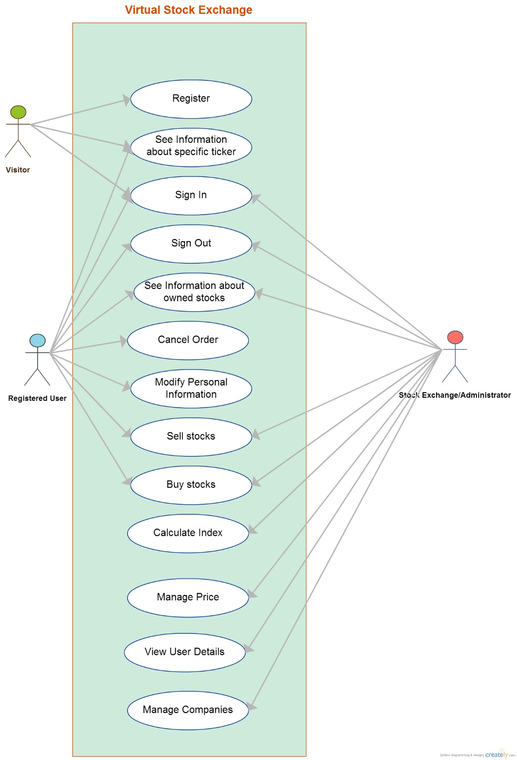
- Activity Diagram

