1.Odd Or Even

import java.util.Scanner;
public class OddOrEven {
public static void main(String[] args){
System.out.print("Enter a number : ");
Scanner scanner = new Scanner(System.in);
int num=scanner.nextInt();
if(num%2==0){
System.out.print(num+ " is even number");
}
else{
System.out.print(num + " is odd number");
}
scanner.close();
}

}

2.Calculator

import java.util.Scanner;
public class Calculator{
public static void main(String[] args){
System.out.print("Enter the choice for calculator 1.Additon 2.Subtraction 3.Multiplication 4.Division : ");
Scanner sc = new Scanner(System.in);
int choice=sc.nextInt();
System.out.println("enter Two numbers");
double a = sc.nextDouble();
double b = sc.nextDouble();
switch(choice){
case 1 : double sum = a+b;
System.out.print("sum is " + sum);
break;
case 2 : double diff = a-b;
System.out.print("difference is " + diff);
break;
case 3 : double prod = a*b;
System.out.print("Product is " + prod);
break;
case 4 : double div;
if(b==0){
System.out.print("cannot be divided by zero");
break;
}
else{
div=a/b;
System.out.print("Division is " + div);
break;
}
default : System.out.println("Invalid Choice");
break;
}
}
}

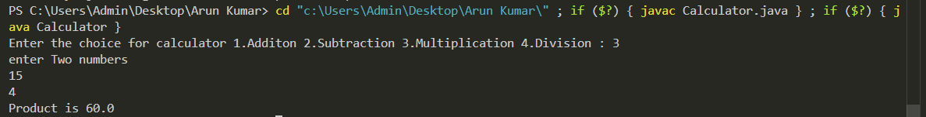
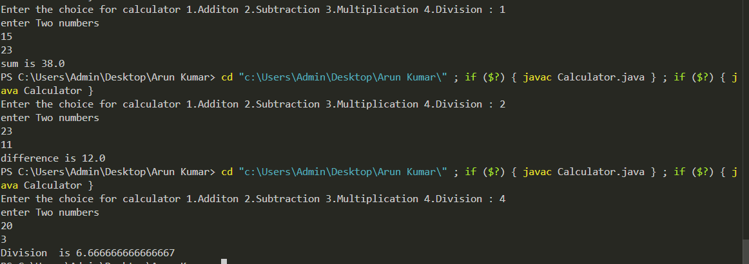

3. Addition of 2 Numbers

import java.util.Scanner;
public class Add {
public static void main(String[] args) {
Scanner sc = new Scanner(System.in);
System.out.print("n1 : ");
int n1 = sc.nextInt();
System.out.print("n2 : ");
int n2 = sc.nextInt();
int sum = n1+n2;
System.out.print("Sum is "+ sum);
sc.close();
}
}

4. Swapping of Two Numbers

import java.util.Scanner;
public class Swap {
public static void main(String[] args) {
Scanner sc = new Scanner(System.in);
System.out.print("n1 : ");
int n1 = sc.nextInt();
System.out.print("n2 : ");
int n2 = sc.nextInt();
int temp =n1;
n1=n2;
n2=temp;
System.out.println("After Swapping : ");
System.out.println("n1 = " + n1 + " n2 : " + n2);
}
}

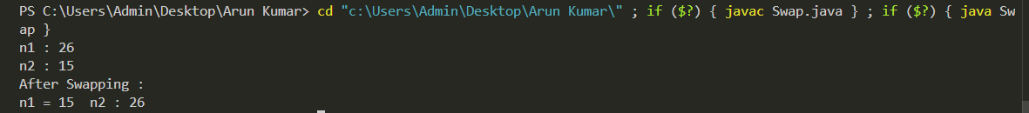

5. Largest of 3 Numbers

import java.util.Scanner;
public class Largest{
public static void main(String[] args) {
Scanner sc = new Scanner(System.in);
System.out.println("Enter Three Numbers : ");
int n1 = sc.nextInt();
int n2 = sc.nextInt();
int n3 = sc.nextInt();
if(n1>n2 && n1>n3){
System.out.println("Largest is "+ n1);
}
else if(n2>n3){
System.out.println("Largest is "+ n2);
}
else{
System.out.println("Largest is "+ n3);
}
}
}

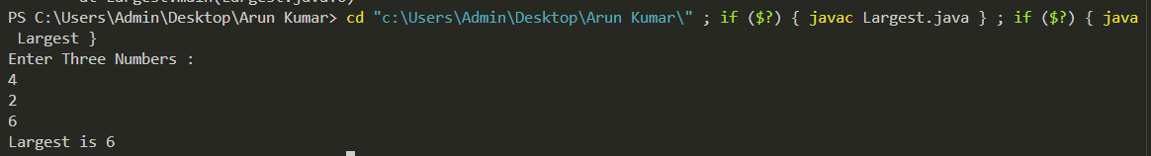

6.check number can be expressed in sum of 2 prime numbers

import java.util.Scanner;
public class ClassIsPrime {
public static boolean isPrime(int num) {
if (num<=1){
return false;
}
for (int i = 2; i <= Math.sqrt(num); i++) {
if (num % i == 0) {
return false;
}
}
return true;
}
public static void main(String[] args) {
Scanner sc = new Scanner(System.in);
System.out.print("Enter a number : ");
int n = sc.nextInt();
boolean found = false ;
System.out.println("Combinations is ");
for(int i = 2; i<=n;i++){
if (isPrime(i) && isPrime(n-i)){
System.out.println(n + " = " + i + " + " + (n-i));
found = true;
}
}
if(!found){
System.out.println("Can't be Expressed");
}
}
}

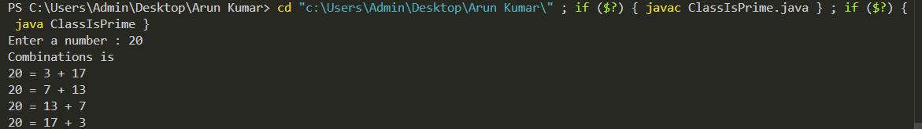

7.Solve the roots of Quadratic Equation

import java.util.Scanner;

public class QuadraticEquation {
public static void main(String[] args) {
Scanner scanner = new Scanner(System.in);

System.out.print("Enter coefficient a: ");
double a = scanner.nextDouble();

System.out.print("Enter coefficient b: ");
double b = scanner.nextDouble();

System.out.print("Enter coefficient c: ");
double c = scanner.nextDouble();

double d = b * b - 4 * a * c;

if (a == 0) {
System.out.println("Coefficient 'a' cannot be zero.");
} else if (d > 0) {
double r1 = (-b + Math.sqrt(d)) / (2 * a);
double r2 = (-b - Math.sqrt(d)) / (2 * a);
System.out.println("Roots are real and different.");
System.out.println("Root 1 = " + r1);
System.out.println("Root 2 = " + r2);
} else if (d == 0) {
double root = -b / (2 * a);
System.out.println("Roots are real and equal.");
System.out.println("Root = " + root);
} else {
double realPart = -b / (2 * a);
double imaginaryPart = Math.sqrt(-d) / (2 * a);
System.out.println("Roots are complex and different.");
System.out.println("Root 1 = " + realPart + " + " + imaginaryPart + "i");
System.out.println("Root 2 = " + realPart + " - " + imaginaryPart + "i");
}

scanner.close();
}
}

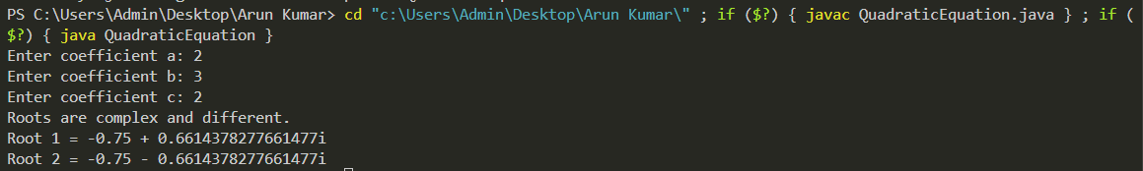
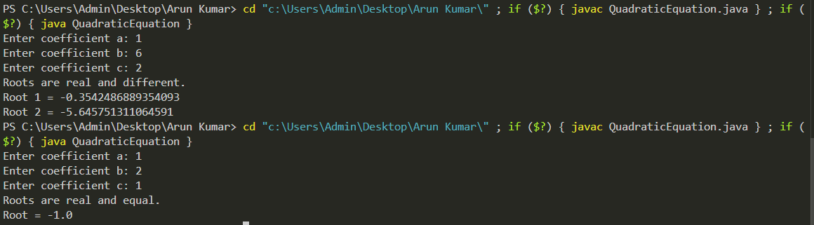

8.Palindrome

import java.util.Scanner;
public class Palindrome {
public static void main(String[] args) {
Scanner sc = new Scanner(System.in);
System.out.println("Enter a word : ");
String n = sc.nextLine();
String rev = "";
for(int i=n.length()-1;i>=0;i--){
rev+=n.charAt(i);
}
if (n.equalsIgnoreCase(rev)){
System.out.println("Palindorme");
}else{
System.out.println("Not Palindorme");
}
}
}

9. Bank Details using Inheritance (Lab 5)

import java.util.Scanner;

class Account {
String customerName;
String accountNumber;
String accountType;
double balance;

Account(String customerName, String accountNumber, String accountType, double balance) {
this.customerName = customerName;
this.accountNumber = accountNumber;
this.accountType = accountType;
this.balance = balance;
}

void deposit(double amount) {
if (amount > 0) {
balance += amount;
System.out.println("Amount deposited successfully. New Balance is " + balance);
} else {
System.out.println("Invalid deposit amount.");
}
}

void displayBalance() {
System.out.println("\n--- Account Details ---");
System.out.println("Name : " + customerName);
System.out.println("Account No : " + accountNumber);
System.out.println("Type : " + accountType);
System.out.println("Balance : " + balance);
}
}

class SavAcct extends Account {
double interestRate = 0.05;

SavAcct(String name, String number, double balance) {
super(name, number, "Savings", balance);
}

void computeAndDepositInterest() {
double interest = balance * interestRate;
balance += interest;
System.out.println("Interest of " + interest + " added. New balance: " + balance);
}

void withdraw(double amount) {
if (amount > balance) {
System.out.println("Insufficient balance.");
} else {
balance -= amount;
System.out.println("Amount withdrawn successfully. New balance: " + balance);
}
}
}

class CurAcct extends Account {
double minimumBalance = 1000;
double serviceCharge = 100;

CurAcct(String name, String number, double balance) {
super(name, number, "Current", balance);
}

void withdraw(double amount) {
if (amount > balance) {
System.out.println("Insufficient balance.");
return;
}
balance -= amount;
System.out.println("Amount withdrawn successfully. New balance: " + balance);
checkMinimumBalance();
}

void checkMinimumBalance() {
if (balance < minimumBalance) {
balance -= serviceCharge;
System.out.println("Balance below minimum. Service charge of " + serviceCharge + " imposed.");
System.out.println("New balance: " + balance);
}
}
}

public class Bank {
public static void main(String[] args) {
Scanner sc = new Scanner(System.in);

System.out.print("Enter customer name: ");
String name = sc.nextLine();

System.out.print("Enter account number: ");
String number = sc.nextLine();

System.out.print("Enter account type (savings/current): ");
String type = sc.nextLine().toLowerCase();

System.out.print("Enter initial balance: ");
double balance = sc.nextDouble();

// Use a flag to control the loop
boolean exit = false;

// --- Savings Account Logic ---
if (type.equals("savings")) {
SavAcct sa = new SavAcct(name, number, balance);
sa.displayBalance();

while (!exit) {
System.out.println("\n--- Savings Account Operations ---");
System.out.println("1. Deposit");
System.out.println("2. Withdraw");
System.out.println("3. Compute/Deposit Interest");
System.out.println("4. Display Balance");
System.out.println("5. Exit");
System.out.print("Enter your choice: ");

int choice = sc.nextInt();
double amount;

switch (choice) {
case 1: // Deposit
System.out.print("Enter amount to deposit: ");
amount = sc.nextDouble();
sa.deposit(amount); // Uses Account's deposit()
break;

case 2: // Withdraw
System.out.print("Enter amount to withdraw: ");
amount = sc.nextDouble();
sa.withdraw(amount); // Uses SavAcct's withdraw()
break;

case 3: // Compute Interest
sa.computeAndDepositInterest();
break;

case 4: // Display Balance
sa.displayBalance();
break;

case 5: // Exit
exit = true;
System.out.println("Exiting....");
break;

default:
System.out.println("Invalid choice. Please try again.");
}
}

// --- Current Account Logic ---
} else if (type.equals("current")) {
CurAcct ca = new CurAcct(name, number, balance);
ca.displayBalance();

while (!exit) {
System.out.println("\n--- Current Account Operations ---");
System.out.println("1. Deposit");
System.out.println("2. Withdraw");
System.out.println("3. Display Balance");
System.out.println("4. Exit");
System.out.print("Enter your choice: ");

int choice = sc.nextInt();
double amount;

switch (choice) {
case 1: // Deposit
System.out.print("Enter amount to deposit: ");
amount = sc.nextDouble();
ca.deposit(amount); // Uses Account's deposit()
break;

case 2: // Withdraw
System.out.print("Enter amount to withdraw: ");
amount = sc.nextDouble();
ca.withdraw(amount); // Uses CurAcct's withdraw() and checks minimum balance
break;

case 3: // Display Balance
ca.displayBalance();
break;

case 4: // Exit
exit = true;
System.out.println("Exiting.....");
break;

default:
System.out.println("Invalid choice. Please try again.");
}
}

} else {
System.out.println("Invalid account type entered.");
}

sc.close();
}
}

