**SPACE INVADERS**

**Group-14**

**Battula Joshit-S20210010038**

**Aneesh Lokray-S20210010019**

**Overview:**"Space Invaders" is a classic arcade game released in 1978 by Taito, designed by Tomohiro Nishikado. In the game, the player controls a spaceship that moves horizontally across the bottom of the screen, aiming to shoot descending rows of alien invaders. The player must dodge the aliens' attacks and barriers while attempting to eliminate them. As the player progresses, the aliens move faster and reappear on the screen once all are destroyed, increasing the difficulty. The objective is to score as many points as possible by destroying the alien invaders before they successfully shoot the player's spaceship. "Space Invaders" is regarded as one of the most influential video games of all time and played a significant role in popularizing the video game industry.

**Working of the Game:**

**Game Setup:**

● When the player runs the game,they will be prompted to enter their username.

● The game then loads the Background Image,Player Base,Aliens and other game elements.

**Game Loop:**

● The game enters the main loop, where it continually checks for player input, updates game state, and renders graphics.

**Player Controls:**

● The player controls a character using keyboard inputs. Arrow keys typically handle movement (left, right, Shoot).

**Collision Detection:**

● The game checks for collisions between the player base and bullets of aliens along with aliens and bullets of the player base.

● After the collision, Explosion animation is implemented so that the collision will be realistic.

**Scoring:**

● The game tracks the player's score. The score increases by ten every time a player shoots down an alien.

**Game Events and Conditions:**

● Various game events occur, such as the player colliding with alien bullets, and player bullets colliding with aliens.

● Game conditions are checked to determine whether the player is died or not.

**Game Over and Win States:**

● If the player collides with alien bullet thrice in a row without reaching next 100 points, the game enters a game-over state, where the player can choose to retry or quit or to visit the leaderboard.

● There is not end to this game. Reaching the max score possible is this game is the way to play.

**Leaderboard and High Scores:**

● The game records and stores usernames and their highest scores.

● Players can access the leaderboard after the game to view top 10 scores and compare their performance.

**Packages Used:**

**Pygame:** The main Pygame package, which provides functionalities for creating video games in Python.

**Pygame-Mixer:** This submodule handles loading and playing sounds in Pygame.

**Pygame-Locals:** This submodule contains various constants used for event handling and key inputs.

**OS:** A module in Python that provides functions for interacting with the operating system. It's used here to check file existence.

**Json:** A lightweight data interchange format. In this code, it's used for saving and loading high scores.

**Random**: A module that implements pseudo-random number generators for various distributions.

**Screen-Shots of the game:**

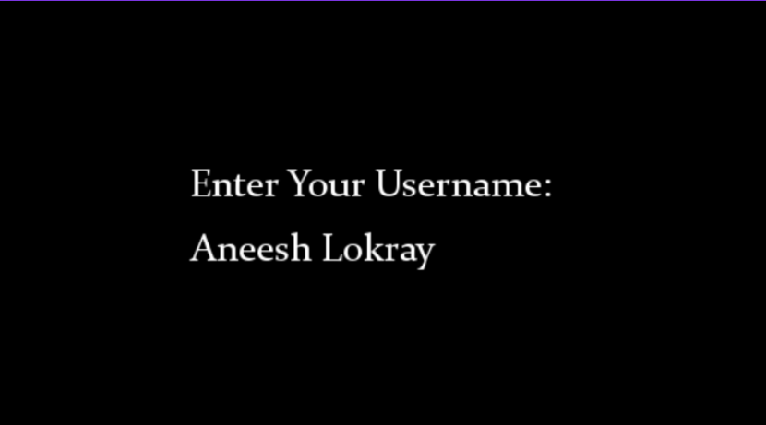 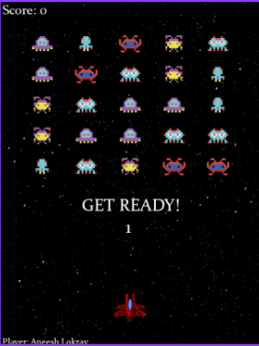

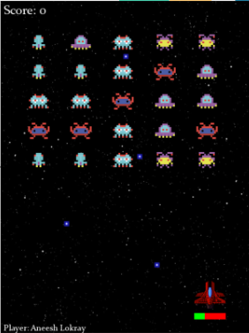 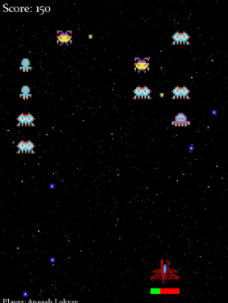

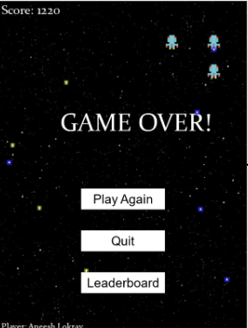 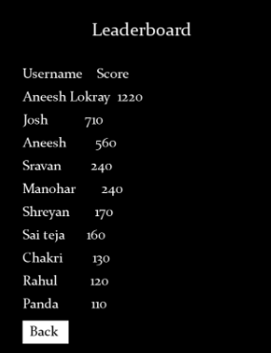

**Future Improvements:**

* Implement power-ups that provide temporary advantages to the player, such as Shield, Rapid Fire, Damage Boost
* Introduce different types of aliens with unique behaviours and abilities.
* Include challenging boss battles at the end of each level or at specific intervals.
* Allow the player to upgrade their spaceship with various enhancements, such as Increased health, Faster movement speed, Stronger weapons.

**Conclusion:**

In conclusion, Space Invaders demonstrates the significance of multimedia systems in gaming. Its pixelated graphics and iconic sound effects create a nostalgic charm, enhancing player engagement. The game's simple yet challenging gameplay, coupled with its immersive multimedia elements, exemplifies how graphics, sound, and gameplay dynamics combine to craft memorable gaming experiences. Space Invaders stands as a timeless classic, showcasing the enduring impact of multimedia on the gaming industry's evolution and its ability to captivate players across generations.