

**Cases in Finance**

**SBS – BBA – ACC**

**Dubai - Assignment – 2020**

|  |  |  |  |  |  |
| --- | --- | --- | --- | --- | --- |
| STUDENT ID |  |  |  |  |  |

UNIT TITLE / CODE: ___________________________________________________

NAME (in Full): __________________________________________________

## GENERAL INSTRUCTIONS

* All assignments are to be submitted **10th April 2020** on to [examinationboard@atmsedu.org](mailto:examinationboard@atmsedu.org) and cc to [azrafatima@atmsedu.org](mailto:azrafatima@atmsedu.org)[,](mailto:afatima@atmsedu.org) [assignmentsubmission2019@gmail.com](mailto:assignmentsubmission2019@gmail.com)
* If assignment is not submitted on date, will follow with penalty of 10% deduction of marks for every day.
* Similarity between students work is strictly not accepted, any student found with similar work will be graded Zero and fail for the course. However, Plagiarism is an academic offence and will not be tolerated under SBS
* Assignment once submitted to exam board is final for marking.
* Total 100 marks

## GUIDELINES FOR ASSIGNMENT

1. If assignment is Question & Answer based then.
   * Introduction is needed for each question.
   * Question has to be answered based on the mark allotted for each question with references if any idea or information is taken from other source.
2. If assignment is case based then,
   * Executive summary
   * Table of content
   * Body of assignment (questions related to case need to be answered)
   * Conclusion / Recommendation if any
   * References (in-text + citation) to be used

## Total Marks / 100

**PLAGIARISM**

Plagiarism is a form of **cheating**, by representing someone else's work as your own or using someone else's work (another student or author) without acknowledging it with a reference. This is a serious breach of the Academic Regulations and will be dealt with accordingly. Students found to have plagiarised can be **excluded from the program**.

Plagiarism occurs whenever you do any of the following things without acknowledging the original source:

* Copy information from any source (including the **study guide**, books, newspapers, the internet)
* Use another person's concepts or ideas
* Summarise or paraphrase another person's work.

## How do I avoid plagiarism?

To ensure you are not plagiarising, you must acknowledge with a reference whenever you:

* use another person's ideas, opinions or theory
* include any statistics, graphs or images that have been compiled or created by another person or organization
* Paraphrase another's written or spoken word.

## What are the penalties?

The penalties for plagiarism are:

* Deduction of marks,
* A mark of zero for the assignment or the unit, or
* Exclusion from the program.

Plagiarism is dealt with on a case-by-case basis and the penalties will reflect the seriousness of the breach.

## Please note: claiming that you were not aware of need to reference is no excuse.

**Part A** 5 Marks x 10 = 50 Marks

**Attempt any TEN of the following questions.**

1. Explain various problems associated with the financial statement analysis.

2. Discuss various types of capital budgeting techniques. Also identify the most appropriate technique and justify with logical reasoning.

3. List and describe the three general areas of responsibility for a financial manager.

4. The managers of a firm wish to expand the firm's operations and are trying to determine the amount of debt financing the firm should obtain versus the amount of equity financing that should be raised. The managers have asked you to explain the effects that both of these forms of financing would have on the cash flows of the firm. Write a short response to this request. 

5. Assume you are a credit manager in charge of approving commercial loans to business firms. Identify three aspects of a firm's cash flows you would review and explain the type of information you hope to gain from reviewing each of those five aspects.

6. Give some examples of ways in which manager's goals can differ from those of shareholders.

7. Describe the major differences between individual and institutional investors.

8. What issues are involved in ratio analysis? Explain the impact of those issues on financial planning.

9. Lincoln Industries' current ratio is 0.5. Considered alone, which of the following actions would increase the company's current ratio? Explain your choice.

|  |  |
| --- | --- |
| a. | Use cash to reduce long-term bonds outstanding. |
| b. | Borrow using short-term notes payable and use the cash to increase inventories. |
| c. | Use cash to reduce accruals. |
| d. | Use cash to reduce accounts payable. |
| e. | Use cash to reduce short-term notes payable. |

10. Compare and contrast various methods of capital budgeting.

11. Brodax has $20 million in current assets and $10 million in current liabilities, while Smaland's current assets are $10 million versus $20 million of current liabilities. Both firms would like to "window dress" their end-of-year financial statements, and to do so each plans to borrow $10 million on a short-term basis and to then hold the borrowed funds in their cash accounts. Which of the statements below best describes the results of these transactions? Justify your choice with logical arguments.

|  |  |
| --- | --- |
| a. | The transaction would improve both firms' financial strength as measured by their current ratios. |
| b. | The transactions would raise Broadax's financial strength as measured by its current ratio but lower Smaland's current ratio. |
| c. | The transactions would lower Brodax 's financial strength as measured by its current ratio but raise Smaland's current ratio. |
| d. | The transaction would have no effect on the firm' financial strength as measured by their current ratios. |
| e. | The transaction would lower both firm' financial strength as measured by their current ratios. |

**Part B** 10 Marks x 5 = 50 Marks

**Answer any FIVE of the following questions*.***

**Exercise 1**

A firm generated net income of $862. The depreciation expense was $47 and dividends were paid in the amount of $25. Accounts payables decreased by $13, accounts receivables increased by $28, inventory decreased by $14, and net fixed assets decreased by $8. There was no interest expense. What is the net cash flow from operating activity? Explain the usefulness of the net cash flow from operating activities in decision making.

**Exercise 2**

Following information is extracted from the books of Brox Ltd:

1. Current Accounts
   * 2017: CA = 18,900; CL = 11,300
   * 2016: CA = 14,700; CL = 11,600
2. Fixed Assets and Depreciation
   * 2017: NFA = 88,100; 2016: NFA = 85,700
   * Depreciation Expense = 1500
3. Long-term Debt and Equity (R.E. not given)
   * 2017: LTD = 17,000; Common stock & APIC = 1,400
   * 2016: LTD = 15,650; Common stock & APIC = 1,400
4. Income Statement
   * EBIT = 16,000; Taxes = 1400
   * Interest Expense = 1,240; Dividends = 1,700

Required:

1. Compute the cash flow from asset for Brox Ltd.
2. Comment on usefulness of cash flow from asset in financial decision making.

**Exercise 3**

Following financial information is related to Glow Corporation and Blue Corporation:

Glow Corporation Blue Corporation

2001 2000 2001 2000

Current ratios 1.16 .95 2.25 2.17

Working capital $11 ($2) $30 $28

A/R turnover 31.7 times 45 times 30 times 30 times

Inventory Turnover 16.6 times 22.5 times 15 times 15 times

Asset turnover 2.4 times 3.2 times 3.6 times 3.8 times

Total debt to total assets 86.9% 81.7% 14.2% 15.4%

Sh. Equity to total assets 13.1% 18.3% 85.8% 84.6%

Gross margin ratio 30% 33% 25% 25%

Return on sales 10% 11.9% 10% 10%

Return on assets 24.5% 38.5% 35.5% 38.5%

Return on equity 186.3% 210.5% 41.4$ 45.5%

Required: Conduct financial analyses of the two companies on the basis of above data and deduct which is performing better and why?

**Exercise 4**

Using the following information, answer the questions listed below:

**Dana Dairy Products Key Ratios**

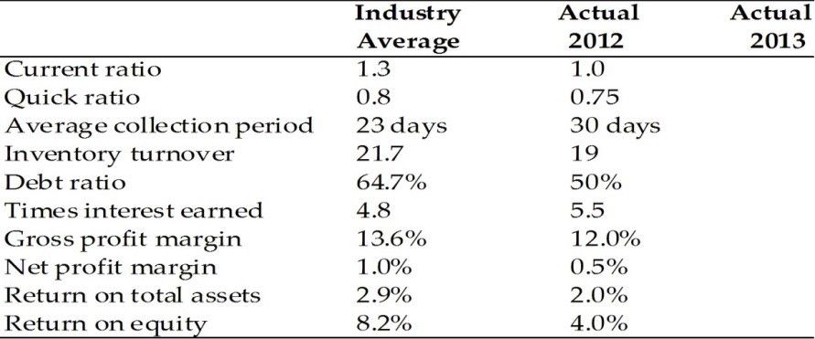

**Income Statement**

**Dana Dairy Products**

**For the Year Ended December 31, 2013**

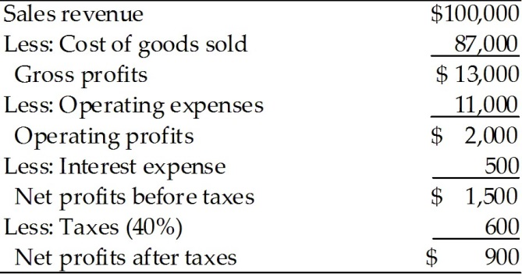

**Balance Sheet**

**Dana Dairy Products**

**December 31, 2013**

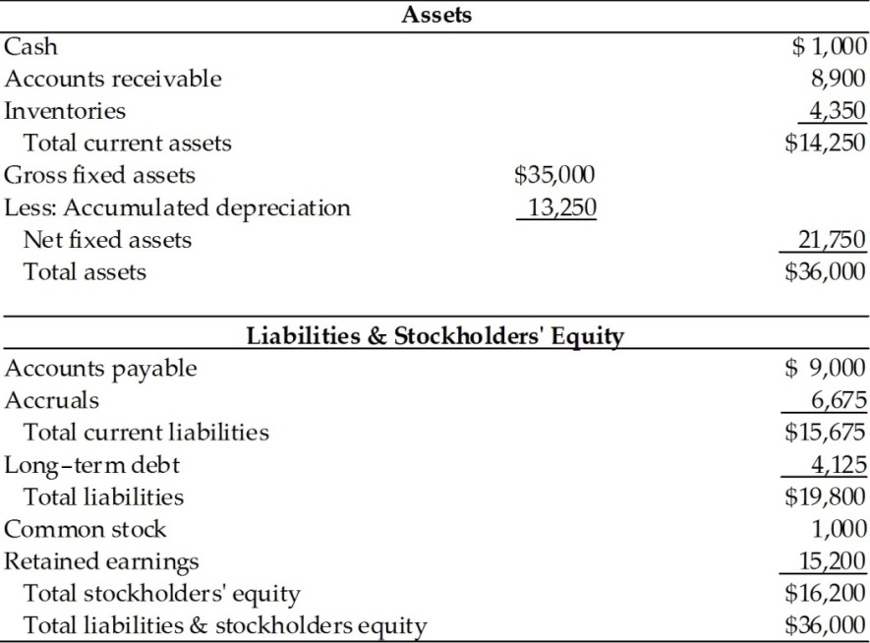

Required:

1. Calculate the following ratios for 2013:
   1. Current ratio.
   2. Net working capital
   3. Inventory turnover
   4. Average collection period
   5. Gross profit margin
   6. Net profit margin
   7. Return on assets
   8. Return on equity
2. Based on the calculations in part (i) above, comment on the performance of the company as compared to its industry and its own last year results.

**Exercise 5**

a. A stock is expected to pay a year-end dividend of $2.00, i.e., D1 = $2.00. The dividend is expected to decline at a rate of 5% a year forever (g = -5%). If the company is in equilibrium and its expected and required rate of return is 15%, what is the price of stock? Show all calculations.

b. Alcott's preferred stock pays a dividend of $1.00 per quarter. If the price of the stock is $45.00, what is its nominal (not effective) annual rate of return? Show all calculations.

c. How common stocks differ from preferred stocks? In case of liquidation, which one has the preferential rights and why? Discuss.

**Exercise 6**

Hutchinson Corporation has zero debt-it is financed only with common equity. Its total assets are $410,000. The new CFO wants to employ enough debt to bring the debt/assets ratio to 40%, using the proceeds from the borrowing to buy back common stock at its book value. How much must the firm borrow to achieve the target debt ratio? Show all calculations.

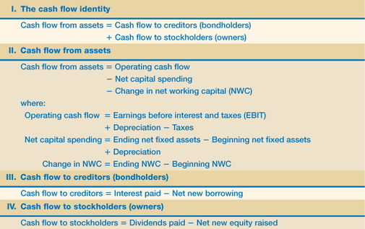**List of Formulae**

For Cash Flow From Assets:

For Ratios:

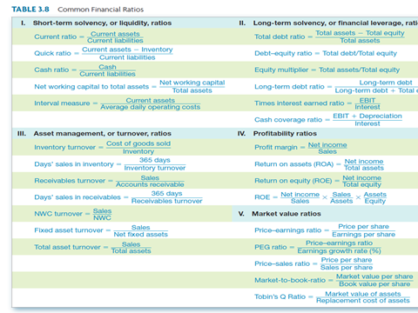

**VALUATION OF PREFERRED STOCK**

* The value is simply the stated annual dividend divided by the required rate of return on preferred stock (Kp)

**V= Dividend**

**Kp**

**THE DIVIDEND DISCOUNT MODEL (DDM)**

* For Constant Growth Model the formula is:

**Vj = D1**

**K - g**

* Assumptions of DDM:
* Dividend grow at a constant rate.
* The constant growth rate will continue for an infinite period .
* The required rate of return (k) is greater that the infinite growth rate (g)
* Debt to Asset Ratio:

**Debt to Asset Ratio = Total Debts**

**Total Assets**