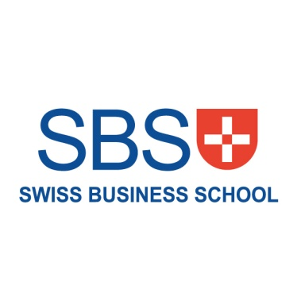

**Human Resource Management**

**SBS MBA**

|  |  |  |  |  |  |  |  |  |
| --- | --- | --- | --- | --- | --- | --- | --- | --- |
| STUDENT ID |  |  |  |  |  |  |  |  |

|  |  |  |  |
| --- | --- | --- | --- |
| UNIT TITLE |  | UNIT CODE |  |

|  |
| --- |
| Name (in Full) __________________________________________________________ |

**Total Marks: _______ / 40**

**CASE STUDY: MANAGING PEOPLE FOR ORGANIZATIONAL EFFECTIVES**

You are an engineering graduate with an MBA and 10 years of management experience, and have just been appointed as CEO of a manufacturing company. The company has existed since the 1950s, but tariff reductions since the 1970s have placed it under increasing pressure. In recent years the company has been on the brink of closing down and your task is to turn it back into a viable enterprise. You were reluctant to take on the obviously difficult job and had a number of other options, but the board convinced you by offering a very attractive salary package and undertaking to support your decision fully, provided that you delivered results within a year.

The senior management team consists of five people, all of whom were appointed by the previous CEO when he took up his job seven years ago. The former CEO’s background was in accounting and his approach to dealing with the company’s difficulties could best be described as ‘cost minimization’ – he sought to rescue falling profits by reducing costs wherever possible. He was, moreover, what he described as an ‘old fashioned manager’ which in practice meant being a strict disciplinarian and asserting his right to make decisions without consulting staff. The approach to encouraging staff performance has been the threat of dismissal. The senior management team were in agreement with him on this strategy and this remains their preferred option.

As a result of this approach, the company’s plant and machinery has not been upgraded for some years. The production process is an assembly line and workers are rarely rotated among different jobs. Further, most staff are employed on individual contracts and paid poorly by industry standards. The only assessment of performance is based on production output (which is low by industry standards), and no staff are formally appraised. In spite of a lack of manufacturing jobs in the area, voluntary turnover – employees resigning – is high and this is compounded by the fact that staff are routinely dismissed for minor errors or breaches of procedure. This is justified by the other managers on the basis that ‘there are plenty more where he came from!’ due to high unemployment in the area. The company has already faced a number of formal complaints about unfair dismissal, some of which have ended up in court.

**Answer the following questions.**

1. In your role as CEO, outline how you would change the people management practices in the company.
2. How would your proposed changes improve organizational performance?
3. What do you see as the major barriers to change and how would you overcome them?