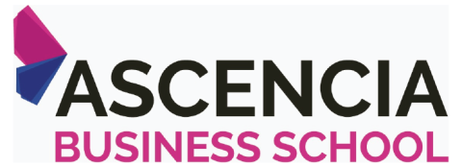



**Financial Management**

# ABS – MBA

**Assignment – Al Ain 2019**

STUDENT ID

|  |  |  |  |
| --- | --- | --- | --- |
|  |  |  |  |

UNIT TITLE / CODE:

NAME (in Full):

## GENERAL INSTRUCTIONS

* All assignments are to be submitted on **12th December**, **2019** on to [examinationboard@atmsedu.org](mailto:examinationboard@atmsedu.org) and cc to [afatima@atmsedu.org](mailto:afatima@atmsedu.org).
* Hardcopy submissions on **13th December 2019.**
* Any Assignment submission extension request must come to Dr. Azra Fatima ([afatima@atmsedu.org](mailto:afatima@atmsedu.org)) 5 days before the date of submission with a valid reason and supported documentary evidence.
* If assignment is not submitted on date, will follow with penalty of 10% deduction of marks for every day.
* Similarity between students work is strictly not accepted, any student found with similar work will be graded Zero and fail for the course. However, Plagiarism is an academic offence and will not be tolerated under SBS
* Assignment once submitted to exam board is final for marking.
* Total mark will be converted to 90 & class participation of 10 marks. Total 100 marks

## GUIDELINES FOR ASSIGNMENT

1. If assignment is Question & Answer based then.
   * Introduction is needed for each question.
   * Question has to be answered based on the mark allotted for each question with references if any idea or information is taken from other source.
2. If assignment is case based then,
   * Executive summary
   * Table of content
   * Body of assignment (questions related to case need to be answered)
   * Conclusion / Recommendation if any
   * References (in-text + citation) to be used.

## Total Marks 90

**PLAGIARISM**

Plagiarism is a form of **cheating**, by representing someone else's work as your own or using someone else's work (another student or author) without acknowledging it with a reference. This is a serious breach of the Academic Regulations and will be dealt with accordingly. Students found to have plagiarized can be **excluded from the program**.

Plagiarism occurs whenever you do any of the following things without acknowledging the original source:

* Copy information from any source (including the **study guide**, books, newspapers, the internet)
* Use another person's concepts or ideas
* Summarise or paraphrase another person's work.

## How do I avoid plagiarism?

To ensure you are not plagiarising, you must acknowledge with a reference whenever you:

* use another person's ideas, opinions or theory
* include any statistics, graphs or images that have been compiled or created by another person or organization
* Paraphrase another's written or spoken word.

## What are the penalties?

The penalties for plagiarism are:

 Deduction of marks,

 A mark of zero for the assignment or the unit, or  Exclusion from the program.

Plagiarism is dealt with on a case-by-case basis and the penalties will reflect the seriousness of the breach.

## Please note: claiming that you were not aware of need to reference is no excuse.



**Part A**

### *Answer any NINE (9) out of TEN (10) questions.*

1. Which of the following statements is CORRECT? Rationalize your choice.

|  |  |
| --- | --- |
| a. | It is usually easier to transfer ownership in a corporation than it is to transfer  ownership in a sole proprietorship. |
| b. | Corporate shareholders are exposed to unlimited liability. |
| c. | Corporations generally face fewer regulations than sole proprietorships. |
| d. | Corporate shareholders are exposed to unlimited liability, and this factor may be  compounded by the tax disadvantages of incorporation. |
| e. | Shareholders in a regular corporation (not an S corporation) pay higher taxes than  owners of an otherwise identical proprietorship. |

1. Comment on various methods of capital budgeting. Which method do you think is the most appropriate and why? Justify your arguments with logical reasoning.
2. Blue Red Company decided to issue $700 million of new common stock and use the proceeds to pay off some of its outstanding bonds. Assume that the company, which does not pay any dividends, takes this action, and that total assets, operating income, and its tax rate all remain constant. What affect it can have on the company’s financial statements. Discuss.
3. What is the difference between liquid and illiquid investment. Explain with the help of an example.
4. Why scholars still believe fundamental analysis as a major source decision making for the investors? Discuss.
5. Following four options are available to you. Each option cost $35,000. Each option is going to provide you the revenue for next 3 years.

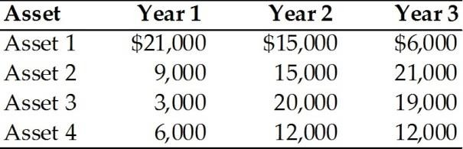

Which of the above option a financial manager would choose? Justify your answer with logical arguments.

1. What are the drawbacks of ratio analysis technique of financial statement analysis? Explain them.
2. Contrast between organizational investors and individual investors.
3. What do we call the price that a borrower must pay for debt capital? What is the price of equity capital? What are the four most fundamental factors that affect the cost of money, or the general level of interest rates, in the economy?
4. The managers of a firm wish to expand the firm's operations and are trying to determine the amount of debt financing the firm should obtain versus the amount of equity financing that should be raised. The managers have asked you to explain the effects that both of these forms of financing would have on the cash flows of the firm. Write a short response to this request.

# Part B

### *Answer any SIX (6) out of SEVEN (7) questions.*

**Exercise 1**

Discuss preferred and common stock. When does a company apply these stock options? Why equity is considered by some researchers better than equity. Justify with logical arguments.

**Exercise 2**

Glomby Company is financed only with common equity. Its total assets are $780,000. The new CFO wants to employ enough debt to bring the debt/assets ratio to 40%, using the proceeds from the borrowing to buy back common stock at its book value. How much must the firm borrow to achieve the target debt ratio? Show all calculations.

## Exercise 3

JBS Inc. recently reported net income of $4,750 and depreciation of $885. How much was its net cash flow, assuming it had no amortization expense and sold none of its fixed assets?

How does net cash flow affect managerial decision making?

## Exercise 4

Rao Corporation has the following balance sheet.

|  |  |  |  |
| --- | --- | --- | --- |
| Cash | $ 10 | Accounts payable | $ 20 |
| Short-term investments |  | Accruals | 20 |
| Accounts receivable | 50 | Notes payable | 50 |
| Inventory | 40 | Current liabilities | $ 90 |
| Current assets | $130 | Long-term debt | 0 |
| Net fixed assets | 100 | Common equity | 30 |
|  |  | Retained earnings | 50 |
| Total assets | $230 | Total liab. & equity | $230 |

## Required:

* 1. How much net operating working capital does the firm have?
  2. How does net working capital affect the decision making?

## Exercise 5

Following information is extracted from the books of Giant Corporation:

1. Current Accounts
   * 2019: CA = 22,900; CL = 15,300
   * 2018: CA = 17,600; CL = 12,400
2. Fixed Assets and Depreciation
   * 2019: NFA = 98,100; 2018: NFA = 75,700
   * Depreciation Expense = 2700
3. Long-term Debt and Equity (R.E. not given)
   * 2019: LTD = 47,000; Common stock & APIC = 1,400
   * 2018: LTD = 35,850; Common stock & APIC = 1,400
4. Income Statement
   * EBIT = 22,000; Taxes = 1400
   * Interest Expense = 2,840; Dividends = 2,700

Required:

1. Compute the cash flow from asset for Giant Corporation.
2. Comment on usefulness of cash flow from asset in financial decision making.

## Exercise 6

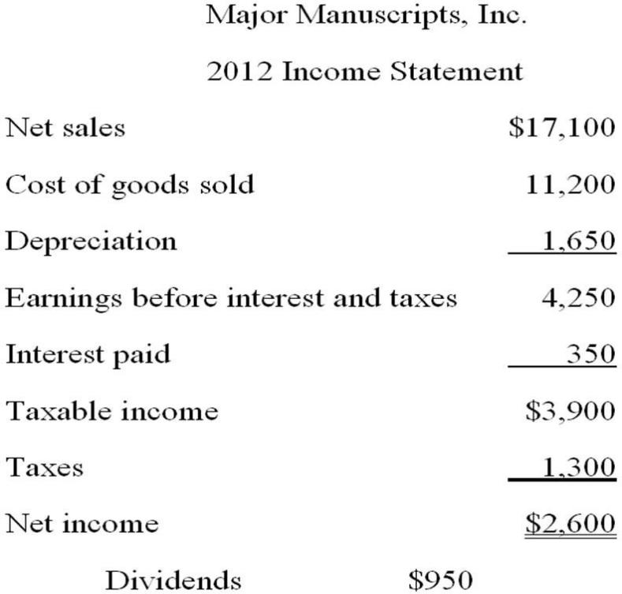

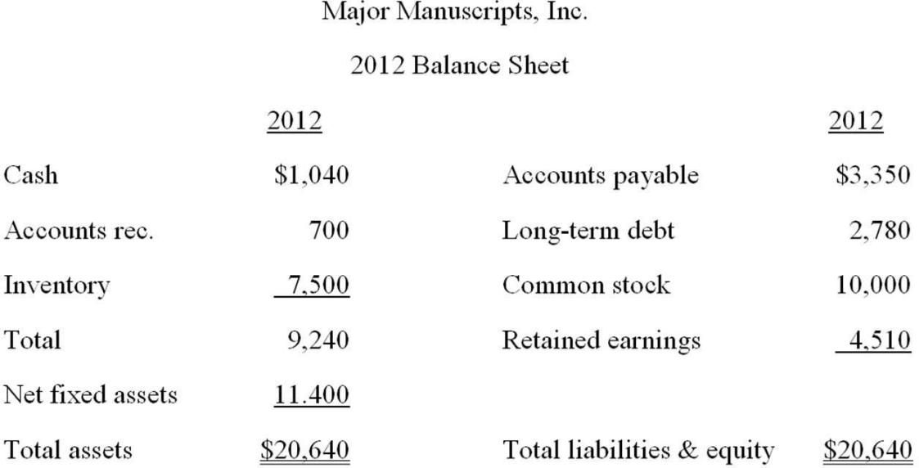

Required:

* 1. If Major Manuscripts, Inc. decides to maintain a constant debt-equity ratio, what rate of growth can it maintain assuming that no additional external equity financing is available?
  2. How sustainable growth contributes towards the growth of a corporation? Discuss.

## Exercise 7

1. Blendy Company provides the following balance sheet and income statement for the year of 2017.

BLENDY COMPANY BALANCE SHEET

AS OF 31 DECEMBER, 2017

|  |  |
| --- | --- |
| ASSETS | “$” |
| Current Assets: |  |
| Cash in hand | 100,000 |
| Inventory | 90,000 |
| Debtors | 145,000 |
| Total current assets | 3,35,000 |
| Non-Current Assets: |  |
| Building | 1,290,000 |
| Plant & Machinery | 770,000 |
| Vehicles | 470,000 |
| Total non-current assets | 2,530,000 |
| Total Assets | 2,865,000 |
| LIABILITIES |  |
| Current Liabilities: |  |
| Creditors | 410,000 |
| Tax Payables | 20,000 |
| Salary Payables | 92,000 |
| Total Current liabilities | 5,22,000 |
| Non-Current Liabilities: |  |
| Long term loan | 10,00,000 |
| Total Liabilities | 15,22,000 |
| OWNER’S EQUITY: |  |
| Paid up capital | 740,000 |
| Retained Earning | 543,000 |
| Share premium | 60,000 |
| Total | 1,343,000 |
| Total Liabilities & Equity | 2,865,000 |

BLENDY COMPANY INCOME STATEMENT

FOR THE YEAR ENDED 31 DECEMBER, 2017

|  |  |
| --- | --- |
| Net Sales | $ 900,000 |
| Cost of goods sold | (550,000) |
| Gross profit | 350,000 |
| Operating Expenses | (90,000) |
| Earnings before interest and tax (EBIT) | 260,000 |
| Interest expense | (60,000) |
| Earning before tax | 200,000 |
| Tax (35%) | (70,000) |
| Earning after tax | 130,000 |

Required:

1. Calculate the following ratios:
   1. Average payment period.
   2. Average collection period.
   3. Inventory turnover ratio.
   4. Fixed assets turnover.
   5. Total assets turnover ratio.
   6. Quick ratio.
   7. Return on Equity
   8. Interest coverage ratio Note: Assume 360 days in a year.
2. Assuming that the industrial average for collection and payment period is 110 and 150 days respectively and fixed asset turnover is 40%, evaluate the performance of the BLENDY COMPANY based on your answer in part (a) above.