**_______________________________­­­­­­__________**

**Marketing Management**

**MBA/MSc**

**Assignment – Bahrain 2020**

|  |  |  |  |  |  |
| --- | --- | --- | --- | --- | --- |
| STUDENT ID | 190 | 4 | 0 | 5 | 0 |

**SBSBAHMSC1904050**

UNIT TITLE / CODE: **Marketing Management**

NAME (in Full): **Saleh Ali Allowaimi (MKT 501)**

**Marks / 100 Total**

**Executive Summary**

Almarjan Chemical Painting Company is a painting and decoration in Dammam , eastern province of Saudi Arabia and has two othe branches in Riyadh and Mdinah.

In this study we will review the marketing strategy of this company include: the competition overview, target market, Segmentation, SWOT analysis and the $p’s assessment of Market research and BCG matrix. Finally will put my conclusion and recommendation.

**Table of content**

|  |  |
| --- | --- |
| * Executive Summary | 2 |
| * Table of contents | 3 |
| * Questions of the assignment | 4 |
| * Brand Overview and Background | 5 |
| * Marketing strategy | 5 |
| * Competition Overview | 6 |
| * Target Market | 6 |
| * Segmentation | 6 |
| * SWOT Analysis | 7 |
| * Market Research (4Ps) | 8 |
| * BCG Matrix | 9 |
| * Conclusion and recommendation | 11 |
| * References | 12 |

**Marketing Management Assignment Structure – Marketing Strategy (Brand)**

For your brand of choice please prepare a marketing strategy on the below guidelines. This should clearly reflect the marketing mix – product, place, price, promotion and packaging as discussed in the class. The learnings on Brand Equity in the class should be the emphasis of the assignment.

Please note the brand should have linkage in the UAE – must be an existing brand or a brand that intends to be introduced in the UAE.

1. Executive Summary – summarizing points 2-8.
2. Brand Overview – describe the current status of the brand with a brief historical background. Also define the brand’s current state on the Product Life Cycle.
3. Competition Overview – Define competition
4. Target Market – Define who is being targeted
5. Segmentation – Demographic, Behavior, Psychographic
6. SWOT – on brand or industry
7. Market Research if any carried out – if no research carried out then suggest a need if any
   1. Product – BCG matrix. Also include packaging plans if any.
   2. Place – Choice of retail strategy
   3. Price – penetrative or skimming or competitive
   4. Promotion – pull or push strategy including choice of medium – digital or traditional
8. Conclusions and Recommendations – suggestions for change in current practices if any to make it more effective should be discussed.
9. Appendix – Any other information you may provide.

**Marketing Management of Almarjan Chemical painting Company**

**Brand Review and Background:**

Almarjan Chemical Painting Company is a painting and decoration company launched in 2014 by A Saudi businessman named Mohammed Aldijani in Dammam , eastern province of Saudi Arabia.

In 6 years , the brand as innovative company in the field of painting and home decoration has built a positive reputation. Especially in Epoxy resin decoration coating and painting, and customer preference in time wall and ceil 3D decoration

The company started as a paint and decoration company as a reseller of the most famous painting materials and also working for the painting and decoration customers demand, the owner was not satisfy to be a member of this large market without competitive values and strategy; On 2016 he focused on epoxy resin chemicals use in decoration and painting of the floors of houses , shops , hotel, large workshops and store. The epoxy resin has advantages on the other used material include sustainability, flexibility in designs and innovation to satisfy the customer needs. They were the only supplier of this service at that time and they grow rapidly. Today they have branches in three big cities and serve more than 15 cities in Saudi Arabia and Bahrain.

The Mission of Almarjan Company emphasize on to change the world of painting and coating decoration practice in Saudi Arabia and Gulf Area. And to challenge the satisfaction of the market customers and attract them using the most innovative chemical painting materials.

**Marketing Strategy:**

It is important to give through though to the companies penetration strategy before launching the new Chemical painting and decorative materials . These are few things customer sees & needs to be appealing:

a. Ongoing training for employees to use the new products and apply the new designs.

b. Free product samples for first hand experience before leaving it to the market

c. Internet engagement, Employees must have access to internet as in outlet for them to swap ideas & market the products.

**Competition overview:**

Almarjan Company Chemical Painting Company has strong competition in the market of painting material or applications and also has competitors of the decoration markets, some of their competitors are Jotun , Aljazera and Hempel painting company. Also there many decoration company like Abayat mega store. The focus on the Epoxy Resin help the company to be one of the main player for specific group of customers. Especially the mega stores and hotel and shops market, where the look for either the sustainability and strength of the work or the innovative easy apply work which is the competitive values of Almarjan company.

**Target market:**

Almarjan company is a chemical painting and decoration line and their main target was initially middle-income and females new home owner. Then they targeted the large business market like Hotels and mega-company stores. Also they targeted the small shops like coffee shops.

On Instagram, and YouTube they posted videos of their new works and worked with the influencer on Snapchat to introduce their new collections**.**

**Segmentation:**

**Demographic:**

 The demographic segmentation of Alamjan company is mainly targeted the Hotels, Large store Businesses, small shops businesses and middle-level income female new house owners’ populations. The hotel and mega store target percentage is approximately 40 %, and the small-middle shop-based businesses is 30% and new home target is 20%. The main targeted cities are Dammam, Riyadh and Madinah where the company has branches.

**Behavior**:

Almarjan company divides the total market into smaller homogeneous groups based on consumer purchasing behavior such as home-business building, small-big businesses, middle-level income groups, and high-level income groups. It carried out its behavioral segmentation based on purchasing habits from consumers such as frequency of use, brand loyalty, benefits required at any occasion, and so on. Moreover, the most welcomed products are the Floor Epoxy works and wall decoration marble-like products according to its sales volume and net income in all markets.

**Psychographic:**

Psychographic segmentation distinguishes the business according to characteristics, beliefs, behaviors, desires, and type of the business the consumer work on. The company launched its variant product such as Floor epoxy-resin, Extra clear epoxy resin, resin colors and designs, wall marble like decoration and ceiling 3D decoration according to the demand by its customers.

**SWOT:**

SWOT analysis is an effective tool used to analyze the potion of the business at the current being and future to show the Strengths, Weaknesses, Threats and Opportunities. It help the business to focus more and put the business on the correct track.

**Strengths:**

1.The market is huge in Riyadh and Dammam and Accepted in Madinah

2. Material and services sold by Almarjan Company, Epoxy Resin with different quality and clarity , marble-like décor wall , 3d ceil and Floor designs.

3-Professional training supplied by the high professional staff work in the company

3.High-value resistant materials used in highly demand mega store .

4. Has customer choice designs not duplicated else where.

5. Effective branding and marketing activities make it a strong player (Marketing itself through distinct social media platforms)

**Weaknesses:**

1. The price of material and work sometimes expensive for the middle-level income and small businesses.

2. Not sold in every region like small or middle cities.

3- The material not available locally, and the external supplier increase the price in the last three years.

4-The work-related lost material is 20% which is costly

**Opportunities**:

1. Opportunities to collaborate Festival activities Company

2. Opportunity to reach emerging economies by adapting to their culture.

3. Opportunity to expand the market demands by training more painters and decoration labors for their own business

**Threats:**

1. There are a lot of competitors in the painting markets and there's a lot of overlap.

2. Maintaining low prices is a major concern due to higher raw material costs due to high inflation.

3. Customers in the decoration markets are very selective so trust in the brand needs to be sustained.

**Market Research:**

In my opinion, there is no need to conduct any market research.

**Product**:

Almarjan company work in different variant product such as Floor epoxy-resin, Extra clear epoxy resin, resin colors and designs, wall marble like decoration and ceiling 3D decoration materials in addition to professional training on the different application of their products and works.

The packaging of Almarjan’s products attracts and catches one's attention because of its colors, strength, designs and flexibility and short time work . The packaging even has an image of western painter applying the material in showroom. This illustration is intended to demonstrate to the viewer how easy and professional it is to mix the material and apply it.

**The BCG Matrix**

**What is the BCG Matrix?**

The Boston Consulting group’s product portfolio matrix (BCG matrix) is designed to help with long-term strategic planning, to help a business consider growth opportunities by reviewing its portfolio of products to decide where to invest, to discontinue or develop products. It's also known as the [Growth/Share Matrix](http://www.smartinsights.com/digital-marketing-strategy/online-business-revenue-models/essential-marketing-strategy-models-growthshare-matrix/).

The Matrix is divided into 4 quadrants based on an analysis of market growth and relative market share, as shown in the diagram below.

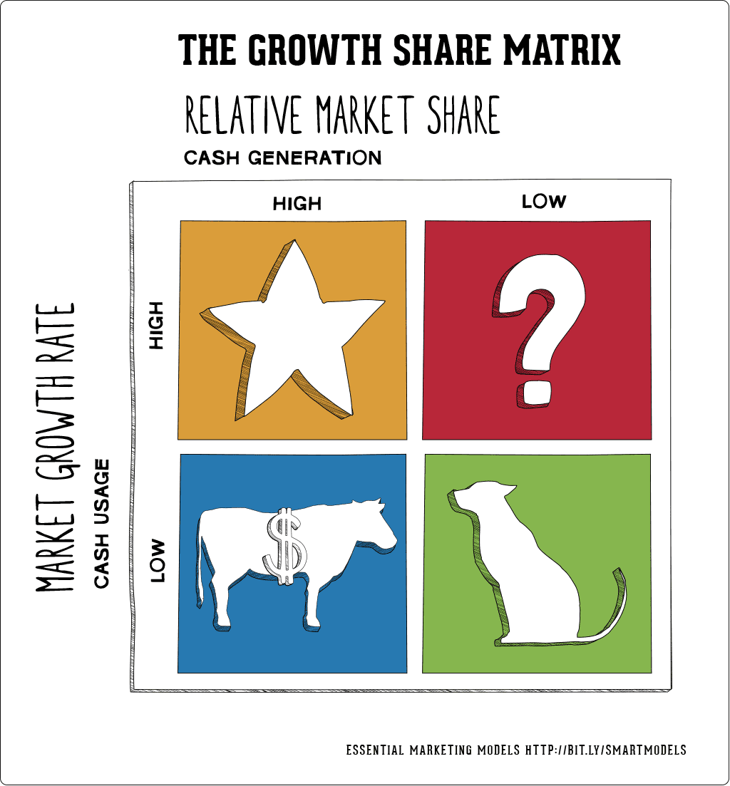

* **1. Dogs:** These are products with low growth or market share. In our business it is extra-clear epoxy resin works . It is more expensive and doesn’t have high demand. So, better to target the artist for this products. And make a small package if it.
* **2. Question marks or Problem Child:** Products in high growth markets with low market share. In our business it includes 3D ceil work, there are high demand by Hotels and new Shops but the company doesn’t concentrate in these works. These Service and product need to be on focus during the marketing especially for the small shops and showroom businesses
* **3. Stars:** Products in high growth markets with high market share. like the low-cost epoxy resin work for mega store and Hotel Floors. The target here is so clear and the company has already established good relationship with 30% of the Hotel in Dammam and 5% of Hotels in Riyadh, but need to expand the targeted Hotels in Madinah where there are more than 50 5-star Hotels with 150 hundreds of 2-3-stars Hotels
* **4. Cash cows:** Products in low growth markets with high market share, like the marble-like work where it has reasonably good price with excellent decoration work, but still the market not familiarize with it, and our company is the only company do this work in eastern province and Madinah and no high competition in Riyadh we expect good expansion of this work in the next few years.

**Place**:

Place is also a vital factor in marketing strategy growth. Almarjan moved to a bigger showroom located on the business street on Dammam and in Madinah moved to a new showroom in the haram area where most of hotels located. The showroom has large show area where different materials and decors seen easily and also (Do it your self-area) where the customers can try different designs digitally and can try epoxy resin design onsite. In addition to the almarjan Instagram account, the company has another Instagram account: Almarjan Store. On one of their Instagram pages, people can shop for the products and get them easily shipped to their respective locations.

**Price**:

Compared with similar other painting and decoration companies, the price of Almarjan products have been generally seen as fair. Though the price of Almarjan epoxy products is relatively high among other painting products. The company follows the competitive pricing strategy to distribute its product in the market and to gain a competitive advantage. The marble-liked wall decoration is also considered good price product

**Promotion**:

The company follows the pull marketing strategy which implies that implemented marketing strategy will automatically draw consumers towards its product. The company follows both digital and traditional marketing strategies to promote their product. The company promoted its product by media influencer marketing such as the Snapchat local Stars for the product launch. Moreover, they use digital platforms such as Instagram, YouTube, Facebook, and YouTube to promote their products.

**Conclusion and Recommendation:**

**﻿**In conclusion, the marketing tactics implemented by Almarjan Company have been successful. By using social media to build visibility and brand loyalty, the company has been able to expand its consumer base. They have thus been popular in Saudi Arabia. The company should promote its product to a place like Jeddah and The Other Arabian Gulf countries especially Dubai and Doha.

**References:**

[Annmarie Hanlon](https://www.smartinsights.com/author/annmarie-hanlon).2019. ***How to use the BCG Matrix model.*** Smart Insights (<https://www.smartinsights.com/marketing-planning/marketing-models/use-bcg-matrix/>)

Philip Kotler, Kevin Lane Keller.2012***.Marketing management***, 14th ed.Pearson Education, Inc.,USA

***Marjanepoxy (***<https://www.instagram.com/marjanepoxy/>)

Yumpu.2014 *Epoxy Resins Market* . (<https://www.yumpu.com/en/document/read/53449484/epoxy-resins-market-pdf>)