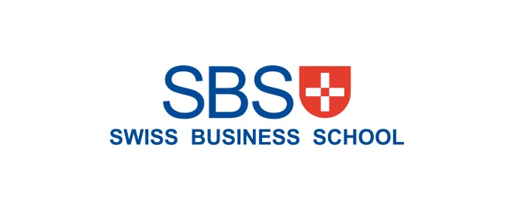

**Marketing Management**

**MBA/MSc**

**Assignment – Bahrain 2020**

|  |  |  |  |  |  |
| --- | --- | --- | --- | --- | --- |
| STUDENT ID | 1 | 1 | 2 | 4 | 0 |

UNIT TITLE / CODE: MKT501

NAME (in Full): Khaled Mohammed ElBadry Hamza

1-Executive Summary: 

**AL SHIFA: Source of Trust**

Al Shifa is a leading Saudi Brand of Natural Honey that is belonging to Sunbulahgroup, which operates in more than 35 countries with an ambitious plan to expand its geographic reach to 50 countries by 2023.

Al Shifa has a cost leadership strategy focusing on increasing the profit by reducing operational cost, investing in embracing new manufacturing technology, and efficient logistics to be able to be charging relatively 20% affordability more than the leading competitor, which is Langanese ( German nature honey brand).

Al-Shifa has reached the maturity level with high share and low growth, and 80% of the brand portfolio considered as a cash cow; consequently, the investment in the Research and Development, consumer researches, and mega marketing activities is much lower than earlier.

Al Shifa is the market leader with a well-established value proposition of the source of trust, with a Unique selling point (USP) as a constant value for money nature honey brand.

In light of the chairman's vision for the Alshifa honey brand to become a leading global player, and based on the Brand SWOT analysis, it would take the following strategic approaches.

* Short term- quick tactical wins- one year:

Increase the amount of the product used by existing customers (this is why food producers issue recipe cards that use their ingredients).

* Add or updating product features.
* Price promotions to attract customers who use a rival brand.
* Advertising to encourage trial of the product people who do not use this category of product at all.
* Strategic approaches for 3-5 years:
* Leading the innovation in Honey and embrace the new health and wellness trend.
* Expand the Brand portfolio to embrace the associated honey-based products.
* Invest in penetrating youth and kids' white areas.
* Develop the brand equity in the prospective new export markets.
* Expand the brand presence globally through joint-venture or acquisitions.
* Table of content:
  1. Brand Overview.
  2. Competition Overview.
  3. Target Market.
  4. Segmentation.
  5. SWOT
  6. Brand 4 Ps.

7.1-Product BCG Matrix.

7.2-Place -Choice of retail choice.

7.3-Price.

7.4-Promotion and choice of medium.

* 1. Conclusion and Recommendations.
  2. References.
  3. Appendix

2-Brand Overview:

Al Shifa is a Saudi brand that is synonymous with 100% natural honey. Al Shifa honey is belonging to Sunbulahgroup, which operates in more than 35 countries with an ambitious plan to expand its geographic reach to 50 countries by 2023.

Al Shifa honey is the proud recipient of the quality mark by the Saudi Arabian Standards Organization (SASO), it is producing in Jeddah, Saudi Arabia, and over 30 years it is being Sourced from the best locations around the world to ensure quality and taste for its customers.

Al Shifa has reached the maturity stage, it needs to reap considerable rewards for the time and money spent developing the Al Shifa products so far, The product’s features may continue to be refreshed from time to time, and there will be some promotion to differentiate the product from the competition and increase the market share. However, the marketing activities and expenditure levels are much lower than earlier on in the life cycle.

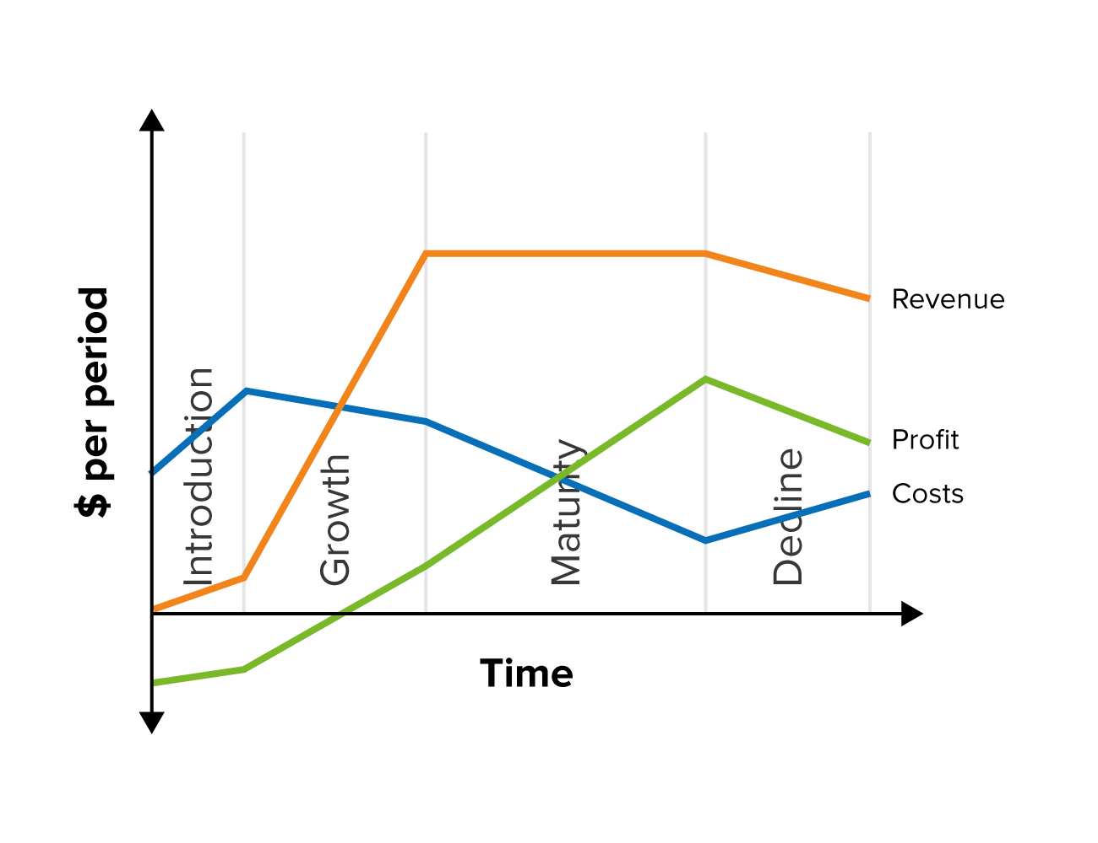

Al Shifa

3-Competition Overview

Al-Shifa is the market leader in KSA in the retail channel, following by Langnese which is a German brand that competing for the neck to neck with Alshifa, while Rawdat Al-Nahil and Sari alternately come in the third and fourth position, Sari is belonging to Sunbulahgroup and considers as a fighter brand.

Langanese is the main competitor of Alshifa, which perceived as high-quality German brand; however, it is no longer a competitive advantage versus Alshifa that has a heritage as a reputable Saudi brand with an emotional linkage to the consumer in Saudi as the name extracted from the Quran, and it is the brand of choice for the Muslim Pilgrims.

Those four brands are presenting up to 75% of the branded Honey with around 8000 TON and 350 MM Saudi Riyal; it worth mentioning that the unbranded street Honey market presents approximately 17-18% in volume and 42-43% in value in Saudi Arabia.

On the other hand, Al Shifa is the market leader in the catering channel, which presents around 17% of the total branded honey market with particular packaging configuration, mainly 30 gm Jar and squeezable bottle, while Hero and Nectaflor brands mutually come after in the second and third positions.

4-Target Market:

Al Shifa is targeting men, fathers as they are the decision-maker of the honey purchasing, following by women, mothers as an entry gate to kids; meanwhile, it worth highlighting that consumption index among kids is under index in Honey comparing to adults.

The targeted age is between 20-40 years old as the acceptance of change and gives a trail to a new brand is restively high.

Geographically, Al Shifa is targeting the countries with the significant Muslim population getting the benefits of the brand emotional attachment to Muslim believers due to brand equity, which mainly coming from the brand name and country of origin.

5-Segmentation:

In KSA, Al Shifa is targeting Men, Fathers with the age of 25- 40 years old, followed by the women, housewives with the age of 20-40 years old.

Geographically, in addition to the GCC countries, Al Shifa is targeting Indonesia in Asia, Egypt, and Algeria is Africa, Spain, Europe, plus a decent presence in Canada and the USA.

6-Alshifa SWOT analysis:

7.Al-Shifa 4 Ps:

7.1 Product- BCG matrix.

Within the brand, Nature Honey -Poly flora which is 80% of the total portfolio considered as a cash cow with high market share and low market growth; however, the newly established segment like Black forest and Acacia honey are considered as a question mark with low market share and high market growth, while the new flavored Honey like Honey with ginger, Manuka and Royal Jelly considered as stars with high market share and high market growth.

7.2 Place

In B2C, Al Shifa is allocating most of the support in the Modern trade whereas, it maintains stronghold of the shelf presence within the home category, as it has its area; meanwhile, it has some trial to expand into a new retail environment like pharmacy and Duty-free.

In B2B Al Shifa targeting high tier customers, mainly five stars hotels and niche restaurant with customized packagings such as 30 gm jar and squeezable bottles.

7.3 Price

In the retail channel, Alshifa has a penetrative pricing strategy with 20% affordability more than the leading competitor Langnese, while it has a skimming price strategy versus the other brands.

7.4- Promotion and the choice of medium:

Mainly Pull promotion, the category, in general, is Pull promotion, at which the shopper does not dare to buy production unless it needed or out of stock at home- constant demand per user, steady consumption., the rationale behind that is to stop the consumer from trying different brands.

Choice of medium is a mix of both digital and traditional; however, the investment in the digital medium is much more to the tradition support like sampling or instore activities, the digital mainly focusing on the social media channels like Facebook, Tweeter and Instagram using the relevant food influencers from in the Gulf region with low investment in a TV campaign.

The reason behind that is the mega effect of social media channels due to its propagation, impact, and cost efficiency comparing to the other digital medium.

8-Conclusion:

Al Shifa has all the enablers to achieve its long-term vision as a global brand in nature honey; however, the brand needs to decide its strategic approaches to reach its final destination, I would recommend the brand owner with the following.

* Strengthens brand equity by focusing more on brand resonance, the active engagement (brand loyalty) with the consumers even if they do not purchase the brand.
* Speed up the new product innovation, re-innovate the current product features.
* Invest in the consumer researches to understand in depth the consumer's new habits, Usage, and attitude trends and consequently decide the ultimate communication channel and approach.
* Expand the in-store trade marketing activities during Hajj and Umrah season to increase the new consumer trails through the annual pilgrims as a new brand ambassador to their country.
* Accelerate the georgical expansion through a Joint-venture or acquisition of manufacturing facilities or an emerging brand.

10-References:

* Sunbulahgroup,2019,Sunbulahgroup.com/Alshifa.html, available at <http://www.sunbulahgroup.com/honey-jam.html>,accessed on May 1st 2020, 10:30 pm.
* Arabnews, Arabnews.com/532311,available at <https://www.arabnews.com/news/532311>.

Accessed on May 2nd 2020, at 8 pm.

* Langnese,2018,Langnese-honey.co, available at <https://langnese-honey.com/about-us/>.

Accessed on May 2nd,2020,8:30pm.

* Course material: Dr. Rado Cocean,2019, course of Strategy and business planning profession certificate: the KPIs institute, Romania, UAE office.
* Interview: Abuziad Albaraa,2020, interview of formal Al Shifa brand Manager, phone interview, May 5th 2020 , 1 am, interviewee mail: [Bara2@windowslive.com](mailto:Bara2@windowslive.com)
* Interview: Mir Arshad,2020, Interview of consumer insight assistant. Manager at Sunbulahgroup, phone interview, May 5th 2020 ,11:30 am Interviewee mail: [mkk@sunbulahgroup.com](mailto:mkk@sunbulahgroup.com).
* Mindtools.com, Porter generic strategies, available at [https://www.mindtools.com/pages/article/newSTR_82.htm#.XrrvcZzIcRI.email](https://protect-eu.mimecast.com/s/dP9hCQ7ZxfX6AwHAJvZd?domain=mindtools.com)

Accessed on May 11th, 2020,12am

* Mindtools,Mindtools.com, strategy tools, SWOT analysis, available at [https://www.mindtools.com/pages/article/newTMC_05.htm#.XrrwwHXaluE.email](https://protect-eu.mimecast.com/s/rZNwCZ0qKc7MG4sPij8E?domain=mindtools.com)
* Mindtools, Mindtools.com, PLC Diagram, available at <https://www.mindtools.com/media/Diagrams/the-product-life-cycle.jpg?_ga=2.54669675.1559161471.1588940722-1208648478.1563183956>.

Accessed on 2nd May,2020, 10:00pm.

* World population review, Muslim-population, available at <https://worldpopulationreview.com/countries/muslim-population-by-country/>

Accessed on May 6th,2020,8:30pm.

* Mindtools.com, Porter generic strategies, available at [https://www.mindtools.com/pages/article/newSTR_82.htm#.XrrvcZzIcRI.email](https://protect-eu.mimecast.com/s/dP9hCQ7ZxfX6AwHAJvZd?domain=mindtools.com)

Accessed on May 11th, 2020,12am.

10.Appendix:

* Appendix 1- Brand overview:

Al-Shifa products For over 30 years have been gathered the finest Honey from the heart of the world's most famous forests and brought into you in its purest form, just as it was created in nature, Sourced from the best locations around the world to ensure quality and taste for our customers. These locations include tropical forests of South America, Australia, and the Alps mountains in Northern Europe.

Al-Shifa has 23 different SKUs with different packaging configurations at which it can cover the various consumer and channel requirements.

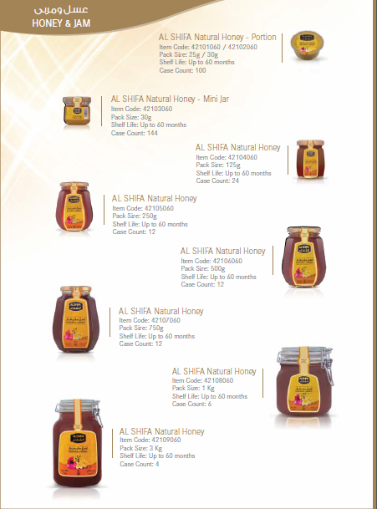

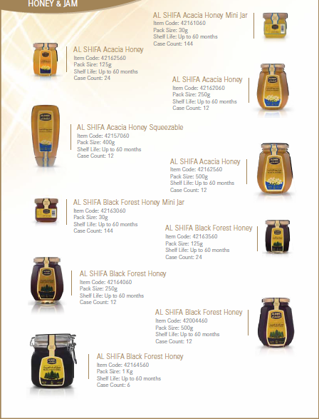

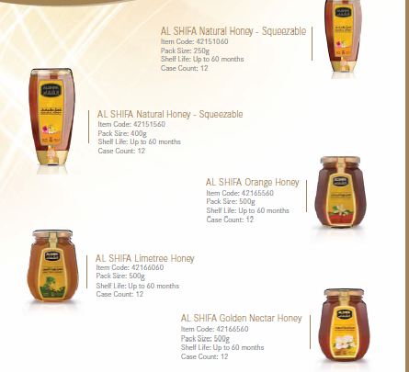

Appendix 2- Brand Leadership Strategy:

Al Shifa has a cost leadership strategy focusing on increasing the profit by reducing operational cost, investing in embracing new manufacturing technology, and efficient logistics.

Porter called the generic strategies "Cost Leadership" (no frills), "Differentiation" (creating uniquely desirable products and services), and "Focus" (offering a specialized service in a niche market). He then subdivided the Focus strategy into two parts: "Cost Focus" and "Differentiation Focus." These are shown in figure 1 below.

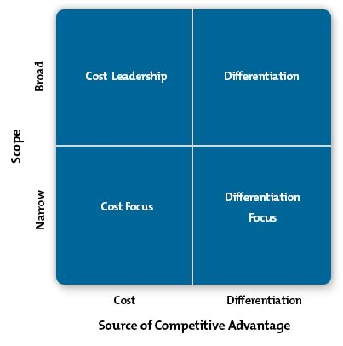

Cost Leadership is about minimizing the cost to the organization of delivering products and services. The cost or price paid by the customer is a separate issue.

The terms "Cost Focus" and "Differentiation Focus" can be a little confusing, as they could be interpreted as meaning "a focus on cost" or "a focus on differentiation." Remember that Cost Focus means emphasizing cost-minimization within a focused market, and Differentiation Focus means pursuing strategic differentiation within a focused market.

Appendix 3-How to build a brand strategy:

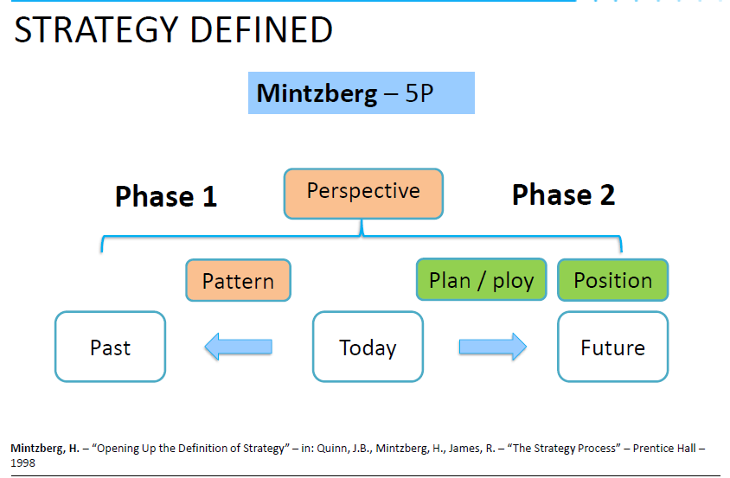

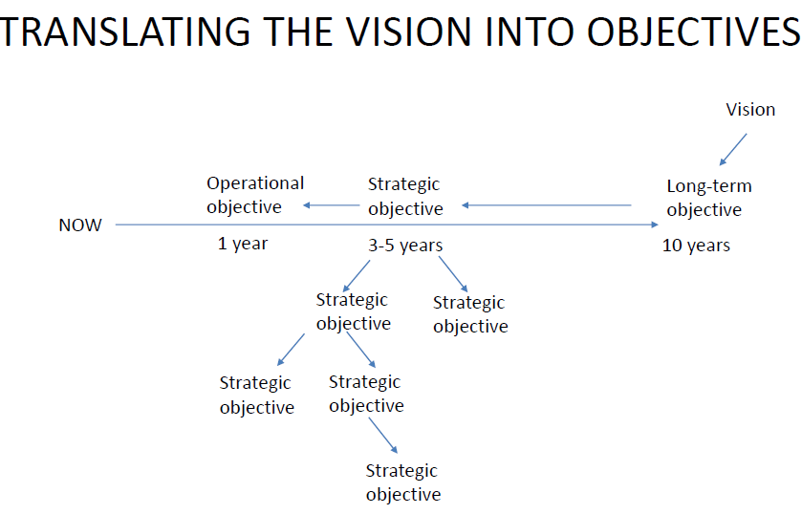

Appendix 4- BCG Matrix:

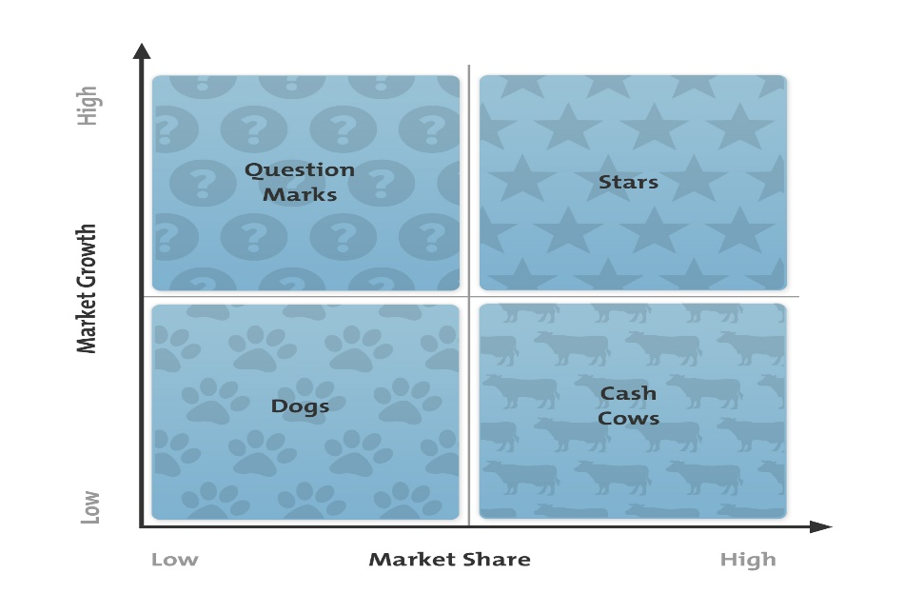

Adapted from The BCG Portfolio Matrix from the Product Portfolio Matrix, ©1970 The Boston Consulting Group

Management consultants at the Boston Consulting Group developed their matrix in the early 1970s. They designed it to help managers at large corporations decide which business units they should invest in

The categories are:

* **Dogs: Low Market Share and Low Market Growth** Dogs are business units or products that have a low market share in a low-growth market. They often do not make much profit, but they do not need much investment either. Much of the time, it needs to offer a price discount to sell Dog products.
* **Cash Cows: High Market Share and Low Market Growth**These businesses or products are well established. They're likely to be popular with customers, which makes it easier for you to exploit new opportunities. However, you should avoid spending too much effort on these, because the market is only growing slowly, and opportunities are likely to be limited.
* **Stars: High Market Share and High Market Growth**Businesses and products in this quadrant are seeing rapid growth. There should be some good opportunities here, and you should work hard to realize them.
* **Question Marks (Problem Children): Low Market Share and High Market Growth**These are the opportunities that no one knows how to handle. They aren't generating much revenue right now, because you don't have a large market share. But they're in high-growth markets, so they could become Stars or even Cash Cows if you can build market share. However, if you cannot increase market share, Question Marks could absorb a lot of effort with little return.

**Market Share and Market Growth**

To use the matrix most effectively, you need know how market share and market growth are related.

**Market share** is the percentage of the total market that your business or product serves, measured in either revenue terms or unit-volume terms. The higher your market share, the higher the proportion of the market you control.

The Boston Matrix assumes that if you enjoy a high market share, you'll be making money, since, theoretically, you'll have learned how to maximize the product's profitability.

The matrix leads you to ask whether you should invest additional resources in a particular business unit or product line just because it is making money. The answer? That depends on market growth.

**Market growth**measures a market's attractiveness. Markets seeing high growth – where the total market is expanding – are highly attractive. Businesses have many opportunities to grow their profits in these markets, even if companies' market share remains stable.

By contrast, low-growth markets are less attractive. Competition can be bitter, and you may only be able to retain market share by discounting aggressively

Appendix 5-SWOT Analysis:

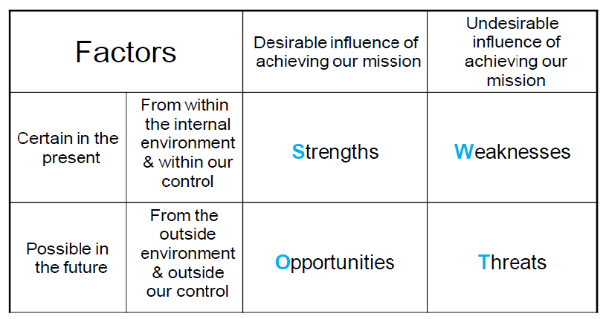

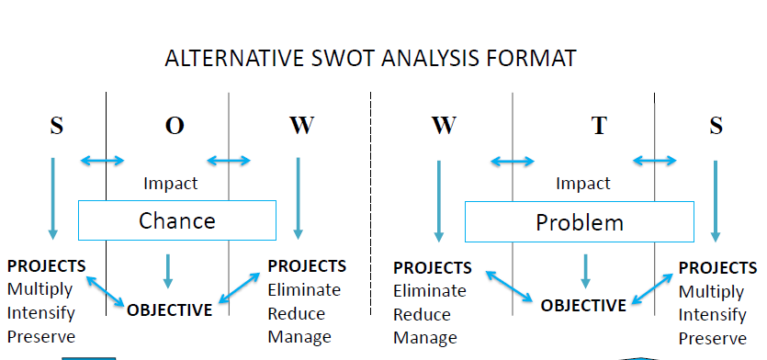

Appendix 6- Keller’s brand equity model:

The model, seen in figure 1, illustrates the four steps that you need to follow to build strong brand equity.

**Figure 1 – Keller's Brand Equity Model**

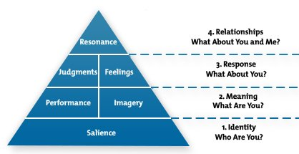

KELLER, KEVIN, STRATEGIC BRAND MANAGEMENT: GLOBAL EDITION, 4th, © 1901. Reprinted by permission of Pearson Education, Inc., New York, New York.

The four steps of the pyramid represent four fundamental questions that your customers will ask – often subconsciously – about your brand.

**Step 1: Brand Identity – Who Are You?**

In this first step, your goal is to create "brand salience," or awareness – in other words, you need to make sure that your brand stands out, and that customers recognize it and are aware of it.

You're not just creating brand identity and awareness here; you're also trying to ensure that brand perceptions are "correct" at key stages of the buying process.

**Step 2: Brand Meaning – What Are You?**

Your goal in step two is to identify and communicate what your brand means, and what it stands for. The two building blocks in this step are: "performance" and "imagery."

"Performance" defines how well your product meets your customers' needs. According to the model, performance consists of five categories: primary characteristics and features; product reliability, durability, and serviceability; service effectiveness, efficiency, and empathy; style and design; and price.

"Imagery" refers to how well your brand meets your customers' needs on a social and psychological level. Your brand can meet these needs directly, from a customer's own experiences with a product; or indirectly, with targeted marketing, or with word of mouth.

A good example of brand meaning is Patagonia®. Patagonia makes high-quality outdoor clothing and equipment, much of which is made from recycled materials.

Patagonia’s brand performance demonstrates its reliability and durability; people know that their products are well designed and stylish, and that they won't let them down. Patagonia’s brand imagery is enhanced by its commitment to several environmental programs and social causes; and its strong “reduce, reuse, recycle” values make customers feel good about purchasing pr

**Step 3: Brand Response – What Do I Think, or Feel, About You?**

Your customers' responses to your brand fall into two categories: "judgments" and "feelings." These are the two building blocks in this step.

Your customers constantly make judgments about your brand and these fall into four key categories:

* Quality: Customers judge a product or brand based on its actual and perceived quality.
* Credibility: Customers judge credibility using three dimensions – expertise (which includes innovation), trustworthiness, and likability.
* Consideration: Customers judge how relevant your product is to their unique needs.
* Superiority: Customers assess how superior your brand is, compared with your competitors' brands.

Customers also respond to your brand according to how it makes them feel. Your brand can evoke feelings directly, but they also respond emotionally to how a brand makes them feel about themselves. According to the model, there are six positive brand feelings: warmth, fun, excitement, security, social approval, and self-respect

**Step 4: Brand Resonance – How Much of a Connection Would I Like to Have With You?**

Brand "resonance" sits at the top of the brand equity pyramid because it's the most difficult – and the most desirable – level to reach. You have achieved brand resonance when your customers feel a deep, psychological bond with your brand.

Keller breaks resonance down into four categories:

* Behavioral loyalty: This includes regular, repeat purchases.
* Attitudinal attachment: Your customers love your brand or your product, and they see it as a special purchase.
* Sense of community: Your customers feel a sense of community with people associated with the brand, including other consumers and company representatives.
* Active engagement: This is the strongest example of brand loyalty. Customers are actively engaged with your brand, even when they are not purchasing it or consuming it. This could include joining a club related to the brand; participating in online chats, marketing rallies, or events; following your brand on social media; or taking part in other, outside activities

The End.