**MARKETING MANAGEMENT**

**SBS MBA/MSc**

|  |  |  |  |
| --- | --- | --- | --- |
| STUDENT ID | **SBS** | **MBA** | **14110054** |

Name: Nazar Ibrahim Ahmed Nasur

**Submission Date**: 9th, April, 2020

**Table of contents:**

**Executive Summary…………………………………………………………………………………………………………………………… 2**

**Brand overview…………………………………………………………………………………………………………………………………. 2**

**Competitive Overview………………………………………………………………………………………………………………………. 3**

**Target Market…………………………………………………………………………………………………………………………………… 4**

**Segmentation……………………………………………………………………………………………………………………………………. 5**

**SWOT Analysis…………………………………………………………………………………………………………………………………… 7**

**Market Research……………………………………………………………………………………………………………………………….. 8**

**Conclusion…………………………………………………………………………………………………………………………………….…. 15**

**Appendix…………………………………………………………………………………………………………………………………………. 16**

1. **Executive Summary**

In this study plan, it is requested to clarify a full study plan of an organization. The organizations that I have selected is LEGO company is a Children's Edutainment Franchise for the UAE, the idea is to diversify children’s skills through creative and entertaining engagement, so that they can move from the one-dimensional, technology obsessed typical child of today to a multi-dimensional, multi-skilled individual with a dynamic mind and high achievement potential. In order to fulfil this goal, we have identified a US based Children’s Edutainment brand for which we would like to acquire UAE franchise rights. We have established initial contact with the brand, but the process of targeted professional engagement of the franchisor with regard to this objective is yet to begin.

brand strategy is a long-term plan for the development of a successful brand in order to achieve specific goals. A well-defined and executed brand strategy affects all aspects of Marketing is the activity, set of institutions, and processes for creating, communicating, delivering, and exchanging offers that have value for customers, clients, partners, and society at large a business and is directly connected to consumer needs, emotions, and competitive environments.

One of the reasons I have chosen this organization is because their uniqueness, simplicity, high quality and Precision.

Brand strategy is a plan of actions that is set up (formulation, development, implementation and evaluation) or description of strategies for an organization to meet and achieve its goals and objectives involved in top-level management and decision-making management. Using a comprehensive brand strategy will help to start at the beginning. In other words, begin by setting your business goals, to take the needed actions or decisions to reach those objectives or goals, helps to strengthen the company and find its core competency, add competitive advantage and improve it. Furthermore, to increase the success of an organization’s brand strategy plan it is important to take in to account to put the right strategies that suits the organizational culture and market. Culture is a major factor in the way people in organization outline objectives, and goals because “If a particular strategy does not match the organization's culture, it would hinder the ability to accomplish the outcomes expected from that strategy implementation.”

As a brand strategy we should know why we are creating a new brand? What do we hope to achieve by launching the new brand? Use those long-term objectives as a basis for all of strategic branding.

1. **Brand Overview**

The report study will be based UAE an existing organization in the field of services for the community, the name of the company will not be revealed in the report, hereafter will refer to it as ‘Discovery Centre.

We are established investment entrepreneurs’ group in UAE, started on 2015 with different field of services as trading, tourism and kids’ entertainment serving the community more effectively and

excellently by creating exceptional real-life experience through our service and product offered through our specialized teams in each field.

Our main business stream is the trading services however, it has other source of revenue thru small businesses which include tourism and kids’ entertainment services.

**Where this Idea Come From?**

As an individual experienced limitation, confusion, lack of availability in kids entertainment options to provide suitable alternative to my family, I determine to find best fit and healthy entertainment option to my beloved kids, here is where the research start up to shortlist the available option, however, the only basic stage is one in the current market and its services with limitation.

1. **Competition Overview:**

Competition is Rivalry in which every seller tries to get what other sellers are seeking at the same time: sales, profit, and market share by offering the best practicable combination of price, quality, and service.

**Competition and buying patterns**

Convenience and location are the most import factors in the decision of making the owner to rent a unit. Unit near food court and family’s area are the best place to open a new discovery center for kids’ entertainment and education

**Main Competitor**

|  |  |  |  |  |  |
| --- | --- | --- | --- | --- | --- |
| Name | Location | Product/Service Offering(s) | Prices* (AED/service) | Number of Customers Per Day | Strengths/ Weaknesses |
| Poop & Play | World Trade Centre | * Kids entertainment |  | 20 |  |
| Kidoos | Dalma mall | * Playground * BD parties * Magic show * Snow Park * Clown ballooning * Cooking * Painting * Human bubbles * Hand work * Sand making | Full day  Below 3 year = 100 AED  Above 3 years = 120 AED  Per hour 60 AED for below 3 years old  Above 3 years = 80 AED | Weekdays: 30  Weekend: 50 customers |  |
| Others | **Dalma mall** | * Games in beach, making their own product as castle * Face painting * Playground areas * 2 sands * 3 others | Full day  63 AED  - If 2 siblings one is 1 year and above and the other one is less than 1 year, it is free | Weekdays: 30 – 70 customers  6Pm to 7 pm is the maximum number of customers  Weekend: 100 -200  From 5PM to 8Pm is the maximum number of customers | Place near food court |

1. **Target Market:**

**Market Analysis Summary**

Abu Dhabi Discovery Centre is expecting to have 70% Entertainment center and 30% STEM Methodology learning. The expected size of the center will be approximately 290 sq.mt, it will be in the center of Abu Dhabi city in Dalma mall. It will be sufficient to meet the demand because of its place so, all people outside & inside Abu Dhabi can reach the mall

A target market refers to a group of potential customers to whom a company wants to sell its products and services. This group also includes specific customers to whom a company directs its [marketing efforts](https://www.investopedia.com/terms/m/market-orientation.asp). A target market is one part of the total market for a good or service.

Using a comprehensive strategic management will help to sets the short- and long-term goals for an organization, to take the needed actions or decisions to reach those objectives or goals, helps to strengthen the company and find its core competency, add competitive advantage and improve it. Furthermore, to increase the success of an organization’s strategic management plan it is important to take in to account to put the right strategies that suits the organizational culture and market. Culture is a major factor in the way people in organization outline objectives, and goals because “If a particular strategy does not match the organization's culture, it would hinder the ability to accomplish the outcomes expected from that strategy implementation.”

In our organization, we will use “Market development” which means we are targeting new markets, or new areas of our existing market. We are trying to sell more of the same things to different people and different countries and societies by developing the product that suits every society and their thoughts.

First of all, we will target different geographical markets, then Conduct a [PESTLE Analysis](https://www.mindtools.com/pages/article/newTMC_09.htm), SWOT Analysis  to identify opportunities and threats in this different market.

(Ansoff, 1989, Lynch, 2003)

It will target Age group: from 3-14 years, Middle- & upper-class Kids, Mall visitors, schools and nurseries, families looking for STEAM concept for their kids.

* Steam Education Center, will be focusing on child development and fun with safe, clean, and stimulating environment for physically active children from age **3 to 14 and** under to play in and explore with their imagination and creativity, in approximately 250 Sqm open divided area according to activity type and kids age.

1. **Market Segmentation:**

Market segmentation is a marketing term that refers to aggregating prospective buyers into groups or segments with common needs and who respond similarly to a marketing action. Market segmentation enables companies to target different categories of consumers who perceive the [full value](https://www.investopedia.com/terms/f/full-value.asp) of certain products and services differently from one another.

We can segment the market in several ways:

* Geographically by region or area
* Demographically by age, gender, family size, income, or life cycle
* Psychographically by social class, lifestyle, or personality
* Behaviorally by benefit, use, or response

The objective is to enable the company to differentiate its products or message according to the common dimensions of the market segment.

Differentiation/ focus in one segment: Unique new mixture of different level of multiple LEGO kid’s entertainment center to provide quality lifestyle to kids and families

Differentiation (Higher price for unique offering- *Skillful marketing and quality management*) / focus in one segment (Apply either strategy in segment or **niche (exclusive- differentiation**): Unique new mixture of different level of multiple LEGO kid’s entertainment center to provide quality lifestyle to kids and families.

We will Use the market development strategy by gaining competitors customers, improving the product quality, convincing current customers to use more of company’s product, with the use of marketing communication tools like using different promotional channels, such as online or direct sales. Furthermore, we will segment our market to target a special group of people (kids specially) until the age of 14. We will focus our segment by Geographically, Demographically and Psychographically.

* Age group: from 3-14 years
* Middle- & upper-class Kids
* Mall visitors, schools and nurseries, families looking for STEAM concept for their kids

Customer Preference Survey Details & Results

* Total Response: 450
* Period: 6 Days total include:
  + weekdays & weekend
* Customers Category: 73% Emirates nationals
* Gender: 45% Male, 54% Female
* Ages: Vary, with:
  + 52% from 25 – 35
  + 30% from 36 – 45,
  + 16% 25 & under
* Mall visit: 52% frequent visit 2-3 a week
* Families & Kids: 93% positive response to the idea

|  |  |  |  |  |
| --- | --- | --- | --- | --- |
| Key Activities | Customer Segments | Value Propositions  For customers | Marketing | Revenue Streams |
| * ***bricks*** * ***building blocks*** * ***video games*** * ***STEAM related activities*** * ***Painting*** | * **Age group: from 3-14 years** * **Middle- & upper-class Kids** * **Mall visitors, schools and nurseries, families looking for STEAM concept for their kids** | * **Engage kids and family with creative concept aim to develop new generation** * **Best value for money** * **Higher interaction with community & surroundings** * **Diversity of offers** * **Great experience in new entrainment** * **Useful time pass activities** * **Online services & ease of connect** | * **Websites** * **Social media** * **Groups** * **Retail Stores** * **Direct Contacts** | * **Main Services Sales** * **Mini Cafeteria** * **Retail Store** |

1. **SWOT Analysis**

**Identifying the significant**

**capabilities of the Organization (SWOT analysis)**

**(Strengths – Weaknesses – Opportunities – Threats)**

**SWOT** Analysis is a strategic tool and technique to measure the strategic capabilities, understand the organization internal environment Strengths and Weaknesses, and recognize the external environment Opportunities open to you and the Threats you face. (Ref. MindTools)

|  |  |  |
| --- | --- | --- |
|  | HELPFUL | HARMFUL |
| INTERNAL | Strengths   * Employee empowerment * Professional management * High teamwork atmosphere. * Social response * High quality services/transactions * Customer care * Customized fun safe, clean environment for kids to let their creativity flow while spending time. * Unique new mixture of different level of multiple LEGO kid’s entertainment center to provide quality lifestyle to kids and families. * Experience | Weaknesses   * less employees * lack of capital * lack of reputation * lack of control * location * NEW Marketing |
| EXTERNAL | Opportunities   * Expo 2020 event provide local market 40% of new business opportunities. * Khalifa fund accepts to facilitate our projects for this year up to 100% financing * Entrance of new technologies * The proposed indoor playground is an opportunity to engage in playful learning activities that stimulate creativity and an interest in learning. Using LEGO® bricks and other building toys, emphasizes STEAM principles, teamwork & socialization. | Threats   * Competitor market: Main competitor providing all Legos product * Environment protection standards: we need to develop technically and economically feasible solutions that meets government regulations standards. * Many distributors are establishing control of supply and distribution channels of the market * New regulations. |

1. **Market Research**

**Some facts on STEM**

Research shows that 75% of the fastest growing occupations now require STEM skills and knowledge. Hence, preparing our young generation for STEM-enabled careers is critical to the success and well-being of our communities in particular and the nation at large.

By exposing students to STEM and giving them opportunities to explore STEM-related concepts, they develop a passion for it and are better equipped to pursue a future in a STEM field. [A curriculum that is STEM-based](https://www.engineeringforkids.com/programs/) has real-life situations to help students learn. And brands like Snapology integrate multiple classes and disciplines to provide opportunities to see how concepts relate to life in order to spark a passion for a future career in a STEM field. Making math and science both fun and interesting helps the student to

do much more than just learn. STEM activities provide hands-on and minds-on lessons for the student. Fun and engaging activities are the most effective means of educating children. Snapology lessons involve a level of interaction that is far above than that found in standard school curricula, which ensures their consistent attention and enjoyment. The children’s enthusiasm combined with the accessibility of Snapology teaching materials and suite of STEM enrichment programs are what make it an ideal STEM education platform for children ages 4 to 18.

**What research says - Proven Benefits of Stem Education In Early Years**

Teaching STEM in the early years enables children to make the vital connections between everyday life and the STEM disciplines. It also lays down the foundations for future academic success because the skills learned are transferable to other subjects.

STEM education in the UAE is therefore increasing in popularity—more schools are implementing STEM learning into their curriculum and making it an integral part of what they teach. Others recognize the importance and seek the right kind of resources to form STEM alliances.

Some of the key proven benefits of STEM education at a young age are as follows:

Fosters ingenuity and creativity:

Ingenuity and creativity can pair with STEM and lead to new ideas and innovations. Without ingenuity and creativity, the recent developments in artificial intelligence or digital learning would not be possible.

Builds resilience:

During STEM education activities, students learn in a safe environment that allows them to fall and try again. STEM education stresses the value of failure as a learning exercise, which will enable students to embrace mistakes as part of the learning process. This allows students to build confidence and resilience, which will enable them to keep going when the going gets rough.

Encourages experimentation:

Without a little risk-taking, and experimentation, many of the technological advancements that have occurred in the last couple of decades would not be possible. Many of these innovations were created by people who were initially told that their ideas wouldn’t work. This type of attitude can be encouraged with STEM learning during the K-12 years.

Encourages teamwork:

STEM education can be taught to students of all ability levels. Students of varying levels of ability can work together in teams to find solutions to problems, record data, write reports, give presentations, etc. The end result is students who understand how to collaborate with others and thrive in a team-oriented environment.

Encourages knowledge application:

In STEM education, students are taught skills that they can use in the real world. This motivates students to learn, as they know that the skills that they acquire can be utilized immediately, and in ways that positively impact them and their loved ones. The ability to apply their knowledge to new and novel tasks will bode well for them when they enter the workforce.

Encourages tech use:

STEM learning teaches kids about the power of technology and innovation. So, when students encounter new technologies, they will be prepared to embrace them, instead of being hesitant or fearful. This will give them the upper hand in the global landscape, as the world is becoming increasingly tech-centered.

Teaches problem-solving:

STEM education teaches students how to solve problems by using their critical thinking skills. By engaging in STEM learn experiences, students learn how to examine problems and then create a plan to solve them.

Encourages adaption:

To succeed in life, students have to be able to apply what they have learned to a variety of scenarios. STEM education teaches them to adapt the concepts that they learn to various iterations of a problem or issue.

The 2018 edition of the Future of Job report by World Economic Forum highlights that among the range of established roles that are set to experience increasing demand in the years up to 2022 are data analysts and scientists, software and applications developers, and e-commerce and social media specialists, roles that are significantly based on and enhanced by the use of technology. Also expected to grow are roles that leverage distinctively human skills.

As we move further towards a knowledge-based economy, a large majority of jobs will be linked to careers focused on science, technology, engineering and maths (STEM). If we don’t engage children now, we are doing them a disservice.

**Khalifa Fund as an important partner in the Snapology project**

We are seeking Khalifa Fund support for this project because it is closely aligned with the country’s vision for the future. Moreover, regardless of economic fluctuations, parents will always be willing to spend on ensuring a brighter future for their children, which makes for a viable business model.

Attached below is an article about Sheikh Abdullah Bin Zayed, UAE’s Foreign Minister emphasizing the importance of STEM education for children and its potential impact on UAE’s economy.

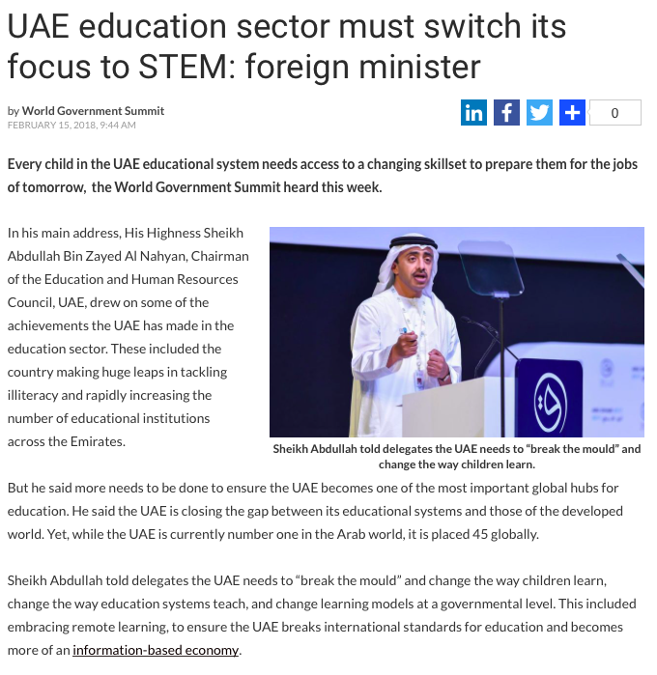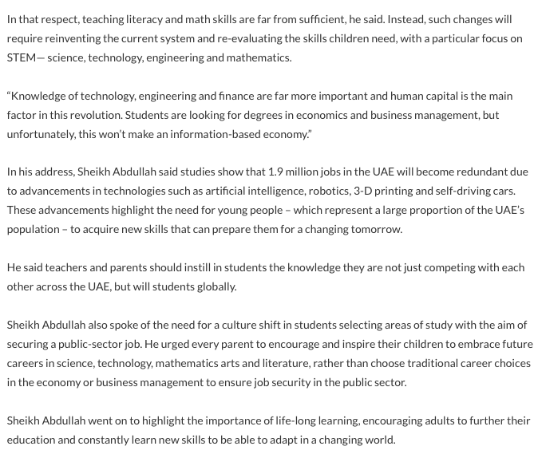

**7.1Product/Service**

|  |  |  |  |  |  |  |  |
| --- | --- | --- | --- | --- | --- | --- | --- |
| Product / Service | |  | | --- | | * Birthday Parties | | * Camps | | * Classes | | * Field trips | | * Creative play | | * Product sales | |
| Place (Distribution) | Dalma mall considers as family mall on the center of Abu Dhabi |

* 1. **Place**

|  |  |
| --- | --- |
| City | Abu Dhabi |
| Location “Google Maps” |  |
| Nearest Landmark | Dalma mall |
| Type of Space (Select from List) | Mall |
| Space Size (in square meters) | 290 sq.mt |
| Approximate Annual Lease Cost | 500,000 |
| Why have you chosen this Space? | Family mall |
| Have you secured the Space? | NO |
| Have you done any work in the space? | NO |

* 1. **Price**

|  |  |  |  |  |  |  |  |
| --- | --- | --- | --- | --- | --- | --- | --- |
| |  | | --- | | * Birthday Parties | |  | |  | |  | |  | |  | | **75 AED/ child** |
| |  | | --- | | * Camps | |  | |  | |  | |  | | **100 AED / Child** |
| |  | | --- | | * STEM Classes | |  | |  | |  | | **70 AED / Child** |
| |  | | --- | |  | | * Playground area | | **60 AED/ Child** |

* 1. **Promotion**
* **Websites**
* **Social media**
* **Groups**
* **Retail Stores**

We will Use the market development strategy by gaining competitors customers, improving the product quality, convincing current customers to use more of company’s product, with the use of marketing communication tools like using different promotional channels, such as online or direct sales. Furthermore, we will segment our market to target a special group of people (kids specially) until the age of 14

* **Direct Contacts**

**Market Viability**

The project is expected to have market viability due to the following reasons:

A good education, especially one that is directly relevant to children’s future career prospects is always is demand regardless of market fluctuations

Parent recognize that science and technology are central to our lives and the rate at which development is taking place in these areas is growing exponentially

STEM Discovery Center effectively combines education with entertainment (edutainment)

Subjects like Robotics and Video Game development that STEM Discovery Centre teaches are highly appealing to children

Education Market Growth: According to a report released in 2018 by the Boston Consulting Group (BCG), the UAE’s education market is expected to grow from $4.4 billion in 2017 to $7.1 billion by 2023.

**Growing STEM Awareness**: There is a growing awareness in the UAE of the importance of STEM as a fundamental part of education. Schools in the UAE are attempting to teach students this modern approach to academics in a traditional way, and parents are noticing. Theoretical study will only go so far without a more practical, hands-on approach that allows them to truly see what STEM has to offer. STEM Discovery Centre has perfected its method over the last 9 years, with a focus on adaptability to constantly changing conditions.

Birthday parties for children generate a considerable amount of business for food outlets and hotels. With its STEM themed birthday parties, STEM Discovery Centre will capture the interest of parents and children alike. These parties will serve the dual purpose of generating revenue and promoting the STEM Discovery Centre concept at large

**Important Assumptions**

|  |  |  |
| --- | --- | --- |
| 1 | Forecasted Sales | Based on multiple sub-verticals:   * Birthday Parties * Camps * Classes * Field Trips * Creative Play * Scouting * Product Sales * Other income |
| 2 | Cost of Sales | As a service-based business, Snapology doesn’t have a specific cost of goods per se  Costs incurred in servicing a sale include:   * Direct labor * Sales commissions * Additional materials and supplies |
| 3 | Growth Rate | First year revenue is 1,280,000 (3,500 per day). Subsequently it will grow by 15% each year  Most costs will increase by approx. 10% each year. This excludes costs like rents, that will be negotiated to be a constant for at least the first 3 years |

**Conclusion**

In conclusion, all organizations should know where they are heading, should have vision,mission, objectives, strategy and organizational structure. To cover all procedures and criteria the organization need to build up a strategic decision to reach their goals. Organizations should take a practical action rather than a responsive action to influence the customers, and reach their long-term goals.

It is a known and accepted fact that people and organizations that plan ahead are much more likely to become what they want to become than those that do not plan at all.

So, once the organization exploits the above Strategy along with the vision, mission, tools matrix, brand strategy and long-term recommended procedures for evaluation, it usually consequences in opening up new markets in the existing markets.

The Snapology project is driven by two factors, i.e., Conviction and Passion.Conviction about how critical STEM education is for the younger generation and the societies they will impact and shape, and a personal passion to be involved in an educational enterprise that promotes the same.

However, despite my keen interest in children’s STEM education I am aware that passion isn’t enough to drive a business and I didn’t want to undertake the risk and time of learning the business from scratch. Therefore, I chose the franchise route, which is defined as “being in business for yourself, but not by yourself”, that will significantly facilitate the fulfillment of my goal.

The benefits of buying the Snapology Franchise include:

(1) Brand equity and name recognition

(2) Tried and tested curriculum, programs and products,

(3) Standard building design and décor,

(4) Detailed techniques in running and promoting the business,

(5) Training of employees.

(6) Ongoing assistance in promoting and upgrading of the services and products.

By working with the Snapology concept, we will ensure that we are using a proven methodology to deliver the best STEM education possible for children.

**Northern   
Emirates**

We rock the spectrum

**GCC - Franchise**

2019

2020

2021

2022

**Dubai & Surrounding**

2020

**Dalma Mall**

2023

2022

2021

Fun & Social activity -merging concept of all

Fun, Education & Challenge – Advance Level serving the Generation

Fun & Education – Intermediate Level serving full Community

Fun & Learn – Basic Level serving all category

**Future changes expected and getting ready for sustainability.**

We will do the following to get ready for sustainability:

* Create long-term financial value.
* Take care about our employees, customers and communities and work to make positive social changes.
* Create smart, integrated public policy.
* Create strong organizational structures that support sustainability.
* Create conditions that support sustainability-related innovation.
* Incorporate a commercial and social license to operate into business strategy.
* Promote the center to advance stage that suit with new vision of UAE generation as such
* EXPO 2020.

**(**Iveybusinessjournal, 2013)

**Appendix:**

**BUSINESS MODEL**

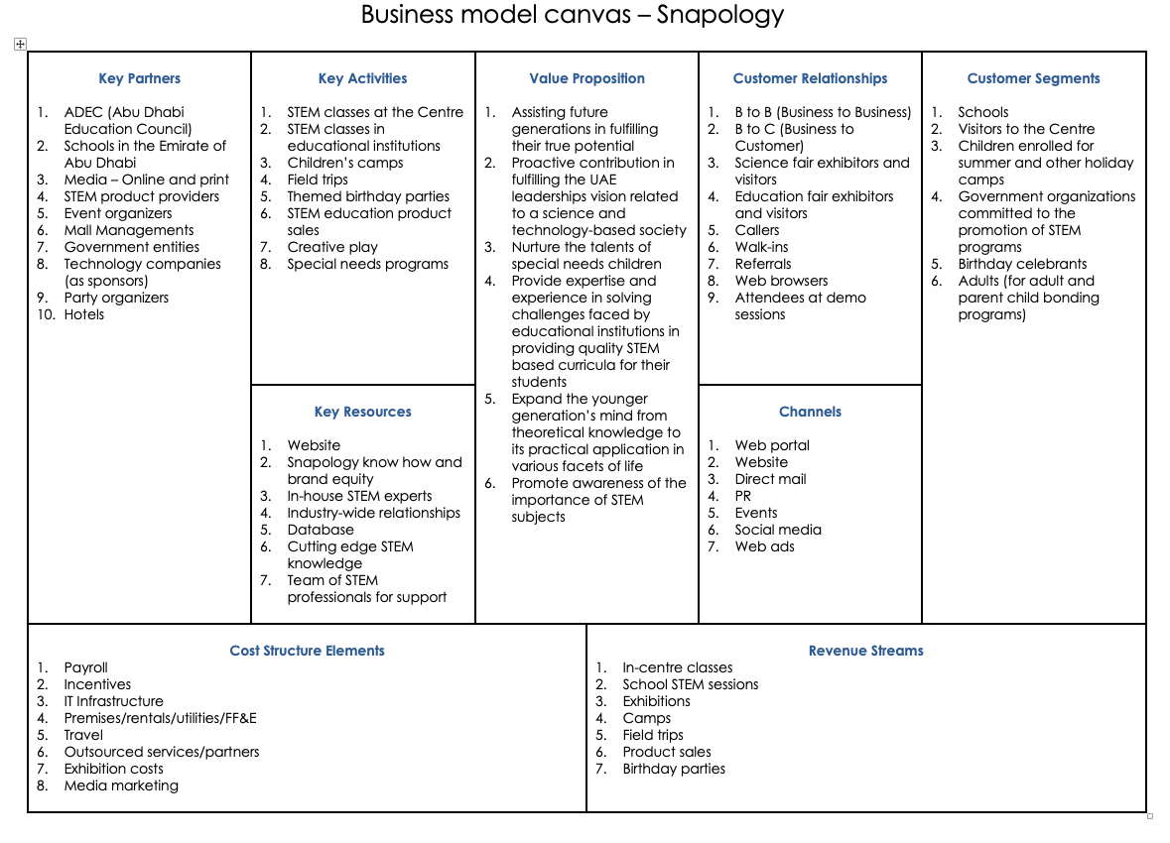

**Reference:**

* What is competition, 2020. [Online] Available from : <http://www.businessdictionary.com/definition/competition.html>
* Investopedia, 2020.[Online] Available from : <https://www.investopedia.com/terms/t/target-market.asp>