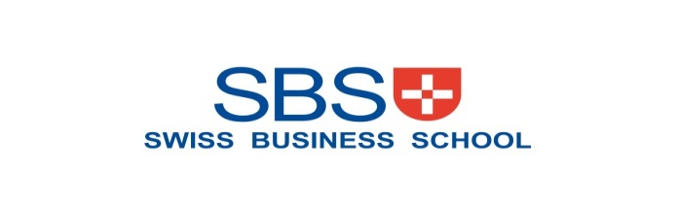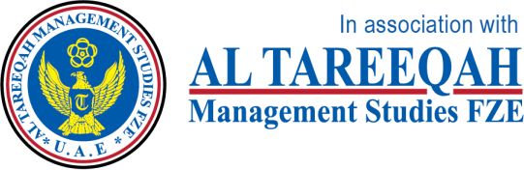

**MARKETING MANAGEMENT**

**SBS MBA/MSc**

**Assignment – Al Ain 2020**

|  |  |  |  |  |  |
| --- | --- | --- | --- | --- | --- |
| STUDENT ID | 1 | 0 | 2 | 4 | 6 |

UNIT TITLE / CODE: Marketing Management

NAME (in Full): **Zafer Mekhael Hanna**

## GENERAL INSTRUCTIONS

* All assignments are to be submitted **9th April 2020** on to [examinationboard@atmsedu.org](mailto:examinationboard@atmsedu.org) and cc to [azrafatima@atmsedu.org](mailto:%20azrafatima@atmsedu.org), [assignmentsubmission2019@gmail.com](mailto:assignmentsubmission2019@gmail.com)
* If assignment is not submitted on date, will follow with penalty of 10% deduction of marks for every day.
* Similarity between students work is strictly not accepted, any student found with similar work will be graded Zero and fail for the course. However, Plagiarism is an academic offence and will not be tolerated under SBS
* Assignment once submitted to exam board is final for marking.
* Total 100 marks

## GUIDELINES FOR ASSIGNMENT

1. If assignment is Question & Answer based then.
   * Introduction is needed for each question.
   * Question has to be answered based on the mark allotted for each question with references if any idea or information is taken from other source.
2. If assignment is case based then,
   * Executive summary
   * Table of content
   * Body of assignment (questions related to case need to be answered)
   * Conclusion / Recommendation if any
   * References (in-text + citation) to be used

## Total Marks / 100

**PLAGIARISM**

Plagiarism is a form of **cheating**, by representing someone else's work as your own or using someone else's work (another student or author) without acknowledging it with a reference. This is a serious breach of the Academic Regulations and will be dealt with accordingly. Students found to have plagiarised can be **excluded from the program**.

Plagiarism occurs whenever you do any of the following things without acknowledging the original source:

* Copy information from any source (including the **study guide**, books, newspapers, the internet)
* Use another person's concepts or ideas
* Summarise or paraphrase another person's work.

## How do I avoid plagiarism?

To ensure you are not plagiarising, you must acknowledge with a reference whenever you:

* use another person's ideas, opinions or theory
* include any statistics, graphs or images that have been compiled or created by another person or organization
* Paraphrase another's written or spoken word.

## What are the penalties?

The penalties for plagiarism are:

* Deduction of marks,
* A mark of zero for the assignment or the unit, or
* Exclusion from the program.

Plagiarism is dealt with on a case-by-case basis and the penalties will reflect the seriousness of the breach.

## Please note: claiming that you were not aware of need to reference is no excuse.

## Marketing Management Assignment Structure –

**Marketing Strategy (Brand)**

For your brand of choice please prepare a marketing strategy on the below guidelines. This should clearly reflect the marketing mix – product, place, price, promotion and packaging as discussed in the class. The learnings on Brand Equity in the class should be the emphasis of the assignment. Please note the brand should have linkage in the UAE – must be an existing brand or a brand that intends to be introduced in the UAE.

**Table** of **Contents**:

1. **Executive Summary**---------------------------------------------- 4
2. **Brand Overview** ------------------------------------------------- 4

----------------------------------------------------------------------------- 5

1. **Competition Overview** ------------------------------------------ 5

--------------------------------------------------------------------------- 6

---------------------------------------------------------------------------- 7

1. **Target Market** ------------------------------------------------------ 8
2. **Segmentation** ------------------------------------------------------ 9

---------------------------------------------------------------------------- 10

1. **SWOT** -------------------------------------------------------------- 10

---------------------------------------------------------------------------- 11

1. **Market Research** ------------------------------------------------ 11

---------------------------------------------------------------------------- 12

----------------------------------------------------------------------------- 13

1. **Conclusions and Recommendations** -------------------------- 14
2. **References**. --------------------------------------------------------- 15
3. Executive Summary



**T**his **M**arketing **S**trategy provides a comprehensive view about Emirates Airlines brand.

Therefore it is include general information about the company such as background, products and services, mission and objectives and their overall market position.

EmiratesAirlines is Dubai based Airline Company, and it is subsidiary of Emirates Groups. The airline is the leading as well as the largest airline of not only UAE but also of Middle East. The airline operates more than 3400 flights per week. These flights take off from its hub at UAE to more than 133 cities in 73 countries around the world.

Twenty years ago Emirates Airline was born as the official airline of UAE. The airline in 1985 started its operations, when in mid-1980’s the Gulf Air cutback to Dubai. From that time till now the airline has shown tremendous growth. The airline purchases its aircraft from the top companies in the world Air Bus and Boeing.

EmiratesAirlines has many products and services such as

* Passenger flights (Emirates)
* Air Cargo (Emirates SkyCargo)
* Aviation services (Dnata)
* Airline Catering (Emirates Flight Catering)
* Retail (Emirates High Street/ Emirates Leisure Retail/ Sirocco)
* Risk management and security Emirates Group Security/ Trans guard Group

### Training services Emirates Aviation University.

1. **Brand Overview**.

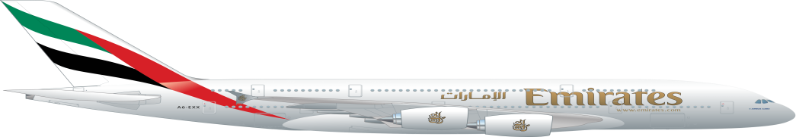

**The** EmiratesAirlines’ brand value grew 17% over last year to reach US$ 7.7 billion. For the fifth year running, the airline has steadily risen up in the global ranking of the world’s top brands to be placed at #171. In addition, Emirates’ brand value has more than doubled since 2009, when it first appeared on the Brand Finance Global 500 report.

**In 1990**:

Emirates launched its first set of commercials with the slogan so be good to yourself, Fly Emirates.

**In 1999:** It launched a very rare A330-200 launch commercial with different pictures showing its aircraft with the original logo and the current logo (which was launched a few months before).

Commercials have **reappeared in 2002**, though the airline would not adopt the slogan Fly Emirates. Keep Discovering until 2004.

**In 2008,** Emirates launched a slogan mainly revolving around its route network of 100 destinations in 59+ countries across six continents – Fly Emirates. Keep Discovering and Fly Emirates. To over Six Continents. And now Emirates currently uses the slogan Fly Better.

Emirates introduced a new design in **August 2008** for its 16,000 uniformed staff, designed by Simon Jersey. The offboard uniform includes the Emirates hat, red kick-pleats in the skirts, more fitted blouses and the return of red leather shoes and handbags.

Now Emirates’ aero planes carried a section of the [United Arab Emirates](https://en.wikipedia.org/wiki/United_Arab_Emirates) flag on the tail fins, a [calligraphy](https://en.wikipedia.org/wiki/Calligraphy) of the logo in Arabic on the engines and the "Emirates" logo on the fuselage both in [Arabic](https://en.wikipedia.org/wiki/Arabic) and English. The colour scheme used since 1985 was changed in November 1999 to the one still in use today. Plus they have the new Expo2020 added to some of their aero planes.

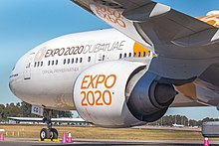

The **Product Life Cycle** refers to the sequence of stages a product goes through. Any new product in market go through a sequences of stages from introduction to maturity ,growth to decline and this sequence of all stages is called product life cycle.

According to product life cycle at the movement airline industry on its maturity stage due to big and perfect competition in the market.

1. **Competition Overview**

**Competition is** the Rivalry between companies selling similar products and services with the goal of achieving revenue, profit, and market share growth.

Market competition Motivates companies to increase sales volume by utilizing the four components of the marketing mix, also referred to as the four P's. These P’s are stand for Product, Place, Promotion, and Price.

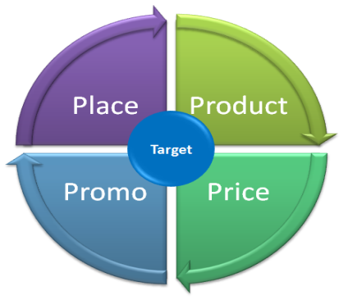

EmiratesAirlines is considered as the largest airline in the Middle East and operates about 3,600 flights per week from the *Dubai*[*International*](https://www.marketing91.com/international-marketing/) airport. Their airlines inspire travelers across the globe with their wide network of destinations thus providing world-class service.

Although EmiratesAirlines has a strong support of the Dubai government. And it has excelled in [customer service](https://www.marketing91.com/5-steps-to-setup-better-customer-service-process/), in-flight entertainments, and exclusive lounges. But still they have many of big competitors.

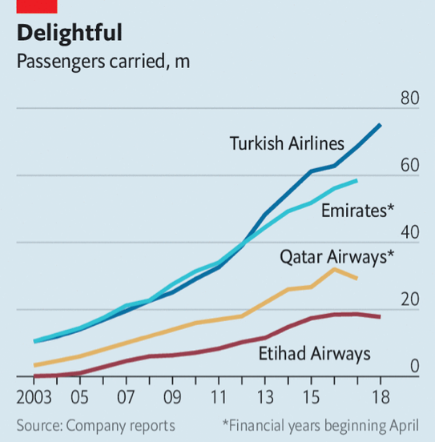

Through this study, let me discuss the top of their competitors.

1. **Turkish airlines**

A famous airline of Turkey, Turkish airlines serves many non-stop destinations from one airport. It is the first airline company of Turkey. This airline started its aviation journey with five aircraft in the year 1933. At present, it has about 326 aircraft flying to about 120 countries. Over the years it has gained high-quality flying experience for its passengers. It provides various in-flight services like lounge facilities, in-flight entertainment which highlights the brand. It has a strong association with the sports team and has also sponsored many events which gave way to increase the brand equity of Turkish Airlines.

1. **Qatar Airways**

Also a top Emirates competitor, Qatar Airways is a state-owned airway headquartered in Qatar and established in 1997. The airlines link over 150 international destinations with a fleet of about 180 latest generation 180 aircraft. The company functions flights various leisure and business destinations across the globe. It has strategic partnerships with Royal Air Maroc and Cathay Pacific.

1. [**Etihad Airways**](https://www.marketing91.com/marketing-mix-etihad-airways/)

[Etihad Airways](https://www.marketing91.com/marketing-mix-etihad-airways/) is the second largest airline of UAE. Established in the year 2003, it is headquartered in Abu Dhabi and owned by the Abu Dhabi Government. This airline operates about 1000 flights per week and covers about 55 countries worldwide.

Apart from the airline services, Etihad also operates Etihad Holidays and Etihad Cargo. This airline company has a good branding and visibility and it has sponsored many events. Due to its main focus in customer service and in-flight entertainment, Etihad Airways is considered as one of the top Emirates competitors.

1. [**Lufthansa**](https://www.marketing91.com/marketing-mix-lufthansa-airlines/)

[Lufthansa](https://www.marketing91.com/marketing-mix-lufthansa-airlines/) is an aviation company and largest German airline. The company consists of about 620 aircraft.  The network airline segment of Lufthansa provides passenger service to about 263 destinations across 86 countries. Due to their global reach and a solid balance sheet, Lufthansa is considered as one of the top Emirates competitors.

1. **Fly Dubai**

Fly Dubai established in the year 2008, and it is a low-cost airline.  The airline operates in about 95 destinations and serves the Middle East, Asia, Europe, and Africa. With 1,400 flights per week. It has about 500 pilots and 1,000 cabin crews serving the flight. As this airline is one of the fastest growing airlines and aims to make the travel more affordable, even though it is fully owned by the Investment Corporation of Dubai (ICD), both Emirates and fly Dubai are operated independently and under separate management teams. So Fly Dubai is indeed considered as Emirates competitor.

1. **Saudi Arabian Airlines:**

Saudi Arabian Airlines is a well-known airline in Saudi Arabia. The company provides various air transportation services for passengers, baggage, and cargo. This airline is available across the world. Established in the year 1945, Saudi Arabian Airlines owns about 140 aircraft which includes the latest jets like B777-268L, B787-9, Airbus A320-200, Airbus A330-300, and Airbus A321.

This airline has gained many national and international awards. Saudi Arabian Airlines has various groups who specialize in marketing activities to bring the brand to the top level. Due to the various strategic alliances and extensive resources of the airline, Saudi Arabian Airlines is considered as one of the top Emirates competitors.

1. [**British Airways**](https://www.marketing91.com/swot-analysis-of-british-airways/)**:**

The largest airline company of the United Kingdom, [British Airways](https://www.marketing91.com/swot-analysis-of-british-airways/) was formed in the year 1974. It was established by the British Government to manage two nationalized airline corporations, British European Airways and British Overseas Airways Corporation. Over the years two more airways, Cambrian Airways, and Northeast Airlines joined them and formed British Airways. This airway has strong support from the British government. The company maintains its own engineering branch to maintain its various aircraft. Due to the usage of technology at all places, this airway has developed an online ordering system to enable the use of e-tickets and other online services. Due to their [strong brand](https://www.marketing91.com/develop-keep-strong-brand/) and many years of service, British Airways is considered as one of the top Emirates competitors.

As a conclusion the airway companies are very much essential in the current world owing to the number of people traveling for various purposes across the globe. Emirates airline provides excellent service to the customers to make them choose Emirates for their travel.

1. 4. Target Market

A **target market** is a group of customers within a [business](https://en.wikipedia.org/wiki/Business)'s [serviceable available market](https://en.wikipedia.org/wiki/Serviceable_available_market) at which a business aims its [marketing](https://en.wikipedia.org/wiki/Marketing) efforts and resources. A target market is a subset of the total market for a product or service.

The target market typically consists of consumers who exhibit similar characteristics (such as age, location, income or lifestyle) and are considered most likely to buy a business's market offerings or are likely to be the most profitable segments for the business to service.

According to (Kotler and Armstrong, 2010, p 215) targeting is the process of evaluating each market segment’s attractiveness and selecting one or more segment to enter.

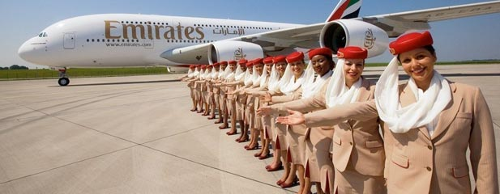

Emirates is repositioning the company’s global marketing strategy to target what it calls **“globalists**” as it looks to meet its aspirations of becoming the world’s biggest carrier.

Emiratestargeted audience is:

* Individuals who are **well-travelled**, or have ambitions to become well-travelled, and who also embrace the opportunity to try the unfamiliar.
* Value-seeking fliers, Not very price-sensitive, upper middle and Upper-class fliers seeking comfort and flying experience.
* UAE’s tourism and business segment Customers.
* Expatriates in UAE.
* Transit passengers.

Since Dubai is aiming to attract 20 million visitors annually, this provides Emirates with plenty of

Rooms to growth and increase the volume of their target audience.

1. Segmentation – Demographic, Behavior, Psychographic

**S**egmentation: According to (Kotler and Armstrong, 2010, p 215) “market **segmentation** is **dividing market** into **smaller groups** with distinct needs, characteristics, or behavior that might require separate marketing strategies and mixes. Market targeting is the **process** of evaluating each market segment’s attractiveness and selecting one or more segments to enter.

- Age

**Demographic**

- Gender

- Family size/ family life- cycle

- Income

- Occupation.

- Education / generation and nationality

**Behavioral**

- Usage frequency.

- Benefits needed.

- Usage occasions

- Brand loyalty

- Personality traits

**Psychographic**

- Attitudes

- Interests

- Values

- Other lifestyle factors

1. **Demographic**:

Refers todividing the market into groups based on variables such as age, gender, family size, family life- cycle, income, occupation, education, generation and nationality.

Demographic factors are the most popular bases for segmentation customers group. ” (Kotler and Armstrong, 2010, page 218)

* **Age:** There is no limitation for age of **Emirates customer**. Emirates segment its customers according to their age; since there is different requirements apply to the customers depending on their age. The airline has segment their age under infants, children and adults.
* **Gender:** Both genders – male and female can use Emirates airline services.
* **Family size and Family life- cycle**

There is no limitation for families, as long as the traveler be able to pay the ticket cost and has the legal situation for travelling, they can use Emirates airline services. Most of the tourists which visit Dubai are families and single persons from the Middle East, Asia pacific, Africa and some from western countries.

* **Income** Most of the time the price for Emirates airline is average based on the services. Those their salary are high and with average income can buy ticket from the airline. For example customers with more between 4000 to 10000 AED are the most customers for the airline.

1. **Behavioral:** EmiratesAirlines **segment** **customers** according to their buying pattern like usage frequency, benefits needed, usage occasions and brand loyalty.

1. **Psychographic segmentation**:

In this method EmiratesAirlines **segment** **customers** by their personality traits, attitudes, interests, values, and other lifestyle factors. These characteristics may or may not be instantly observable, but the customer has demonstrated them in some way through their online behavior.

1. SWOT – on brand or industry

As we know, SWOT stands for strengths, weaknesses, opportunities and threats.

**Strengths of Emirates:**

* Emirates airlines currently operates more than 3400 flights per week, flies to over 133 destinations in more than 73 countries around the world. The airline has more than 269 aircraft and flies to destinations in six continents with constant pursuit of further expansion (Informa Markets, 2019). This immense span of operations is certainly a great strength for the airline.
* Dubai is one of the leading tourist destinations in the world and the hub of Emirates. The image of the city has been reflected in the airline resulting in a highly positive brand image. - - Exceptional customer services and amenities have also played a big role in the brand recognition. Emirates was named the World’s Best Airline and received 12th consecutive award for best In-flight entertainment at Skytrax World Airline Awards 2016 (Emirates, 2019).
* Emirates has an impressive portfolio of sponsorships with some of the most famous football clubs in the world e.g. AC Milan, Real Madrid, Paris Saint-German and Arsenal (Emirates, 2019). The sponsorship deal with English football club Arsenal provided Emirates an excellent opportunity of naming a stadium as Emirates Stadium. The airline has also made a deal with the Asian Football Confederation. These deals show how hungry and committed Emirates is for expansion and visibility around the world.
* Emiratesemploy people from every continent in the world. The workforce consists of over 160 nationalities. This diversity coupled with superb talent makes the airline a global organization.
* The Emiratesairline invests heavily in employee training and offers a competitive reward package for its employees.

**Weaknesses of Emirates**

- Emirates witnessed a sloth in demand in the last few years in the USA after years of growth. The airline has announced it would slash capacity on its routes from Dubai to Boston, Los Angeles, Seattle, Fort Lauderdale, and Orlando (Levine-Weinberg, 2017).

- Some airlines have accused Emirates of receiving government subsidies.  Another allegation is that the airline does not pay due taxes. While Emirates has refuted these allegations, they leave a negative mark in the minds of many people.

- There were some instances when the Emirates flights had met with **accidents**. During the year 2004, one of the Emirates flights that were operating from Johannesburg to Dubai had faced serious damage at the time of takeoff, when it had failed to become airborne before the runway end. There were a few more cases of accidents.

- Emirates airline does not seem to cater to the middle class and budget traveler. This is, in fact, yet another weakness as the [target](https://www.marketing91.com/swot-analysis-target/) customers become less.

**Opportunities for Emirates**

Though Emirates serves more than 133 destinations, it can still pursue further international expansion strategy. Once the US market bounces back, it should expand in the USA by resuming double daily flights from some larger U.S. cities, or by connecting new markets to Dubai. Likewise, as the demand for convenient and affordable travelling is on the rise, the idea of introducing a subsidiary budget airline could be an opportunity worth exploring.

**Threats to Emirates**

Competitors are the major threats to the airline. Emergence and performance of airlines such as Etihad, Qatar Airways, and Turkish Airlines are note-worthy in this regard.  These airlines are expanding rapidly posing a threat to Emirates.

Any decline of tourism to Dubai can also be a threat to Emirates as Dubai is its hub. Likewise, diplomatic, political, or economic turmoil may also slowdown the business of the airline. However, these marco-environmental factors are not unique to Emirates only. They can impact on any business regardless of their identities.

America’s three major domestic airlines — American, Delta, and United have been campaigning for restrictions on the routes and destinations foreign carriers e.g. Emirates, Etihad, and Qatar can fly into the US. This is also a threat to Emirates particularly for its American market.

1. Market Research if any carried out – if no research carried out then suggest a need if any

**The Market research** is the pillar to benefit from using marketing mix or the four (4) main tools to market your business. It is what will prompt you to identify essential and critical information you need to use the 4Ps – product, price, promotion, and place

Marketing Mix of Emirates Airlines analyses the brand/company which covers 4Ps (Product, Price, Place, Promotion) and explains the Emirates Airline marketing strategy.

Let us start the Emirates Airline Marketing Mix:

### Product

Emirates Airlines provides different classes according to its service standards. The classes include “Diamond First Class” which includes the adjustable seats that can be converted into minibars, beds, for privacy and security reasons. Emirates airlines is the first company to provide shower on flights and private suits.

Second class is “Pearl Business Class” which is specially designed for business executives who need extra work-space and facilities; it provides partitions for privacy and also offers USB and laptop charging point.

Third class is “Coral Economy Class” which is for an economy traveler include all the basic services such as entertainment, internet facilities etc.

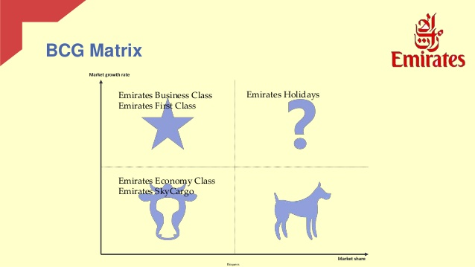

### 7.2 Place

Following is the distribution strategy of Emirates Airlines:

Emirates airlines carries out its operation from Dubai strategically occupying the central hob for all the international routes connecting eastern and western cities in the world. Being well known for its long routes, Emirates airlines has also introduced new short routes benefiting its customers. It links various one hundred forty cities across seventy-eight countries and six continents across the globe. Its distribution strategy involves sale of tickets through travel agents and tour operators.

Emirates also has a website for cancellation of tickets, buying of tickets, rescheduling of the flight and drawing information about the various periodical offers and discounts.

### 7.3 Price

The pricing strategy of Emirates Airline is according to the market segmentation according to the class services offered by them.

Since Emirates Airlines has its hub in Dubai, it serves low cost tickets to its consumers compared to other airlines. Emirates airlines has a varying pricing strategy in its marketing mix. It has developed shorter and low cost routes without any layover. Although the prices of these routes are lower, the company generates revenue through volumes. Due to direct flights, Emirates airlines has adopted effective price policy for the shorter routes. In order to attain flexible pricing for the seats and extract the maximum profits the company also adopts dynamic pricing policy levying the highest cost per seat. In general company identifies the needs of the customers with different needs and belonging to differential financial statuses. Emirates Airlines also uses premium price policy for its premium customers who demand luxurious and customized services at fights.

### 7.4 Promotion

The promotional and advertising strategy in the Emirates Airline marketing strategy is as follows:

Emirates Airlines engages itself in various promotional activities through advertisements in magazines, newspapers, television, radio, websites etc. to keep the customers aware about its new offers and services through different sources, Emirates has one of the most active and engaged social communities, with a combined following of 11 million across Facebook, Twitter, Instagram, LinkedIn, and Google+.

The company also sponsored ICC cricket world cup in 2011 as well as 2015 thereby increasing its reach to millions. Sponsorships with some of the most famous football clubs in the world e.g. AC Milan, Real Madrid, Paris Saint-German and Arsenal (Emirates, 2019). The sponsorship deal with English football club Arsenal provided Emirates an excellent opportunity of naming a stadium as Emirates Stadium.

Emirates Airlines often generates promotional discounts during the off season pricing the tickets at affordable rates attracting the tourists across the world to Dubai. The company also runs innovative campaigns like “The Kids go free” wherein meals, tickets and accommodation of the kids was free with two paid members which generated lot of business for the company. The Emirates Airline foundation is committed in providing aid to various countries during difficult

Times.

1. Conclusions and Recommendations

**As conclusion**: The airline industry is cyclical and sensitive to a number of external economic factors that affect the number of domestic and international travelers, including consumer confidence and corporate profit. Improved economic conditions over the five years to 2016 have increased demand for both business and consumer travel. The newer aircrafts are continuing to update to satisfy the request from consumers. There has been a tremendous surge in the percentage of people who are now traveling longer distances and becoming frequently flyers more than ever before. As far as changes in travel preferences millennial are found to be willing to spend more on business travel than other generations when it comes to business travel. Globally the aviation industry is consumers over 200 million tons of jet fuel per year (IBIS World, 2016).

**My recommendations** to Emirates Airlines are:

* EmiratesAirlines can have **greater potential in America and Europe**, because of greater number of countries in these Continent with high class population. As Emirates supports average cost carrier, this growth of high class in America and Europe can provide a huge market potential for this airline to improve.
* **Operational cost of Emirates** is very **high** only due to huge investments on technologies, aircrafts and best quality services. Emirates should control its cost and should decrease its cost through improvement and development of operations activities .Emirates should improve maintenance process, effective and efficient flight schedule of the company and better utilization of the company resources like aircrafts etc. Another way for reduction of cost is advancement in its technologies by investment in technologies and in this way cut of labour cost. For example it is strongly recommended to new installation of self-check service system on all airports.
* **Advancement in Information Technology** is most important for progress of emirates airlines and in this order it should make contracts with E-Business Company for improving its services and increase the customer’s satisfactions. E-CRM is the latest technology and adopted by Emirates this strategy since increasing in numbers of the internet users and this way out for keep long term relation with customers. (Jiang, 2003).

Eventually, EmiratesAirlines make comprehensive analysis and review of company internal and

external factors and its competitors and should develop new strategies for staying and keep good

position in airline industry at this maturity time.

**References**:

1. Kotler and Armstrong, 2010, p 215

**In-text** (Kotler and Armstrong, 2010, p 215):

* + Dr. **Philip Kotler** is an American marketing author, consultant, and professor; currently the S. C. Johnson & Son Distinguished Professor of International Marketing at the Kellogg School of Management at Northwestern University. He gave the definition of marketing mix
  + Professor**Gary Armstrong** is an award-winning teacher of undergraduate business students.

1. www.Emirates247.com
2. www.ukessays.com
3. www.study.com
4. MBA Skool
5. Investors digest
6. www.gofrixty.com
7. www.centreforaviation.com
8. www.Hubspot.com