**Executive Summary**

* The report shows the Rabea Teas’ objectives and marketing strategies in terms of its 4ps that is it is shown that Rabea can offer and increase its product range by offering other related products
* The Entry of Rabea Tea in Saudi Market and later on introducing in Bahrain market
* The Changing of Sole Distribution Licence from BMMI to Ali Rashid Al Amin
* This report is to show a marketing plan for Rabea Tea Products in the Bahrain Market
* Competition overview between Rabea Tea and Lipton In Bahrain market is Summarized
* What happened when the Rabea Tea Strong was implemented in Bahrain market?
* Different Range of Products and the changes in packing done in 2020
* The market survey of all the supermarkets and hypermarkets
* Market Displays and different Promotions done during 2020
* What are the major steps to be taken to increase the sales in Bahrain is mentioned.

**Brand Overview**

Rabea Tea was trademarked in 1969. Since then the company has launched a comprehensive range of Tea varieties under Rabea Tea brand to make it superior to the competing Tea brands in the region with its variety and choices. The company has taken the decision to develop and expand its business to include Tea blending and packing. At that time, industrial “revolution” had already swept Saudi Arabia in the 70's and 80's. With the influx of new wealth, some of the more far-sighted titans of Saudi industry recognized the financial and cultural advantages of establishing local manufacturing operations. Ahmed Mohammed Saleh Baeshen & Co. had its share in that revolution. In 1994, it established the largest Tea factory as a major and qualitative leap to establish the integrated Tea industry in the Kingdom.

Ahmed Mohamed Saleh Baeshen & Co. succeeded in registering its honorary brand Rabea Tea in the Guinness World Records, breaking a new attempt for the largest tea bag in the world during an event held at Red Sea Mall in Jeddah.

The event coincided with the launch of the company’s latest “innovative product Full Leaf Tea Bags, which guarantees costumers the optimum quality and taste,” which has been tendered through its loose full leaf tea over the years.

The company was able to break this new world record by manufacturing the largest tea bag in history as measured by the certified adjudicator from Guinness World Records who landed from New York for this occasion.

Weighing at 250 kg, Rabea Tea’s largest bag measures 4 meters in height and 3 meters in width, enough to prepare 100,000 cups of tea. The bag is scheduled to tour Riyadh and Dammam. The company decided to donate the tea bag to charitable organizations.

The innovation of the Full Leaf Tea Bags was developed over more than a decade of R&D.

The product is blended and packaged at the company’s factory in Jeddah, being one of the most state-of-the-art tea factories in the Middle East region. The factory is equipped with a world-class tea laboratory aimed to maintain the level of quality and taste, in addition to numerous innovations at the level of blending, filling and packaging.

**History**

Rabea Tea has been ranked among the top 100 local Saudi brands for the year 2013, and became “The House of Quality Tea.” Rabea Tea continued to develop and diversify its products over the years to satisfy all needs and tastes. Its leading packaging has also topped the market shelves and "Points of Sale" across the Kingdom. Today, Rabea Tea has a variety of carefully selected Tea from around the world to be introduced into the regional markets with innovative packaging designed to preserve its rich flavour and freshness.

(ref: <http://rabea.com/en/page/About_us>)

At the present situation Rabea tea is one of the major leading Tea Brand in Bahrain. During the initial Entry in the Bahrain Market Rabea Tea was taken over and distributed by the BMMI-one of the leading Food distributor’s in Bahrain, Due to the heavy competition in the Bahrain market Rabea tea was not able to take a position in the Top Tea brands, Later on in 1990’s Al Amin Distributions , an another Leading Distributor took over the Rabea tea Brand and started Distributing all over Bahrain.

As per the current Market, Rabea tea Holds the second position in the Bahrain market just after the Lipton Tea. Due to the taste and the historical background among the Arab’s ,it took only few years for the Rabea tea to capture the market.

Rabea tea is Facing its very Difficult situation in the Bahrain market to take over its 1st position, As per the management analysis Rabea Tea will take over its 1st position over a 10 years time in all the GCC countries.

**Competition Overview**

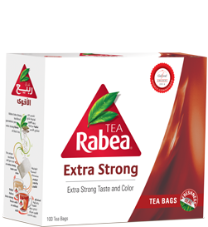 **v/s** 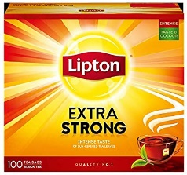

When the Rabea tea started in 1969 , the co-founder Ahmed Mohammed Saleh did not find any Competition in the marker and it was an easy task for the Rabea tea to get sold in the market. In about 20 years of time Rabea Tea became the market leader and the masterpiece of Rabea Tea Product became its Tea bag. As there is a huge migration of Asians in the GCC countries and the Entry of Lipton Tea in the Bahrain market was at the same time and the Market leadership was taken over by the Lipton in Saudi Arabia. There Rabea tea come to know about the Taste and preference of Asians. Most of the Asians prefer to have Strong Teas and Rabea tea was selling all types of Light Tea powder as it was preferred by the Arabs.

Slowly in 2010 Rabea tea started to export Strong Tea bags and strong tea powder in the Bahrain market but it didn’t hit the market as per the expectation. But Rabea tea slowly gradually kept growing in the Bahrain market and In Addition, in the Best New Beverage Product Category “Extra Strong” Rabea Tea has won the highly recommended prize at Gulf food Awards 2014.

As of now Rabea Tea holds 45% of market share in the Saudi Marker and 25% of Tea market share in Bahrain also.

Rabea Tea continued to develop and diversify its products over the years to satisfy all needs and tastes. Its leading packaging has also topped the market shelves and "Points of Sale" across the Kingdom. Today, Rabea Tea has a variety of carefully selected Tea from around the world to be introduced into the regional markets with innovative packaging designed to preserve its rich flavour and freshness. (ref; <http://rabea.com/en/page/About_us>)

**Target Market**

The tea has no basic sector to target, but also Rabea tea is not targeting the Restaurants and cafeterias, it is mainly sold in the supermarkets and hyper markets. They are mainly focusing on individuals and families.

As the Rabea tea is a favourite tea among the Arabs, it is not trying to sell this product at a lower cost by reducing the quality of the product.

The success of Rabea tea is that it still holds the quality of the tea which they were having at the initial stage of starting this company.

In today’s world market of Tea is increasing and this market is highly growing in GCC as

compared to other countries and it has been projected about 10% increase will be there by 2022.

Consumers purchase different products such as flavoured teas, strong teas, tea bags , tea leaves and Rabea tea succeeded in availing all these products to the consumer at a reasonable rates.

Many of the products are sold by the major outlets like LULU and CARREFOUR through online channels over the internet, and there is a huge online sale during this Corona effected situation for the Rabea tea in Bahrain. and have second highest growth in market share of distribution channels. Despite of having online channels people more over prefer to shop in Supermarket and hypermarkets. In GCC Rabea Tea and Lipton Teas are having greatest revenue as well as market leaders in Tea industry.

**Segmentation**

There is no segmentation based on demographic. When a customer is choosing a Rabea tea Brand it is not based in AGE, INCOME, GENDER or RELIGION. All type of age group using the Rabea tea.

But as per the market survey, Rabea tea is mainly used by the Arab Peoples.

Also is not only used in any specific type of sectors but also many hotels and restaurants use this brand tea specifically for their customers. Therefore, Rabea tea is partially segmented as per the bevor.

And at the last most commonly used sector for Rabea tea brand is Psychographic sector. Many of the customers uses their Rabea Tea as their Habit, Taste Preference and due to daily used product

Rabea products are already well-known brands through the GCC countries, with effective advertisements and the Quality and word of mouth, since customers tend to share their positive views with their friends and family. After buying the Rabea Tea, consumers learn, and experience the quality and see themselves that they got what they expected. Consumers’ formed attitudes about the brand are buying a product that are tasty and Mind Blowing, makes you feel good, and look cool and satisfy all.

**SWOT**

SWOT stands for Strengths, Weaknesses, Opportunities, and Threats, so a SWOT Analysis is a technique used to assessing these four aspects of your business.

As per the swot analysis in the Bahrain market the Rabea Tea is holding about 30 % of the tea market share in Bahrain .The most commonly sold item for the Rabea Tea is its Rabea tea bag 100gm ,the Rabea tea bag is sold in the market about 50% compared to the other tea bags. There is a huge expectation in Bahrain and mainly in the strong tea bag category, but Rabea is mainly concentrating on its Rabia tea bag which is very light, but slowly in 2010 the Rabea has introduced its Rabea extra strong to the market but it didn’t get the expected space in the Bahrain market in this strong teabag category .As 70% of the market share leader - the Lipton was still holding the strong tea bags section in the market and it is facing a huge difficulty in getting the market share of strong tea bags and strong tea powders.

In 2020 the Rabea tea bag promotion with a gift pack was sold about 60 percentage among the t-bag category in the current market during the Ramadan period.

As per the market survey there is a huge opportunity in the Bahrain market and only the competition for the Rabia it is the Lipton tea bag sold by the Unilever .The Rabea Tea is facing a huge difficulty in getting to top the market leader .Due to the competitive pricing and the quality of the product Rabea tea bag is still holding the second place in the market and it is driving for its first position in the market .As per the Bahrain market survey in 2018 it is expected that by 2025 Rabea Tea will Conquer the Bahrain market and will be the Leader in the market.

By giving Exclusive promotions in the market Rabea tea has proved the market that it is on its way to Conquered the Bahrain Market. The price of the Rabia t-bag is very competitive in the market. According to the 2019 survey the most sold Rabia T-Bag is in as shown

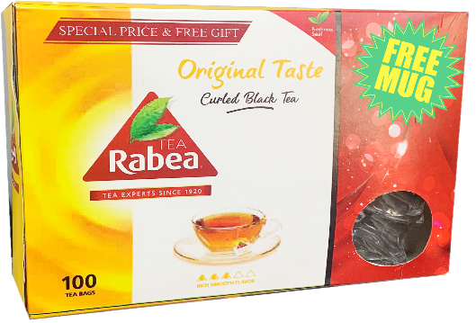

**Market Research**

Product-

Rabea Tea offers a wide range of products including T-bag, T-powders and Leaf Tea. Currently these are the top selling product categories, all these products specialized for Quality products (Marketing mix of Rabea tea).

The first product of Rabea Tea is Tea Bag. Apart from this, it offers currently in Flavoured Teas and in different packings Some of the packings are attached Below:

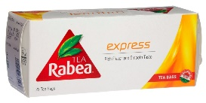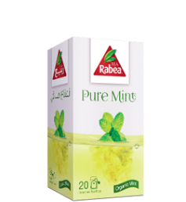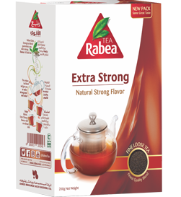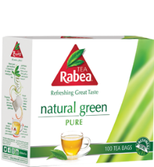

Due to the Competition in the market Rabea tea has changed its Outer packing to become more attractive and beautiful during January 2020. The New packing photos are attached below:

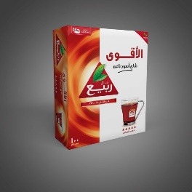 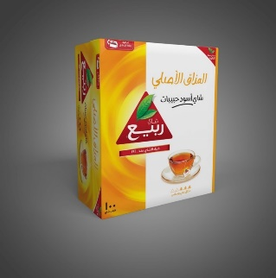 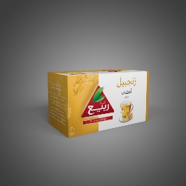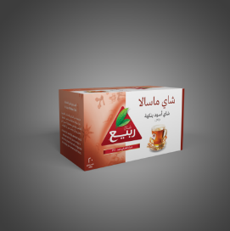 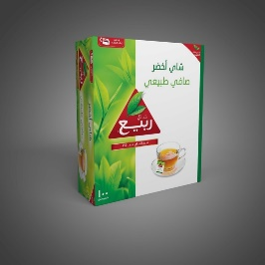

The new Packing has introduced its packing quality of providing a foil inside the packing to maintain the freshness of the product. The new Packing of the product is expected to make a drastic change in the Bahrain Market.

**Place**

Rabea Teas are conceded by other supermarkets, Hyper markets, Retail Stores ,Whole sale Market and in Down Trade Markets. Rabea Tea has about 500 retail locations in Bahrain and sells its products all over in Bahrain. The Wide rage of Distribution locations by Ali Rashid Al Amin makes Rabea tea to Avail its Product all over Bahrain. Rabea Teas long term plans to reach all the people in Bahrain at an easy access.

As per the market survey in 2019 these are the top Sellers of Rabea tea in the Bahrain market:

Helli and Carrefour tops the most Rabea Tea Selling Outlets in Bahrain, Followed by Ramez Trading, Lulu Hyper market and so on…

**Price**

The Pricing Structure for Rabea Tea is very competitive in the market.

Proving a good quality Tea for a Competitive rate makes other tea brands to sell their product Difficult. Having the Largest Tea Factory of Rabea in the neighbouring Country- Saudi Arabia makes it easy for the availability and accessing the product.

The cost cutting for the Rabea tea is mainly due to the reduction of Transportation cost and easy availability.

**Promotion**

There is a huge promotion going on in the market for Rabea tea. Most of the outlets such as Carrefour, Helli, Lulu are filled with the Rabea Tea Gondolas and Shelfs. Different Kinds of promotions are being offered by the Rabea Tea. Also, to get familiar with the product Rabea Tea is also Conducting Many Tasting Campaigns in different Outlets in Bahrain.

Some of the promotion photos are attached Below:

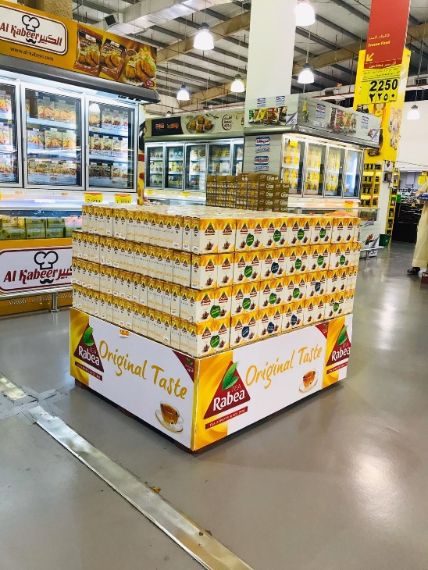 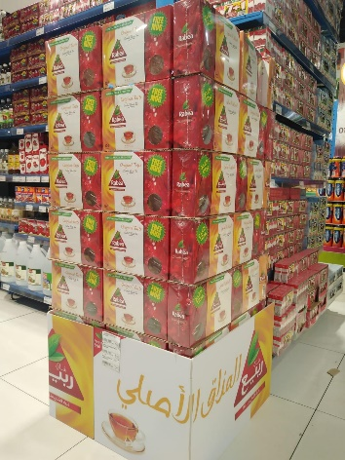 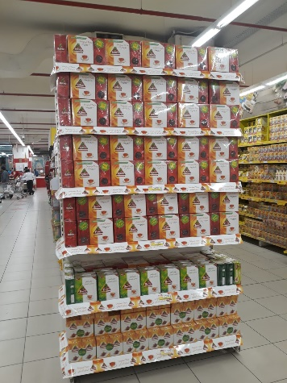

Due to the Huge Promotion activities conducted in the Bahrain Market , Rabea Tea is at its Growing Stage and it is at its Good Stage.

The marketing communications mix is effective because Rabea Tea attracts new customers and creates balance between keeping existing customers. This is one of the strengths of Rabea Tea. Rabea Tea has introduced its offers to almost all the outlets at the same time in Bahrain. Print advertisement in general, simple but send a strong message. The Advertisement exceeds the expectations of everyone with these Teas and they are able to demonstrate on the rise for consumers. Promotion of Rabea is best, Rabea Tea uses Commercials or billboards as ways to make its targeted customer aware about its offers. But Rabea Tea needs other ways for promotion as to encourage more new products. Then it may use the environment and can create brand awareness. Marketing implication is that Rabea Tea is Planning its marketing strategy for online ecosystem. This means that Rabea Tea is preparing to cut for television and print advertising and increasing to the social media.

Rabea uses direct marketing to promote new products to the target market. These new products are usually advertised heavily. However, to make a bigger impact, Ali Rashid Al Amin uses salespeople to approach certain organizations or individuals in target market segments .As the Rabea Tea approaches Catering organizations in Hotels and Restaurants to promote its products. Rabea Tea uses direct marketing to establish stronger relations with target customers and motivate them to purchase the company’s products.

**Conclusion**

It is seen from market and company’s analysis that Rabea Tea has the potential to execute its

objectives and can offer new products and expand its share so by looking to Rabea’s overall

strategies and objectives the following points are recommended:

• It should broaden its product range as providing Different Flavoured and healthy products

• It should increase its marketing communication ways i.e. using of social media

• It can have collaboration with some Coffee brands and try for some Changes in the Market.

• It may have proper management in controlling the labour issues.

• It may include online Recipes to make the customers try their item at different Styles

• Rabea Tea could have merger and acquisition with other companies to expand its business and to implement its Global growth strategy of 2022 to attain sustainable, long term growth across its global portfolio of business.

-------------------------------------------Thank you--------------------------------------------------------