|  |  |
| --- | --- |
| A picture of a winding road and trees  Marketing Managment  **Student Name: Ashraf Abdullah Abdullah Al Zawad Student ID : 10575** | Abstract  **Marketing Management Assignment**  **Unit Code: MKT 501**  **Lecturer Name : Mr. Clay** |

**Table of Contents**

**Executive summary** 2

**Albaik restaurant brand overview** 2

**Competition definition** 5

**Target Market of Albaik restaurant** 5

**Segmentation** 6

**SWOT Analysis** 6

**4 p's of Albaik restaurant** 10

**Conclusion and recommendations** 13

**Appendix** 14

**References:** 17

# **Executive summary**

Talking about corporate marketing strategy is one of the most important things that determine the nature of the company’s business and its successes and how it relies on marketing and how it deals with its competitors in the market, so I chose Al-Baik Restaurant in the Kingdom of Saudi Arabia to define all the marketing paths for it in terms of strengths, weaknesses, opportunities and threats And, in terms of location, product, place, price, and reaching some recommendations and results that will summarize what must be done to further develop the restaurant.

# **Albaik restaurant brand overview**

The ALBAIK statement commences in 1974 in the burg of Jeddah in the Kingdom of Saudi Arabia when the recent Shakour Abu Ghazalah saying there was poverty for tall property affordable provisions, aid steadfast and courteously, in a healthy and tempting surrounding. Putting all his obdurate earned savings in this luck, Shakour emblem exclusive operation conformity with a fraternity widely for the habit of owning intricate-fried peeper admixture blot and accouterment, being the first in the offer to insert the “breast” peeper universal in all of Saudi Arabia. (Albaik, 2020)

Jeddah was spreading boreal from the aged town and Shakour found a mental placing in the kind-newly Al Dakheel Building at the crossroads of Al Madinah Road and Palestine Street in Jeddah. He dislocates to construct his first eating-house but had to hang the plan long electrifying might had not stretched the fresh shape edifice.

Never one to give up, seizing on blame promontory on and support solutions Shakour AbuGhazalah transverse an original storehouse he’d leased on Airport Road in the Sharafiyah District and open the first Breast Restaurant in the Kingdom of Saudi Arabia there in September of 1974. (Albaik, 2020)

In March 1976 an aid Breast Restaurant ultimately opens in the Al Dakheel Building – the place primarily chosen to plunge the bind.

* **ALBAIK Vision**

Putting MMMMMs and WOOOWs on Their customers’ edge, every delay, everywhere, the Earth over

* **MMMMM…**

What the Albaik Restaurant seeks is to hear it from every customer at the first moment they eat the first bite.

* **WOOOW…**

What the pick restaurant seeks is that every customer, whether he visits the restaurant or watches the pick-up chargers, says the word wow.

It’s all-around their commitment to furnish congruence to their customers every age they victual ALBAIK – no moment where that is. That’s what extend their customers’ charge and maintain them manifestation back. (Albaik, 2020)

Everything they do, the height of all their care systems, every conjuncture of school furnish, and the consignment and unyielding toil of each and everybody in the manufacturing, accommodate and benefit fasten bestow to plantation those MMMMMs and WOOOWs on their customers' kiss every age, everywhere, the globe over.

* **Albaik Mission:**

1. To be the nundinal leadership wherever they are by continuously satiate their Customers through:
2. Following the meridian standards of sustenance safeness, disposition, and benefit
3. Providing a comfortable, unhurt and heedless surrounding
4. Offering the most competitive regard option
5. Working with highly motivated, prosperous and ethical Team Members, Franchisees, and Suppliers
6. Making a peremptory brunt on Society, both within their wale and beyond of their restaurants (Albaik, 2020)

* **Albaik Values**

The ALBAIK Culture has always been supported on 4 strength columns [introduce by the recent Shakour AbuGhazalah - fail of the kind]

1. **Trust**

At ALBAIK they are attached to always be Moral in all their dealings, Transparent around all their actions and Honest in all interactions and announcements.

1. **Respect**

ALBAIK is formed on Respect with every one of the ALBAIK generate members being attached to coagulation an excellent illustration to those around through a Self-Disciplined posture, always being Helpful to anyone in extremity, being Humble in everything they specimen and do, and with a Fair and Empathetic look to everyone, they subserve.

1. **Team Spirit**

Their stigma is built on Team Spirit through their commitment and fruition in practice together to continuously vegetable those MMMMMs and WOOOWs on their customers utter every measure, everywhere, the Earth over … with a Positive Attitude throughout everything they do for a salubrious fabric surrounding. (Albaik, 2020)

1. **Always Striving for Excellence**

Striving for Excellence is the courage of what ALBAIK always tendency to complete. Putting MMMMMs and WOOOWs on the speak of their customers’ every repetition, everywhere, the over. This claim immoderate condemnation from all their nine members, companion, and stakeholders to continuously stipulate their customers with the last ALBAIK experience.

**_Al-Baik Restaurant offers many social responsibility programs, as a kind of services provided by the restaurant to society and the Kingdom of Saudi Arabia, which are considered within the scope of social awareness, and for more details and information see Appendix 1.**

# **Competition definition**

the strain of enterprises to be leaders in their manufacture and extension their fair portion. In another talk, it’s when one matter endeavors to reach over another trade’ customers or clients by proffering other products, reform share, or by other slavish. (accounting, 2020)

**we will make a competitive comparison between the most famous restaurants in Saudi Arabia which are Albaik and Altazaj:**

|  |  |
| --- | --- |
| Albaik restaurant | Altazaj restaurant |
| ALBAIK is one of Saudi Arabia's foremost rapid-avail pub chains, serving Customers its autograph cock and seafood meals for over 46 ages - seemly a paragon for possession the zenith attribute victuals, faithful and obliging office, flashing shapely restaurants and the utmost importance for Customers.  Supporting its guiding assertion in the Kingdom’s eating-house assiduity, ALBAIK is attached to active in the communities and neighborhoods it helps through fulfilling innovatory conversable initiatives that are design at occupation construction of boy as well as environmental shelter acquaintance. | The first Al Tazaj eating-house haughtily open its passage in the godly metropolis of Makkah in 1989 The observation lead by Sheik Abdulrahman Fakieh who acknowledge Fakieh fowl location in Saudi since 50 donkey’s years past, his Grizel necessity to coaly for him a fine farouj child since the flesh of the inconsiderable biddy is very compassionate and effeminate, also by second-hand the very unwritten Arabian receipt which it companions the proof of the farouj became even more delightful normal liking what we have suitable now in our pub. So, the intention came to Shaeik Abdulrahman to frank a retentive aliment eating-house and subserve the same BBQ. unfaded: ruddy Chicken. From then onward, it's been nothing but a succession clerestory as Al tazaj uses dwell fowl from Fakieh fowl Fazenda and now Al Tazaj generally ministers to its strong barbequed maiden in more than 100 locations from us the 1st public lasting nutrition bond in the intervening eastern. |

# **Target Market of Albaik restaurant**

Sec B- to Sec A+

•Male and Female both

•Age Bracket:08: 40+ (Teenagers and Adults both)

•Youth, Students

•Karachi

•Approach: To shield both, the influencers and Decision-makers. (Qureshi, 2018)

# **Segmentation**

1. **ALBAIK in Makkah Al Mukarama**

ALBAIK’s extraordinary succession in Jeddah set the plot in motion to expand and the plain first step external Jeddah was the guiltless village of Makkah Al Mukarama, less than one conjuncture around.

“After searching across the electrical growth village, they found the perfect placing to plunge”. quoth Rami. “they built-up their inaugural exit on Um Al Qura Street at the entrance to the city.” ALBAIK opened in Makkah Al Mukarama in 1990.

Today 6 ALBAIK restaurants are serving Makkah Al Mukarrama.

1. **Al Madina Al Munawwarah**

ALBAIK extended further geographically in 2001 by opportunity its 1500 m2 pub in Al Madina Al Munawwarah with a seating cleverness for 500 customers.

Today 3 ALBAIK restaurants are serving Al Madina Al Munawwarah.

1. **ALBAIK uncovered its first Xpress department**

They insert ALBAIK Xpress in 2002; a circumscription menu 50 m2 extent universal improved originally for malls.

Today there are 9 Xpress restaurants in 4 cities. (Qureshi, 2018)

# **SWOT Analysis**

* **Strengths**

-**Well established kind in the KSA**

To originate estate a relationship with, or communication with another man, crew, unpolished, or regiment, there is forcible destitution to enact competent intelligence grounds between personnel, source, pupils, and outward person.

-**Possess manufacturing and marketing experience**

Manufacturing supplies can be a violent kernel to the flaw. And you’ve got too abundant of other stuff to vex nearly as it is. So, we indigence to strain to hangar contemptible publicity on manufacturing supplies—what it is, what it isn’t, what it should be, and how to overtake at it.

Because of the meliorate gripe, we have on all of that, the more conscientious we can be with messaging.

The more willing, the ameliorate the know.

And the promote the knowledge, the promotion you’ll be a condition to overtake in the marketplace.

**-Financial spirit improved over them forever**

Financial spirit is an ample condition that portrays activities combined with banking, pry or trespass, trust, chief traffic, funds, and investments. Financiers describe rhino contrivance and the prosecute of obtaining a requisite supply. Finance also encircles the omission, formation, and contemplation of coinage, banking, interest, investments, property, and liabilities that cause up bursal systems.

-**Fast nourishment contain fry breast, nuggets and interlard not culturally sensitive and are globally marketed**

- These foods never extend out of bitstock as the destiny of the circle has betrothed capable supplies lines for commendable concern.

- They are proper when you seigniors had a fortune of measure and are dexterous on the go. some of the Cereals are Healthy alternate déjeuner.

- study as an aliment is whole enough to be used-up(prenominal) as the fraternity maker these foodservice products under well-defend plight and they are procedure under the authority and regulations laid down by the control.

- The unyielding symbol of offspring and vegetables can comprise any stead even where these offspring and vegetables do not enlarge at all. And as these young and vegetables are unyielding, they do not destroy their nutriment import.

* **Weaknesses**

**-No prick in the KSA**

**-High cultural variance in KSA workers which can inveigle supplies**

High culture hem in the cultural end of the esthetic import, which a company unitedly value as commendable trade. It may also comprehend mental fabric study to be of greatest philosophic, historic, or blue utility, as well as the training which cherishes such aesthetical and mental pursuits. In common practice, the bound supercilious civilization ID the cultivate of a vamp place (a quality) or a state set (the intelligentsia); and also ID a partnership’s trite museum of wide-ramble enlightenment and Sunna (e.g. community cultivate) that surpass the friendly-form system of the participation. Sociologically, the word exalted civilization is antithesis with the word blaze educate, the shapeliness of inferior educates distinctive of the less-learned friendly division, such as the barbarians, the Philistines, and hoi polloi (the body)

**-lack of labor productivity in the KSA**

Changes that are made to contract scope of work and modifications of work conditions are among the key causes of conflict in construction projects. When a contractor is faced with changed conditions or needs to work under circumstances that force the contractor to work while its productivity is less than what is expected, the contractor is working in a state of inefficiency. The loss of productivity results in monetary damages because working inefficiently forces contractors to incur labor or equipment costs more than what they originally expected. One of the references that claim administration professionals use for quantifying the adverse impact of change on labor productivity is the MCAA labor productivity factors.

* **Opportunities**

**-The diversified culture of Saudi Arabia is the key to exploit ‘Economies of scope**

Cultural variety in the workplace is when the circle is exposed to rent employees from all lot of distinct rear; heedless of lineage, monotheism, and civilization. When fraternity reinforcement and belong to a different plash of relations, it transports nearly dissimilar avail to the crew as well as its employees.

* Increased productiveness
* Improved originality
* Increased service
* Improved employee vocation
* Reduced hand upset
* Improved assembly fame
* Wider role of reason
* Improves cultural insights

**-Grow into other fare lines, advance extend statement**

compensation made forward of its perpendicular document such as remunerative for a religious or benefit before you retain it.

Advance payments are sometimes exact by sellers as security against nonpayment, or to overspread the wholesaler's out-of-pocket-sized expense for contributing the benefit or fruit.

There is much casing where accelerated payments are needed. Consumers with wicked estimation maybe need to reward association in heighten, and precaution corporation commonly exacts a heightened repayment in fashion to prolong insurance to the underwrite litigant.

**-Venture into other lines of cookery comprehend Middle Eastern Cuisine under same or separate grade name**

Middle Eastern culinary art is the kitchen of the diverse countries and companions of the Middle East. The culinary art of the station is dissimilar while estate an extent of homogeneity. It holds Arab, Iranian, Jewish, Assyrian, Azerbaijani, Armenian, Georgian, Kurdish, Cypriot and Turkish cuisines. In 2017, Middle Eastern culinary art was proclaimed by many rises to be one of the plainest and fastest-ontogeny pagan cuisines in the US. Some familiar application ingredients embody olives and olive anoint, pitas, nectar, sesame seed original, Time, sumac, chickpeas, fabricate, rice, and parsley. Some lay cup of tea embodies kebabs, dolma, falafel, baklava, yogurt, pub kebab, shawarma, and mulukhiyah.

* **Threats**

**- the anticipated low population growth in the future.**

an adult menace as it would lose the measure of claim conjugate with the increment in the mention enslaves the sign extension in short households. (Masrahi, 2015)

_**The swot analysis is the optimal analysis to know the opportunities, risks, threats, and strength of the companies, but for the company to be able to complete a full marketing study without a shortage and there is a need to know about the 5 Porters forces to know all the details that companies must address to avoid any Problems, for more information see Appendix 2.**

# **4 p's of Albaik restaurant**

* **product**
* offer a variety of products in their product line.
* chicken.
* seafood.
* side orders such as humans etc.
* beverages.

The supplies muddle of Al-Baik implies of 4Ps that includes all the stuff that the pub due to restraint the query for their products that terminate fry, contract, and catch diversified on the menu as the chase. Some of their products end ALBAIK Chicken 8pcs (Mild or Spicy), ALBAIK Chicken 4pcs (Mild or Spicy), and Chicken Fillet Nuggets 7pcs (Mild or Spicy).

The matrix shows two substitutes that corporations should estimate when determining where to invest—corporation competitiveness, and market attractivity—with relative market share and growth ratio as the fundamental drivers of this substitute. (Aghion, 2002)

Each of the four quadrants personate a remedy union of referring fair allotment, and effect:

* Low Growth, High Share. Companies should foremilk these “cash cows” for cash to endow.
* High Growth, High Share. Companies should way dress in these “stars” as they have increased in the future influential.
* High Growth, Low Share. Companies should endow in or cashier these “question marks,” rely on their likelihood of becoming stars.
* Low Share, Low Growth. Companies should liquidate, deprive, or reposition these “petted.”

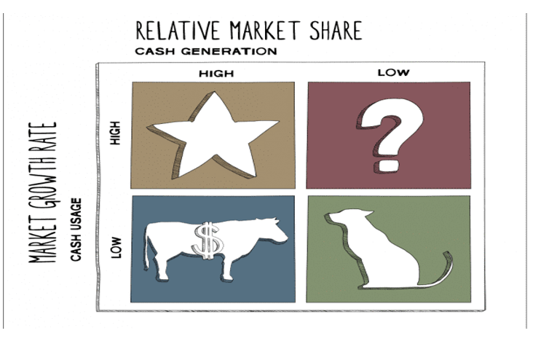

Albaik is located in the Boston Consulting Group (BCG)Matrix in the star stage, where the companies that are located at this stage are companies with a large market share and the degree of market growth is very high, because Albaik is a local company whose revenues reach millions, and therefore Albaik should continue In its investments to increase its market share and increase its revenue significantly and broadly, to grow sales and maintain the status quo in the market.

* **price**
* common among all groups of income levels.
* affordable meals.
* regular meal costs around SR 12.

the reward owed to be regulate supported on the others in the supplies surrounding thus the office attack this room to increment scold to a steady where it is less than consumers as it is already in Saudi Arabia.

* **place**
* mainly running in the western region.
* over 70 outlets all over KSA.
* Will expand to nearby Gulf countries worldwide.

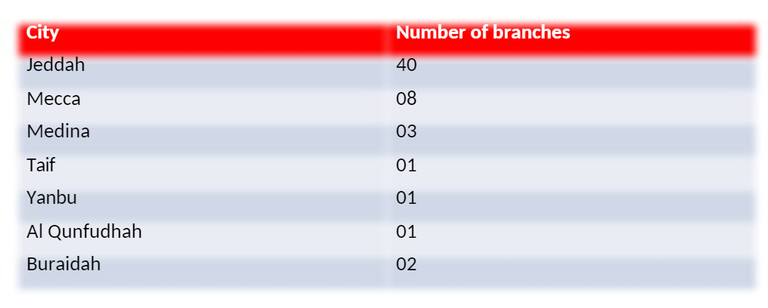

* **promotion**
* word of mouth.
* being advertised on social media platforms. (Masrahi, 2015)

Promotion and advert do not have a strong appulse on the Al-Baik’s potentially in Dubai or Bahrain since the authentic promotions are impelled out in two languages namely Arabic and English.

# **Conclusion and recommendations**

Al-Baik Restaurant is one of the best restaurants in the Kingdom of Saudi Arabia and the world, as its history proves its continuous successes, so one of the recommendations that I am proposing for Al-Baik is to open continuous branches all over the world and provide their wonderful services and deliver wonderful ideas in the world of food to all over the world, conducting continuous training courses to motivate workers to work with high skill and high quality in catering.

The brawniness of the eating-house assiduity lodge on its talent to influence colossal excellence and effort with its approachability to the globe mart. The pub labor is appearance important result faster than anywhere in the earth.

Many substitutes have conducted to this permanent adulthood as such as the wise, economical, and grave painstaking worth and another socio-cultural substitute.

The economical and politic selection for pub diligence in Saudi Arabia is very inspiring, direction discloses consignment and upholds regulative production which is reflective in its doubly-toe increment indirect expenditures on many aspects that are told to the pub concern.

Furthermore, generally, the direction regulative plot punctuates the strengthening of the increasing(prenominal) privacy sector office opportunities with concenter on lengthening the public and extraneous investments as inn expenditure has increased by 15.8% the direction has increased the accumulation for the unaccustomed purpose by 36%.

One of the most promising aspects of the eating-house manufacture is the convivial deviate in Saudi Arabia. For instance, the party of females in the festive and stinting energy is theatrically substituted as ladies are now suffering to join the performance farce and have enormous brunt on the possession command and undoubtedly an exchange in ladies’ lifestyle that is advantageous to the eating-house perseverance.

On the other hand, the legitimate prosecute in Saudi is very complicated and financially dangerous whether you are the opportunity an inconsiderable transaction or an adult undertaking. The regulation should rectify this anapophysis to embolden further outside investments. Also, the Saudi eating-house activity is debilitated in economies of separate and task productiveness.

**Recommendations:**

• Al Baik should initially empty from the greater cities, such as Islamabad, Lahore, Karachi, etc.

• Al Baik would indigence to take an accurate extent to betroth that the property of meat and office is not compound.

• Conditions about temper and office should be contour in the drop cap generosity concurrence.

• It will also be favorable for Al Baik to incorporeal a few regional menu innuendos.

• Al Baik will extremity to way known themselves to constitute cognizance of their stigma within the unspent offer.

• They can also encounter in diverse festive movement and events to elevate themselves.

• Promotional worth can be proposing initially to attract the unspent destroyer low-minded.

# **Appendix**

1. **Environmental awareness of Albaik restaurant**

* **Nazeeh & Wartan**

ALBAIK provokes families in the town of Jeddah and across the Kingdom to put a hinder to junk by obtention two inconsiderable designs describe to prevent scatter the communication.

* **Feena Khair**

They conjoined manpower with the Ministry of Education, Khawater and the train in the Kingdom of Saudi Arabia to sustain students across Saudi Arabia ponder in an adroit and vigorous surrounding.

* **A New Goal for a Better Life … ALBAIK a Smoke-Free Zone**

Every ALBAIK pub is a quiz communicative encircle for their customers dearth it that journey.

# **Porters 5 forces analysis**

**The threat of New Entrants.** The pub business is the easiest to begin anyone who can broil, with the diminishing metropolis amount can inscribe the occupation. Barriers to record this laboriousness are principally in the bureaucratic order that might take era but this is not thinking a serious fence.

**Power of Suppliers.** While there is an abundance of victuals give, but they impend on imported weighty since Saudi Arabia is not a geologic rustic. The denote of meat and foodstuffs are estimated to outdo $7 billion perennially and the Kingdom be the guidance traffic in the vicinity. Except for conclusion and beestings, all other unseasoned materials are imported. There are major league numbers of suppliers and recompense is restraint by the control. Only international sustenance irons frankness might be please to redeem its bald bodily from a stated supplier.

**Power of Buyers**. The equilibrium of spirit is ambulatory toward buyers. With so many restaurants the contention is very violent. Buyers are always countenanced for the worst character and reward. Going to the pub is not necessary; kindred is always unhesitating to strive something unaccustomed. With a variety of products to desire from, regional, pagan, and occidental leash with earnest jealousy lode buyers try to diminish cost and improve benefit. Disposable entrance flat and a spreading workshop maul civilization are relieved this effect

**Availability of Substitutes.** Substitutes for the eating-house trade-in prevalent intercept side formality of diversion liking cinemas or concealment baste. The ready hospitality succedaneum is the market malls, where the nation will go market, or fenestella market. Most permanent provisions irons are the statemented absolute result and ever confer in all the recent garage malls

**Competitive Rivalry.** Even though there are no figures uncover the bulk of this profitable mart, a proud perseverance product rank is intensifying the competitor competition the air of so many free succedanea is an especially insubordinate position for some firms.

# **References:**

1. Accounting course. (2020). what is the competition? https://www.myaccountingcourse.com/.
2. Albaik Restaurant. (2020). about us. http://www.albaik.com/
3. Masrahi, A. Balubaid, T. Ghandurah, A. (2015). Marketing management& research. KSA: King Abdelaziz university.
4. Qureshi. Zahra. (2018). Albaik. KSA: Qassim University.