

**MARKETING MANAGEMENT**

**SBS MBA/MSc**

**Assignment – Bahrain 2020**

|  |  |  |  |  |
| --- | --- | --- | --- | --- |
| 1 | 0 | 0 | 0 | 8 |

# STUDENT ID

UNIT TITLE / CODE: MKT501_______________________________________

# NAME (in Full): Ahmed Kamal Mazhar__________________________________

**GENERAL INSTRUCTIONS**

* All assignments are to be submitted **14th May 2020** on to examinationboard@atmsedu.org and cc to azrafatima@atmsedu.org, assignmentsubmission2019@gmail.com
* If assignment is not submitted on date, will follow with penalty of 10% deduction of marks for every day.
* Similarity between students work is strictly not accepted, any student found with similar work will be graded Zero and fail for the course. However, Plagiarism is an academic offence and will not be tolerated under SBS
* Assignment once submitted to exam board is final for marking.
* Total 100 marks

**GUIDELINES FOR ASSIGNMENT**

* 1. If assignment is Question & Answer based then.
     + Introduction is needed for each question.
     + Question has to be answered based on the mark allotted for each question with references if any idea or information is taken from other source.
  2. If assignment is case based then,
     + Executive summary
     + Table of content
     + Body of assignment (questions related to case need to be answered)
     + Conclusion / Recommendation if any
     + References (in-text + citation) to be used

**Total Marks / 100**

**PLAGIARISM**

Plagiarism is a form of **cheating**, by representing someone else's work as your own or using someone else's work (another student or author) without acknowledging it with a reference. This is a serious breach of the Academic Regulations and will be dealt with accordingly. Students found to have plagiarised can be **excluded from the program**.

Plagiarism occurs whenever you do any of the following things without acknowledging the original source:

* + Copy information from any source (including the **study guide**, books, newspapers, the internet)
  + Use another person's concepts or ideas
  + Summarise or paraphrase another person's work.

**How do I avoid plagiarism?**

To ensure you are not plagiarising, you must acknowledge with a reference whenever you:

* + use another person's ideas, opinions or theory
  + include any statistics, graphs or images that have been compiled or created by another person or organization
  + Paraphrase another's written or spoken word.

**What are the penalties?**

The penalties for plagiarism are:

* + Deduction of marks,
  + A mark of zero for the assignment or the unit, or ✓ Exclusion from the program.

Plagiarism is dealt with on a case-by-case basis and the penalties will reflect the seriousness of the breach.

**Please note: claiming that you were not aware of need to reference is no excuse.**

# **Marketing Management Assignment Structure – Marketing Strategy (Brand)**

For your brand of choice please prepare a marketing strategy on the below guidelines. This should clearly reflect the marketing mix – product, place, price, promotion and packaging as discussed in the class. The learnings on Brand Equity in the class should be the emphasis of the assignment.

Please note the brand should have linkage in the UAE – must be an existing brand or a brand that intends to be introduced in the UAE.

1. Executive Summary – summarizing points 2-8.
2. Brand Overview – describe the current status of the brand with a brief historical background. Also define the brand’s current state on the Product Life Cycle.
3. Competition Overview – Define competition
4. Target Market – Define who is being targeted
5. Segmentation – Demographic, Behavior, Psychographic
6. SWOT – on brand or industry
7. Market Research if any carried out – if no research carried out then suggest a need if any
   1. Product – BCG matrix. Also include packaging plans if any.
   2. Place – Choice of retail strategy
   3. Price – penetrative or skimming or competitive
   4. Promotion – pull or push strategy including choice of medium – digital or traditional
8. Conclusions and Recommendations – suggestions for change in current practices if any to make it more effective should be discussed.
9. Appendix – Any other information you may provide.

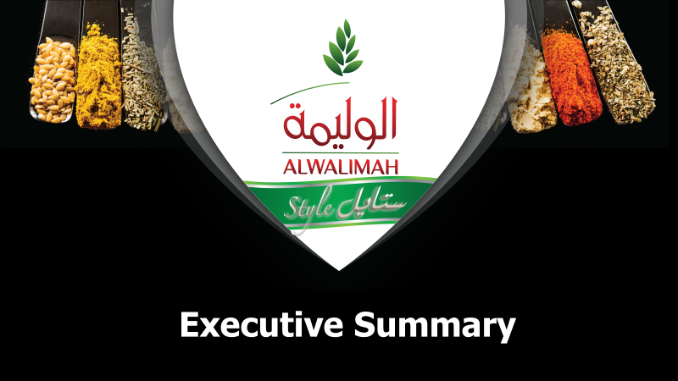

The innovative culinary trend in Saudi has attracted various flavored hot, cooking and instant sauces while Cooking sauces are majorly used to provide instant taste to the cuisine.

Rice is a staple food in Saudi Arabia that is served for lunch and dinner, traditional dishes called Kabsah & Biriani are widely consumed in Saudi and non-Saudi homes with a long cooking process.

AlWalimah brand is part of Mayar food company which operates in this field since 1946 and has 6 different Rice brands with highest contribution to AlWalimah Rice which has a strong brand equity and position in the rice category in KSA.

The company has invested heavily in the R&D in order to invent a product that can ease the cooking process of the traditional plates and ensured to link its POWER brand AlWalimah.

AlWalimah sauces compliment the rice to deliver a consistent delicious plate while saving time and deliver high convenience.

AlWalimah sauces had a great launch and managed to grow sales and shares consistently while competition is hard within a growing segment, AlWalimah team has determined their target audience and directing all their funds to maintain and recruit new customers through digital medium.

AlWalimah sauces has reached the Question mark quadrant, it is still building market share and

While AlWalimah Rice consider to be the Cash COW product based on the high sales volume within low growth category.

AlWalimah team should continue with their strategy with some improvement;

* Stay investing on the pull and push strategy in order to defend their position vs competitors as well as recruiting and educating new customers.
* Ensure introducing new flavors as an extension for the existing successful variances to capture the missing segments where competitors are enjoying alone.
* Add new distribution channel.
* Expand and introduce the product in other GCC countries

**Table of content:**

1. Executive Summary
2. Brand Overview
3. Competition Overview
4. Target Market
5. Segmentation
6. SWOT Analysis
7. Marketing Mix:

Product & Package – Place – Price - Promotion

1. Conclusions and Recommendations
2. Appendix.

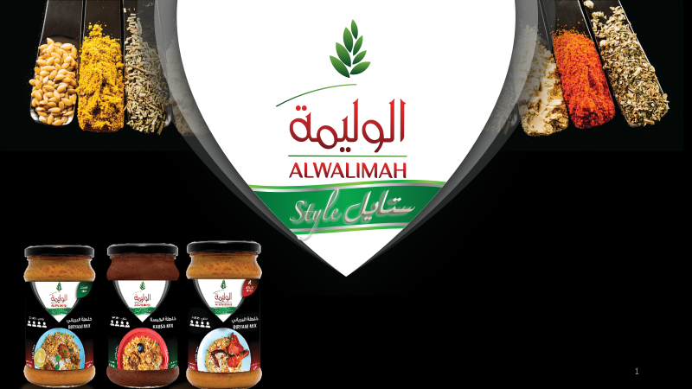

**2. ALWalimah Style Sauces Brand overview**

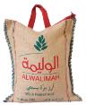

The story of AlWalimah Rice brand began in 1994 when it was launched in KSA market, an Indian rice cultivated in the states of Punjab and Haryana in the fields of northern India (1),

AlWalimah Rice brand has a strong # 2 position in KSA market with a strong brand equity and salience (2).

Rice is a staple food in Saudi Arabia that is served for lunch and dinner. A traditional dish called kabsah is widely consumed in Saudi homes. The majority of Saudis include rice as a major part of their daily diet.

Saudi Arabia’s rice per capita consumption is estimated at 35 kg/year. For MY2017/18, total rice consumption is estimated at 1 million MT. The total rice consumption is expected to increase by about 2 percent to 1.1 million in MY 2018/19 (3)

Saudi Arabia has been ranked 47th within the group of 155 countries in terms of rice consumption per capita, 7 places above the position seen 10 years ago. (4)

Leveraging the size of the Rice category and consumption per capita rate while building on the strength and equity of AlWalimah Rice the company has decided to extend the success of AlWalimah brand and to introduced AlWalimah Style Sauces in September 2019, they were the first local brand to enter this category after launching in the supermarket channel with 2 variances and 3 different Sku’s, their main objective was to show how the sauces complements the rice and propose a package solution brand for convenience and saving time for mother to spend more quality time with her kids .

Saudi Arabia – the third largest importer of spices in the world after the US and Spain, according FAO 2010 data – is ranked as one of the fast growing markets for food products in the Gulf region(5)

For further information on AlWalimah Rice vision, rice category overview and AlWalimah Sauces history and previous launches trails check (Appendix 1)

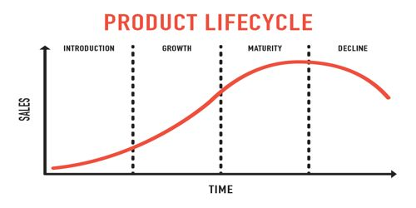 (6)

AlWalimah Style sauces are in the growth phase now focusing on build brand preference and increase market share, the unit cost started to decrease due to the increase of the sales.

The company has invested heavily in the introduction phase through building product awareness and develop a market for the product with a differentiated positioning.

**3. Competition:**

AlWalimah Sauces compete in different categories with many players and one common

advantage; it is the only recipe which doesn’t need any additives during the cooking journey,

Super easy use just adds Rice, Sauce and the chicken or meat or Shrimp.

That strengthen its position vs competitors in the same segment when it comes to COST, TIME efficiency, convenience & consistent exact delicious taste every time.

1. AlWalimah sauces compete with the dry spices.

|  |  |  |  |  |
| --- | --- | --- | --- | --- |
| ***Brand*** | ***Nature*** | ***AVG price -SR*** | ***Strength*** | ***Weakness*** |
| ***AlWalimah Sauces*** | Ready to use | 13.95 – 300gm | Trusted brand – strong equity | Limited assortment |
| **Mehran** | Dry spices | 7.50 per 50 gm | Big assortment-multinational brand | Weak distribution network |
| **Isad** | Dry spices | 15.75 | Local manufacturing | New to the market |

1. AlWalimah sauces also compete with the food enhancers (additives).

|  |  |  |  |  |  |
| --- | --- | --- | --- | --- | --- |
| ***Brand*** | ***Nature*** | ***AVG price*** | ***Price per gm*** | ***Strength*** | ***Weakness*** |
| ***AlWalimah Sauces*** | Ready to use | 13.95 – 300gm | 0.0465 | Trusted brand – strong equity | Limited assortment |
| **Maggi** | Food additive | 8.50 – 200gm | 0.0425 | Trusted brand – strong equity | Very small business, less focus by Maggi team |
| **MF** | Food additive | 11.50 – 250gm | 0.0460 | Big assortment | New in Saudi market |

Appendix 2 covers further analysis on the dry spices market overview by Retail Audi - NOV 16

Appendix 3 show AlWlaimah sauces and its competitors.

**4. Target Market: (7)**

AlWalimah sauces are targeting Mum’s 25-45 years old saudi’s and Arab expats who are pasionate about serving a delciouse traditional plates at home with the best quality and freshness to her beloved , simultaneosly reduce the time spend in the kitchen while preparing the meals so she can spend more quality time with their kids , families and friends .

**5. Segmentation:**

**Demographic:**

* Females 25-45 years Saudi’s and Arab expats, workers and house wives.

**Psychographic:**

* Mum’s are always eager to ensure serving the SAME BEST taste for her family every time.
* They want to spend more time with family and friends while cooking the famous traditional plates Kabsa and Byeriani which require a lot of efforts and ingredients during the preparation for in home cooking.

**Behavior:**

* Our target audience are people value the quality and freshness of their food.
* People want to reduce the time spend in the kitchen while preparing the food.
* Medium and heavy users of sauces and spices.

**Geographic:**

* GCC

**6.SWAT Analysis:** (8)

**Strengths:**

1. The company is part of a bigger group which give it a higher financial stability. (9)
2. The company is investing heavily in the automation systems of the day to day operation process, supply chain and HR to boost the company efficiency, reduce cost and upgrade its process for the future.
3. The company is operating since 1946 with different brands, AlWalimah brand is operating since 1994 with high brands equity, heritage and quality.
4. The Company has robust distribution network with territories covering the entire kingdom and dedicated sales force.
5. First Rice distributor in KSA with distinctive relationship with the suppliers from over 75 years.
6. The company is investing heavily in R&D project (AlWalimah Sauces are the first project)

**Weakness:**

1. The company is investing less frequent on ATL and BTL campaigns on the Rice brands.
2. The company depend on outsourced supplier with production constrains in peak seasons which put the company on supply risk and expansion limitations.
3. High turnover in management level creating a disturbance in the functions strategies & way of operating the business

**Opportunities:**

1. The Sauces category is growing leveraging the easy solutions proposed for the customers by reducing the cooking time and ensure consistent taste every time vs normal cooking practices.
2. The presence of competitors like; Maggi & MF widen the competition and the choices for the customers, in addition has encourage the retailers (supermarkets) to give the category more focus after the great sales and good margins as well as the customer preferences.
3. The other GCC countries has also a great preference for AlWalimah Sauces successful variances which open for a great expansion opportunity there.

**Threats:**

1. Maggi is a great brand which has presence in different culinary categories, Maggi as part of Nestle has a strong brand equity and huge investment on ATL/BTL events.
2. Carrefour and Panda private labels has recorded success in most of the categories they operate, this might be a risk if they can manage to prepare an acceptable recipe.
3. **Market research:**
4. **Product:**  AlWalimah Sauces are newly introduced to the market in a category which exist but tremendously expanding over a short period, accordingly we can consider AlWalimah sauces in the **QUESTION MAREKS quadrant –** the brand is still building market share and the category is growing with the same momentum of AlWalimah Sauces.

AlWalimah Rice consider to be the **Cash COW** product based on the high sales volume and market share while the Rice category is overall stable and do not deliver a significant growth year over year.

**Packaging**,

AlWalimah Sauces are launched in glass Jars 300ml which give the customer a convenient for home usage and easy storage, the 300ml package on the retail shelves gives the impression of the size difference with the competitors (300ml vs 200ml and 250ml) due to the length and width package difference.

The package has a premium design and clear claim and communication for the product.

1. **Place:**

AlWalimah Sauces are distributed in selective channel, only retail supermarkets (Hyper and Supermarket stores), they have started by this channel which can create a massive awareness and distribution among the kingdom due to the presence of the chain supermarkets in majority of KSA cities.

Supermarkets in KSA are an essential destination that the whole family every week specially the hypermarkets which exist in the malls, AlWalimah Sauces captured these stores with high traffic in their sampling campaign during the introduction phase in order to build the maximum awareness and education for the customers.

1. **Price:**

AlWalimah Sauces prices are competitive vs competition due to the fact that no additional additives to be used in the cooking process, while the other competitors are offering the same price per gm.

They are following a penetration price strategy within the segment which is helping them in growing their sales and shares during the past 9 months.

1. **Promotion:** (10)

AlWalimah Sauces are following a mix between a push and pull strategy,

They create the push through running discounts to retailers and trade promotions as well as creating customer demand through constantly developing new products and offering these products in stores – while creating the pull by using advertising & promotion deals to build up customer demand for the product.

AlWalimah Sauces team focus on the digital medium by advertising the products on the social media platform and by creating the word of mouth and educating the users on the usage of the sauce through a well-trusted influencer on Snap chat, Instagram.

They have built this plan based on their target audience (25-45 years) whom spend long time on social media platforms, they are fast - looking for convenience and open for trails.

For illustration of AlWalimah Sauces push and pull strategy check Appendix 4.

1. **Conclusion and Recommendations**

AlWalimah Sauces have the right formula to continue succeeding within that growing segment, people are looking for convenience, good quality and strong brand to trust which are the main differentiator for AlWalimah Sauces.

The brand has established a good base during the introductory phase and now it should be looking on how to strengthen their performance, distribution and market share, they should be focusing on lifting up their 5 P’s;

1. **Product:** AlWalimah team should invest in product development and marketing plans in order to gain more shares while maintain the high sales.
2. **Packaging**: The R&D team should start directly in developing different sizes/flavors which can strengthen our position with the competitors and open the door for a new distribution channel, i.e.
3. 1 Kg sku for the hotels and restaurants business
4. Plastic bags for camping and travel.
5. New recipes for other traditional / non-traditional plats.
6. **Place:** They need to start distributing in other channels (i.e. wholesale market) which can increase the distribution in the large and medium groceries where the competitors exist.

Other GCC countries is a great opportunity to expand the distribution through based on the similarity in preference & dishes.

1. **Price:** AlWalimah team should maintain the competitive price /gm on the 300ml sku and look for smaller size with (higher price/gm) to boost the margin.
2. **Promotion:** AlWalimah team has done a great job during the launch of the product on the digital platform which they have to continue doing however they need to shift part of their investment into the in mall advertisements/activations to captures the traffic and increase the awareness, also in the booming of cinemas in Saudi Arabia it would be a great opportunity to run some activations their due to the similarity between their target audience and the Cinema visitors .

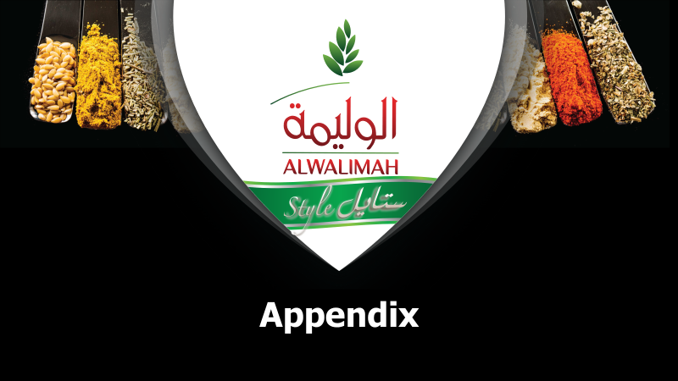

**Appendix 1:** AlWalimah Rice vision, rice category overview and AlWalimah Sauces history**:**

1. AlWalimah Rice brand **vision** is to help mothers to build family values through strengthening the family’s cooking enjoyment by providing them with a convenient quick method for cooking daily main dishes

b) **Kantar NOV 16 -** showing the Rice leading brands in KSA based its meaningful, difference, salience and power.

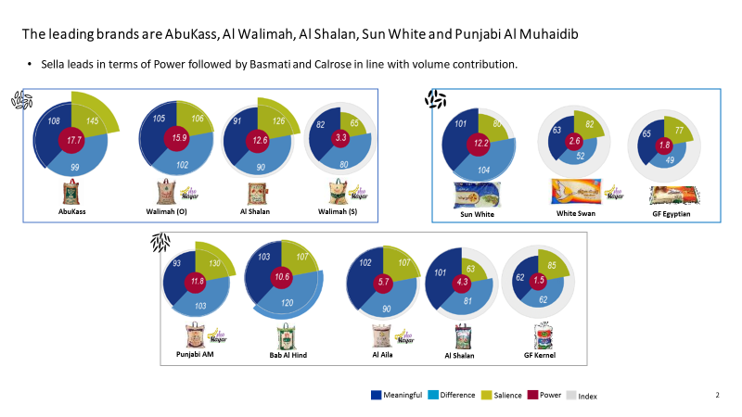

c) **AlWalima sauces history and previous launches;**

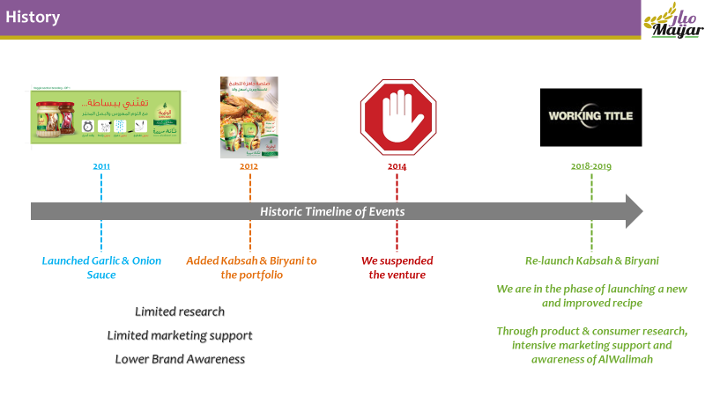

**Appendix 2 -** Retail Audi date analyzing the dry spices category

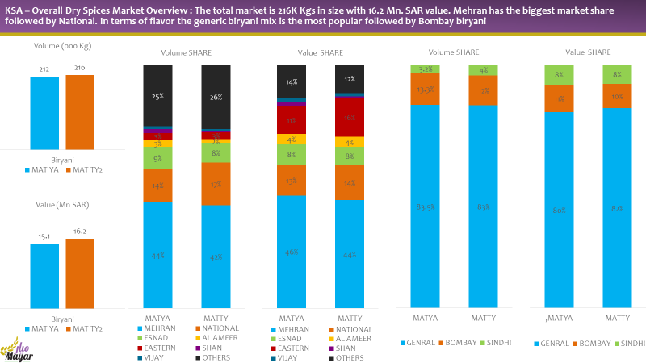

**Appendix 3.** AlWalimah sauces and its competitors

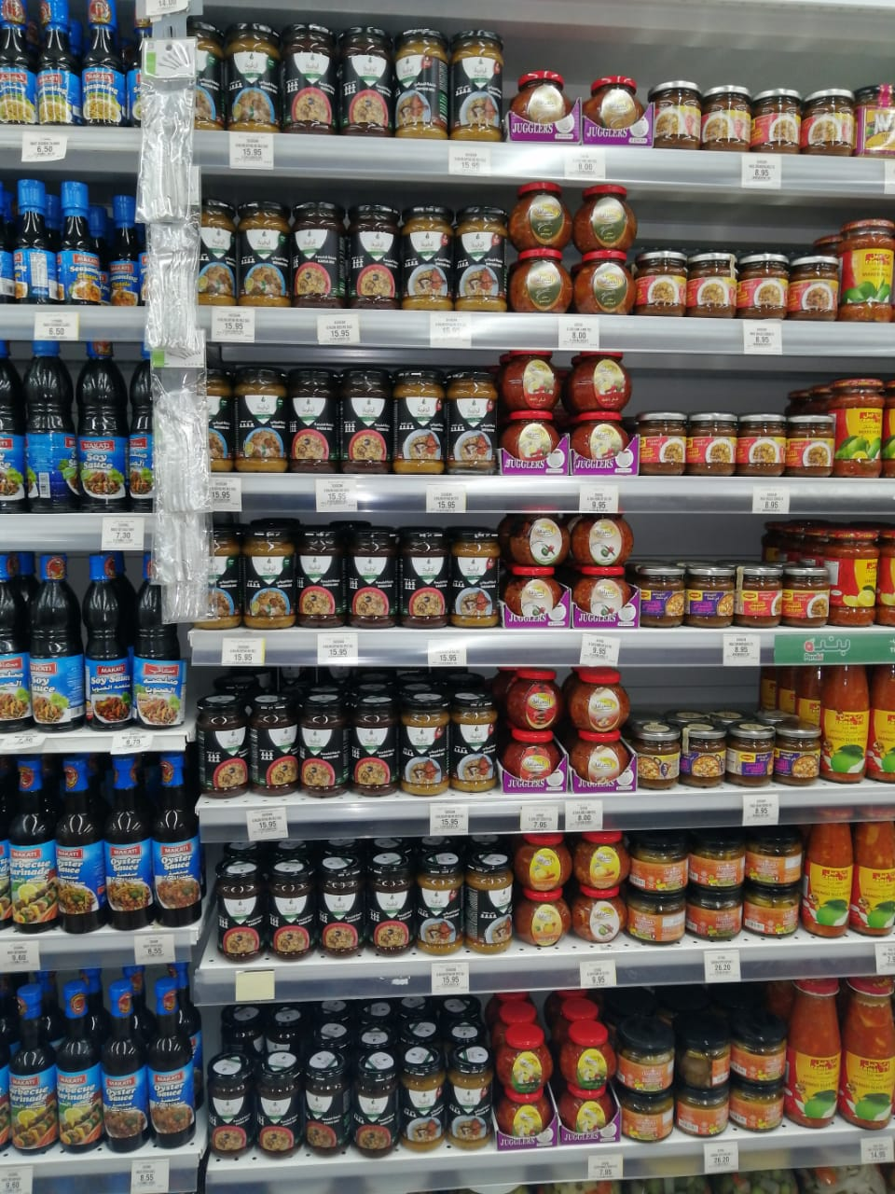 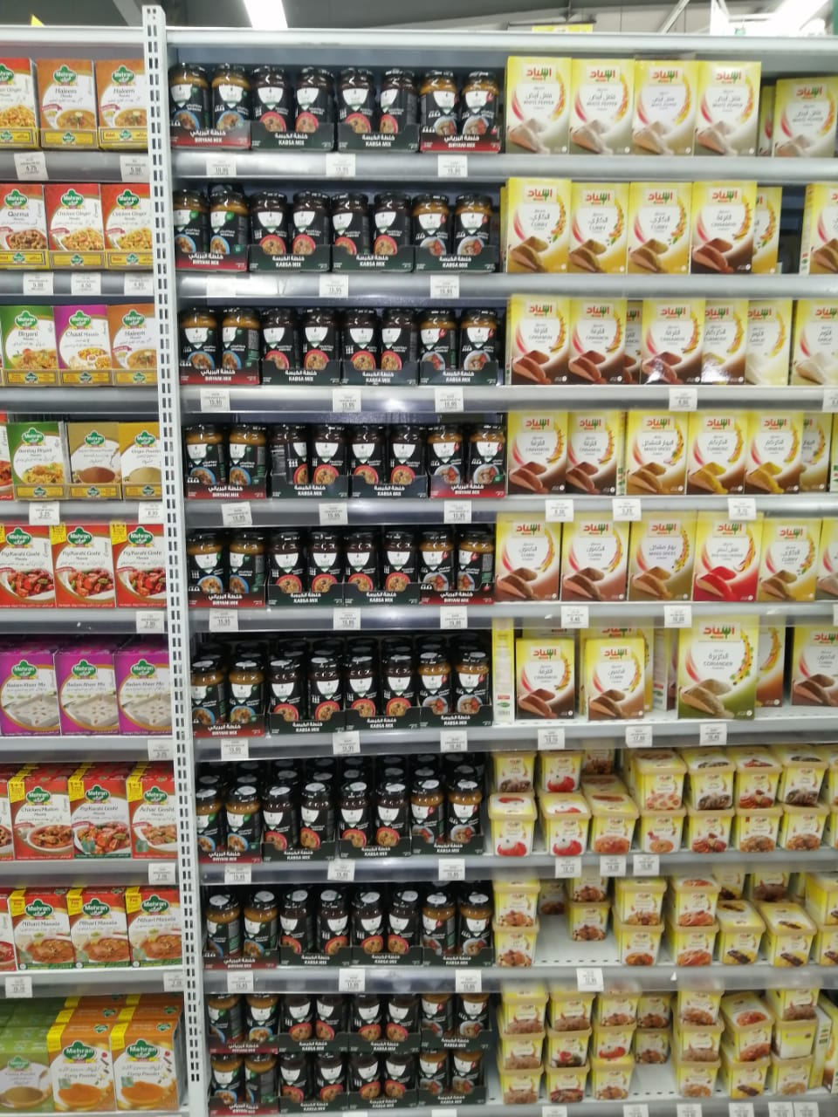

**Appendix 4.** illustration of AlWalimah Sauces push and pull strategy.

1. Cross merchandising with the Rice category and home shelf branding

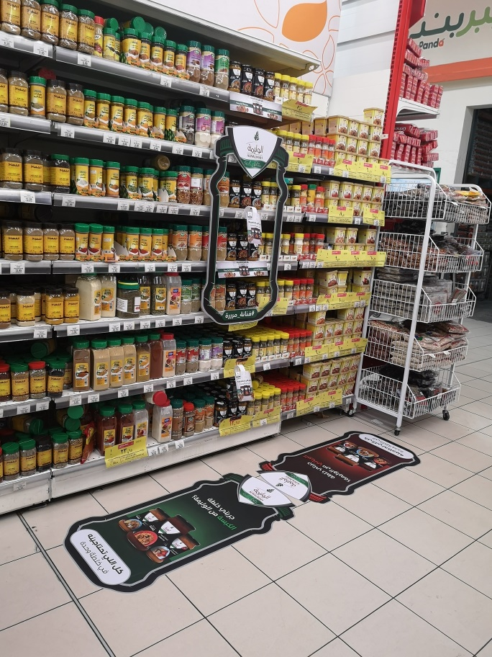

1. In mall branding-mobi

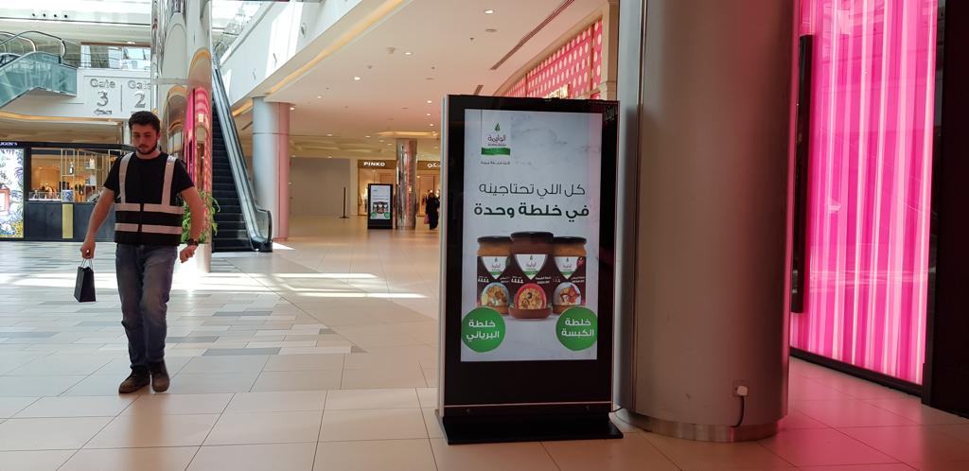

1. In market extra visibility and promotions

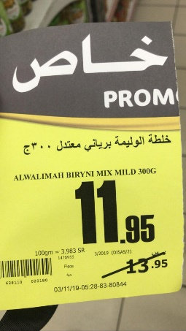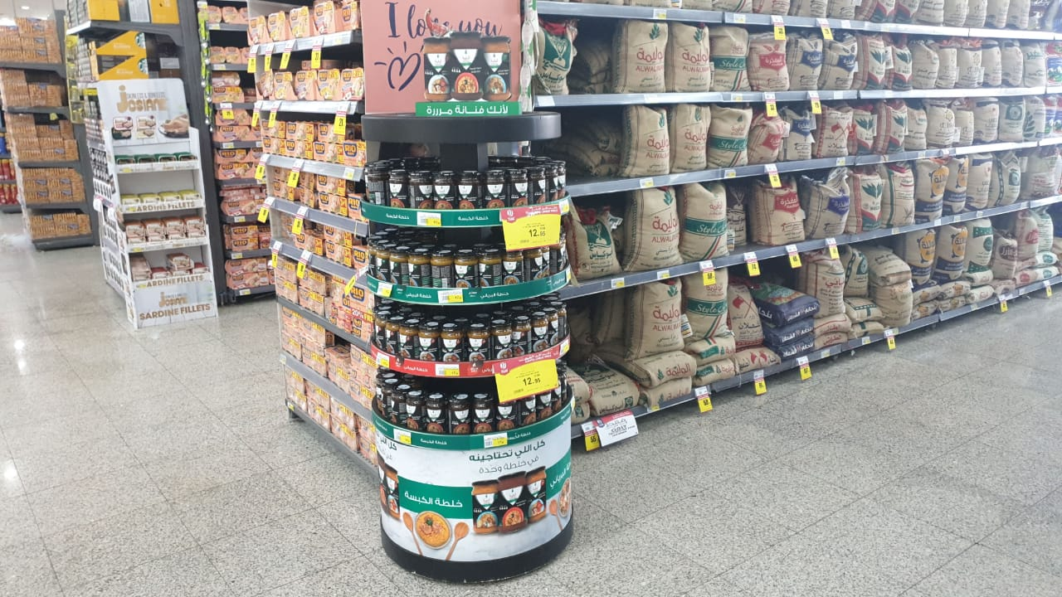

**Reference:**

1. <http://www.alwalimah.com/brand_Story> - <http://www.mayar.com/en/brand/>
2. KANTAR MILWARDBROWN – Sep 19 - Nilsen retail audit – March 2020 , Panda retailer sellout data (NKAD) + Appendix 1(b)
3. <https://www.foodexsaudi.com/en/news/472>
4. <https://www.helgilibrary.com/indicators/rice-consumption-per-capita/saudi-arabia/>
5. <https://saudigazette.com.sa/article/87728>
6. <https://www.assignmentpoint.com/business/marketing-business/product-life-cycle.html>
7. Target market,Segmentation data has been shared by AlWalima brand manager and PMO through an interview : Badry, KB - Omran,FO .2020, overview on AlWalimah Sauces target market and Segmentation . Interview by myself , mobile , 1st May 2020 ,11:30 PM.
8. <http://www.muhaidib.com/page/our-sectors>
9. <https://www.businessnewsdaily.com/4245-swot-analysis.html>

(10)<https://smallbusiness.chron.com/push-pull-promotional-strategy-10972.html>