

**MARKETING MANAGEMENT**

**SBS MBA/MSc**

**Assignment – Bahrain 2020**

|  |  |  |  |  |  |
| --- | --- | --- | --- | --- | --- |
| STUDENT ID | 1 | 1 | 0 | 0 | 8 |

UNIT TITLE / CODE: MARKETING MANAGEMENT / MKT501

NAME (in Full): ABDULRAHEEM SALEH SALEM BAWAZIR

## GENERAL INSTRUCTIONS

* All assignments are to be submitted 7**th May 2020** on to [examinationboard@atmsedu.org](mailto:examinationboard@atmsedu.org) and cc to [azrafatima@atmsedu.org](mailto:azrafatima@atmsedu.org)[,](mailto:afatima@atmsedu.org) [assignmentsubmission2019@gmail.com](mailto:assignmentsubmission2019@gmail.com)
* If assignment is not submitted on date, will follow with penalty of 10% deduction of marks for every day.
* Similarity between students work is strictly not accepted, any student found with similar work will be graded Zero and fail for the course. However, Plagiarism is an academic offence and will not be tolerated under SBS
* Assignment once submitted to exam board is final for marking.
* Total 100 marks

## GUIDELINES FOR ASSIGNMENT

1. If assignment is Question & Answer based then.
   * Introduction is needed for each question.
   * Question has to be answered based on the mark allotted for each question with references if any idea or information is taken from other source.
2. If assignment is case based then,
   * Executive summary
   * Table of content
   * Body of assignment (questions related to case need to be answered)
   * Conclusion / Recommendation if any
   * References (in-text + citation) to be used.

## Total Marks / 100

**PLAGIARISM**

Plagiarism is a form of **cheating**, by representing someone else's work as your own or using someone else's work (another student or author) without acknowledging it with a reference. This is a serious breach of the Academic Regulations and will be dealt with accordingly. Students found to have plagiarised can be **excluded from the program**.

Plagiarism occurs whenever you do any of the following things without acknowledging the original source:

* Copy information from any source (including the **study guide**, books, newspapers, the internet)
* Use another person's concepts or ideas
* Summarise or paraphrase another person's work.

## How do I avoid plagiarism?

To ensure you are not plagiarising, you must acknowledge with a reference whenever you:

* use another person's ideas, opinions or theory
* include any statistics, graphs or images that have been compiled or created by another person or organization
* Paraphrase another's written or spoken word.

## What are the penalties?

The penalties for plagiarism are:

* Deduction of marks,
* A mark of zero for the assignment or the unit, or
* Exclusion from the program.

Plagiarism is dealt with on a case-by-case basis and the penalties will reflect the seriousness of the breach.

## Please note: claiming that you were not aware of need to reference is no excuse.

**Marketing Management Assignment Structure –**

**Marketing Strategy (Brand)**

For your brand of choice please prepare a marketing strategy on the below guidelines. This should clearly reflect the marketing mix – product, place, price, promotion and packaging as discussed in the class. The learnings on Brand Equity in the class should be the emphasis of the assignment.

Please note the brand should have linkage in the UAE – must be an existing brand or a brand that intends to be introduced in the UAE.

1. Executive Summary – summarizing points 2-8.

2. Brand Overview – describe the current status of the brand with a brief historical background. Also define the brand’s current state on the Product Life Cycle.

3. Competition Overview – Define competition

4. Target Market – Define who is being targeted

5. Segmentation – Demographic, Behavior, Psychographic

6. SWOT – on brand or industry

7. Market Research if any carried out – if no research carried out then suggest a need if any

7.1 Product – BCG matrix. Also include packaging plans if any.

7.2 Place – Choice of retail strategy

7.3 Price – penetrative or skimming or competitive

7.4 Promotion – pull or push strategy including choice of medium – digital or traditional

8. Conclusions and Recommendations – suggestions for change in current practices if any to make it more effective should be discussed.

9. Appendix – Any other information you may provide.

# EXECUTIVE SUMMARY

As an ex-employee of HUAWEI for 9 years. In this research we have been introduce HUAWEI as ICT leading company & demonstrate smartphones sector specifically. As a part of latest smartphone marketing strategy. We addresses the advance position of HUAWEI brand in smartphone market competition although it was positioned in smartphone industry lately. As well as exploring how it benefits from it is huge revenue, profits & R&D budget. Nowadays there is an unexpectable pandemic impact most of industries. The impact expected to be as less as possible to HUAWEI as a far east company. Then, going to segmentations part. HUAWEI prioritize wide range of target people for HUAWEI P40 smartphone. Passing to internal & external affect to HUAWEI global propagation specially US ban that not only limited to US market but reach to software service provided to HUAWEI by US suppliers. Quarter to Quarter & year to year financial situation enforcing HUAWEI to dominate the market very well.

Table of Contents

[EXECUTIVE SUMMARY 4](#_Toc40665899)

[OVERVIEW 6](#_Toc40665900)

[HUAWEI Overall 6](#_Toc40665901)

[HUAWEI Smartphones 6](#_Toc40665902)

[MARKETING ANALYSIS 8](#_Toc40665903)

[Pandemic Environment 8](#_Toc40665904)

[Competitor Environment 8](#_Toc40665905)

[Media Environment 9](#_Toc40665906)

[STP (Segmentation, targeting & positioning) 10](#_Toc40665907)

[Segmentation 10](#_Toc40665908)

[Demographics 10](#_Toc40665909)

[Psychographic 11](#_Toc40665910)

[Social Cultural & Behavior 11](#_Toc40665911)

[Targeting 11](#_Toc40665912)

[Positioning 12](#_Toc40665913)

[SWOT ANALYSIS 12](#_Toc40665914)

[Strengths 12](#_Toc40665915)

[Weaknesses 12](#_Toc40665916)

[Opportunities 13](#_Toc40665917)

[Threats 13](#_Toc40665918)

[MARKETING MIX 14](#_Toc40665919)

[Product 14](#_Toc40665920)

[Place 14](#_Toc40665921)

[Promotion 14](#_Toc40665922)

[Price 14](#_Toc40665923)

[Packaging 15](#_Toc40665924)

[BCG MATRIX 16](#_Toc40665925)

[HUAWEI Stars 16](#_Toc40665926)

[HUAWEI Cash Cow 16](#_Toc40665927)

[HUAWEI Question Mark 16](#_Toc40665928)

[HUAWEI Dog 17](#_Toc40665929)

[MARKET RESEARCH 17](#_Toc40665930)

[Budget 17](#_Toc40665931)

[Implementation 17](#_Toc40665932)

[Control 18](#_Toc40665933)

[CONCLUSION 18](#_Toc40665934)

[RECOMMENDATION 18](#_Toc40665935)

[REFERENCE 19](#_Toc40665936)

[Appendix 1 21](#_Toc40665937)

[Appendix 2 22](#_Toc40665938)

# OVERVIEW

## HUAWEI Overall

HUAWEI was originated in the year 1987 by Ren Zhengfei in the name of HUAWEI Technology company limited. Ren has malformed a conference apartment in Shenzhen, China into the world's chief info and communication expertise solution and service supplier. As a leading global provider of information and communications technology (ICT) infrastructure and smart devices. We are committed to bringing digital to every person, home and organization for a fully connected, intelligent world. We have nearly 194,000 employees, and we operate in more than 170 countries and regions, serving more than three billion people around the world. HUAWEI's end-to-end portfolio of products, solutions and services are both competitive and secure. Through open collaboration with ecosystem partners, we create lasting value for our customers, working to empower people, enrich home life, and inspire innovation in organizations of all shapes and sizes. At HUAWEI, innovation focuses on customer needs. We invest heavily in basic research, concentrating on technological breakthroughs that drive the world forward.

## HUAWEI Smartphones

Even though HUAWEI established in eighties, the handset department has been launched at 2003 while first smartphone was exhibited in 2004. Financially HUAWEI performing well yearly basis with noticeable revenue growth in consumer business (34%) which is covering smartphones part or overall (19.1%) including other businesses even. Below charts showing 2019 financial position:

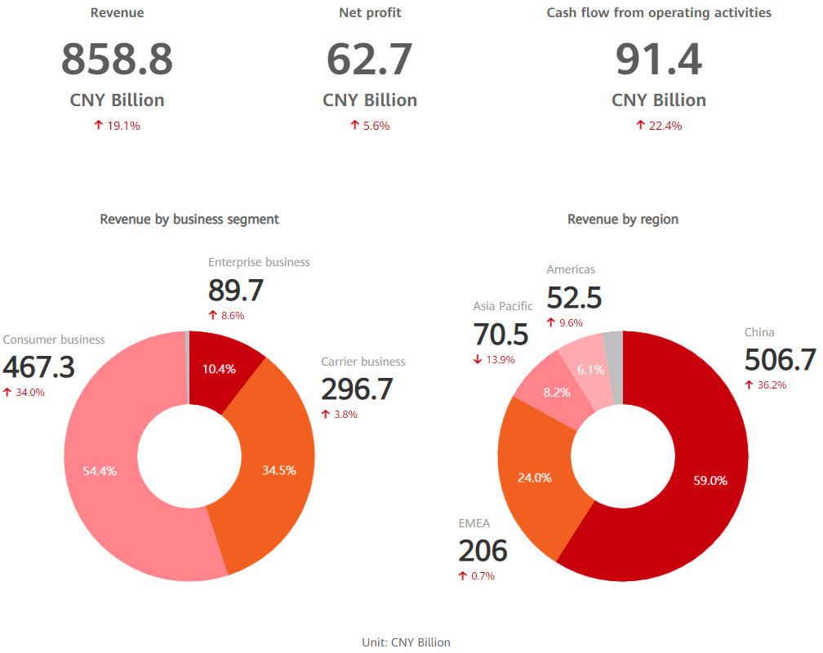

Although It is a fact that current state of global smart phones market on the product life cycle stable in maturity stage; our smartphones positioning in massive growth as per 2019 statistics.

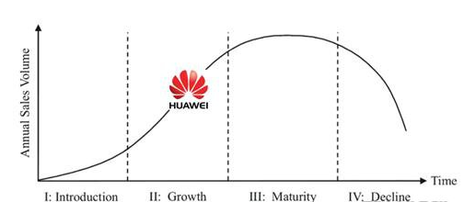

Taking in consideration that we are the only 5th Generation technology End to End provider; the 5G revolution that is already started giving bright view of future. It will renew customer’s interest for state-of-the-art devices.

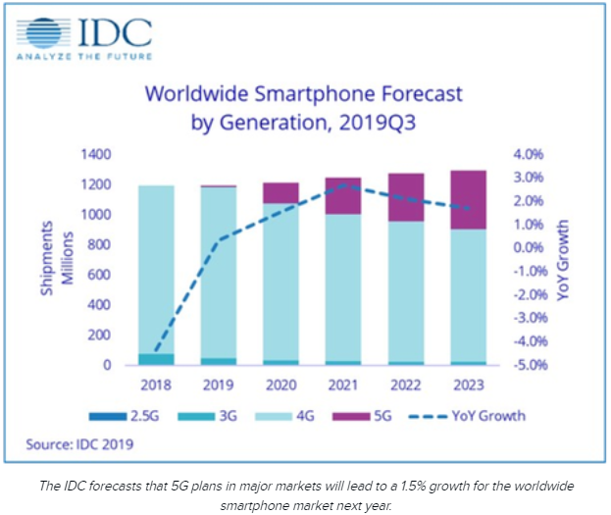

# MARKETING ANALYSIS

## Pandemic Environment

Research firm [Canalys](https://twitter.com/Canalys/status/1234388229564043269" \t "_blank) predicts that, in the best-case scenario, shipments of smartphones will go down by 4.3%, for a total of 1.3 billion units, in 2020. Shipment numbers could go down by as much as 12.6% in the worst-case scenario. If these predictions turn out to be accurate, we will see lower sales for smartphones, at least in the short term. Canalys does predict that smartphone shipments will bounce back to normal by the third quarter of 2020. The silver lining is the situation in China appears to be improving rapidly. While big swaths of the country are still under lockdown, China is reporting fewer new coronavirus cases every day. South Korea, another manufacturing powerhouse, also appears to have the outbreak under control. While there’s no guarantee these positive developments will continue, it does bode well for the two hard-hit countries, as well as the electronics industry.

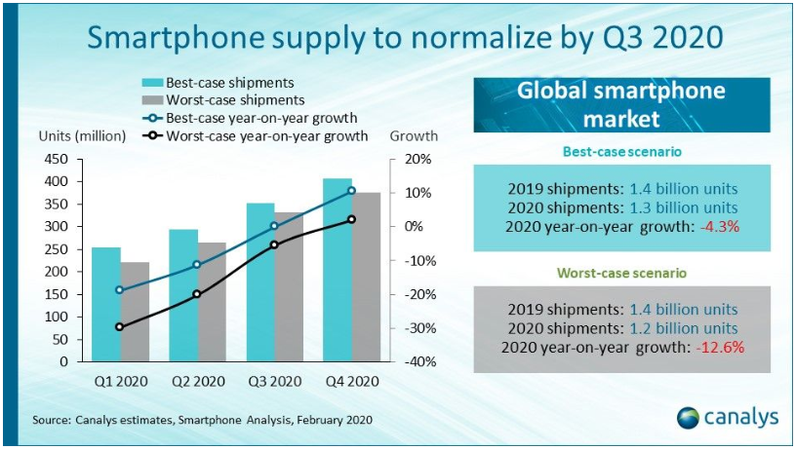

## Competitor Environment

In the past few years, due to lower service costs and lower prices, the smartphone industry has been steadily growing. The company has competed in advanced technology and communications industries, successfully attracting customers to purchase its products and services (BBC news. 2014). The market is fiercely competitive because they deliver the similar goods and facilities, but they have diverse bodily characteristics of mobile headsets and the cost that customers can choose. HUAWEI hopes to offer the best goods and facilities by reducing costs to attract customers and develop products that make the smartphone industry extremely competitive.

The strength of rivalry and the income prospective of a business are functions of several competitive capabilities; the bargaining power of customers, the threat of alternative products, and competition between competitors. Due to the threat of new applicants, HUAWEI's risk is at a low to medium level.

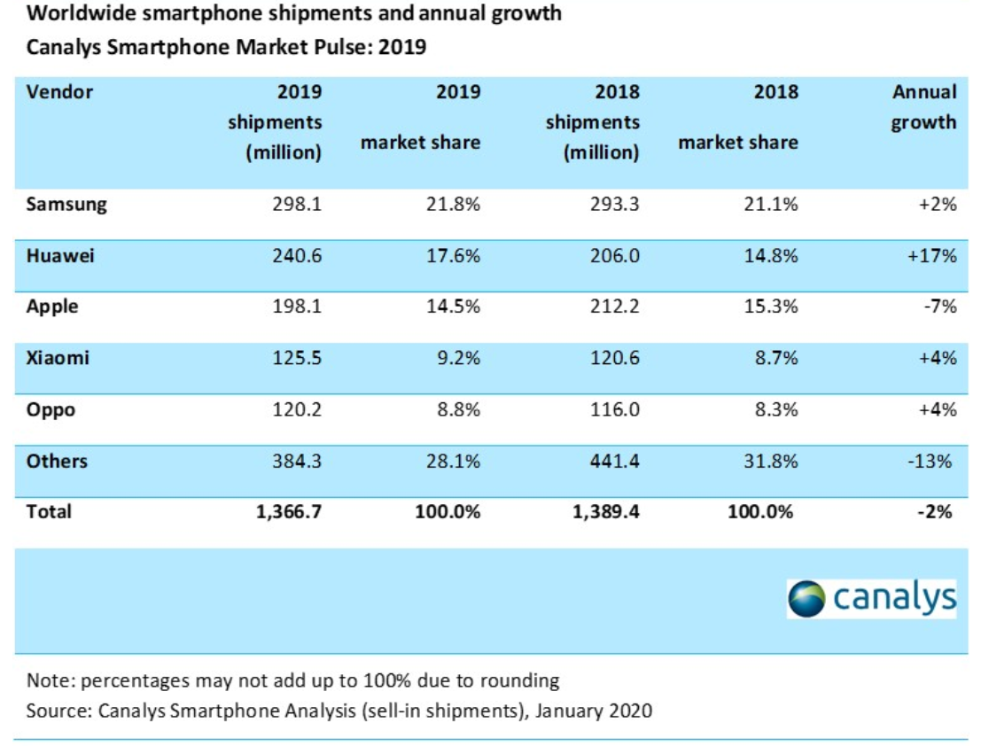

## Media Environment

In the Media, the world over remains abuzz with news and information related to technologies and technological advancements. Each new advancement is welcomed by the media and a lot of hype always remains there regarding new releases. There are several websites and blogs that are dedicated solely to technology and technological innovations. We use media events for the marketing of our products. Moreover, the media environment has evolved a lot with the rise of digital technology and digital media has become the mainstay of marketing rather than print media.  Media is also central to our marketing strategy and apart from digital marketing, it forms the core of our marketing efforts. Media events and similar promotions to create media buzz can be extremely helpful at growing our brand expanding our business faster. Incidentally, Mobile World Conference known as MWC Barcelona is the world's largest annual gathering for the smartphone industry planed last February has been cancelled due to corona virus outbreak. Subsequently, HUAWEI held multiple sessions for a first time ever remotely using digital media with biggest clients all over the world.

# STP (Segmentation, targeting & positioning)

## Segmentation

Market segmentation refers to the process of classifying the needs of consumers or users according to certain standards and dividing customers into different demand groups. When customers design for different needs, at the same time, the same marketing strategy will bring different responses to enterprises, called heterogeneous markets.

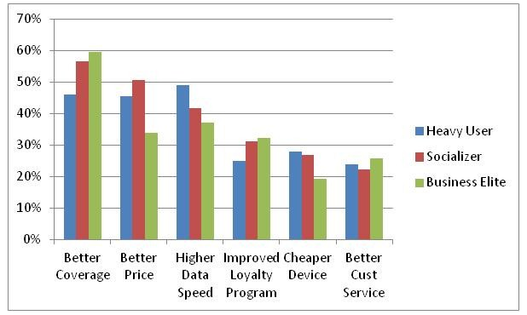

HUAWEI's marketing has always been based on market segmentation, so there are many reasons to segment it. (What) How to enter the dominant market? In this specific standard (for example, economy, culture, geography, etc.), the entire market is divided into several sub-markets, and each sub-market has the same marketing environment.

### **Demographics**

Our potential customers based on age include people in the group of 15-65. This customer group includes both the Gen-Xers and the baby boomers. The baby boomers form the largest group of our customers. It is mainly because of their lifestyle and purchasing power. Most of them want innovative products at affordable prices. These people were born in an era when technological development was happening at a very fast pace and that’s why a large part of this generation is tech savvy. They like smartphones that offer multiple features which can be used for work as well as fun. Income wise HUAWEI’s smartphones priced at somewhere between $40 and $950. It is so that people with low and average income too can buy the product. Refer to Appendix 1.

### **Psychographic**

HUAWEI’s customers are modern and tech savvy people who believe in fun and personal freedom. These people believe in liberty of expression and spend a large part of their daily time using technology. Rather than spending their time on television and in books, these people like to spend their time on social media, websites, blogs and other online channels. They like to read online and spend time on their smartphones and tablets. Large screen smartphones are also in vogue as reading devices. They also love to remain active on the go and many of them are highly passionate about IT and digital technology and channels. A large proportion of this population are passionate video gamers and keep several in their smartphones. They have an image of modern, fun loving and hip generation. They are fans of soccer and basketball as well as Hollywood and music celebrities. They also use their smartphones for watching YouTube videos and to stay connected with their friends and family. The main customers of our product include college students, working professionals, new parents and tech savvy teenagers. Large screen smartphones cater to multiple of their needs including communication, connection, fun and reading. They carry pdf files for reading in their smartphones as well as edit files and send mails using these gadgets. HUAWEI P40 suits all these needs.

### **Social Cultural & Behavior**

Technological growth has happened at a very fast rate. People are more tech savvy there and their level of technology adoption and usage is also higher. People like using smartphones that are loaded with applications and innovative features. In the developed societies, smartphone use is common among people in the age group of 10-75 years. The culture is suitable for technological growth and expansion. People follow a modern lifestyle in these nations and have adopted several forms of digital and electronic technology into their lifestyles. customers are modern and tech savvy people who believe in fun and personal freedom. These people believe in liberty of expression and spend a large part of their daily time using technology. Rather

## Targeting

Our target market includes people from the middle class and upper middle class. The 21st century and the post-recession period has seen the rise of the middle class which is mainly made up of working-class people. In the post-recession period, the level of employment has gone up. Following that the middle-class people are spending more on electronics and lifestyle items. Middle class people aged 20 to 55 form our major target market. these people are also the most enthusiastic about technology and new advancements happening in this sphere.   This category includes both male and female customers.

## Positioning

HUAWEI P40 will be positioned as a product that helps both students and professionals increase their productivity. It will be promoted as a fun and productivity tool that maximizes user’s efficiency through its innovative features while also catering to their need for fun and creativity. HUAWEI P40 is a slim light weight fun that comes loaded with fun and productivity features and has excellent gaming features. Value Proposition: A smart and light weight device with productivity features for students and professionals as well as your own gaming partner and music companion. All of these at a price that is better than your expectations.

# SWOT ANALYSIS

## Strengths

HUAWEI has various strengths that make it able to successfully flourish in the competition. In existing markets, these strengths not merely help to capture market share but also provide support in market penetration (Fern Fort, 2020). Some of its strengths are:

* Task automation has brought quality and consistency to HUAWEI products and has made the company to scale down and scale up based on market demand conditions.
* HUAWEI has highly skilled workforce. The company has also adopted learning programs and successful training to sustain. Huge resources have been investment in development and training of its workers leading to achieve more.
* Over the years, the brand has strong brand portfolio. The company has invested lump sum amount for this purpose. It thinks that brand portfolio proves to be highly useful it the group wants to increase into newer categories of product
* Strong after sale service, this helps to promote products of HUAWEI.
* Affordable prices for product itself & spare parts if needed.

## Weaknesses

* The company is less effective in forecasting new trends leading to missed opportunities. This further results in high inventory both in-house and in channel
* Product range gaps are found in the products sold by HUAWEI.
* The products of HUAWEI are successful in terms of sale but their unique selling point and positioning are not clearly defined such as those of Samsung and Apple which can result in segment attacks (Xia, 2017).
* Higher rate of attrition in workforce- the rate of attrition in HUAWEI is high as compared to its competitors.

## Opportunities

* To gain market share, as there is already decrease found in transportation cost because of low shipping prices, it is possible that the this will bring down expense for HUAWEI products therefore providing an prospect for the brand to pass on these cost saving benefits to customers or either boost profitability
* The market development opportunity can lead to competitor edge dilution which will further enable the company to increase competitiveness as compared to the competitors
* The company can also take benefit from free trade agreements and new technology standard that will provide opportunity to enter a new developing market (Danmeng, 2007)
* Customer spending and economic uptick is also a greatest opportunity to increase market share and capture new customers

## Threats

* In some markets, growing local distributor strengths present a threat as the competition has provided high margin to local distributors
* In China, increased prices and increased wage level such as $15/hour can result in serious profitability pressure for the company
* Changing buying behavior of consumers can also prove to be a threat driven by model of supply chain and existing physical infrastructure
* Since the past few years, the company has developed various product categories but they are often in response of the products developed by competitors, this shows no regular innovative products supply. Furthermore, this has resulted in low and high swings.
* US Ban that is not limited to sales in US market only but also preventing Google to offer their service to us as HUAWEI.

# MARKETING MIX

## Product

HUAWEI P40 is a smart, modern technology and AI enabled smartphone with 6.58 inches screen and weighing 209 g. The device comes equipped with some of the best features currently available including an OLED display and 50 MP rear camera. It also comes loaded with more than 30 apps and more can be downloaded from Google play. It comes with 256 GB capacity. The smartphone is available in black, silver frost, blush gold, ice white & deep-sea blue color variants. It will carry a tow year warranty and a one-year extended warranty at an extra price. For more details, please refer to appendix 2.

## Place

Located in Shenzhen, China, HUAWEI is a global company with network and business activities in more than 170 countries / regions and has established long-term partnerships with more than 13,000 suppliers. It manages global business well through its distributor network.

Our primary distribution channel is online retail through which HUAWEI P40 will be made available in key markets. In the GCC, it will be available through our own website as well as other e-commerce sites and our brand retail stores. In addition to solid local distribution channel used by most of smartphones manufactures as an intensive distribution.

## Promotion

Digital marketing channels and techniques will form the core of our promotional strategy. Apart from that, HUAWEI will use media events and social media advertising to promote the P40 model. Our website and social media accounts will be a key part of our promotion strategy. HUAWEI P40 will also use sponsorships and advertising in print media including technology magazines to promote. Push model.

## Price

Currently, HUAWEI ’s pricing strategy to determine the price level it pursues is a competitive pricing strategy. Due to the large number of competitors in the industry, competitor’s data are easily available.In addition, the cost of pricing some products that have no competitor information or are more expensive. Currently, it also uses product packaging pricing, where products are packaged together and sold at a price lower than the sum of individual items.For some products, We also uses an optional product pricing strategy, which provides the price of the basic product and the separate price of the attached accessories.HUAWEI has determined the price of the final product. Retailers and wholesalers buy products at lower prices and profit from their own profits.

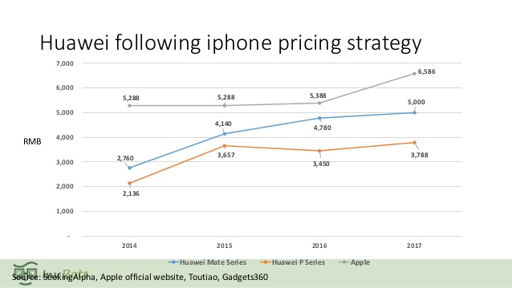

## Packaging

The way a product or service is provided greatly influences the decision to buy or use the product. HUAWEI understand the value of customers. use it. We always recommend to offer some accessories free of charge for our customers. In HUAWEI P40 case, we used below packaging:

Buy HUAWEI P40 Online & get a following

*“Grab HUAWEI FreeBuds 3 White + 12-month HUAWEI Mobile Cloud 50GB Storage + HUAWEI VIP Service FREE with your order”.*

# BCG MATRIX

The matrix given below shows the market share and growth rate of HUAWEI’s products.

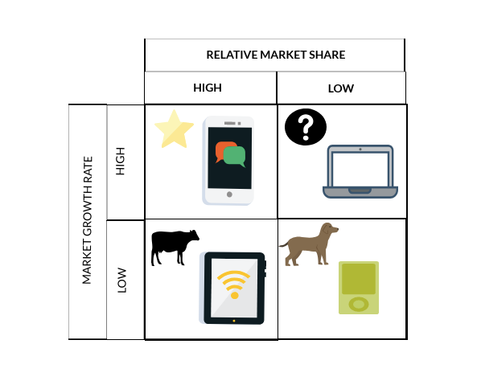

## HUAWEI Stars

The Consumer Strategic Business Unit, led by HUAWEI’s smartphone business, was named a star due to its rapid growth. Embedded artificial chipset (Wang 2017).

## HUAWEI Cash Cow

HUAWEI operators are a strategic business unit that sells network equipment to mobile operators. For many years, HUAWEI has been a cash cow for HUAWEI because it has high profitability and continues to generate high profits (2019 annual report). HUAWEI can invest in other business units such as consumer business that include smartphones and Statista 2018.

## HUAWEI Question Mark

Due to its uncertain growth, HUAWEI ’s corporate business unit can be classified as the question mark of this Chinese group, but given the high growth opportunities in this area, such as data centers, artificial intelligence and the Internet (PR Newswire 2018).

## HUAWEI Dog

HUAWEI's cloud services business unit is relatively new and belongs to the dog category in its SBU product portfolio because its growth is unpredictable, but due to big data demand, the cloud computing market is expected to grow rapidly in the next few years, so Huawei must Continue to invest in this sector (Tao 2018).

# MARKET RESEARCH

After analyzing the HUAWEI P40, we can of course guess that all the laws are a high point: in this analysis, we delved into the technical specifications of the brand to discover the features provided by its flagship product. The latest HUAWEI model has been launched in the market, and its technical characteristics have improved the specifications of the P30 Pro while maintaining the same design and size. Despite the veto power, the Asian company is continuing to develop smartphones and P40 series product lines. This is obvious: this year the company launched P40, P40 Pro and P40 Pro +, and we are already P40 Pro models. Huawei P40 Pro, 6.58 "90 Hz processor Kirin 990 5G, 8 GB RAM, 256 GB internal memory and 50-megapixel sensor, with its OLED display and top camera package, is expected to become a stable smartphone candidate in this year's high-end market Products.

# BUDGET

The budget of the market plan can be changed according to tools used in the marketing strategies. Thus, the approximate budget of the marketing plan for HUAWEI is 4 US millions.

# IMPLEMENTATION

The project of marketing will be implemented step by step; all these steps are given below:

1. Select the implementation method, recommended one is social media
2. Evaluate the procedure
3. Compare the outcomes
4. Monitor the results

# CONTROL

The whole marketing plan will be assessed and controlled by the HUAWEI marketing lead.

# CONCLUSION

It is concluded that Huawei is doing great business with P40 series. The market development opportunity of HUAWEI P40 can lead to competitor edge dilution which will further enable the company to increase competitiveness as compared to the competitors. For many years, HUAWEI has been a cash cow for HUAWEI because it has high profitability and continues to generate high profits. The company has highly skilled workforce. The company has also adopted learning programs and successful training to sustain. Huge resources have been investment in development and training of its workers leading to achieve more.

# RECOMMENDATION

It is recommended to HUAWEI to invest in its marketing strategy as much as possible to sustain profitable business.

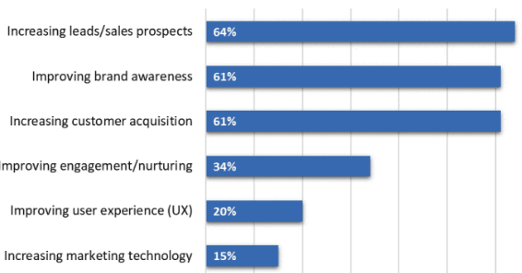

We need focus on our marketing plan regarding HUAWEI P40 and evaluate its progress from the chart given above.

# REFERENCE

Annual Report (2017) “Huawei investment & Holding Co., Ltd” [Online] at http://www-file.huawei.com/-/media/CORPORATE/PDF/annual-report/annual\_report2017\_en.pdf?la=en [Accessed on 15th June 2018]

Arabian gazette (2017) “*Global smart phone trends 2017*” Nexis.com [Accessed 31 Jan 2018].

Auchard, Eric (2017) “China’s Huawei enters PC market to take on Lenovo, HP, Dell” ***Reuters***[Online] at https://www.reuters.com/article/us-huawei-tech-computers-idUSKBN18J1ST [Accessed on 23rd.5.2018]

Auchard., and Jiang, S. (2017) “Huawei aims to challenge Apple and Samsung on technology as well as price” ***Reuters***[Online] at https://www.reuters.com/article/us-smartphone-huawei-tech/huawei-aims-to-challenge-apple-and-samsung-on-technology-as-well-as-price-idUSKBN1CL1SQ [Accessed 31 Jan 2018]

BBC news. 2014. China’s Huawei reports 19% jump in sales. Retrieved February 11, 2017. From <http://www.bbc.com/news/business-28397624>.

Danmeng, Q., 2007. The Environment analysis and the countermeasure about Internationalization management of Huawei. Science & Technology Information, 2007(27), p.236.

Fern Fort, 2020. Huawei SWOT Analysis Matrix [Step By Step] Weighted SWOT. [online] Fern Fort University. Available at: <http://fernfortuniversity.com/term-papers/swot/1433/1033-huawei.php>

PR Newswire (2018) “The Internet of Things (IoT) market is expected to grow from USD 170.57billion in 2017 to USD 561.04billion by 2022, at a Compound Annual Growth Rate (CAGR) of 26.9%” [Online] at https://www.prnewswire.com/news-releases/the-internet-of-things-iot-market-is-expected-to-grow-from-usd-17057-billion-in-2017-to-usd-56104-billion-by-2022-at-a-compound-annual-growth-rate-cagr-of-269-300585814.html [Accessed on 15th June 2018].

Turnbull, Peter W., Leek Sheena and Ying Grace. 2010. Customer Confusion: The Mobile Phone Market. Journal of Marketing Management, 16(1):143-163.

Wang Aimin. 2015. Analysis of Huawei’s Smartphone Marketing Strategies in Arab World Nashwan Mohammed Abdullah Saif

Wang, X. 2012. Analysison the Marketing Channel of 3G Mobile Phone. Knowledge Economy, (12), 118-118.

Xia, W. and Gan, D.Z., 2017. The Marketing strategy of HUAWEI Smartphone in China.

Yang, K. 2005. Exploring factors affecting the adoption of mobile commerce in Singapore. Telemetric and Informatics, 22 (3):16-31.

huawei. (n.d.). Huawei Annual Report 2019. [online] Available at: <https://www.huawei.com/en/press-events/annual-report/2019>.

www.canalys.com. (n.d.). Canalys - analysis. [online] Available at: https://www.canalys.com/analysis/channels+analysis [Accessed 17 May 2020].

Counterpoint Research. (2020). Global Smartphone Market – Apple Gained the Top Spot in Q4 2019 While Huawei Surpassed Apple to Become the Second-Largest Brand in CY 2019. [online] Available at: <https://www.counterpointresearch.com/global-smartphone-market-apple-gained-the-top-spot-in-2019-q4-while-huawei-surpassed-apple-to-become-the-second-largest-brand-in-cy-2019/>.

IDC: The premier global market intelligence company. (2018). IDC - Smartphone Market Share - Vendor. [online] Available at: <https://www.idc.com/promo/smartphone-market-share/vendor>.

# Appendix 1

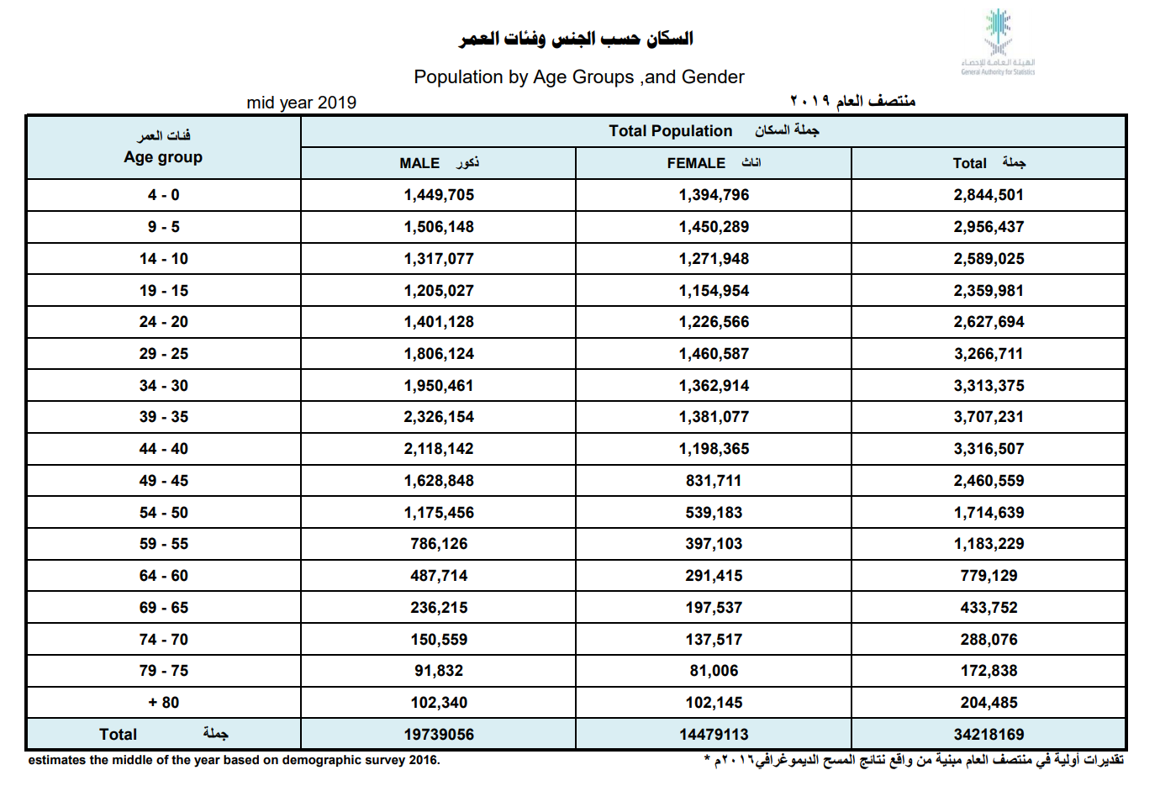

# Appendix 2

