**Abstract**

|  |  |
| --- | --- |
| Marketing MANAGEMENT MKT501  Mr. Clay Gervais | MBA Student: Seddiqa Baqeri  ID: 11145  Submitted on 14 May 2020 |

Batelco is a market leader in Bahrain and it was established in the beginning of 80s. It is a well-known Bahraini brand. Batelco is a company that provides multiple technical products and services for individuals as well as companies. It serves in its home country, middle east and north Africa countries. Currently Batelco is in growth stage. Batelco faces two strong competitors who are Zain and STC.

Batelco is segmenting its home country, middle east and north Africa countries. It serves both genders. And its target market in Bahrain are almost the majority of citizens and non-citizens.

Batelco has several strengths such as its popular brand and its strategy that assures the continuous improvement of customer experience. On the other hand, it has some weakness areas such as its technical problems and application errors.

Batelco is able to obtain the market opportunity by continuously providing the newest technological products and services, providing special offers in specific time periods and by providing unique customer experience. Batelco faces multiple threats in its market as recently the work style has changed but Batelco has successfully adopted the change.

Batelco’s product strategy is to provide the newest technological products and services before its competitors. Its price strategy is to provide more than one payment plan and providing products and services lower than competitors price. Its place strategy is to be close to its customers by establishing multiple branches and developing online shops as well as live chats with its agents. Also, Batelco has shared a hot line to serve its customers. Batelco uses different channels to announce its products and services.

Batelco operations are good, however, they need to overcome its weakness to not be behind its competitors. The study has provided multiple recommendations to improve Batelco’s services in order to provide better customer experience.

**Table of Content**

1. Introduction
   1. Background Information…………………………………………….……..4
   2. The Purpose of the Study…………………………………………….…….4
   3. Research Methodology………………………………….…………………4
   4. Key Findings………………………………………....…………….……....4
   5. Study Layout……………………………………………………………….5
   6. Study Limitation…………………………………………………………...5
2. Research Methodology and Findings …………………………………………5
3. Addressing the Purpose of the Study

3.1 Brand Definition…………………………………………….…………….5

3.2 Batelco Background Information……………...………………….………6

3.3 Definition of Marketing Strategy ……………………………….………..6

3.4 Batelco Current Position and State in Product Life Cycle………………..7

3.5 Batelco Competitors………………………………………………………7

3.5.1 Zain Telecom Company……………………………………………..7

3.5.2 Saudi Telecom Company……………………………………………8

3.6 Batelco Segmentation and Target Market…………………………………8

3.7 SWOT Analysis……………………………………………………………9

3.8 Batelco Marketing Strategy……………………...……………………….11

3.8.1 Product Strategy………...…………………….…………………….11

3.8.2 Price Strategy……………………………………………………….11

3.8.3 Place Strategy……………………………………………………….12

3.8.4 Promotion Strategy………………………………………………….12

1. Conclusion…………………………………………………………………….12
2. Recommendations ....……….……………………………………………...….13
3. References……………………………………………………………………..14
4. Appendixes

7.1 Interview………………………………………………...………………...18

7.2 Batelco’s Prices ……………………………………………………......…19

7.3 BCG Matrix………………………………………………………...……..20

**Table of Figures**

1-Figure1: Batelco Logo…………………………………………………..………..6

1. **Introduction**
   1. **Background Information**

Marketing strategy is a set of

decisions which establish a business’ market position. These decisions are made after a deep analysis of market, customers and competitors. In other words, it is a way of viewing customer’s needs and behaviors as well as viewing competitor’s marketing strategy to meet customer’s needs and their ads, promotion, distribution, packing and sales strategy. Marketing strategy aims to provide customers with higher service experience than competitors at minimum cost to reduce the effect of other competitors on its sales and market share. Basically, marketing strategy finds the target customers and attempts to attract and serve them better than competitors (Adewale, 2013, P: 59).

* 1. **The Purpose of the Study**

The study is aimed at analyzing the marketing strategy of Bahrain Telecommunication Company (Batelco) by viewing its current position in the market, its competitors and its target customers. More specifically, the study aims to answer the following:

1. Batelco current position in the market and its current position state on the product life cycle.
2. Batelco competitors.
3. Batelco segmentation and its target market.
4. SWOT analysis.
5. Batelco marketing strategy of product, place, price and promotion.

* 1. **Research Methodology**

In order to address the purpose of the study secondary information was collected as well as an interview with one of the Batelco staff.

* 1. **Key Findings**

Batelco is a Bahraini telecommunication company was established in 1980s. Batelco is a market leader in Bahrain. Moreover, Batelco has multiple strengths which enable it to establish a competitive advantage over its competitors. On the other hand, Batelco has several weaknesses which needs managers’ attention to overcome them. Batelco needs to compete aggressively in its market as every day might be a new opportunity and new challenge that might affect its position if no right decision is made.

**1.5 Study Layout**

The study starts with research methodology then addressing the purpose of the study followed with conclusion and finally recommendations.

* 1. **Study Limitation**

One of the Batelco’s competitors is STC, the study could not find its market share in Bahrain as there is no information published. However, other information has been shared in the study.

1. **Research Methodology and Findings**

For the purpose of gathering information about Batelco, secondary data has been collected and an interview with one of the Batelco staff has been conducted. The interviewee has been asked multiple questions to determine the Batelco segmentation, strength, market opportunity, threats and Batelco packaging of its products.

the interviewee has informed that they are serving customers who are 18 years old and above. Batelco serve also those who do not work. Moreover, the Batelco strength is that it is the oldest company in Bahraini telecommunications sector, having shares in more than one country and Batelco has built the telecommunication infrastructure and they leased its services to the competitors. The available opportunities in its market are to provide the newest technological products and services, to provide special offers in a specific time period and to provide unique customer experience. Furthermore, Batelco threats is when competitors are able to provide better services or when competitors have offers on their specific products/services which Batelco do not have. Other threats might be the market force to change. Batelco has simple packaging way as a plastic bag with Batelco logo is used.

1. **Addressing the Purpose of the Study**
   1. **Brand Definition**

Brand is a special logo that distinguish a company from its competitors. It is used as a marketing tool to promote awareness of the brand’s tangible and intangible things provided by the company in the mind of customers. A brand should be protected and developed in order to successfully survive and grow. A superior brand has obvious message, has reliability, able to bind with customers emotionally and encourage them to buy its products and services and be loyal to the company. A brand can be defined as customer perspective. This perspective should be influenced in order to give the brand a positive view (Heidi Cohen, 2011).

* 1. **Batelco Background Information**

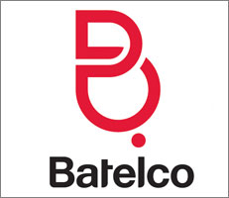Batelco is a Bahraini brand was established since 1981. It is a company that provides several telecommunication services and products to individuals as well as organizations of all sectors including governmental sector. Batelco contributes in development of Bahrain as it provides the newest technological products that improves individuals and business work style and their method of communication (Batelco.com, 2020; Mubasher Info, 2020). The below is Batelco brand design (Logok. 2019):

Figure1: Batelco Logo

In 2003, Batelco has realized the importance of brand equity to distinguish itself from the new competitor in its market which was Zain company. Batelco had to change its brand twice to develop a good brand reputation. However, they could not change its reputation as “old fashioned” company. Batelco developed a new plan as they understand their customers demand. A red color and approachable font type have been used to spread fun which result a better view of the brand. Batelco has continued its attention to the brand equity by developing it and as result it has been awarded for excellent brand progress (Unisono Agency, 2015).

**3.3 Definition of Marketing Strategy**

A number of significant researchers has defined marketing strategy as effectively using firm resources to define its business by establishing unique advantage over competitors in a specific market. The researchers stated that marketing strategy is a combination of marketing techniques that are used to achieve its aims. The decision makers decide the nature, power, path, and interface between the influences of environmental factors and firm product, price, place and promotion (Adewale, 2013, P: 60).

**3.4 Batelco’s Current Position and State in Product Life Cycle**

Batelco is considered as a market leader in Bahrain (Batelco.com, 2020). Its stock volume BHD 359,296 while its turnover is BHD 135,454.86. The current market share is BHD 1,663,200,000 and its capital equals BHD 166,320,000.000. The rate of market shares equals 0.38%. Its stock par value, market cap and book value are BHD 0.10, BHD 627,026,400.000 and BHD 0.28 respectively. The earnings per share equals to BHD 0.02 and the growth rate equals 25.17% (Mubasher Info, 2020) As per Bahrain bourse Batelco has 21 branches within Bahrain and it operates by 1436 employees (Bahrainbourse.org., 2020).

As shown in annual report for 2019, Batelco is in growth stage which is the second phase of “product life cycle” (MBA Skool-Study.Learn.Share., 2020). It has been published that Batelco’s strategy is focusing in increase its sales continuously. An increase in sales has been recorded for three products. These are “fixed broadband (15%), data communications (13%) and mobile services (3%)” (Batelco.com., 2019)

**3.5 Batelco Competitors**

Batelco is mainly faced by two strong competitors in its market. These two competitors are Zain and Saudi telecom company (Oxford Business Group., 2020).

**3.5.1 Zain Telecom Company**

Zain telecom company was established in Kuwait since 1983. Its old name was MTC Vodafone. In 2003, Zain had an expanding strategy which allowed them to operate successfully in eight countries in Middle East and Africa (Zain.com. 2020). As per Bahrain bourse, Zain has 21 branches within Bahrain and it operates by 274 employees. Its market share equals to BHD 37,168,000 (Bahrainbourse.org., 2020). Price per share equals to BHD 0.10 and growth rate equals -2% (Pitchbook.com., 2020; Oxford Business Group., 2020; Bh.zain.com., 2020). It can be concluded that Batelco is currently in a stronger position than Zain as it has higher market share and higher growth rate.

Zain strategy is communicating with its customers through different channels. This strategy assists managers to take right decisions in its market (Bh.zain.com. 2019). To survive in a competitive market, Zain’s strategy for year 2015 to 2019 was to provide creative solutions by improving its employees’ skills and knowledge. Also, Zain strategy was focusing on social responsibility by supporting educational and building skills programs (Bh.zain.com., 2014). For example, in 2019, Zain has arranged a program for university students to give them the opportunity to work within the company and have the knowledge of a real-life work (Bh.zain.com., 2019). One of significant writer has stated that one of marketing techniques is social responsibility as it builds a good image and reputation for the company which in result attracts customers to its products and services (IdeaCafe.com, 2017).

**3.5.2 Saudi Telecom Company**

Saudi telecom company (STC) was established in Saudi Arabia since 1998 (Mubasher.info. 2020). The name of company was VIVA Bahrain but recently has been changed to STC Bahrain (Pitchbook.com., 2020). The company has entered Bahrain market in 2009 (Oxford Business Group., 2020).

STC is competing aggressively in Bahrain as after operating few years, STC has been announced as “best brand and growth strategy” in middle-east countries. STC strategy is continuously thinking and operating in a creative way (Stc.com.bh., 2020). STC is trying to be the first company that fulfills all needs of its customers as STC was the first company announcing 4G service. Moreover, STC strategy is to provide the best customer experience. STC has used multiple channels to sell and receive payments from its customers of its products and services. Furthermore, STC uses different ways of enhancing its image in eyes of its customers. For example, STC pays donations to Bahrain charities (Stc.com.bh., 2020).

**3.6 Batelco Segmentation and Target Market**

Market segmentation is the process of dividing the market on specific basis such as age and gender to assist managers to decide which market to use its product’s ads (blog.alexa.com., 2019). After dividing the market, a company selects one or few of it, those which most likely wans the company’s products and services (Thebalancesmb.com, 2020).

Batelco serves companies as well as individuals of middle east and north Africa countries. (Batelco.com., 2020).

In Bahrain, Batelco is targeting all individuals including tourists and companies. It has been announced that Batelco is offering prizes up to USD 8,000.000 for Bahrain visitors who use Batelco services (Al-Wasat Newspaper, 2005). In 2016, Batelco has announced a special offer for University of Bahrain students to attract them (Facebook.com., 2016). University of Bahrain is a governmental university for both genders, in 2016, there were 22,002 students from Bahrain and from thirty-seven other countries (Uob.edu.bh., 2016). Recently Batelco has offered unlimited internet for home internet packages. This offer was targeting the audience of movie fanatics, online gaming teenagers and those who need to download huge documents (Batelco.com., 2020). In 2019, Batelco has announced an offer on monthly payments on multiple advanced devices and in its ad, it was targeting individuals and business owners as in their website the following was written “Enhance your living experience with great deals on smart home products, Enhance your office experience with great deals on smart office products”. Batelco is not only serving its customers but their services extend to serve non-Batelco customers as Bwallet was created to receive money from others and vice-versa in easy way (Batelco.com., 2019).

Therefore, per the above discussion and as per data collected from interview, the market segmentation of Batelco is both genders, from age 18 years old and above, students, employees and non-employees as well as tourists in countries of middle east and north Africa. While its target market is all citizens and non-citizens individuals and companies who demand technological products and who are willing to change the life style using company’s product and services.

**3.7 SWOT Analysis**

SWOT analysis is a study that assist managers in setting business strategies as it identifies four factors, these are: strengths (S), weaknesses (W), opportunities (O) and threats (T). The managers should view the internal strengths and weaknesses of their business as well as the external opportunities and threats. These analysis assist managers to decide how to use company’s strength to gain the advantage of the available opportunity in the market. Also, managers can decide how to reduce its weakness to be stronger in facing market threats (Liveplan, 2018).

One of Batelco’s strengths is that it is the oldest telecommunication company in Bahrain comparing it to its competitors as Batelco was established in Bahrain since 1981while Zain established in Bahrain since 2003 and STC in 2009 (Oxford Business Group., 2020; Bh.zain.com., 2019; Mubasher Info, 2020). In other words, Batelco is a reputable company from a very long time. As per data collected from interview, the interviewee stated that Batelco is the mother of telecommunication sector. Also, she stated that Batelco strength came from the build of “telecommunication infrastructure” and leasing its services to the competitors. Another strength is that Batelco has shares not only in Bahrain, but also in other countries.

Another strength is that Batelco has strategy that assures the continuous improvement of customer experience (Batelco.com. 2020). And has established different channels to communicate more closely with its customers. Customers are able to communicate with Batelco staff in its website through live chat, on its social channels such as Instagram, Twitter, Facebook, by sending emails and by calling their call center or contacting them through fax line (Batelco.com., 2020).

On the other hand, Batelcohas some weakness such as, Batelco had some technical issues in its system which in return effected the home internet services on 29 of April 2020 (Twitter.com., 2020). Customers in Batelco’s Instagram on 30 of April 2020 were complaining about Batelco App that is not working well. Also, one of the customers was complaining about the late delivery of internet fiber. Another customer stated that he and his relatives are having very slow internet speed and unreasonable bill amounts. Moreover, some customers stated that some of Batelco’s products are out of stock when they want to buy. Additionally, one of the customers stated that Batelco is not taking any action regarding their raised complains (Instagram.com., 2020).

As per data collected from the interview, the opportunities for Batelco in its market are to provide the newest technological products and services, to provide special offers in a specific time period and to provide unique customer experience. Batelco is aggressively competing in its market as shown in Instagram application, Batelco, Zain and STC all have posted in the same day a special offer on a selected service. For example, all of them has posted on 22 of April a unique ad to attract customers to buy their products and services. Batelco has posted a competition between its followers with the winner getting a free phone. Zain has announced a free gigabyte worth of data for its customers while STC has announced cash-back when buying a specific product from its shop (Instagram.com., 2020). Another market opportunity, the government of Bahrain has announced that all students will continue studying from home (DT News., 2020), the opportunity was giving a special offer on home internet, on 14 March, STC has taken this opportunity to announce unlimited home internet on classes websites, while Batelco has announced on 18 March the same service but to attract more customers they announced that this service can be benefited from by all its customers and not only students; while Zain announced unlimited service for only fiber internet (Instagram.com., 2020). It can be stated that each day there is an opportunity for Batelco to take it as each day the competitors are announcing of their different products, services and their special promotions. Customers are usually searching for the best deal to obtain. Therefore, Batelco should always look ahead to be the first choice that customers think about. Threats in this market might be inability of Batelco to adopt to continuous market changes and sudden improvement in competitors services and offers. An example is when Zain in 2018 has been announced as the fastest internet in the market (Bh.zain.com., 2019). Batelco might face threats when for example, competitors announce a special offer on their products while Batelco does not, then Batelco might lose of number of potential customers that might buy competitors’ products. As stated earlier, customers will buy whoever provides the best deal. Recently and in light of the COVID-19 crisis, Bahrain government has announced that companies should reduce the employee’s numbers in the workplace (Tradearabia.com., 2020). Therefore, it was very challenging for the telecom sector to continue to operate and serve their customers with same level of before. Batelco was able to successfully manage the operation by letting its employees continue work from their homes and overcome any technical errors.

**3.8 Batelco Marketing Strategy**

Marketing strategy is a process that contains four main elements which are the following:

1. Product: are tangible and intangible things provided by the company for the aim of selling them.
2. Price: it is the return on tangible and intangible things gained from customers.
3. Place: it is the location of tangible and intangible things where companies display their tangible things for sale.
4. Promotion: is the way that companies use to announce the benefits and encourage customers to buy it.

Managers are attracting their customers and potential customers to their products and services (MaRS Startup Toolkit., 2020). Another writer has included other elements than the stated four, such as packaging strategy. Basically, packing strategy means the way the tangible things are being presented to the customers (entrepreneur, 2004).

**3.8.1 Product Strategy**

Batelco’s strategy is to be the leader of its market by providing newest creative digital products and services in the market before its competitors. Therefore, Batelco became able to be the first telecom company to provide 5G service to its customers during last year. Also, Batelco was the first to provide the newest Apple watch. Another Batelco strategy is to continuously develop and improve its services (Content.batelco.com., 2019)

**3.8.2 Price Strategy**

As shown on Batelco’s website, it is clear that its strategy is to provide several products with several payments’ options as Batelco offers three different payment methods these are as follows: payment within 24 months, payment within 18 months and payment within 12 months. In general, the cost charged by Batelco is lower than its competitors. For example, it shows that iPhone 11 Pro with 256 GB costs BHD 10.417 for 24 months, BHD 13.889 for 18 months and BHD 20.833 for 12 months. All with advanced payment of BHD 105.000 (Shop.batelco.com., 2020) While Zain cost its customers BHD 18.500 for 24 months with advanced payment BHD 22.200, BHD 18.500 for 18 months with advanced payment BHD 133.200 and BHD 18.500 for 12 months with advanced payment BHD 244.200. All plans with no payments for two months (Bh.zain.com., 2019.). STC charges its customers from BHD 13.000 to 14.500 for 24 months and BHD 18.500 to 19.500 depending on the plan type. All plans with no advance payments (Stc.com.bh. 2020).

**3.8.3 Place Strategy**

Batelco has 21 branches within Bahrain (Bahrainbourse.org., 2020) to sell its products and services. Recently, Batelco has provided delivery services where customers are able to buy products through Batelco online shop. Moreover, Batelco has developed electronic services where customers can serve themselves. Also, Batelco has established online chat where customers can communicate with Batelco agents live. Additionally, Batelco has published multiple phone numbers to assist its customers by answering their enquires (Batelco.com., 2020).

**3.8.4 Promotion Strategy**

Batelco uses different channels to announce about its products and services such as social media like Instagram, Twitter and Facebook. Also, Batelco has its own channel in YouTube. Moreover, Batelco has developed its own website. Additionally, Batelco promotes its services/products through TV, newspapers and billboards in the street (Batelco.com., 2020).

A writer stated that studies has showed another important element in marketing strategy which is packaging. Packaging is how the product has been covered to protect it and make it easy to move it from one place to another. Packaging has been considered as an element that has a positive impact on the mind of clients which attract them to buy the product (Myofficemagazine.co.za., 2015). As per data gathered from interview, Batelco has simple packaging way as a plastic bag with Batelco’s logo printed on it.

1. **Conclusion**

Batelco is a Bahraini brand that operates in its home country and in a number of other countries. Batelco is offering multiple services and products to its individual customers and companies. Currently Batelco is in growth stage. Batelco faces two strong competitors which are Zain and STC.

It has been observed that the market segmentation of Batelco is a wide segmentation as it serves it home country, middle east and north Africa countries. And its target market in Bahrain are almost the majority of citizen and non-citizen.

Batelco has some several strengths. A popular brand, holding shares in multiple countries, and its strategy that assures the continuous improvement of customer experience, are all Batelco strengths. On the other hand, its technical problems, App errors, service delivery time, slow internet speed, unreasonable bill amounts, out of stock products, and no action taken for customer complaints, are all Batelco weaknesses.

Batelco is able to obtain the market opportunity by continuously providing the newest technological products and services, providing special offers in specific time periods and by providing unique customer experience. Batelco faces multiple threats in its market as recently the work style has changed but Batelco has successfully adopted to the change. Other threats facing Batelco is inability to provide the right services/products and offers which might lead to it falling behind competitors.

Batelco product strategy is to provide the newest technological products and services before its competitors while its price strategy is to provide more convenience payment plans and lower than competitors price. Its place strategy is to be close to its customers as much as possible. Batelco has multiple branches and has developed online shops as well as live chats with its agents. Also, Batelco has shared a hot line to serve its customers. Batelco uses different channels to announce about its products and services.

1. **Recommendations**

It has been observed that Batelco is a well-known company in Bahrain from ages. Based on the above discussed weaknesses, the writer recommends the following:

1. Batelco should protect its brand in the market and to continue being a well-known brand to all generation to maintain its position in the market which in result creates barriers to any new entrants in the market.
2. Batelco should have good stock management. Batelco should determine the market demands to make sure that their demands are always available at time of request.
3. Batelco should always make sure that its applications are working well without any errors, and in case of any sudden error Batelco IT should fix it in a short-time period.
4. Batelco should deliver customers’ orders on the promised date, and the promised date should not be longer than ten days.
5. Batelco should find a solution for its internet speed to be faster in all areas.
6. Batelco should have more aggressive offers in order to attract Zain and STC’s customers which will lead to weaken their position in the market.
7. Batelco should provide more creative customer service and establish fully digitalize branches where customers are able to serve themselves.
8. Batelco staff should clarify the bill amount that customer will pay with full transparently.
9. Batelco should let its customers be updated regarding the raised complaints by sending them official letters of response that justify Batelco’s position with reasonable answer.
10. Batelco should use unique packaging styles instead of using simple plastic bags.
11. **References**

* Adewale, G., 2013. Impact of Marketing Strategy on Business Performance A Study of Selected Small and Medium Enterprises (Smes) In Oluyole Local Government, Ibadan, Nigeria. *IOSR Journal of Business and Management (IOSR-JBM)*, [online] 11(4), pp.59-66. Available at: <http://iosrjournals.org/iosr-jbm/papers/Vol11-issue4/I01145966.pdf?id=5006> [Accessed 24 April 2020].
* Al-Wasat Newspaper, 2005. Batelco begins a campaign to promote international roaming. [online] Available at: <http://www.alwasatnews.com/news/452049.html> [Accessed 28 April 2020].
* Bahrainbourse.org. 2020. *Bahrain Telecommunications Co. ( B.S.C)*. [online] Available at: <https://www.bahrainbourse.org/bahrain-telecommunications-co--bsc?searchtext=bahrain+telecommunication+company> [Accessed 24 April 2020].
* Bahrainbourse.org. 2020. *ZAIN BAHRAIN B.S.C*. [online] Available at: <https://www.bahrainbourse.org/zain-bahrain-bsc?searchtext=Zain> [Accessed 24 April 2020].
* Batelco.com. 2020. *About Us | Personal*. [online] Available at: <http://batelco.com/about-batelco/about-us/> [Accessed 24 April 2020].
* Batelco.com. 2020. *Code Of Practice | Personal*. [online] Available at: <http://batelco.com/support/code-of-practice/> [Accessed 30 April 2020].
* Batelco.com. 2020. *Contact Us | Personal*. [online] Available at: <http://batelco.com/contact-us/> [Accessed 3 May 2020].
* Batelco.com. 2020. *Home Broadband Packages / Unlimited Plans | Personal*. [online] Available at: <http://batelco.com/internet/home/packages/> [Accessed 28 April 2020].
* Batelco.com. 2020. *Why Batelco | Personal*. [online] Available at: <http://batelco.com/why-batelco/> [Accessed 28 April 2020].
* Batelco.com. 2019. *Annual Reports | Personal*. [online] Available at: <http://batelco.com/investor-relations/annual-reports/> [Accessed 24 April 2020].
* Batelco.com. 2019. *Issue 4*. [online] Available at: <http://batelco.com/pdf/batelco_catalogue_Mar-2019.pdf> [Accessed 28 April 2020].
* Zain.com. 2020. *About us* [online] Available at: <https://www.zain.com/en/about-us/> [Accessed 24 April 2020].
* Bh.zain.com. 2020. *Zain Bahrain Announces Its Financial Results For The Year Ending 31 December 2019*. [online] Available at: <https://www.bh.zain.com/en/zainbahrain/2019financials> [Accessed 5 May 2020].
* Bh.zain.com. 2019. *About Us*. [online] Available at: <https://www.bh.zain.com/en/zainbahrain/aboutus> [Accessed 30 April 2020].
* Bh.zain.com. 2019. *Iphone 11 Pro*. [online] Available at: <https://www.bh.zain.com/en/personal/devices/smartphones/iphone/iphone-11-pro> [Accessed 3 May 2020].
* Bh.zain.com. 2019. *Zain Bahrain Hosts University Students From Al Ahlia And Gulf University*. [online] Available at: <https://www.bh.zain.com/en/zainbahrain/ahliauni?msisdn=> [Accessed 25 April 2020].
* Bh.zain.com. 2019. *Zain Bahrain Management Team Enjoys Customer Interaction Day*. [online] Available at: <https://www.bh.zain.com/en/zainbahrain/zain-bahrain-management-team-enjoys-customer-interaction-day> [Accessed 25 April 2020].
* Bh.zain.com. 2019. *Zain Bahrain The Fastest Network In The Kingdom For The Second Consecutive Quarter*. [online] Available at: <https://www.bh.zain.com/en/zainbahrain/zain-bahrain-the-fastest-network-in-the-kingdom-for-the-second-consecutive-quarter> [Accessed 1 May 2020].
* BH.ZAIN.COM., 2014. *Zain Sustainability Report 2014*. [ebook] Bahrain: Zain, pp.1-58. Available at: <https://www.bh.zain.com/en/zainbahrainsite/csr/Documents/zain_sustainability_270415-.pdf> [Accessed 25 April 2020].
* Cohen, H., 2011. *30 Branding Definitions*. [online] Heidi Cohen. Available at: <https://heidicohen.com/30-branding-definitions/> [Accessed 7 May 2020].
* Content.batelco.com. 2019. *Annual Report 2019*. [online] Available at: <http://content.batelco.com/wp-content/uploads/2020/03/10123308/Batelco-AR19-English-Final.pdf> [Accessed 3 May 2020].
* DT News. 2020. *Education Ministry Keen On Distance Education For Students With Special Needs | THE DAILY TRIBUNE | KINGDOM OF BAHRAIN*. [online] Available at: <https://www.newsofbahrain.com/bahrain/62836.html> [Accessed 3 May 2020].
* Facebook.com. 2016. *Batelco*. [online] Available at: <https://www.facebook.com/batelco/posts/dont-miss-out-exclusive-offer-for-uob-students-trade-in-your-old-smartphone-for-/10153666304130889/> [Accessed 28 April 2020].
* Instagram.com. 2020. *Batelco (@Batelco) • Instagram Photos And Videos*. [online] Available at: <https://www.instagram.com/batelco/?hl=en> [Accessed 30 April 2020].
* Instagram. 2020. *Batelco’S Instagram Profile Post: “To Support The Efforts Against COVID19…”*. [online] Available at: <https://www.instagram.com/p/B9374PLFiSx/> [Accessed 3 May 2020].
* Instagram. 2020. *Stc Bahrain On Instagram"With Stc Home Broadband, It’S Time To Study..."*. [online] Available at: <https://www.instagram.com/p/B9uZ1pgJ8sT/> [Accessed 3 May 2020].
* Instagram. 2020. *Zain Bahrain On Instagram: As A Proud Member Of #Teambahrain…”*. [online] Available at: <https://www.instagram.com/p/B94JM0Qpr_3/> [Accessed 3 May 2020].
* Logok. 2019. *Batelco Logo | Logok*. [online] Available at: <http://logok.org/batelco-logo/> [Accessed 7 May 2020].
* MaRS Startup Toolkit. 2020. *Marketing Strategy | Marketing Mix: Product, Price, Place & Promotion | Entrepreneur’S Toolkit*. [online] Available at: <https://learn.marsdd.com/article/the-marketing-mix-in-marketing-strategy-product-price-place-and-promotion/> [Accessed 4 May 2020].
* MBA Skool-Study.Learn.Share. 2020. *Growth Stage Definition, Importance & Overview | Marketing Dictionary | MBA Skool-Study.Learn.Share.*. [online] Available at: <https://www.mbaskool.com/business-concepts/marketing-and-strategy-terms/11918-growth-stage.html> [Accessed 24 April 2020].
* mubasher.info. 2020. *Bahrain Telecommunications BSC (Batelco) - Mubasher Info*. [online] Available at: <https://english.mubasher.info/markets/BB/stocks/BATELCO> [Accessed 24 April 2020].
* mubasher.info. 2020. *Saudi Telecom Co (7010)*. [online] Available at: <https://english.mubasher.info/markets/TDWL/stocks/7010/profile> [Accessed 25 April 2020].
* Myofficemagazine.co.za. 2015. *Packaging As Part Of The Marketing Mix – My Office News*. [online] Available at: <https://myofficemagazine.co.za/packaging-as-part-of-the-marketing-mix/> [Accessed 8 May 2020].
* Oxford Business Group. 2020. *Bahrain's Mature Telecoms Market Sees Growth From Data Demand*. [online] Available at: <https://oxfordbusinessgroup.com/overview/bahrains-mature-telecoms-market-sees-growth-data-demand> [Accessed 27 April 2020].
* Parsons, N., 2018. *What Is A SWOT Analysis, And How To Do It Right (With Examples)*. [online] LivePlan Blog. Available at: <https://www.liveplan.com/blog/what-is-a-swot-analysis-and-how-to-do-it-right-with-examples/> [Accessed 29 April 2020].
* Pitchbook.com. 2020. *Zain Bahrain Company Profile: Stock Performance & Earnings | Pitchbook*. [online] Available at: <https://pitchbook.com/profiles/company/98315-65> [Accessed 27 April 2020].
* Shop.batelco.com. 2020. *Batelco | Browse Our Eshop Now*. [online] Available at: <https://shop.batelco.com/> [Accessed 3 May 2020].
* Stc.com.bh. 2020. *About Us*. [online] Available at: <https://www.stc.com.bh/content/about-us> [Accessed 5 May 2020].
* Stc.com.bh. 2020. *Stc Device Add-Ons*. [online] Available at: <https://www.stc.com.bh/content/postpaid-device-add-ons> [Accessed 3 May 2020].
* Stc.com.bh. 2020. *VIVA Bahrain Awarded For Best Brand And Best Growth Strategy At Telecoms World Middle East 2013*. [online] Available at: <https://www.stc.com.bh/content/stc-bahrain-awarded-best-brand-and-best-growth-strategy> [Accessed 5 May 2020].
* Tracy, B., 2004. *The 7 Ps Of Marketing*. [online] Entrepreneur. Available at: <https://www.entrepreneur.com/article/70824> [Accessed 4 May 2020].
* Tradearabia.com. 2020. *Bahrain Makes Masks Must At Work Place*. [online] Available at: <http://www.tradearabia.com/news/HEAL_366637.html> [Accessed 3 May 2020].
* Trott, H., 2017. *How To Use Corporate Social Responsibility (CSR) As A Marketing Tool*. [online] IdeaCafe.com. Available at: <https://blog.ideacafe.com/how-use-corporate-social-responsibility-csr-marketing-tool> [Accessed 25 April 2020].
* Twitter.com. 2020. *Batelco (@Batelco) On Twitter*. [online] Available at: <https://twitter.com/Batelco?ref_src=twsrc%5Egoogle%7Ctwcamp%5Eserp%7Ctwgr%5Eauthor> [Accessed 30 April 2020].
* Uob.edu.bh. 2016. *Fast Facts University Of Bahrain*. [online] Available at: <http://www.uob.edu.bh/en/images/About_UOB/Fast_Facts_18-9-2016_English.pdf> [Accessed 28 April 2020].
* Ward, S., 2020. *Use Target Marketing And Market Segmentation To Improve Your Bottom Line*. [online] The Balance Small Business. Available at: <https://www.thebalancesmb.com/target-marketing-2948355> [Accessed 4 May 2020].
* Yesbeck, J., 2019. *4 Types Of Market Segmentation With Examples - Alexa Blog*. [online] Alexa Blog. Available at: <https://blog.alexa.com/types-of-market-segmentation/#market-segmentation> [Accessed 4 May 2020].
* Zubair, M., 2015. *Batelco. Rebrand*. [online] Brand Auditing Dubai | Naming Consultancy Bahrain | Branding Services in Dubai. Available at: <https://www.unisonoagency.com/batelco-rebrand/> [Accessed 8 May 2020].

1. **Appendixes**

**7.1 Appendix 1: Interview**

An interview was conducted with one of Batelco staff through phone on 30th April at 10:30 PM in order to gain information that are not published in Google driver.

Interviewer: Hi, I’m a Master student in Swiss Business school, I have been requested to write about any Bahraini brand. I have decided to write about Bahrain Telecommunication Company. I appreciate if you can share with me some business information.

Interviewee: Hi, wish you all the best in your studies. What kind of information you need?

Interviewer: first of all, what is the minimum age to buy a chip/product, and is it possible if I want to buy a product but I don’t work (no salary)?

Interviewee: the minimum age is 18 years old. For the second part of your question, yes you can buy any product but you have to pay 3 to 6 months advanced payment.

Interviewer: what are the strength things that Batelco got?

Interviewee: One of the strengths is that Batelco is a national company and it considered as the mother of telecommunication sector as it’s the oldest company in Bahrain. Batelco has built the telecommunication infrastructure and they leased its services to the competitors. Another strength is that Batelco has shares not only in Bahrain, but also in other countries like Saudi Arabia, Jordan and Egypt.

Interviewer: okay, the second question is what are the opportunities in the market which Batelco can obtain?

Interviewee: As you know, Batelco is competing aggressively with two competitors which is Zain and STC. In this competitive market, Batelco should always make sure the availability of the newest products in its shops and to provide excellent customer experience. Also, Batelco is monitoring its customers to make sure that they are selling their products and services cheaper with good quality than others. Our failure to manage the stock of all products, to provide excellent customer experience or not having any special offers like competitors, will lead losing our customers and might lead our competitors to succeed over us. Any further question?

Interviewer: yes, what are the market threats for Batelco?

Interviewee: Batelco might face threats when competitors become able to provide better services or when competitors has offers on their specific products/services which we don’t have. Other threats might be the market force to change. Recently the work style had to change as the government has announced that companies should reduce the number of workers in the workplace. Batelco has very flexible management which has helped the company to shift some of its workers to work from home to continue providing services to its customers. Batelco strategy is to provide excellent customer experience even in the worst crises.

Interviewer: one last question, how you are packaging your products?

Interviewee: we are using simple plastic bag. The bag is printed on Batelco logo.

Interviewer: thank you. I have no any further questions. Thank you for your time to answer my questions. I appreciated.

Interviewee: your most welcome. Don’t hesitate to ask any further questions or clarification at any time. Wish you all the best.

Interviewer: sure. Thank you.

Interviewee: your welcome.

**7.2 Appendix 2: Batelco’s Prices**

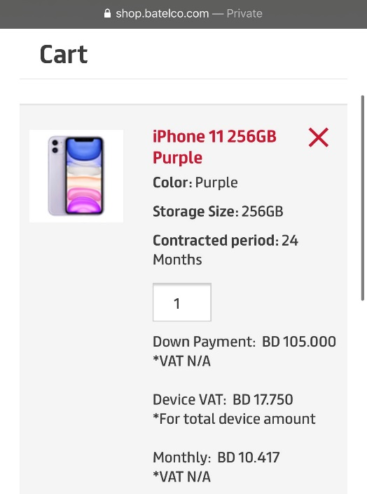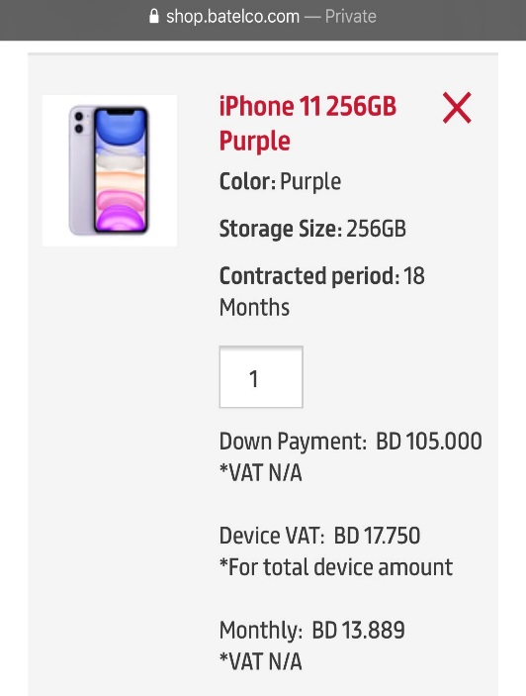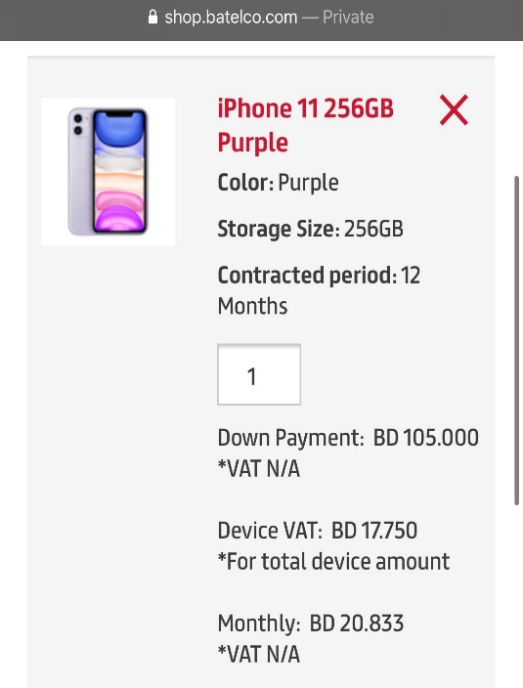

**7.3 Appendix 3: BCG Matrix**

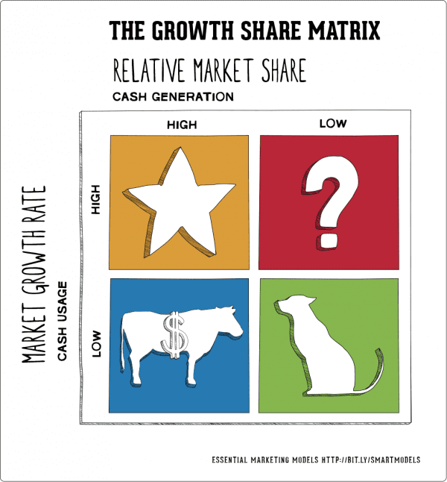BCG matrix between Batelco and Zain. Batelco market share is BHD 1,663,200,000 while Zain market share is BHD 37,168,000. Batelco growth rate is 25.17% while Zain growth rate is -2%.

Batelco has higher market share and higher growth rate than Zain. Then Batelco is Star.

Zain has lower market share and lower growth rate than Batelco. Then Zain is Dog.