 

# MARKETING MANAGEMENT

# SBS MBA/MSc

**Assignment – Bahrain 2020**

STUDENT ID

|  |  |  |  |  |
| --- | --- | --- | --- | --- |
| **1** | **0** | **7** | **0** | **6** |

UNIT TITLE / CODE: **MKT 501**

NAME (in Full): **Mana Hussain H Alyami**

## GENERAL INSTRUCTIONS

* All assignments are to be submitted **7th May 2020** on to [examinationboard@atmsedu.org](mailto:examinationboard@atmsedu.org) and cc to [azrafatima@atmsedu.org](mailto:%20azrafatima@atmsedu.org), [assignmentsubmission2019@gmail.com](mailto:assignmentsubmission2019@gmail.com)
* If assignment is not submitted on date, will follow with penalty of 10% deduction of marks for every day.
* Similarity between students work is strictly not accepted, any student found with similar work will be graded Zero and fail for the course. However, Plagiarism is an academic offence and will not be tolerated under SBS
* Assignment once submitted to exam board is final for marking.
* Total 100 marks

## GUIDELINES FOR ASSIGNMENT

* 1. If assignment is Question & Answer based then.
     + Introduction is needed for each question.
     + Question has to be answered based on the mark allotted for each question with references if any idea or information is taken from other source.
  2. If assignment is case based then,
     + Executive summary
     + Table of content
     + Body of assignment (questions related to case need to be answered)
     + Conclusion / Recommendation if any
     + References (in-text + citation) to be used

## Total Marks / 100

**PLAGIARISM**

Plagiarism is a form of **cheating**, by representing someone else's work as your own or using someone else's work (another student or author) without acknowledging it with a reference. This is a serious breach of the Academic Regulations and will be dealt with accordingly. Students found to have plagiarised can be **excluded from the program**.

Plagiarism occurs whenever you do any of the following things without acknowledging the original source:

* Copy information from any source (including the **study guide**, books, newspapers, the internet)
* Use another person's concepts or ideas
* Summarise or paraphrase another person's work.

## How do I avoid plagiarism?

To ensure you are not plagiarising, you must acknowledge with a reference whenever you:

* use another person's ideas, opinions or theory
* include any statistics, graphs or images that have been compiled or created by another person or organization
* Paraphrase another's written or spokenword.

## What are the penalties?

The penalties for plagiarism are:

* Deduction of marks,
* A mark of zero for the assignment or the unit, or
* Exclusion from the program.

Plagiarism is dealt with on a case-by-case basis and the penalties will reflect the seriousness of the breach.

**Please note: claiming that you were not aware of need to reference is no excuse.**

***Victoza (Liraglutide) (A medicine to treat Type-2 Diabetic in KSA)***

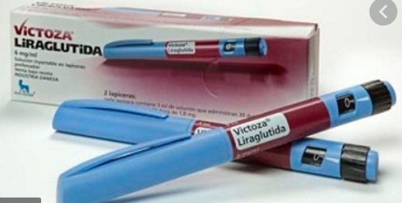

Table of content

1. Executive Summary 5

2. Brand Overview – describe the current status of the brand with a brief historical background 6

Define the brand’s current state on the Product Life Cycle 6

3. Competition Overview – Define competition 7

4. Target Market – Define who is being targeted 9

5. Segmentation – Demographic, Behavior, Psychographic 10

Behavioral Segmentation 11

Psychographic Segmentation 11

6. SWOT – on brand or industry 11

7. Market Research 13

7.1 Product – BCG matrix 14

7.2 Place – Choice of retail strategy 15

7.3 Price – penetrative or skimming or competitive 15

7.4 Promotion – pull or push strategy including choice of medium – digital or traditional 15

8. Conclusions and Recommendations 16

9. Appendix 17

A1 17

A2 17

A3 18

A4 18

Bibliography 19

List of figures

Figure 1 Product Life Cycle (Tao & Tang, 2016) 2

Figure 2 Growing competition among diabetes treatment (Dolgin, 2019) 4

Figure 3 Target Market (Yin, 2019) 5

Figure 4 Types of Market Segmentation (Sgaier, 2017) 7

Figure 5 Main elements of SWOT (Bosch & Bellver) 8

Figure 6 BCG Matrix (Mohajan, 2017) 10

# 1. Executive Summary

In the ***section 2*** the product is introduced and finding revealed that Victoza (Liraglutide) is used for the diabetic patients for controlling of sugar. It directly injected through pen or inject under the skin. This medicine is also used for diet and exercise for chronic weight management in adult patients.This product reaches to the highest level of Product life cycle (Maturity). It is more demanded product in a market and mostly doctors prescribed this product to diabetic patient of Type-2. In ***section 3*** competition analysis has done under which the potential competitors are assessed for the Victoza (Liraglutide) (A medicine to treat Type-2 Diabetics. It is identified that as compared to the competitors Bydereon and Trulicity Victoza has maintained a significant market image. In the ***section 4*** it is elaborated that target market concept is key for business success and as well as a key for increasing sale and attracting new venture in new market. However, in this study the product Victoza is targeting mainly people facing Type-2 diabetic’s issue. In the ***section 5*** it is discussed that segmentation is an activity to divide the business market and consumers and potential consumers into the group of consumers based on the type of shared characteristics. For this concern the selected product “Victoza (Liraglutide) (A medicine to treat Type-2 Diabetic)” the segmentation analysis presented on the basis of demographic, behavioral and psychographic aspects. Demographically targeting people between the ages of 18 to 55, psychographically it targeting people who are more conscious about brand and quality and on behavioral consideration it is targeting market based on the user status, brand loyalty status and usage rate. In the ***section 6*** main elements of the SWOT are illustrated. These points are focused effectively in order to conduct the SWOT analysis on the pharmaceutical industry. The SWOT analysis has portrayed that the Pharma Sector still have to do a lot in order to deal with growing threats and minimizing weaknesses. In the ***section 7,*** the market research on the Victoza (Liraglutide) is done because now company is looking forward to introduce d Victoza (Liraglutide) in the context of UAE. In the context of the BCG Matrix the product relies in the Start section of the Matrix. It is the reason that now company is planning to capture a new market in UAE.

# 2. Brand Overview – describe the current status of the brand with a brief historical background

Liraglutide used in named of VICTOZA and it is used for the diabetic patients for controlling of sugar. It directly injected through pen or inject under the skin. Doctors are recommended to take his medicine through injection and result of this medicine is more effective than other medicines. It reduces the risk of heart attack and reduces the risk of other diseases. Patients Use this medicine on the recommendation of physician, if patient increase doze of this medicine without prescribed by doctor, it reduce the blood sugar level in a body, nausea, dizziness abdominal pain. Continuous use of over doze might side effect like medullary thyroid cancer, angioedema, gallbladder disease. Liraglutide is a glucagon-like peptide-1. This medicine is allowed for use in Europe in 2009 and allowed to use in KSA I 2010. In 2017, this medicine is 163rd prescribed medicine in the USA and it affects the risk of death. This medicine is also used for diet and exercise for chronic weight management in adult patients. According to the centers of Dieses control and prevention (CDC) for the data of 2007, diabetes might affect around 10 million people in KSA and it is projected that this figure reaches to 15 million people in KSA and out of them 90% to 95% relating to type-2 diabetic (by insulin resistance).

## Define the brand’s current state on the Product Life Cycle

According to the product life cycle, first type to introduce product in a market and there are four stages of PLC (introduction, Growth, Maturity and Decline).

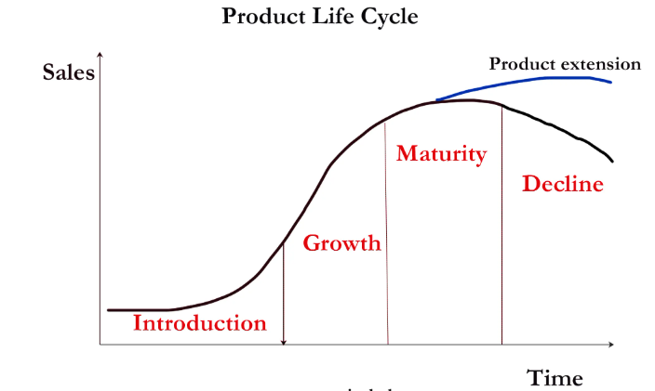

Figure Product Life Cycle (Tao & Tang, 2016)

Liraglutide introduce in a market in 2009 and very doctors are recommended this product to their patient. Novo Nordisk the manufacturer of diabetes drug Victoza. The drug-maker Novo Nordisk is a biggest producer producing insulin. The half of the overall sales of the Novo Nordisk is based on the Insulin. This is an introductory face of this product. Parma companies conducted seminars and brief explain about the product and provide future benefit of this product. Doctors are observed the result of the product and after satisfactory result; they start to recommend this product to other patient. In 2017, around 24 million patients are using this product and found best result of this product. In Second stage of product is growth, after satisfactory benefit of this product, most of the doctor starts the use of this product and this product is made in different countries locally ( on basis of registered patient). Product cost become low on production of large manufacturing and it provides benefit to the consumer. ***This product reaches to the highest level of Product life cycle (Maturity*** (Tao & Tang, 2016)***). It is more demanded product in a market and mostly doctors prescribed this product to diabetic patient of Type-2.***

# 3. Competition Overview – Define competition

According to the statement of (Ringwood & Coe, 2019), a competition analysis under which the potential competitors are assessed. It is one of the most frequently adopted technique focus during the prospect of market research. It is done to determine associated risk and opportunities such as for any new products. On contrary (McMillan, 2018), state that a highly comprehensive and in-depth analysis of competitors provides marketer an understanding how potential and existing customers rate the level of competition. It helps in the significant yet positive identification of the weaknesses and strengths of competitors. Also, a mechanism utilized by concerning authorities in order to develop the efficient and vibrant competitive strategies for perspective targets market. Moreover based on the following factors.

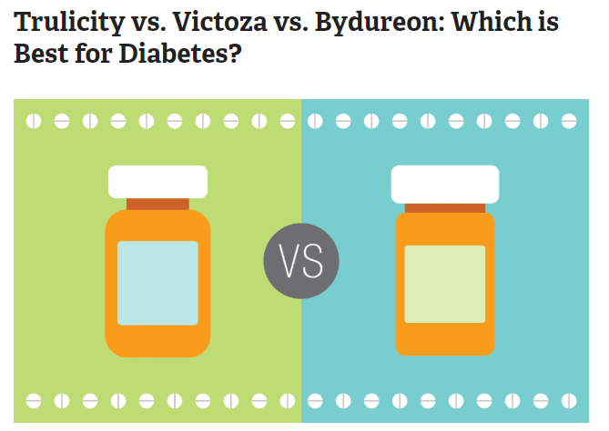

Figure Growing competition among diabetes treatment (Dolgin, 2019)

The competitor analysis of the Victoza (Liraglutide) (A medicine to treat Type-2 Diabetic) is elaborated with the identification of its major competitors. It is identified that as compared to the competitors Bydereon and Trulicity Victoza has maintained a significant market image. Bydereon and Trulicity is two major competitor to Victoza but still the market presence Victoza strong due to its continuous concern on the market research (Refer A3). It is analyzed that the rate of competition among the various pharma sector are high. However, the firms are continually engage in developing and marketing the most sustainable treatment for diabetes. It is the reason that this area of pharma industry is become increasingly competitive. In addition to this, all if the three medicine Victoza Bydereon and Trulicity are creating similar types of the side effect but when it is to be focus on the weight gain and weight loss Victoza is playing more prosper role in reducing the weight people having high obesity issue (Refer A4). It is even noticed that people have reduced the weight till six pounds (Dolgin, 2019).

# 4. Target Market – Define who is being targeted

As stated by (JAFARIAN, 2019), the target market evolves with the process of breaking a market in different segments. In addition concentrating on the efforts of marketing is a key concept where customers wants, need and desires are more closely match with the offered goods or services. With support (Yin, 2019) has stated target market concept is key for business success and as well as a key for increasing sale and attracting new venture in new market. The benefits of target marketing is that it aims the marketing efforts limited to the specific consumer groups makes the pricing, distribution and promotion of the product or service cost effective and more easy and also allow authorities to put keen focus on all the marketing activities in an effective and constructive manner. It clearly means that target marketing is an important marketing function helps marketers in identifying market and acting accordingly to sustain the good steps in attracting and retaining consumers. In addition to this, without the proper analysis it is not easy to complete the process of target marketing because prior and relevant information is highly needed in order to create the sound way completing target market activities in the best possible way.



Figure Target Market (Yin, 2019)

However, in this study the product Victoza is targeting mainly people facing Type-2 diabetic’s issue. It legitimately infused through pen or infuses under the skin. Specialists are prescribed to take his medication through infusion and consequence of this medication is more powerful than different drugs. It lessens the danger of coronary failure and decreases the risk of different infections. Patients Use this medication on the suggestion of doctor, if persistent increment rest of this medication without endorsed by specialist, it lessen the glucose level in a body, queasiness, dazedness stomach torment (Lapolla, 2018) (Refer A2).

# 5. Segmentation – Demographic, Behavior, Psychographic

As stated by (Hardcastle, 2016) segmentation is an activity to divide the business market and consumers and potential consumers into the group of consumers based on the type of shared characteristics. Also, Consumer behavior is the study of how groups, organization and even individual customers select, buy, use and dispose ideas, services or goods in order to satisfy the needs and wants. It is even refers as an action of different consumers in the premises of marketplace and also the related underlying motive for particular actions. Consumer Behavior is influenced by different factors including economic factors, personal factors, cultural and social factors and psychological factors (Sgaier, 2017). In addition to this, demographics of the consumers and psychograph stated of consumers are equally important in order to segment that target market in and effective and efficient manner. The most important elements of economic factors are personal income, disposable income, discretionary income, family income expectations regarding future income, liquid assets and consumer credit and level of standard of living. For example consumers started to spend more with the increase in the income and demand less in the low or absence of income. Secondly, the noteworthy element of the personal factors is age, occupation, life cycle stage, lifestyle and personality and self-concept. For example people of different ages have different expectation, demands and needs. Another example is that in the domain of self-concept perception of one for any prospect is change and determining. In the domain of psychological factors main elements are motivation, perception, involvement, learning, lifestyles and attitude (Islam, 2017). However, for the selected product “Victoza (Liraglutide) (A medicine to treat Type-2 Diabetic)” the segmentation analysis presented on the basis of demographic, behavioral and psychographic aspects.



Figure Types of Market Segmentation (Sgaier, 2017)

#### Demographic Segmentation

It is the most important and essential criterion followed during the identification of target market. Howe on the demographic basis Victoza (Liraglutide) is targeting both male and female. Also it is targeting the people between the ages of 18 to 55. It is targeting to the people belongs to high income class and also targeting to consumers of all religion and race. It can also be taken by both married and single.

### Behavioral Segmentation

Based on the user status, brand loyalty status and usage rate Victoza (Liraglutide) is targeting people. This is important to focus in order to acquire the sustainable image in market.

### Psychographic Segmentation

Psychographic aspects Victoza (Liraglutide) targeting people who are more conscious about brand and quality. It is specifically targeting the consumer form the upper and middle class that is A and B social grade (refer A1).

# 6. SWOT – on brand or industry

According to the statement of (Bosch & Bellver), SWOT analysis is the tool helps to identify the strength, weakness, opportunities and threats impacting on the business activities, The SWOT analysis is important for every department including the marketing, HR, R&D, recruiting, and T&D. SWOT analysis helps in reducing weaknesses and threats to business. In the above figure the main elements of the SWOT are illustrated. These points are focused effectively in order to conduct the SWOT analysis on the pharmaceutical industry.

#### Strengths of pharmaceutical industry

The pharmaceutical industry is providing high quality products and services and it has great overall excellence and value. The component of internal industry may include human capital, physical resources or features which the industry is controlling. The pharmaceutical industry is overhead low operating. In addition to this the other strengths of pharmaceutical industry my include low turnover of staff, high investment return, firm fiscal management, equipment of art laboratory and an experienced staff whose main role is to do research (Bisht, 2018).

#### Weaknesses of pharmaceutical industry

The major weakness is the low investment in the innovative R& D. The diffuse nature of pharmaceutical industry means that only around 20 to 30 organizations are more than enough to deal with the costs of transaction which is linked with sustained and export with the regulation of entry in the established market. Also, most of the organizations lack competing ability with MNCs in the discovery of new drug, in the research and molecules commercialization in all over the world as a result of minimum resources and the linkage of storage among academic and industry which is most important for the industrial growth is lacking in the pharmaceutical industry (Islam, 2017).

#### Opportunities of pharmaceutical industry

With rapid increase on the technology a high level of opportunities are cultivated for the pharmaceutical industry. With the process of the automation actives such as robotics mechanism can be used to help the paralyzed patients. In addition to this, they have an opportunity for the diversification to diversify into the health and nutritional sector and help people in creating more organic activities and helping individuals to grow and developed in an effective and sound manner. Along with this they also have an opportunity to create the wrist band watched indicating reflection in the life of people living in the stage of later life.

#### Threats of pharmaceutical industry

Threats of pharmaceutical industry are very high because of the growing competition. In addition to this, the regime of patent product poses great challenge to the pharmaceutical industry until it invested in the process of development and research. Additionally, the efforts of R&D in the pharmaceutical industry is hampered due to lack of enabling requirement of regulator is another threats to company. The order of drug price control put unrealistic ceiling on the price and profitability of product also threating for pharmaceutical industry. Also, the market of generic in the developed counties may be influence by several factors and the authorized generic release by major manufacturer of drug (Tang, 2018). The player of new mid-sized by creating themselves in the market of generic and enhance competition because of the manufacturer of east European and new Chinese.

# 7. Market Research

Novo Nordisk the manufacturer of diabetes drug Victoza. The drug-maker Novo Nordisk is a biggest producer producing insulin. The half of the overall sales of the Novo Nordisk is based on the Insulin. The company has done an extensive market research on the insulin therapy because in the field of medical the companies are doing high research to bring innovation in the medication. In addition to this, Victoza admits that there are certain challenging times ahead and the modern insulin because treating the type 2 diabetes becoming very difficult. Also Novo Nordisk has realized that the delaying in bringing new drugs to the market can leave them open to high competition. It is the reason that Novo Nordisk is working effectively to bring new medical innovation in order to treat Type-2 Diabetics. Novo Nordisk has researched that degludec and degludec plus will make the prospective growth in market. It will create the new growth for the insulin. It is prospectively hoped that degludec is now become a leading treatment in the context of Medical world in order to reach the high market growth.

## 7.1 Product – BCG matrix

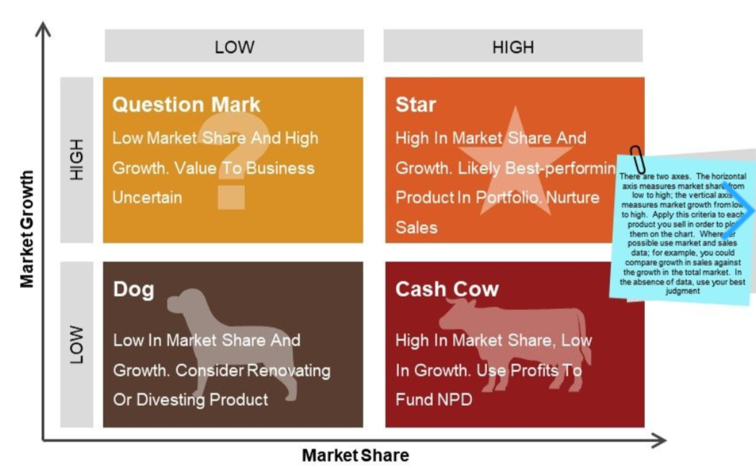

Figure 6 BCG Matrix (Mohajan, 2017)

According to the statement of (Mohajan, 2017) Product is one of the most essential element of 4Ps. With respect to the BCG matrix the selected product Victoza (Liraglutide) is elaborated under this section. It is already explained that Liraglutide used in named of VICTOZA and it is used for the diabetic patients for controlling of sugar. Liraglutide is a glucagon-like peptide-1. This medicine is allowed for use in Europe in 2009 and allowed to use in KSA I 2010. In 2017, this medicine is 163rd prescribed medicine in all over the world and it affects the risk of death. This medicine is also used for diet and exercise for chronic weight management in adult patients. In 2017, around 24 million patients are using this product and found best result of this product. It is even noticed that after satisfactory benefit of this product, most of the doctor starts the use of this product and this product is made in different countries locally on the basis of registered patient. Product cost become low on production of large manufacturing and it provides benefit to the consumer.

In addition to this, in the context of the BCG Matrix the product relies in the Start section of the Matrix. It is due to the reason that product is high in market share and market growth. In the premises of KSA the product has maintained a significant market growth now Novo Nordisk the manufacturer of diabetes drug Victoza is looking forward to expand the business activities in the context of UAE. Novo Nordisk has researched that degludec and degludec plus will make the prospective growth in market. It will create the new growth for the insulin. It is prospectively hoped that degludec is now become a leading treatment in the context of Medical world based on these analysis the company has now decided to expand in UAE in order to treat the Type-2 Diabetics Patients.

## 7.2 Place – Choice of retail strategy

According to the statement of (Končar, 2016), the choice of retail strategy is based on the five main elements (1) defining the positions, (2) Identification of target market, (3) determine benefits, (4) decide on tactics and (5) setting a budget and schedule. At the same side the placement of the product is another difficult task to be done. It is the reason that the company has adopted a retail strategy and the medicine Victoza (Liraglutide) is available at the retail stores in UAE.

## 7.3 Price – penetrative or skimming or competitive

As far as the pricing strategy is considered to enter into the market of UAE. Setting the price of the product is really a difficult task to be done. Therefore keeping this relevance in mind the company will going to adopt the penetration pricing strategy because the by keeping the prices low the new product in UAE market allow company penetrate deeply and extensively into the market in a shorter time period.

## 7.4 Promotion – pull or push strategy including choice of medium – digital or traditional

According to (Puchkova, 2016), the push strategy can be used to push the product to the customer on comparison the pull strategy used to pull the consumer towards the product. The push strategy is one of the eat quick way which is used to move a consumer from the awareness to the process of buy and pull strategy is all about establishing continuous linked with the brand. The purpose of both to move the consumer with the journey of awareness to buy. Therefore, pull strategies can be more accomplished at establishing ambassadors of brand. It is essential for organization adopts a complementary balance among two and the same process will be adopted by the company for the promotional activities of Victoza (Liraglutide). In addition, it is going to implement both traditional and digital media to reach the audience because company is targeting a huge market.

# 8. Conclusions and Recommendations

Victoza (Liraglutide) is used for the diabetic patients for controlling of sugar. It directly injected through pen or inject under the skin. It is more demanded product in a market and mostly doctors prescribed this product to diabetic patient of Type-2. Also, as compared to the competitors Bydereon and Trulicity Victoza has maintained a significant market image. The product Victoza is targeting mainly people facing Type-2 diabetic’s issue. Demographically targeting people between the ages of 18 to 55, psychographically it targeting people who are more conscious about brand and quality and on behavioral consideration it is targeting market based on the user status, brand loyalty status and usage rate. Additionally, the market research on the Victoza (Liraglutide) is done because now company is looking forward to introduce d Victoza (Liraglutide) in the context of UAE. In the context of the BCG Matrix the product relies in the Start section of the Matrix. Based on the sound market growth the company is now decided to expand its business activities within the realm of UAE. Additionally, both traditional and digital media to reach the audience and it will follow the penetrating pricing strategy to acquire the sound position in market. However, following recommendations are made;

* It is recommended to conduct a proper environmental analysis in order to create the strongest position in market.
* It is suggested to protect the right of the industry by dealing with all the legal externalities
* It is suggested to focus more on the digital marketing strategies as compared to the traditional marketing strategies
* It is also recommended to change the pricing strategy from penetrating to skimming to obtain the maximum profit.

# 9. Appendix

# A1

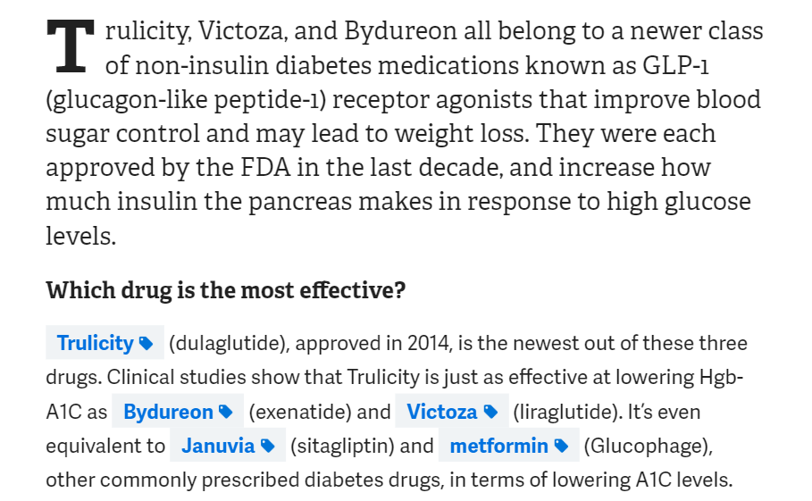

# A2

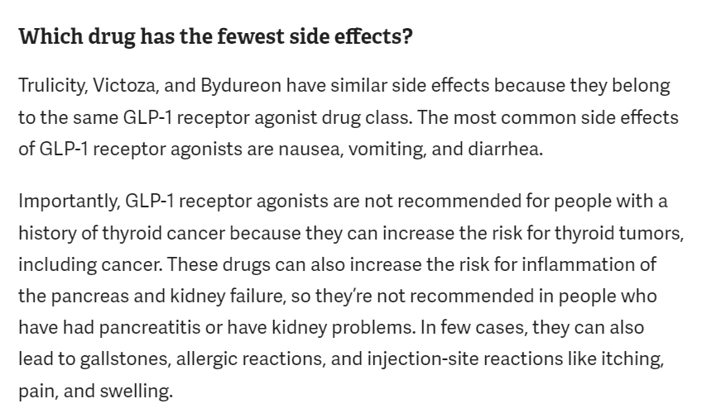

# A3

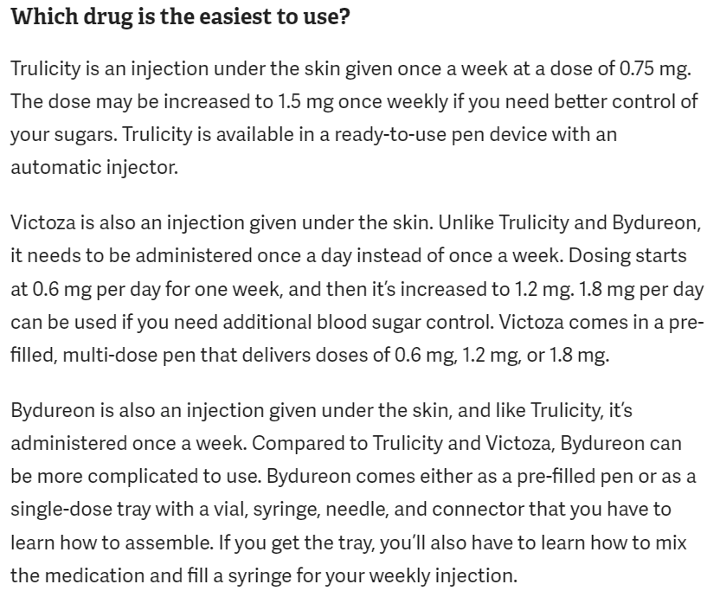

# A4

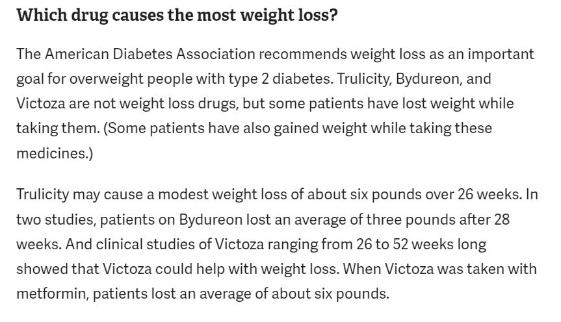

# Bibliography

Bisht. (2018). Indian Pharmaceutical Industry in 2018-SWOT Analysis. NOLEGEIN-Journal of Global Marketing, 7-11.

Bosch, & Bellver. (n.d.). Second-generation preimplantation genetic testing for aneuploidy in assisted reproduction: a SWOT analysis. Reproductive BioMedicine Onlin.

Dolgin. (2019). bacterial strains, and the glucagon-like peptide-1 receptor agonist Victoza (liraglutide), commonly used to treat type 2 diabetes Tiziana Life Sciences, headquartered in. Nature BiotechNoloGy.

Hardcastle. (2016). Psychographic profiling for effective health behavior change interventions. Frontiers in psychology, 6, 1988.

Islam. (2017). Implementing SWOT-FTOPSIS methods for selection of the best strategy: Pharmaceutical industry in Bangladesh. Journal of Modern Science and Technology, 5(1), 110-124.

JAFARIAN. (2019). Successful Strategy for Determining the Target Market of Iranian System Software Developer Knowledge Base Companies: A Case Study.

Končar. (2016). The role of retail strategy in the development and efficiency of business on the global electronic market. Strategic Management, 21(4), 22-28.

Lapolla. (2018). Long-term effectiveness of liraglutide for treatment of type 2 diabetes in a real-life setting: a 24-month, multicenter, non-interventional, retrospect.

McMillan. (2018). Who Owns the Internet? A Brief Overview of the US Antitrust Law and EU Competition Law in the Internet Industry. Strategic Studies.

Mohajan. (2017). An analysis on BCG Growth sharing matrix.

Puchkova. (2016). Balancing push and pull strategies within the production system. IFAC-Papers On Line, 49(2), 66-71.

Ringwood, & Coe. (2019). July). The Wave Energy Converter Control Competition: Overview. In ASME 2019 38th International Conference on Ocean, Offshore and Arctic Engineering. American Soc.

Sgaier. (2017). A case study for a psychographic-behavioral segmentation approach for targeted demand generation in voluntary medical male circumcision. Elife,.

Tang. (2018). SWOT analysis and revelation in traditional Chinese medicine internationalization. Chinese medicine, 13(1), 5.

Tao, & Tang. (2016). Internet of Things in product life-cycle energy management. Journal of Industrial Information Integration, 1, pp.26-39.

Yin. (2019). The speed of adjustment to the target market value leverage is slower than you think. Journal of Financial and Quantitative Analysis, 1-66.