**MARKETING MANAGEMENT**

**SBS – MBA/MSC**

**UNIT CODE: MKT 501**

**LECTURER: MR. CLAY GERVAIS.**

**MARKETING MANAGEMENT STRATEGY**

**THE BRAND**

**SUBMISSION DATE: 19 MAY 2020**

**STUDENT NAME: JOHANNA DE BOD**

**STUDENT ID :10707**

**TABLE OF CONTENTS**

1. **Executive summary 3**
2. **Brand overview 5**
3. **Competitive overview 7**
4. **Target Market 8**
5. **Segmentation 8**
6. **SWOT analysis 9**
7. **Market research 11**

**Product 13**

**Place 13**

**Price 15**

**Promotion 16**

1. **Conclusion and recommendations 17**
2. **Appendix 17**
3. **References 18**

**1.Executive Summary**

American Mission Hospital is a non-for-profit hospital in Bahrain since 1893.

The hospital is managed by the Dutch Reform Church in America. Bahrain is the smallest country on the Persian Gulf with over 1.5 million inhabitants of which 600 000 are nationals and the rest are expatriates.

The discovery of oil in 1932 brought rapid modernization to Bahrain. The First hospital was built in 1903, which is still standing (original building) and functioning. Our Hospital is responsible for primary and secondary health care in Bahrain.

Health care was delivered by missionaries who have worked under terrible circumstances and been exposed to all health risks. The first physician on the island Dr. Storm continued on the island until his death. His grandson is still a member of the Dutch Reformed Church of America.

Rendering services to the community. We have grown over the past years from a mission station to a full fletch hospital with 3 ambulatory clinics ( Amwaj 2014, Sar 2011 and Riffa 2017) Manama are since 1903. which has ambulatory clinics and inpatient departments. Currently, we are seeing 360000 patients per year and has done over 50 000 deliveries since 1903.

We are providing mostly primary and secondary care to our patients. Patients that need tertiary care are been referred to other health care facilities. Home health care is the only lacking service.

Our logo is representing the tree of life. the tree of life is a 9.75 m Prosopis cineraria tree that is over 400 years old and roots are 50 meters deep. It is on a hill in a barren area of the Arabian desert, 2km from Jebel Dukhan the highest point in Bahrain, and 40 km from Manama. It is abundantly covered in green leaves. The tree is not near any water source.

**Our SWOT analysis is the following :**

**Strengths**

* Stable well-established hospital system since 1903
* Funded by Dutch Reform Church of America
* Provide quality care

**Weakness**

* Non-for-profit organization
* Only provide primary and secondary care

**Threads**

* Economic instability
* Global influences
* Competition in health care - new hospitals opening

**Opportunities**

* To be the best provider in Bahrain
* Community participation
* Improve and extend our service delivery
* To be the leader in health care

**Mission:**

To provide high-quality health care at an affordable cost to all who seek care and to provide that care with the biblical principles of compassion, grace, and love.

**Vision:**

To be the leader in setting the standards of high quality, innovative healthcare in Bahrain, and to other facilities.

Home healthcare is supportive care provided by skilled medical, nursing, and allied care to help someone get better while at home. Over 100 years ago, it was the only way to provide dedicated healthcare for many health conditions. Home healthcare has increased recently due to:

* Rising hospital costs
* Increase in chronic illnesses
* The rapid growing elderly population
* Less costly and more appropriate

The GCC nations have only recently started adopting and recognizing the home healthcare model and the private sector has emerged as a key player.

In the UAE, there are approximately 42 private companies providing home healthcare services to cater to the demand for the services, which is expected to increase 20% yearly as per the Health Authority - Abu Dhabi, 2010.

Research has done globally suggested that home health care is preferred by 95% of patients over 75+ years

AMH has shown extensive growth for the last 7 years and continues to grow.

We are going to target the middle class and lower-income class as well as a high-income class if the need arises. For this marketing purpose, we are targeting the lower-income population.

To implement a home health care service.

We will run our service out in 3 phases , which will give us the opportunity to review and adjust as times go.

**2.Brand Overview**

**Describe the current status of the brand with a brief historical background. Also, define the brand’s current state on the Product Life Cycle.**

American Mission Hospital is in Bahrain since 1893. Bahrain is the smallest country on the Persian Gulf with over 1.5 million inhabitants of which 600 000 are nationals and the rest are expatriates.

The discovery of oil in 1932 brought rapid modernization to Bahrain. The First hospital was built in 1903, which is still standing (original building) and functioning. Our Hospital are responsible for the health care in Bahrain to all and extended our services to other areas of the middle east and across borders. Health care was delivered by missionaries who have worked under terrible circumstances and been exposed to all health risks. The first physician on the island Dr. Storm continued on the island until his death. His grandson is still a member of the Dutch Reformed Church of America.

The hospital is managed by the Dutch Reformed Church of America. We are a not-for-profit organization. Rendering services to the community. We have grown over the past years from a mission station to a full fletch hospital with 3 ambulatory clinics ( Amwaj 2014, Sar 2011 and Riffa 2017) Manama are since 1903. which has ambulatory clinics and inpatient departments. Currently, we are seeing 27000 patients per year and has done over 50 000 deliveries since 1903. We are providing mostly primary and secondary care to our patients. Patients that need tertiary care are been referred to other health care facilities.

Our logo is representing the tree of life. the tree of life is a 9.75 m Prosopis cineraria tree that is over 400 years old and roots are 50 meters deep. It is on a hill in a barren area of the Arabian desert, 2km from Jebel Dukhan the highest point in Bahrain, and 40 km from Manama. It is abundantly covered in green leaves. The tree is not near any water source.

As a not for profit organization, our service charge will be limited

We are serving our community and full fill our mission and vision.

**Mission:**

To provide high-quality health care at an affordable cost to all who seek care and to provide that care with the biblical principles of compassion, grace, and love.

**Vision:**

To be the leader in setting the standards of high quality, innovative healthcare in Bahrain and to other facilities.

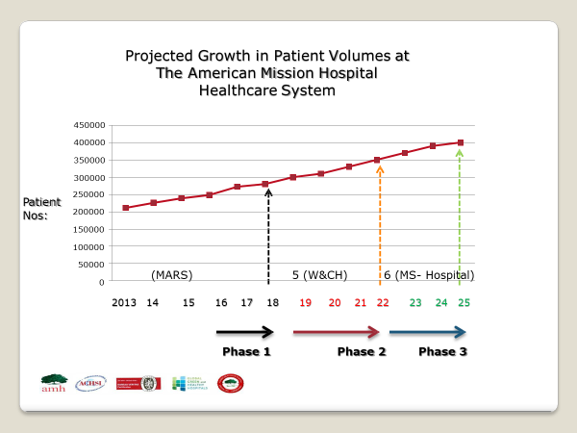

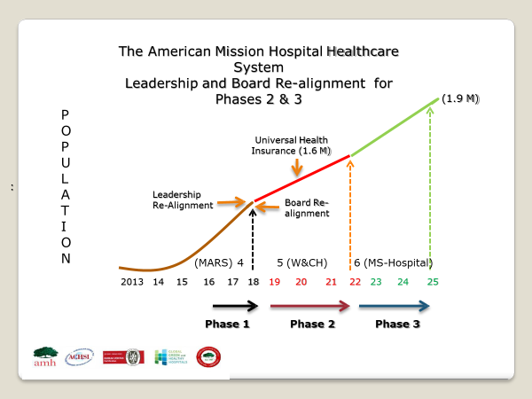

**3.Competition Overview**

Competition is the act or process of competing such as the efforts of two or more, parties/companies acting independently to secure the business/ support of a third party by offering the most favorable terms or services in the same field e.g. advance technology or advances 3D ultrasound service for detecting fetal abnormalities.

In Bahrain, we have 3 health care facilities under control by the government which is focussing on primary secondary and tertiary care. And there are 5 Private hospitals form which we are one of them .25 Other small primary health care facilities .

As a not for profit organization and private hospital our services is well within the market.

Our mission speaks louder than words. That is what we are good at and what keep us in the market since 1983.

We are serving our community and full fill our mission and vision.

Home health care is only rendered by one private hospital that is targeting the middle class to high-class people they are providing health care for bedridden patients and are providing nurses on an Adhoc basis.

Living in nurses that will be responsible for the total care of the patient eg. Long term Ventilated care.

**4. Target Market – Define who is being targeted.**

Low class to medium class people.

All age groups

Both male and female

People with chronic diseases.

We want to reach the 500 000 laborers in the Southern Hemisphere of Bahrain, which are receiving a minimum wage between 80 to100 BD per month.

They are working in construction, retail, security, and hospitality (cleaners). They have no health insurance or low-class health insurance that only are excepted by certain primary clinics. Lack of transport and access to medical care. The middle class belongs to insurance which has limited health coverage.

Map Covering the current Population

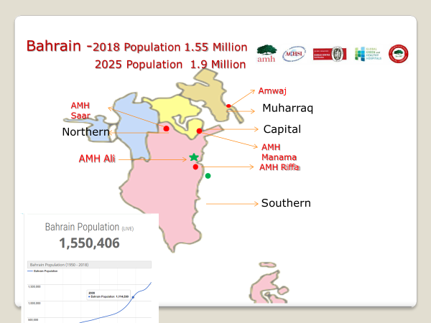

**5. Segmentation**

**Geography**

We are targeting the Southern area of Bahrain, due to no health facilities in this region. It is an underdeveloped area of Bahrain. Is also the dessert and Agricultural area.

**Demographic**

Gender - more males than females as most labor camps are situated in this region. Mostly Families in this area and average siblings per household range from 2 to 8, which is normal for this culture. The average age of marriages ranges from 18 to 90.+ years of age.

All age groups are represented in these areas from newborn to 90+ years. Income is generated through selling of farm produce and poultry and camels. Tradition is still practiced here and no influence from urbanization present. Labour camps are consisting of males only and age ranges from 18 to 60. Occupations mostly farmers, housewives, laborers, school-going children.

**Psychographic segmentation**

All habitats are locals from Bahrain. Speak the same language, has the same traditions and same interest. All belong to the Muslim tibian community. Plain a simple lifestyle. Living in tents and homemade shacks or houses with elements from nature (sand, palms, tents). Labour camps are mostly temporary structures.

Lifestyle is plain and simple through farming and fishing and diving for pearls. Social interaction is on day to day basis and family ties is very strong in this very conservative lifestyle.

**6. SWOT ANALYSIS.**

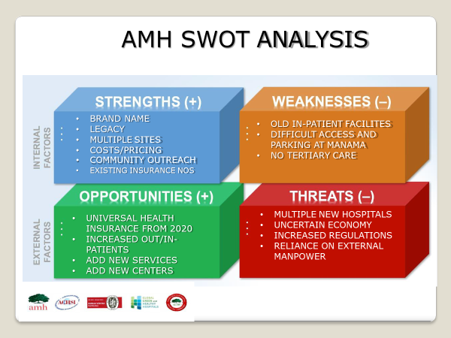

**Strengths**

* Stable well-established hospital system since 1903
* Qualified staff**.**
* IT support system - self build
* Supported by Government
* Funded by Dutch Reform Church of America
* Provide quality care

**Weakness**

* Non-for-profit organization
* Only provide primary and secondary care
* Structural limitations
* Low turnover of staff

**Threads**

* Economic instability
* Global influences
* Competition in health care - new hospitals opening
* Not a variety of cases
* Containing expenditure

**Opportunities**

* To be the best provider in Bahrain
* Community participation
* To grow towards to be a healthcare system
* Improve and extend our service delivery
* To be the leader in health care

**7.Market Research.**

Home healthcare is supportive care provided by skilled medical, nursing, and allied care to help someone get better while at home. Over 100 years ago, it was the only way to provide dedicated healthcare for many health conditions. Home healthcare has increased recently due to:

* Rising hospital costs
* Increase in chronic illnesses
* The rapid growing elderly population
* Less costly and more appropriate

The GCC nations have only recently started adopting and recognizing the home healthcare model and the private sector has emerged as a key player.

In the UAE, there are approximately 42 private companies providing home healthcare services to cater the demand for the services, which is expected to increase 20% yearly as per the Health Authority - Abu Dhabi, 2010.

Research done globally suggested that home health care is preferred by 95% of patients over 75+ years

**Why home health care?**

Patient convenience: Provides patients the comfort and privacy of their own homes.

Patient savings: home health care is cost effective compared to hospitalization

Risk reduction: reduce the need for pre-hospitalization and provide safety against hospital acquired infection

System efficiency: Eases the availability of hospital resources e.g. hospital beds and skilled medical staff.

**Benefits of Home Healthcare to Insurance Companies**

Cost  reduction: Homecare reduces the time a patient has to spend hospitalized and reduces the overall healthcare cost of patient.

**To provide home health care services that promotes the patients’ value of life by:**

Minimizing patient illness and disability

Maximizing patient’s potential level of independence

Restoring, maintaining and promoting patient health

Helping individuals and families access needed services.

Preventing the need for hospital admission, making earlier discharge from hospital possible, and reducing the frequency of re-admission.

Determining needs and abilities and developing and coordinating plans of care.

Improving, maintaining or delaying loss of functional abilities.

Primary Market Research Method #1 – Surveys

Survey market research was chosen and we have partnered with a research company to send field workers to complete 10000 surveys on the field.

We choose this type due to

* A relatively large sample to query.
* Have the resources (time and money) to conduct a survey.

We also have used focus Groups especially in our labor camps and remote sites.

Data are available from our current patient data banks/attendance.

**Below slides suggest the estimated growth in the current healthcare system**

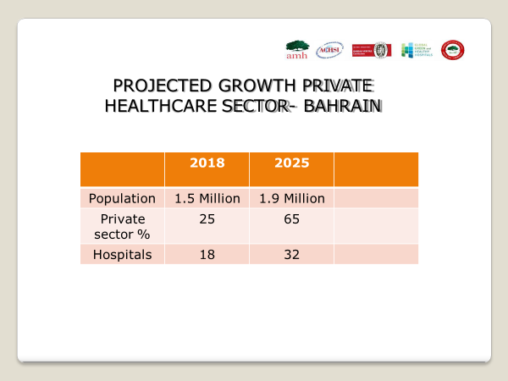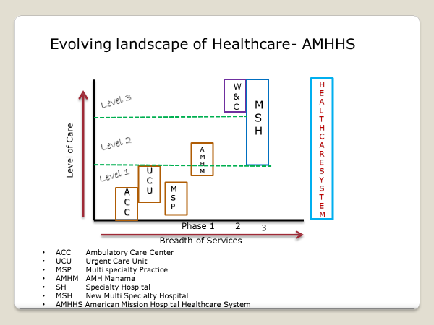

**7.1 Product – BCG matrix.**

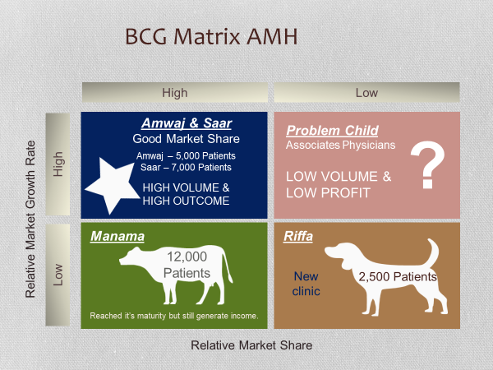

**7.2 Place – Choice of retail strategy**

Home healthcare is supportive care provided by skilled medical, nursing, and allied care to help someone get better while at home. Over 100 years ago, it was the only way to provide dedicated healthcare for many health conditions. Home healthcare has increased recently due to:

* Rising hospital costs
* Increase in chronic illnesses
* The rapid growing elderly population
* Less costly and more appropriate

The GCC nations have only recently started adopting and recognizing the home healthcare model and the private sector has emerged as a key player.

In the UAE, there are approximately 42 private companies providing home healthcare services to cater the demand for the services, which is expected to increase 20% yearly as per the Health Authority - Abu Dhabi, 2010.

Research has done globally suggested that home health care is preferred by 95% of patients over 75+ years

The main focus is Homecare based at home and on Site. We take the care to the people and affordable prices for all: “ Hospital on wheels”

The people we want to reach is the 500 000 laborers in Bahrain which are receiving a minimum wage between 80 to 100 bd per month and our elderly community and people with chronic diseases

They are working in construction, retail, security, and hospitality (cleaners). The average workweek for them is 8 hours per day and one day a month off. The choice is to reach the low to middle-class people, due to them not having health insurance or low-class health insurance that only are excepted by a certain primary clinic.

Lack of transport and access to medical care. The middle class belongs to insurance which has limited health coverage.

Service that we are going to be provided is:

* Home visits to post deliveries and breastfeeding awareness.
* Post-op visits for dressings, catheter care and NGT feeding.
* Physiotherapy, and care for bedridden patients.
* Due to COVID 19 delivering of medication at home to limit exposure.
* Pre-employment services eg.mobile Xrays and lab services.
* We want to reach all patients in the remote areas of Bahrain.

Bahrain has a lot of villages that have no access to health care.

Service will be done in 3 phases

**First phase:**

Home health visits by nurses and physicians performing the following:

* Injections, dressings, catheter and NGT change,
* Nebulization
* Tracheostomy care
* Phlebotomy
* Postnatal visits
* Well mother and baby visits
* Tracing of communicable diseases

**Second Phase:**

Mobile clinics to remote areas with a dedicated primary care service eg.

Postnatal care, all services rendered under phase one and more extensive

**Third Phase:**

Mobile hospital truck with radiology facilities and lab facilities and for a minor procedure eg. Dental extractions, circumcisions. Ophthalmology services.

Other specialized services needed.

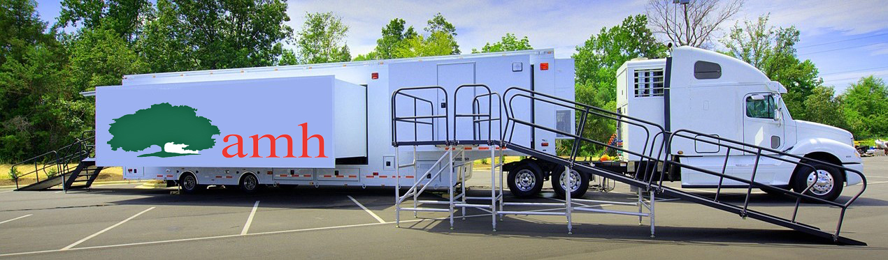

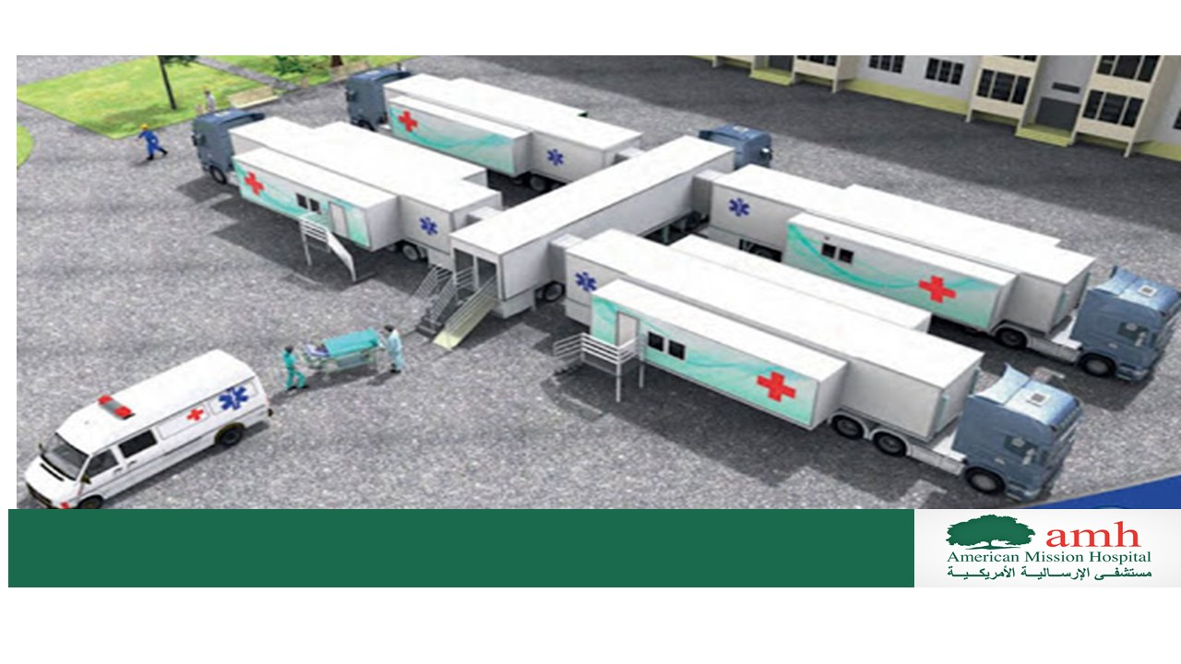

**7.3 Price**

As a not for profit organization, our service charge will be limited

We are serving our community and full fill our mission and vision.

**Penetrative pricing** – to first get the customers to establish what they can afford. We believe that our pricing should be affordable and accessible.

Health visits will be BD 3.

The screening will be free

Phlebotomy services - 25 % discount

Hospitalization will be with reducing costs.

Sponsorships can be generated. Yearly we have an Island Classis Golf tournament as part of fundraising activities

**This slide shows that to implement or initiate community-based care the costs can be kept low.**

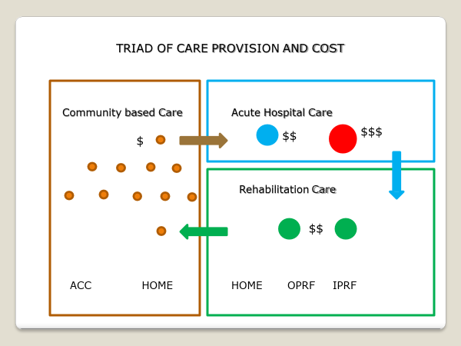

**7.4 Promotion**

The promotion strategy we are going to use is the pull strategy to invite the people in.

To use our services and to feel important and wanted.

The promotion of service needs to be carefully selected as we are targeting the middle to lower class people, who will not always have access to the latest technology. We will then promote through pamphlets, by word of mouths, newsletters to the different companies, newspaper, SMS messages can be sent and advertisement on a mobile bus or other public transport. Mobile app with low data usage .

Lately, most of the people have access to cell phones as this is the communication medium of all people nationwide. Excellent data and call packages are available in the Gulf.

**See attached flyers as part of a promotion** .

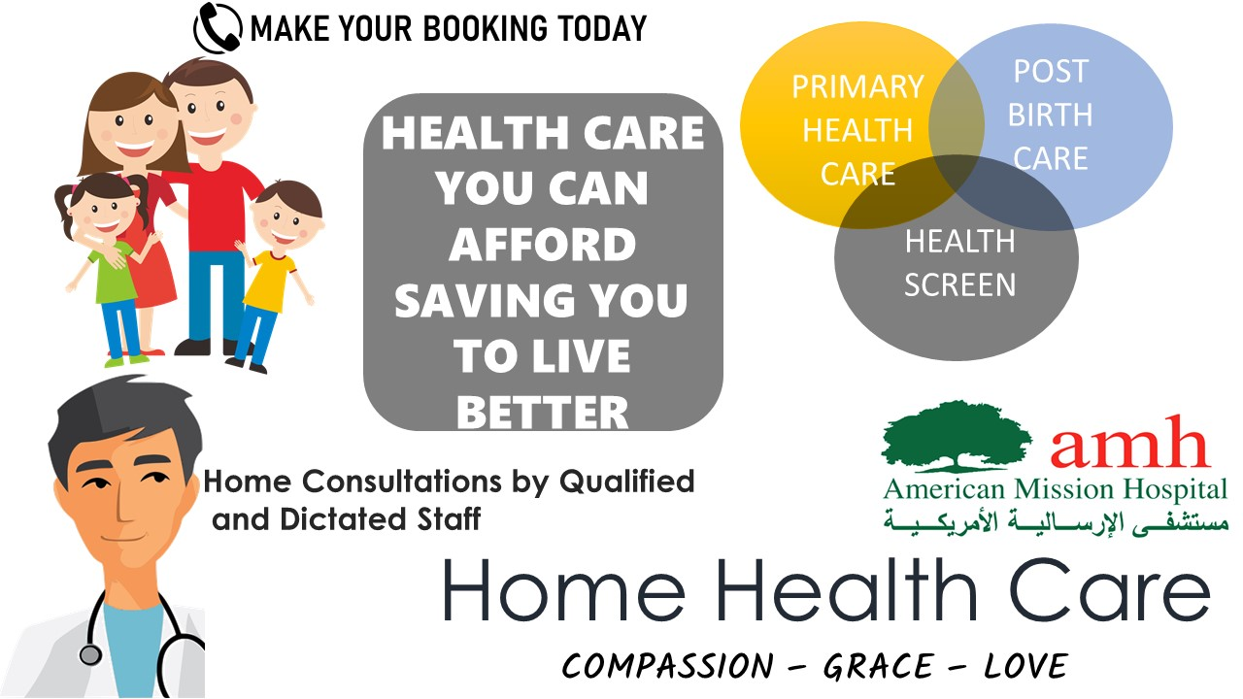

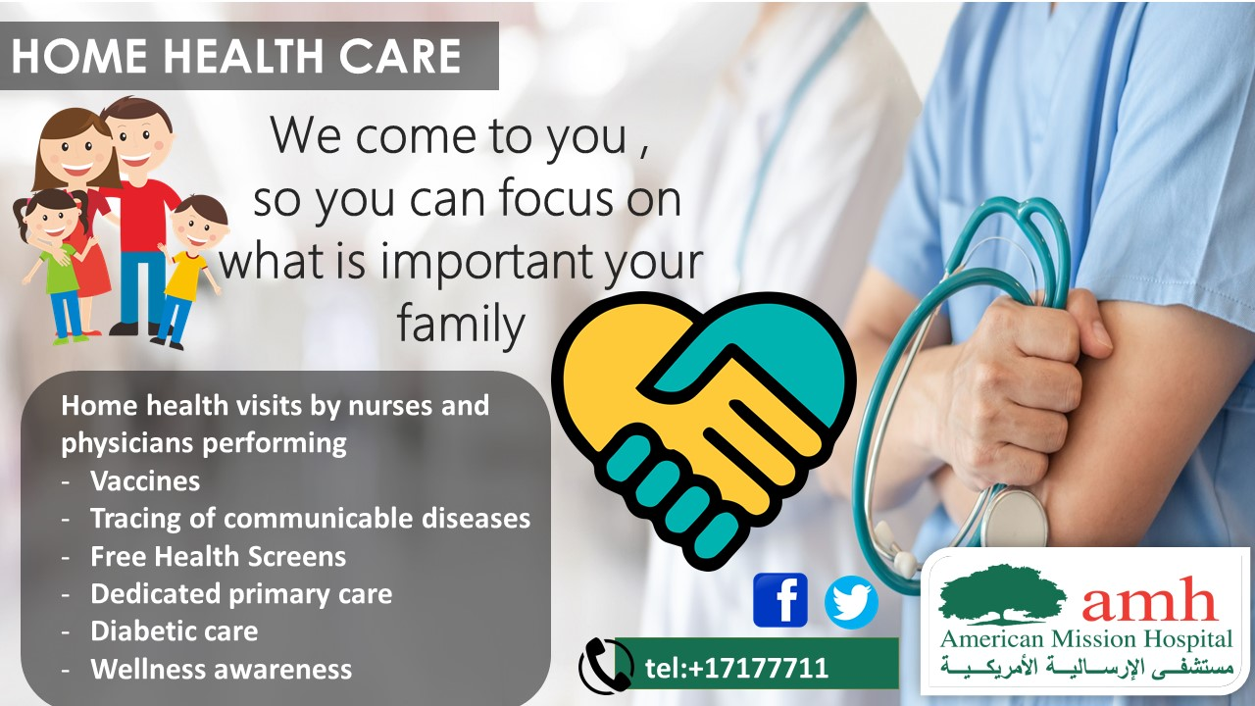

**8. Conclusions and Recommendations**

Our current strategy is to reach all people and to provide affordable and compassionate care. AMH has been in Bahrain for more than a decade and still seeks a way to reach out to the community. Every hardship we see as a challenge. and to keep doing what we good at, what we are compassionate about. Deliver this service with grace and love.

Home health care will be done in stages to see the response of the community and after each stage, we will do a thorough study to see if we reach our goals and adjustment will be made according to the result.

**9.Appendix**

1.Poster of Home health service

2.Poster of Home health care.

10.References.

1. Kotler.Philip.Keller.Kevin.Lane.Marketing Management .14 edition. New Jersey.Prentice-Hall .Pearson
2. [www.amh.org.bh](http://www.amh.org.bh)
3. <https://www.smartinsights.com/marketing-planning/marketing-models/use-bcg-matrix/>
4. Renier De Bod Graphics designer