

**Marketing Management**

**MBA/MSc**

**Assignment – Bahrain 2020**

|  |  |  |  |  |  |
| --- | --- | --- | --- | --- | --- |
| STUDENT ID | 9 | 8 | 9 | 9 |  |

UNIT TITLE / CODE: Marketing Management / MKT 501

NAME (in Full): Talal Almutairi

**GENERAL INSTRUCTIONS**

* All assignments are to be submitted **14th May 2020** on to [examinationboard@atmsedu.org](mailto:examinationboard@atmsedu.org) and cc to [azrafatima@atmsedu.org](mailto:azrafatima@atmsedu.org)[,](mailto:afatima@atmsedu.org) [assignmentsubmission2019@gmail.com](mailto:assignmentsubmission2019@gmail.com)
* If assignment is not submitted on date, will follow with penalty of 10% deduction of marks for every day.
* Similarity between students' work is strictly not accepted, any student found with similar work will be graded Zero and fail for the course. However, Plagiarism is an academic offence and will not be tolerated under SBS
* Assignment once submitted to exam board is final for marking.
* Total 100 marks

**GUIDELINES FOR ASSIGNMENT**

1. If assignment is Question & Answer based then.
   * Introduction is needed for each question.
   * Question has to be answered based on the mark allotted for each question with references if any idea or information is taken from other source.
2. If assignment is case based then,
   * Executive summary
   * Table of content
   * Body of assignment (questions related to case need to be answered)
   * Conclusion / Recommendation if any
   * References (in-text + citation) to be used.

**Total Marks / 100**

**PLAGIARISM**

Plagiarism is a form of **cheating**, by representing someone else's work as your own or using someone else's work (another student or author) without acknowledging it with a reference. This is a serious breach of the Academic Regulations and will be dealt with accordingly. Students found to have plagiarised can be **excluded from the program**.

Plagiarism occurs whenever you do any of the following things without acknowledging the original source:

* Copy information from any source (including the **study guide**, books, newspapers, the internet)
* Use another person's concepts or ideas
* Summarise or paraphrase another person's work.

**How do I avoid plagiarism?**

To ensure you are not plagiarising, you must acknowledge with a reference whenever you:

* use another person's ideas, opinions or theory
* include any statistics, graphs or images that have been compiled or created by another person or organization
* Paraphrase another's written or spoken word.

**What are the penalties?**

The penalties for plagiarism are:

* Deduction of marks,
* A mark of zero for the assignment or the unit, or
* Exclusion from the program.

Plagiarism is dealt with on a case-by-case basis and the penalties will reflect the seriousness of the breach.

**Please note: claiming that you were not aware of need to reference is no excuse.**

**Marketing Management Assignment Structure –**

**Marketing Strategy (Brand)**

For your brand of choice please prepare a marketing strategy on the below guidelines. This should clearly reflect the marketing mix – product, place, price, promotion and packaging as discussed in the class. The learnings on Brand Equity in the class should be the emphasis of the assignment.

Please note the brand should have linkage in the UAE – must be an existing brand or a brand that intends to be introduced in the UAE.

1. Executive Summary – summarizing points 2-8.

2. Brand Overview – describe the current status of the brand with a brief historical background. Also define the brand’s current state on the Product Life Cycle.

3. Competition Overview – Define competition

4. Target Market – Define who is being targeted

5. Segmentation – Demographic, Behavior, Psychographic

6. SWOT – on brand or industry

7. Market Research if any carried out – if no research carried out then suggest a need if any

7.1 Product – BCG matrix. Also include packaging plans if any.

7.2 Place – Choice of retail strategy

7.3 Price – penetrative or skimming or competitive

7.4 Promotion – pull or push strategy including choice of medium – digital or traditional

8. Conclusions and Recommendations – suggestions for change in current practices if any to make it more effective should be discussed.

9. Appendix – Any other information you may provide.

**Table of Contents**

**Executive Summary** 2

**McDonald Overview** 2

**Competition Definition (Comparison Between McDonald)** 5

**Target Market of McDonald** 6

**McDonald Market Segmentation** 6

**McDonald SWOT Analysis** 7

**4 p's of McDonald** 9

**Conclusion** 12

**Recommendations** 13

**Appendix** 14

**References** 16

**Executive Summary**

It is one of the most important marketing objectives, to ascertain the needs of consumers and to convert them into ideas, products, and services, so that what is produced is transferred to the consumer in order to meet a specific desire he has, as the optimal use of all resources available to the company is guaranteed. (Kotler, 2012)

Where marketing can be considered as it is the process through which the manufacture, delivery, and exchange of products of value to customers, partners, and society as a whole.

A marketing strategy sets goals and takes certain steps for planning, through which the desires of the consumer are known and fulfilled in a specific market, and the marketing strategy is a set of strategies that are applied in companies in order to increase business growth and development, in order to achieve the desire and satisfaction of the customer.

In this research, we will discuss the marketing strategy of McDonald's, which is considered one of the largest brands in the world, which specializes in foodstuffs and the provision of fast food, and we will examine the details such as the target market for McDonald's and distribution to the market, and the analysis of the SWOT and the study of the 4ps' of McDonald's, and at the end Research Many recommendations that will be evaluated and repaired will be extracted from McDonald's marketing strategy.

**McDonald Overview**

It is the beginning of McDonald's when Dick and Mac began looking for work opportunities in California after they felt that they were not getting their chance in New England, at first they failed to produce and manufacture films, and after some time they proved themselves worthy of operating restaurants, and with the beginning of 1948, they took a risk and that They rolled out a Speedee serving hamburger system at 15 cents, and that success has made the brand franchise, for more information see appendix 1.

* **McDonald life cycle**

One of the most important things that must be done is taking into account a large number of customers and their desires and the available options that must be provided to them, and this is what McDonald's is doing as it depends on developing its customer list and working to determine market research, and because the requirements and desires of customers change over time McDonald's is trying to renew and develop from its list of products.

What distinguishes marketing is that it monitors customer requirements over time to continue providing customers with the desires they need. (Pri Dhavale, 2012)

McDonald's introduced many new products and canceled many of its old products, making sure that the new options did not affect the old one. (McDonald, 2020)

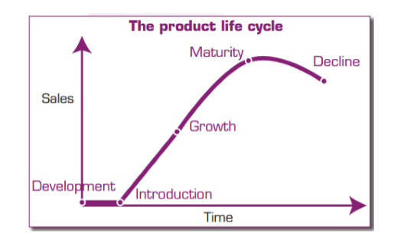

What distinguishes McDonald's is that the list of products that it puts on the market is working to change it in every period and the other in the different stages of its life cycle, and the marketing followed by McDonald's depends on the stage that the product reached.

|  |  |
| --- | --- |
| Name | McDonald |
| Logo |  |
| Industries served | Food Processing |
| Geographic area served | Worldwide |
| Headquarters | Chicago, USA |
| Current CEO | Chris Kempczinski |
| Revenue | CHF 21.08 Billion |
| Profit | CHF 5. 92 Billion |
| Employees | 210, 000 |
| Main Competitor | Taco Bell, KFC, Pizza Hut |

* **Macdonald Vision**

"to move with velocity to drive profitable growth and become an even better McDonald’s serving more customers delicious food each day around the world." (McDonald, 2020)

* **McDonald's Mission**

"to be our customers’ favorite place and way to eat and drink." (McDonald, 2020)

* **McDonald Values**

**Responsible Leadership**

McDonald's is committed to using the measure of goodness, as it relies on the idea of ​​being a good product for people, industry and the planet, working to reduce the impact of waste, and providing a sustainable and humane industry, from pushing people to do good by being millions of people who help others through RMHC.(McDonald, 2020)

**Inclusiveness**

McDonald's is considered one of the most democratic brands in the world, welcoming all different cultures, ages and backgrounds, and investing in all people and labor in all its places. (McDonald, 2020)

**Progressiveness**

What McDonald's is doing is that it works on innovation always, through the original work of it to the invention of leadership through a happy meal for customers, and always be at a high speed of innovation in tomorrow than they do today. (McDonald, 2020)

**Local Integration**

McDonald's traveled around the world and far away, but still maintained local contact in every country they are in and works to integrate with cultures and meet the needs, and in most cases, the human resources in McDonald's living in the neighborhood and provide McDonald's services to hundreds of thousands with pride. (McDonald, 2020)

**Competition Definition (Comparison Between McDonald)**

Competition or competitiveness between companies is the tool that makes the company able to offer goods and services in a particular market and people are highly interested in it, compared to the performance and ability of other companies by offering the same product in the same market or in other markets, which is the extent of the company’s ability to withdraw its market share from another company.

|  |  |
| --- | --- |
| McDonald | KFC |
| The beginning of McDonald's dates back to 1940 and the Speedee system is the first service system that has been provided in the restaurant and is a pioneer in the chain of restaurants to this day, the services provided by the restaurant vary according to the nature of the leadership, and some of the other sections of the restaurants provide entertainment games for children, and the most famous product is hamburgers Sweets, chicken, and French fries, and McDonald's also offers products to vegan customers. McDonald's takes into consideration the country’s culture. (McDonald, 2020) | The beginnings of KFC in 1930 are considered to be in the period that coincided with the Great Depression, as its first name was Sanders Court and Café, while at present their KFC logo is one of the most widespread logos and brands in the world, KFC is characterized by its confidentiality in its recipes made from 11 kinds of herbs and spices, along with a new finger flavor for their chicken.  The product that they offer to the customer is fried chicken, chicken rolls, salads, sandwiches, and several sweets. (KFC, 2020) |

Competition in trade is the argument or emulation among the corporation selling homogenous products and/or aim the same target spectators to get more sales, extension income, and convenient more market share as acquire to others.

**Target Market of McDonald**

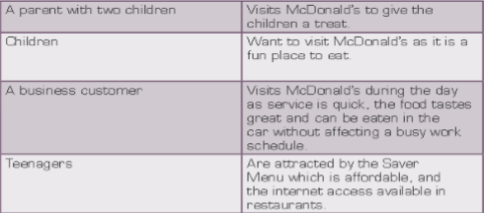

McDonald's works as much as possible to attract the largest number of customers and enlarge its target market, and for that, it provides many services such as Happy Meal where they give one game in every happy meal, as there are different Walt Disney games and characters, and McDonald's provides a place to play Children in her restaurants.

McDonald's reliance on such a strategy helps increase customers by attracting families, and in order to target young people and adolescents, internet facilities and networks are provided in the outlets of the restaurant, for more information see appendix 2. (Cooper, 2009)

**McDonald Market Segmentation**

The aspects that will be discussed in the table below are the basis in directing McDonald's marketing management in order to know how to deal with price, location, promotion and process, and elements of physical evidence for the marketing mix. (Facella, 2008)

McDonald's is the perfect choice for the family, and when it was beginning in the United Kingdom it was working mainly to target the urban class, and today what it focuses on is where the food will be eaten without compromising on the quality of food, service, and hygiene. (Facella, 2008)

And one of the slogans McDonald uses that she insists keep her alive is, "You deserve a break today." (Facella, 2008)

"Feed your inner child", and thus McDonald's ensures this strategy that maintains a positive relationship with its customers. (Facella, 2008)

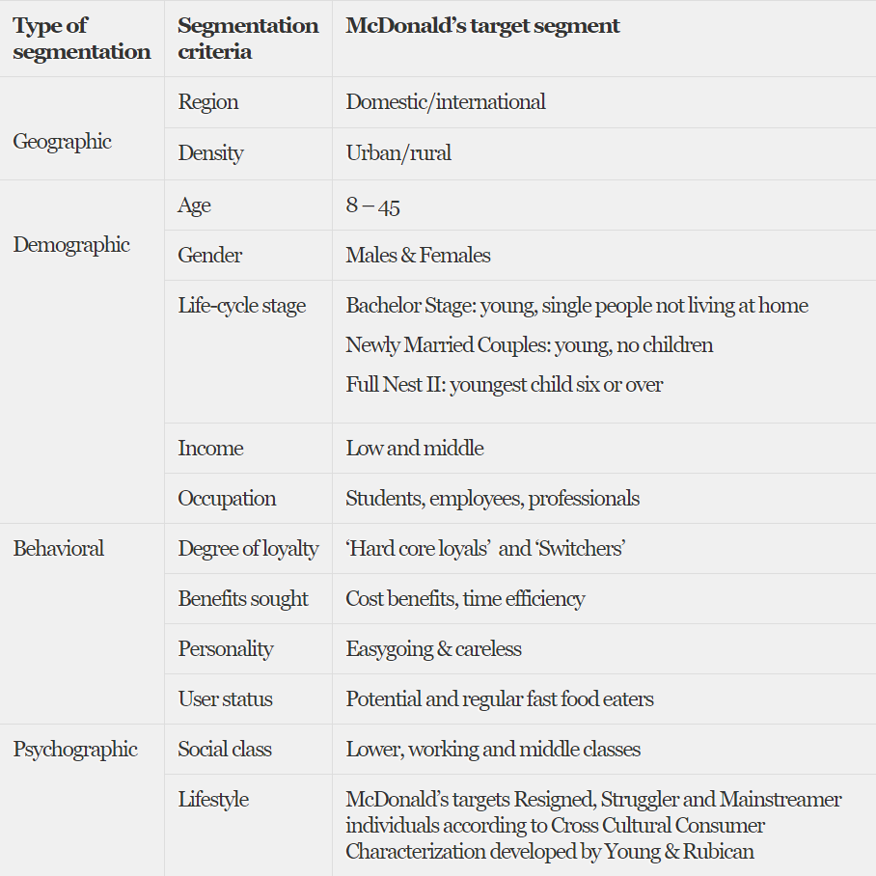

**McDonald SWOT Analysis**

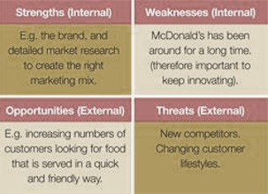

* **Strengths**

**Global Brand**

The McDonald's brand is considered one of the most prevalent brands as it has been a well-established brand for customers for years, as it ranked ninth on the list of top 100 brands.

**Strong operational capabilities**

McDonald's operating capabilities are robust, allowing it to offer quality products.

**World-class supply chain**

It works to provide products of very high quality in all its branches all over the world, and some of its products such as Big Mac and Chicken McNuggets have become very famous.

**Quality products**

McDonald's name is a symbol of quality and work efficiency concerning everything that pertains to the product. (Harris, 2009)

* **Weaknesses**

**Weak Revenue Growth**

Because of the saturation of its markets and the maturity of the customers, the company has been unable to expand and increase the number of revenues. (Harris, 2009)

**Weak product development**

One of the factors that affect the product development process is McDonald's strong competition, and the product development process requires a larger and broader effort.

* **Opportunities**

**Expansion**

Despite the large market segments that McDonald's exploits to display its products, it suffers from a few outlets inside the cities, so McDonald's has an opportunity to expand and increase the number of its outlets. (Harris, 2009)

**Franchise (restaurants operated by McDonald's)**

McDonald plans to sell restaurants that it manages to franchisees, as the operating revenue of franchise-managed restaurants is much higher than the company’s management, and the prospect of selling McDonald’s restaurants to franchisors will increase the profitability of McDonald’s business.

**Growing diving (overseas market)**

The food market is one of the most rapidly changing markets, based on the desires of customers, and that counts as an opportunity for McDonald's. (Harris, 2009)

* **Threats**

**Intense competition**

McDonald's faces fierce market competition from all local, national and regional retailers of food products, and the competition with McDonald's has included fast food establishments, cafes, pizzerias, supermarkets, and food stores. (Harris, 2009)

**Increased health awareness**

With the development of technology, methods of learning, and health awareness, customers have become more aware of the quality of food beneficial to their bodies, and thus a market that reduces the demand for ready-made foods that McDonald's manufactures. (Harris, 2009)

**Increase sales tax**

The increase in the tax increased prices for customers, and thus a reduction in the level of sales and demand for products, and thus a reduction in the percentage of McDonald's revenue. (Harris, 2009)

**4 p's of McDonald**

* **product**

McDonald's tries as much as possible to focus on satisfying the desires and needs of customers by providing products that satisfy their desires, but with the change of these desires, it is difficult to catch up with these desires, as McDonald's to avoid this problem canceled old products and manufactured new products. (John, 1998)

And take into account the non-impact of one of the products on the other, which may lead to the dismantling of sales from the current option.

**BGC:**

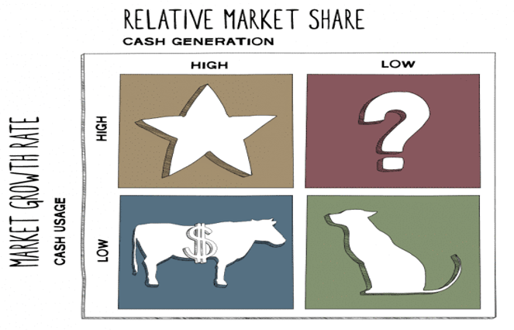

Each of the four quadrants personate a remedy union of referring fair allotment, and effect:

* Low Growth, High Share. Companies should foremilk these “cash cows” for cash to endow.
* High Growth, High Share. Companies should way dress in these “stars” as they have increased in the future influential.
* High Growth, Low Share. Companies should endow in or cashier these “question marks,” rely on their likelihood of becoming stars.
* Low Share, Low Growth. Companies should liquidate, deprive, or reposition these “petted.” For more information see appendix 3.

McDonald is located in the Boston Consulting Group (BCG)Matrix in the star stage, where the companies that are located at this stage are companies with a large market share and the degree of market growth is very high, because MacDonald is an international oil company whose revenues reach billions, and therefore McDonald should continue In its investments in order to increase its market share and increase its revenue significantly and broadly, in order to grow sales and maintain the status quo in the market.

* **price**

The customer’s perception of the product is the primary determinant of the price that is collected against the product, the product is considered to be a physical component, but rather a mental perception of the consumer’s desire, and the low price of the products is evidence that the low price is used as a marketing tool that the offered product is at risk, And the value of the brand must be taken into account when determining the price.

Another potential outcome of the price cut is that competitors may offer the same prices and therefore there will be no additional demand, and thus a reduction in the profit margin without any increase. (John, 1998)

McDonald's has a certain strategy for increasing pricing and increasing prices, and some meals at McDonald's are driving this increase and maintaining increased sales like Happy Meal and combo meals.

The price is one of the most important parts of the marketing mix because it is responsible for generating profits and completing the production operations of McDonald's to the fullest. (John, 1998)

* **place**

The place is considered one of the important elements in the marketing mix, as much depends on it in an effective marketing strategy for the success of the product, and through it, a group of specialized operations is managed to provide the product to the final consumer, and the place consists of distribution channels that make the product an opportunity to be available in all times. (John, 1998)

McDonald's restaurant offers every time you visit many services, and feel comfortable and happy, as it works to provide a healthy environment and a high service atmosphere, McDonald's has started providing internet service through mixed sales outlets with music and provides places for children to play. (John, 1998)

* **promotion**

The methods that McDonald's uses to promote its products are effective, as a great understanding of the customer helps determine the nature of the promotion and whether the cost of the promotion is high or low, and the main goals of McDonald's in order to do the promotion are to educate people, feel positive and remember the feeling.

McDonald's relies on advertising on TV, party shelters, and billboards and some of the most popular marketing campaigns are: (John, 1998)

* "You deserve a break today so wake up and get away."
* "Food, people and fun"
* " I love him"

MacDonald uses the promotional tools "advertising, personal selling, public relations, direct marketing, and sales promotion" to reach the largest number of customers.

**Conclusion**

If the marketing strategy is ready, the consequence of this is assuming responsibilities, each according to their responsibility, until the plan can be implemented.

And McDonald's must always strive to achieve the desire of customers, because meeting their needs is the basis for the success of its production operations and increasing it and thus increasing the expected profits, and because the McDonald's brand is one of the most widespread brands, this will help it to expand significantly and increase the branches of retailers and their sales lines.

Despite all the challenges that confront McDonald's, whether it is new competition or development in the store, it is still at the forefront of restaurants and companies that generate billions of profits and works to expand its business in a large and wide way.

**Recommendations**

1. McDonald's is a large global company with many branches in all countries. In order to make its largest market share, it must increase its retailers and expand its market share.

2. McDonald's is a restaurant that serves food and fast food. Therefore, it must consider the existence of healthy meals for those who depend on a healthy diet.

3. Allocating a good position for vegetarians in order to increase their customers and thereby increase profits.

4. Continue the process of presenting new products and different food dishes in order to study and change customers' desires.

5. Providing all possible ways to increase customers, and providing all comfortable and healthy families.

6. Allocate good space for the promotion process and further expand your McDonald's ads.

7. Partnering with some of the restaurant's outside companies, and holding business meetings.

8. Providing new mechanisms and services through the internet and providing a space for the customer in order to be able to request what he can and quickly.

**Appendix**

1. **Organizational Chart of McDonald**

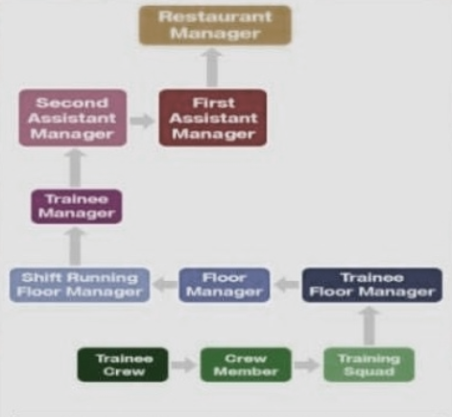

1. **CEO of McDonald**

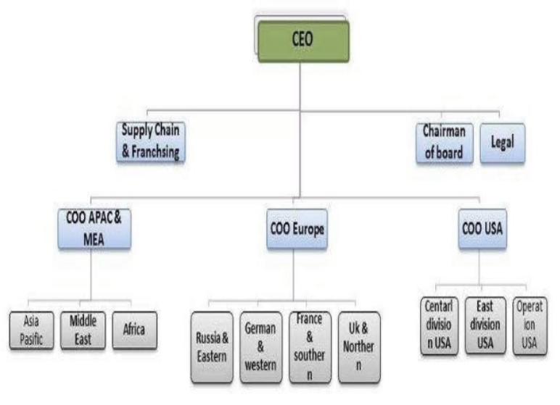

1. **Products of McDonald in the BGC**

* Hamburger, MacAloo Tikki, and French fries are stars.
* A non-veg menu of McDonald’s is not that popular and that’s why it is a question mark.
* Its Dessert menu is struggling to attract customers, and that’s why it’s in Dog in BCG matrix.

**References**

1. Barnes, D., (2008), Operations Management: An International Perspective. UK Cengage Learning EMEA.
2. Cooper. R.G., Edgett. S.J (2009). Product Innovation and Technology Strategy. USA: State – Gate International.
3. Facella, P., Genn, A. (2008). Everything knows about the business I learned at McDonald’s: the 7 leadership principles that drive break out success. The USA. McGraw – Hill
4. Harris. P.S., (2009): None of us is as good as all of us: how McDonald’s prospers by embracing inclusion and diversity. John Wiley and Sons
5. John F. Love (1998). McDonald’s: Behind the arches. UK: Transworld Publishers Ltd.
6. KFC. (2020) About us. <https://www.kfc.com/>
7. Kotler. Ph. & others. (2012). Marketing management. library of Congress Cataloging in Publication Data. Kotler, Philip.
8. McDonald. (2020). About us. <https://corporate.mcdonalds.com/>
9. Pri Dhavale (2012): McDonald’s marketing strategy. SlideShare's Publications [www.google.com](http://www.google.com)